# INSTITUTE FOR ADVANCED

# COMPUTING AND

# SOFTWARE DEVELOPMENT

# AKURDI, PUNE

Documentation On

**“ONLINE SHOPPING SYSTEM”**

E-DAC SEP- 2020

*Submitted By:*

**Group No: 99**

**Name: Vivek Narnolia**

**Roll Number: 2211**

Prashant Karhale Mr. Akshay Parab

(Centre Coordinator) (Project Guide)

**Revision History**

|  |  |  |  |
| --- | --- | --- | --- |
| **Date** | **Version** | **Description** | **Author** |
|  | 1.0 | SRS documents focuses on Introduction, Objectives, Project Scope, Functional & Non-Functional requirements, Usages Scenario and Work Plan |  |

**Table of Contents**

**1. Introduction…………………………………………………………………………………4**

1.1 Purpose…………………………………………………………………………………………………………………..4

1.2 Scope………………………………………………………………………………………………………………………4

1.3 Definitions, Acronyms, and Abbreviations………………………………………………………………4

1.4 Overview…………………………………………………………………………………………………………………4

#### 2. Overall Description……………………………………………………………………..5

2.1 Product Perspective………………………………………………………………………………………………..5

2.2 Product functions……………………………………………………………………………………………………5

**3. Specific Requirements……………………………………………………………………5**

3.1 Functional Requirements…………………………………………………………………………………………5

3.2 Non-Functional Requirements…………………………………………………………………………………5

3.3 Tools Used……………………………………………………………………………………………………………….6

**4. System Diagrams.…………………………………………………………………………6**

4.1 Use case Diagram……………………………………………………………………………………………………6

4.2 E-R Diagram ……………………………………………………………………………………………………………7

4.4 Class Diagram …………………………………………………………………………………………………………8

4.4 Sequence Diagram…………………………………………………………………………………………………..9

4.5 Data Flow Diagram…………………………………………………………………………………………………..9

**5. Table Structures…………………………………………………………………………..10**

5.1 Users………………………………………………………………………………………………………………………10

5.2 Admins……………………………………………………………………………………………………………………10

5.3 Products…………………………………………………………………………………………………………………11

5.4 Cart………………………………………………………………………………………………………………………..11

5.5 Orders…………………………………………………………………………………………………………………….11

5.6 Payments……………………………………………………………………………………………………………….12

**6. Conclusion………………………………………………………………………………….12**

**7. Future Scope……………………………………………………………………………….12**

**8. References………………………………………………………………………………….12**

# SOFTWARE REQUIREMENTS SPECIFICATION

1. Introduction

* This document is the Software Requirement Specification (SRS) for the online shopping system “**Tulsi**”. It will outline all of the agreed upon features of the online shopping system. This document includes a description of the software and its subsystems.
* This document is broken into a number of sections used to logically separate the software requirements into easily referenced parts.
* This Software Requirements Specification aims to describe the Functionality, Attributes and Design Constraints imposed on Implementation of the software system described throughout the rest of the document.

1.1 Purpose

Defining and describing the functions and specifications of the online shopping system is the primary goal of this Software Requirements Specification (SRS). This Software Requirements Specification illustrates, in clear terms, the system’s primary uses and required functionality.

1.2 Scope

The application to be created is an online shopping system. It will perform basic functions that will allow the Web customer uses some web site to make purchases online. Top level use cases are Login, User Registration, View Items, Add products to cart and Place Order. Login use case could be used by previously registered user to login on the website. View Items use case could be used by customer as top-level use case if customer only wants to find and see some products. This use case could also be used as a part of Make Purchase use case. User Register use case allows customer to register on the web site.

1.3 Definitions, Acronyms, and Abbreviations

* Website – A address that is connected to the internet to provide one or more web pages or other content.
* Online – Connected to a computer network or accessible by computer
* Browse – Reading superficially or at random
* Search – The activity of looking thoroughly in order to find something
* Shopping cart – A handcart that holds items (groceries or other goods) while shopping.
* Checkout – Confirm and pay goods (or services) using a payment facility

1.4 Overview

E-commerce is a web based application or mobile application implemented for easy to access product or services around the corner of world, buy, sell, chat, transact, get service and maintains records. Using record we can track customer and inform customized and future offers and discount.  
Legal contract department prepare policy contract and sends to customer after payment has received from the customer.

#### 2. OVERALL DESCRIPTION

**2.1 Product Perspective**: E-Commerce website or application supports a number of functions for both the consumer and marketer

* System interfaces:
* User Interface
* Hardware:
* Software:
* Communication: Can communicate via alert, emails, text message etc.

##### **2.2 Product functions:**

Provides following list of functions:

* Allow to login and become prime member
* Show categorized product with detailed specification
* Add to cart
* Check offers
* Make Wish list
* Remind me later
* Online Transaction
* Chatting with parties
* Maintain records

3. Specific Requirements

3.1 Functional Requirements

* Login
* Logout
* Registration
* Admin
* Add product
* Update Product
* Delete Product
* View Product
* Shopping Cart
* Add product to cart
* Place order
* Payment Processing
* Shipping

3.2 Non-Functional Requirements

* Operating System
* Accessibility
* Availability
* Efficiency
* Usability
* Flexibility
* Security
* Maintainability

3.3 Tools Used:

* **Application Type**- Web Based Application
* **Technologies & Languages-** HTML, CSS, Bootstrap, JavaScript, Node Js, Express Js, React Js, MySql .
* **Tools Used**- Visual Studio Code
* **Operating Systems:** Windows 10

4. System Diagram

4.1 Use Case Diagram

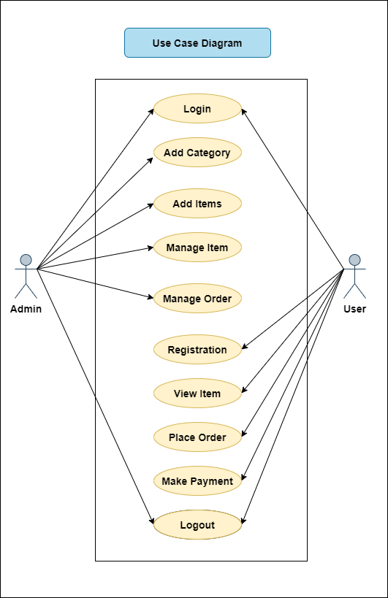

4.2 E-R Diagram

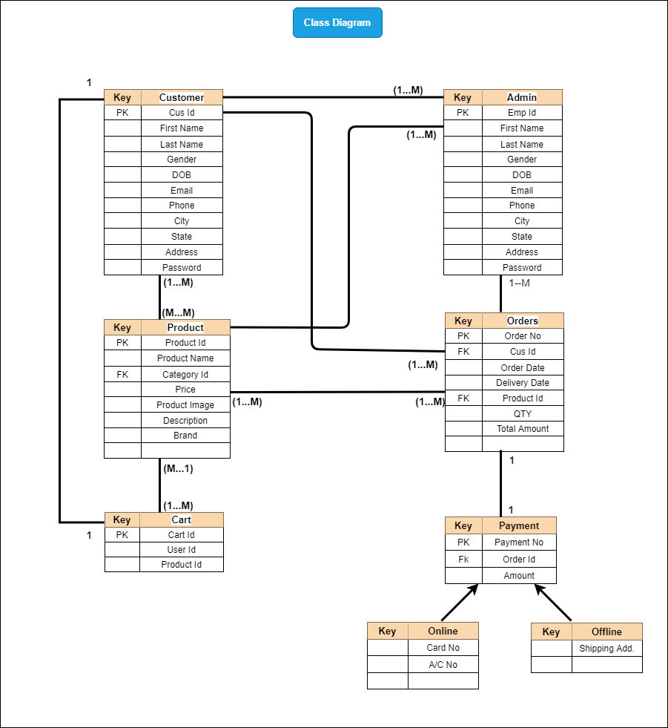

4.3 Class diagram



4.4 Sequence Diagram

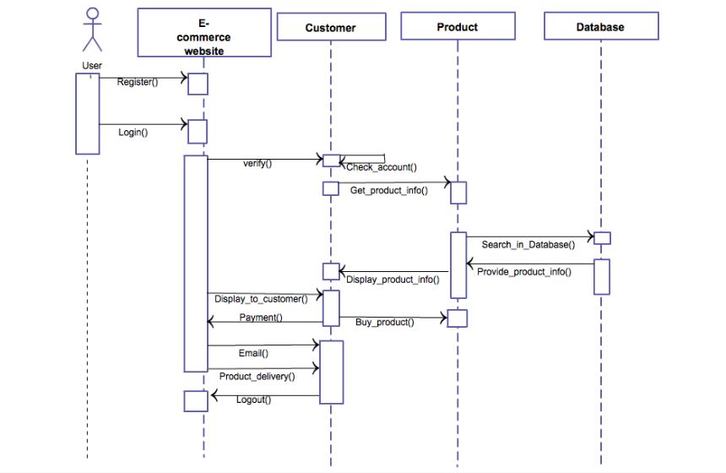

4.5 Data Flow Diagram

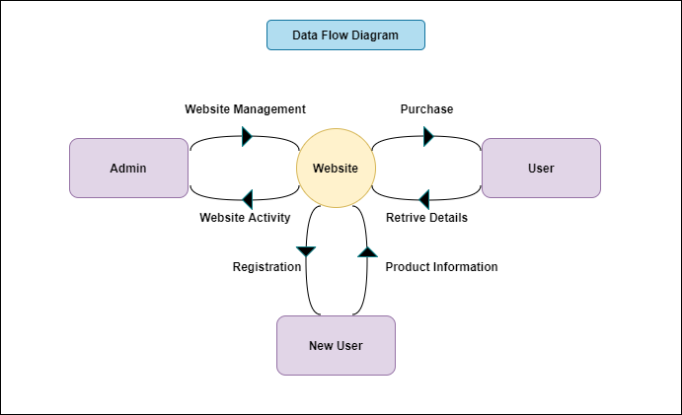

5. Table Structures

5.1 Users

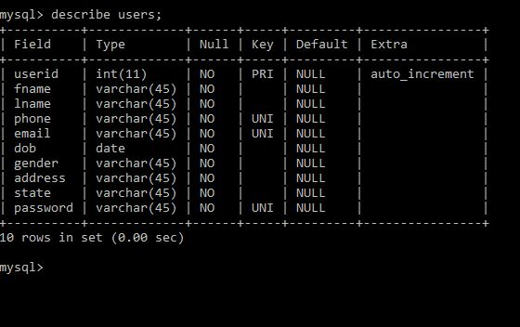

5.2 Admins

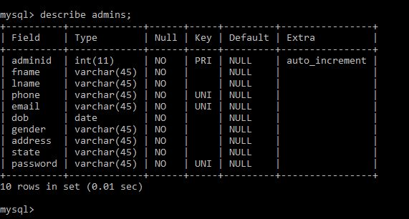

5.3 Products

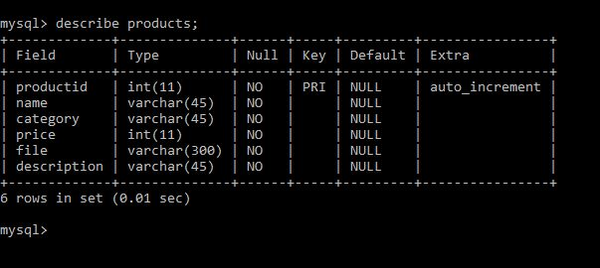

5.4 Cart

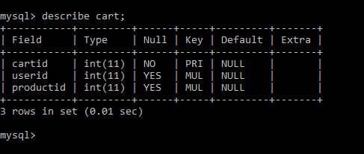

5.5 Orders

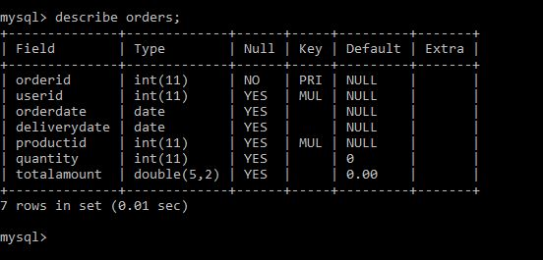

5.6 Payments

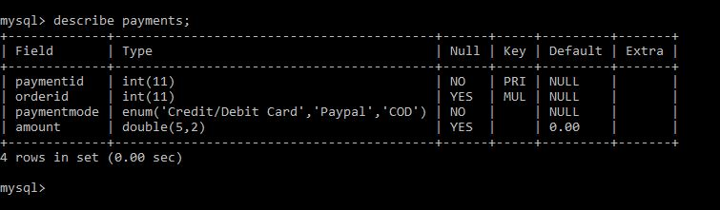

6. Conclusion

* Online shopping system puts forth the actual working of an E-commerce website. Login, Registration, Add Products, Edit products, Add to cart, Payment etc. are the key features of our project. User can access services and functionalities from anywhere and anytime for their own comfort.

7. Future Scope

* This project can be updated further by adding online payment facility by using Credit/Debit card or various UPI’s for the users. The software is flexible enough to be modified and implemented as per future requirements. I have tried our best to present this free and user–friendly website. Message, Email and Product tracking alerts can be added to the system so that users do not miss the updates.

8. References

1. <https://reactjs.org/docs/getting-started.html>
2. <https://nodejs.org/en/>
3. https://www.w3schools.com/html/html_css.asp
4. https://www.getbootstrap.com