Vivek Patel

CSC 453 Section 810

Assignment 2

2/03/2019

1. 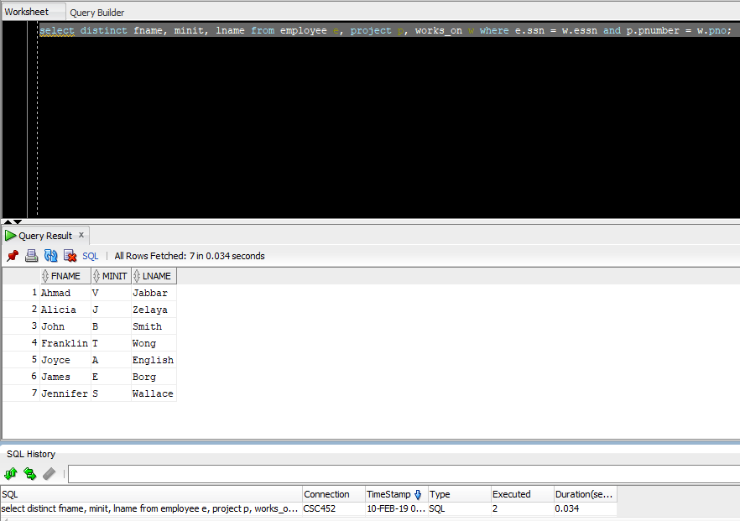
2. 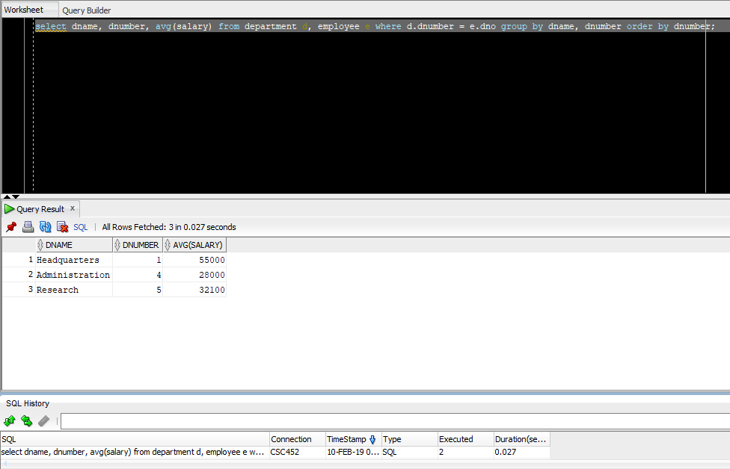
3. 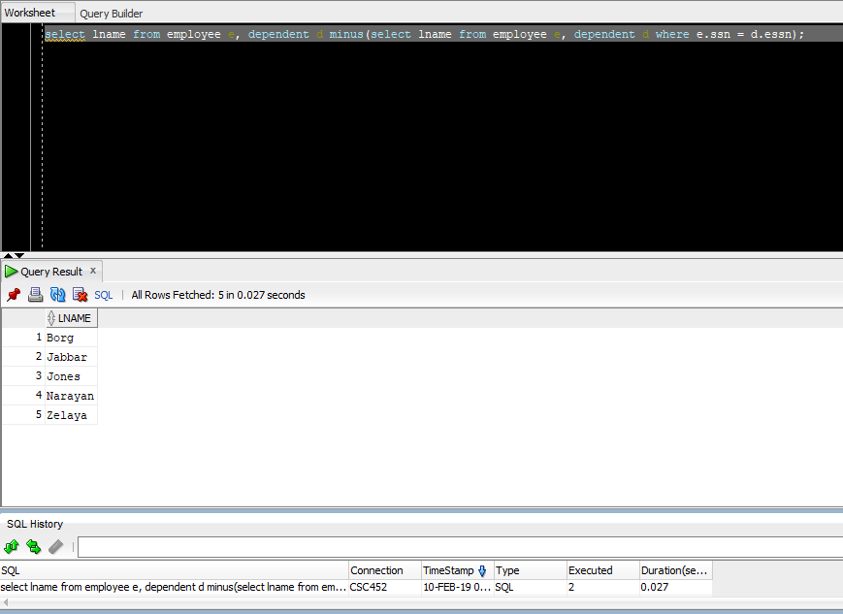
4. 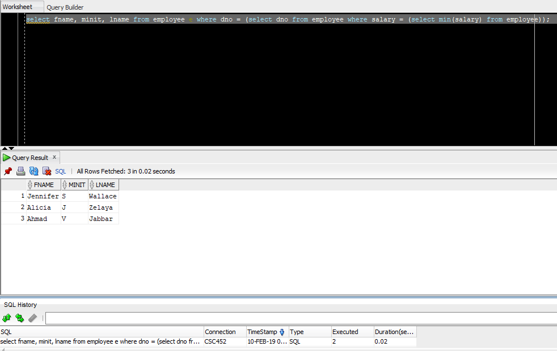
5. This one is very much wrong, but I had so many different times I had the correct count for each, but it had a set for each department. Eventually I got tired and this is my final answer. 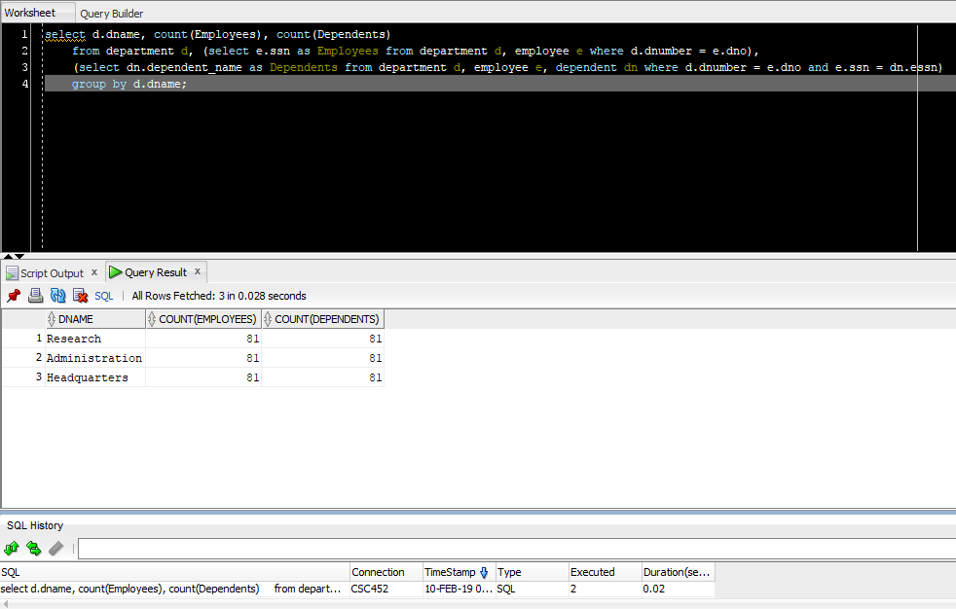
6. 