Problem 4.16

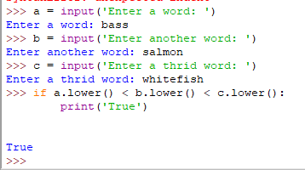

Problem 4.25

