IDP — Technical Report | Vivek Preetham | Bluno Intern Assignment

Overview
FastAPI service with a LangGraph StateGraph pipeline that parses, classifies, and extracts structured fields from invoices, sea waybills, and airway bills. Dual parsers (docling + LlamaParse) run in parallel and their outputs are merged. Rule-based extraction runs first; a single batched Groq LLM call handles all low-confidence fields. Responses include per-field confidence scores, line items (invoices), HITL review flag, and per-node timing.

Pipeline Architecture
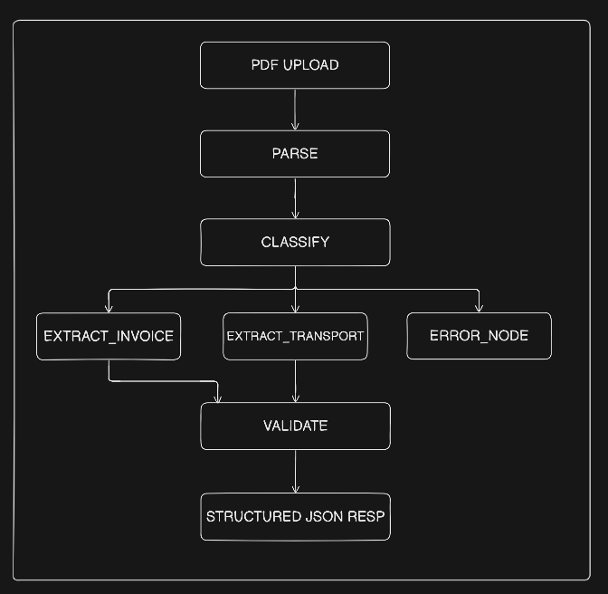
Node Summary
Node | Role | Strategy
parse | Dual parsing | docling + LlamaParse in parallel, outputs concatenated. Both fail → HTTP 422.
classify | Type routing | Keyword scoring first, LLM fallback. Routes to extract or error_node.
extract | Field extraction | Hybrid rule-based → batched LLM. Transport form fields go straight to LLM.
validate | Pydantic + HITL | Per-field coercion. HITL flag if key field confidence < 0.7 or errors exist.

Field-Level Precision & Recall (14 invoice PDFs, tests/evaluate.py)
Field | Precision | Recall | TP | FP | FN | Method
issuer | 100% | 100% | 14 | 0 | 0 | Rule-based: text before 'Bill To:'
date | 100% | 100% | 14 | 0 | 0 | Rule-based: label-anchored regex
total | 100% | 100% | 14 | 0 | 0 | Rule-based: Total line + Decimal
invoice_number | 100% | 100% | 14 | 0 | 0 | Rule-based: 'Invoice #' pattern
reference_ids | 100% | 100% | 14 | 0 | 0 | Derived from invoice_number

Note: Evaluation set is 14 invoices from a single SuperStore template. Transport documents were not evaluated quantitatively (no labelled ground truth available).
Key Design Decisions
- Dual parser merge: Both outputs concatenated — neither parser's gaps affect extraction.
- Hybrid extraction: Regex first (free, fast); single batched Groq call for all low-confidence fields.
- Transport LLM-first: Form-layout PDFs interleave label and value tokens — regex captures template placeholders. LLM handles all text fields with explicit instruction to ignore them.
- Decimal for money: Avoids float rounding. _safe_decimal() coerces individually — one bad field never rejects the whole response.
- Partial success: Field failures → ExtractionError in errors list, not HTTP 422. All other fields still returned.
- LLM: Groq + llama-3.1-8b-instant — ~750 tok/s, JSON mode, free tier. Model swappable via GROQ_MODEL env var.

Failure Cases
Case | Root Cause | Fix
Sea waybill fields extracted as template labels (e.g. bl_number='No', shipper='/ Exporter (complete name and address)') | PDF lineariser interleaves form label and value tokens. Regex matched the placeholder text instead of typed value. | Rewrote extract_transport.py: rule-based only for unambiguous formats. All text fields sent to LLM with explicit prompt to ignore template labels.
LLM returning string 'null' for optional fields (e.g. due_date='null' → parse error in validate) | Groq returned the string literal "null" instead of JSON null for absent optional fields. | Added sanitisation: strings in {null, none, n/a, na, undefined} normalised to Python None before writing to extracted_fields.

Known Limitations
- Evaluation set is one invoice template — performance on other vendor layouts not measured.
- No transport ground truth — precision/recall for sea waybill / airway bill not reportable.
- Groq free tier: 30 req/min cap. Large /batch calls may hit this limit.
- No persistent storage — results returned in HTTP response only, no audit trail.

