Flask + MongoDB Atlas Assignment

Question 1
Create a Flask application with an /api route. The route reads data from data.json and returns it as JSON.
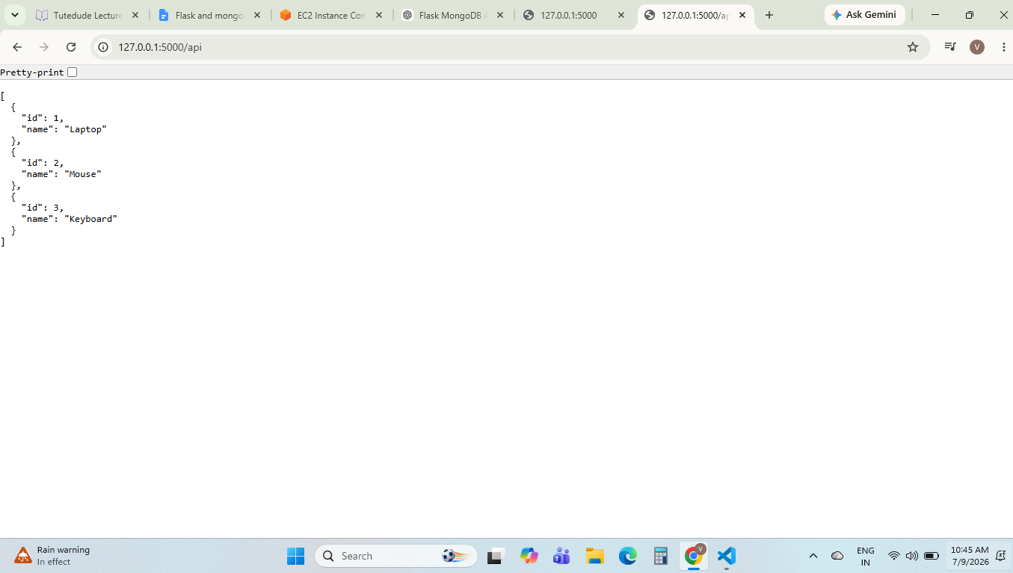

Question 2
Create a frontend form that inserts data into MongoDB Atlas. On success, redirect to a success page. On error, display the error on the same page.
Step 1: Student Form
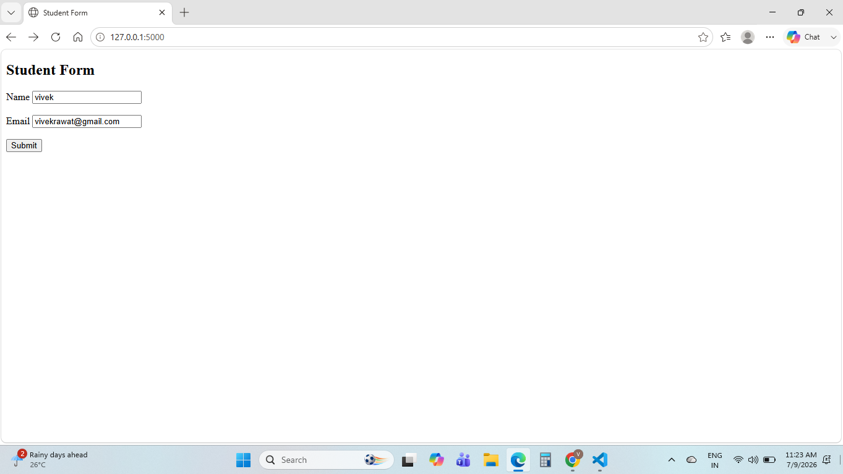
Step 2: Success Page
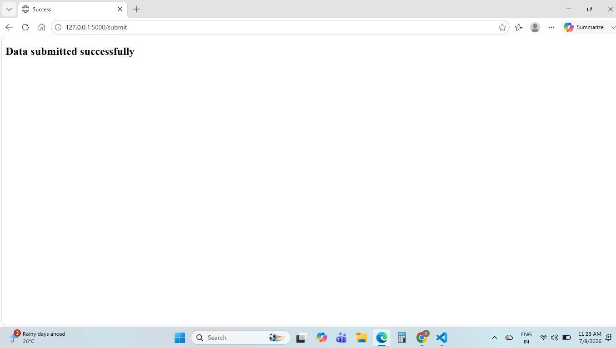
Step 3: MongoDB Atlas Document
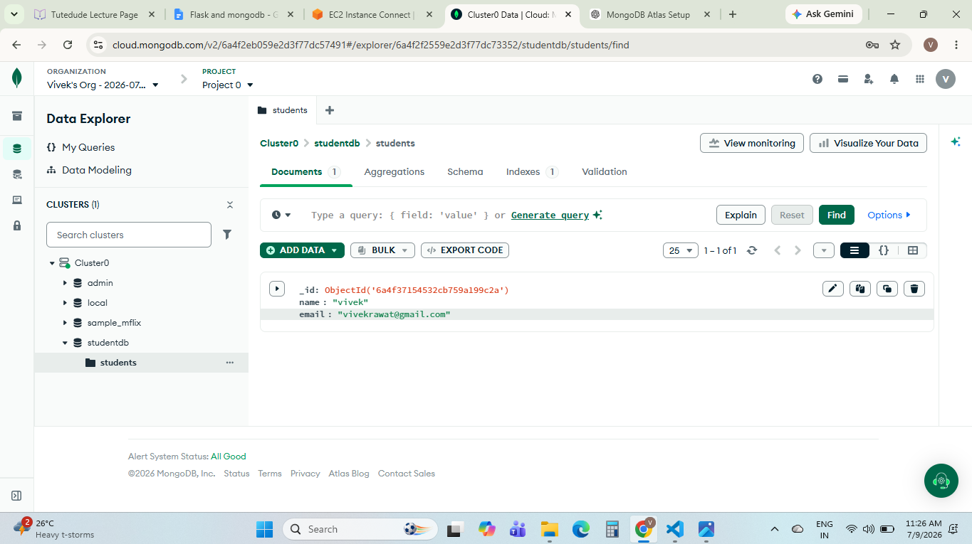

Explanation
1. Created a Flask application.
2. Implemented the /api route to return JSON data from data.json.
3. Designed a frontend HTML form.
4. Connected the application to MongoDB Atlas using PyMongo.
5. Stored submitted data in the students collection.
6. Displayed 'Data submitted successfully' after successful insertion.
7. Displayed an error on the same page if insertion failed.

GitHub Repository
Paste your GitHub repository link here before submission.

