CLOUDOPS
MICROSERVICE PLATFORM
Deployment & Verification Documentation

Architecture | Frontend + API Gateway + User / Product / Order Services + MongoDB
Containerization | Docker & Docker Compose
Cloud Deployment | AWS EC2, ECR, VPC, Security Group, SSM
Infrastructure as Code | Terraform

Project status: Successfully deployed and verified on AWS

1. Project Overview
CloudOps Microservice Platform is a containerized e-commerce-style application built as a set of independent microservices. The frontend communicates with the backend through an API Gateway, while the Product and Order services use MongoDB for persistent application data.
For cloud deployment, Docker images were pushed to Amazon ECR and the application stack was deployed on an AWS EC2 instance. Terraform was used to provision the networking and compute infrastructure, while AWS Systems Manager (SSM) was used for secure instance access without relying on an SSH private key.

2. Technology Stack
Technology | Purpose
React / Vite | Frontend user interface
Python services | User, Product and Order microservices
Gateway / Nginx | API routing and frontend/backend communication
Docker | Containerization of application services
Docker Compose | Running the complete service stack together
MongoDB | Application data storage
Amazon ECR | Private container image registry
Amazon EC2 | Cloud compute host
AWS VPC / Security Group | Networking and inbound/outbound access
AWS SSM | Secure remote management of EC2
Terraform | Infrastructure as Code

3. Project Structure
The project contains separate frontend, gateway, microservice, Kubernetes and Terraform configurations.
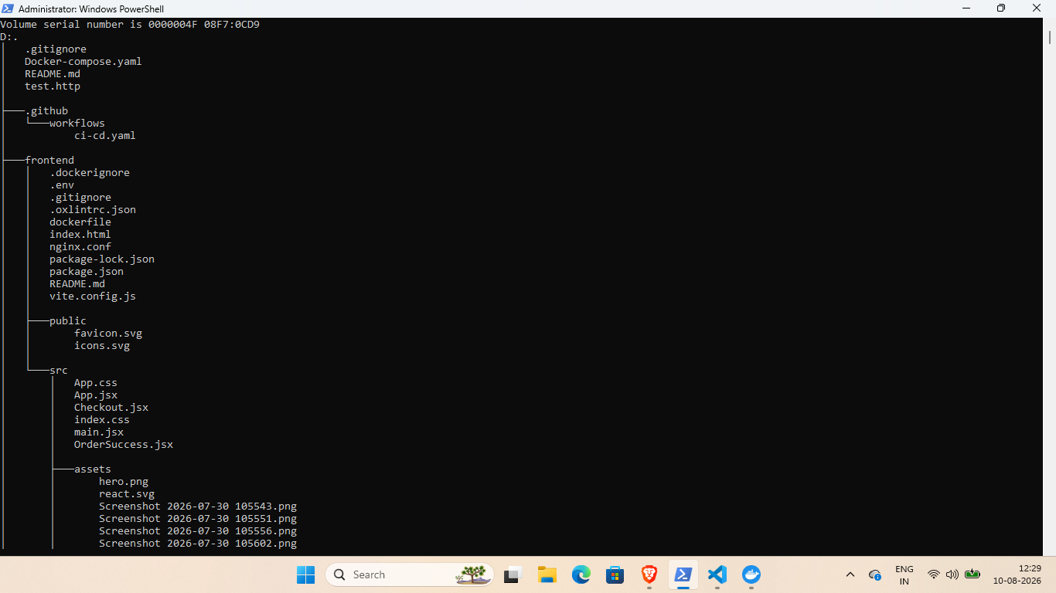
Figure 1 — Project structure and application components
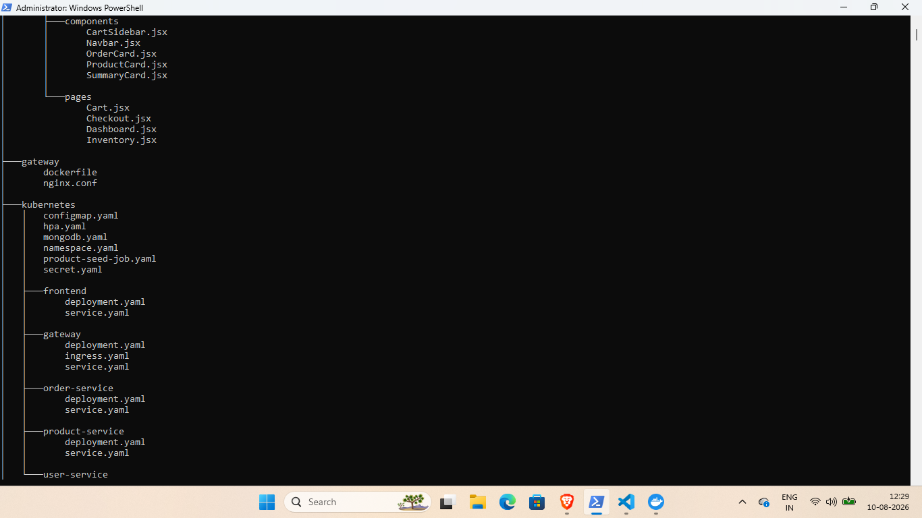
Figure 2 — Kubernetes manifests and Terraform directory structure

4. Infrastructure Provisioning with Terraform
Terraform manages the AWS infrastructure used by the deployment. The final infrastructure includes a VPC, public subnet, Internet Gateway, route table, security group and EC2 instance. The EC2 instance also uses an IAM instance profile for AWS Systems Manager access.
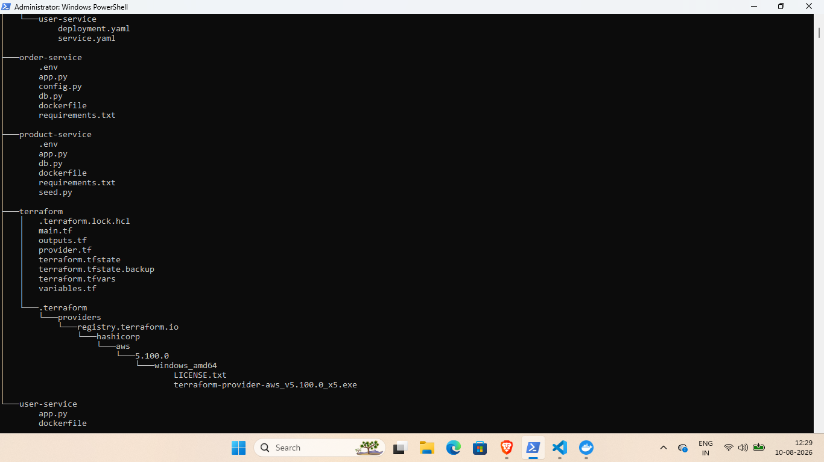
Figure 3 — Terraform configuration files
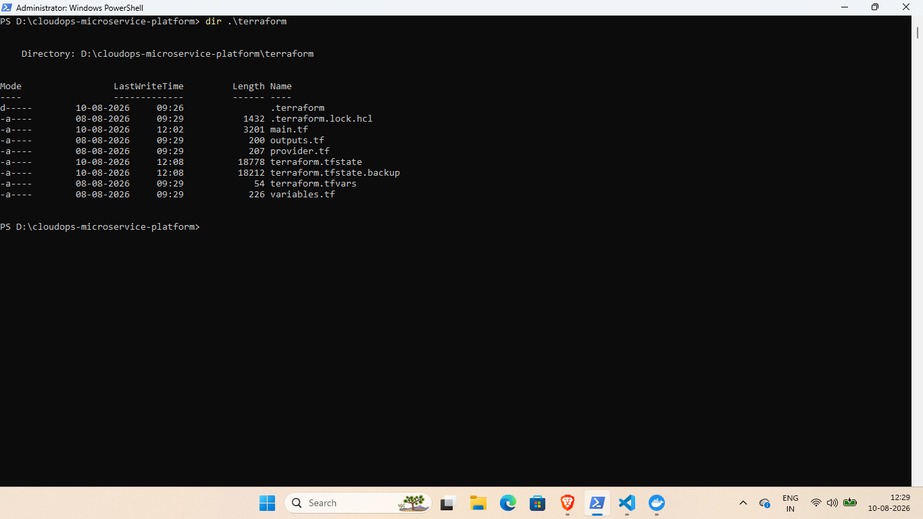
Figure 4 — Terraform outputs: EC2 instance, public IP and VPC

5. AWS EC2 Verification
The deployed EC2 instance was verified through the AWS CLI. The instance was running and had a public IPv4 address used to access the frontend.
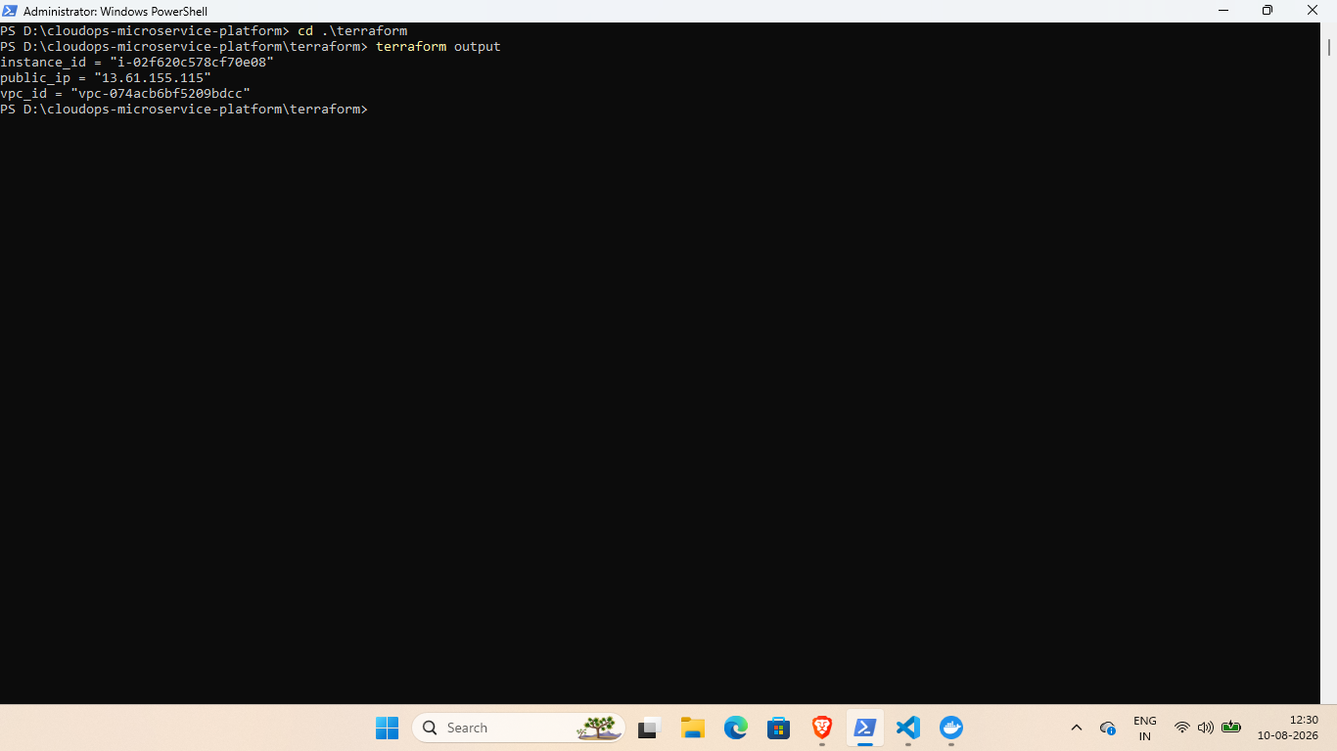
Figure 5 — AWS EC2 instance verification

6. Amazon ECR Container Registry
The application services were containerized and their images were stored in Amazon ECR. The repositories include the frontend, gateway and backend microservices.
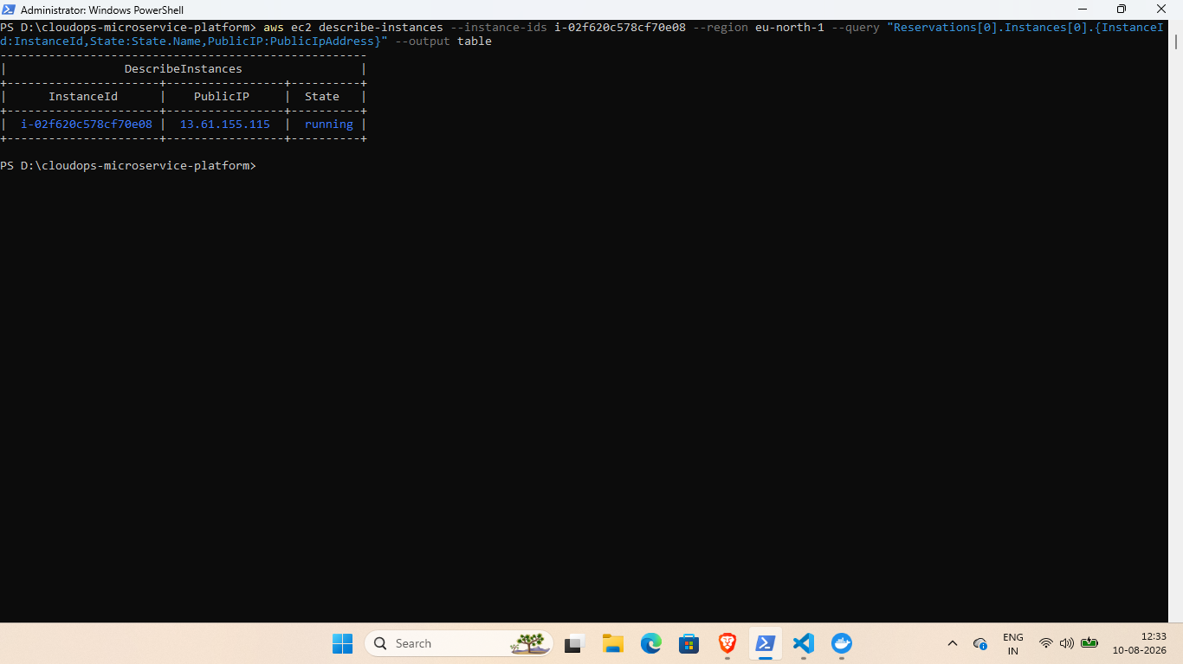
Figure 6 — Amazon ECR repositories
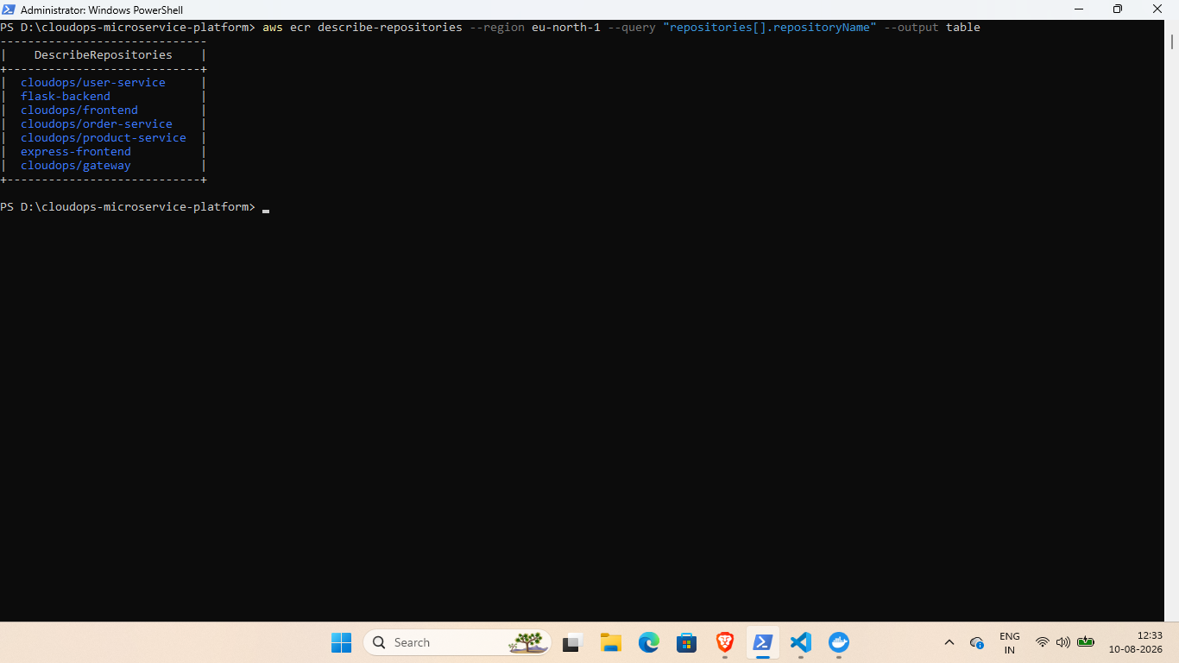
Figure 7 — Frontend image present in Amazon ECR

7. Secure EC2 Access with AWS Systems Manager
AWS Systems Manager Session Manager was used to access the Ubuntu EC2 instance without using an SSH private key. The session was successfully established and Docker was available on the server.
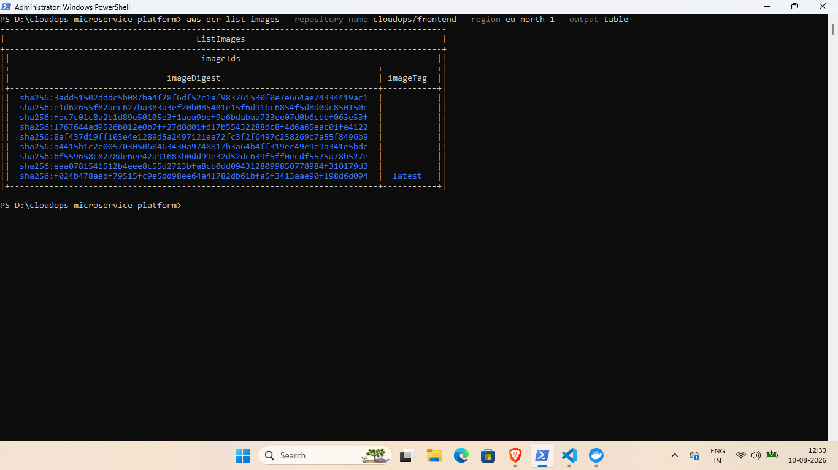
Figure 8 — SSM session and Docker version

8. Docker Compose Deployment
The production stack was started with Docker Compose. The final stack contains the frontend, gateway, user-service, product-service, order-service and MongoDB containers.
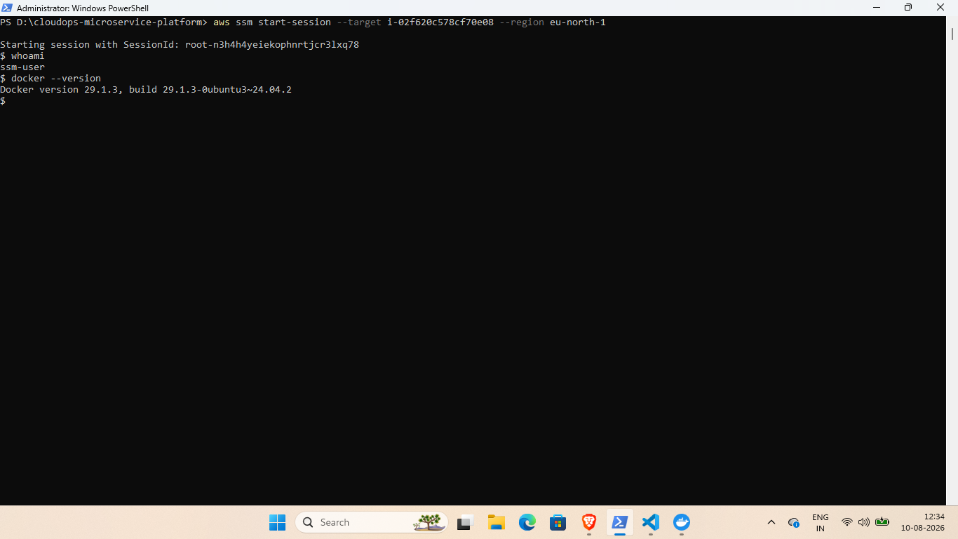
Figure 9 — All application containers running with Docker Compose

9. Backend API Verification
The Product API was tested from inside the EC2 instance through the gateway. The response returned the seeded products, confirming that the gateway, product service and MongoDB integration were working together.
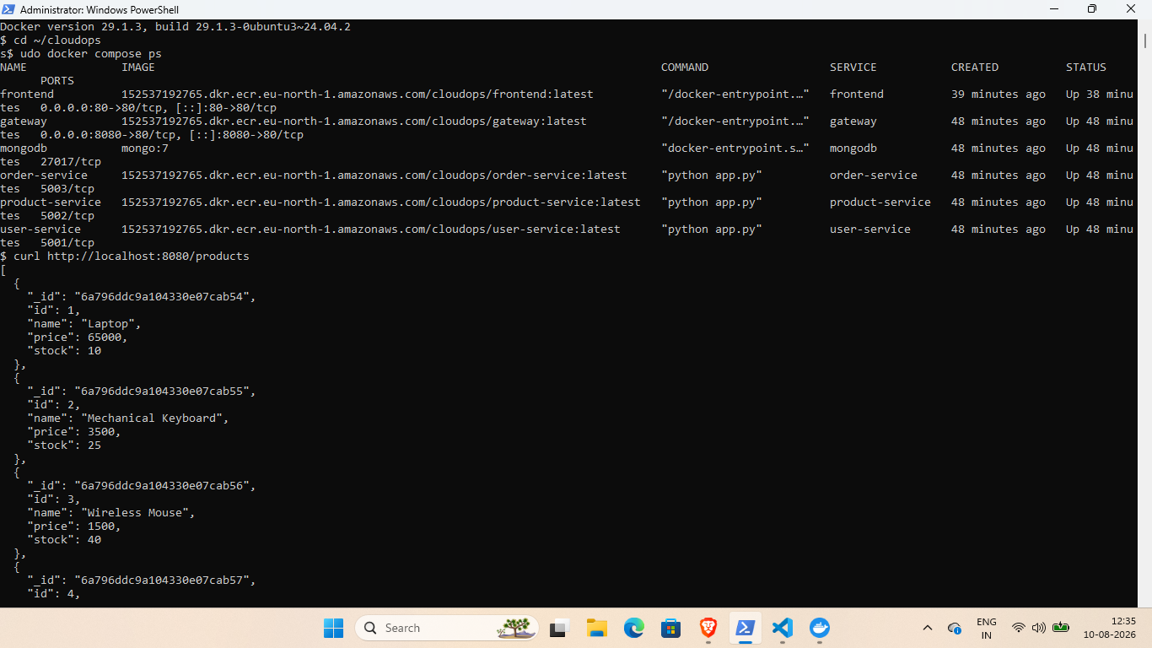
Figure 10 — Product API response (part 1)
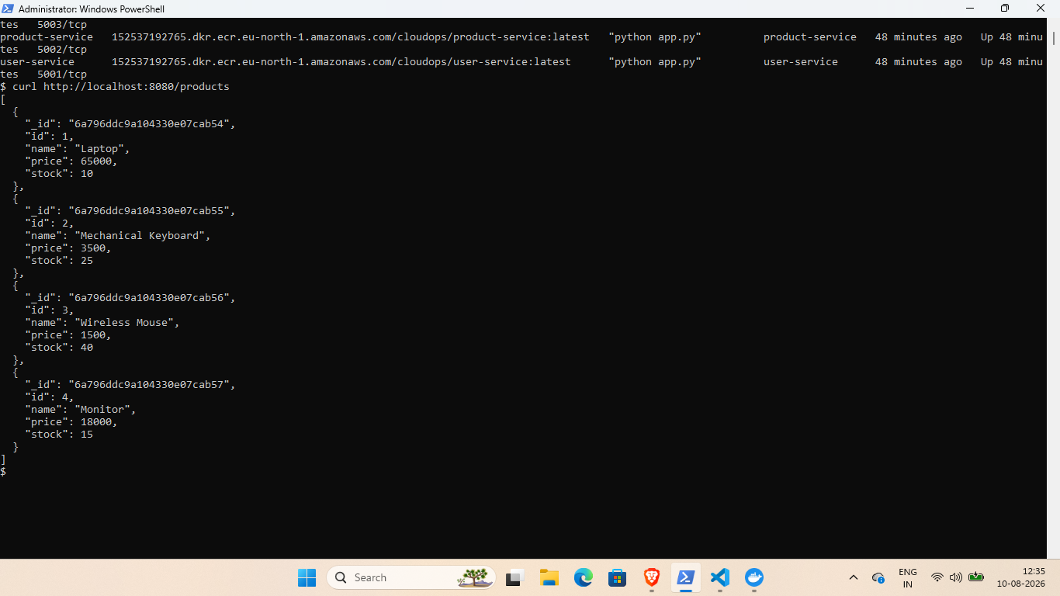
Figure 11 — Product API response (part 2)

10. Live Application Verification
The deployed frontend was opened through the EC2 public IP. The dashboard displayed four products, total stock and the order section, confirming successful frontend-to-backend communication.
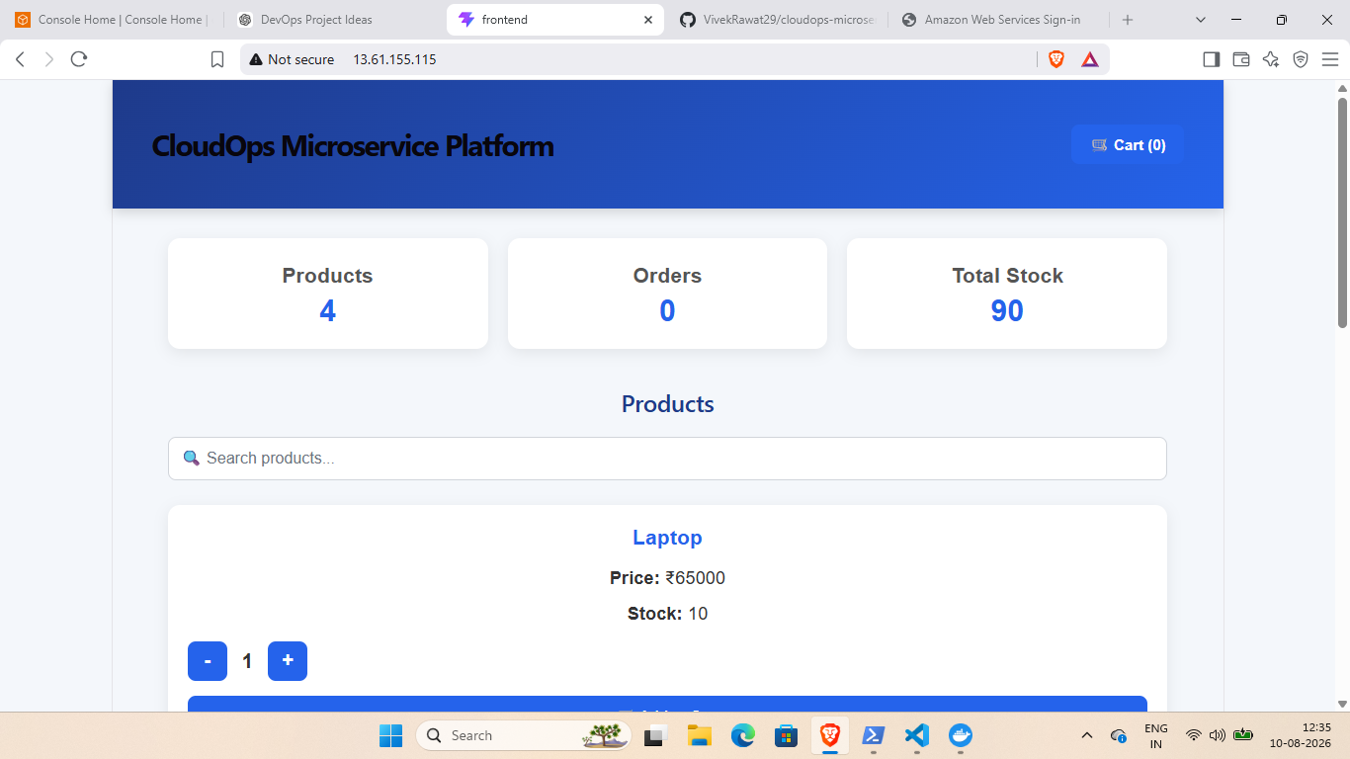
Figure 12 — Live CloudOps Microservice Platform homepage
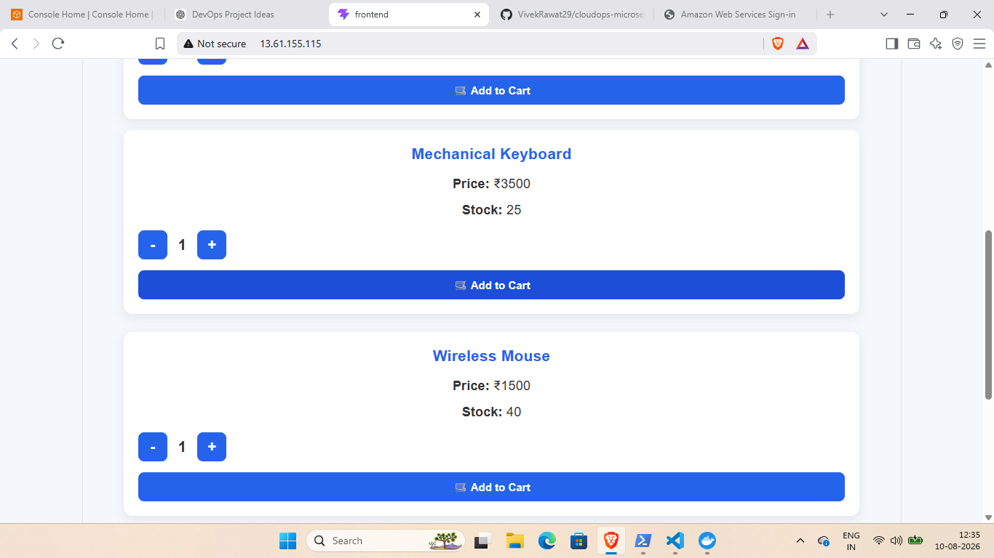
Figure 13 — Product catalogue
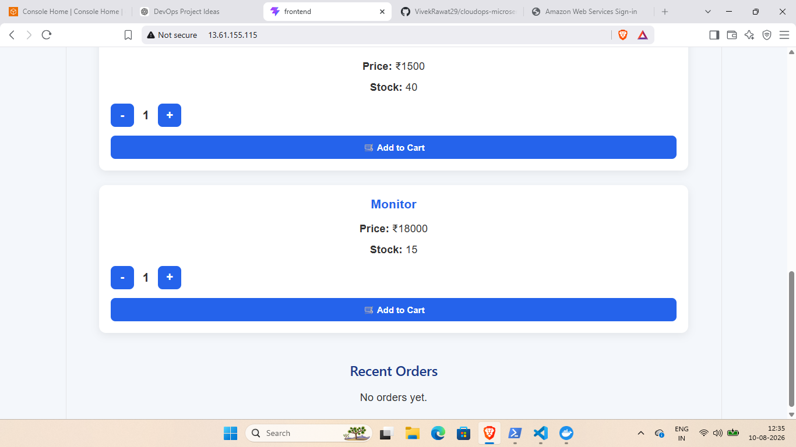
Figure 14 — Product catalogue and Recent Orders section

11. Cart and Checkout Flow
The application was tested beyond simply loading the homepage. Products were added to the cart, the cart total was calculated, and the checkout form was completed.
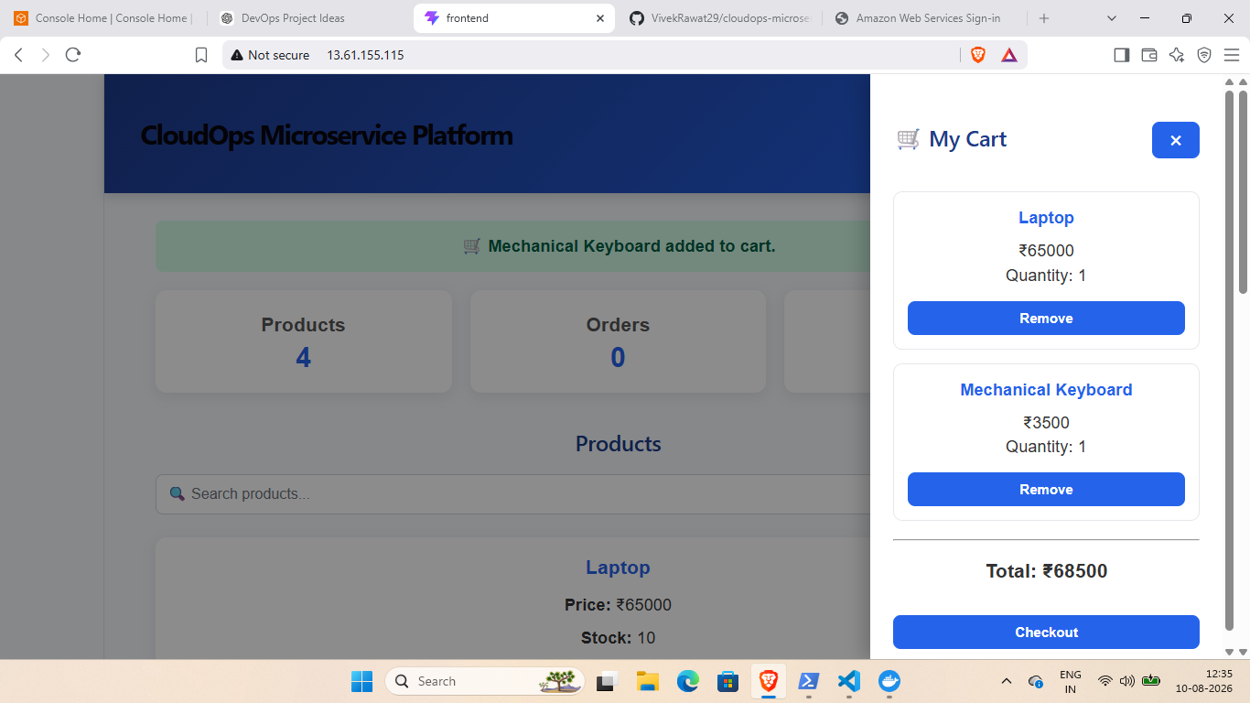
Figure 15 — Shopping cart with selected products
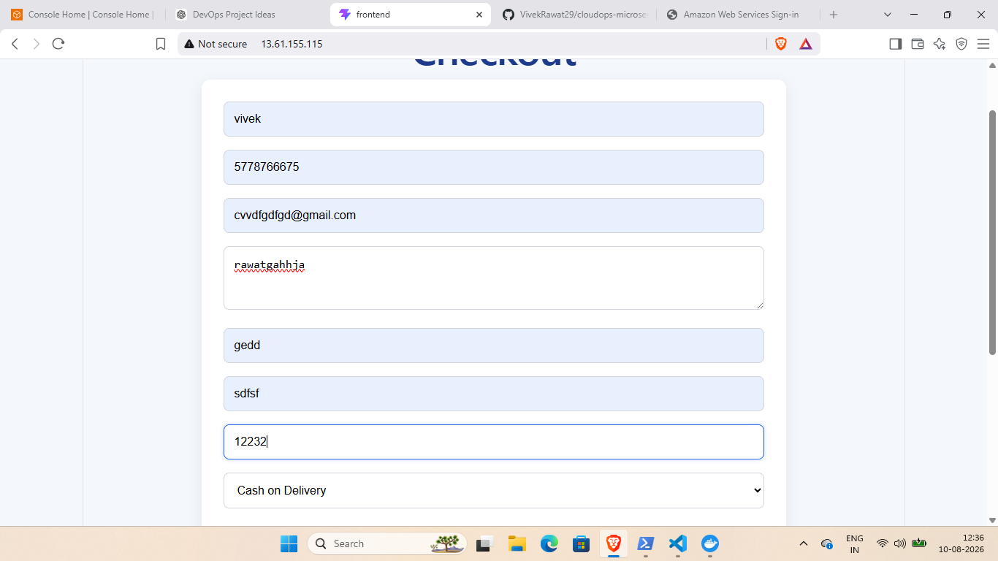
Figure 16 — Checkout form

12. Order Placement Verification
An order was successfully placed through the deployed application. The confirmation page displayed the order ID and processing status. The Recent Orders section subsequently displayed the placed orders with product, quantity, total and confirmed status.
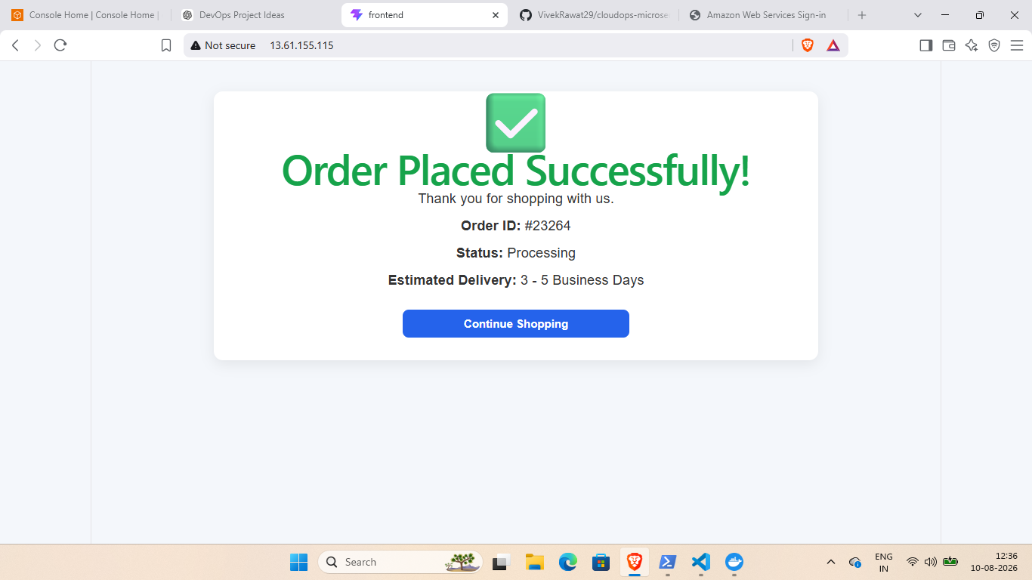
Figure 17 — Successful order confirmation
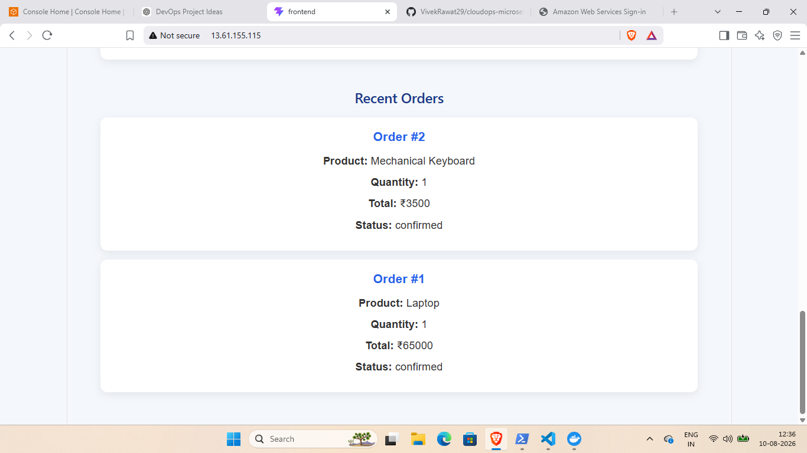
Figure 18 — Recent Orders showing persisted orders

13. Deployment Flow
Source Code → Docker Images → Amazon ECR → AWS EC2 → Docker Compose → Microservices → MongoDB → Public Frontend
Terraform provisions the AWS infrastructure. Docker images are stored in ECR and pulled by the EC2 host. Docker Compose starts the complete application stack. The frontend is exposed publicly through the EC2 instance, while the gateway routes requests to the backend services.

14. Final Verification
Verification | Status
Terraform infrastructure | Completed
EC2 instance running | Verified
ECR repositories/images | Verified
SSM access | Verified
Docker Compose services | All running
Product API | Working
Frontend | Accessible
Product catalogue | Working
Cart and checkout | Tested
Order creation and persistence | Verified

15. Conclusion
The CloudOps Microservice Platform was successfully containerized, pushed to Amazon ECR, deployed on AWS EC2 using Terraform-managed infrastructure, and verified end-to-end. The final application supports product browsing, cart operations, checkout and order persistence through the deployed microservice architecture.

END OF DOCUMENTATION

