Kubernetes (Minikube) Deployment Assignment Report

Objective
Deploy a Flask backend and Express frontend locally using Kubernetes using Minikube.

Prerequisites
- Docker Desktop
- kubectl
- Minikube
- Local Docker images

Implementation Steps
- Started Minikube cluster.
- Loaded backend and frontend Docker images.
- Created backend Deployment and ClusterIP Service.
- Created frontend Deployment with BACKEND_URL environment variable.
- Created frontend NodePort Service.
- Applied all YAML manifests.
- Verified Pods and Services.
- Opened application using minikube service.

Commands Used
minikube start --driver=docker
minikube image load flask-backend:latest
minikube image load express-frontend:latest
kubectl apply -f backend-deployment.yaml
kubectl apply -f backend-service.yaml
kubectl apply -f frontend-deployment.yaml
kubectl apply -f frontend-service.yaml
kubectl get pods
kubectl get services
minikube service express-frontend-service

Screenshots
Figure 1: Minikube service output
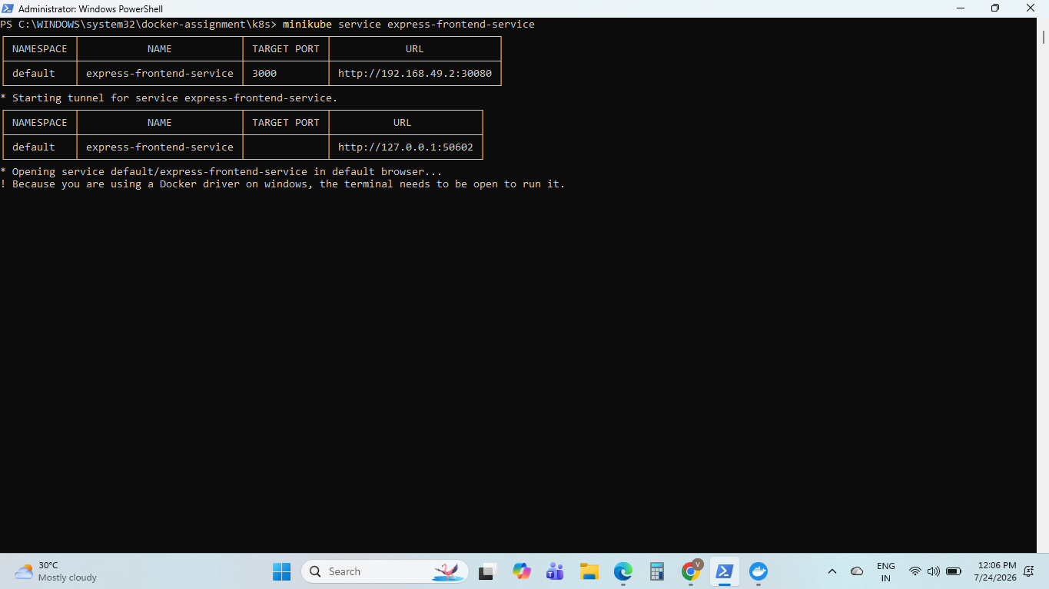
Figure 2: Successful application output
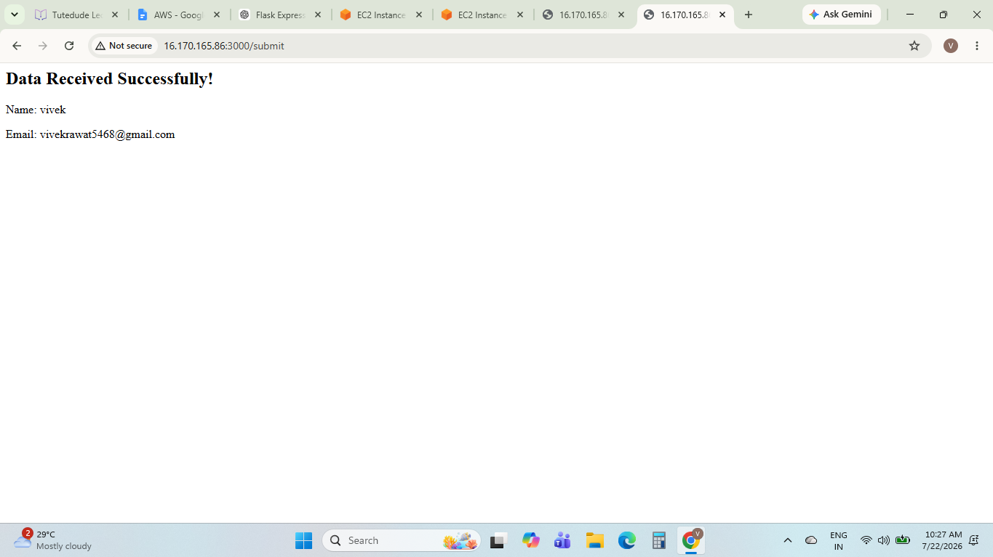

Result
The application was successfully deployed on Kubernetes using Minikube. The frontend communicated with the Flask backend successfully and the submitted data was displayed correctly.

