Python Assignment
Student: Vivek Rawat

Question 1: Grade Checker
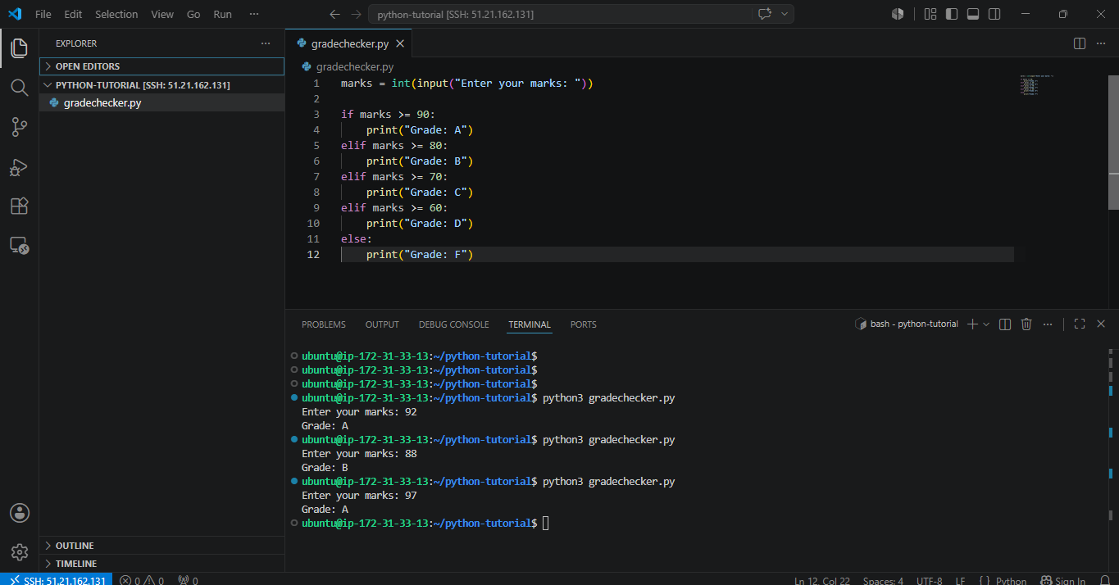

Question 2: Grade Update
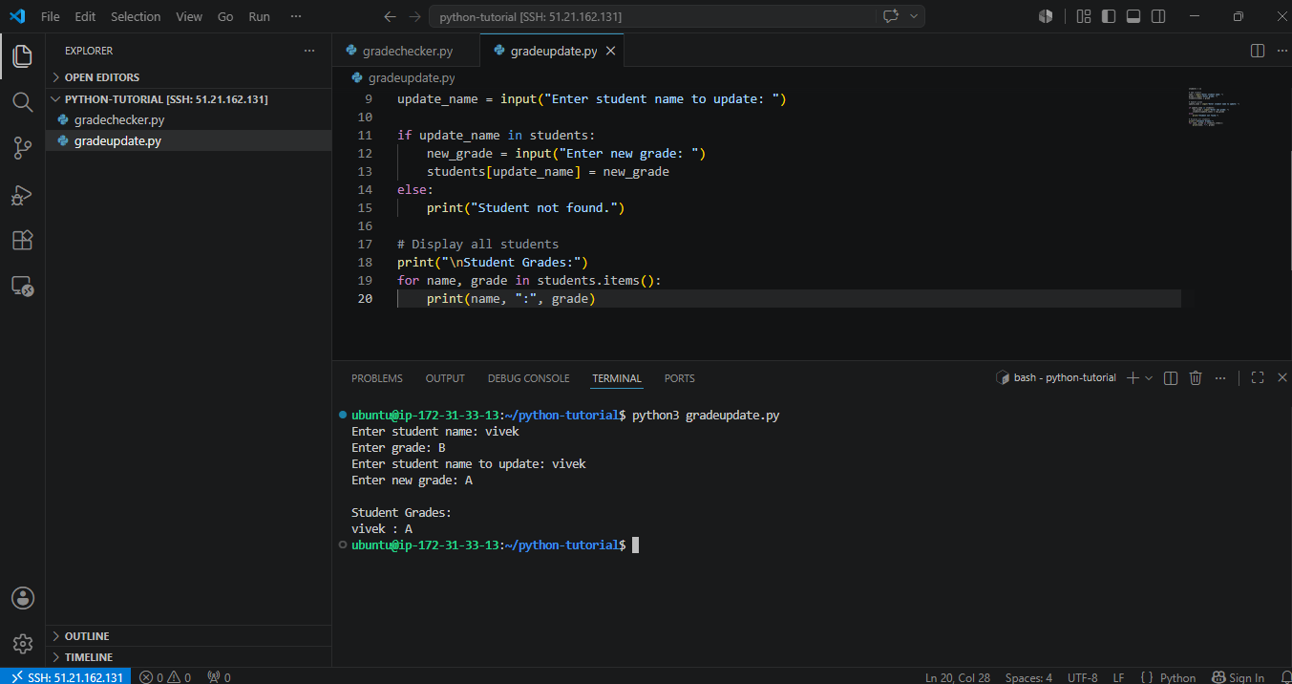

Question 3: File Write
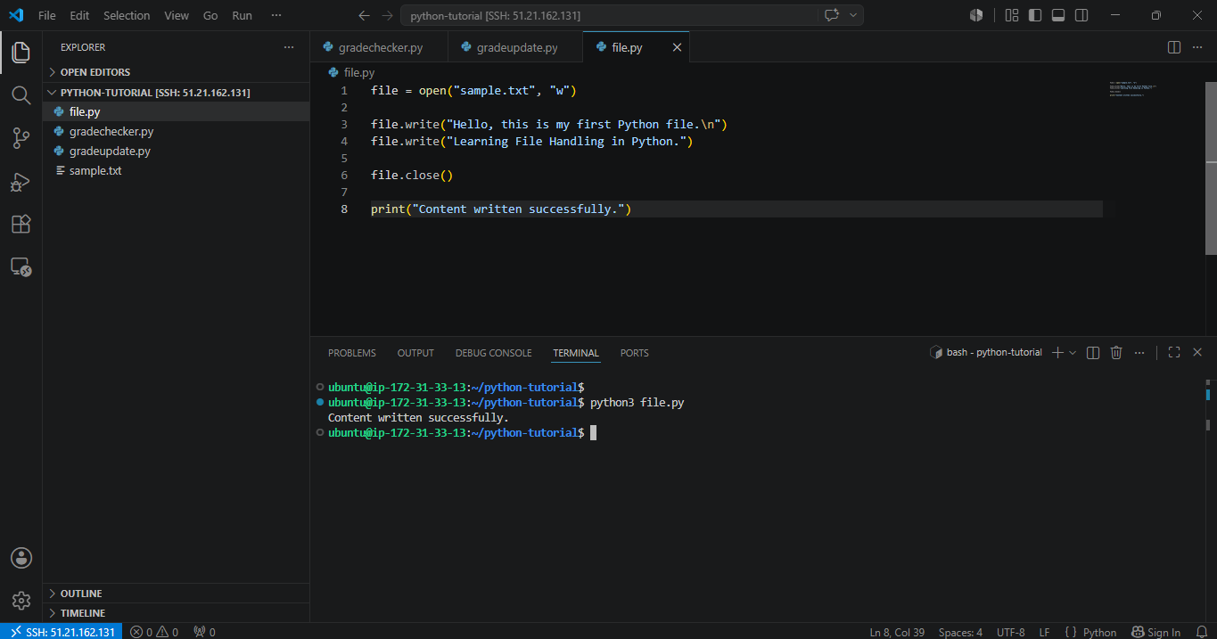

Question 4: File Read
