langchain- framework powerd by LLM to develop GENAI applications

--------------------------------------------------------------

analogy with PDF search. search application should have

-semantic search: seraches the pdf with along with meaning

-natural language understanding

-context aware text generation

-----------------------------------------------------------------

semantic search

-convert words into embedings

-compare the embedings using cosine similarity etc

----------------------------------------------------------------

lamaindex, Haystack--similar framework like langchain

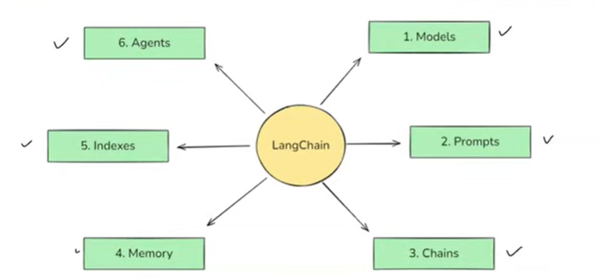

Lang chain components

Two types of models in models components

Chains: Important feature of langchain:provides piplines to build LLM based architecture

Indexes

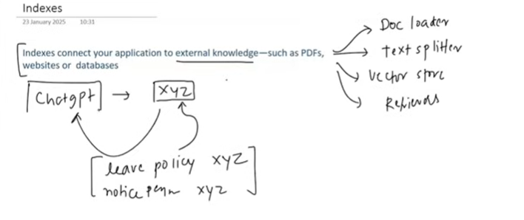

Doc loader

Text spliter

Vector store

Retriever

Memory:

LLM doesn’t have memory. That means each question we ask to LLM is independent

Memory feature in Langchain helps build this memory

