# Assessment

## Problem Statement

Detection of the Orange Circle in the Shared Video. Here is the snapshot of the video shared

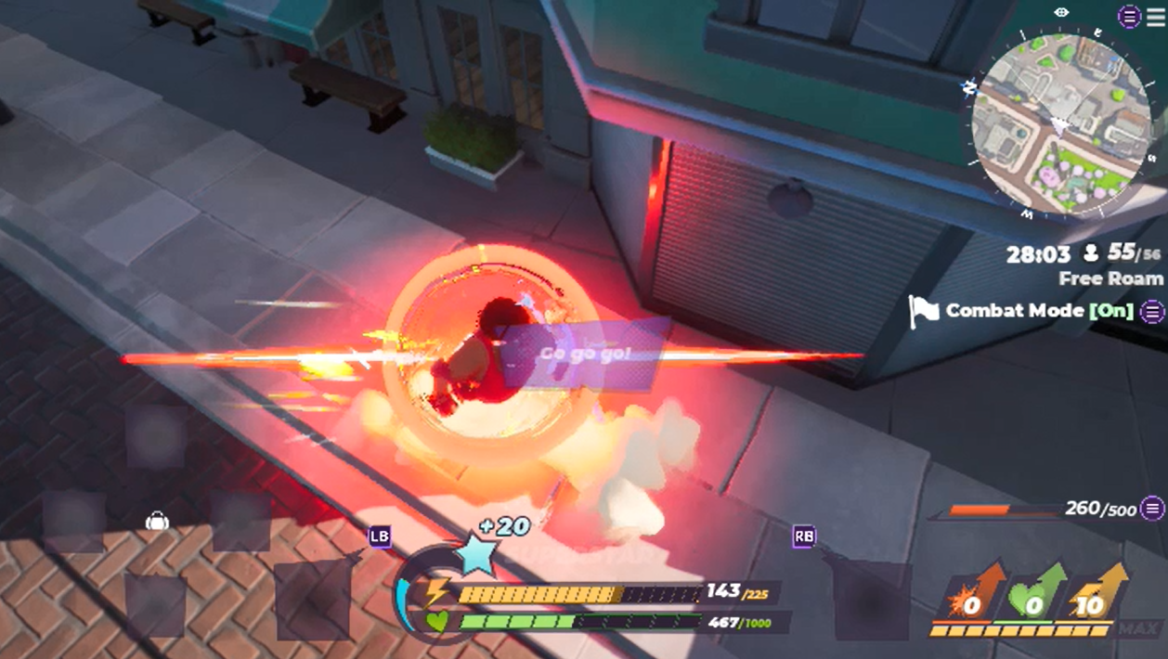

You would have to detect the orange circle whenever happening as shown below

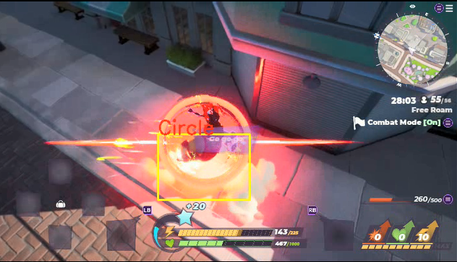

You would have to do this using Image Processing.

## Deliverable

* Source Code
* Video Showing the Detection happening as shown below in the snapshot
  + 

## Markings

You would be evaluated in the below points

1. Approach on how you tackle the problem
2. Coding Style
3. Number of True Positives

## Deadline

You must submit the results by 18 March 2023.