Assignment 10
1. Download https://dlcdn.apache.org/spark/spark-3.5.5/spark-3.5.5-bin-hadoop3.tgz
2. Extract it.
3.Open terminal and type the command: nc -lk 9999
Now
4.Go to the extracted folder/bin and open in terminal.
5.In the terminal type the command: ./spark-shell -i pathToYourScalaFile
wordCount.scala =>
import org.apache.spark.sql.SparkSession
import org.apache.spark.sql.functions._
val spark = SparkSession
.builder
.appName("StructuredNetworkWordCount")
.master("local[*]")
.getOrCreate()
import spark.implicits._
val lines = spark.readStream
.format("socket")
.option("host", "localhost")
.option("port", 9999)
.load()
val words = lines.as[String].flatMap(_.split(" "))
val wordCounts = words.groupBy("value").count()
val query = wordCounts.writeStream
.outputMode("complete")
.format("console")
.start()
query.awaitTermination()

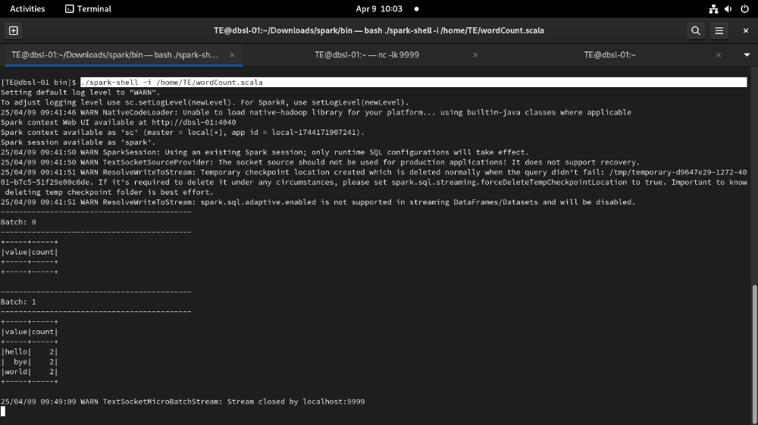
6. Now from nc -lk 9999 terminal type input and press enter .
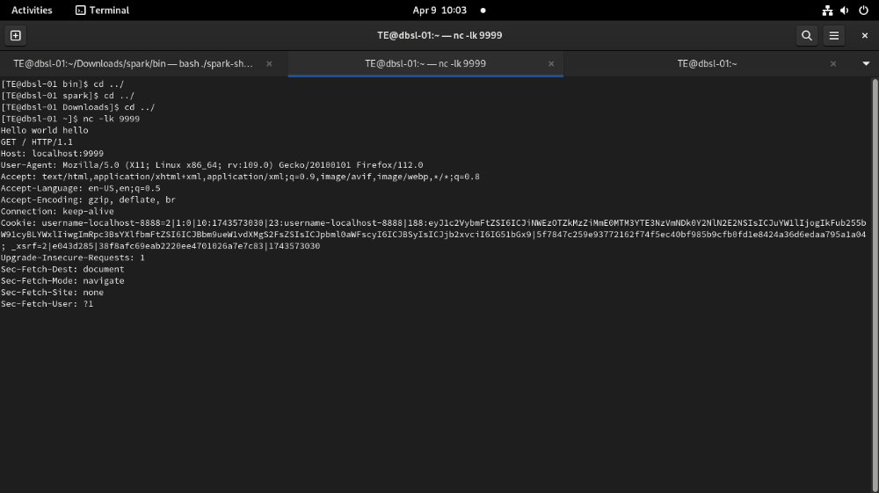
This job will be read by wordCount.scala and gives the o/p

