**School of Computing and Mathematical Sciences**

**CO7201 Individual Project**

**Final Report Template**

**Finance Tracker**

**Vivek Shah**

**vps5@student.le.ac.uk**

**Student Id - 239062179**

**Project Supervisor: Dr. Babajide Afeni**

**Principal Marker: Dr. Craig Bower**

**Word Count: 4500**

**Submission Date – 28/04/2025**

**DECLARATION**

All sentences or passages quoted in this report, or computer code of any form whatsoever used and/or submitted at any stages, which are taken from other people’s work have been specifically acknowledged by clear citation of the source, specifying author, work, date and page(s). Any part of my own written work, or software coding, which is substantially based upon other people’s work, is duly accompanied by clear citation of the source, specifying author, work, date and page(s). I understand that failure to do this amounts to plagiarism and will be considered grounds for failure in this module and the degree examination as a whole.

Name: Vivek Shah

Date: 28/04/2025

**Abstract**

This dissertation presents the design, development, and evaluation of Finance Tracker, a personal finance management mobile application developed for Android devices. The primary goal of the application is to assist users in tracking their income and expenses, managing monthly budgets, and gaining insights into their financial habits through intuitive data visualization.  
  
The application was developed using Kotlin and Jetpack Compose with a Clean Architecture approach. Data storage is managed both locally using Room Database and in the cloud via Firebase Firestore, enabling multi-device synchronization. Key features include user authentication (email/password and Google Sign-In), multi-currency support with real-time exchange rates, and category-based expense tracking.  
  
Through manual testing and user feedback, the Finance Tracker app demonstrates high usability, performance, and reliability. Future enhancements, such as subscription tracking and machine learning-based spending predictions, have been identified to further improve the user experience.

**Table of Contents**

1 Introduction 8

1.1 Background And Motivation 8

1.1.1 Problem Statement 8

1.2 Aim And Objectives 9

1.2.1 Relevance of Project 9

1.2.2 Aim 10

1.2.3 Objectives 10

1.3 Structure Of Dissertation 11

2 Literature Review 12

3 Requirements Analysis 14

3.1 Essential Requirements 14

3.2 Desirable Requirements 14

3.3 Optional Features 14

4 System Design and Architecture 16

4.1 Architectural Overview 16

4.2 Clean Architecture Layers 16

4.2.1 Presentation Layer 16

4.2.2 Domain Layer 16

4.2.3 Data Layer 16

4.3 Database Design and Data Flow 16

4.4 Communication Between Layers 16

4.5 Application Flow 16

4.6 Scalability and Maintainability 16

5 Technologies and Tools Used 17

6 Implementation 18

6.1 Front End Development (UI) Implementation 18

6.1.1 Architecture 18

6.1.2 User Interface Design 18

6.1.3 User Input and Validation 18

6.1.4 Important Features/Components 18

6.1.4.1 Google Sign-In 18

6.1.4.2 Currency selection 18

6.1.4.3 Add Transaction Form 18

6.1.4.4 Charts and Visualization 18

6.2 Back End Development 18

6.2.1 Architecture 18

6.2.2 Database Design 18

6.2.3 Cloud Integration 18

6.2.4 API Integration (if any) 18

6.2.5 Important Features 19

6.2.5.1 Authentication 19

6.2.5.2 Syncing transactions to Firebase 19

6.2.5.3 Profile data saving 19

6.2.5.4 Currency conversion fetching 19

7 Testing and Evaluation 20

7.1 System Testing 20

7.1.1 Purpose 20

7.1.2 Unit Testing 20

7.1.3 Integration Testing 20

7.1.4 Manual Testing 20

7.1.5 Test Cases 20

7.1.6 Test coverage 20

7.2 Usability Testing 20

7.2.1 Purpose 20

7.2.2 Recruiment and Orientation 20

7.2.3 Introduction to the App and Display of Diff screens 20

7.2.4 Usability Testing Scenario 20

7.2.4.1 Initial App Exploration and Profile Setup 20

7.2.4.2 Adding and Categorizing Expenses 20

7.2.4.3 Setting and Monitoring Budget Goals 20

7.2.4.4 Visualizing Transactions and Budget Trends 20

7.2.4.5 Managing Multiple User Profiles 20

7.2.4.6 Using Pre-Purchase Features 20

7.2.5 Study Result 20

8 Challenges and Solutions 21

8.1 Technical Challenges 21

8.2 UI/UX Challenges 21

8.3 Performance Challenges 21

8.4 Testing Challenges 21

9 Future Work 22

9.1 Feature Enhancements 22

9.2 Technical Improvements 22

9.3 User Experience (UX) Enhancements 22

9.4 Integration with External Services 22

9.5 Scalability and Cloud Optimization 22

10 Conclusion 23

11 References 24

12 Appendices 25

**List of Figures and Tables**

# Introduction

## Background And Motivation

My interest in application development began when I started working on basic app projects during my earlier studies. Later, in conversation with a friend, I learned that he managed his expenses by manually recording them in notes. This inspired me to think about a more organized and efficient way to manage personal finances through a dedicated application.

During my master's studies, I also took a subject on mobile application development, where I developed a petition management app using XML and Java. This experience further strengthened my interest in the field. After completing that project, I decided to work on an expense management application for myself.

Moving to a new country as a student and managing expenses while balancing part-time work proved to be challenging. This personal need became the primary motivation for building an expense tracking app to help manage my finances more effectively.

While researching the latest trends in app development, I found that Java is gradually being phased out in favor of Kotlin, which is now the preferred and future language for Android development. Additionally, I discovered that Jetpack Compose offers a more streamlined and efficient approach to designing user interfaces compared to the traditional XML method.

One might question why I chose to develop a new app instead of using an already existing expense management application. Although there are many apps available in the market, most either come with limited free features, intrusive advertisements, or require paid subscriptions for full access. I wanted an application that could be tailored exactly to my needs — simple, lightweight, and free of unnecessary complexities. Moreover, building my own app allowed me to apply my learning practically, explore modern development tools, and create a project that would contribute to my professional portfolio.

Driven by the desire to learn modern technologies, strengthen my skills, and lay a strong foundation for my future career, I decided to learn Kotlin and Jetpack Compose and use them to build this project.

This blend of personal necessity, academic learning, and future career aspirations formed the core motivation behind this project.

### Problem Statement

In today's fast-paced world, managing personal finances has become increasingly complex, particularly for individuals who struggle to keep track of their income, expenses, and savings. Many people often rely on manual methods, such as note-taking or spreadsheets, which are prone to errors, time-consuming, and lack accessibility. Additionally, numerous finance tracking applications available in the market either come with complex user interfaces, limited free features, require paid subscriptions for full access, or fail to provide essential functionalities like multi-currency support and offline accessibility.

Furthermore, many of the existing apps fail to address privacy concerns, often collecting excessive user data or requiring constant internet access, leaving users vulnerable to data breaches or lack of privacy control. Users need a more efficient, secure, and customizable solution that empowers them to manage their finances seamlessly, without the constraints of ads, subscription costs, or complex setups. There is also a growing demand for applications that provide real-time data visualization, secure cloud synchronization, and offline access, which many existing apps do not adequately support.

Thus, the problem arises from the lack of a comprehensive, secure, and user-friendly mobile solution that allows users to efficiently manage their finances, track their spending habits, set and monitor budgets, and gain insights into their financial situation in a personalized and accessible manner.

This project aims to solve these challenges by developing a Finance Tracker App that is easy to use, provides essential features for effective financial management, and ensures security and privacy while being accessible offline and on multiple devices.

## Aim And Objectives

In today's fast-paced world, managing personal finances effectively has become a critical necessity. Many individuals struggle with tracking their income, expenses, and savings, leading to overspending and inadequate financial planning. While numerous finance tracking applications are available, most are either too complex, require subscriptions, or lack essential features such as multi-currency support and offline accessibility. This project aims to address these shortcomings by developing a user-friendly, secure, and feature-rich Finance Tracker App designed to streamline the management of personal finances.

### Relevance of Project

The need for a personalized and efficient finance tracking solution is driven by the following factors:

1. **Growing reliance on digital solutions:** Mobile apps have become the primary medium for individuals to manage various aspects of their daily lives, including financial activities. The increasing reliance on mobile devices for financial management highlights the demand for accessible, intuitive apps.
2. **Need for better financial awareness:** Many individuals lack the tools to effectively track and analyze their spending patterns, leading to overspending, poor budgeting, and limited savings. Providing an accessible and easy-to-use finance tracker can significantly improve financial literacy and empower users to make better financial decisions.
3. **Accessibility and privacy concerns:** While many existing finance apps require constant internet access, this limits usability for individuals in offline situations. Additionally, privacy concerns surrounding the collection of personal data by these apps emphasize the need for secure, offline-capable solutions.
4. **Customization and flexibility:** Every individual has unique financial habits and needs. A finance tracker that offers customizable categories, multi-currency support, advanced filtering options, and data export features can cater to a wider range of user preferences, enhancing their overall financial management experience.

### Aim

The primary goal of this project is to develop a secure, intuitive, and feature-rich mobile application that helps users manage their personal finances efficiently. The app will provide expense tracking, budgeting tools, financial data visualization, and multi-device synchronization to enhance user experience and financial awareness.

### Objectives

To achieve the aim outlined above, the specific objectives of the project are as follows:

1. **Develop a simple, user-friendly interface** using Jetpack Compose to facilitate easy tracking of expenses and income.
2. **Implement robust budgeting features** that allow users to set monthly budgets and monitor their spending habits.
3. **Provide dynamic financial visualizations** (such as charts and graphs) to enhance users' understanding of their financial data.
4. **Integrate multi-currency support**, allowing users to manage their finances in different currencies with live or cached exchange rates.
5. **Ensure offline functionality** so that users can add and view transactions even when there is no internet connection.
6. **Implement secure authentication mechanisms** (e.g., email/password login and Google Sign-In) to ensure the protection of user data.
7. **Enable data synchronization across multiple devices** via secure cloud storage (Firebase integration) to ensure seamless access to financial data from any device.
8. **Allow the export of financial data** in CSV or PDF formats for offline backup or external analysis.
9. **Maintain high standards of privacy and data security**, minimizing unnecessary data collection and providing users with control over their personal information.
10. **Conduct thorough testing and evaluation** of the application to ensure its reliability, performance, and overall user satisfaction.

## Structure Of Dissertation

Explain briefly what each chapter will contain:

* **Chapter 1: Introduction(this)** - This chapter introduces the project, outlining its background, objectives, and significance. It provides an overview of the problem being addressed and sets the foundation for the report.
* **Chapter 2: Literature Review -** This chapter discusses previous research, existing solutions, and technologies relevant to the project. It highlights gaps and how the current work aims to address them.
* **Chapter 3 Requirement Analysis -** This chapter details the functional and non-functional requirements identified during the planning phase, forming the basis for system development.
* **Chapter 4: System Design and Architecture -** This chapter describes the design approach, including system architecture diagrams, data flow, and design principles used to create an efficient and scalable solution.
* **Chapter 5: Technologies and Tools Used -** This chapter lists and explains the programming languages, frameworks, libraries, and tools utilized during the development of the project.
* **Chapter 6: Implementation -** This chapter provides a detailed explanation of how the system was developed, including key features, coding practices, and integration of various modules.
* **Chapter 7: Testing and Evaluation -** This chapter discusses the testing strategies employed to verify the system’s functionality, performance, and reliability, along with evaluation results.
* **Chapter 8: Challenges and Solutions** - This chapter outlines the major challenges encountered during the project and the strategies or solutions adopted to overcome them.
* **Chapter 9: Future Work -** This chapter suggests potential enhancements, optimizations, and additional features that could be explored to further improve the system.
* **Chapter 10: Conclusion -** This chapter summarizes the overall work, reflecting on the achievements, learnings, and the successful fulfillment of the project objectives.
* **Chapter 11: References -** This chapter lists all the academic papers, articles, books, websites, and other resources referenced throughout the project.
* **Chapter 12: Appendices -** This chapter includes supplementary materials like diagrams, additional data, code snippets, or documentation that supports the main content but is too detailed for the main body.

# Literature Review

Managing personal finances has increasingly become a digital activity, leading to the development of various financial tracking applications. While each application or study offers valuable insights, significant gaps still exist, particularly concerning accessibility, customization, and real-world usability for everyday users.

(Oswal, 223) This paper introduces an Android application designed to support higher-level management, staff, sales personnel, and other stakeholders by providing mobile access to business analytics. The application presents organizational data through various types of visualizations, such as area charts, bar charts, D3 charts, and integrations with Google Maps. By offering these analytical insights directly on mobile phones and tablets, the application aids industries such as insurance, manufacturing, and banking in strategic decision-making and operational planning. Business Intelligence (BI) solutions, when integrated into mobile platforms, can significantly enhance organizational efficiency by enabling the measurement and monitoring of key performance metrics, including sales revenue, product sales, departmental expenditures, and supply chain operations. Traditionally, large volumes of organizational data were maintained in extensive Excel sheets, making analysis time-consuming and complex. This application addresses that challenge by providing intuitive, real-time data visualization tools, thereby simplifying the decision-making process and promoting better strategic outcomes.

(Wong, 2023) Recent studies have highlighted a growing interest in personal finance and budgeting, largely driven by the financial challenges brought on by the COVID-19 pandemic. This project aims to address this demand by developing an easy-to-use mobile application designed to support users in managing their finances effectively. The application features an intuitive user interface that encourages consistent budgeting habits and financial awareness. Additionally, a recommender system within the app offers personalized advice and clear visualizations of spending, helping users better understand and control their expenses. Many individuals, especially newcomers to managing their finances, struggle with basic financial concepts such as credit applications and debt management. This proposed application seeks to fill this gap by providing a practical tool for students and adults to start their budgeting journey, while also contributing to the growing body of literature on mobile application development in the field of personal finance and budgeting.

(Imawan, 2025) This study presents the design, development, and evaluation of an Android-based personal finance management application, specifically aimed at young adults in higher education. Recognizing the unique financial challenges faced by this demographic, such as limited financial experience and fluctuating income, the application includes key features such as income tracking, expense monitoring, budgeting, and financial goal setting. Built using the Waterfall model, the app ensures secure logins, offers an intuitive transaction management system, and provides customizable goals, budget projections, and automated reminders to promote better financial habits. Usability testing, conducted with 50 users using a 5-point Likert scale, revealed an overall satisfaction score of 4.6/5, categorized as 'Excellent.' Users appreciated the app's user-friendly interface, precise tracking capabilities, and motivational reminders, though they also suggested incorporating more customization options and advanced financial analysis in future updates. This study highlights the effectiveness of digital tools in enhancing financial literacy and resilience, demonstrating that personalized technology can positively influence financial behaviors in young adults. Future research will focus on adding more customization features and integrating AI-driven capabilities to enhance the application's impact.

(French, 2021) This study represents the first attempt to evaluate whether smartphone applications can effectively improve financially capable behaviors. In this research, four smartphone apps, collectively branded as ‘Money Matters,’ were distributed to working-age individuals (16–65 years) of the largest credit union in Northern Ireland (Derry Credit Union). The suite of apps included a loan interest comparison app, an expenditure comparison app, a cash calendar app, and a debt management app. The assessment methodology involved a Randomized Control Trial (RCT), using the U.K. Financial Capability Outcome Frameworks to set the context for the evaluation. The treatment group, which received the apps, showed statistically significant improvements in various measures related to 'financial knowledge, understanding, and basic skills,' as well as 'attitudes and motivations.' These improvements led to enhanced financial behaviors, with participants demonstrating a greater tendency to track their income and expenses and increased resilience when faced with financial challenges.

(Girdhar, 2024,September) The Expense Tracker app provides an intuitive solution for managing both income and expenses, allowing users to track their spending on a daily, weekly, monthly, or annual basis. With features such as selecting expense categories, adding location details, and uploading additional data, users can customize their entries easily. The app stores this information in a relational database, enabling users to view and sort their expenditures over different time periods. This functionality reduces the need for manual calculations, offering an efficient way to monitor personal finances. The app also provides users with the ability to enter their income to estimate daily expenses, storing these results for personalized tracking. Ideal for individuals who frequently travel or engage in social activities, the app enables users to track group expenses and split bills effortlessly. The tracker generates graphical representations of spending based on the chosen time frame. Additionally, users can set their monthly income or expenditure limits to maintain better control over their financial habits. The integrated features of this tracker provide a comprehensive tool for managing spending and cash flow.

Across the reviewed literature, a common limitation persists: while technological innovations are extensively explored, accessibility, user-friendliness, and offline capabilities are often overlooked. Many existing solutions assume technical literacy, consistent internet access, and stable income patterns—assumptions that do not hold true for many real-world users. Therefore, there remains a critical need for a simple, intuitive, secure, and customizable finance tracking application that caters to a broader and more diverse audience.

# Requirements Analysis

The requirements for the Finance Tracker application were categorized into essential, desirable, and optional requirements...

## Essential Requirements

These are the core features that the Finance Tracker App must have to fulfil its primary purpose.

* **User Authentication:** Users must be able to register and log in using email/password authentication.
* **Google Sign-In:** Support for Google authentication to provide an easier sign-in process.
* **Expense and Income Management:** Users should be able to add, edit, and delete expenses and income with details such as amount, category, and date.
* **Budget Management:** Implement budget tracking, allowing users to set and monitor monthly budgets.
* **Local Data Storage:** Store financial data locally using Room Database to enable offline access.
* **Data Visualization:** Provide charts and graphs to help users analyze their income and expenses.
* **Secure Data Storage:** Ensure proper encryption and authentication to protect sensitive financial data.

## Desirable Requirements

These features will enhance usability and provide additional functionality to improve the user experience.

* **Cloud Synchronization:** Implement Firebase integration to allow users to sync financial data across multiple devices.
* **Notifications & Reminders:** Send alerts to notify users about budget limits and upcoming expenses.
* **Transaction Filtering & Searching:** Allow users to filter and search transactions by category, date, or amount for quick access.
* **Multi-Currency Support:** Integrate a currency conversion feature to support transactions in different currencies.
* **User-Friendly UI:** Design an intuitive and visually appealing interface to ensure smooth navigation and usability.

## Optional Features

These features are not mandatory but would provide additional benefits and improve the overall experience.

* **Data Export**: Enable users to export financial records in CSV and PDF formats for external use.
* **Receipt Scanning (OCR)**: Implement Optical Character Recognition (OCR) to allow users to scan receipts and auto-fill expense details.
* **Fingerprint Authentication:** Allow biometric login for enhanced security and quick access.
* **Multiple Account Support**: Let users manage different financial accounts (e.g., personal and business).
* **Dark Mode**: Introduce a dark mode theme for better accessibility and user preference.

# System Design and Architecture

In the System Design and Architecture section, I will detail how the architecture of your application has been structured, explaining the rationale behind the design choices, the organization of various components, and how they interact with each other. This section typically follows a logical flow from high-level architectural design down to the specific components and modules of the system.

## Architectural Overview

## Clean Architecture Layers

### Presentation Layer

### Domain Layer

### Data Layer

## Database Design and Data Flow

## Communication Between Layers

## Application Flow

## Scalability and Maintainability

# Technologies and Tools Used

|  |  |  |
| --- | --- | --- |
| **Category** | **Technology/Tool** | **Reason for Selection** |
| Programming Language | Kotlin | Official language for Android, modern and concise |
| UI Framework | Jetpack Compose | Declarative UI, efficient, and recommended by Google |
| Database | Room Database | Provides an abstraction over SQLite, supports offline access |
| Authentication | Firebase Authentication | Secure and easy-to-implement authentication (Email/Google) |
| Cloud Storage | Firebase Firestore | Real-time synchronization and cloud backup |
| State Management | View Model & Live Data | Manages UI-related data efficiently |
| Networking | Retrofit | Simplifies API calls (e.g., currency conversion API) |
| Dependency Injection | Hilt (Dagger) / Koin | Improves modularity and testability |
| Background Tasks | Coroutines & Flow | Efficient async programming, recommended for Kotlin |
| Charts & Graphs | MPAndroidChart | Popular library for interactive data visualization |
| Multi-Currency Support | Exchange Rate API (e.g., OpenExchangeRates, Fixer.io) | Fetches real-time exchange rates for currency conversion |
| Data Export | Apache POI / OpenCSV | Enables CSV and PDF export for financial reports |
| User Preferences | SharedPreferences | Saves user setting preferences |
| Push Notifications | WorkManager | Sends budget reminders and transaction alerts. |
| Development Environment | Android Studios | Official IDE for Android development, offers a rich set of tools, debugging features, and seamless integration with Android SDK and Kotlin. |
| Testing | JUnit | Used for writing unit tests for core business logic. JUnit helps in identifying bugs early, ensures components work independently, and improves overall app stability. |

Table 1 : Tools and Technology

# Implementation

In the Implementation chapter of the report, I would detail the process of how your mobile finance tracker app was developed and implemented. This chapter should include technical information, code implementation, design decisions, challenges faced, and how the features were brought to life.

## Front End Development (UI) Implementation

### Architecture

Explain the pattern followed (e.g., MVVM, Clean Architecture).

### User Interface Design

Explain the structure of key screens (Home screen, Add Transaction screen, Profile screen, etc.)

Mention navigation (e.g., Bottom Navigation Bar, Navigation Graph).

### User Input and Validation

How you handle forms, validations, and errors in UI.

### Important Features/Components

Go over major features in frontend like:

#### Google Sign-In

#### Currency selection

#### Add Transaction Form

#### Charts and Visualization

## Back End Development

### Architecture

Explain the clean architecture setup on backend side (Repository pattern, Data Sources, etc.)

### Database Design

Room Database tables/entities.

How you structured the local storage.

### Cloud Integration

Firebase Authentication

Firebase Firestore/Realtime Database for sync

Explain structure of cloud data.

### API Integration

If you're using Retrofit for currency conversion API, explain the setup.

### Important Features

Go over major features in frontend like:

#### Authentication

#### Syncing transactions to Firebase

#### Profile data saving

#### Currency conversion fetching

# Testing and Evaluation

In your Testing and Evaluation chapter, show how I checked if the app works correctly, is reliable, user-friendly, and meets its goals.

## System Testing

### Purpose

### Unit Testing

### Integration Testing

### Manual Testing

### Test Cases

### Test coverage

## Usability Testing

### Purpose

For evaluating my finance tracker app, a combination of surveys and usability testing was used. These methods provided complementary insights into user experience and ensured thorough feedback for refinement. A diverse group of 20 participants was selected to ensure various perspectives were considered. They represented different age ranges, genders, and occupations. Usability testing offered in-depth qualitative insights by observing participants interact with app features such as budget setting and notifications. Real-time challenges, like navigating graphical expense representations was identified. Additionally, it validated the intuitiveness and value of features like transaction graphs and secure authentication.

### Recruitment and Orientation

Participants were selected based on their interest in financial management and familiarity with mobile apps. A diverse user base was targeted, considering factors like age, occupation, and tech-savviness. Participants for the survey were chosen based on their experience with tracking personal expenses and using mobile applications. This criterion ensured that respondents had the necessary background to provide insightful feedback. Once they agreed to participate, they were given a brief overview of the study's goals. The introduction emphasized that participation was voluntary, and confidentiality of responses was guaranteed. Participants were also made aware of the purpose of the survey and how their feedback would be used.

At the start of the session, participants were briefed on the purpose of the usability test. They were assured that the goal was to evaluate the app's functionality, not their performance. The confidentiality of their responses was emphasized. The survey was distributed to participants via a direct link to Google Forms. The survey itself was divided into various sections, with each segment addressing a different aspect of the expense tracker app, such as its usability, the effectiveness of features, and overall user satisfaction. The questions were a combination of multiple-choice items, Likert scale ratings, and open-ended responses, which allowed both quantitative and qualitative feedback. Clear and concise instructions were provided to ensure participants understood how to complete the survey. The collected data from the completed surveys were stored securely and handled with utmost care to maintain participant anonymity. Ethical guidelines were strictly followed, highlighting the voluntary nature of the survey and the respectful treatment of user data. These measures were in place to guarantee the reliability of the collected information while adhering to high standards of ethical research practice.

### Introduction to the App and Display of Diff screens

At the beginning of the usability testing session, participants were provided with a mobile device that had a prototype version of the Expense Tracker app installed. This prototype included several key screens that represent the core features and functionality of the application. The purpose of this phase was to introduce participants to the app's user interface and ensure they understood the primary functions available on each screen before interacting with the app.

Each screen was presented to the participants, accompanied by a clear and concise explanation of its purpose and how it contributes to the overall user experience. Below is a breakdown of the main screens that were demonstrated:

1. **Dashboard Screen:**

This was the first screen introduced, functioning as the app’s central hub. It provides a comprehensive overview of the user’s financial status, including total spending for the current month, the remaining amount in their budget, and the progress towards any defined savings goals. The layout is designed for quick insights, using progress bars and summary cards for intuitive understanding.

1. **Add Transaction Screen:**

This screen enables users to manually add financial transactions such as income or expenses. Participants were shown how to input key transaction details including the amount, transaction type (Income or Expense), category, date and time, currency, and any optional notes. Users can also link previously saved items or select from recurring transactions. The goal is to make the process fast and straightforward to encourage frequent usage.

1. **View Records Screen:**

This section allows users to review all previously added transactions. Transactions are listed chronologically with filtering and searching options, allowing users to sort records by category, date range, or amount. Tapping on an entry brings up detailed information and options to edit or delete the transaction.

1. **Charts Screen:**

The Charts screen visually represents the user's spending behavior through various graphical formats, such as pie charts and bar graphs. For example, the pie chart displays a breakdown of spending by category (e.g., Rent, Food, Travel), helping users identify areas where they spend the most. These visual insights are useful for self-assessment and financial planning.

1. **Settings Screen:**

The Settings screen serves as the control panel for personalizing and configuring the app. Key options demonstrated include:

* Profile Management: View and edit personal details such as name, email, country, phone number, and base currency.
* Category Management: Add, remove, or edit income and expense categories based on personal preferences.
* Budget Settings: Configure or adjust monthly budget limits to track and control spending.
* Dark Mode: Toggle between light and dark themes to enhance visual comfort based on user preference or time of day.
* Logout: Securely sign out from the current session.

Each screen was carefully designed to align with user expectations and improve financial management experiences. Participants were encouraged to ask questions during the walkthrough to clarify any aspects before engaging in actual interaction tasks during the testing phase.

### Usability Testing Scenario

#### Initial App Exploration and Profile Setup

* Objective: Evaluate first-time user experience and ease of setting up user profiles.
* Task: Participants set up accounts, create profiles, and configure their budgeting preferences.
* Feedback to Gather:
* First Impressions: Assess the app’s design, navigation, and user interface (e.g., color scheme, layout).
* Ease of Setup: Evaluate how straightforward account creation and preference settings are.
* Difficulties or Confusion: Note any unclear steps or issues encountered.

#### Adding and Categorizing Expenses

* Objective: Assess the ease of tracking expenses and setting categories.
* Task: Participants add multiple types of expenses (e.g., groceries, rent, entertainment) and organize them into categories.
* Feedback to Gather:
* Ease of Use: Evaluate the simplicity of adding expenses and navigating categories.
* Relevance of Categories: Check if the available categories cover user needs.
* Suggestions for Improvement: Identify missing or redundant features.

#### Setting and Monitoring Budget Goals

* Objective: Evaluate the ease of setting and adjusting monthly budget goals.
* Task: Participants set a monthly budget and explore how to edit or reset it through the Settings screen.
* Feedback to Gather:
* Ease of Use: Is the budget setup process simple and intuitive?
* Clarity: Are users aware of how their budget is applied or tracked in the app?
* Suggestions for Improvement: Allow category-wise budget limits, offer confirmation or guidance after budget is set

#### Visualizing Transactions and Budget Trends

* Objective: Evaluate the graphical representation of expenses and budget tracking.
* Task: Participants review pie charts, bar graphs, or other visualizations showing their spending habits.
* Feedback to Gather:
* Design Appeal: Check if graphs are visually appealing and easy to understand.
* Insights and Clarity: Assess whether the visuals provide actionable insights.
* Suggestions for Visualization: Identify missing data points or alternative graph styles.

#### Managing Multiple User Profiles

* Objective: Test how the app supports multi-user functionality.
* Task: Participants switch between different user profiles and manage their individual expenses.
* Feedback to Gather:
* Ease of Switching Profiles: Evaluate how quickly users can switch accounts.
* Data Separation: Assess whether expenses are securely and properly managed for different users.
* User Experience: Gather insights into the intuitiveness of multi-user features.

### Study Result

Here are eight survey questions tailored for evaluating Expense Tracker App. These are based on Don Norman's principles of Interaction Design (e.g., consistency, feedback, and usability) and Jordan’s Four Pleasures Framework (physio-pleasure, socio-pleasure, psycho-pleasure, and ideo pleasure). These questions can help assess usability, design, and emotional appeal: (Norman, 2004) (Kefalidou G., 2016)

1. How intuitive and clear are the features of the app, such as adding transactions, viewing reports, or setting budgets?

(Rate from 1 - Not Intuitive at All to 5 - Extremely Intuitive)

1. How consistent is the design across different sections of the app, such as the transaction view and graphical analysis?

(Rate from 1 - Very Inconsistent to 5 - Very Consistent)

1. If you make a mistake, such as entering incorrect data or forgetting a passcode, how easy is it to recover and continue using the app?

(Rate from 1 - Very Difficult to 5 - Very Easy)

1. How comfortable and accessible is the app to use, considering the font size, color scheme, and navigation design?

(Rate from 1 - Very Uncomfortable to 5 - Very Comfortable)

1. Does the app stimulate you intellectually, for example, through insights from transaction trends or the use of visual data representations?

(Yes/No) Please elaborate.

1. Do you feel the app enhances your ability to manage finances and communicate financial goals with others (e.g., family, friends, or business partners)?

(Rate from 1 - Not at All to 5 - Significantly)

1. How enjoyable is it to use the app in terms of screen readability, navigation, and touch responsiveness?

(Rate from 1 - Not Enjoyable to 5 - Extremely Enjoyable)

1. Does the app align with your personal values, such as promoting financial discipline, technology innovation, or sustainability?

(Yes/No) Please explain.

The rest of the questions have been pasted in the appendix section for the in-depth references of the questionnaire.

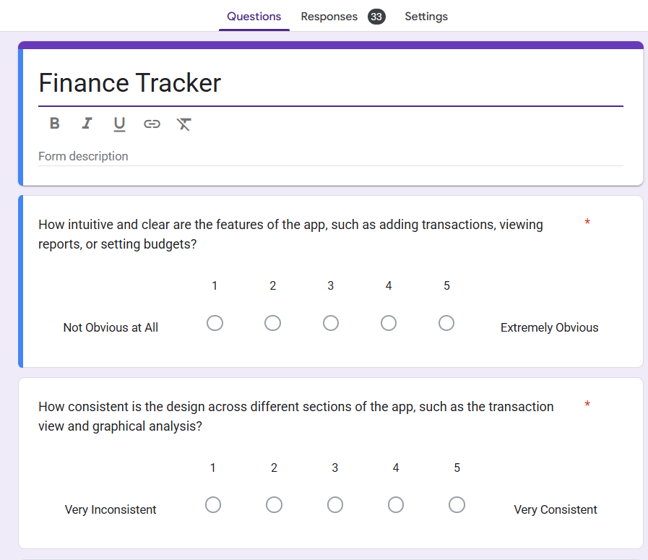

Figure 7‑1 Google Form Questions

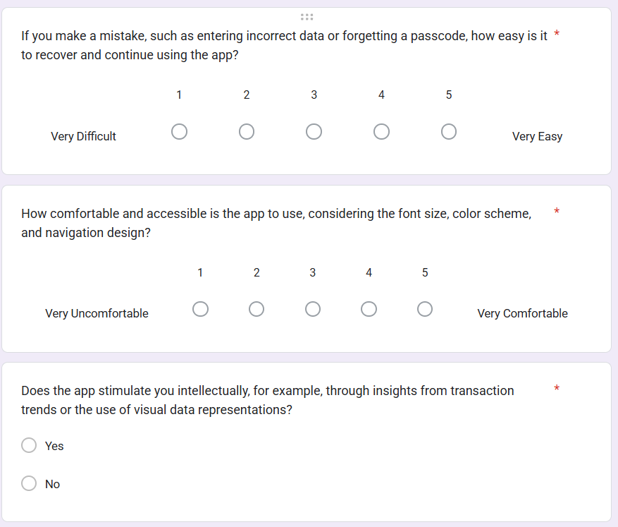

Figure 7‑2 Google Form Questions

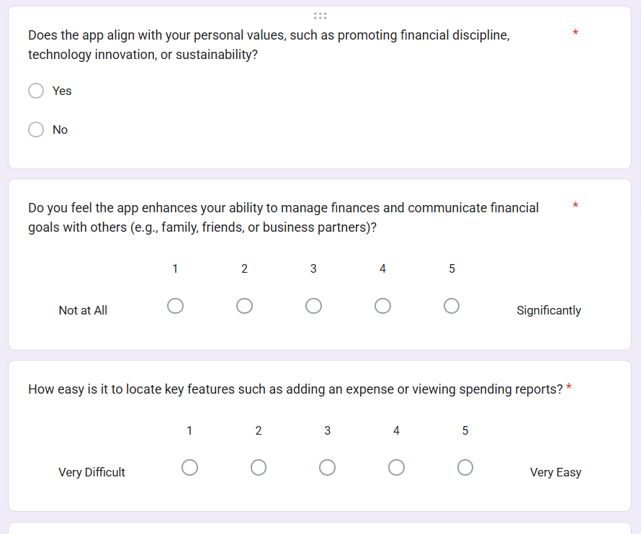

Figure 7‑3 Google Form Questions

**Results based on the survey questions:**

Based on the feedback results from 20 participants, here's an analysis of the responses to each question using both descriptive statistics for rating questions and frequency counts for yes/no questions:

1. Affordance (Norman's Principle) (Norman, 2004) (Kefalidou G., 2016)

* Equal Split: 23 participants said "Yes", and 5 said "No"
* Implication: The significant majority who found the app's affordances clear indicates that the design elements effectively communicate their intended use, making the app easy to navigate.

1. Consistency (Norman's Principle) (Norman, 2004) (Kefalidou G., 2016)

* Mean Rating: 3.64
* Most Frequent Rating: 4 (9 times)
* Variability: Ratings are somewhat spread out, with a lean towards higher ratings.

1. Mapping (Norman's Principle) (Norman, 2004) (Kefalidou G., 2016)

* Equal Split: 24 participants said "Yes", and 4 said "No"
* Implication: The majority of users found the app’s mapping to be intuitive, meaning that the relationships between controls and their effects are well- aligned with user expectations.

1. Constraints (Norman's Principle) (Norman, 2004) (Kefalidou G., 2016)

* Mean Rating: 3.54
* Most Frequent Rating: 5 (10 times)
* Variability: Ratings ranged from 1 to 5, showing a wide range of experiences.

1. Visibility (Norman’s Principle) (Norman, 2004) (Kefalidou G., 2016)

* Mean Rating: 3.57
* Most Frequent Rating: 4,5 (8 times)
* Variability: Ratings ranged from 1 to 5, showing a wide range of experiences.

1. Feedback (Norman’s Principle) (Norman, 2004) (Kefalidou G., 2016)

* Mean Rating: 3.57
* Most Frequent Rating: 4 (11 times)
* Variability: Ratings ranged from 1 to 5, showing a wide range of experiences.

1. Physio Pleasure (Jordan’s Pleasure Framework) (Norman, 2004) (Kefalidou G., 2016)

* Mean Rating: 3.46
* Most Frequent Rating: 4,5(8 times each)
* Variability: Opinions vary widely, indicating differing levels of physical comfort and ease of use.

1. Ideo Pleasure (Jordan’s Pleasure Framework) (Norman, 2004) (Kefalidou G., 2016)

* Equal Split: 21 participants said "Yes", and 7 said "No"
* Implication: This split suggests that the app's intellectual stimulation is polarizing among users.

1. Pyscho Pleasure (Jordan’s Pleasure Framework) (Norman, 2004) (Kefalidou G., 2016)

* Mean Rating: 3.46
* Most Frequent Rating: 4 (9 times)
* Variability: A noticeable number of participants found the app enjoyable and found control over their finances.

1. Socio Pleasure (Jordan’s Pleasure Framework) (Norman, 2004) (Kefalidou G., 2016)

* Mean Rating: 3.57
* Most Frequent Rating: 5 (10 times)
* Variability: A noticeable number of participants found the app helpful and found control over their finances.

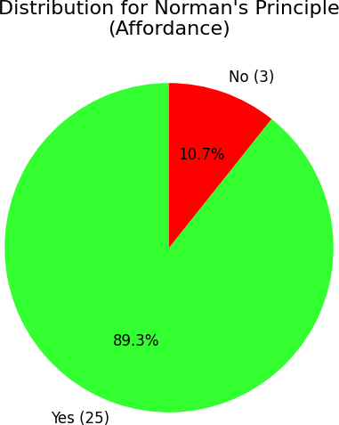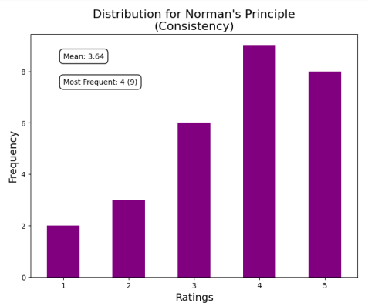

Figure 7‑5 Survey Result (Affordance)

Figure 7‑5 Survey Result (Consistency)

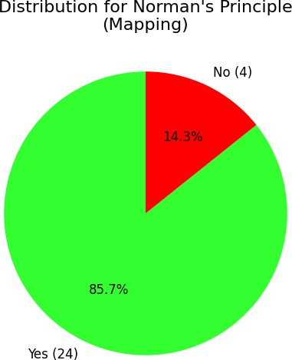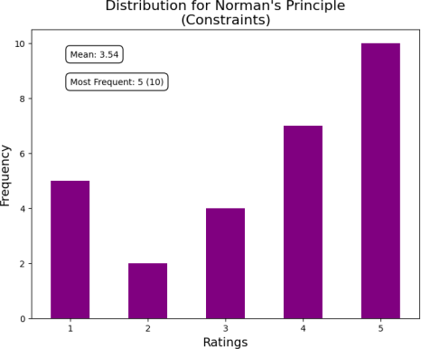

Figure 7‑6 Survey Result (Visibility)

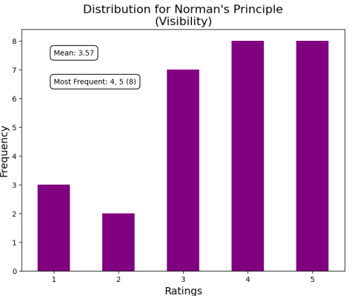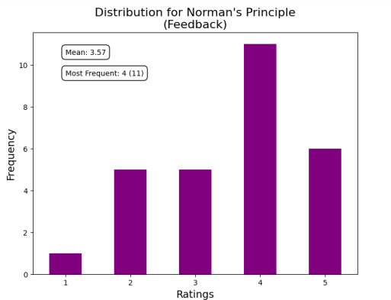

Figure 7‑7 Survey Result (Feedback)

# Challenges and Solutions

Explain that during the development of the application, various technical, design, and user-experience challenges were encountered, and how they were addressed.

## Technical Challenges

## UI/UX Challenges

## Performance Challenges

## Testing Challenges

# Future Work

Briefly explain that while the app achieves its core goals, there are many opportunities for enhancement based on feedback, new technology, and evolving user needs.

## Feature Enhancements

## Technical Improvements

## User Experience (UX) Enhancements

## Integration with External Services

## Scalability and Cloud Optimization

# Conclusion

This project successfully developed an Android-based personal finance management application aimed at helping individuals manage their financial activities with greater ease and accuracy. The application provides a secure, intuitive platform for users to track their income, monitor their expenses, set financial goals, and visualize their financial data through interactive charts. Through the integration of modern technologies such as Kotlin, Jetpack Compose, Firebase Authentication, Firestore, and Room Database, the app offers both offline accessibility and real-time cloud synchronization, ensuring a reliable user experience.

The implementation of key features like budget management, multi-currency support, data visualization, and secure authentication addresses major challenges faced by users in managing their day-to-day finances. In addition, user-centric features such as reminders, currency conversion, and data export enhance the overall usability and functionality of the application.

Testing and evaluation through user feedback demonstrated high levels of satisfaction with the app's usability, design, and performance, while also highlighting areas for potential future enhancements. Despite challenges faced during the development, appropriate solutions were applied to ensure the delivery of a robust and scalable application.

In conclusion, this project not only achieved its initial objectives but also laid a strong foundation for future improvements. Further work can be undertaken to enhance personalization, introduce AI-driven recommendations, expand platform support, and provide deeper financial insights to users. The project demonstrates how thoughtfully designed digital tools can empower users to develop better financial habits, promoting long-term financial literacy and well-being.

# References

1. Oswal, S., & Koul, S. (2013). Big data analytic and visualization on mobile devices. In *Proc. Nat. Conf. New Horizons IT-NCNHIT* (p. 223).
2. Wong, C. K., & Salleh, M. N. M. (2023). Personal Finance and Budgeting Mobile Application,“CashSave”. *Applied Information Technology And Computer Science*, *4*(1), 1372-1387.
3. Imawan, R., Putra, W. P., Alqahtani, R., Milakis, E. D., & Dumchykov, M. (2025). Enhancing Financial Literacy in Young Adults: An Android-Based Personal Finance Management Tool. *Journal of Hypermedia & Technology-Enhanced Learning*, *3*(1), 64-88.
4. French, D., McKillop, D., & Stewart, E. (2021). The effectiveness of smartphone apps in improving financial capability. In *Financial literacy and responsible finance in the fintech era* (pp. 6-22). Routledge.
5. Girdhar, G., Kumar, S., Bhardwaj, A., & Sharma, M. (2024, September). Design and Development of Expense App. In *2024 International Conference on Advances in Computing Research on Science Engineering and Technology (ACROSET)* (pp. 1-4). IEEE.
6. Google Developers, *Official Android Documentation*, URL: <https://developer.android.com>.
7. Google Firebase, *Firebase Documentation*, URL: <https://firebase.google.com/docs>.
8. JetBrains, *Kotlin Coroutines Guide*, URL: <https://kotlinlang.org/docs/coroutines-overview.html>.
9. Google Material Design, *Material Design Guidelines*, URL: <https://material.io/design>.
10. Google Developers, *Room Database Guide*, URL: <https://developer.android.com/training/data-storage/room>.
11. P. Lackner, *Philipp Lackner [YouTube Channel]*, YouTube. URL: <https://www.youtube.com/@PhilippLackner>.
12. Shah, V. (2025). Finance Tracker [Google Form]. URL: <https://docs.google.com/forms/d/e/1FAIpQLSdFxKfUDtfoqlzX43mCwaZVH270Qh2yDwKKG3O3J4cn4GRiIg/viewform?usp=sf_link>

# Appendices

## Survey Form

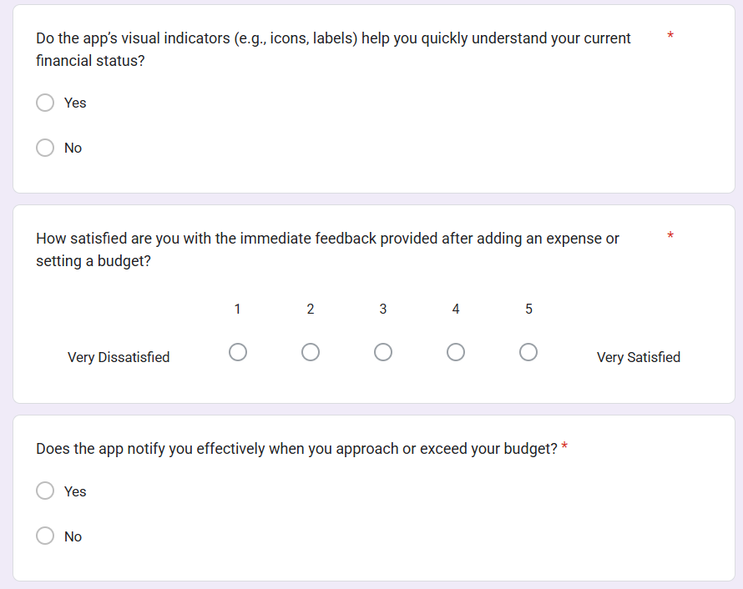

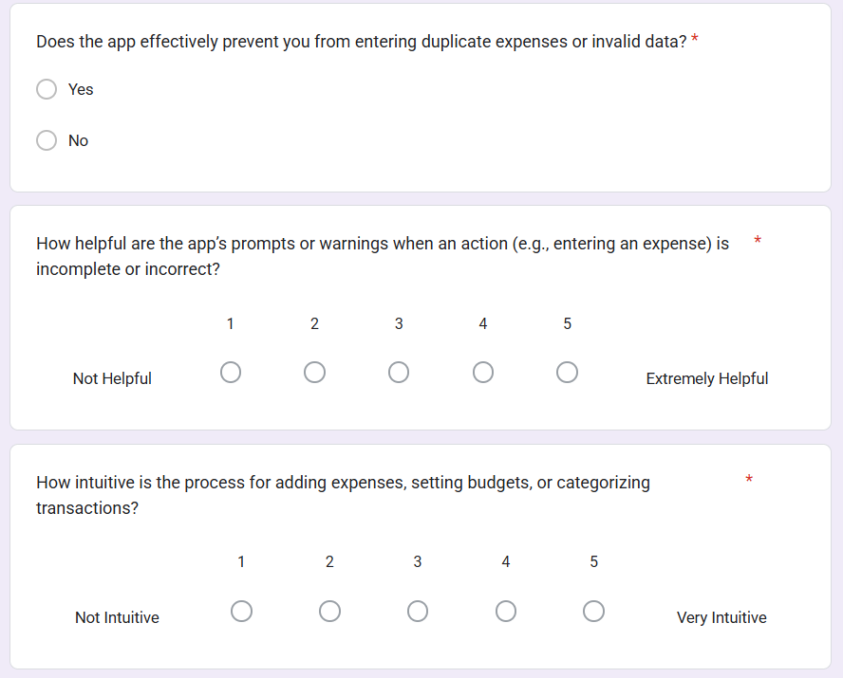

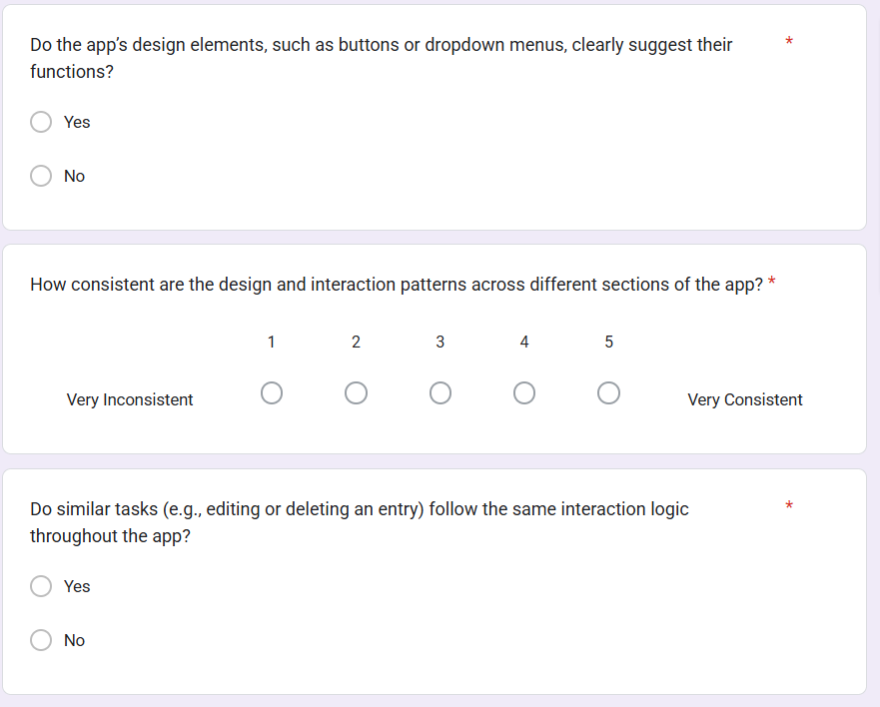

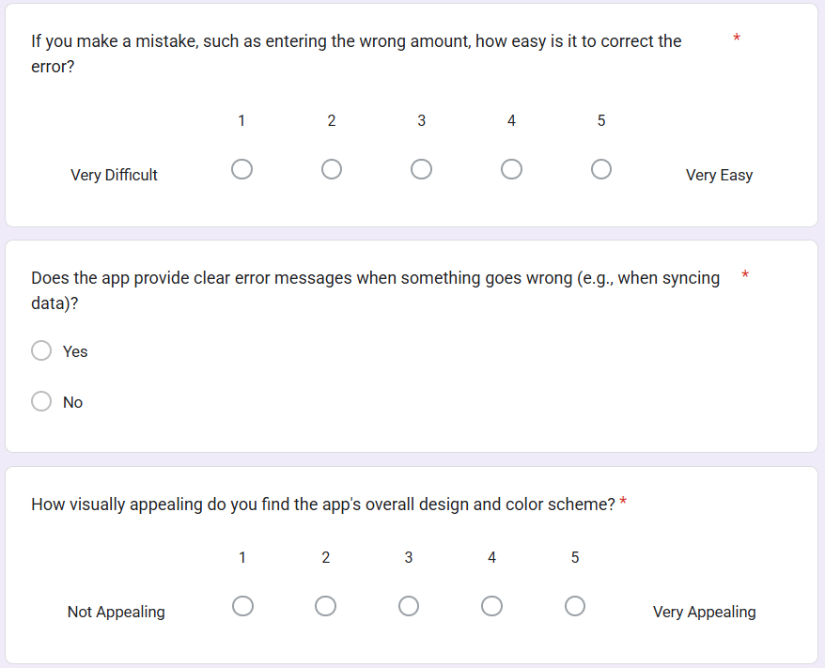

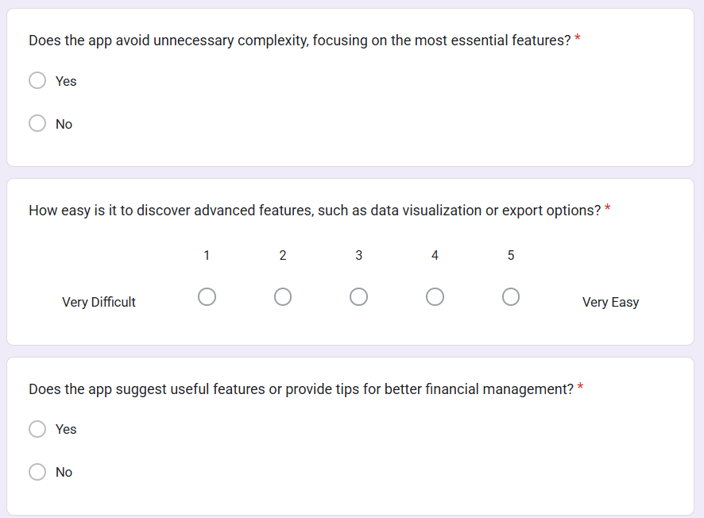

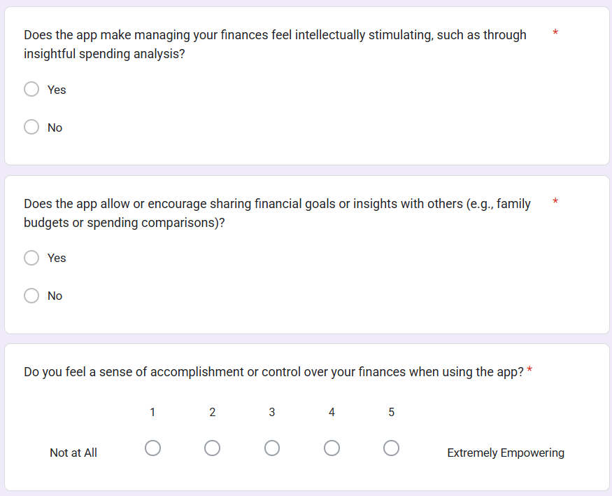

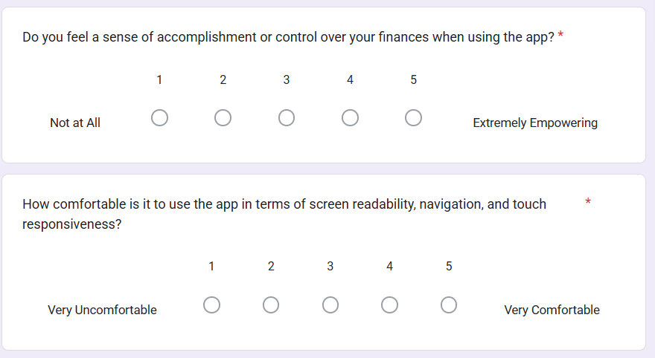

## Survey Result

