**A**

**INTERNSHIP PROJECT REPORT ON**

**“Airline Management System”**

**Submitted By**

|  |  |  |
| --- | --- | --- |
| **Name** | **Roll No** | **Exam Seat No.** |
| **Mr. Shelke Vivek Pradip** | **3238** | **T190104316** |
| **Mr. Sahane Pushkraj Lahanubhau** | **3231** | **T190104307** |
| **Mr. Shinde Rohit Nivrutti** | **3242** | **T190104321** |
| **Mr. Sapute Prathmesh Somnath** | **3232** | **T190104310** |
| **Mr. Sayyad Mohammadsaani Shahid** | **3236** | **T190104314** |

***Under the Guidance of***

**Mrs. Pooja Dalwi**

(Sumago Infotech PVT.LTD)



**(TE Computer Engineering 2019 Course)**

**AMRUTVAHINI COLLEGE OF ENGINEERING SANGAMNER-422608**

***2023-2024***

**CERTIFICATE**

Amrutvahini Sheti & Shikshan Vikas Sanstha’s

**AMRUTVAHINI COLLEGE OF ENGINEERING SANGAMNER**



This is to certify that

|  |  |  |
| --- | --- | --- |
| **Name** | **Roll No** | **Exam Seat No.** |
| **Mr. Shelke Vivek Pradip** | **3238** | **T190104316** |
| **Mr. Sahane Pushkraj Lahanubhau** | **3231** | **T190104307** |
| **Mr. Shinde Rohit Nivrutti** | **3242** | **T190104321** |
| **Mr. Sapute Prathmesh Somnath** | **3232** | **T190104310** |
| **Mr. Sayyad Mohammadsaani Shahid** | **3236** | **T190104314** |

**have completed a Project on**

**“Airline Management System”**

Under the guidance

Of Mrs. Poonam Dalwi

Sumago infotech PVT.LTD

**as a part of**

Internship Program during academic year 2023-2024

# ACKNOWLEDGEMENT

First, we would like to thank **Sumago InfoTech PVT.LTD, Nashik** for giving us the opportunity to do an internship within the organization.

we would like to thank trainerorganization internship coordinator for positive an enriching learning environment

It is indeed with a great sense of pleasure and immense sense of gratitude that we acknowledge the help of these individuals.

We are highly indebted to and Principal **Dr. M. E. Venkatesh**, for the facilities

provided to accomplish this internship.

we would like to thank our Head of the Department **Dr. S. K. Sonkar** for his constructive criticism throughout my internship.

we would like to thank **Prof. R. S. Gaikwad,** College internship coordinator

Department of Computer Engineering for their support and advices to get and complete internship in above said organization.

we are extremely great full to my department staff members and friends who helped us in successful completion of this internship.

# ABSTRACT

This report explores the innovative use of React.js in the development of an airline ticket reservation website, aiming to enhance user experience and streamline the booking process. React.js, a popular JavaScript library for building user interfaces, provides a dynamic and responsive platform for crafting modern web applications.

The project involves the integration of React.js to create a highly interactive and efficient user interface for airline ticket reservations. Leveraging React's component-based architecture allows for the modular construction of various features, ensuring scalability and maintainability. Additionally, React's virtual DOM optimizes rendering performance, resulting in a seamless and responsive booking experience.

Key features of the developed website include new user account sign-up and login, dynamic reserved tickets updates, and an intuitive user interface for easy navigation. The use of React.js enables the implementation of a single-page application (SPA) approach, reducing page reloads and enhancing overall responsiveness.

In conclusion, the incorporation of React.js in the development of the airline ticket reservation website proves to be a promising approach, elevating the user experience through its modular architecture, efficient rendering, and responsive design.

**INDEX**

|  |  |
| --- | --- |
| **Title** | **Page No.** |
| **Introduction**   * Motivation * Problem Statement * Purpose * Scope | 7-10 |
| **System Analysis**   * Existing System * Feature * Stakeholder * Requirement Analysis-Functional Requirement, Security Requirement | 11-12 |
| **System Design**   * Use-case diagram | 13 |
| **Implementation Details**   * Software/Hardware Specification | 14 |
| **Output and Report Testing** | 15-18 |
| **Future Enhancement** | 19 |
| **Conclusion** | 20 |
| **End** | 21 |

**Introduction**

The introduction of the Airline Management Website heralds a new era in aviation operations, seamlessly merging technological innovation with the intricacies of airline management. In a digital landscape where accessibility, efficiency, and user experience are paramount, this web platform emerges as a comprehensive solution to address the diverse needs of airlines. The website serves as a central hub for administrators, staff, and customers, providing a secure and intuitive interface for managing flights, reservations, and crucial operational facets.

At its core, the website prioritizes user authentication and authorization, ensuring a secure and controlled access environment. This foundational element sets the stage for a range of features designed to streamline and enhance the airline's day-to-day operations. From managing flight schedules, seat reservations, and real-time updates to empowering customers with a user-friendly reservation system, the website becomes a pivotal tool for optimizing airline schedules and enhancing the passenger booking experience.

Passenger and crew management functionalities contribute to operational efficiency, while financial modules offer robust tracking and reporting capabilities. The website's integration with external systems ensures the latest information on weather, airport details, and regulatory compliance, further enhancing decision-making processes.

As a customer-centric solution, the website places a strong emphasis on relationship management, maintaining detailed passenger profiles and facilitating seamless feedback mechanisms. The goal is to elevate the overall passenger experience, from the moment of booking to the completion of the journey.

With a scalable architecture, the website anticipates the evolving needs of the airline industry, ensuring adaptability and performance optimization. Security measures embedded within the system adhere to aviation regulations and data protection standards, safeguarding sensitive information and ensuring compliance.

In essence, the Airline Management Website represents a holistic approach to modernize and streamline airline operations, offering a dynamic and user-centric platform that aligns with the evolving demands of the aviation industry.

**Motivation:**

The motivation driving the development of the Airline Management Website is grounded in a comprehensive understanding of the evolving dynamics within the aviation industry and the imperative to harness technological advancements for operational enhancement. The website is conceived as a pivotal tool to streamline and centralize operations, offering a unified platform for managing flights, reservations, and critical facets of airline logistics. With a keen focus on customer satisfaction, the website is designed to provide a seamless and user-friendly experience, from intuitive reservation systems to personalized services, ultimately elevating the overall journey experience. Embracing the complexities of resource management, the platform aims to optimize schedules, automate routine tasks, and enhance overall operational efficiency. A key motivation is to empower decision-makers with real-time, data-driven insights, facilitating informed choices in an industry where precision is paramount. The commitment to adaptability ensures the website's capability to integrate new technologies, comply with evolving regulations, and maintain competitiveness in a dynamic landscape. Central to its motivation is a dedication to security, data privacy, and compliance with aviation regulations, recognizing the critical importance of maintaining trust. Ultimately, the website aspires to provide airlines with a competitive advantage, positioning them as industry leaders through advanced features, personalized services, and future-proof scalability.

**Problem Statement:**

The aviation industry faces several challenges that necessitate the development of the Airline Management Website. Operational inefficiencies, disparate systems, and the complexity of managing dynamic flight schedules contribute to resource underutilization and hinder optimal performance. Existing reservation systems often lack user-friendliness, leading to suboptimal customer experiences and potential revenue loss. Manual processes for crew and aircraft management are prone to errors, impacting operational reliability and safety. Inadequate data accessibility hampers real-time decision-making, hindering the airline's ability to respond swiftly to market changes and disruptions. Furthermore, the absence of a centralized platform exacerbates security risks and compliance challenges, potentially compromising sensitive passenger information. The Airline Management Website aims to address these problems by providing an integrated, user-friendly, and secure solution that streamlines operations, enhances customer experiences, optimizes resource management, facilitates data-driven decision-making, and ensures compliance with industry standards. Through this comprehensive approach, the website seeks to mitigate existing challenges and propel airlines towards a more efficient, secure, and customer-centric operational model.

**Purpose:**

The Airline Management Website is conceived with a multifaceted purpose aimed at redefining and optimizing the operational landscape of the aviation industry. Its central objectives encompass the enhancement of operational efficiency through the streamlining and centralization of diverse functions, ranging from meticulous flight scheduling to crew management. At its core, the website endeavors to provide passengers with an enriched and seamless experience by offering an intuitive reservation system, personalized services, and an overall elevated travel journey. Resource optimization stands as a key goal, utilizing real-time insights and automation to maximize the efficiency of aircraft and crew deployment. The platform is designed to empower decision-makers with comprehensive data analytics, fostering informed responses to market dynamics, disruptions, and operational intricacies. An emphasis on adaptability and future-proofing ensures the website's resilience in the face of technological advancements, regulatory shifts, and evolving industry trends. Robust security measures and compliance mechanisms are integral to safeguarding sensitive passenger data, thereby establishing trust and mitigating potential risks. Through centralization and collaboration, the website aims to position airlines as industry leaders, offering a competitive advantage, cost reduction, and sustained compliance with aviation standards. In essence, the Airline Management Website is a comprehensive solution crafted to propel airlines toward heightened operational excellence, customer satisfaction, and enduring success in the dynamic aviation landscape.

**Scope:**

The scope of the Airline Management Website is wide-ranging, encompassing a comprehensive suite of functionalities designed to transform and optimize diverse aspects of airline operations. At its core, the website is tasked with managing and optimizing flight operations, including scheduling, seat reservations, and real-time updates. The reservation system facilitates a user-friendly interface for customers to explore flight options, choose seats, and make reservations, while passenger management features maintain detailed profiles and streamline check-in processes. Crew management functionalities track schedules and certifications, ensuring compliance with aviation regulations. The system extends to the management of the aircraft fleet, incorporating maintenance schedules, fuel usage monitoring, and safety compliance. Baggage handling is addressed through a tracking system, and financial modules integrate seamlessly to manage transactions, revenue, and expenses. The inclusion of a robust Customer Relationship Management (CRM) component enhances customer interactions, while reporting and analytics tools provide insights into key performance indicators and financial metrics. The system integrates with external platforms for real-time updates on weather, airport information, and regulatory compliance. Accessible through both web and mobile interfaces, the website prioritizes security and compliance, emphasizing scalability and performance optimization to accommodate a growing user base and ensure future adaptability. Additionally, the integration of automation features aims to contribute to cost reduction, making the Airline Management Website a holistic solution tailored to address the multifaceted needs of the aviation industry.

**System Analysis**

**Existing System:**

The Existing System is fully manually system. In the old system or manual process, it consumes a lot of time to gather information. The system does not provide efficient services to user.

**Features:**

* User Authentication
* Search and Booking Interface
* Dynamic reserved tickets updates
* Seat Selection
* Responsive Design
* Cancellations and Refunds

**Stakeholder:**

* User
* Admin

**Requirement Analysis:**

1. **Hardware Requirement**

* Operating system: Windows
* Web Browser: IE, Firefox, Chrome, or any compatible browser
* Front end: Reaxt-js, HTML, CSS, JavaScript,Bootstrap
* Back end: Mongo DB
* Documentation Tool: MS-Office

1. **Software Requirement**

* Processor: 32 or 64 bits
* RAM: 1 or 2GB
* Disk: 120GB Hard disk or SSD

**Functional Requirement:**

1. User Registration and Authentication:

* Users should be able to register for an account.
* The system must authenticate users securely.
* Provide password recovery mechanisms.

1. User Roles:

* Define user’s route(oneway ,twoway)
* Admins should have control over user permissions.

1. Categories and Tags:

* Categories Flights in different types(oneway , twoway, national,international)
* Responsive Design:
* Ensure the website is accessible and functions well on various devices (desktop, tablet, mobile).

1. Responsive Design:

* Ensure the website accessible and functions well on various devices (desktop, tablet, mobile)

1. SEO Optimization:

* Support for meta tags, keywords, and other SEO best practices.
* Generate clean and search engine-friendly URLs.

1. Security:

* User-id
* Password

**System Design**

**Design Constraint:**

1. **Use Case Diagram:**

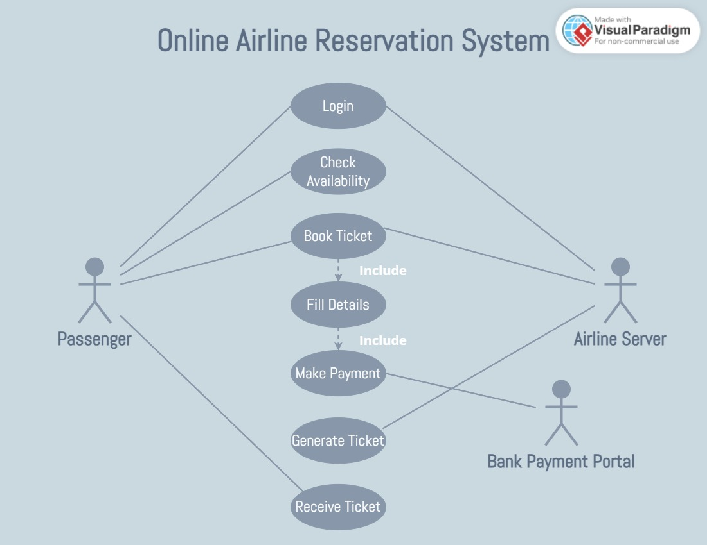

**Implementation Details**

**Implementation detail:**

1. **Hardware Requirement**

* Operating system: Windows
* Web Browser: IE, Firefox, Chrome, or any compatible browser
* Front end:React-js, HTML, CSS, JavaScript,Bootstrap
* Back end: Mongo-DB
* Documentation Tool: MS-Office

1. **Software Requirement**

* Processor: 32 or 64 bits
* RAM: 1 or 2GB
* Disk: 120GB Hard disk or SSD

**Output and Report Testing**

**Home page:**

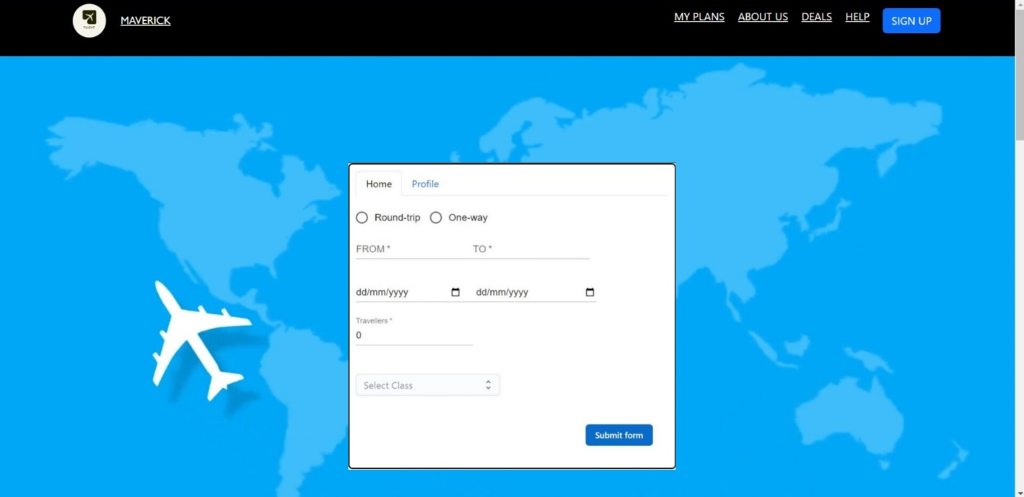

**Airports Near you:**

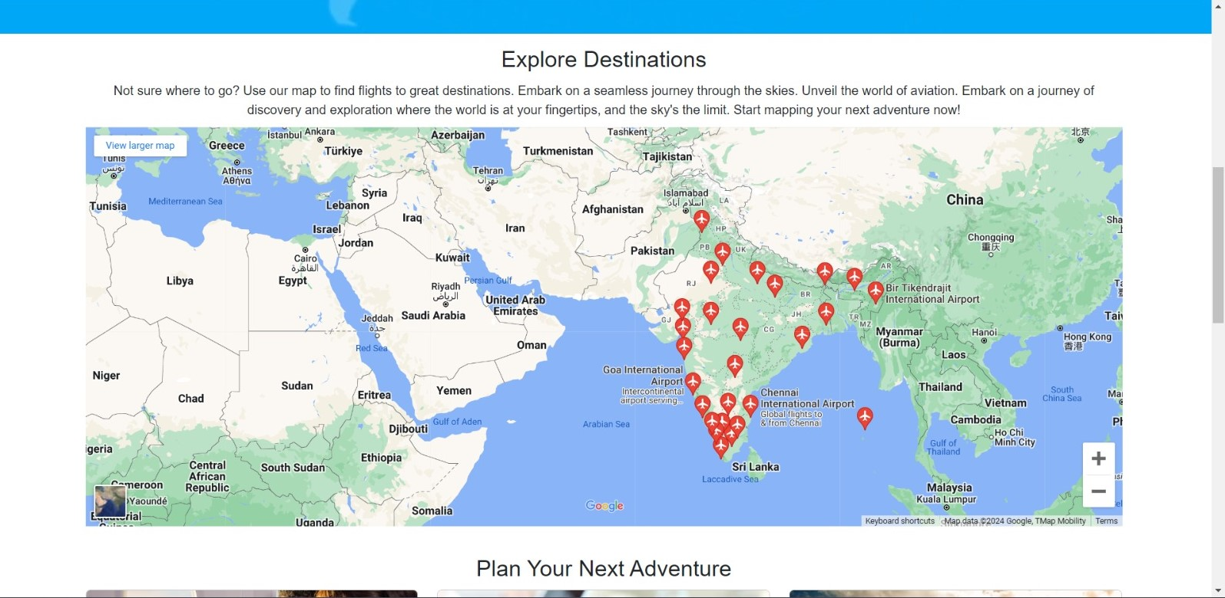

**About Us:**

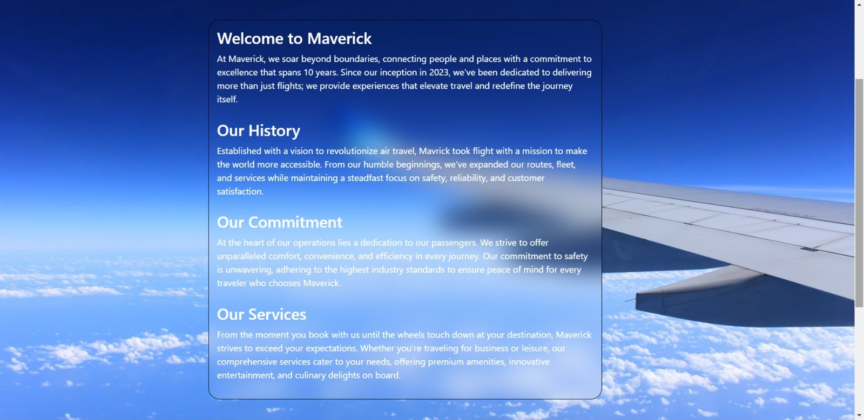

**Offers:**

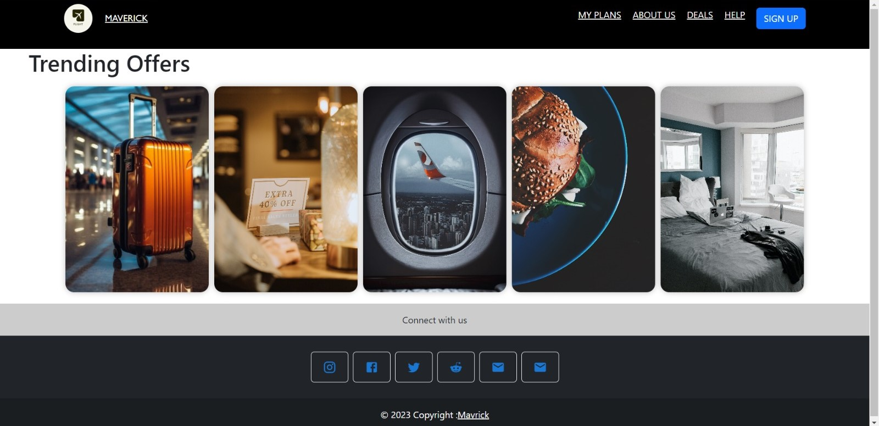

**Log-in Form:**

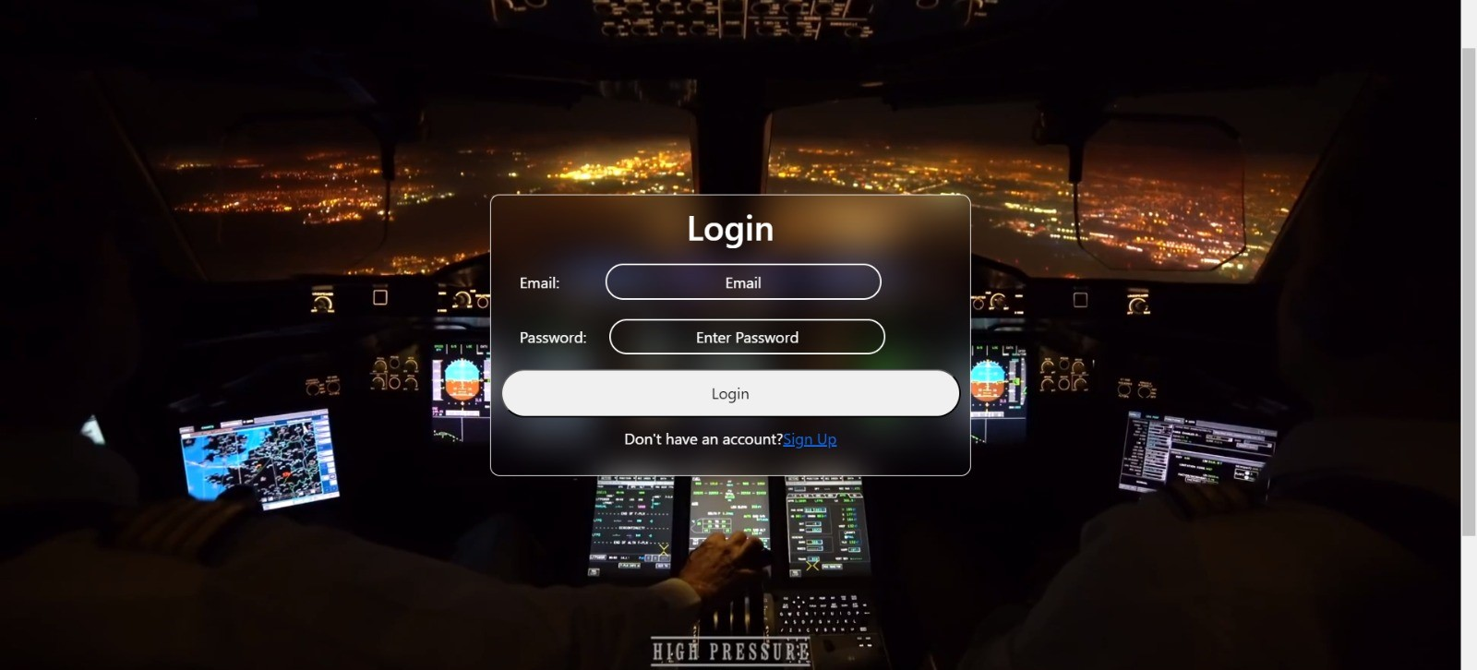

**Sign-up Form:**

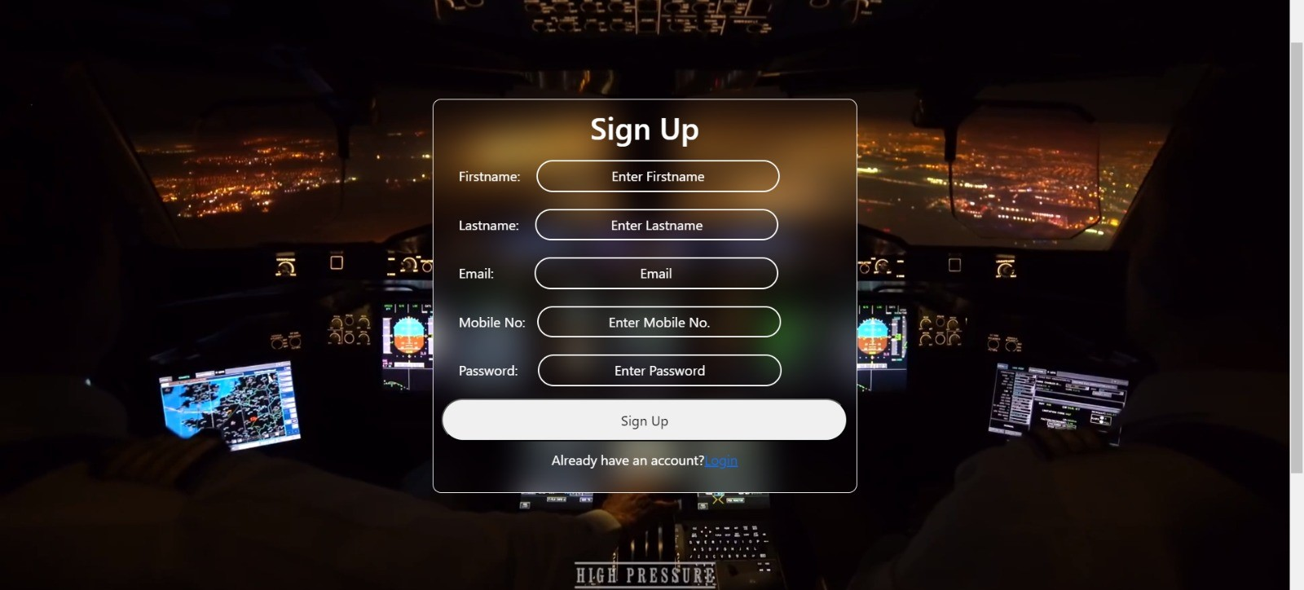

**Team:**



**Future Enhancement**

As we peer into the future of developing an airline ticket reservation website using React.js, a plethora of innovative enhancements unfolds, promising to redefine the user experience. Virtual reality (VR) integration stands out as a transformative feature, potentially allowing users to virtually navigate through aircraft cabins, explore amenities, and experience destinations before confirming their bookings. The implementation of advanced chatbots equipped with natural language processing capabilities could revolutionize customer support, offering instantaneous and personalized assistance throughout the entire booking journey.

Biometric technology is poised to take center stage, providing passengers with secure and seamless boarding experiences through the use of facial recognition or fingerprints as digital boarding passes. Additionally, the prospect of a dedicated smartwatch application emerges, catering to the needs of on-the-go travelers by granting them swift access to critical flight details and notifications directly from their wearable devices.

Blockchain technology presents an exciting avenue for enhancing the transparency and security of loyalty programs. Enabling users to trace and verify their accrued rewards seamlessly could foster increased trust and engagement. Machine learning algorithms, a cornerstone of future enhancements, hold the promise of delivering advanced personalization. These algorithms could analyze user behavior to offer tailored recommendations for flights, preferred seat selections, and additional services, creating a highly customized and satisfying user journey.

The concept of interactive in-flight entertainment systems, driven by synchronized user devices, envisions a future where passengers enjoy a personalized entertainment experience. Intelligent travel assistants powered by artificial intelligence could provide real-time travel updates, weather forecasts, and local recommendations, seamlessly integrating into the travel experience. Furthermore, the integration of smart home devices into travel plans could automate adjustments to home settings based on departure and return times, providing a holistic and interconnected experience.

In essence, these forward-looking enhancements not only embrace cutting-edge technologies but also envision a future where the airline ticket reservation website becomes a holistic and personalized travel companion, enhancing convenience, security, and overall satisfaction for users.

**Conclusion**

In conclusion, the development of the airline ticket reservation website using React.js has proven to be a significant stride towards creating a cutting-edge, user-centric, and technologically advanced platform. The integration of React.js, with its component-based architecture and virtual DOM, has empowered the project with the agility and responsiveness necessary to meet the evolving demands of the modern travel landscape.

The modular nature of React.js allowed for the seamless integration of various features, ensuring scalability and ease of maintenance. The single-page application (SPA) approach not only enhances user experience by reducing page reloads but also contributes to the overall efficiency of the booking process. The real-time updates on flight availability and dynamic pricing provide users with accurate and up-to-date information, enhancing their decision-making process.

Challenges encountered during the development process were met with strategic solutions, highlighting the adaptability and problem-solving capabilities of the React.js framework. The commitment to responsive design principles ensures a consistent and enjoyable experience for users across diverse devices, fostering inclusivity and accessibility.

Looking forward, there is immense potential for future enhancements to elevate the platform even further. Artificial intelligence, augmented reality, and blockchain technologies present exciting opportunities to redefine user interactions and transaction security. The integration of voice-activated commands, predictive analytics, and virtual travel assistants aligns the platform with emerging trends in user interface and experience.

s