✅ Why the <form> tag is useful (and often recommended)
Feature | With <form> | Without <form>
Automatic data submission (POST/GET to server) | Yes (uses action + method) | Must be handled manually with JS
Built-in browser validation | Yes (e.g., required, type="email") | Must be implemented manually
Accessibility & semantics | Forms are recognized by assistive tech | Harder for screen readers
Enter key works automatically | Yes | Must be added manually
File uploads (<input type="file">) | Works natively via forms | Very complex without forms
Graceful degradation (works with JS disabled) | Yes | No
💡 Example Comparison
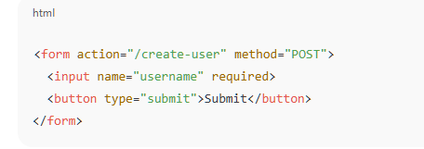
• Browser sends request automatically.
• No JavaScript required.
• Validation works.
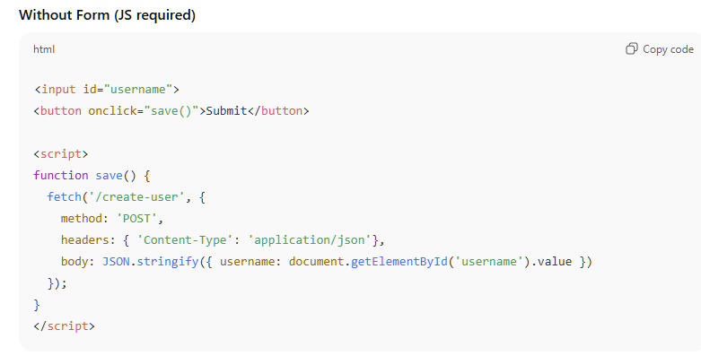
- Must manually collect input data
- Must manually make network request
- No built-in validation unless coded
- Will not work if JS is disabled

🔑 So Why Do Developers Use Forms?
- Forms are standardized and reliable
- Forms reduce code
- Forms improve accessibility
- Forms support file uploads easily
- Forms work even if JavaScript fails

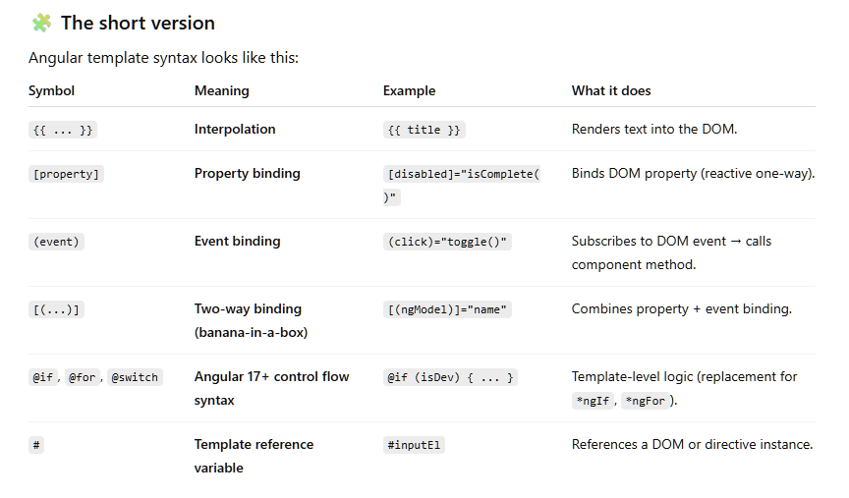

Angular change detection
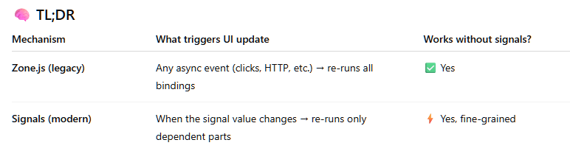

effect()
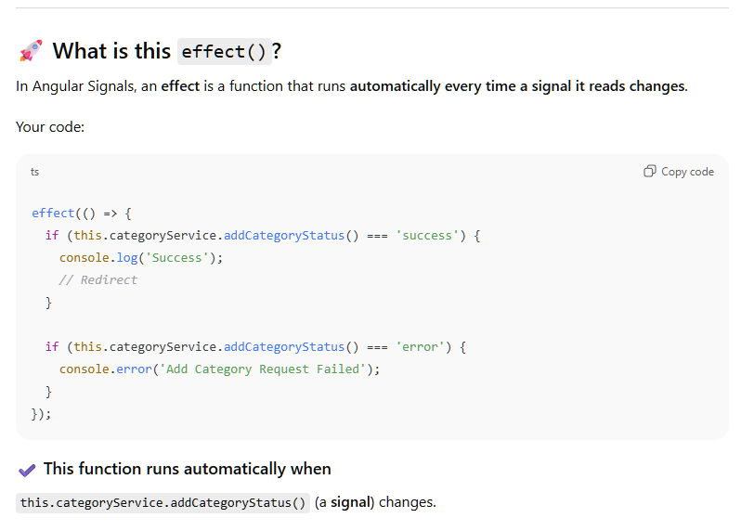

input()
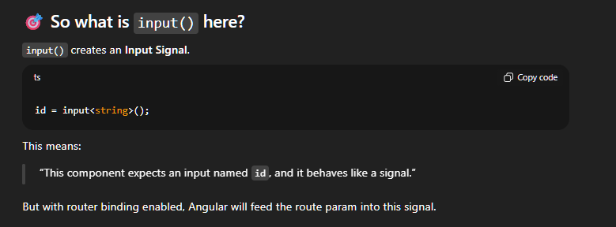

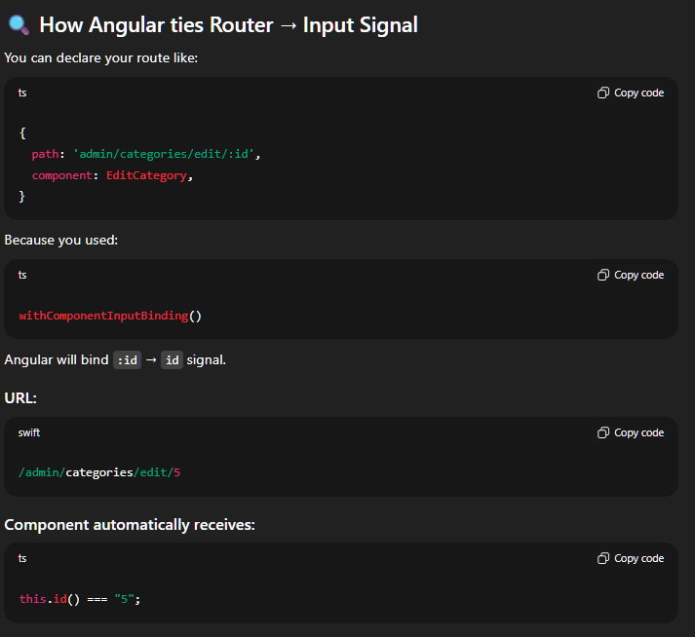

Todo app in Angular
1.Create Model
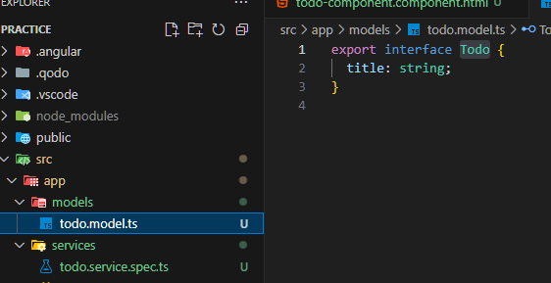

2.Create Services- ng g s todo
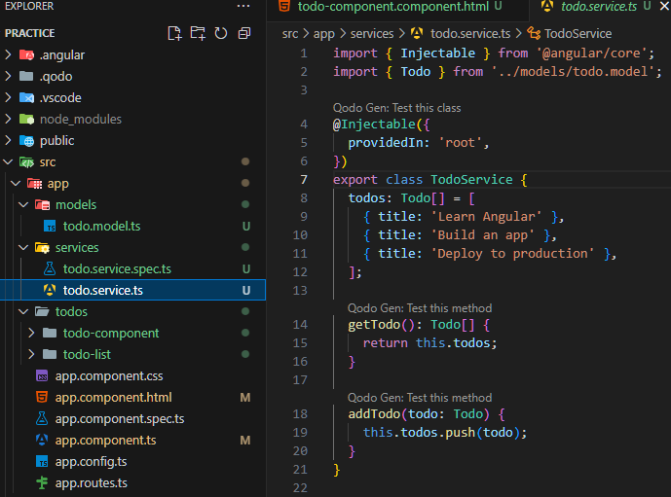
3.Create components
- Ng g c todo-list
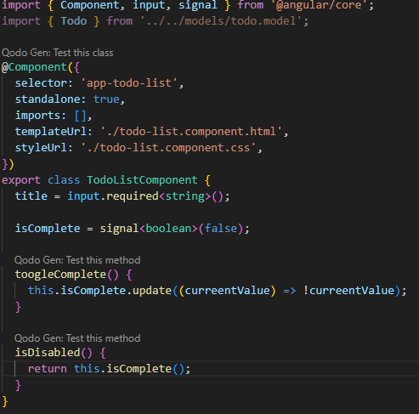
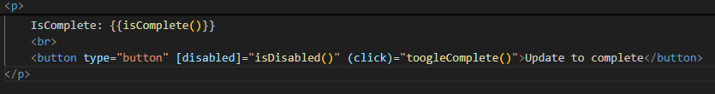

- Ng g c todo-component
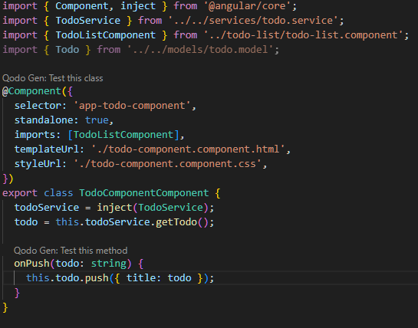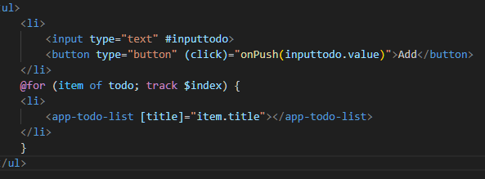

Router in Angular
Define you path and respective component in this way in app.routes.ts file
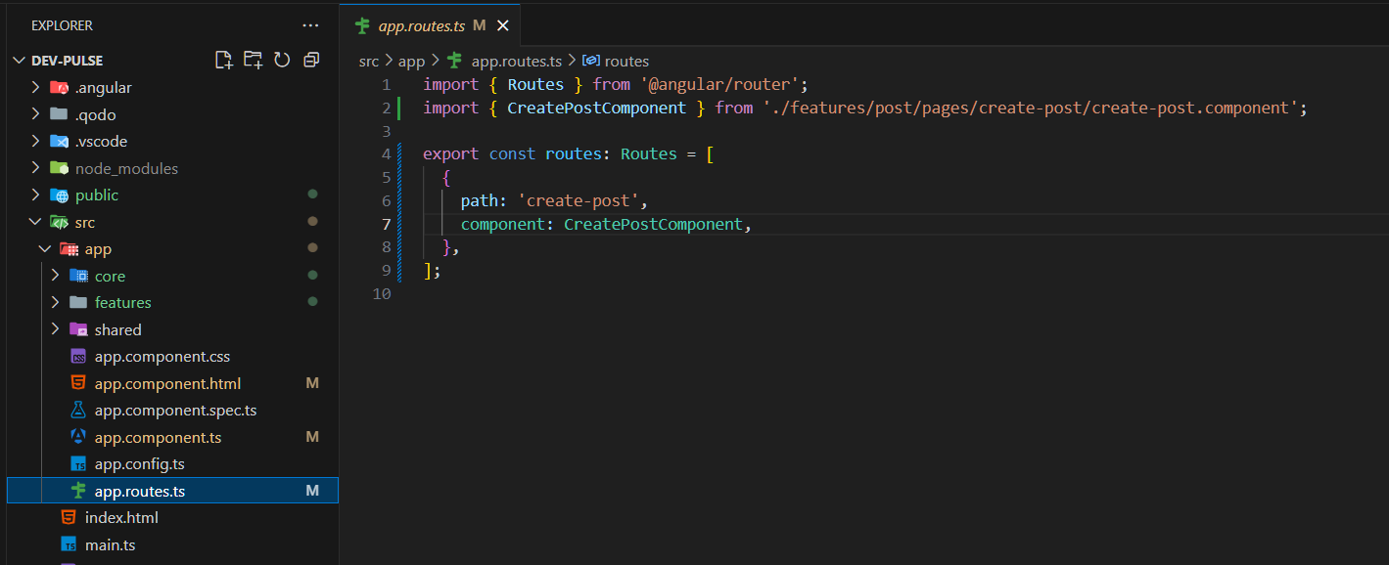
Use router-outlet element in the root component
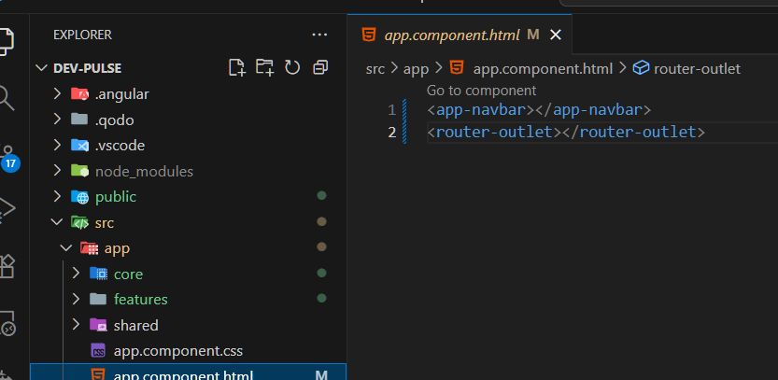

Navigation
Use [routerLink] to navigate
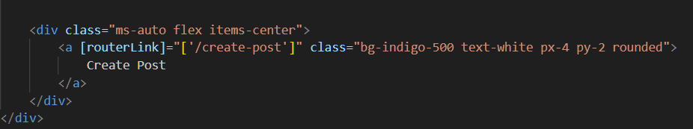

Angular Forms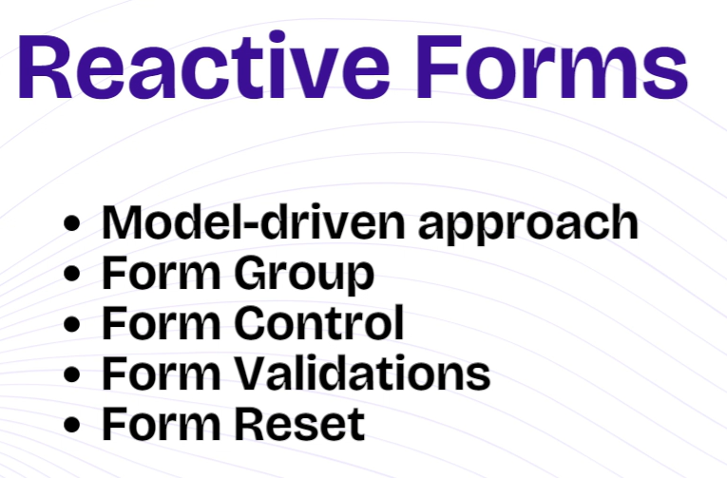

Reactive-Forms

Create a FormGroup with FormControl
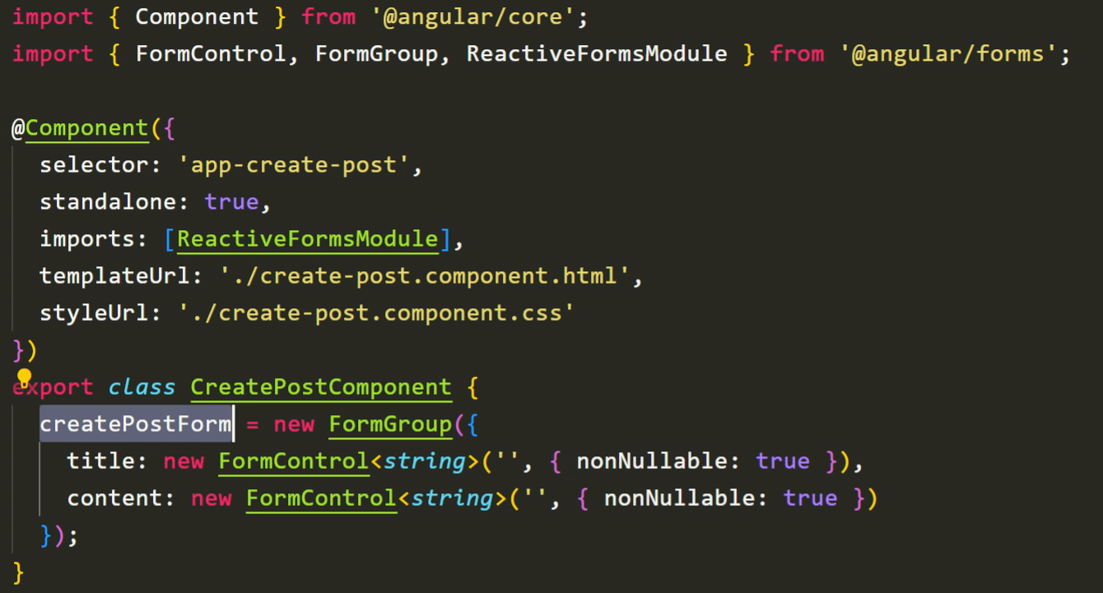

Bind the FormGroup and map the FormControl in html form
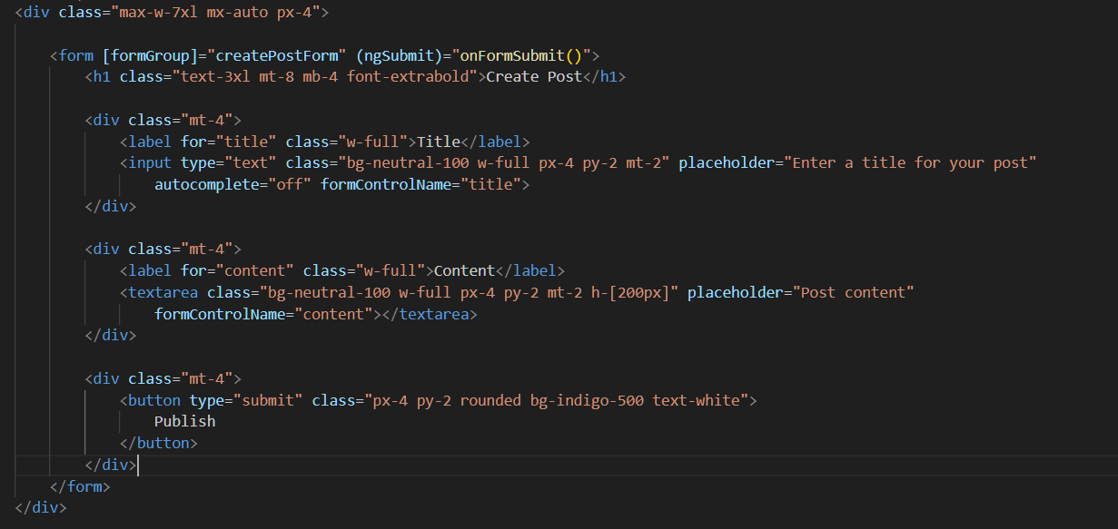

Validation in angular reactive-form