🧠 Big Picture First
EF = ORM = Translator
You write C# objects + LINQ, EF translates it into SQL and runs it on the DB.
You are not avoiding SQL.
You’re just speaking SQL in C#.

0️⃣ Database & Table → C# Class
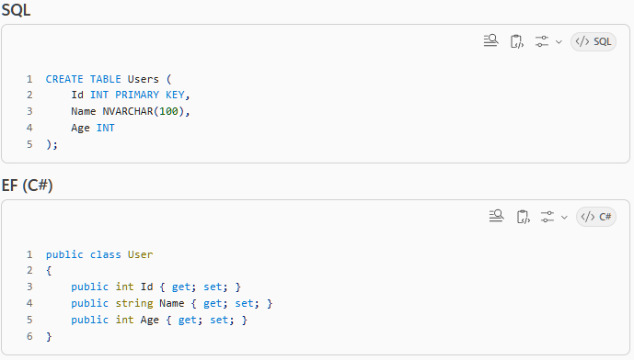
🧠 Mapping
Table → class
Column → property
Row → object
1️⃣ SELECT * FROM table
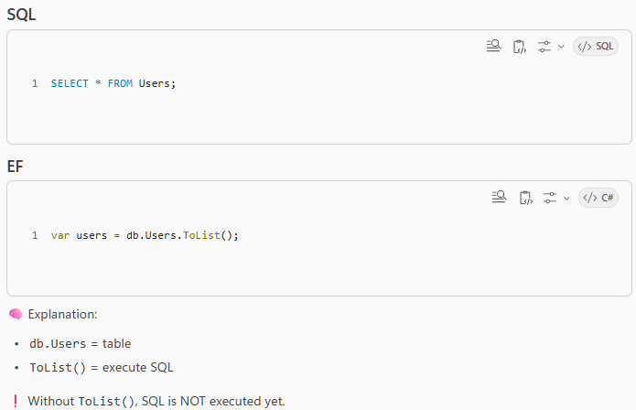
2️⃣ WHERE clause (filtering)
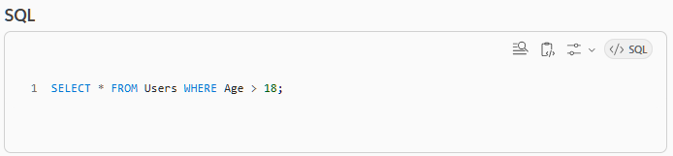

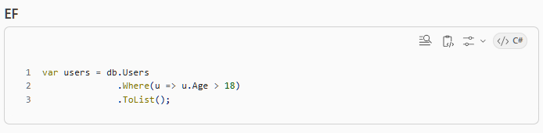

🧠 Mapping:
WHERE → Where()
SQL condition → lambda expression
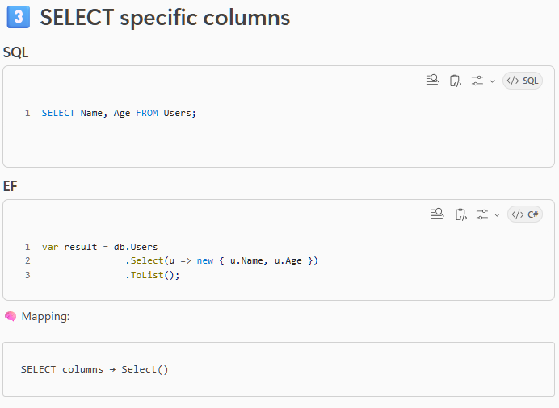
4️⃣ ORDER BY (sorting)
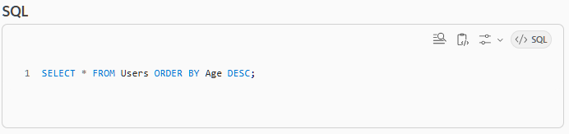
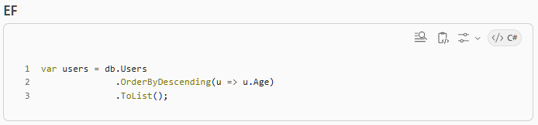
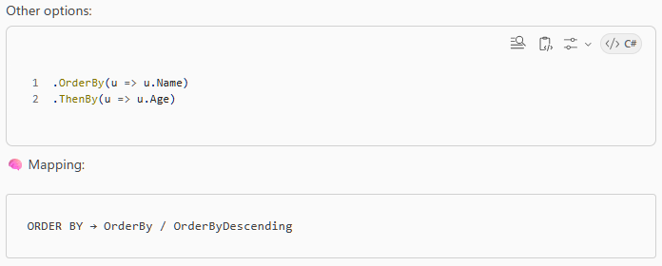

5️⃣ LIMIT / TOP
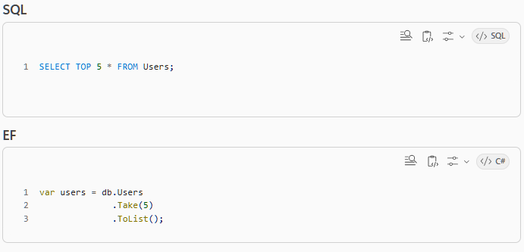
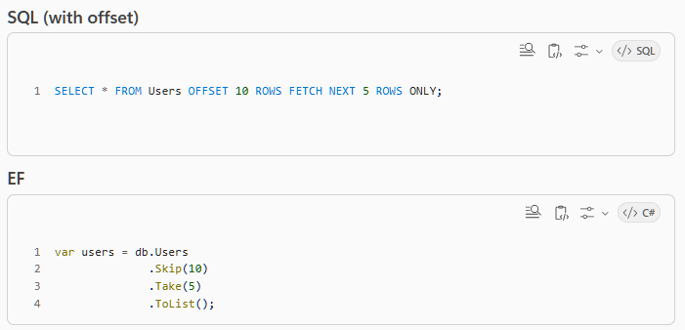
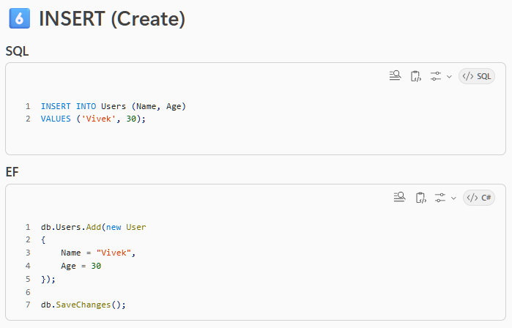
🧠 Important:
Add() → stage insert
SaveChanges → execute SQL
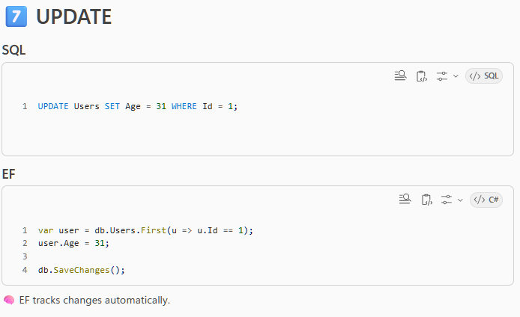
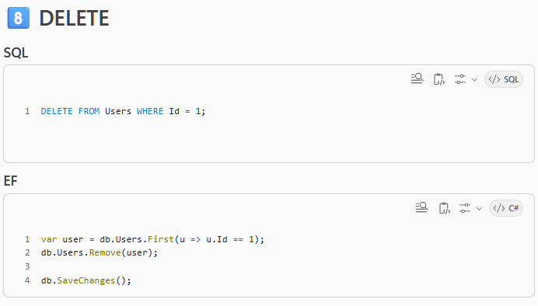
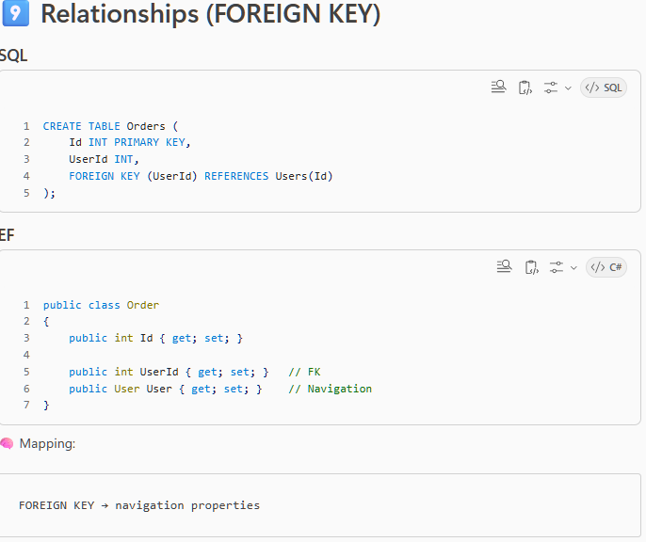
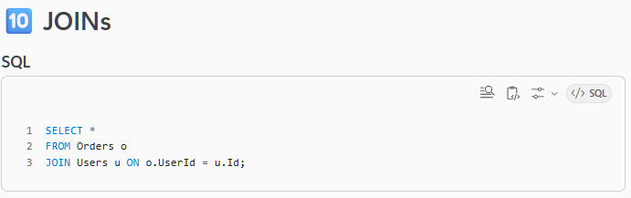
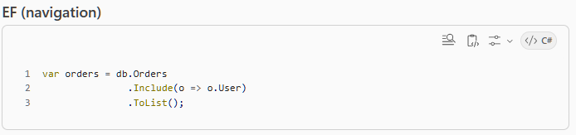
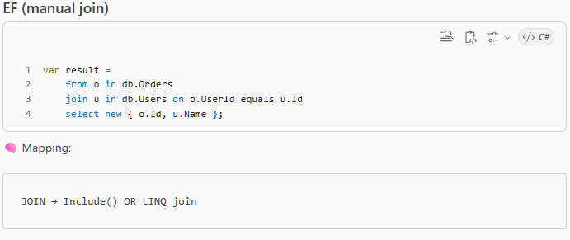
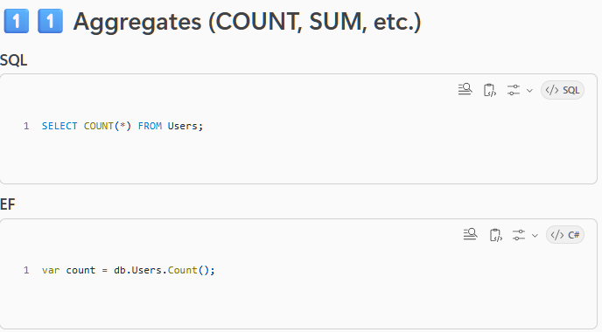
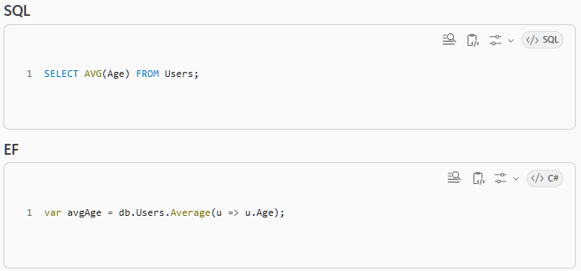
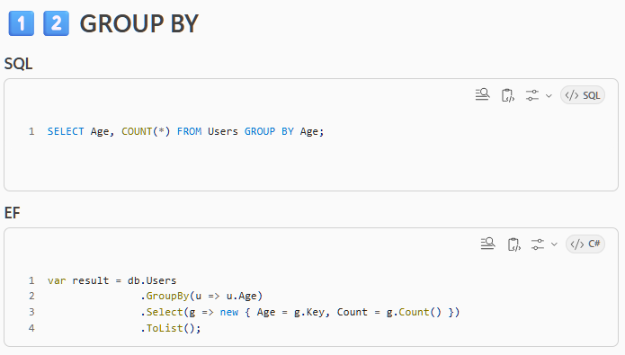
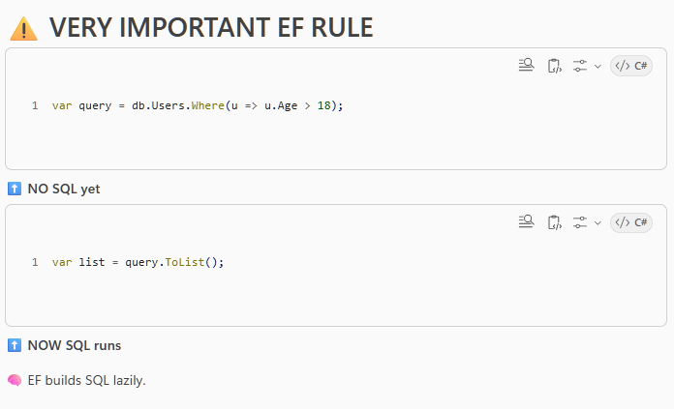
🧾 Cheat Sheet (remember this)
SQL | EF
SELECT | Select()
WHERE | Where()
ORDER BY | OrderBy()
LIMIT | Take()
JOIN | Include()
INSERT | Add()
UPDATE | Change object
DELETE | Remove()
GROUP BY | GroupBy()
EXECUTE | ToList()
✅ Final truth (important)
EF does NOT replace SQL knowledge.
If you understand SQL → EF feels easy.
If you don’t → EF feels confusing and “magical”.
I’ll cover three big things:
- ✅ Attributes like [NotMapped] and friends (what they REALLY mean)
- ✅ LINQ vs EF Core — who does what
- ✅ What you already learned = LINQ + EF combined (not separate worlds)
No fluff, spoon-fed.

1️⃣ Attributes on Entity classes (the [NotMapped] confusion)
Yes — you remembered correctly.
There ARE things that are intentionally NOT mapped to SQL.
These are called Data Annotations (attributes).

✅ [NotMapped] — most common confusion
Scenario
You want a property for C# logic, but NOT for the database.
Example
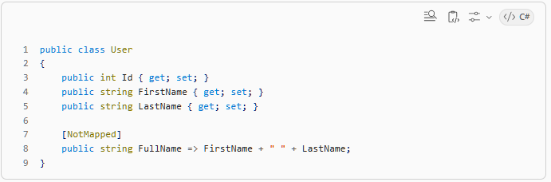
What happens?
✅ SQL table:
Id | FirstName | LastName
❌ NO FullName column
Why this exists?
Because:
- DB should store data
- C# can compute derived values
🧠 Rule
[NotMapped] = “EF, don’t look at this property.”

✅ Other IMPORTANT attributes (you DID miss some — good instinct)
[Key] — Primary Key
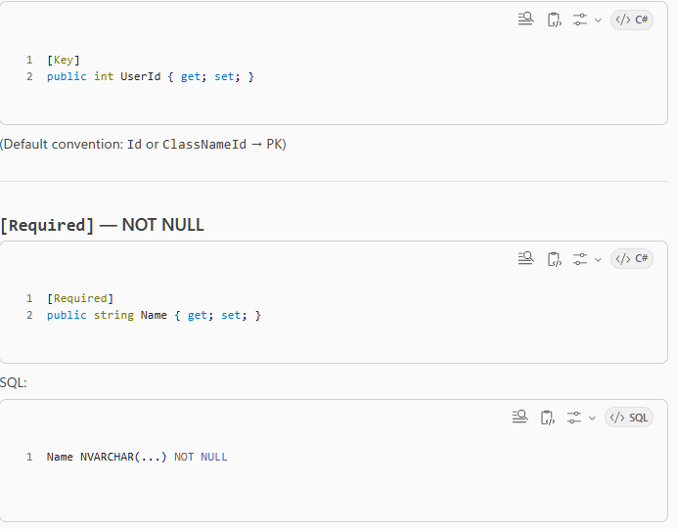
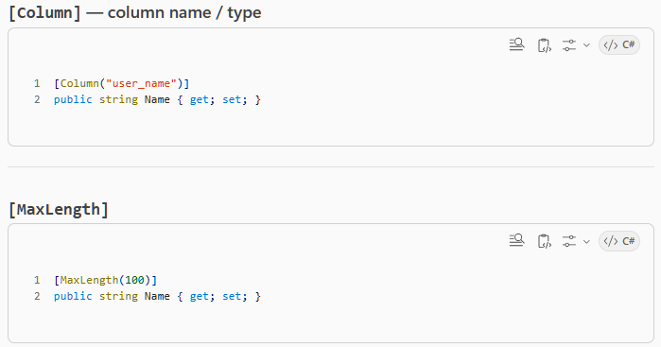
SQL:
NVARCHAR(100)
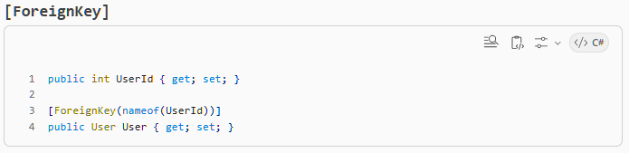
🧠 Big truth about attributes
Attributes = HOW classes map to tables
LINQ = HOW you query those tables
Different responsibilities.

2️⃣ LINQ vs EF Core — THIS is the core confusion 🔥
Let’s separate them properly.

✅ LINQ (Language Integrated Query)
LINQ is:
- A C# language feature
- Works on:
  - Lists
  - Arrays
  - Collections
  - EF DbSets
  - In-memory objects
Example (pure C#)
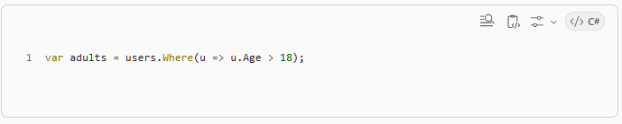
No DB needed.
🧠 LINQ is:
“How you EXPRES​​S queries in C#”
✅ EF Core
EF Core is:
- A database provider
- Understands LINQ
- Converts LINQ → SQL
🧠 EF Core is:
“How LINQ gets translated to SQL”

🔑 Very important separation (read twice)
LINQ = what you write EF = who runs it against SQL
EF = who runs it against SQL
3️⃣ Same LINQ, different behavior (THIS CLEARS EVERYTHING)
Example
.Where(u => u.Age > 18)
Looks SAME everywhere, but:

Case 1️⃣ LINQ on a List (in-memory)
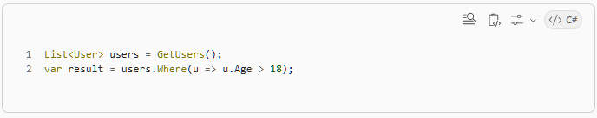
✅ Runs in C#
✅ No SQL
✅ Uses CPU + memory

Case 2️⃣ LINQ on DbSet (EF Core)
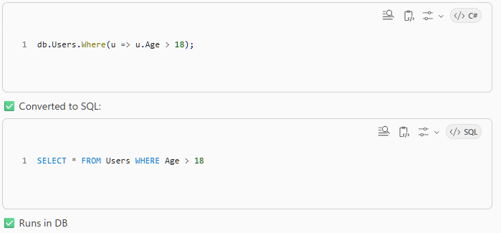
🧠 Key insight (most important sentence today)
LINQ doesn’t know SQL. EF Core does.
LINQ is just an expression tree. EF Core inspects it and says:
“Okay, I’ll translate this to SQL.”

4️⃣ Why SOME LINQ works and SOME fails in EF
Another thing that confuses people 👇
✅ SQL-translatable LINQ (works)
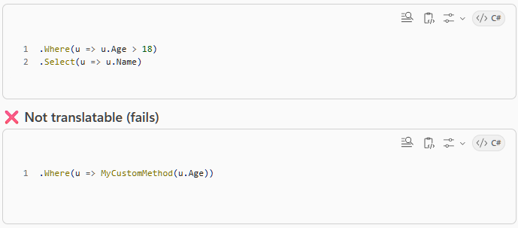
Why?
Because SQL doesn’t know your C# method.
🧠 Rule:
Only LINQ that can be expressed in SQL will run in EF

5️⃣ Where YOU are right now (sanity check ✅)
✅ Everything I explained earlier WAS LINQ
✅ EF Core was silently converting it to SQL
✅ Attributes define mapping
✅ LINQ defines querying
✅ EF glues them together
You didn’t miss basics — you missed architecture boundaries, which is normal.

✅ Final mental model (lock this in)
Class + Attributes → Table structure
DbContext → Database connection
LINQ → Query language
EF Core → LINQ → SQL translator
Database → Executes SQL

🔥 Interview-level one-liner
LINQ is the query language, EF Core is the ORM that translates LINQ into SQL, and attributes control how C# objects map to database tables.
not all EF operations are LINQ
✅ Queries use LINQ
✅ CRUD commands use EF Core APIs
They work together, but they are not the same thing.

1️⃣ Two big categories in EF Core
Think EF Core has TWO toolkits, not one.
EF Core =
1) LINQ (for querying data)
2) EF Core APIs (for change tracking & database commands)
2️⃣ LINQ methods (QUERY side ✅)
These are used to READ data.
They:
- describe what data you want
- get translated to SQL
✅ Common LINQ methods you already used
Where
Select
OrderBy / OrderByDescending
GroupBy
Join
Skip / Take
Any
All
Count
Sum / Avg / Min / Max
First / FirstOrDefault
Single / SingleOrDefault
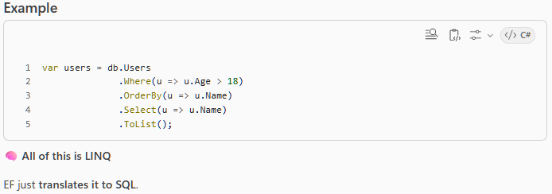
3️⃣ EF Core command methods (NOT LINQ ❌)
These are EF Core–specific APIs.
They:
- track changes
- send INSERT / UPDATE / DELETE to DB
✅ These are NOT LINQ
Add
AddAsync
AddRange
Update
Remove
RemoveRange
SaveChanges
SaveChangesAsync
Find / FindAsync
Attach
Entry
Example
db.Users.Add(user);
db.SaveChanges();
🧠 This is EF Change Tracking, not querying.

4️⃣ The most confusing ones (your examples ✅)
Let’s clarify each one you mentioned:

✅ Add / AddAsync
❌ NOT LINQ
✅ EF Core command
db.Users.Add(user);
db.SaveChanges();
SQL generated:
INSERT INTO Users (...)
✅ Remove / RemoveAsync
❌ NOT LINQ
✅ EF Core command
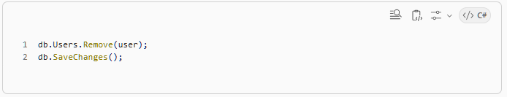
✅ FirstOrDefault
✅ LINQ method
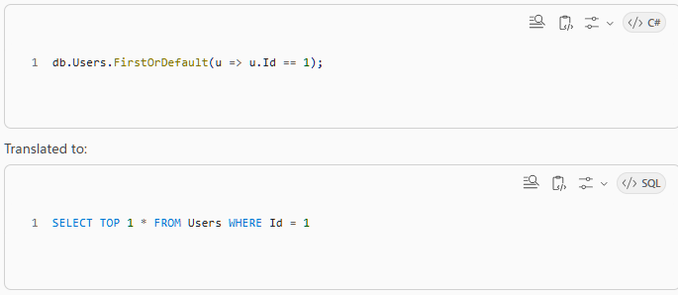
✅ Find / FindAsync (SPECIAL case ⚠️)
🚨 This is EF Core — NOT LINQ
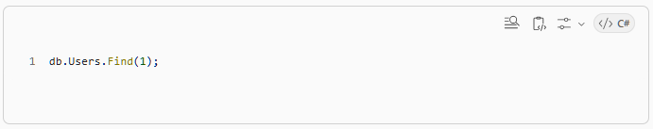
Why special?
- Checks EF cache (change tracker) first
- If not found → queries DB by primary key
🧠 Think:
Find() = fast primary-key lookup shortcut
5️⃣ Execution methods (bridge between LINQ & EF)
These trigger SQL execution.
✅ Execution points
ToList
ToArray
First / FirstOrDefault
Single / SingleOrDefault
Any
Count
Max / Min
Until one of these runs:
✅ NO SQL is executed
6️⃣ Async versions — same concept, async I/O
These are still EF Core, not LINQ:
ToListAsync
FirstOrDefaultAsync
SingleAsync
SaveChangesAsync
FindAsync
They just:
- don’t block the thread
- use async DB calls

7️⃣ One clean MASTER TABLE (memorize this)
✅ LINQ (Query language)
Used for READING
- Where
- Select
- Join
- GroupBy
- OrderBy
- Skip / Take
- First / Single
- Count / Any

✅ EF Core APIs (Change tracking + commands)
Used for WRITING
- Add / AddAsync
- Update
- Remove
- SaveChanges
- Find
- Attach
- Entry

8️⃣ Why they feel mixed together (important insight)
This line mixes both worlds:
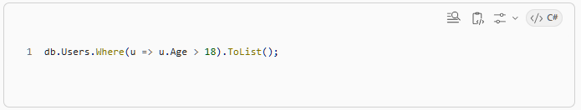
- db.Users → EF Core
- Where → LINQ
- ToList → execution
- SQL → generated by EF
🧠 That’s why it feels confusing:
EF exposes LINQ as its query language.

✅ Final lock-in mental model
LINQ = “what data do I want?”
EF Core = “how do I store & persist data?”
DbContext = “I manage both”

Interview-ready one-liner 🎯
EF Core uses LINQ for querying data and EF-specific APIs for tracking changes and executing database commands like insert, update, and delete.
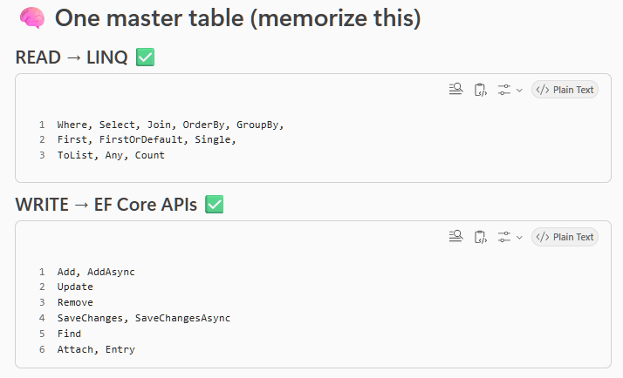
🚨 The single most important rule
LINQ is ONLY for querying (READ)
EF Core APIs handle CREATE, UPDATE, DELETE
There is NO such thing as:
- LINQ insert
- LINQ update
- LINQ delete
Those are EF Core responsibilities.

🎯 Interview-perfect one-liner
EF Core uses LINQ for reading data and EF Core APIs like Add, Update, Remove, and SaveChanges for create, update, and delete operations.

