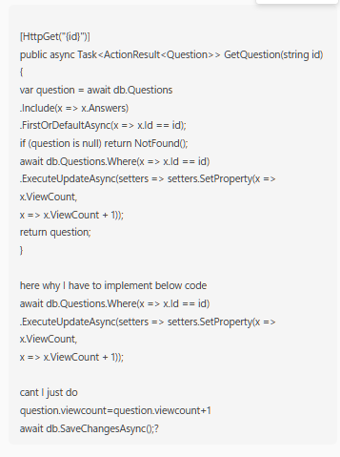
✅ Your doubt
Why this:
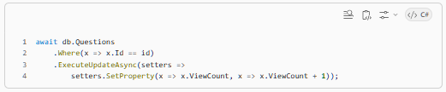
Instead of:
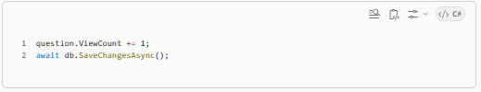

✅ Short Answer
👉 Both work
👉 But they behave very differently

🧠 1. What your approach does (tracked update)
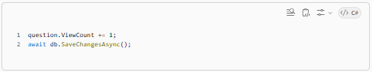
✅ Flow
- Load question from DB
- Modify in memory
- EF tracks change
- EF sends UPDATE query

⚠️ Problem: Race condition
Imagine:
User A → loads ViewCount = 10
User B → loads ViewCount = 10
Both do:
+1
Both save:
A saves → 11
B saves → 11 ❌ (lost update)
👉 You expected 12, but got 11

⚡ 2. What ExecuteUpdateAsync does
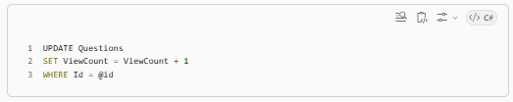
WHERE Id = @id
Show more lines
👉 This runs directly in database

✅ Result
User A → DB increments → 11
User B → DB increments → 12 ✅
👉 No race condition

🔥 3. Key Difference
Approach | Where increment happens | Safe under concurrency
Load + SaveChanges | App memory | ❌ No
ExecuteUpdateAsync | Database | ✅ Yes

💡 4. Why DB-side update is better here
This is called:
✅ Atomic update
Database guarantees:
ViewCount = ViewCount + 1
is executed safely even with multiple requests

🚀 5. Performance benefit
Your approach:
- SELECT query (load question)
- UPDATE query (save)
👉 2 round trips

ExecuteUpdateAsync:
- Only UPDATE
👉 1 round trip ✅

⚠️ 6. Another subtle issue
With your approach:
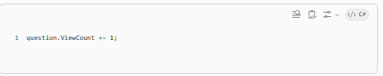
👉 You are updating a tracked entity that also has Answers loaded

👉 EF might:
- track more data
- do unnecessary change tracking

🧠 7. Why Microsoft added ExecuteUpdateAsync
Before EF Core 7:
People had to do raw SQL:
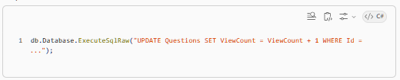
Now:
✅ safer
✅ type-safe
✅ LINQ-based

🎯 8. When to use which

✅ Use ExecuteUpdateAsync when:
- counters (views, likes)
- bulk updates
- concurrency matters
- performance matters

✅ Use SaveChanges when:
- updating full entity
- business logic involved
- multiple fields change together

🔥 9. Best Practice for your case
👉 You did correct thing
Because:
ViewCount = HIGHLY concurrent field

🧠 Interview answer (important)
“Updating counters like ViewCount using ExecuteUpdateAsync ensures atomic database-level increments, avoiding race conditions and reducing round trips compared to tracked entity updates.”

✅ Final takeaway
👉 Your method = correct for production systems
👉 Your idea works, but is not safe under concurrency

👍 Bonus tip
If you still want to use SaveChanges:
You would need:

But EF doesn’t make this easy → messy
👉 That’s why ExecuteUpdateAsync is preferred

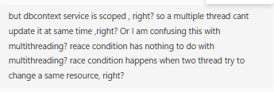
This is a very important conceptual confusion, and you’re very close to getting it right. Let me clean it up clearly 👇

🧠 1. Your Thinking (partially correct)
You said:
DbContext is scoped → so multiple threads can't update it → so no race condition
✅ Correct about DbContext
❌ Wrong conclusion about race condition

🔥 2. Key distinction you’re missing
✅ Race condition ≠ only multithreading inside ONE app
👉 That’s the biggest misunderstanding

⚡ 3. What “Scoped DbContext” actually guarantees
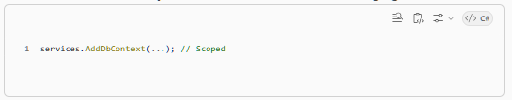
👉 Means:
Per HTTP request → new DbContext instance
So:
Request | DbContext instance
User A | dbContext A
User B | dbContext B
✅ Each request is isolated
✅ No shared DbContext

🚨 4. Where the race condition actually happens
NOT in memory
✅ Happens at DATABASE LEVEL

Scenario
Two users hit your API at same time:
GET /questions/1
GET /questions/1

Step-by-step
Request A:
reads ViewCount = 10
Request B:
reads ViewCount = 10

Now both are separate DbContexts:
A: question.ViewCount = 10
B: question.ViewCount = 10

Then both do:
+1

A saves:
UPDATE ViewCount = 11
B saves:
UPDATE ViewCount = 11 ❌

👉 BOOM — race condition

🧠 5. Important realization
✅ Race conditions happen across requests, not just threads

Your earlier definition:
“race condition happens when two threads update same resource”
✅ Extend it:
👉 “Two independent operations (even from different requests/processes) reading and writing shared data”

🔥 6. Why DbContext doesn’t protect you
Because:
👉 DbContext only tracks its own copy of data
It has NO idea:
someone else updated DB after I read it

⚡ 7. Why ExecuteUpdateAsync fixes it
This:

👉 Tells DB:
Don't trust application value
Just increment current value safely

✅ DB handles concurrency internally
Database guarantees:
10 → 11 → 12 → 13
(no overwrite)

🔍 8. Multithreading vs Race Condition (clear separation)
Concept | Meaning
Multithreading | multiple threads in same process
Race condition | concurrent access to shared data

✅ Key insight
❗ You can have race condition without multithreading

Example in your case
- different users
- different HTTP requests
- different DbContexts
- STILL conflict

💡 9. Real-life analogy
Imagine:
Bank balance = 1000
Two ATMs:
ATM A reads → 1000
ATM B reads → 1000
Both withdraw 100:
A writes → 900
B writes → 900 ❌
👉 Lost money

🚀 10. Proper fixes (3 ways)

✅ 1. Atomic DB update (you used)
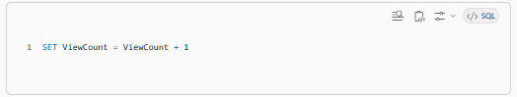
✅ Best for counters

✅ 2. Concurrency tokens (row version)
EF detects conflict → throws error

✅ 3. Locks (rare)
SELECT ... FOR UPDATE

🎯 11. Final clarity

✅ Scoped DbContext ensures:
- thread safety in app
- isolation per request

❌ It does NOT ensure:
- DB-level consistency
- protection from concurrent updates

✅ Final 1-line takeaway
Even though DbContext is scoped, race conditions happen because multiple requests read and update the same database record concurrently — and only database-level atomic operations can prevent lost updates.

🧠 Interview-ready answer
“Scoped DbContext ensures isolation per request, but race conditions still occur at the database level when multiple requests read and update the same data concurrently. That’s why atomic updates like ExecuteUpdateAsync are preferred for counters.”

✅ Your Thought
“We are not incrementing something like a counter, so race condition is less likely”
👉 Correct instinct ✅
👉 But not completely safe ❌

🧠 1. Why this feels safer than ViewCount
In your previous case:
C#
ViewCount = ViewCount + 1
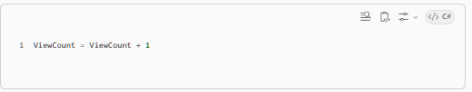
👉 That’s a read-modify-write operation
👉 Highly sensitive to race conditions → lost updates

Now your update is:
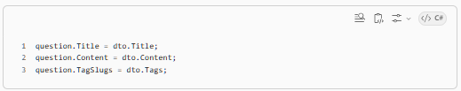
👉 Looks like:
"just replace values"
✅ No arithmetic = fewer issues
✅ Usually safe in low concurrency

⚠️ 2. BUT race condition still EXISTS
Let’s simulate:

Scenario
Two users (or tabs or requests):
User A loads question
User B loads question
Both see:
Title = "Old Title"

User A updates:
Title = "New Title A"

User B updates:
Title = "New Title B"

What happens?
A saves → "New Title A"
B saves → "New Title B" ✅ overwrites A

👉 This is called:
❗ Lost update

🔥 3. Key Insight
✅ Race condition is NOT only about counters
✅ It’s about overwriting someone else’s changes

⚡ 4. Why it’s less dangerous here
Compared to counters:
Case | Severity
ViewCount | ❌ critical data corruption
Title/Content | ⚠️ last-write-wins (acceptable sometimes)

👉 So:
- counters must be strict ✅
- content updates often tolerate overwrite ✅

🧠 5. Real systems behavior
Most apps (StackOverflow, etc.):
👉 Use last write wins
Unless:
- collaborative editing
- high data integrity required

🚀 6. If you WANT to prevent race condition
Use:
✅ Optimistic Concurrency (best practice)
Add a version column:
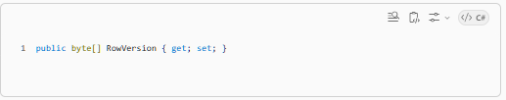
Configure:
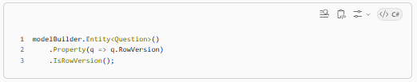
Then EF does:
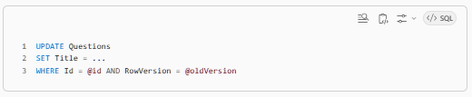
If someone else updated:
👉 Update fails
👉 EF throws exception

You handle:
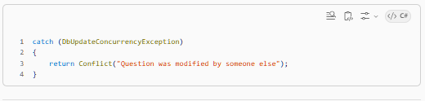
⚡ 7. Alternative: manual version check
Simpler:
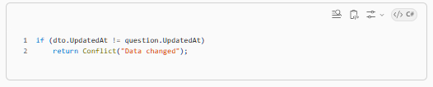
🔍 8. Why you didn’t worry earlier
Because:
👉 Your use case is probably:
- single user edits their own question
- low contention
- acceptable overwrite

✅ 9. Final Answer to your question
“Are we safe from race conditions here?”
👉 Answer:
- ❌ No, race conditions still exist
- ✅ But impact is lower (no numeric corruption)
- ✅ Usually acceptable in many systems

🎯 Interview-ready answer
“While this update avoids arithmetic race conditions like counters, it can still suffer from lost updates if multiple requests modify the same record concurrently. In many systems, this is acceptable as last-write-wins, but for stricter consistency, optimistic concurrency control using row versioning should be used.”

✅ Final takeaway
Counters → must use atomic DB update ✅
Content updates → may tolerate overwrite ⚠️
Strict systems → use concurrency control ✅

