✅ Concept
✅ Code mapping (YOUR code)
✅ Deep doubts (like queue vs exchange storage)
✅ Interview-ready answers

🚀 1. High-Level Architecture (YOUR PROJECT)
Question Service (Producer)
↓
RabbitMQ Exchange ("questions")
↓
Queue ("questions.search")
↓
Search Service (Consumer)
↓
Typesense (Search DB)

🧠 2. RabbitMQ Core Concepts (Clean)
✅ 1. Producer
Sends message
👉 Your code:
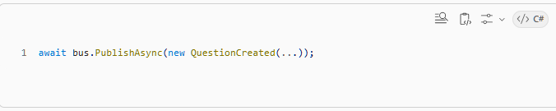
✅ 2. Exchange (Router)
Exchange DOES NOT store data
It decides → "where should this message go?"
👉 Your code:
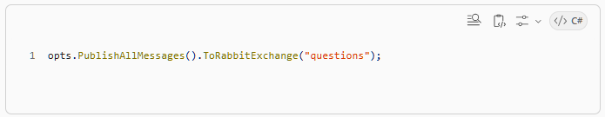
✅ So:
- All messages → exchange "questions"

✅ 3. Queue (Storage)
Queue = where messages are actually stored
👉 Your code:
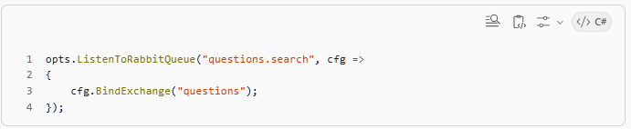
✅ So:
- Queue name = questions.search
- Bound to exchange questions

✅ 4. Consumer
Reads from queue
👉 Your handlers:
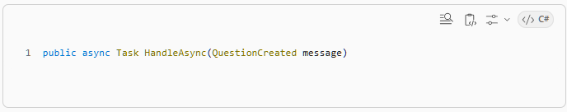
🔥 3. End-to-End Flow (with YOUR code)
Step 1: Producer sends
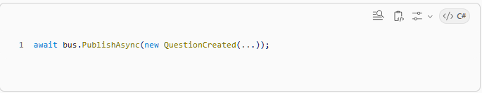
Step 2: Exchange receives
Exchange: "questions"

Step 3: Exchange routes → Queue
Queue: "questions.search"
(because of binding)

Step 4: Queue stores message ✅

Step 5: Consumer picks message
QuestionCreatedHandler
Step 6: Data goes to Typesense
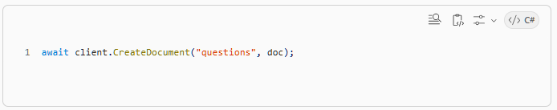
⚡ 4. VERY IMPORTANT DOUBT (you asked)
If consumer is down → does exchange store data?
❌ WRONG THINKING:
Exchange will hold messages
✅ CORRECT:
🟢 Queue stores messages, not exchange

🔥 What actually happens
CASE 1: Queue exists ✅
Producer → Exchange → Queue ✅
(stored here)
👉 Even if consumer is DOWN:
✅ Messages stay in queue
✅ Nothing is lost (if durable)

CASE 2: Queue does NOT exist ❌
Producer → Exchange → ❌ no queue
👉 Message is LOST

✅ 5. So your question:
“Queue is created when search service runs?”
YES ✅
Because of:
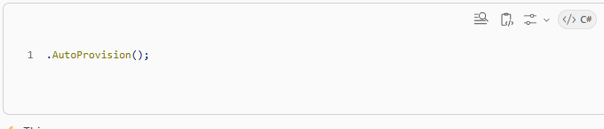
👉 This means:
- queue is auto-created
- binding is auto-created

🚨 IMPORTANT SCENARIO
🚫 If SearchService is DOWN at startup
Queue may NOT exist
→ Messages can be lost

✅ Solution (production best practice)
Queue must be:
- pre-created OR
- declared by first consumer and stay there
👉 Once created → it persists in RabbitMQ

💡 KEY CLARITY
Queue lives inside RabbitMQ server
NOT inside your service memory

🧠 6. Types of Exchange (INTERVIEW GOLD)

✅ 1. Direct Exchange
route by exact key
👉 Example:
routingKey = "question.created"

✅ 2. Fanout Exchange
broadcast to ALL queues
👉 Example:
multiple services get same event

✅ 3. Topic Exchange (Most used)
pattern-based routing
Examples:
question.*
question.created
question.deleted

✅ 4. Headers Exchange
Rare, based on headers

💡 In YOUR case
Wolverine is likely using fanout internally (since no routing key specified)
👉 Meaning:
all bound queues get the message

🔍 7. Why use RabbitMQ here?
You achieved:
✅ Loose coupling
✅ Async processing
✅ Scalability
✅ Service independence

⚡ 8. Why not call search service directly?
QuestionService → HTTP → SearchService
Problems:
❌ tight coupling
❌ failure propagation
❌ latency

🔥 9. About your Handlers (GOOD DESIGN)

✅ Create
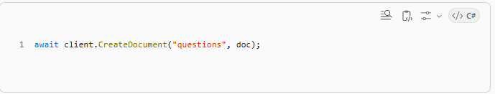
✅ Update
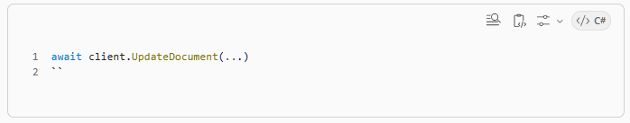
✅ Delete
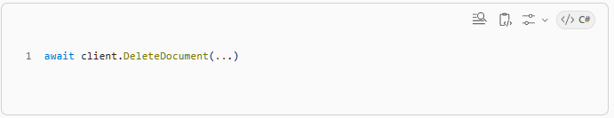
👉 This is called:
Event-driven projection

🧠 10. Big Pattern You’re Using
✅ Event-Driven Architecture + CQRS

System | Responsibility
PostgreSQL | source of truth
RabbitMQ | communication
Typesense | search model

⚠️ 11. Important Interview Topics

✅ 1. Message durability
If queue is:
- durable ✅ → survives restart
- non-durable ❌ → lost

✅ 2. Acknowledgment (ACK)
Consumer must ACK message
Otherwise:
👉 message reprocessed

✅ 3. At-least-once delivery
RabbitMQ guarantees:
✅ message arrives ≥ 1 time
❌ exactly once NOT guaranteed

✅ 4. Idempotency (IMPORTANT)
Your handler should handle duplicates:
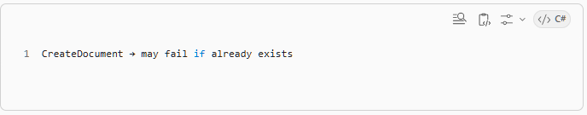
👉 You may prefer:
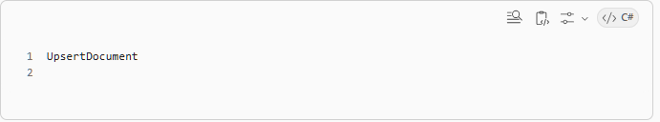
🔥 12. Your Biggest Confusion (final clarification)
Queue is like database but only for consumer?
✅ Partially correct, fix it:
👉 Queue is:
temporary storage inside RabbitMQ server
NOT inside consumer
NOT inside exchange

✅ Correct mental model
RabbitMQ Server:
Exchange (router)
Queue (storage)
Messages (stored safely)

🎯 13. Final Cheat Sheet (read before interview)

✅ Core Flow
Producer → Exchange → Queue → Consumer

✅ Key Facts
- Exchange = router
- Queue = storage
- Consumer reads from queue
- Producer sends to exchange

✅ Your System
QuestionService → Exchange ("questions")
→ Queue ("questions.search")
→ SearchService
→ Typesense

✅ If consumer down?
✅ Messages stay in queue

✅ If queue not created?
❌ Messages lost

✅ Why RabbitMQ?
- async
- decoupling
- scalability

✅ What you built
“An event-driven architecture where QuestionService publishes domain events to RabbitMQ, and SearchService consumes them to maintain a search index in Typesense.”

