Entity Framework Migration
Add_Migration “Name of migration”
Update-Database

Basic CRUD

Get:
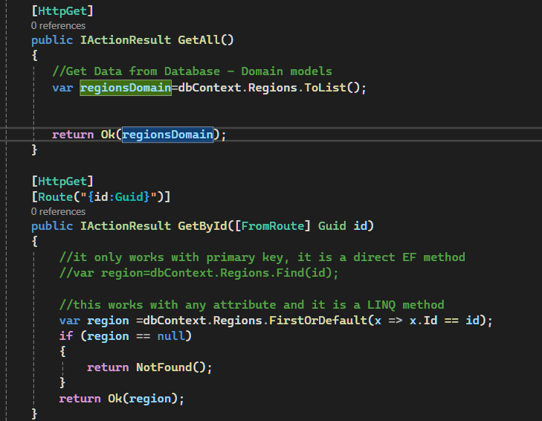

Post:
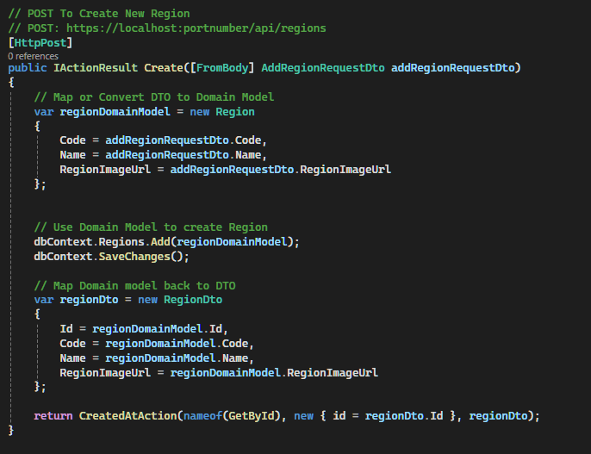

Put:
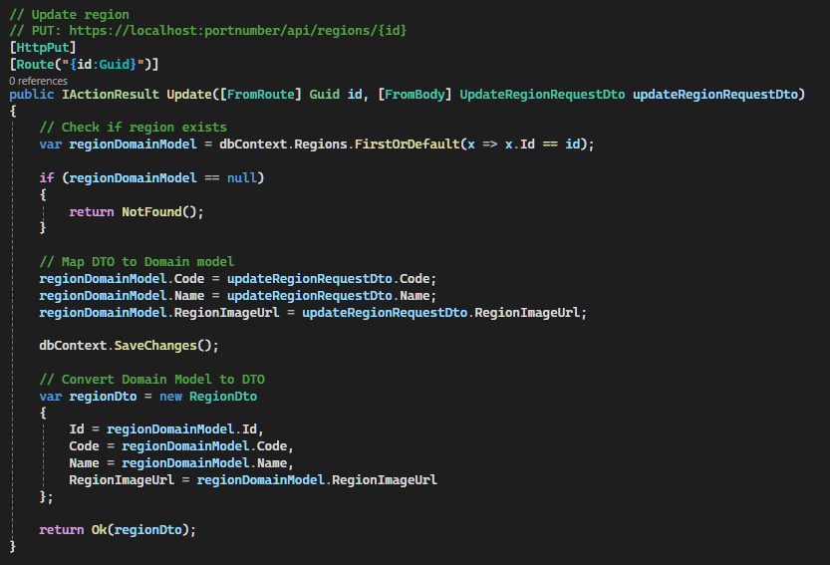

Delete:
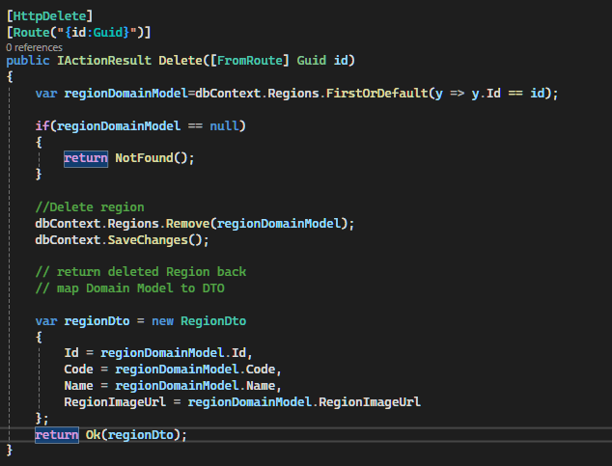

Navigation Properties
Allowing to Navigate From one Entity to another
Walks Domain model will have Region Navigation Property
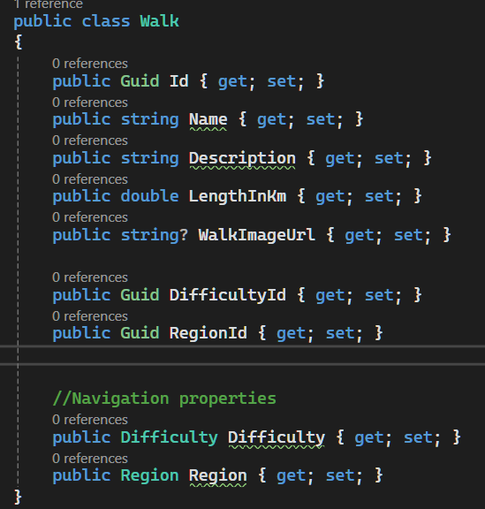

Include()
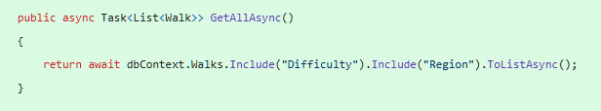
Use Include() to access the navigation property
If you load an entity, like this:
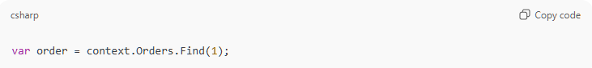
Then EF will track the order, but the navigation property Customer will be null unless:
- You used .Include(o => o.Customer)
- Lazy loading is enabled (and Customer is virtual)
- You explicitly load it (context.Entry(order).Reference(o => o.Customer).Load())
🔍 So to summarize:
- Navigation properties themselves are not tracked automatically.
- If they're included via eager/lazy loading or manually attached, then they are tracked.
- Just having a navigation property on a class doesn't mean EF tracks it or its changes.

Add()
context.Orders.Add(order) will cause the related Customer entity to be inserted into the database if:
- order.Customer is not null
- Customer is a new (untracked) entity
🔍 Example:
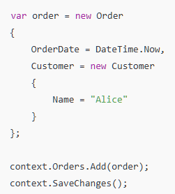

💥 What happens here?
- order is a new entity.
- Customer is also new.
- When you call .Add(order), EF Core walks the object graph and sees that order.Customer is a new (untracked) entity.
- EF will insert both:
  - A row into the Customers table
  - A row into the Orders table, with the correct foreign key
🧠 EF Core's Behavior
This is called cascading add (or graph add). Entity Framework Core automatically marks related entities with the appropriate EntityState (Added, in this case) if they’re reachable via navigation properties.
- If Customer already exists in the database, you should not create a new instance like in the example above. Instead, you should attach or reference the existing one to avoid duplicate inserts.

Filtering, Sorting and Pagination
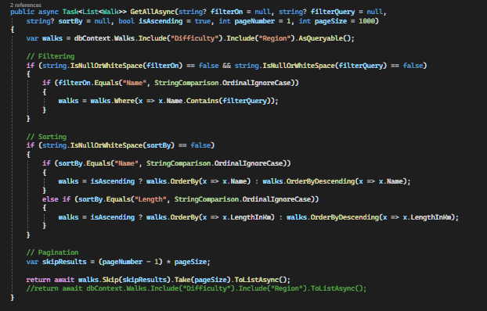
use it in a controller action below

Relationships

Many to many relationships
Here category and blogpost have multiple relationship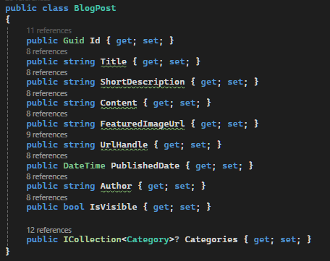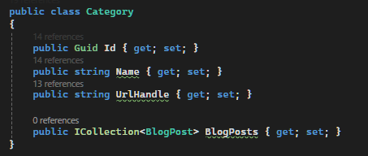

Include()
To get the related properties in entityFramework you have use include() function

Authentication and Authorization
JWT (JSON Web Token) is a widely used standard in modern web development, especially for stateless authentication. Let's break this down into parts:

🔹 First, Why JWT?
✅ The Problem Before JWT:
Traditionally, after logging in:
- The server would create a session and store it in memory or a database.
- It would send a session ID to the client (browser/mobile app).
- The client sends this session ID with every request, so the server knows who the user is.
🔴 Problems with that:
- Server has to store session state (memory/database → doesn’t scale well).
- Managing load balancing or horizontal scaling is harder.
- Session timeout and clean-up logic needed.

✅ JWT Solves That by Being Stateless
JWT is a self-contained token that:
- Contains all the required user data/claims.
- Is digitally signed, so the server can verify it hasn’t been tampered with.
- Requires no session storage on the server.

🔹 JWT Workflow Summary
- Login: User logs in with username/password.
- JWT Created: Server validates the credentials, then creates a JWT like this:

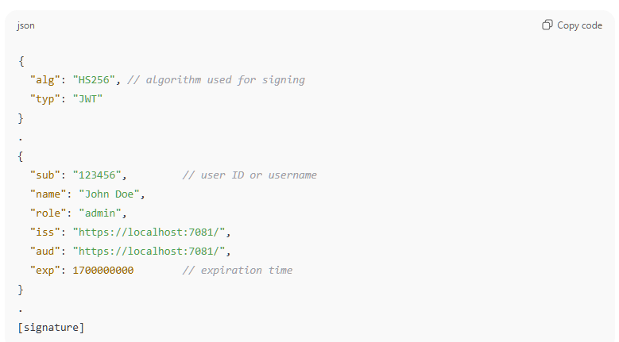
- Token Sent: Server sends the token to the client.
- Client Stores It: Typically in browser memory or localStorage.
- Client Sends It Back: With every request in the Authorization header like:
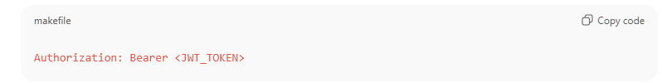
- Server Verifies:
  - Valid signature?
  - Not expired?
  - Correct issuer/audience?
  - Then allows access.
🔹 Understanding Your Code
Here's what your code is doing, step by step:
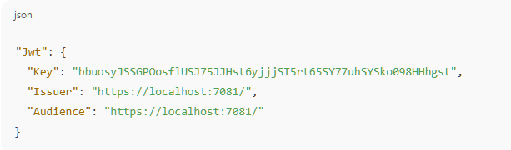
This is your JWT configuration. It defines:
- Key: Secret used to sign the token (so the server can later verify it).
- Issuer: Who created the token.
- Audience: Who the token is meant for.
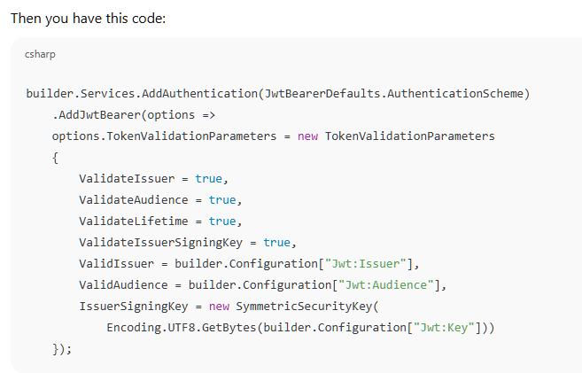
This does the following:
- Tells ASP.NET to use JWT Bearer Authentication.
- When a request comes in, the server:
  - Checks the signature using the key.
  - Validates the issuer and audience.
  - Ensures the token is not expired.
  - Ensures it hasn’t been tampered with.

🔹 Wait — But Isn’t JWT Just Sending the Login Data Back?
Kind of, but not exactly.
❌ It’s not sending passwords or sensitive credentials.
✅ Instead, it sends:
- Identity claims (like username, role).
- Metadata like expiration.
- All this is signed, so you know it’s authentic.
Think of JWT as a passport:
- You show it at every request.
- It proves your identity.
- But you don’t have to log in again or store anything on the server.

🔹 Is JWT Encrypted?
By default, NO, JWT is not encrypted — it’s encoded and signed.
You can see the content if you paste it into https://jwt.io. But since it's signed, you can't modify it without invalidating the signature.
If you need to hide sensitive info, you should either:
- Not include it in the token.
- Or use encrypted JWTs (JWE), which are less common.

🔚 Summary
Concept | Purpose
JWT | Token proving identity — used for stateless authentication
Key | Secret to sign/validate JWT
Issuer | Who issued the token
Audience | Who the token is intended for
TokenValidationParameters | Tells server how to validate incoming JWTs
Authorization: Bearer <token> | How JWT is sent with each HTTP request
❓ When the JWT is sent to the client...
Is the secret key inside the token? Is it encrypted or hashed?
❌ No — the secret key is NOT sent to the client at all.
Not encrypted, not hashed — it’s never included in the token.

🔐 What Is Actually Sent to the Client?
Just the JWT itself, which looks like this (a base64-encoded string):
<HEADER>.<PAYLOAD>.<SIGNATURE>
Each part is base64-encoded:
1. Header (not secret)
{
"alg": "HS256",
"typ": "JWT"
}
2. Payload (not secret)
{
"sub": "123",
"username": "jack",
"role": "admin",
"exp": 1700000000,
"iss": "https://localhost:7081/",
"aud": "https://localhost:7081/"
}
✅ This data is not encrypted, just base64-encoded, which means anyone can read it.
3. Signature (this is where the secret key is used — but not revealed)
HMACSHA256(
base64UrlEncode(header) + "." + base64UrlEncode(payload),
secret_key
)
This signature is generated on the server only using the secret key, but the key itself is never part of the JWT.

📦 So What Does the Client Get?
Example JWT the client receives:
eyJhbGciOiJIUzI1NiIsInR5cCI6IkpXVCJ9.
eyJ1c2VybmFtZSI6ImpvaG4iLCJyb2xlIjoiYWRtaW4iLCJleHAiOjE3MDAwMDAwMDB9.
NlXK2NO9WkFoS6AQuZCexP9h7aRdr1bKhIj8zqvYYzg
- Anyone can decode the header and payload.
- But only someone with the secret key can generate a valid signature.

🤔 Can a Hacker Guess or Steal the Key?
- The secret key is stored securely on the server only.
- If the key is weak (e.g. "1234"), a hacker might try to brute-force it.
- But if it’s strong (like yours: "bbuosyJSSGPOosflUSJ75JJHst6yjjjST5rt65SY77uhSYSko098HHhgst"), it’s practically impossible to forge the token.

🔐 Summary Table
Thing | Encrypted? | Who can see it? | Contains secret?
JWT Header | ❌ No | Anyone | ❌ No
JWT Payload | ❌ No | Anyone | ❌ No
JWT Signature | ✅ HMAC (with secret key) | Anyone can see, but can't generate without key | ✅ Depends on secret key
Secret Key | ❌ Not included in token | 🔒 Server only | ✅ Yes

✅ Key Point:
The secret key is never sent to the client — it's only used on the server to sign and verify JWTs.
Let’s walk through it using your "locked box" analogy, which is a great way to understand JWT:

🔒 JWT as a Locked Box Analogy
🧰 Setup:
- The server has a secret key (used to "lock" or "sign" the box).
- The client never sees or knows the key.
- The client only gets the locked box (the JWT).

📨 Step 1: Server Sends the Locked Box
- After login, the server creates a box (JWT).
- Inside the box: User info like username, role, expiration.
- The server then locks (signs) the box with its secret key 🔐.
- The locked box (JWT) is sent to the client.
➡️ Client now holds the box, but not the key.

🔁 Step 2: Client Sends the Box Back on Each Request
- When the client makes a new request (e.g., to access a protected API), it sends the box:
- Authorization: Bearer <locked_box>

🔍 Step 3: Server Checks the Lock
- Server takes the box.
- It uses its own key to verify:
  - Was this box locked by me?
  - Was the box opened or modified?
  - Is the box still valid (not expired)?
If all checks pass ✅:
- The server trusts the contents and processes the request.
If not ❌:
- The server rejects the request (401 Unauthorized).

✅ Benefits of This System
Feature | Benefit
🔐 Secret Key Only on Server | No need to store user sessions. Server just verifies the box.
📦 Client Sends Same Box Every Time | No login needed again. Stateless.
🔍 Tamper-Proof | If the client tries to open or modify the box, server will know.
🧭 Scalable | Any server that has the key can validate the box — works great in load-balanced systems.

⚠️ Important:
The box (JWT) is not encrypted — it's only signed/locked.
- Anyone (even a hacker) can look inside the box (decode it).
- But only the server can lock (sign) a valid box.
- That’s why you should never put sensitive data (like passwords) inside a JWT.

💡 TL;DR
The client holds a locked box (JWT).
Only the server has the key to verify it.
The client sends back the same box every time.
The server opens it, checks it's legit, and lets the request through.
signature is for authentication and other things is for authorisation?
ChatGPT said:
That's a great distinction you're trying to make — and you're almost there. Let’s refine it:
🧩 Short Answer:
- ✅ Signature validation is part of authentication → "Is this token valid and untampered?"
- ✅ Claim validation (issuer, audience, expiry, roles, etc.) is part of authorization and contextual trust → "Should this user be allowed to access this system or resource?"

🧠 Let's break it down clearly:
Aspect | Purpose | Category | Example
JWT Signature | Verifies token integrity and authenticity | Authentication | "Was this token issued by a trusted source?"
Issuer (iss) | Who issued the token | Authorization / Trust | "Do we trust this issuer?"
Audience (aud) | Who the token is intended for | Authorization / Trust | "Is this token meant for my API?"
Expiration (exp) | Token expiry time | Authorization | "Has the token expired?"
Claims (e.g., roles, scopes) | User info and permissions | Authorization | "Is the user an admin?"

📌 So:
- 🔐 Authentication = “Can I trust the token at all?”
  - Verified using the signature and the signing key.
  - If the signature is invalid, the token is immediately rejected.
- ✅ Authorization = “What is this token allowed to do?”
  - Based on claims like role, scope, aud, iss, etc.
  - You check this after you know the token is valid.

💡 Analogy: Passport Check at the Airport
- Signature (authentication):
  - Is the passport genuine? Not forged? Properly signed?
  - If not → ✋ reject.
- Issuer & Expiry (authorization/trust):
  - Is the passport issued by a country we recognize?
  - Is it still valid (not expired)?
  - Is it intended for entry into this country?
Even if the passport is genuine (signature valid), it might still be denied entry due to expiration, wrong visa, or being issued by an untrusted country.

✅ Final Answer
So, to your question:
Is the signature for authentication and the rest for authorization?
- Yes, in a simplified view:
  - Signature → part of authentication (is the token valid?)
  - Other claims (issuer, audience, expiry, roles) → authorization (can the token be used here? what can it do?)
But in reality, there's some overlap, especially with things like issuer and audience, which are about trust context more than just permissions.

Identity framework
1.Create DbContext by inheriting IdentityDbContext class
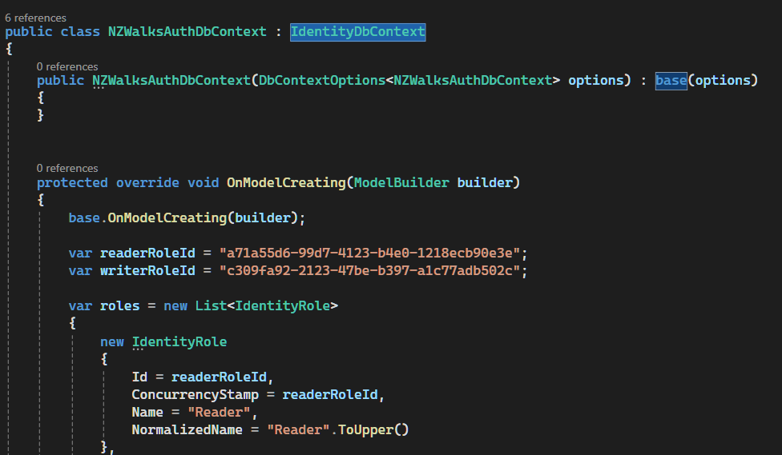
2.Inject DbContext Service
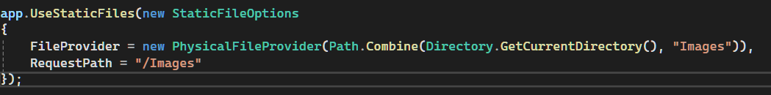
3.Configure Identity user and JWT token
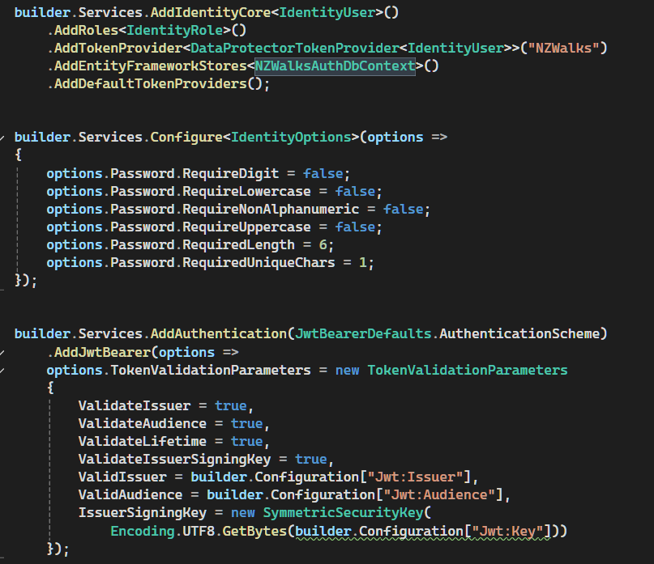

4.Register Identity User Action
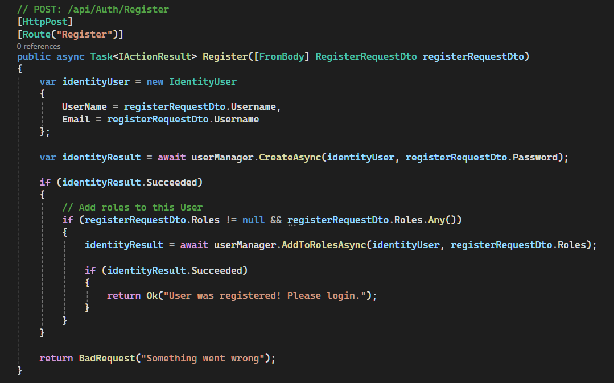
5.Login Identity User Action
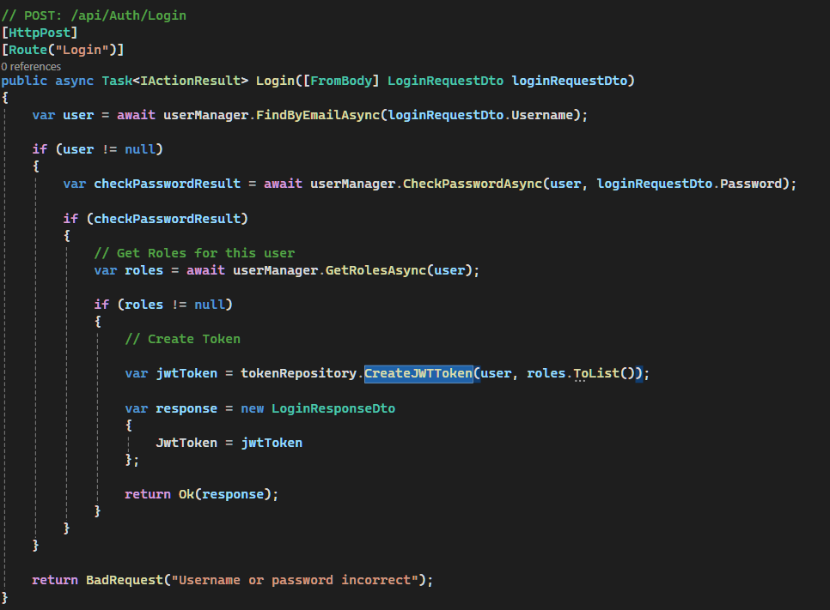
6.Jwt Token Creation
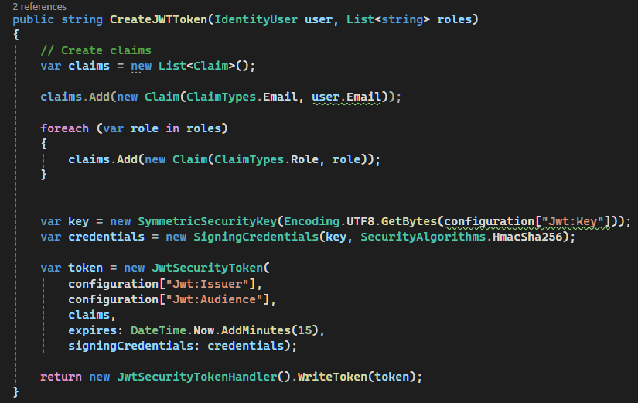

Handling Image Upload
1.Create Image domain model and dtos
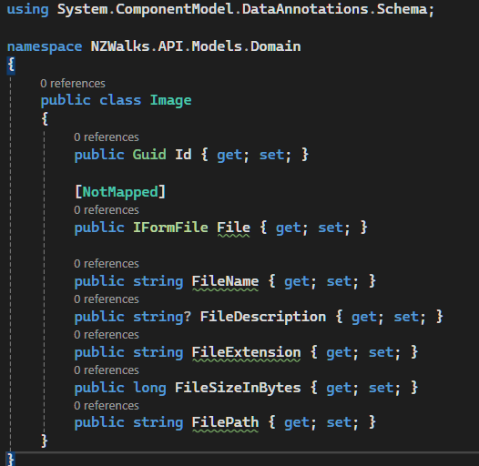
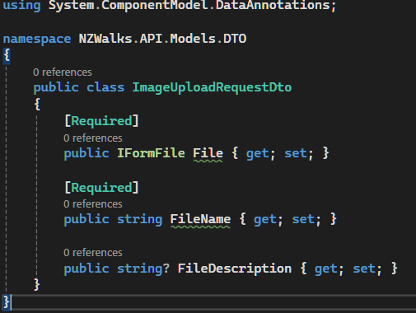

2.Create Repository interface and its implementation and inject it in Program.cs
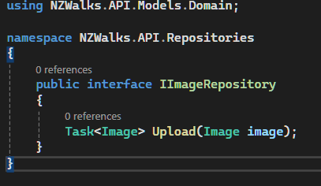
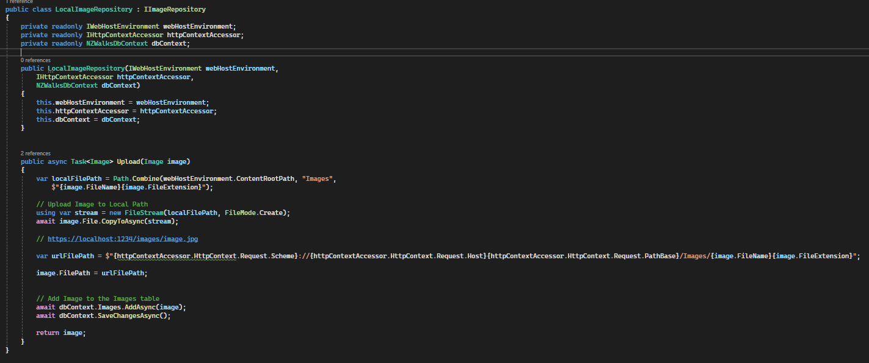
3.Create Images folder
4.Create controller
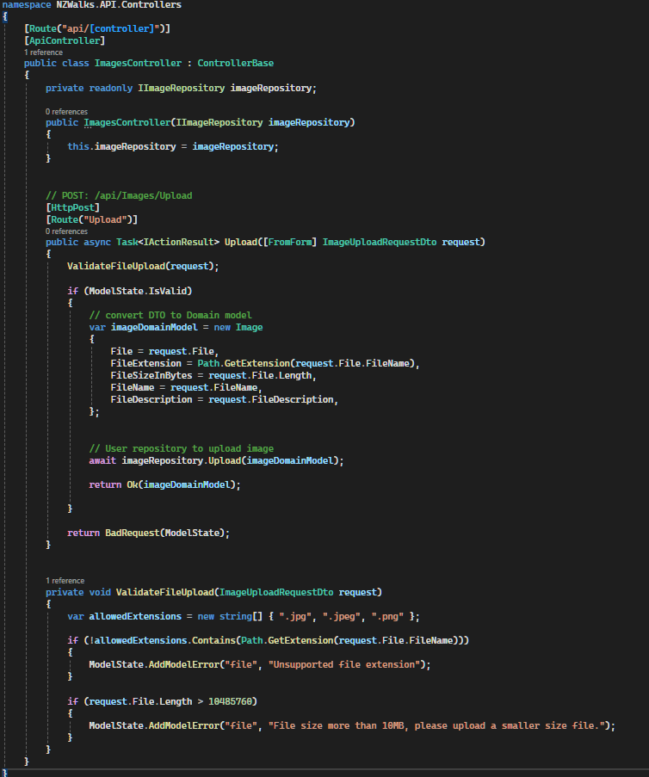

Create middleware to serve static files
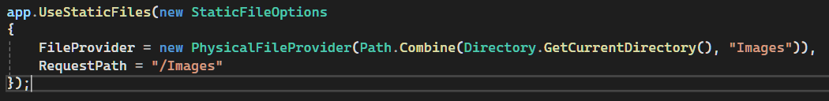

Logging
Refers to the process of capturing and storing information about the application behavior and operation during runtime.
Helps in diagnose and troubleshoot problems

Here’s what’s “enough” for BTS (Behind The Scenes) knowledge:

✅ Must-Know for Mid-Level:
- What is DbContext and DbSet?
  - DbContext = bridge to DB.
  - DbSet = table representation.
- What is ChangeTracker?
  - Tracks entities in memory.
  - Maintains original vs current values.
  - Detects changes and generates SQL on SaveChanges().
- Entity States
  - Added, Modified, Deleted, Unchanged.
- Tracking vs NoTracking
  - Tracking ON = for updates/deletes.
  - NoTracking = for read-only queries (performance).
- Why tracking is heavy
  - Snapshots + comparisons + relationship fix-up.
- Basic CRUD flow
  - Fetch → Modify → SaveChanges().
- Migrations
  - Add-Migration, Update-Database.

✅ Optional (Good to Mention):
- How EF Core generates SQL.
- Why AsNoTracking() improves performance.
- What happens during SaveChanges() (change detection → SQL → transaction).

EF Core BTS Quiz

Q1. What is DbContext in EF Core?
a) A class that represents a single table
b) A class that manages database connection and entity tracking
c) A class that stores migrations
d) A class that only runs SQL queries

Q2. What does DbSet<T> represent?
a) A database connection
b) A table in the database
c) A migration history
d) A SQL command

Q3. What is ChangeTracker?
a) A tool to track migrations
b) A system inside DbContext that tracks entity states and changes
c) A SQL optimizer
d) A logger for queries

Q4. Which of these is NOT an entity state in EF Core?
a) Added
b) Modified
c) Deleted
d) Synced

Q5. What does EF Core store for tracking?
a) Only current values
b) Only original values
c) Both original and current values
d) Only primary keys

Q6. Why is tracking heavy?
a) Because EF Core runs SQL for every property change immediately
b) Because EF Core stores snapshots and compares values for every tracked entity
c) Because EF Core uses NoTracking by default
d) Because EF Core creates indexes automatically

Q7. When should you use AsNoTracking()?
a) For read-only queries
b) For update queries
c) For delete queries
d) For migrations

Q8. What happens if you modify an entity fetched with AsNoTracking() and call SaveChanges()?
a) EF Core updates the database
b) EF Core throws an exception
c) EF Core ignores the changes
d) EF Core automatically tracks it

Q9. Which command creates a migration in EF Core?
a) Update-Database
b) Add-Migration
c) Create-Table
d) Apply-Migration

Q10. What does EF Core do during SaveChanges()?
a) Runs DetectChanges, checks entity states, and generates SQL
b) Drops and recreates tables
c) Deletes all tracked entities
d) Runs migrations automatically

