What middleware really is (core idea)
Middleware in ASP.NET Core is about request pipeline flow:
A request enters → passes through a chain of middleware → hits an endpoint → response flows back.
Every middleware answers three questions:
- Should I run before the next thing?
- Should I call the next middleware?
- Should I do something after the next middleware runs?
That’s it. Everything else is syntax sugar.
The 3 pillars of ASP.NET Core middleware ✅
1️⃣ Short-circuiting
“Do I stop the pipeline here?”
A middleware can decide not to call next().
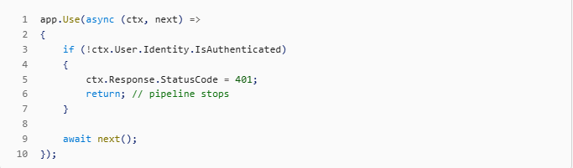
What this teaches you
- Why order matters
- How auth, caching, maintenance pages work
- Why app.Run() ends the pipeline
👉 If you don’t understand short-circuiting, middleware feels magical and confusing.

2️⃣ Pre / Post processing
“Do I run logic before and/or after the next component?”
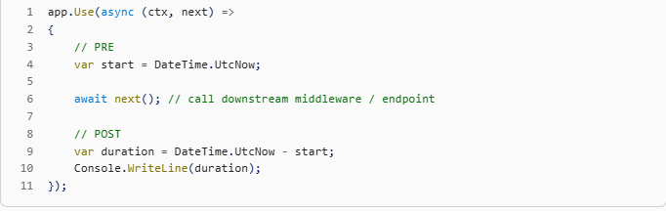
What this teaches you
- How logging, metrics, tracing work
- Why responses can be modified after endpoints
- Why exceptions bubble back up the pipeline
👉 This is the essence of middleware design.

3️⃣ Cross-cutting concerns
“Logic that applies to many or all requests”
Middleware exists mainly to handle things that should not live in endpoints:
Examples:
- Authentication / authorization
- Logging
- Exception handling
- Correlation IDs
- Compression
- Rate limiting
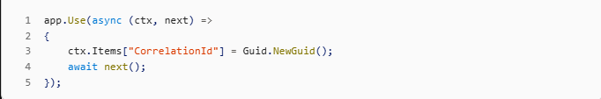
What this teaches you
- Separation of concerns
- Why middleware runs before routing
- Why business logic ≠ infrastructure logic
👉 This is why middleware exists as a concept.

These 3 cover ~90% of real middleware usage
If you know: ✅ How to stop the pipeline
✅ How to run code before & after
✅ What belongs in middleware vs endpoints
You can:
- Read any middleware source code
- Write custom middleware confidently
- Debug pipeline issues effectively

One missing piece (important but secondary)
There’s a 4th supporting concept you should also grasp:
🔁 Ordering & pipeline composition
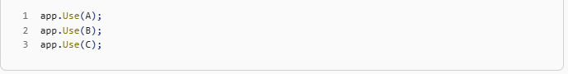
Execution order:
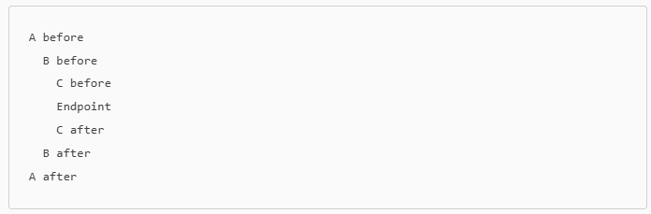
This ties all three pillars together.

How MapGet fits into this (quick clarity)
- MapGet is not middleware
- It defines an endpoint
- Middleware still controls:
  - whether the request reaches it
  - what happens before and after
So Minimal APIs are great because they remove distractions, but middleware learning happens around MapGet, not inside it.

Final answer (crisp)
✅ Yes — learn these three and you understand middleware
✅ They are necessary and mostly sufficient
➕ Add ordering and everything clicks

✅ 1️⃣ A 10-Minute Hands-On Exercise (Minimal API)
Goal: See short-circuiting, pre/post processing, ordering, and cross-cutting concerns in action.
Create a new ASP.NET Core Minimal API project.
Step 1: Baseline – one endpoint
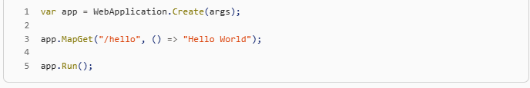
Request:

✅ Works. Nothing interesting yet.

Step 2: Add pre/post processing
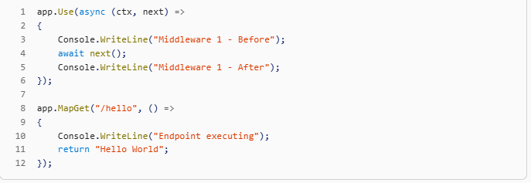
What you’ll observe in logs:
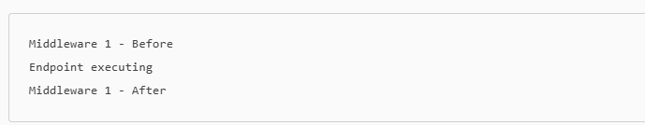
✅ You now understand pre/post processing
✅ Endpoint is inside a pipeline

Step 3: Add a second middleware (ordering)
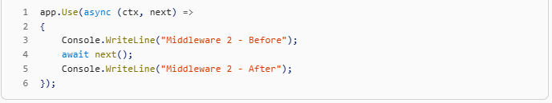
Output:
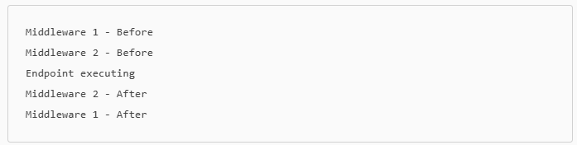
Middleware 1 - After

✅ Pipeline nesting becomes visible
This mental model is CRITICAL:
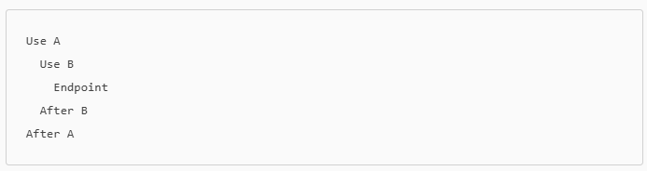
Step 4: Short-circuit the pipeline
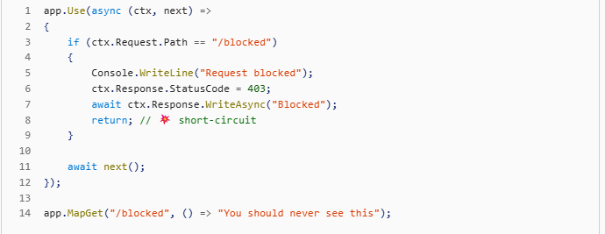
Request:
GET /blocked
Logs:
Request blocked
✅ Endpoint never runs
✅ Later middleware never runs
✅ This is how auth, rate limits, maintenance mode work

Step 5: Cross-cutting concern example (Correlation ID)
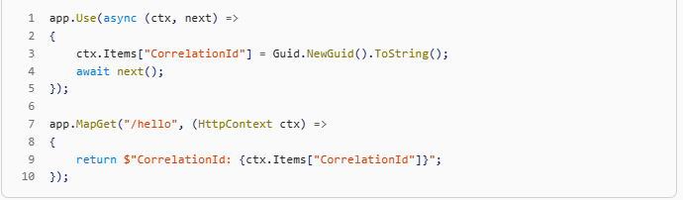
✅ Shared data across the entire request
✅ No coupling to endpoint logic

✅ 2️⃣ Middleware vs Endpoint – Rule of Thumb
Ask ONE question:
“Does this logic apply to many requests, regardless of route?”
If YES → Middleware
If NO → Endpoint

✅ Middleware belongs to:
- Authentication / Authorization
- Logging
- Exception handling
- Metrics / tracing
- Headers, cookies
- Feature flags
- Rate limiting
- Request validation (global)

✅ Endpoint belongs to:
- Business logic
- Use-case execution
- CRUD operations
- Workflow orchestration
- Domain decisions

🔥 Quick test
If you find yourself writing this in an endpoint:
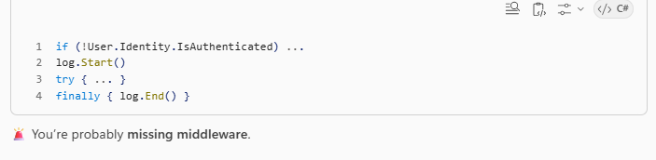
✅ 3️⃣ Middleware Debugging Mental Checklist
When something behaves weirdly, go through this exact checklist:

✅ 1. Ordering
- Is the middleware registered before the one it depends on?
- Example: UseAuthentication() must run before UseAuthorization()

✅ 2. Short-circuiting
- Is some middleware not calling next()?
- Did app.Run() appear too early?

✅ 3. Scope of execution
- Does it use app.Map(...) or path branching?
- Is your request actually entering that branch?

✅ 4. Pre vs Post placement
- Are you modifying the response after it’s started?
- Did you forget await next()?

✅ 5. Endpoint assumptions
- Does this logic assume a route, user, or body exists? → If yes, it might belong after routing.

✅ How MapGet fits (final clarity nail)
This is the final mental model:
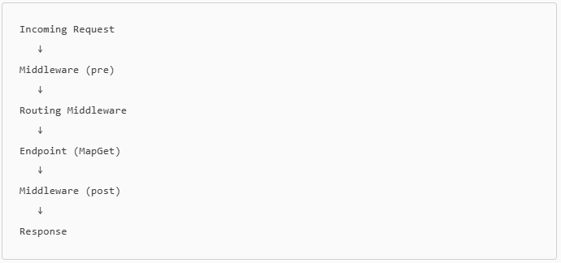
✅ MapGet = destination
✅ Use = highway rules
✅ Middleware controls whether and how you reach endpoints

🎯 Final Takeaway
If you deeply understand: ✅ Short-circuiting
✅ Pre/Post processing
✅ Cross-cutting concerns
✅ Ordering
You understand middleware, not just ASP.NET Core syntax.
1️⃣ If MapGet is not middleware, what is it?
✅ Short answer
MapGet registers an endpoint, not middleware.
✅ Precise definition
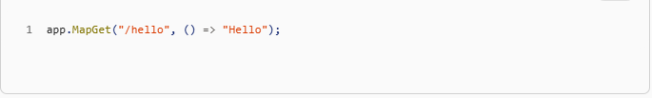
This does three things internally:
- Registers a route pattern (/hello)
- Associates it with a RequestDelegate (your lambda)
- Stores it in the endpoint data source
It does NOT:
- Run per request
- Wrap next()
- Participate in pre/post execution

🔁 Who actually runs MapGet then?
👉 Middleware does.
Specifically:
- UseRouting()
- UseEndpoints() (or the modern equivalent inside WebApplication)
Internally the pipeline looks like this:
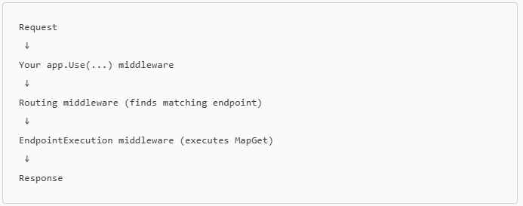
So:
Endpoints are data Middleware is execution
This is a critical distinction.
2️⃣ Is MapGet “a way of allowing routing”?
✅ Yes — but not by itself
Routing requires middleware to activate endpoints.
In older ASP.NET Core (explicit)
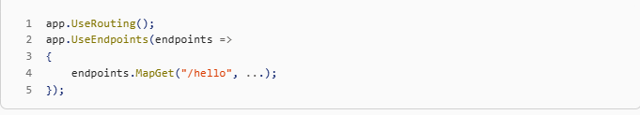
In Minimal APIs (implicit)
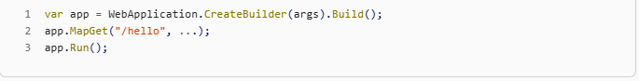
Behind the scenes, ASP.NET Core automatically adds:
- Routing middleware
- Endpoint execution middleware
✅ MapGet = declares routes
✅ Middleware = enables + executes them

3️⃣ What about AddControllers() / MVC?
You were close with the syntax 👇
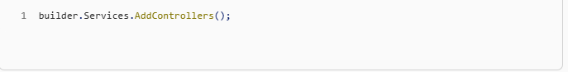
That does dependency injection registration only.
Then later:
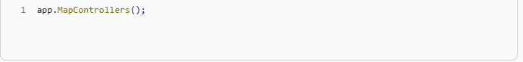
This:
- Registers controller actions as endpoints
- Same role as MapGet, but bulk-loaded
So:
Thing | What it does
AddControllers() | Registers MVC services
MapControllers() | Adds controller endpoints
MapGet() | Adds a single endpoint
Middleware | Executes request flow
✅ Controllers are endpoints, not middleware.

4️⃣ If I put app.Use AFTER app.MapGet, will it run?
⚠️ This is a very important rule:
Middleware runs in the order it is registered Endpoints terminate the pipeline
Example
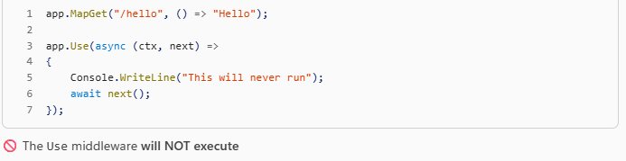
Why?
Because:
- Endpoint execution ends the pipeline
- Once an endpoint runs, there is no next()
✅ Rule of thumb
- All app.Use(...) → before
- All app.MapX(...) → after

5️⃣ Short-circuiting: Is app.Run the same as return?
✅ Yes, conceptually — but with a difference

app.Run = always short-circuits
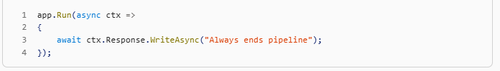
- No next parameter
- Pipeline always stops here
- Terminal middleware
Equivalent to:
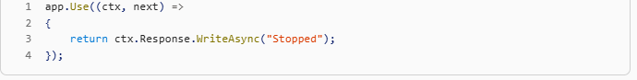
return inside app.Use = conditional short-circuiting
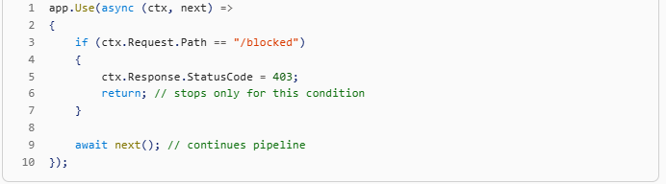
✅ Much more flexible
✅ Used by auth, rate-limiting, feature flags

✅ Comparison
Thing | Short-circuits | Conditional?
app.Run | Always | ❌ No
return in Use | Sometimes | ✅ Yes

6️⃣ Final mental model (this will stick)
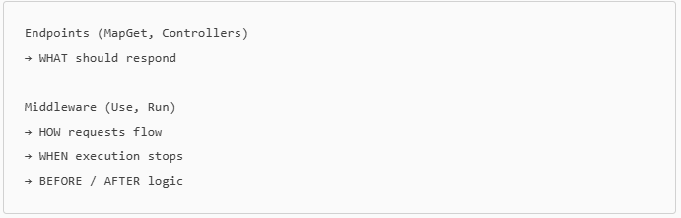
Endpoints are targets
Middleware is control flow
✅ Summary (one-screen version)
- MapGet ❌ not middleware → ✅ endpoint registration
- Routing happens via middleware, not MapGet alone
- Controllers = bulk endpoints
- Middleware must be registered before endpoints
- app.Run = unconditional short-circuit
- return in Use = conditional short-circuit

