🧭 Visual Flow
Here’s how a typical request flows through the OSI layers:
- User clicks a button in React → triggers an HTTP request.
- Application Layer formats the request (HTTP).
- Presentation Layer encrypts it (HTTPS).
- Session Layer manages the connection (maybe keeps it alive).
- Transport Layer ensures it gets there (TCP).
- Network Layer routes it to Azure (IP).
- Data Link + Physical Layers handle the actual transmission.

🧩 OSI Layers Present on the Client Side
Even though you're just writing frontend code, your computer still uses all 7 layers of the OSI model when sending or receiving data over the internet.
Let’s walk through them using a real-world example:
You click a button in your React app that sends a request to a .NET API hosted on Azure.

✅ Layers Active on Your Client Machine
Layer | Role on Client | Example in React/Web
7. Application | Your browser or React app initiates the request | fetch('/api/data') or axios.get(...)
6. Presentation | Formats data (e.g., JSON) and encrypts it | HTTPS, JSON.stringify()
5. Session | Manages connection state | TLS handshake, WebSocket session
4. Transport | Ensures reliable delivery | TCP ensures packets arrive correctly
3. Network | Routes data to the server | IP address of Azure server
2. Data Link | Sends data to your router/modem | MAC address, Ethernet/Wi-Fi
1. Physical | Moves bits over cables or wireless | Fiber, Wi-Fi, 4G/5G

🧠 What You Actually Interact With
As a web developer, you mostly interact with:
- Layer 7 (Application): HTTP, Web APIs, browser.
- Layer 6 (Presentation): JSON, HTTPS.
- Layer 5 (Session): WebSockets, cookies, tokens.
- Layer 4 (Transport): You don’t touch TCP directly, but it powers HTTP.
The lower layers (3 to 1) are handled by your operating system, browser, and network hardware.

🧪 Example Flow: React → .NET API
- React app calls fetch('/api/data').
- Browser wraps it in an HTTP request (Layer 7).
- Data is encrypted with TLS (Layer 6).
- A TCP connection is used (Layer 4).
- The request is routed via IP to Azure (Layer 3).
- Sent over Wi-Fi/Ethernet (Layer 2).
- Transmitted as electrical or radio signals (Layer 1)
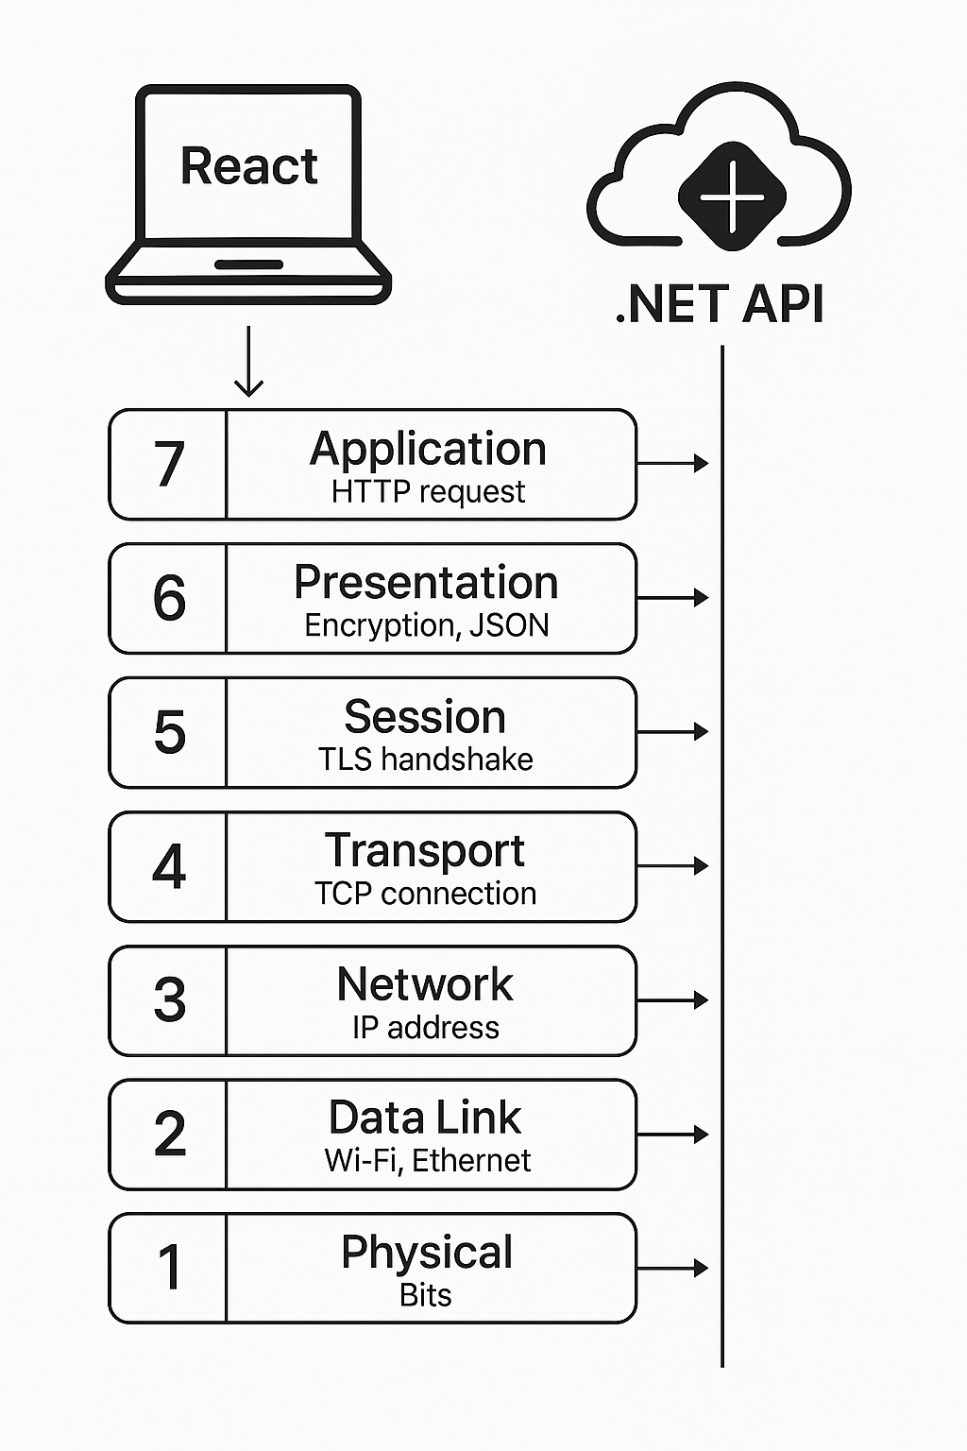
🧠 OSI Model Explained with React + .NET + Azure
🧱 Layer 7: Application Layer
- What it does: Provides services directly to the user.
- In your app: React app makes HTTP requests to your .NET API.
- Example: fetch('/api/data') or axios.get('/api/data').

🧠 Layer 6: Presentation Layer
- What it does: Formats and encrypts data.
- In your app: JSON formatting, HTTPS encryption.
- Example: Your API returns JSON, and HTTPS ensures secure transmission.

🧠 Layer 5: Session Layer
- What it does: Manages sessions and persistent connections.
- In your app: WebSocket connections or session tokens.
- Example: JWT tokens for user sessions, or WebSocket for live chat.

🧠 Layer 4: Transport Layer
- What it does: Ensures reliable delivery of data.
- In your app: TCP is used under the hood for HTTP/HTTPS.
- Example: Azure ensures your API calls are reliably delivered using TCP.

🧠 Layer 3: Network Layer
- What it does: Routes data across networks.
- In your app: IP addresses and routing between client and Azure servers.
- Example: Your React app hosted on a user's browser sends requests to an Azure IP.

🧠 Layer 2: Data Link Layer
- What it does: Transfers data between devices on the same network.
- In your app: Handled by routers/switches in Azure and the user's ISP.
- Example: Not directly visible, but crucial for packet delivery.

🧠 Layer 1: Physical Layer
- What it does: Moves bits over cables or wireless.
- In your app: Fiber optics, Wi-Fi, Ethernet.
- Example: The actual internet connection used by the user and Azure data center.

