What is hook in react?
Short Answer (2–3 lines):
Hooks are built-in React functions that allow functional components to use React features such as state, lifecycle methods, context, and side effects without writing class components. They were introduced in React 16.8 to make component logic simpler and more reusable.
Better Interview Answer
React Hooks are special functions that let us "hook into" React features from functional components. Before Hooks, state management and lifecycle methods were only available in class components. Using Hooks like useState, useEffect, and useContext, we can manage state, perform side effects, and share logic in a cleaner and more reusable way.

Common Hooks
1. useState
Used to manage component state.
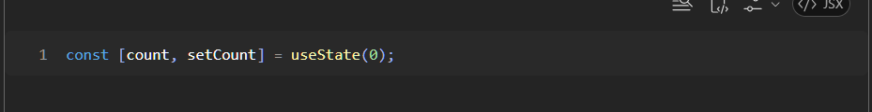
2. useEffect
Used for side effects such as API calls, subscriptions, timers, etc.
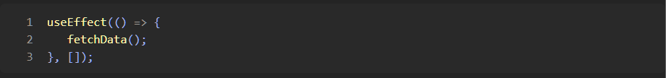
3. useContext
Used to consume data from React Context without prop drilling.
4. useRef
Used to store mutable values or access DOM elements.
5. useMemo and useCallback
Used for performance optimization.

Why Hooks Were Introduced?
Before Hooks:
- Stateful logic required class components.
- Lifecycle methods were spread across multiple methods.
- Reusing stateful logic was difficult.
Hooks solve these problems by:
- Using functional components everywhere.
- Reusing logic through custom hooks.
- Writing cleaner and more readable code.

What is a Custom Hook?
A Custom Hook is a JavaScript function whose name starts with use and can internally use other Hooks. It helps reuse component logic across multiple components.
Example:
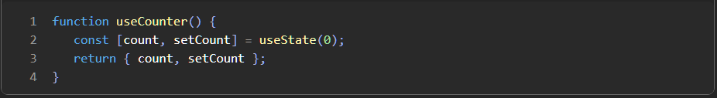

What is State in React?
State = data that belongs to a component and can change over time.
When state changes, React automatically re-renders the component.
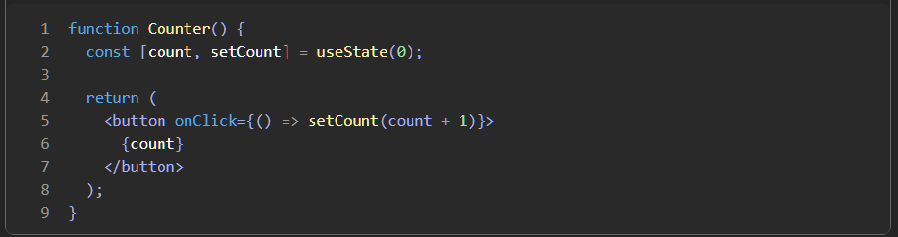
Here:
- count → current value
- setCount() → updates value
- 0 → initial value
If setCount(1) is called, React re-renders the component.

useEffect
Used for side effects.
A side effect is anything outside rendering UI:
- API calls
- Timers
- Event listeners
- Database calls
- Updating document title
- Runs on every render
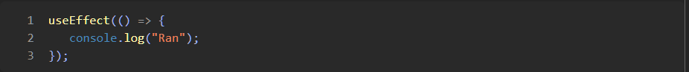
- Runs only once (ComponentDidMount)
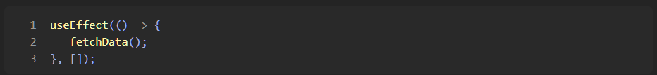
Empty dependency array.
Runs:
  - Only when component mounts
Common use:
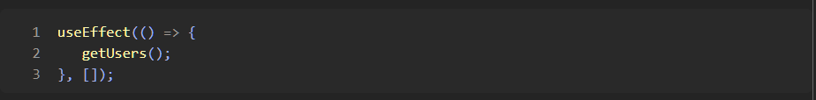
API call only once.

3. Runs when dependency changes
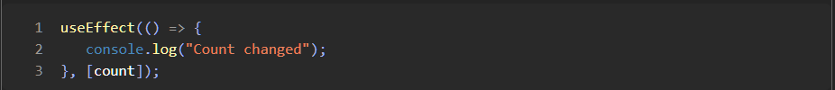
Runs:
- Initial render
- Whenever count changes

4. Cleanup Function (Unmount)
This is what you were referring to.
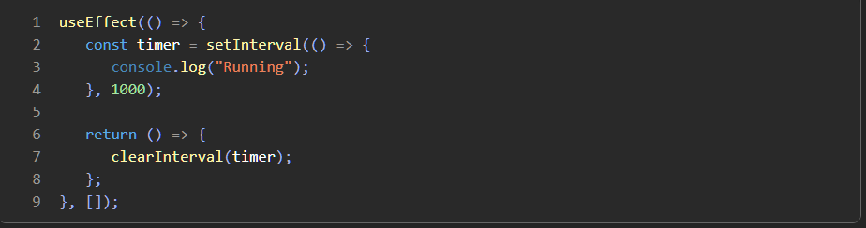
When component is removed:
executes.
Used for:
- Removing event listeners
- Clearing intervals
- Closing websocket connections
- Cleaning subscriptions
Interview answer:
The function returned from useEffect is called a cleanup function. It runs before the component unmounts and helps prevent memory leaks by cleaning resources such as timers, event listeners, and subscriptions.

useRef
Stores a value without causing re-render.
Access DOM
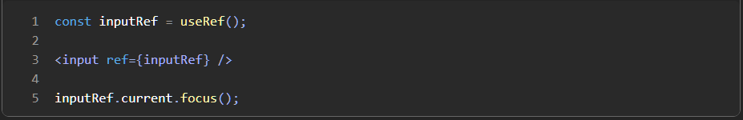
Store value without re-render
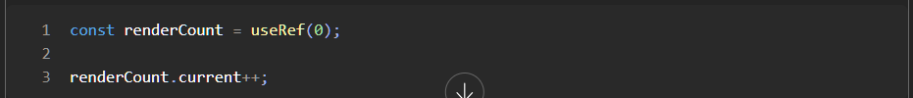
Changing:
does NOT re-render component.
Difference:
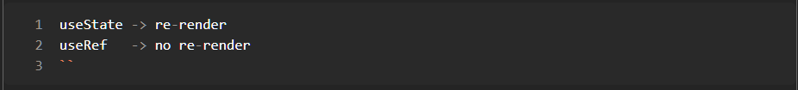

useContext
Solves Prop Drilling.
Without context:
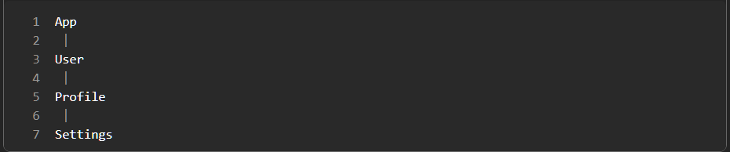
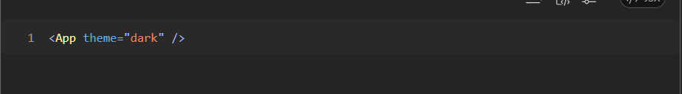
through every component becomes annoying.
Context lets any child access data directly.
Provider:
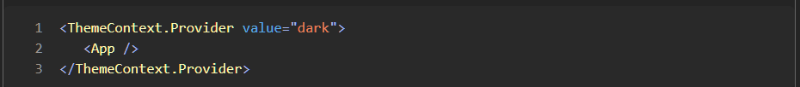
Consumer:
Now any component can read:
without passing props through multiple layers.

useMemo
Caches a calculated value.
Imagine:
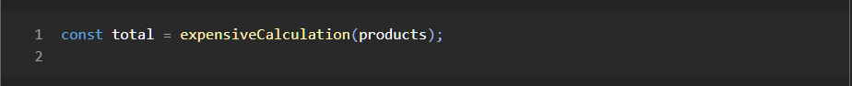
If component re-renders, calculation runs again.
Now calculation only runs when:
changes.
Interview answer:
useMemo is used to memoize a computed value and avoid expensive recalculations during re-renders.

useCallback
Caches a function.
Without useCallback:
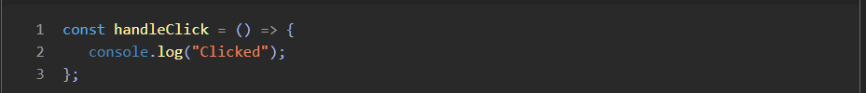
A new function is created every render.
With:
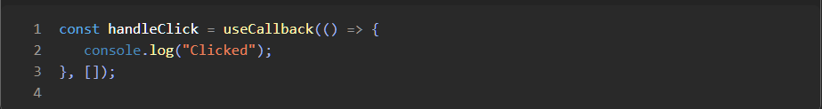
Same function reference is reused.
Mostly used when passing functions to child components.
to avoid unnecessary child re-renders.

Easy way to remember useMemo vs useCallback
useMemo
Returns a value.
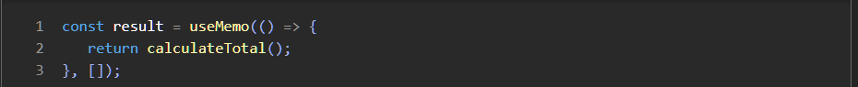
Think:
"Memoize RESULT"

useCallback
Returns a function.
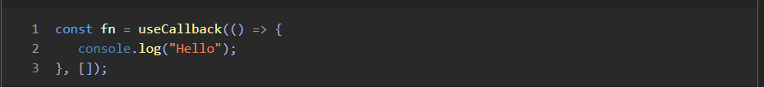
Think:
"Memoize FUNCTION"

Most Common Interview Hooks
Hook | Purpose
useState | Manage state
useEffect | Handle side effects
useContext | Share data globally
useRef | Store mutable value / DOM reference
useMemo | Cache calculated value
useCallback | Cache function reference
30-second Interview Answer
React Hooks are built-in functions that allow functional components to use React features such as state management, side effects, context, and references. The most commonly used Hooks are useState for state management, useEffect for handling side effects, useContext for sharing data across components, useRef for DOM access and mutable values, useMemo for memoizing calculated values, and useCallback for memoizing function references to improve performance.

The core of React is really:
1. Components
2. JSX
3. Props
4. State
5. Hooks
6. Events
7. Conditional Rendering
8. Lists & Keys
9. Forms
10. Component Communication
11. Context API
12. Routing (React Router)
13. API Calls
And among Hooks, these are the ones interviewers actually care about:
useState
useEffect
useContext
useRef
useMemo
useCallback
useReducer (sometimes)
If you understand these deeply, you understand most of React.

Things that are React but not Hooks
Component Lifecycle
Even though functional components don't have lifecycle methods anymore, you should know:
Mounting
Updating
Unmounting
Because:
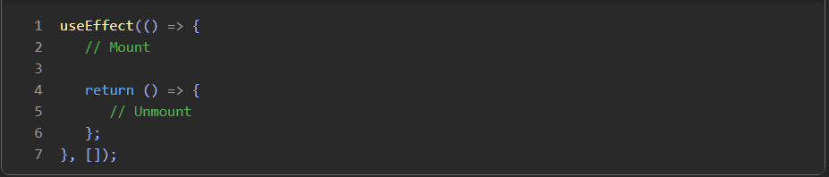
is React's lifecycle model now.

Component Communication
Very common interview topic.
Parent -> Child (Props)
Child -> Parent (Callback Functions)
Sibling -> Sibling (Lift State Up / Context)
Global State (Context / Redux)

Controlled Components
This comes up often.
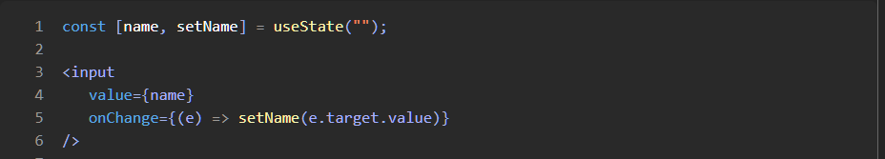
Definition:
A controlled component is a form element whose value is controlled by React state.

Virtual DOM
You should know this even if you never use it directly.
Interview answer:
Virtual DOM is a lightweight JavaScript representation of the real DOM. React compares the new Virtual DOM with the previous one and updates only the changed parts of the real DOM, improving performance.

Reconciliation
Fancy word interviewers love.
Definition:
Reconciliation is React's process of comparing two Virtual DOM trees and determining the minimum changes required in the real DOM.

React.memo
Often asked with useMemo/useCallback.

``

