✅ 🔥 Must-know Azure AD concepts (interview-ready)
1. 🧠 Core idea (VERY IMPORTANT)
You should be able to say this clearly:
Azure AD (Entra ID) is an identity provider that handles login, authentication, and issuing tokens for applications.

2. 🔄 OAuth2 + OpenID Connect flow (MOST IMPORTANT)
You were already struggling with this — interviewers LOVE this.
You must understand:
✅ Flow (backend-focused)
- User clicks Login with Microsoft
- Browser → Auth Server (/authorize endpoint)
- User logs in
- Auth server returns Authorization Code
- Backend sends code → /token
- Gets:
  - ✅ access_token (for API)
  - ✅ id_token (user info)

✅ Be able to answer:
- What is authorization code flow?
- Why don’t we send tokens directly to frontend?
- Difference between:
  - access_token
  - id_token

3. 🔐 Tokens (VERY FREQUENT)
✅ Access Token
- Used to call APIs
- Contains scope/permission
✅ ID Token
- Contains user identity (who logged in)

Interview Q:
👉 Why not use access token for user info?
Answer:
It’s not guaranteed to be stable or contain identity claims → that’s what ID token is for.

4. 🔑 App Registration (IMPORTANT)
You should know:
- App registration = your application’s identity
- Contains:
  - Client ID
  - Redirect URI
  - Secrets / Certificates

Interview Q:
👉 Why do we register an app?
Answer:
So Azure AD knows:
- who is requesting login
- where to send response
- what permissions are allowed

5. 🔐 Scopes & Permissions (VERY IMPORTANT)
This connects with your earlier doubt.
✅ Scope means:
"What this app is allowed to do"
Examples:
- User.Read
- api://myapi/read

Interview Q:
👉 "Whoever has scope can access API?" (your earlier doubt)
Correct answer:
❌ No
✅ Only if:
- token is valid ✅
- issued by trusted auth server ✅
- contains required scope ✅

6. 🧾 JWT Basics (ASKED VERY OFTEN)
You must know structure:
Header.Payload.Signature
Payload contains:
- sub → user id
- aud → audience
- iss → issuer
- exp → expiry

Interview Q:
👉 How do APIs validate tokens?
Answer:
- Verify signature
- Verify issuer
- Verify audience
- Verify expiry

7. 🔄 Refresh Token (IMPORTANT)
You already asked this 👍
✅ Flow:
- Access token expires
- Use refresh token → get new access token

Interview Q:
👉 What if refresh token expires?
Answer:
User must log in again

8. 🏢 B2B vs B2C (BASIC BUT ASKED)
Type | Use case
B2B | Employees / internal apps
B2C | Customers / public apps

9. 🔐 Roles vs Scopes (ADVANCED but useful)
Feature | Meaning
Scope | API permission
Role | User permission inside app

❌ What you can safely SKIP (for now)
Don’t waste time on:
- Conditional Access policies
- Identity Governance
- SAML (unless specifically asked)
- Hybrid AD / on-prem sync
- Advanced security configs

🎯 What interviewer ACTUALLY checks
They’re not testing Azure UI.
They want to see if you understand:
✅ How login works end-to-end
✅ Where tokens go
✅ Why backend is involved
✅ How API is protected

🔥 Most common interview question (from your recent confusion)
👉 “How does client stay logged in if token is not stored in frontend?”
Perfect answer:
Backend maintains session (cookie-based), or frontend stores token securely (httpOnly cookie or memory).
In secure architectures, frontend does NOT directly manage sensitive tokens.

✅ Final roadmap (for YOU)
Focus only on:
- OAuth2 Authorization Code flow ✅
- Access vs ID token ✅
- App registration ✅
- JWT validation ✅
- Scopes ✅
- Refresh token ✅

🚀 If you want
I can:
- Give you real ASP.NET + Azure AD integration flow
- Or interview mock questions based on this
- Or explain the SAME flow using your project (food delivery / RabbitMQ app)
Just tell me 👍

Confusions and Answers
✅ A tenant is a dedicated identity space (directory) for an organization in Microsoft cloud
where an organization manages:
- users
- applications
- authentication

How we register an app and how we facilitate authentication using OpenID Connect and Azure ad.

Register An Application
Open Entra Id->go to manage->new registration - > give App name -> select access type(single,multi-tenant) -> choose what kind of application (web, spa, public client)-> click register
after you register it will provide different kinds of endpoint
OAuth2.0 authorization endpoint
OAuth2.0 token endpoint
OpenID Connect metadata document
Microsoft Graph API endpoint
Etc..

Authentication
Go to authentication - >
Manage ->
Add a platform(what kind of app we are expected to interact with-web,spa,android,macos) ->
web (for this example) ->
RedirectUrl(url which direct to the application after login/authentication-your application with whom you are experimenting with) ->
Logout Url(redirect to the page where you want to be after loging out and clearing users session) ->
Implicit grant and hybrid flows (Request a token directly from the authorization endpoint)
If the application has single-page architecture code flow, or if it invokes a web api via javascript, select both access tokens and id tokens.
For ASP.NET Core web apps and other web apps the use hybrid authentication, select id tokens
Access tokens -> used for implicit flows
ID tokens -> used for implicit flows and hybrid flows

NOTE :every app registration is a “client”
🔥 So difference in ONE LINE
Scenario | Security mechanism
Backend exists | 🔐 Client Secret
No backend (SPA) | 🔐 PKCE
✅ 1. What is Client Secret ?
👉 Think of it like a password for your application.
When you do App Registration, Azure gives:
- Client ID → public identifier
- Client Secret → private secret (like password)
- Response Type: code

Proof key code exchange (PKCE)

🔥 PKCE Flow (correct sequence)
✅ Step 1 — Browser generates 2 values
code_verifier = random string (secret)
code_challenge = hash(code_verifier)
✅ Step 2 — Browser → /authorize
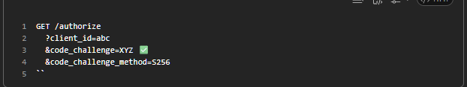
👉 ✅ Only code_challenge is sent here
👉 ❌ code_verifier is NOT sent yet

✅ Step 3 — User logs in
Azure sends back:
authorization_code

✅ Step 4 — Browser → /token
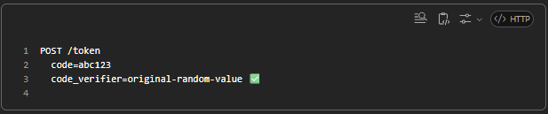
👉 ✅ NOW code_verifier is sent

✅ Step 5 — Azure validates
hash(code_verifier) == code_challenge ?
✅ If match → OK
❌ If not → reject
✅ ✅ 1. Your current system = already teaches Azure AD concepts
You already have:
- ✅ Keycloak (Auth server)
- ✅ API services (resource servers)
- ✅ Gateway
- ✅ JWT validation
- ✅ Scopes (likely in Keycloak)
👉 This is exact same architecture as Azure AD

🔥 2. Direct Mapping: Keycloak → Azure AD
This is the most important part. Read carefully.

✅ Identity system
Keycloak | Azure AD
Realm | Tenant
Users | Users
Roles | App Roles
Clients | App Registrations

✅ Applications
Keycloak | Azure AD
Client | App Registration
Client ID | Client ID
Client Secret | Client Secret

✅ API protection
Keycloak | Azure AD
Client (resource server) | App Registration (API)
Roles / permissions | Scopes
Audience | Application ID URI

✅ Auth flow
Keycloak | Azure AD
Token endpoint | Token endpoint
Login | Microsoft login
JWT token | JWT token

Secure API
Register your app -> Give name -> Select access type (single tenant, multitenant) -> redirect uri (no need as it is a api) -> click register
Expose and api
1.Set the app id uri (audience)
2.Add a scope - A scope = what an app is allowed to do (permission)
🔥 Key difference (THIS is what you were asking)
Concept | Scope | Role
Purpose | What app can do | What user is
Defined in | Expose an API → Scopes | App roles
Token claim | scp | roles
Example | read, write | admin, user
Used by | API permission check | Business logic/authorization

Jump over the api code
🔥 ✅ Your statement (corrected)

“No organization will give full Azure AD access to developers”
👉 ✅ Correct — 100% true in most companies

🔒 How it works in real companies
👤 Identity / Security team
- Owns Azure AD
- Creates:
  - App registrations
  - Scopes
  - Roles
  - Policies

👨‍💻 Developers (you)
- Usually DO NOT get full control
- Instead, you get: ✅ Client ID
✅ Tenant ID
✅ Authority URL
✅ Scopes to use
👉 You just plug these into your app

🔥 Real-world workflow
✅ Step 1: Developer raises request
Example:
“I need an app to call Orders API with read + write access”

✅ Step 2: Identity team configures
They:
- Register API
- Define:
- orders.read
- orders.write
- Register client app (or use existing one)
- Grant:
- client → orders.read
- client → orders.write
- Give admin consent

✅ Step 3: They give you config
You get:
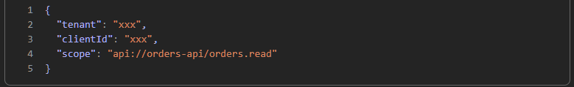
✅ Step 4: You integrate in code
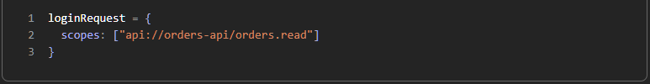
🔥 What you DON’T do as developer (usually)
❌ Create scopes
❌ Manage consent
❌ Control access policies
👉 That’s security team's job

✅ But in small companies / personal projects
👉 YOU do everything:
- Register app
- Define scopes
- Grant permissions

🔥 Important interview insight
If asked:
“Who manages Azure AD configs?”
✅ Say:
“Typically handled by Identity/Security team. Developers integrate using provided client IDs, scopes, and endpoints.”

🔥 Final real-world mental model
Security team = sets rules (Azure AD)
Developer = uses rules (code)

✅ One-line summary
Developers usually don’t control Azure AD fully — they just integrate with pre-configured authentication/authorization setup.

If you want next step (this is where it gets powerful):
👉 I can show you:
- how THIS maps to your BFF + Keycloak setup
- or how interviewers twist this into tricky OAuth questions
Just say 👍

✅ PART 1: Real Company Process (How apps are registered)
🔥 Your doubt:

“Do we raise request to register app? Do we host first? Do we give service ID?”

👉 ✅ Yes — but flow is slightly different than what you think

🏢 Typical Enterprise Flow
✅ Step 1: Developer builds app (locally first)

Build API / React / BFF
Test locally
No Azure AD needed yet

✅ Step 2: Raise request to Identity / Cloud team
You create a ticket like:
App Name: Orders API
Type: Web API
Need:
- Authentication via Azure AD
- Scopes: orders.read, orders.write
Client:
- React App / BFF
Permissions needed:
- orders.read

✅ Step 3: Identity team does Azure AD setup
They:
🔹 Register API

Create App Registration (Orders API)
Set:
App ID URI → api://orders-api

Define scopes:
orders.read
orders.write

🔹 Register Client (if needed)

Create React/BFF app OR use existing one

🔹 Link permissions
Client App → API Permissions
→ orders.read

✅ Give admin consent

✅ Step 4: They give YOU config
You get something like:
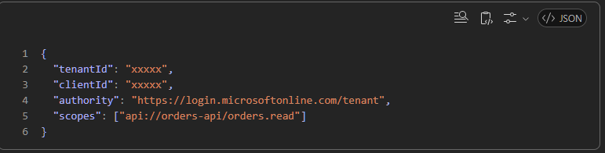
✅ Step 5: You deploy app
Now deployment can be:
Option A: Developer deploys
- Azure App Service
- Container (AKS)
- VM
Option B: DevOps team deploys (more common)
- CI/CD pipeline
- Infra managed separately

🔥 Important clarification (your confusion)
“Do we first host app then register?”
👉 ❌ No strict order
✅ Reality:
- App registration is logical identity, not physical hosting
- You can register BEFORE or AFTER hosting

🔥 Super important concept
👉 Azure AD doesn’t care where your app is hosted
- Localhost ✅
- Azure ✅
- AWS ✅
- On-prem ✅
👉 It only cares about:
clientId
tenantId
redirectUri
scopes

✅ Final answer (process)
✔ Yes, you usually raise a request
✔ Identity team registers app
✔ You integrate using given config
✔ Deployment is separate concern

✅ PART 2: Mapping this to YOUR BFF + Keycloak understanding
Let’s connect with what you were learning 👇

🔥 Your architecture
Browser → BFF (.NET) → API
↓
Keycloak / Azure AD

✅ With Azure AD (same as Keycloak)
🟢 BFF = CLIENT
- Registered as app
- Has:
- clientId
- clientSecret

🟢 API = RESOURCE SERVER
- Registered separately
- Defines:
- orders.read

🟢 Flow
- User logs in via BFF
- BFF talks to Azure AD
- BFF requests:
- scope=api://orders-api/orders.read
- Azure AD returns:
  - ID Token ✅ (user identity)
  - Access Token ✅ (for API)

🟢 BFF → API call
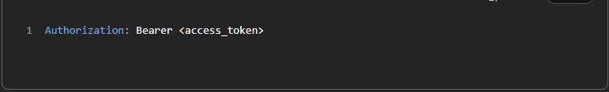
🟢 API checks:
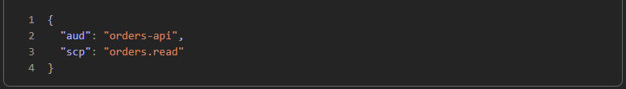
✅ Exact mapping (Keycloak vs Azure AD)
Concept | Keycloak | Azure AD
Client | client | App Registration
Role | realm/client roles | App roles
Scope | client scopes | API scopes
Token | access token | same

✅ PART 3: Interview Traps (VERY IMPORTANT)
🔥 Trick Question 1
“If client requests scope, does it automatically get it?”
❌ Wrong answer: Yes
✅ Correct:
Only if permission is granted + consent given

🔥 Trick Question 2
“What enforces scope?”
❌ Azure AD
✅ YOUR API

🔥 Trick Question 3
“Difference between scope and role?”
✅ Scope → API permission
✅ Role → user privilege

🔥 Trick Question 4
“Can any client call your API if it knows the scope?”
❌ Yes
✅ No:
- Must be registered
- Must be granted permission
- Must get token from Azure AD

🔥 Trick Question 5
“Where is client secret stored?”
✅ Backend (BFF) only
❌ Never frontend

✅ FINAL SUMMARY (lock this)
App registration = identity (not hosting)
Scopes = API permissions
Client must be explicitly granted scopes
Azure AD issues token
API enforces authorization

🚀 Next step (if you want)
I can simulate a complete real system:
👉 React + BFF + API + Azure AD
👉 Exact request → token → validation
👉 With sample .NET code
Just say: “full flow” 👍

