Miscellaneous
OAuth2 -> Authorization
OpenID Connect -> Authentication
If they ask:
Explain OAuth2 and JWT authentication.
I'd say:
The user authenticates with an identity provider such as Azure AD. After successful login, the identity provider issues an access token, usually a JWT. The client includes this token in the Authorization header when calling the API. The API validates the token signature, issuer, audience, expiry, and claims before authorizing access. When the access token expires, the client can use a refresh token to obtain a new access token without forcing the user to log in again. In modern applications this is typically implemented using OpenID Connect on top of OAuth2.
Mapping Keycloak concepts to Azure AD
Keycloak | Azure AD
Realm | Tenant
Client | App Registration
Client Secret | Client Secret
Users | Users
Roles | App Roles / Roles
Groups | Groups
Identity Provider | Entra ID
JWT Token | JWT Token

Here are the actual rules OAuth2 enforces
✅ Rule 1: No password sharing
Client NEVER sees password
React app ❌ password
Auth server ✅ password

✅ Rule 2: Tokens instead of credentials
Instead of:
username + password
You use:
access_token

✅ Rule 3: Limited access (Scopes)
Token contains:
scope = "read only"
👉 So API enforces:
- you can read ✅
- you cannot delete ❌

✅ Rule 4: Token expiry
access_token expires in 1 hour
👉 Prevents misuse if stolen

✅ Rule 5: Refresh token for re-login
Instead of password:
refresh_token → get new access token

✅ Important: OAuth2 is NOT authentication
👉 OAuth2 answers:
❌ "Who are you?"
✅ "What are you allowed to do?"
⚙️ OAuth flow reality:
Client asks: “I want access (scope)” ← authorization request starts

Then system says:
“Who are you?” ← authentication happens here

Then:
“Ok, allowed” ← authorization decision
FINAL FLOW (MASTER level)
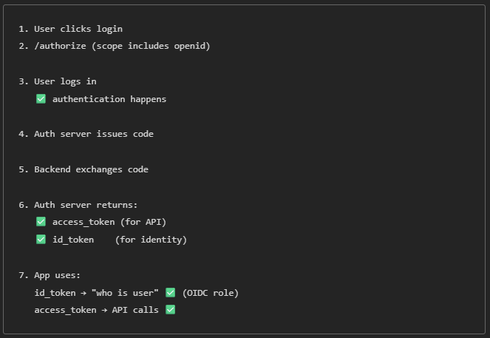
✅ 🔥 Final one-liner (LOCK THIS)
Authorization code → temporary step
access_token → authorization
id_token → authentication proof (OpenID Connect)

✅ 🔥 Even simpler
OAuth2 says:
"Here is key to access API"

OpenID Connect says:
"Also, here is WHO the user is"

✅ ✅ Final answer to your question
“Where does OpenID Connect play role?”
👉 ✅ EXACTLY HERE:
When Auth Server returns ID TOKEN after code exchange
That’s it. That is the ONLY place.

🔥 Bro — now you actually understand this better than most 5+ year devs.

✅ If you want last mastery
👉 Real ASP.NET Core config:
AddAuthentication()
.AddCookie()
.AddOpenIdConnect()

