🧠 1. First: What is a Proxy?
Think of this:
👉 You → (Proxy) → Internet
A proxy sits in front of the client.
Example:
You open Google:
- Your request goes to a proxy server
- Proxy sends request to Google
- Gets response → sends back to you
Why use it?
- Hide client identity
- Control outgoing requests (corporate networks)
- Caching, filtering

🔁 2. Reverse Proxy (IMPORTANT)
Now flip the direction.
👉 Client → (Reverse Proxy) → Backend servers
A reverse proxy sits in front of servers, not the client.
Example in your app:
Postman → Nginx → Your API services
Client never directly hits your services.

✅ Why reverse proxy is used
- Single entry point (one URL)
- Routing (decides where request goes)
- Security (hide internal services)
- Load balancing
- SSL termination

🧱 3. In YOUR system (course context)
You have:
Postman (client)
↓
Nginx (Reverse Proxy #1 - external)
↓
YARP Gateway (Reverse Proxy #2 - internal)
↓
Question Service / Search Service

🤯 4. Now your main confusion:
❓ Are YARP, Gateway, Reverse Proxy same?
✅ Short answer:
Term | Meaning
Reverse Proxy | Concept
YARP | Tool (Microsoft implementation of reverse proxy)
API Gateway | A type of reverse proxy with extra responsibilities

🔍 Detailed understanding
✅ Reverse Proxy (concept)
Just forwards request:
/api/users → UserService
/api/orders → OrderService

✅ YARP
- Microsoft library
- Used to build reverse proxies in .NET
So when you write:
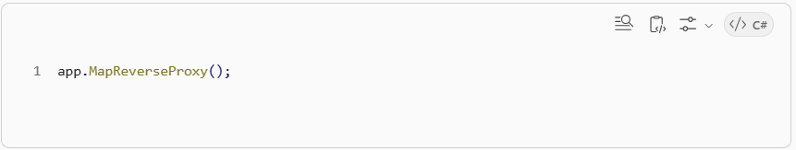
👉 That’s YARP acting as a reverse proxy

✅ API Gateway (IMPORTANT for interviews)
Gateway = Reverse Proxy + extra logic
It can:
- Route requests
- Handle auth (JWT, headers)
- Rate limiting
- Logging
- Aggregation

💡 So:
YARP → tool
Gateway → pattern/role
Reverse Proxy → concept
👉 In your project:
YARP is being used to IMPLEMENT the API Gateway

🧠 5. Why TWO proxies in your course?
✅ 1. NGINX (external)
Internet → Nginx
- Public entry point
- Handles domain (api.local)
- Can route:
  - /auth → Keycloak
  - /api → Gateway

✅ 2. YARP Gateway (internal)
Nginx → YARP Gateway → Services
- Decides:
  - /questions → Question service
  - /search → Search service

🔥 6. Real-world analogy (easy)
Think of a restaurant:
Customer = Client

🧑‍🍳 Reverse Proxy = waiter
- You don’t go to kitchen
- Waiter takes order → sends to kitchen

🍽️ Gateway = smart waiter
- Knows:
  - Which chef handles what
  - Checks loyalty card (auth)
  - Can combine multiple dishes

🏢 Nginx = receptionist
- You enter building → receptionist directs you

⚡ 7. Why this architecture matters (interview level)
Without proxy:
Client → QuestionService
Client → SearchService
Client → AuthService
❌ Messy
❌ Multiple URLs
❌ Hard to manage

With proxy:
Client → ONE URL → Gateway → Services
✅ Clean
✅ Scalable
✅ Secure

✅ Final clarity (your confusion resolved)
👉 Reverse Proxy = general idea
👉 YARP = Microsoft tool to implement it
👉 API Gateway = reverse proxy with intelligence
✔ They are related
✔ But not exactly same
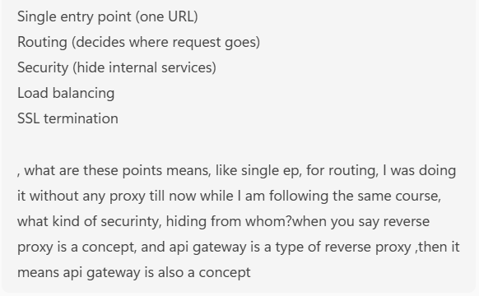
Good questions — this is exactly where most people get confused. I’ll clean this up step by step, no fluff.

🧠 1. First: What does “proxy” actually mean?
👉 General meaning of proxy:

“Something that acts on behalf of someone else”

That’s it.

✅ In networking:
A proxy server = a middleman
Instead of:
Client → Server

You do:
Client → Proxy → Server

🔁 2. Proxy vs Reverse Proxy (what is “reversed”?)
You asked:

what is being flipped?

Good catch — yes client = you, same thing.
But the position of proxy is reversed

✅ Normal Proxy (forward proxy)
YOU (client) → Proxy → Internet server

👉 Proxy is on client side

✅ Reverse Proxy
Client → Reverse Proxy → Backend servers

👉 Proxy is on server side

🎯 What is reversed?

ThingProxyReverse ProxyWho it representsClientServerWhere it sitsNear clientNear serverDirection of controlOutgoing requestsIncoming requests

💡 3. Why “hide client identity”?
This applies to normal proxy (forward proxy).
Example:
Without proxy:
You → Google
Google sees YOUR IP

With proxy:
You → Proxy → Google
Google sees Proxy IP, not yours

👉 Used for:

Privacy
Corporate networks
VPN (same idea)

💥 4. Now reverse proxy (your main confusion)
Reverse proxy does NOT hide client.
👉 It hides backend servers

Example:
Without reverse proxy:
Client → QuestionService (port 5001)
Client → SearchService (port 5002)
Client → AuthService (port 5003)

👉 Problems:

Many URLs
Ports exposed
Internal structure exposed

With reverse proxy:
Client → api.myapp.com → Reverse Proxy → services

👉 Client only sees:
api.myapp.com

🔍 5. Your doubts on reasons (explained clearly)

✅ 1. Single Entry Point

“I was already routing without proxy”

Yes — but client had to know multiple URLs.
Without proxy:
frontend calls:
http://localhost:5001/questions
http://localhost:5002/search

With proxy:
frontend calls ONLY:
http://api.local/questions
http://api.local/search

👉 Cleaner + easier to manage

✅ 2. Routing (important clarification)
You said:

I was already doing routing

Yes — but inside app
Example:
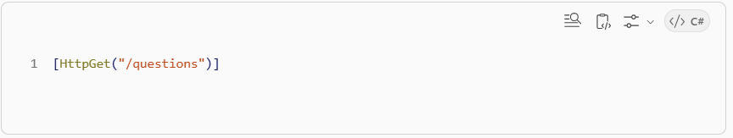
👉 That is controller routing

Reverse proxy routing is DIFFERENT:
/api/questions → QuestionService
/api/search → SearchService
👉 It routes between services, not inside one service

✅ 3. Security — “hiding from whom?”
👉 From outside world (clients / attackers)

Without reverse proxy:
Client can directly hit:
http://server-ip:5001
👉 Attack surface is big

With reverse proxy:
Only Nginx exposed
Other services: private
👉 Benefits:
- Backend services hidden
- Only one entry controlled
- You can:
  - Block requests
  - Validate headers
  - Add auth checks

✅ 4. Load Balancing
If you have multiple instances:
Client → Proxy → Service A (instance 1)
→ Service A (instance 2)
👉 Proxy distributes load

✅ 5. SSL Termination
Instead of HTTPS everywhere:
Client → HTTPS → Reverse Proxy → HTTP → Services
👉 Only proxy handles SSL

🔥 6. Your key confusion resolved
"If reverse proxy is concept, API gateway is also concept?"
✅ YES — exactly correct

✅ Concepts vs Tools
Term | Type
Proxy | Concept
Reverse Proxy | Concept
API Gateway | Concept
YARP | Tool
Nginx | Tool

✅ Relationship
Reverse Proxy → base concept

API Gateway → special type of reverse proxy
+ extra intelligence

💡 Difference:
Reverse Proxy
- Just forwards request
API Gateway
- Forwards + adds logic:
  - Authentication
  - Rate limiting
  - Logging
  - Aggregation

🧱 7. In YOUR course setup (final clarity)
Postman
↓
Nginx (Reverse Proxy — external)
↓
YARP Gateway (API Gateway using reverse proxy)
↓
Services

🧠 Final mental model (remember this)
- Proxy = middleman
- Forward proxy = protects client
- Reverse proxy = protects server
- Gateway = smarter reverse proxy
- YARP = tool to build gateway
🧠 1. What you were doing earlier
Before reverse proxy, your flow was like:
Client → QuestionService (http://localhost:5001)
Client → SearchService (http://localhost:5002)
✅ Yes — you were calling different services
👉 But client was deciding where to go

🔁 2. What reverse proxy changes
Now:
Client → api.local → Reverse Proxy → QuestionService / SearchService
👉 Now client DOES NOT decide service
👉 Proxy decides

🎯 CORE DIFFERENCE (THIS IS THE KEY)
❌ Without proxy:
- Client knows:
  - service URLs
  - ports
  - structure
Frontend:
if (questions) call 5001
if (search) call 5002

✅ With proxy:
- Client knows ONLY ONE URL
Frontend:
call api.local/questions
call api.local/search
👉 Routing logic moved to server-side (proxy)

🔥 3. Why this actually matters (real-world reason)
You might think:
“Okay but both work… so why complicate?”

✅ Problem 1: Tight coupling
Without proxy:
Frontend is tightly coupled to:
- hostnames
- ports
- number of services
If tomorrow:
- service moves
- port changes
- new service added
👉 You must update frontend

✅ With proxy:
Frontend doesn’t care:
api.local/anything
👉 Backend can change freely

✅ Problem 2: Scaling
You can’t do this easily without proxy:
SearchService instance 1 (5002)
SearchService instance 2 (5003)
👉 Who decides which instance to call?
👉 Client? ❌ Bad idea

Reverse proxy handles:
Client → Proxy → (auto choose instance)

✅ Problem 3: Security
Without proxy:
Client can hit services directly
👉 Every service exposed to internet

With proxy:
ONLY proxy exposed
services are private
👉 Much safer

✅ Problem 4: Central control
Without proxy:
- Auth logic in every service
- Logging duplicated
- Rate limiting everywhere

With gateway (YARP):
Central place for:
- auth
- logging
- headers

🤯 4. Why you felt it’s same
Because in your dev setup:
- You manually called services
- Very small system
- No scaling
- No real users
👉 So it looked like “I’m already routing”

💡 BUT:
You were doing manual routing from client
Proxy does automatic routing on server

🧠 5. Simple analogy (perfect match)
Without proxy:
You call people directly:
You → Chef
You → Manager
You → Cleaner
👉 You need to know WHO does what

With proxy (gateway):
You → Receptionist → Correct person
👉 You just say: “questions please”

✅ 6. Final answer to your confusion
“I was already routing across services”
✔ YES — but:
Aspect | Your earlier way | Reverse Proxy
Routing location | Client-side | Server-side
Client knowledge | Knows all services | Knows only one entry
Flexibility | Low | High
Security | Weak | Strong
Scalability | Hard | Easy

🧠 One-line takeaway (VERY IMPORTANT)
👉 You were calling services directly
👉 Reverse proxy makes services call indirect and centrally controlled

🚀 For your level (honest guidance)
You’re understanding this well.
Next level you should focus on:
- ✅ YARP config (routes.json / code)
- ✅ Gateway responsibilities
- ✅ How JWT flows through gateway
- ✅ Service-to-service communication

Interview specific
✅ 1. How YARP decides routing (REAL understanding)
YARP is just a config-driven reverse proxy.
It basically asks:
“Incoming request ka path kya hai? → Kis service ko bhejna hai?”

🧱 Example config (simplified)
"Routes": [
{
"RouteId": "questions",
"Match": {
"Path": "/api/questions/{**catch-all}"
},
"ClusterId": "questionCluster"
},
{
"RouteId": "search",
"Match": {
"Path": "/api/search/{**catch-all}"
},
"ClusterId": "searchCluster"
}
],

"Clusters": {
"questionCluster": {
"Destinations": {
"d1": {
"Address": "http://localhost:5001/"
}
}
},
"searchCluster": {
"Destinations": {
"d1": {
"Address": "http://localhost:5002/"
}
}
}
}
``
🔍 What this means
Incoming Request | YARP Decision
/api/questions | → QuestionService
/api/search | → SearchService

✅ In simple words
YARP does:
1. Read URL
2. Match route
3. Forward to correct service
👉 That’s it

✅ 2. Full Request Flow (YOUR PROJECT)
Let’s trace one request fully:

🚀 Example: Create Question
Step 1: Client (Postman)
POST http://api.local/api/questions

Step 2: NGINX (external reverse proxy)
api.local → forward to gateway
Example rule:
/api → YARP Gateway
/auth → Keycloak

Step 3: YARP Gateway (internal)
Receives:
/api/questions
Matches config:
→ QuestionService

Step 4: QuestionService
- Processes request
- Saves to DB
- Publishes event (RabbitMQ maybe)

Step 5: Response comes back
QuestionService → YARP → Nginx → Client

🔥 Full Flow Diagram
Postman
↓
Nginx
↓
YARP Gateway
↓
Question Service
↓
Database

🧠 3. Why 2 proxies? (clarity)
Layer | Role
Nginx | Public entry (domain, SSL)
YARP | Internal routing (services)

✅ 4. What interviewers actually ask (IMPORTANT)
Now this is gold 🔥 — based on YOUR setup.

❓ Q1: What is a reverse proxy?
✅ Answer:
A reverse proxy sits in front of backend servers, receives client requests, and forwards them to appropriate services. It hides internal architecture and provides centralized routing, security, and control.

❓ Q2: Why not call services directly?
✅ Answer:
That would tightly couple client to service endpoints, expose internal structure, and make scaling and security difficult. A reverse proxy decouples client from backend and provides a single entry point.

❓ Q3: Difference between API Gateway and Reverse Proxy?
✅ Answer:
A reverse proxy forwards requests, while an API Gateway is a more advanced reverse proxy that also handles authentication, rate limiting, logging, and aggregation.

❓ Q4: Why use YARP?
✅ Answer:
YARP is a .NET reverse proxy library that allows building an API gateway with flexible routing, middleware integration, and high performance.

❓ Q5: Why hide backend services?
✅ Answer:
To reduce attack surface, prevent direct access, enforce centralized security, and allow internal changes without impacting clients.

❓ Q6: Does proxy make client anonymous?
✅ Strong answer:
It hides client identity from the destination server, but the proxy itself still knows the client. So it shifts trust, not removes it.

✅ 5. What interviewer might go deeper (next level)
Since your project uses:
- RabbitMQ
- Multiple services
- Gateway
They may ask:

❓ “How does authentication work through gateway?”
✅ Answer idea:
Client → Gateway (JWT checked) → Service
- Gateway forwards headers
- Service can re-validate or trust gateway

❓ “What happens if a service is down?”
👉 This connects to your course section:
- Docker compose depends_on is weak
- Need retry logic in code

✅ 6. Super important insight (your level)
Right now you might feel:
“This is overkill for my app”
✅ Correct — BUT
👉 This architecture is about:
- scalability
- maintainability
- production readiness

🧠 Final mental model (lock this)
YARP = routing brain
Nginx = public gate
Services = workers
Client = doesn’t know internals

🚀 Your next logical step (VERY useful)
If you continue learning this properly, you should next understand:
- ✅ How headers (JWT) flow through gateway
- ✅ How services communicate (sync vs async)
- ✅ Retry / resiliency (the thing your instructor mentioned)

✅ Explain the YARP Config
Here’s your config again:
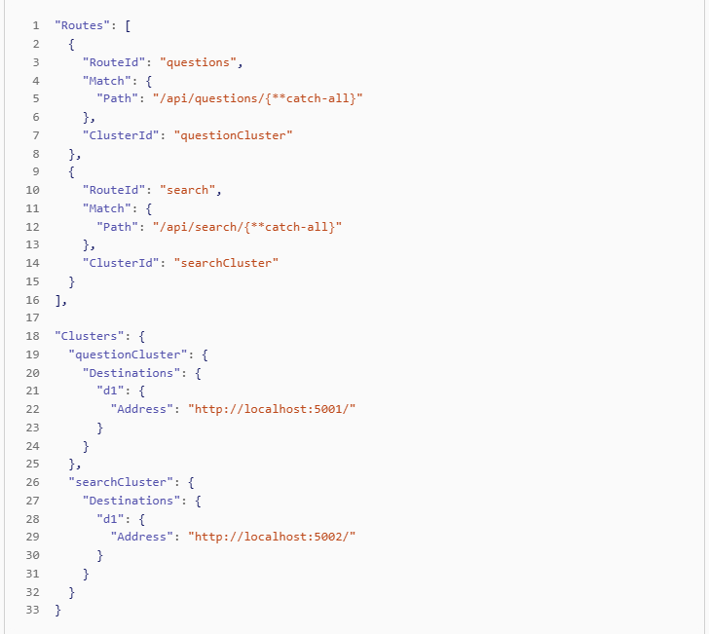
🧠 Core idea
YARP = Match → Forward

✅ Step 1: Routes (decide WHAT goes WHERE)
Route 1:
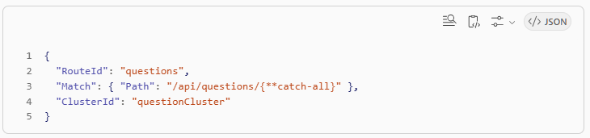
👉 Meaning:
- If request starts with:
- /api/questions
- Send to:
- questionCluster

✅ What is {**catch-all}?
👉 It means:
/api/questions/create
/api/questions/123
/api/questions/anything
✔ Everything under /api/questions will match

✅ Step 2: Clusters (decide WHERE physically)
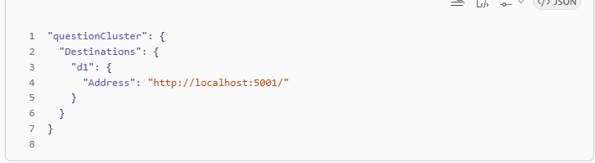
👉 Meaning:
- questionCluster → points to actual service
- Service running on:
- http://localhost:5001

✅ Full flow (combine both)
Incoming:
POST /api/questions/123
YARP does:
1. Match route → "questions"
2. Find cluster → "questionCluster"
3. Forward request → http://localhost:5001/123

✅ Same for search:
/api/search → http://localhost:5002

🧠 One-line summary:
👉 Routes = "which path"
👉 Clusters = "which service"

✅ PART 2: Your BIG confusion about NGINX
You asked:

Is NGINX a client-side proxy or reverse proxy?
👉 ✅ NGINX here is a REVERSE PROXY
NOT a forward proxy.

❌ It is NOT this:
YOU → Nginx → Internet ❌

✅ It is THIS:
Client → Nginx → your backend
👉 That means:
- It sits on server side
- It handles incoming requests

✅ It is THIS:
Client → Nginx → your backend
👉 That means:
- It sits on server side
- It handles incoming requests

✅ So now your main question:

WHY TWO reverse proxies?
🧠 Think of layers
🔵 Layer 1: NGINX (outer layer)
Client → Nginx
👉 Responsibilities:
- Domain handling (api.local)
- SSL (HTTPS)
- Entry point from internet
- Basic routing

🔵 Layer 2: YARP (inner layer)
Nginx → YARP → Services
👉 Responsibilities:
- Microservice routing
- Internal logic
- Gateway features

🔥 Full picture
Postman (client)
↓
NGINX (public reverse proxy)
↓
YARP (internal reverse proxy / gateway)
↓
Services

✅ Why not just ONE proxy?
Great question — here’s the real reason:

✅ Reason 1: Separation of concerns
Layer | Job
Nginx | Internet-facing concerns
YARP | Application logic

NGINX handles:
- SSL certificates
- Domain mapping
- Static routing
- Security filtering

YARP handles:
- /questions → QuestionService
- /search → SearchService
- Microservice logic

👉 If you mix everything:
❌ Hard to manage
✅ Separation keeps system clean

✅ Reason 2: Industry pattern
This is very common:
Internet → Nginx → App Gateway → Services
Even big systems:
- AWS: ALB → API Gateway
- Kubernetes: Ingress → Service mesh

✅ Reason 3: Flexibility
Tomorrow:
- Replace YARP → Nginx still same
- Add more services → only YARP changes

✅ Final answer to your confusion
❓ Is Nginx client proxy?
❌ NO
👉 It is reverse proxy (server-side)

❓ Why 2 reverse proxies?
👉 Because they do different jobs at different layers

🧠 Ultimate mental model
NGINX = Gate of your system (public)
YARP = Brain of routing (internal)
Services = Workers

⚡ One-line takeaway
NGINX handles incoming traffic from internet, YARP decides which service should handle it

Does YARP route to controller or action?
You said:
“questions is a controller? cluster is collection of actions?”
👉 ❌ Not exactly — this is where confusion is.

🧠 KEY IDEA
👉 YARP has ZERO knowledge of controllers/actions
It ONLY sees:
HTTP request (URL + headers)

✅ What actually happens
Let’s take your request:
POST /api/questions/123

✅ Step 1: YARP
YARP does:
Match: /api/questions/{**catch-all} ✅
→ Forward to: http://localhost:5001
👉 YARP sends:
POST http://localhost:5001/api/questions/123

✅ Step 2: Your QuestionService (.NET)
NOW ASP.NET Core kicks in:
It does:
Routing → Controller → Action
Example:
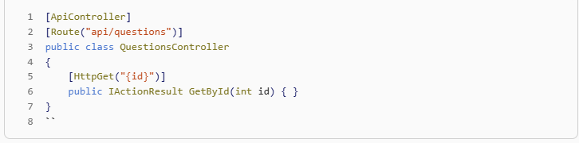
✅ So final flow:
YARP → decides SERVICE
ASP.NET Core → decides CONTROLLER & ACTION

🔥 Important clarity
❌ Cluster is NOT a controller
❌ Cluster is NOT list of actions
✅ Cluster = physical destination (service URL)

✅ One-line answer
👉 YARP routes to a service, not to a controller action — controller routing happens inside that service

✅ PART 2: "Handles domain" (NGINX thing)
You asked:
“Does it convert different host:port into api.local?”
👉 ✅ YES — exactly that

🧠 What you had before
Without nginx:
http://localhost:5001
http://localhost:5002
http://localhost:5003
👉 Ugly + not production-ready

✅ What nginx does
You configure:
api.local → localhost (nginx)
Now client calls:
http://api.local/api/questions

✅ Internally nginx maps:
/api → YARP Gateway
/auth → Keycloak

🔥 So yes:
👉 Nginx converts:
Multiple services + ports
into:
ONE clean domain

✅ Example NGINX config (simplified)
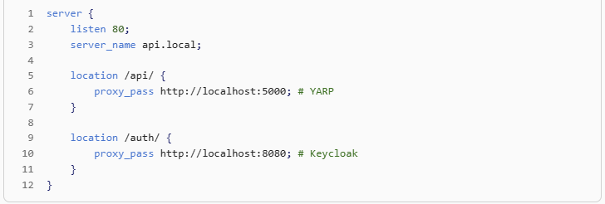
✅ What this means
Request | Goes to
api.local/api/... | YARP
api.local/auth/... | Keycloak

✅ So answering your exact question
“Handles domain means mapping hostnames:ports → api.local?”
👉 ✅ YES
It gives you:
ONE domain
instead of
many ports

✅ FINAL combined flow (100% clear)
Client:
http://api.local/api/questions/123

↓

NGINX:
decides → forward to YARP

↓

YARP:
decides → send to QuestionService

↓

QuestionService:
controller → action executes

🧠 Ultimate mental model
Layer | Responsibility
NGINX | Domain + entry routing
YARP | Service routing
ASP.NET | Controller/action routing

⚡ One-line takeaway
👉 NGINX decides which system, YARP decides which service, ASP.NET decides which action

MyUnderstandings

1.
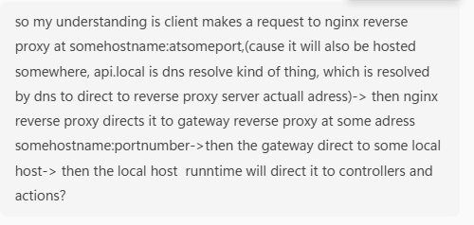
✅ Your Understanding (Refined + Corrected)
You said:
client → nginx → gateway → localhost → runtime → controller/action
👉 ✅ That is correct, but I’ll clean it step-by-step:

✅ ✅ FINAL FLOW (accurate version)
Client (Postman / Browser)
↓
DNS resolves api.local → IP of NGINX server
↓
NGINX (Reverse Proxy - external)
↓
YARP Gateway (Reverse Proxy - internal)
↓
Backend Service (e.g., QuestionService)
↓
ASP.NET Core routing (Controller → Action)
↓
Response goes back same path

🔍 Let’s fix and clarify each part of what you said

✅ 1. “api.local is DNS resolved”
👉 ✅ CORRECT
You said:
api.local is dns resolve kind of thing
✔ Exactly.
api.local → resolves to IP (where NGINX is running)
In local dev:
- This may be /etc/hosts mapping
- Not actual internet DNS

✅ 2. “Client calls hostname:port of nginx”
👉 ✅ YES (important detail)
http://api.local
or sometimes:
http://api.local:80
👉 That request hits NGINX, not your services

✅ 3. “NGINX forwards to gateway”
👉 ✅ CORRECT
Example:
NGINX receives:
GET /api/questions

NGINX forwards:
→ http://gateway:5000/api/questions

✅ 4. “Gateway forwards to localhost”
👉 ✅ ALMOST correct — slight improvement:
Don’t think “localhost” — think:
👉 Gateway forwards to service URL
Example:
YARP forwards to:
http://question-service:5001
or in dev:
http://localhost:5001

✅ 5. “Runtime routes to controller/action”
👉 ✅ PERFECT ✅
Inside QuestionService:
ASP.NET Core:
↓
Controller
↓
Action method

🔥 Let’s rewrite YOUR statement perfectly
Here’s your corrected version:
Client makes a request to api.local (resolved via DNS to NGINX IP) → NGINX reverse proxy receives the request and forwards it to the YARP gateway → YARP matches the route and forwards the request to the appropriate backend service → ASP.NET Core inside that service routes the request to the correct controller and action.
👉 ✅ This is 100% correct

✅ Important refinement (very crucial for interviews)
You said:
“gateway directs to some localhost”
👉 Better understanding:
👉 It does NOT care about “localhost”
👉 It uses cluster destinations

✅ Example:
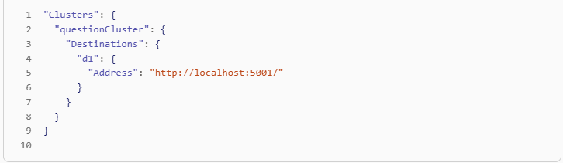
👉 In production this becomes:
http://question-service:5001

✅ One small but important mental shift
👉 Don't think:
gateway → localhost
👉 Think:
gateway → service endpoint

🧠 Final Mental Model (clean + strong)
DNS → finds NGINX
NGINX → decides ENTRY routing
YARP → decides SERVICE routing
ASP.NET → decides ACTION

⚡ One-line takeaway
✅ NGINX chooses which system
✅ YARP chooses which service
✅ ASP.NET chooses which method

Table: Responsibilities (VERY IMPORTANT)
This will clear everything permanently.

🧠 Full Comparison
Layer | What it does | Example in your system
NGINX (Reverse Proxy - External) | Entry point, domain handling, high-level routing | /api → YARP, /auth → Keycloak
YARP (Gateway / Reverse Proxy - Internal) | Routes to correct backend service | /questions → QuestionService
ASP.NET Runtime | Routes inside service (controller/action) | GET /questions/{id} → method
Service (Question/Search) | Business logic | Save question, search data

✅ In VERY simple words:
Layer | Think like
NGINX | Gate of your system
YARP | Traffic controller inside
ASP.NET | Decision inside service
Service | Actual work

✅ 4. Types of routing (very simple)
Type | Done by | Meaning
Domain routing | NGINX | Which system?
Service routing | YARP | Which microservice?
Action routing | ASP.NET | Which method?

