### A Project Report On

MovieFox

Developed At

**Harivandana College**

For the fulfillment of the requirements for the

**B.C.A. – 6th Semester**

## Developed By

**Vishal Makwana**

Submitted To



**DEPARTMENT OF COMPUTER SCIENCE**

**-: Under the Guidance of :-**

## Dr. Ashwin Rathod (Head ofDepartment) Prof. DharmendraAmbani (Project In-charge)

Preface

### The age of information has gone , the correct area is the age of knowledge. These having knowledge would higher resources from the society & at the same time would be earning the higher returns. But knowledge as we know has changed drastically, to ensure that knowledge is imported to student, it is made mandatory by Sauarashtra University for B.C.A student to work on a comprehensive project.

Here is the detailed report on the project I had made at **MovieFox Application**. It has developed on Android in Android Studio IDE.

I really thankful to the Mr. Dharmendra Ambani for kind help and support for providing detail information regarding manual system

.

Finally, I would like to express my gratitude to the member of my family for the support and encouragement I have receives from them. The improvement would always.

I am Vishal Makwana student of BCA Sem – 6 in **Harivandana College**. Thanks to the entire person who has landed their support in shaping of this web application.

The successful completion of Project is generally not an individual effort. It is an outcome of the cumulative efforts of a number of persons, each having its own importance. This session is a vote of thanks for all those who have directly or indirectly contributed in his or her own special way towards the completion of this Project.

I am very thankful to all those who have helped me in preparing and guiding this Project on “**MovieFox Application”**. I am feeling a great happiness to present this Documentation.

I would like to add a few heartfelt words for the people who are part of this Project report in numerous ways. People who give unending support right from the stage Project report idea was conceived. In particular, I would like to thank our **Principal Mr. Ashwin Rathod** who provides us such nice and encouraging environment. I would also like to thank my **Family members** who have always inspired me and directed me towards the successful completion of this Project.

I would like to express my deepest gratitude to **The Faculties of Harivandana college** who showed trust in me with such a challenging project. So I heartily thanks to them for spending his valuable time and providing me better guidance as well as giving new ideas for achieving my goal.

**Developed At Harivandana College Rajkot.**

Computer

Of

Department Science

Harivandana College

**Submitted To**

**Software Required** Android Os

**Documentation Tool** Microsoft Word, Visio

## Main Activity

Main Activity, Trending Activity, Movie Detail Activity, Search Activity, Favourite Activity.

**IDE** Android Studio

**Guided by** Prof. Ashwin Rathod

**Developed By Darshak Pansuriya**

**Index**

|  |  |  |
| --- | --- | --- |
| **No** | **Subject Title** | **PageNo** |
| **1** | **Introduction**   * 1. **Project Summery With Details**   2. **Objectives/Aim/Vision/Scope**   3. **Scope**   4. **Study Of Existing System**   5. **Proposed System**   6. **Project Boundry**   7. **Duration** | **1**  **2**  **2**  **3**  **3**  **5**  **5** |
| **2** | **Litreture Survey**   * 1. **Android Overview**   2. **MYSQL Overview**   3. **PHP Overview**   4. **SQLite Overview** | **6**  **7**  **8**  **9**  **11** |
| **3** | **Project Management**   * 1. **Project Planning Scheduling**      1. **Project Development Model**      2. **Project Plan**   2. **Schedule Represantation** | **14**  **15**  **15**  **17**  **18** |
| **4** | **Requirement Specification**   * 1. **Hardware Requirements**   2. **Software Requirements** | **19**  **20**  **20** |
| **5** | **System Design**   * 1. **Basic Flow Of System**      1. **Use Case Diagram**      2. **Data Flow Diagram**   2. **System Procedural Design**      1. **Contex Level Diagram** | **21**  **22**  **22**  **23**  **24**  **24** |
| **6** | **Implementation**  **6.1 Screen Layout** | **25**  **26** |

|  |  |  |
| --- | --- | --- |
| **7** | **Testing**   * 1. **Testing**   2. **Testing Levles**      1. **Unit Testing**      2. **Integration Testing**      3. **System Testing**   3. **Types Of Testing**      1. **Functional Testing**      2. **Structural Testing** | **32**  **34**  **34**  **34**  **34**  **34**  **35**  **35**  **35** |
| **8** | **Future Work** | **36** |
| **9** | **Conclusion** | **37** |
| **10** | **Reference & Bibliography** | **39** |

# 1

**INTRODUCTION**

#### Project Summery

* + - MoveFox is an mobile application system which is used to get information about new bollywood and hollywood movie details.
    - This is the best movie app I is main purpose to users for watching movies online.
    - This has a smooth, simple and modern UI.
    - User can view movie description and also movie cast details
    - Key Feature of This app:) View Trending Movies
    - 1) Check Movie Rating And Information very easy
    - 2) Simple User Interface with easy design
    - 3) Search Movie Name Which you want movie information
    - 4)Add To Favourties for checking offline in devices

#### Objective/aim/vision

* Use our simple MovieFox app for your easy work to watch online movies
* Access TMDB Top Trending movies in front page
* Change the Daily Notifications time so you get them when you need them.
* Search your favorites movie to check its information
* You can also add to favourites to watch latter
* This App is mainly based on TMDB API.

#### SCOPE

* **Language Scope :**
  + Language – JAVA , SQLite Connectivity
* **Project Scope :**
  + MovieFox mobile application can be implemented in an average sized organization.
  + An average company will not be very keen on spending on spending lots of money on ledgers. Whereas this application will greatly reduce the costs which is using in common and cheap office items like database and mobile applications.
  + And also there is no requirement to store books or accounts.
  + The data is directly stored in the database in the hard disk of the PC.

#### STUDY OF EXISTING SYSTEM :

* I am running my business offline till now.
* I wishes to increase my business. The problem I am facing my business was not online i needs to visit the application first and then proceed with my tasks, i wants us to develop a application which makes my business online and vast so that not only local clients could visit him but the clients from different places and the NRIs could also become part of my business. Through this website i have tried our best to make his offline business more efficient by making it online.

#### PROPOSED SYSTEM

* This mobile application has been designed keeping in mind all the aspects such as loading the data, complexity and maintaining the security of user credentials.
* The main objective behind this mobile application is to develop a web oriented application which can provide an download good thoughts feature to the users. In other words, the project aimed at creating a virtual shop environment for users, in some handy form, which will be available to them through internet.
* Here in this system, complexity refers to the total number of features being provided to users, and their smooth arrangement and functioning required. Following are some of the key features of our system, which distinguishes it from others:

1. Display of all the available trending movies on the home page.
2. User view movie based on tmdb trending movie list
3. User can only movies and its details with cast details
4. Allows the users to search movie name to get information.
5. User can add to favourites to access latter easily.

#### PROJECT BOUNDRY :

* Require Its not available all type of Category which will user needs.

#### DURATION :

In 16 weeks my website will be completed. Analysis : 4 weeks

Design : 3 weeks Coding : 6 weeks Testing : 3 weeks

# 2

**LITERATURE SURVEY**

#### 2.1) Android Overview :

* Android is an open source and Linux-based **Operating System** for mobile devices such as smartphones and tablet computers. Android was developed by the *Open Handset Alliance*, led by Google, and other companies.
* Android offers a unified approach to application development for mobile devices which means developers need only develop for Android, and their applications should be able to run on different devices powered by Android.
* The first beta version of the Android Software Development Kit (SDK) was released by Google in 2007 where as the first commercial version, Android 1.0, was released in September 2008.
* On June 27, 2012, at the Google I/O conference, Google announced the next Android version, 4.1 **Jelly Bean**. Jelly Bean is an incremental update, with the primary aim of improving the user interface, both in terms of functionality and performance.
* The source code for Android is available under free and open source software licenses. Google publishes most of the code under the Apache License version 2.0 and the rest, Linux kernel changes, under the GNU General Public License version 2.

#### History Of Android :

* The code names of android ranges from A to N currently, such as Aestro, Blender, Cupcake, Donut, Eclair, Froyo, Gingerbread, Honeycomb, Ice Cream Sandwitch, Jelly Bean, KitKat, Lollipop and Marshmallow. Let's understand the android history in a sequence.

#### 2.2) MYSQL Overview :

* + **MYSQL DATABASE MANAGEMENT SYSTEM :**
    - MySQL, the most popular Open Source SQL database management system, is developed, distributed, and supported by MySQL.
    - MySQL is a commercial company, founded by the MySQL developers. It is a second generation Open Source Company that unites Open Source values and

methodology with a successful business model.

* The MySQL Web site (ht[tp://www.mysql.com/) pr](http://www.mysql.com/)ovides the latest information about MySQL software and MySQL.
* The official way to pronounce “MySQL” is “My EssQue Ell” (not “my sequel”), but we don't mind if you pronounce it as “my sequel” or in some other localized way.
* **MYSQL FEATURES :**
  + MySQL, the most popular Open Source SQL database management system, is developed, distributed, and supported by MySQL.
  + MySQL is a commercial company, founded by the MySQL developers. It is a second generation Open Source Company that unites Open Source values and methodology with a successful business model.
  + The MySQL Web site (ht[tp://www.mysql.com/) pr](http://www.mysql.com/)ovides the latest information about MySQL software and MySQL.
  + The official way to pronounce “MySQL” is “My EssQue Ell” (not “my sequel”), but we don't mind if you pronounce it as “my sequel” or in some other localized way.

#### 2.3) PHP Overview :

* The full form of PHP is “Hypertext Preprocessor”. Its original name was “Personal Home Page”.
* RasmusLerdorf software engineer, Apache team member is the creator and original driving force behind PHP. The first part of PHP was developed for his personal use in late 1994.
* By the middle of 1997, PHP was being used on approximately 50,000 sites worldwide.
* PHP is server-side scripting language, which can be embedded in HTML or used as a stand-alone.
* PHP doesn‟t do anything about what a page looks and sounds like. In fact, most of what PHP does is invisible to the end user.
* Someone looking at a PHP page will not necessarily be able to tell that it was not written purely in HTML, because usually the result of PHP is HTML.
* PHP is an official module of Apache HTTP Server.
* PHP is fully cross-platform, meaning it runs native on several flavors of UNIX, as well as on Windows and now on Mac OS X.
  + **Advantages of PHP:**
* ***Cost*:** PHP costs you nothing. It is open source software and doesn‟t need to purchase it for development.
* ***Ease of Use*:**PHP is easy to learn, compared to the others. A lot of Ready-made PHP scripts are freely available in market so, you can use them in your project or get some help from them.
* ***HTML- Support:*** PHP is embedded within HTML; In other words, PHP pages are ordinary HTML pages that escape into PHP mode only when necessary.

When a client requests thispage, the web server preprocesses it. This means it goes through the page from top to bottom, looking for sections of PHP, which it will try to resolve.

* ***Cross-platform compatibility*:** MySQL run native on every popular flavor of UNIX and windows. A huge percentage PHP and of the world‟s HTTP servers run on one of these two classes of operating system.
* ***PHP is compatible with the three leading Web servers:*** Apache HTTP Server for UNIX and Windows, Microsoft Internet Information Server, and Netscape Enterprise Server. It also works with several lesser-known servers, including Alex Blits‟fhttpd, Microsoft‟s Personal Web Server, AOL Server and Omnicentrix‟s Omni server application server.
* ***Stability:*** The word stable means two different things in this context:
* The server doesn‟t need to be rebooted often
  + The software doesn‟t change radically and incompatibly from release to release.
  + **To our advantage, both of these apply to both MySQL and PHP.**
* **Speed:** PHP is pleasingly zippy in its execution, especially when compiled as an Apache module on the UNIX side. Although it takes a slight performance hit by being interpreted rather than compiled, this is far outweighed by the benefits PHP drives from its status as a Web server module.

#### 2.4) SQLite Overview :

* SQLite is a relational database management system contained in a C programming library. In contrast to many other database management systems.
* SQLite is not a client–server database engine. Rather, it is embedded into the end program.
* SQLite is ACID-compliant and implements most of the SQL standard, generally following PostgreSQL syntax. However, SQLite uses a dynamically and weakly typed SQL syntax that does not guarantee the domain integrity. This means that one can, for example, insert a string into an column defined as an integer.
* SQLite will attempt to convert data between formats where appropriate, the string "123" into an integer in this case, but does not guarantee such conversions, and will store the data as-is if such a conversion is not possible.
* SQLite is a popular choice as embedded database software for local/client storage in application software such as web browsers.
* It is arguably the most widely deployed database engine, as it is used today by several widespread browsers, operating systems, and embedded systems (such as mobile phones), among others.
* SQLite has bindings to many programming languages.

#### History Of SQLite :

* + D. Richard Hipp designed SQLite in the spring of 2000 while working for General Dynamics on contract with the United States Navy.
  + Hipp was designing software used for a damage-control system aboard guided missile destroyers, which originally used HP-UX with an IBM Informix database back-end. SQLite began as a Tcl extension.
  + The design goals of SQLite were to allow the program to be operated without installing a database management system or requiring a database administrator.

##### Hipp based the syntax and semantics on those of PostgreSQL 6.5. In August 2000, version 1.0 of SQLite was released, with storage based on gdbm (GNU Database Manager).

* + - SQLite 2.0 replaced gdbm with a custom B-tree implementation, adding transaction capability. SQLite 3.0, partially funded by America Online, added internationalization, manifest typing, and other major improvements.
    - In 2011 Hipp announced his plans to add a NoSQL interface (managing documents expressed in JSON) to SQLite databases and to develop UnQLite, an embeddable document-oriented database.
    - UnQLite was released as an independent database.

#### Features Of SQLite :

* + SQLite implements most of the SQL-92 standard for SQL but it lacks some features. For example, it partially provides triggers, and it cannot write to views (however it provides INSTEAD OF triggers that provide this functionality). While it provides complex queries.
  + it still has limited ALTER TABLE function, as it cannot modify or delete columns.
  + SQLite uses an unusual type system for an SQL-compatible DBMS; instead of assigning a type to a column as in most SQL database systems, types are assigned to individual values; in language terms it is dynamically typed.
  + Moreover, it is weakly typed in some of the same ways that Perl is: one can insert a string into an integer column (although SQLite will try to convert the string to an integer first, if the column's preferred type is integer).
  + This adds flexibility to columns, especially when bound to a dynamically typed scripting language. However, the technique is not portable to other SQL products. A common criticism is that SQLite's type system lacks the data integrity mechanism provided by statically typed columns in other products.
  + The SQLite web site describes a "strict affinity" mode, but this feature has not yet been added. However, it can be implemented with constraints like CHECK(typeof(x)='integer').
  + Tables normally include a hidden rowid index column which gives faster access. If a database includes an Integer Primary Key column SQLite will typically optimize it by treating it as an alias for rowid, causing the contents to be stored as a strictly typed 64-bit signed integer and changing its behavior to be somewhat like an auto-incrementing column.
* Future versions of SQLite may include a command to introspect whether a column has behavior like that of rowid to differentiate these columns from weakly-typed, non-autoincrementing Integer Primary Keys.
* SQLite with full Unicode function is optional.
* Several computer processes or threads may access the same database concurrently. Several read accesses can be satisfied in parallel.
* A write access can only be satisfied if no other accesses are currently being serviced. Otherwise, the write access fails with an error code (or can automatically be retried until a configurable timeout expires).
* This concurrent access situation would change when dealing with temporary tables. This restriction is relaxed in version 3.7 when write-ahead logging (WAL) is turned on enabling concurrent reads and writes.
* SQLite version 3.7.4 first saw the addition of the FTS4 (full text search) module, which features enhancements over the older FTS3 module. FTS4 allows users to perform full text searches on documents similar to how search engines search webpages
* .Version 3.8.2 added support for creating tables without rowid,which may provide space and performance improvements.Common table expressions support was added to SQLite in version 3.8.3.
* In 2015, with the json1 extension and new subtype interfaces, SQLite version

3.9 introduced JSON content managing.

# 3

**PROJECT MANAGEMENT**

#### 3.1) Project Planning and Scheduling

* **3.1.1) Project Development Model**
  + **Software Development Process : Waterfall Model**

In the waterfall model, a project progresses through an orderly sequence of steps from the initial software concept through system testing. The project holds a review at the end of each phase to determine whether it is ready to advance to the next phase - from requirements analysis to architectural design. If the review determines that the project isn't ready to move to the next phase, it stays in the current phase until it is ready.

The waterfall model is document driven, which means that the main work products that are carried from phase to phase are documents. In the pure waterfall model, the phases are also discontinuous - they do not overlap. The following shows how the pure waterfall lifecycle model progresses.

The pure waterfall model performs well for product cycles in which you have a stable product definition and when you're working with well- understood technical methodologies. In such cases, the waterfall model helps you to find errors in the early, low-cost stages of a project. It provides the requirement stability that developers crave. If you're building a well-defined maintenance release of an existing product or porting an existing product to a new plat. Form, a waterfall lifecycle might be the right choice for rapid development.

The pure waterfall model helps to minimize planning overhead because you can do all the planning up front. It doesn't provide tangible results in the form of software until the end of the lifecycle, but, to someone who is familiar with it, the documentation it generates provides meaningful progress throughout the lifecycle.

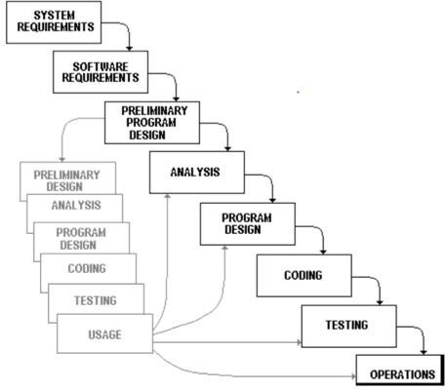

* **3.1.2) Project Plan**

|  |  |  |
| --- | --- | --- |
| **System Analysis** | **Duration** | **Resource Requirement** |
| System Design and Documentation | 3WEEK | All |
| Actual Development | 2 WEEK | All |
| Unit Testing | 2 WEEK | All |
| Integrated of System | 2 WEEK | All |
| Test case preparation | 3 WEEK | All |
| System Testing | 3 WEEK | All |
| Bug Fixing | 1 WEEK | All |

**3.2) Schedule Representation :**

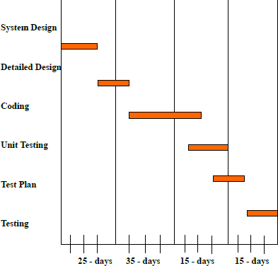

**4**

**Requirements Specification**

* 1. **HARDWARE REQUIREMENTS :**
* Android OS
* Android Minimum Os Version 5.0 Lolipop
* Android SmartPhone
* Ram 2GB
* Memory 512MB

#### SOFTWARE REQUIREMENTS :

* Windows XP, 7, 8, 10.
* Android Studio.
* SQLite Local Database.

# 5

**SYSTEM DESIGN**

#### Basic Flow Of System

* + **5.1.1) Use Case Diagram**

USER

TMDB API

SEND DATA BY API

SEARCH MOVIE

VIEW MOVIE DETAIL

VIEW TRENDING MOVIES

* **5.1.2) Data Flow Diagram**
  + **What is a Data Flow Diagrams(DFD)?**
    - Data flow diagrams are commonly used for understanding the system and can be effectively used for analysis. When you are designing an application system, you must first consider the flow of the data into the out of it. A DFD shows the flow of the data through a system. DFD does not show decision or timing of events.

USER

SIDE

VIEW MOVIE DETAILS

SEARCH MOVIES

VIEW MOVIES

#### System Procedural Design

* + - **5.2.1) Context Level Diagram**

MOVIEFOX

RESPONSE

REQUEST

TMDB API

**6**

**IMPLEMENTATION**

**6.1) Screen Layout :**

* **Trending Activity :**

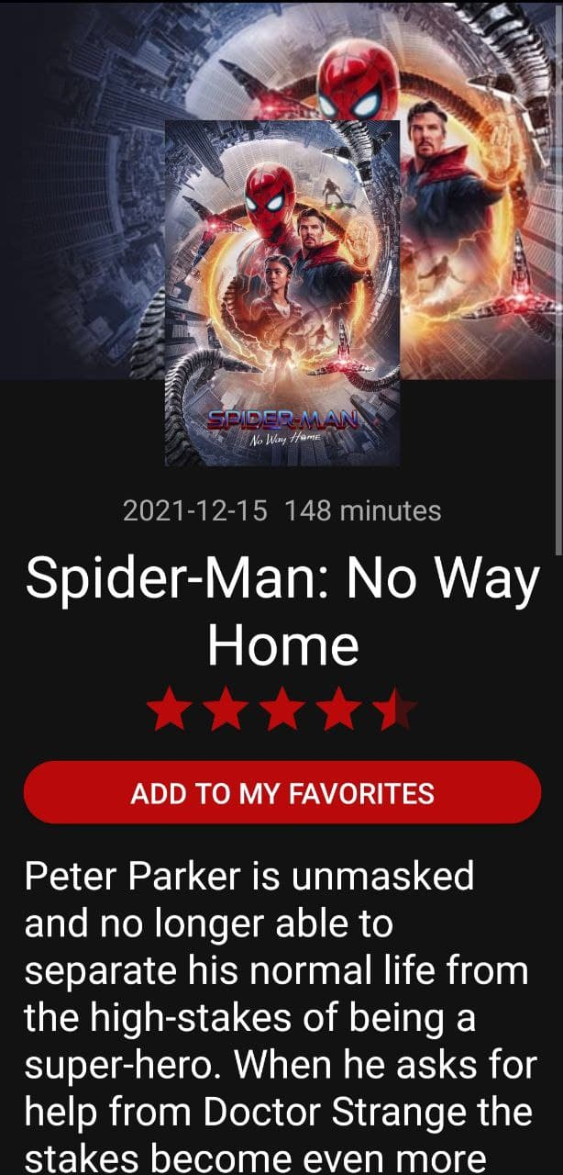

* **Movie Detail Activity :**



* **Cast Detail Activity :**

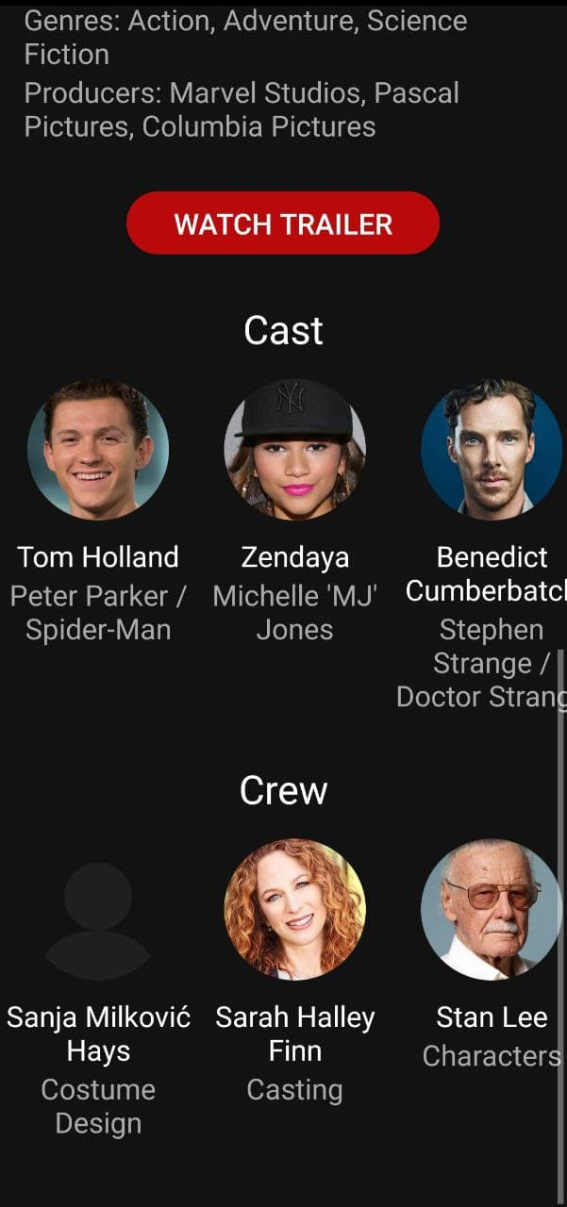

* **Search Activity:**

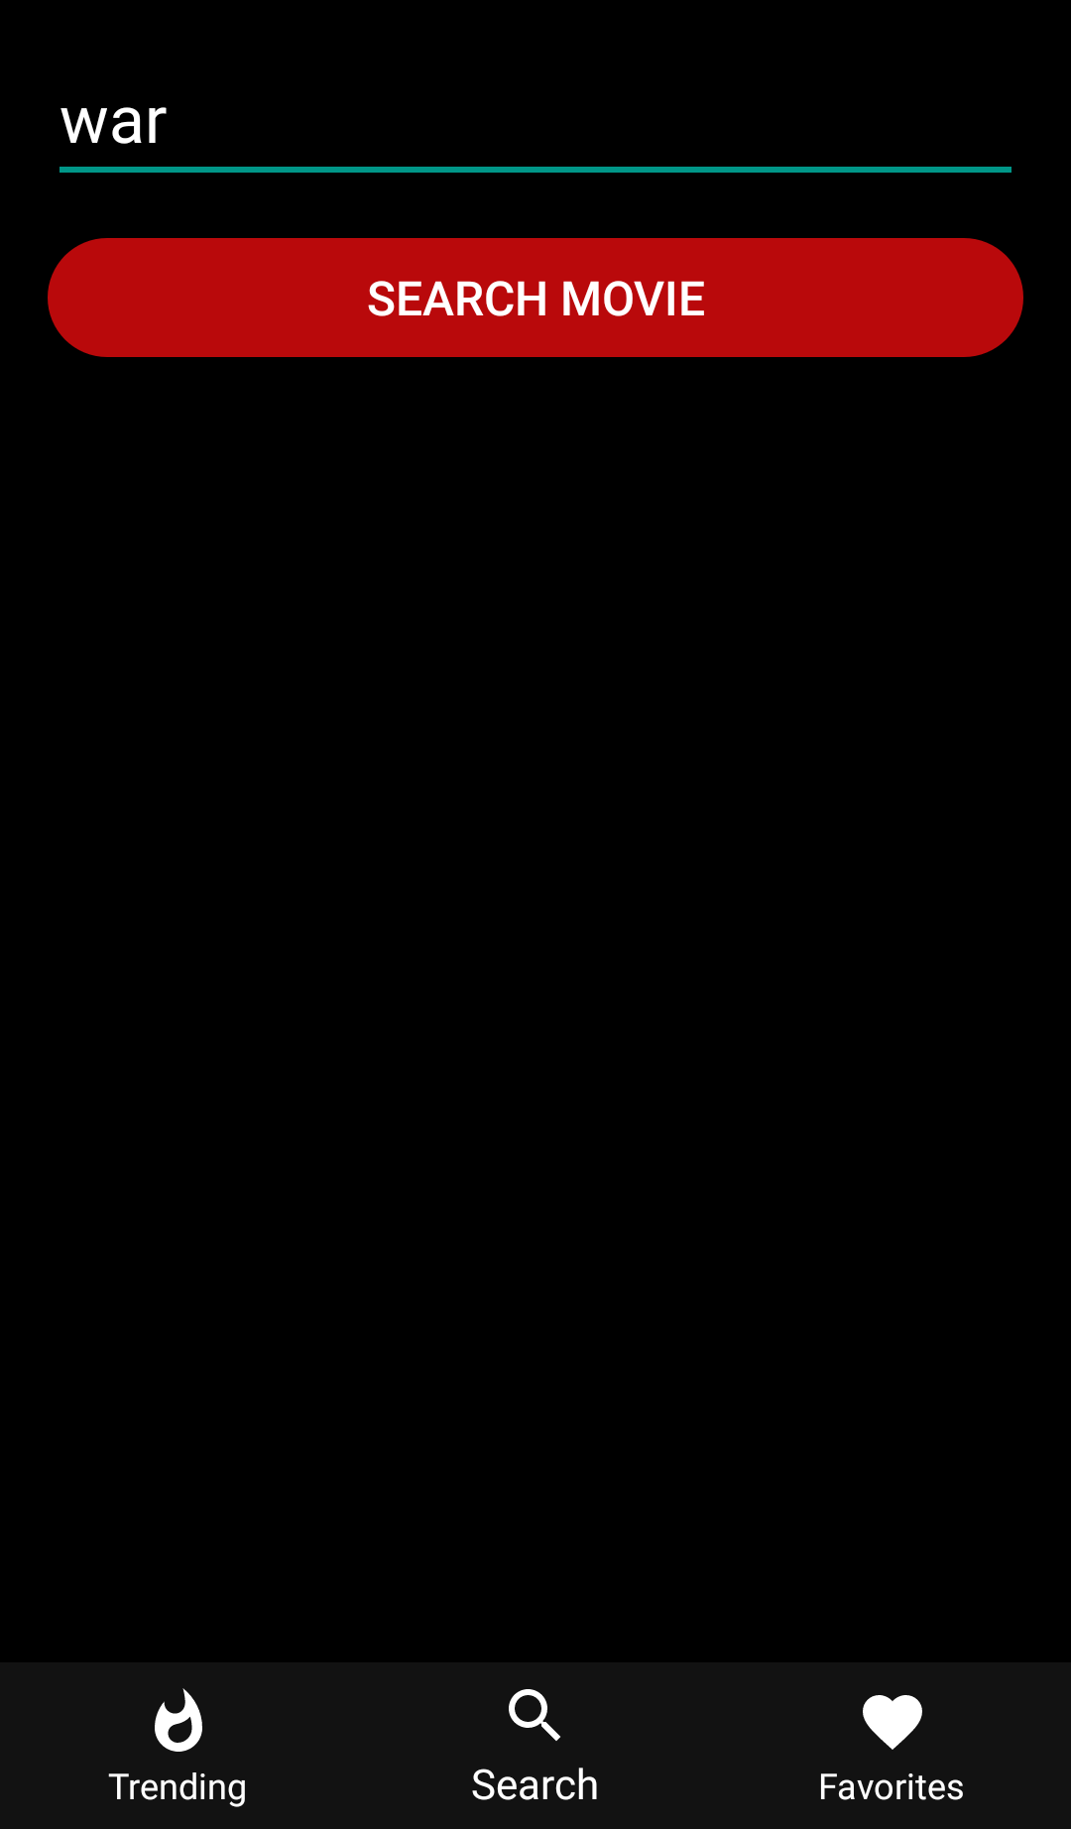

* **Search Result Activity:**

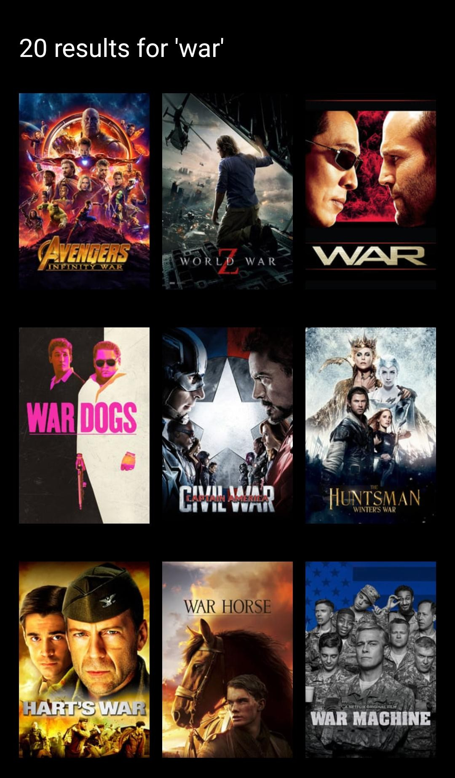

* **Favorites Activity:**

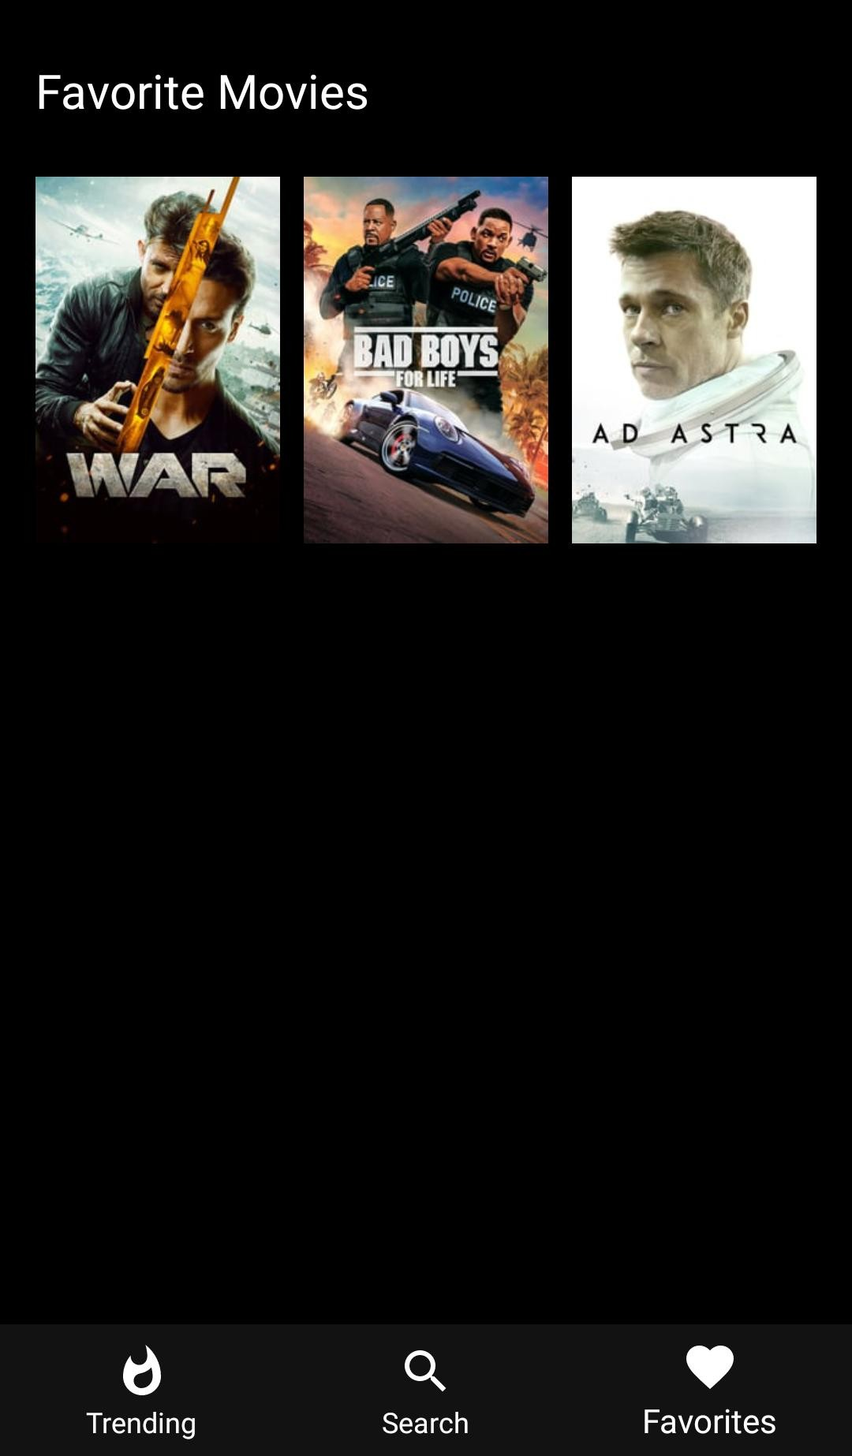

**7**

**TESTING**

* 1. **TESTING**
     + Testing is one of the important steps in system development. Software Testing also provides an objective, independent view of the software to allow the business to appreciate and understand the risks at implementation of the software. Test techniques include, but are not limited to, the process of executing a program or application with the intent of finding soft[warebugs.](http://en.wikipedia.org/wiki/Software_bugs)
     + Software Testing can also be stated as the process of validating and verifying that a software program/application/product:
       - Meets the business and technical requirements that guided its design and development.
       - Works as expected; and
       - Can be implemented with the same characteristics.
* Software Testing, depending on the testing method employed can be implemented at any time in the development process. However, most of the test effort occurs after the requirements have been defined and the coding process has been completed. As such, the methodology of the test is governed by the Software Development methodology adopted.

#### TESTING LEVELS :

* Tests are frequently grouped by where they are added in the software development process, or by the level of specificity of the test.
  + 1. **Unit Testing :**
       - Unit Testing refers to tests that verify the functionality of a specific section of code, usually at the function level. In an object-oriented environment, this is usually at the class level, and the minimal unit tests include the constructors and destructors.
       - These types of tests are usually written by developers as they work on code (white-box style), to ensure that the specific function is working as expected. One function might have multiple tests, to catch corner cases or other branches in the code. Unit testing alone cannot verify the functionality of a piece of software, but rather is used to assure that the building blocks the software uses work independently of each other.Unit testing is also called Component Testing.
    2. **Integration Testing :**
       - Integration Testing is any type of software testing that seeks to verify the interfaces between components against a software design. Software components may be integrated in an iterative way or all together ("big bang"). Normally the former is considered a better practice since it allows interface issues to be localized more quickly and fixed.
       - Integr[ation Testing work](http://en.wikipedia.org/wiki/Integration_testing)s to expose defects in the interfaces and interaction between integrated components (modules). Progressively larger groups of tested software components corresponding to elements of the architectural design are integrated and tested until the software works as a system.
    3. **System Testing :**
       - Sy[stem Testing tests](http://en.wikipedia.org/wiki/System_testing) a completely integrated system to verify that it meets its requirements.

#### TYPES OF TESTING :

* + 1. **Functional Testing :**
       - It is an approach to testing where the tests are derived from the program or component specification. The system is a black box whose behavior can only be determined by studying its inputs and the related outputs.
    2. **Structural Testing :**
       - Structural testing is an approach to testing where the tests are derived from knowledge of the software„s structure and implementation. This approach is sometimes called ‗white-box testing„ to distinguish from black –box testing.

# 8

**FUTURE WORK**

**9**

**CONCLUSION**

* I have developed *“MovieFox”* mobile applicationin order to overcome the difficulties in managing the existing manual system. The mobile application has been designed effectively keeping in mind, the possible future enhancement and additional functionality; it has been designed to run in an efficient way.
* The mobile application is designed to be very user-friendly and interactive manner so that the user cannot find any difficulty while browsing the website. Thereby the proposed website, which is an economically, technically and operationally feasible system has overcome the deficiency that was present in the manual system.

# 10

**REFERENCES**

* + This project was impossible to be a success without the support and help from the experience guide; the books and mainly the internet really prove it for us the “Information Highway”. Everything was really easy to find out on the internet.
  + **WEBSITE :**
    - [www.w3school.com](http://www.w3school.com/)
    - [www.stackoveflow.com](http://www.stackoveflow.com/)
    - [api.themoviedb.org](http://www.flipkart.com/)
    - [www.android.com](http://www.android.com/)