Pothole Detection & Dimension Estimation

In this project as per your instructions we are detecting and calculating dimension of pothole and this detection will work if pothole image are clear and it’s should be a pothole not a cracks in road or in any image.

To run project double click on ‘run.bat’ file to get below screen

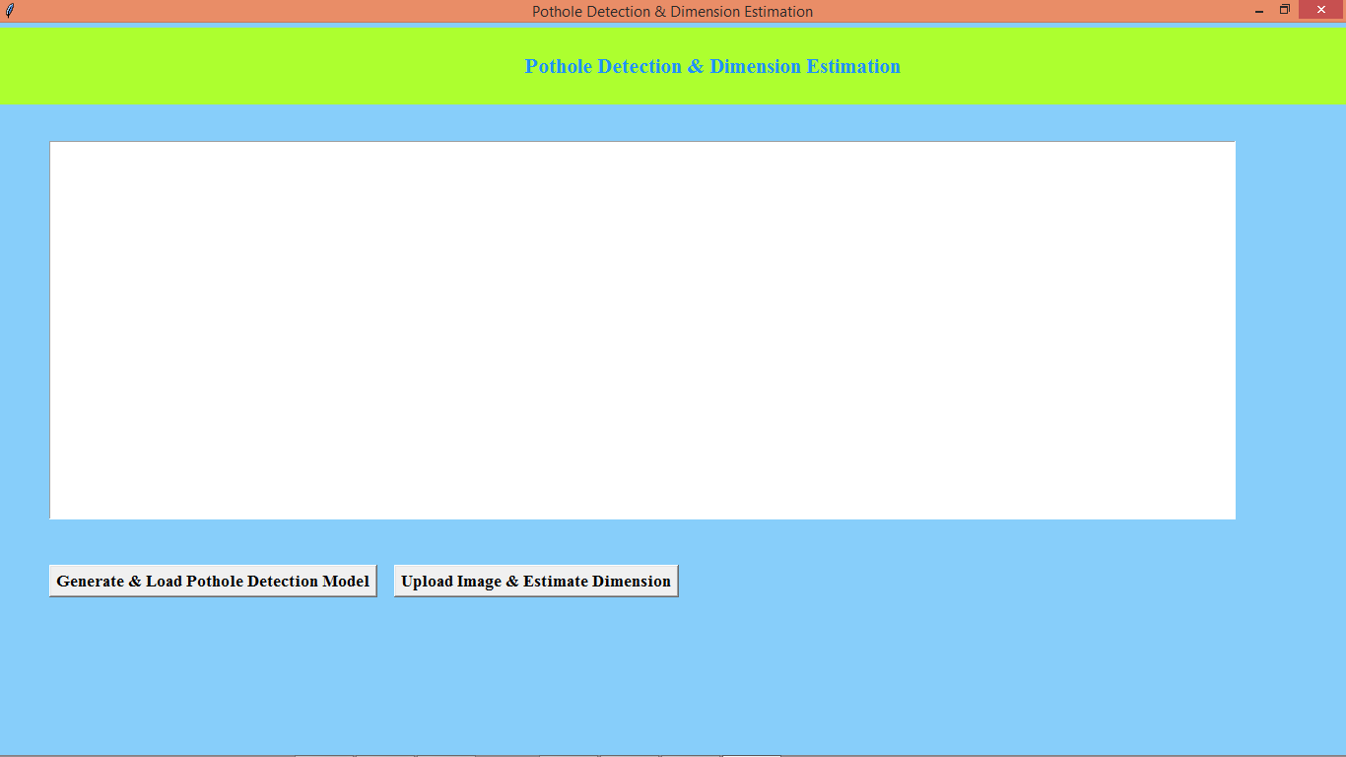

In above screen click on ‘Generate & Load Pothole Detection Model’ button to load model and get below output

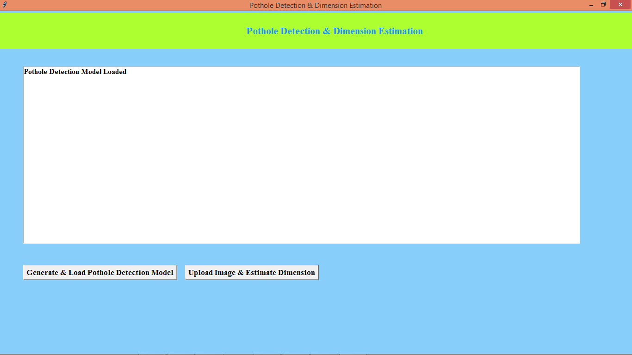

In above screen model is loaded and now click on ‘Upload Image & Estimate Dimension’ button to upload pothole image and get below output

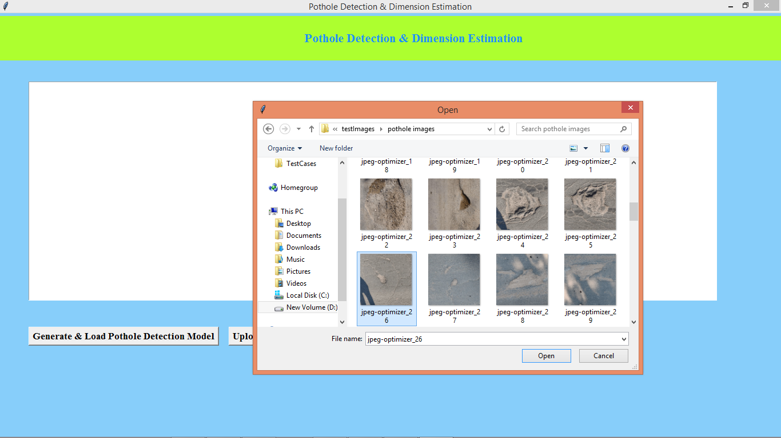

In above screen selecting and uploading sample image and then click on ‘Open’ button to load image and get below output

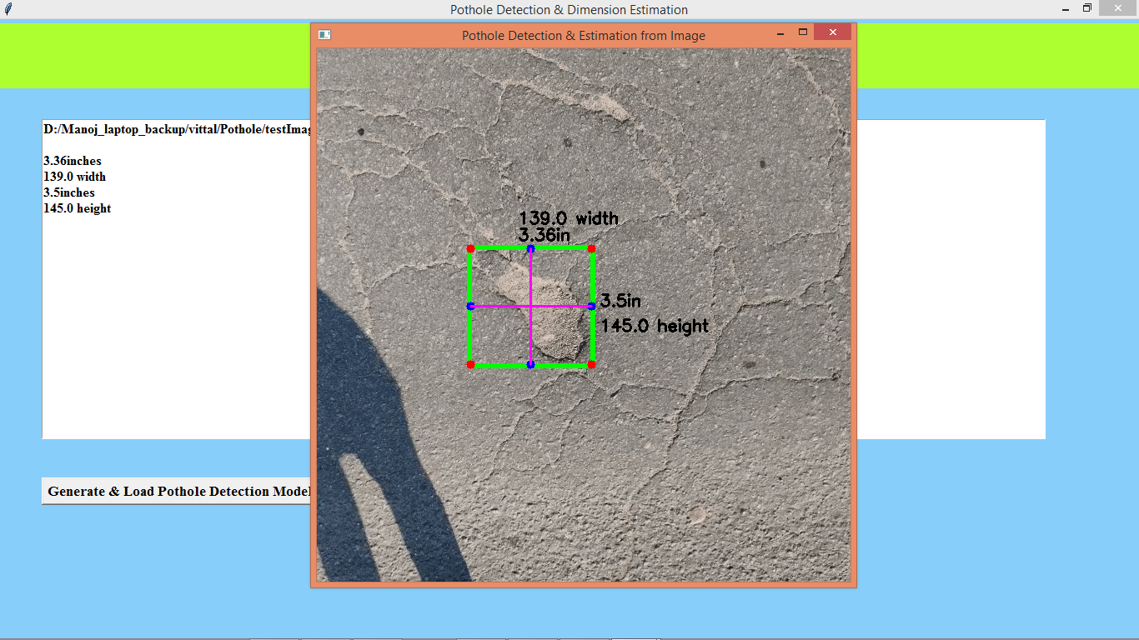

In above screen we can see height and width in pixels and in INCHES are calculated and in text area also we can see estimation details and similarly you can upload and test other images. From given images few images will not work as they are not Pothole images as just its looking like scratches or crack in road so such images will not work. Below is another sample

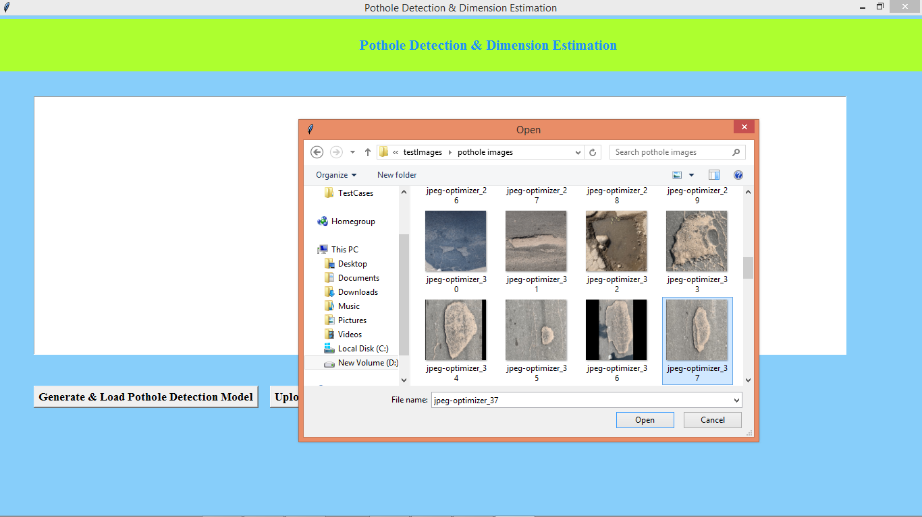

Above screen uploading another image

