**Project Team 1 –Bank Management System**

# Vivekananda Adepu

=

**Project Proposal:**

The objectives to develop a Bank Management System where a person’s account can be maintained by the bank. We aim to solve the financial applications of a customer in the banking environment in order to nurture the needs such as to apply for a credit card or to obtain a mortgage.

The scopefor the proposed system is very wide. It can be used for effective and efficient management in a variety of banking organizations. But, we aim to develop the proposed system for efficient processing of credit cards and mortgages. This would enable the bank to have a centralized system to handlecustomers.

**High level requirements:**

1. *Customer:* A customertable holds the details of him/her and also their contact information.
2. *Bank*: A Bank table can hold it’s name and address of it’s headquarters.
3. *Bank_Branch*: A Branch of a Bank records addresses and ID assigned to it.
4. *Account:* This table holds customer’s account details like the type of account and it’s associated ID, and also available balance.
5. *Loan:* The Loan table holds information pertaining loan number, the accepted amount and type of loan.

**High level conceptual design:**

### Entities:

* 1. Bank
  2. Bank_Branch
  3. Account
  4. Loan
  5. Customer

### Relationships:

1. **Bank***branches***Bank_Branch**.
2. **Bank_Branch** *maintains (Accts)* **Account**.
3. **Bank_Branch** *processes (loan)* **Loan.**
4. **Customer** holds (A_C) **Account**.
5. **Customer** borrows(L_C) **Loan.**

**The following represents ER-Diagram for the same:**

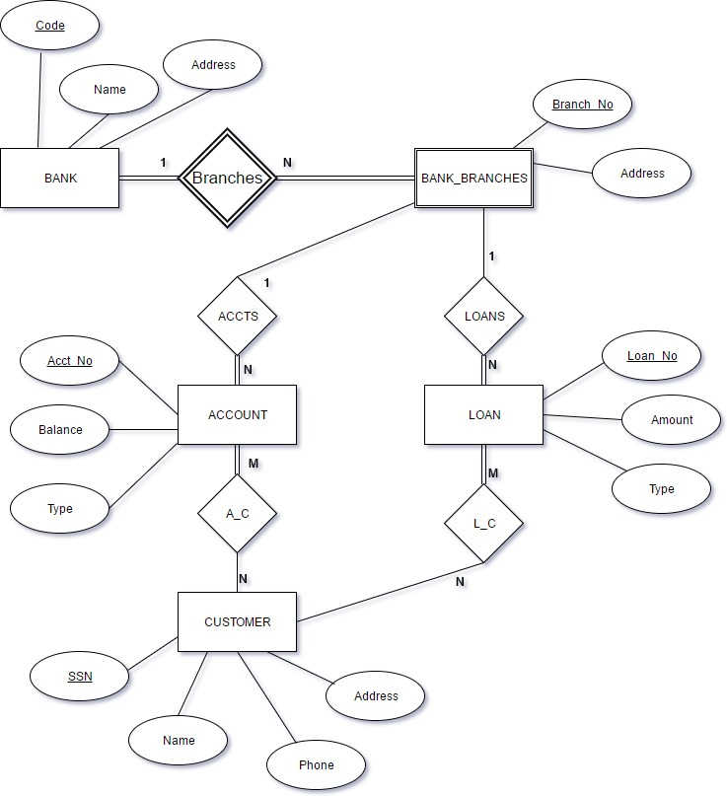

**The below image demonstrates the Fact Table and it’s respective Dimension Tables**

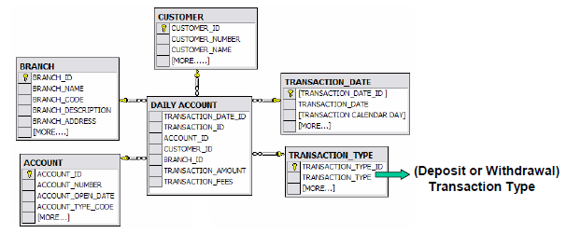

**CREDIT CARDS COMPANY**

**Database name:-** Credit Cards

**Tables/Entities ;-**

**Customers**:- Contains details about customers like name, address, email etc.

**Financial_tansactions** :- Contains details like transaction date, transaction amount etc.

**Ref_country_codes** :- Contains different country codes and country codes.

**Ref_transaction_types**:- Contains transaction type code and transaction type description.

**Merchants**:- Contains details about various Merchants like merchant name, merchant phone, merchant email etc.

**Customer_cards**:- Contains card type, card valid date etc.

**Ref_merchant_category**:- Contains merchant code and merchant category description.

**Ref_currency_codes**;- Contains currency code and currency description.

**Ref_card_types**:- Contains card type codes and card type description.

**Database ERR diagram**

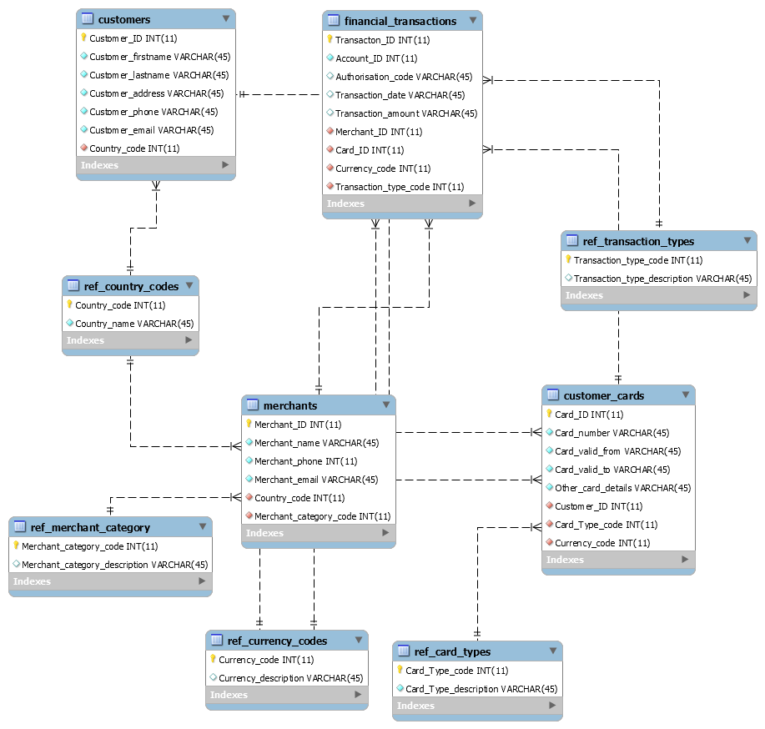

**Customer and customer cards fact table example**

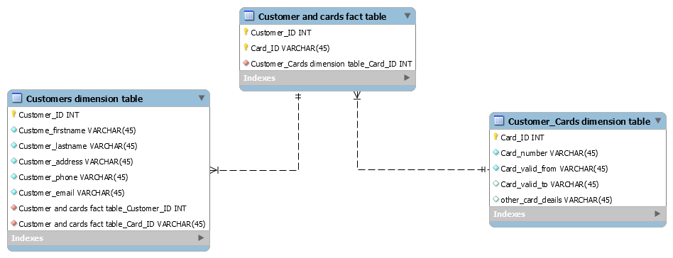

**Problem description:**

Mortgage provider has a set of tables that contain the data about the customer, percentage of interest, amount borrowed etc.,

**Database Overview:**

**Customer details:** Contains details about the customers.

**Monthly_min:** Contains minimum amount that must be paid per type of the loan.

**Pay-off-Time:** Contains the details of pay-off-timesinterest rates depending on the

**Repay:** Contains the amount repaid and installments paid till date.

**E-R diagram:**

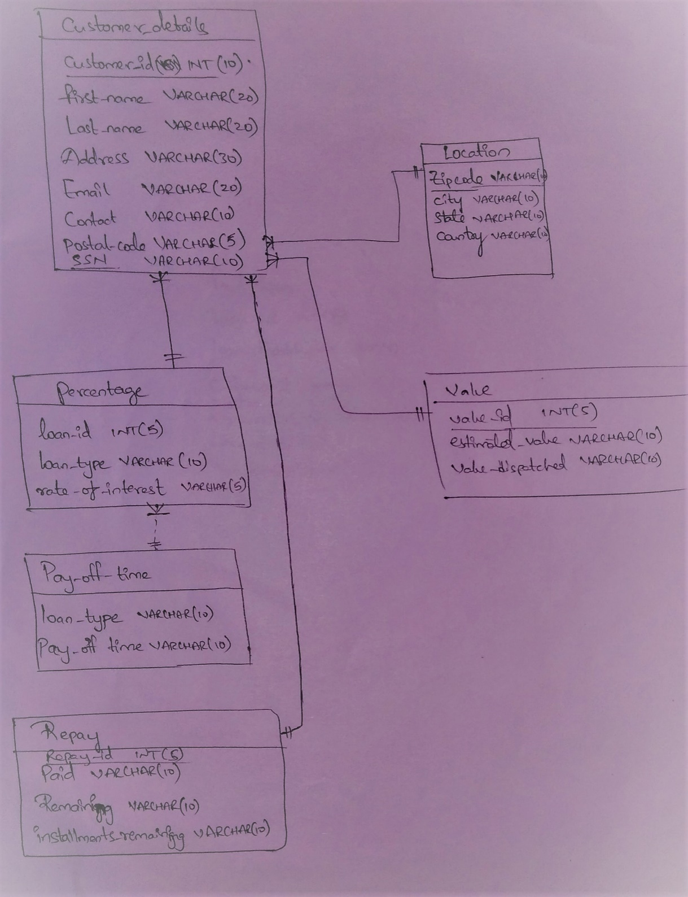

**Fact-dimension tables:**

