**Objectives**

* Explain the need and Benefits of component life cycle
* Identify various life cycle hook methods
* List the sequence of steps in rendering a component

In this hands-on lab, you will learn how to:

* Implement componentDidMount() hook
* Implementing componentDidCatch() life cycle hook.

## **Prerequisites**

The following is required to complete this hands-on lab:

* Node.js
* NPM
* Visual Studio Code

## **Notes**

Estimated time to complete this lab: **60 minutes.**

1. Create a new react application using *create-react-app* tool with the name as “blogapp”
2. Open the application using VS Code
3. Create a new file named as **Post.js** in **src folder** with following properties

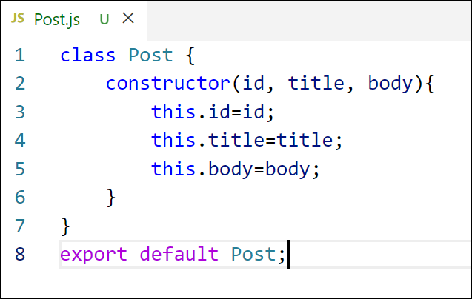

Figure 2: Post class

1. Create a new class based component named as **Posts** inside **Posts.js** file

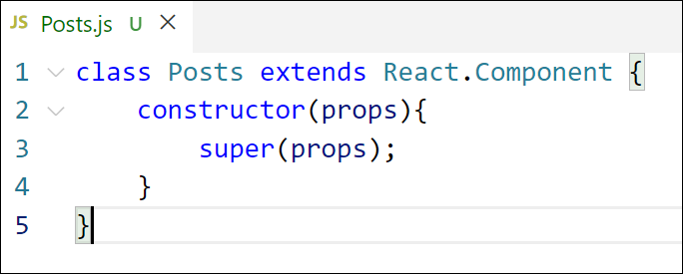

Figure 3: Posts Component

1. Initialize the component with a list of Post in state of the component using the constructor
2. Create a new method in component with the name as **loadPosts()** which will be responsible for using Fetch API and assign it to the component state created earlier. To get the posts use the url (<https://jsonplaceholder.typicode.com/posts>)

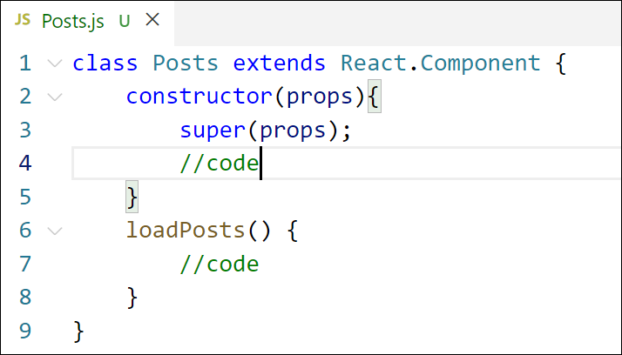

Figure 4: loadPosts() method

1. Implement the **componentDidMount()** hook to make calls to **loadPosts()** which will fetch the posts

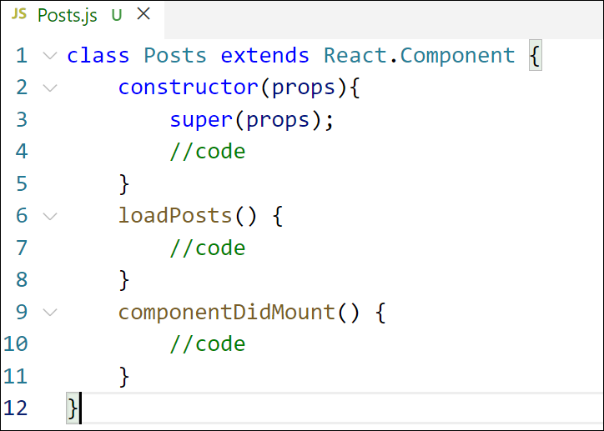

Figure 5: componentDidMount() hook

1. Implement the **render()** which will display the title and post of posts in html page using heading and paragraphs respectively.

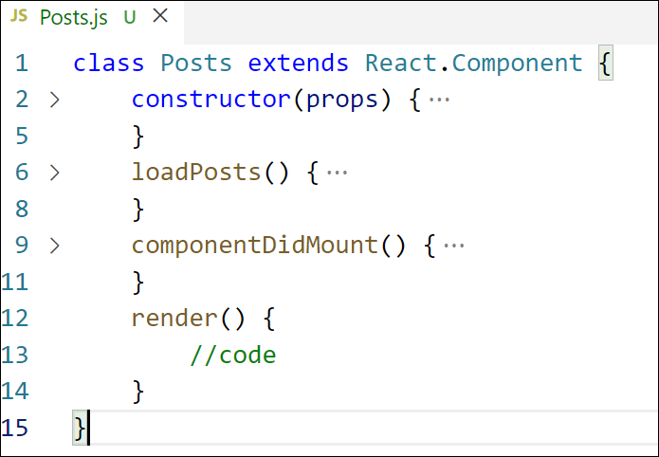

Figure 6: render() method

1. Define a **componentDidCatch()** method which will be responsible for displaying any error happing in the component as alert messages.

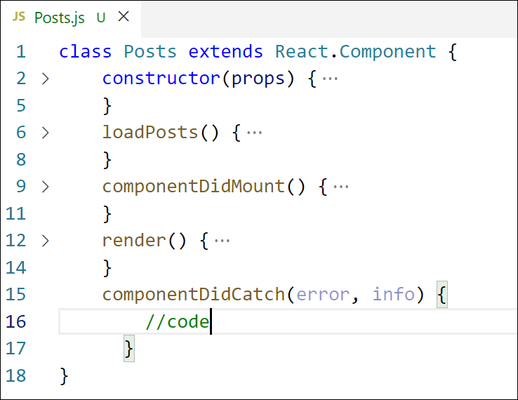

Figure 7: componentDidCatch() hook

1. Add the Posts component to App component.
2. Build and Run the application using *npm start* command.

### ****Need for Lifecycle Methods:****

React components go through different phases (mounting, updating, unmounting). Lifecycle methods allow developers to **hook into** these phases to perform actions like:

Fetching data from APIs.

Managing DOM interactions.

Setting timers or intervals.

Performing cleanup tasks.

### ****Benefits:****

**Controlled Component Behavior:** You can control what happens at each stage of the component's life.

**Data Fetching:** Fetch external data when the component loads (componentDidMount).

**Memory Management:** Clean up listeners/timers during unmounting (componentWillUnmount).

**Error Handling:** Catch and handle runtime errors gracefully (componentDidCatch).

**Optimization:** Update only when necessary using methods like shouldComponentUpdate.

## 2. ****Identify Various Lifecycle Hook Methods****

React lifecycle methods are mainly divided into **3 phases**:

### ****Mounting Phase**** (when component is created):

constructor()

static getDerivedStateFromProps()

render()

componentDidMount()

### ****Updating Phase**** (when props/state changes):

static getDerivedStateFromProps()

shouldComponentUpdate()

render()

getSnapshotBeforeUpdate()

componentDidUpdate()

### ****Unmounting Phase**** (when component is removed):

componentWillUnmount()

### ****Error Handling Phase****:

componentDidCatch(error, info)

## 3. ****List the Sequence of Steps in Rendering a Component****

### 🧭 ****Component Lifecycle Execution Order:****

#### ****Mounting (First render)****

constructor()

getDerivedStateFromProps()

render()

componentDidMount()

#### 🔁 ****Updating (Re-render on state/props change)****

getDerivedStateFromProps()

shouldComponentUpdate()

render()

getSnapshotBeforeUpdate()

componentDidUpdate()

#### ****Unmounting****

componentWillUnmount()

#### ****Error Handling (if something fails)****

componentDidCatch(error, info)

