WEEK 2 PROJECT REPORT
Creating Financial Forecasts
Daily closing-price forecasting using a 20-day moving average and linear regression
Dataset: 2018-05-01 to 2023-04-28 | 1,258 observations

1. Executive Summary
This project compares two simple forecasting models for daily closing prices. The dataset contains 1,258 observations. The first 1,006 observations were used for training and the final 252 for testing. The 20-day Moving Average produced MAE 848.33, RMSE 1,018.12, and MAPE 2.64%. Linear Regression produced MAE 4,072.70, RMSE 4,257.51, and MAPE 12.68%. By test RMSE, 20-day Moving Average performed better in this evaluation. Forecasts are educational estimates, not investment advice.

2. Objective and Indicator Selection
The goal is to implement a basic forecast, justify the design, test it on later unseen observations, and present a 30-business-day forecast. The target is daily closing price (Close), a widely used summary of the final traded price for a session and a field available in the Week 1 dataset.

3. Dataset and Preparation
The Excel workbook was loaded, dates were parsed, closing prices converted to numeric values, records sorted chronologically, and rows with invalid dates or missing closing prices removed. Duplicate dates were removed. The time order was preserved.
Dataset measure | Value
Observations | 1,258
Date range | 2018-05-01 to 2023-04-28
Training observations | 1,006 (80%)
Testing observations | 252 (20%)
First close | 24,099.05
Last close | 34,098.16
Endpoint change | 41.49%
Minimum close | 18,591.93 on 2020-03-23
Maximum close | 36,799.65 on 2022-01-04

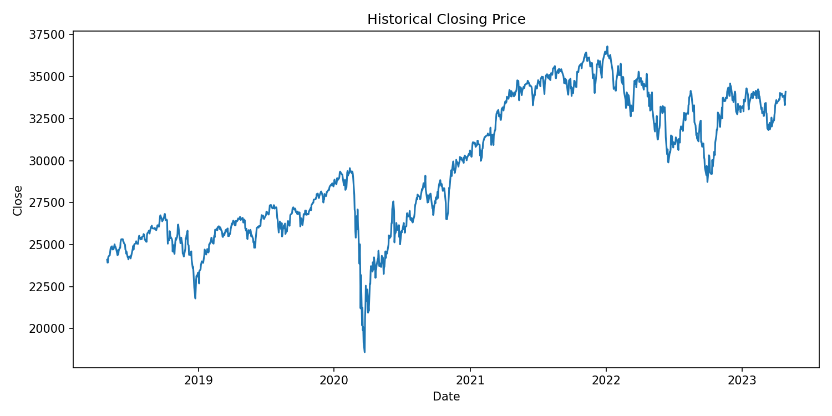
Figure 1. Historical closing price across the full dataset.

4. Model Design and Justification

4.1 20-day Moving Average
For each test date t, the prediction is the average of the 20 closing prices immediately before t: MA(t) = mean(Close[t−20] … Close[t−1]). This provides an interpretable baseline and smooths short-term fluctuations. During the test period, each forecast uses only prices already observed by that date. For the future forecast, predictions are fed back recursively into the recent history.

4.2 Linear Regression
The model is Close(t) = β₀ + β₁ × time index. The intercept and slope are estimated using only the training observations. The fitted slope is 12.2270 price units per observation. This method is transparent and captures a straight-line trend, but it cannot anticipate sudden changes or nonlinear patterns.

4.3 Why a chronological split?
The first 80% of observations were used for training and the final 20% for testing. A random split was avoided because mixing past and future dates can create an unrealistic time-series evaluation and risk information leakage.
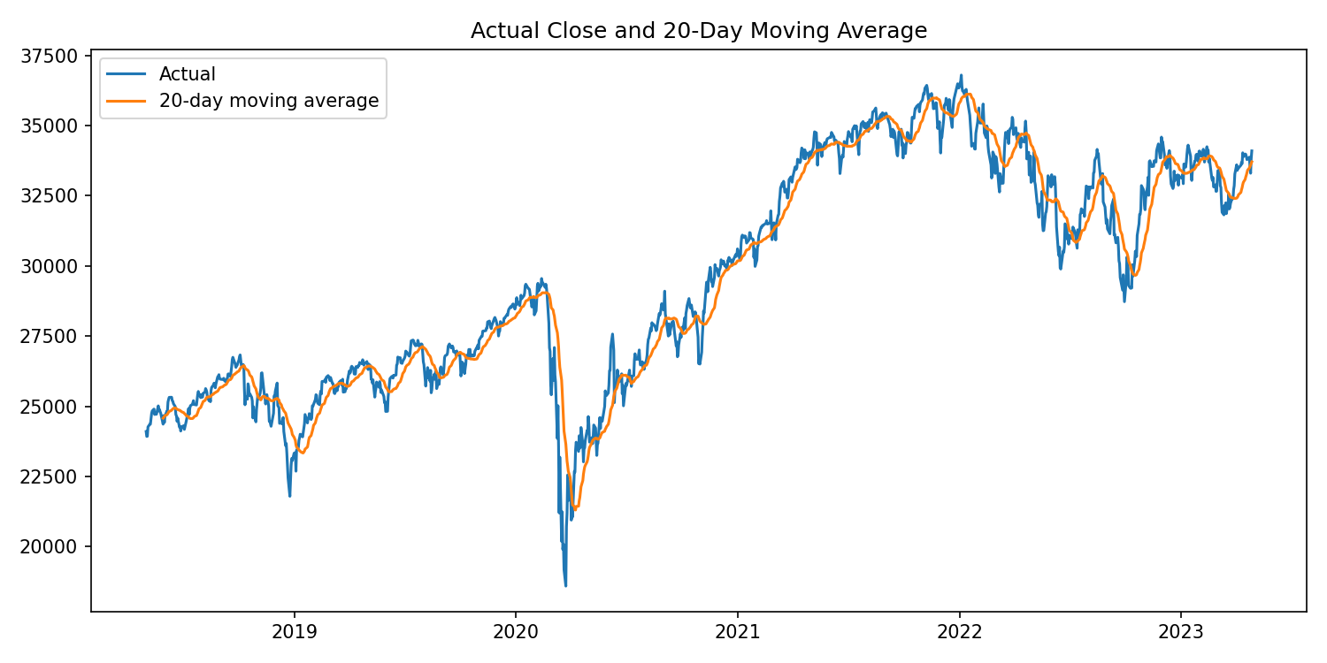
Figure 2. Actual closing price and 20-day moving average.

5. Model Evaluation
MAE is the mean absolute prediction error. RMSE is the square root of the mean squared error and penalizes large errors more strongly. MAPE is the mean absolute percentage error. Lower values indicate better test performance for a given metric. All metrics below are calculated on the same held-out dates.
Model | MAE | RMSE | MAPE
20-day Moving Average | 848.33 | 1,018.12 | 2.64%
Linear Regression | 4,072.70 | 4,257.51 | 12.68%

The lower-RMSE model in this test is 20-day Moving Average. This result is limited to the selected historical test window and does not prove that the same model will perform best in future market conditions.
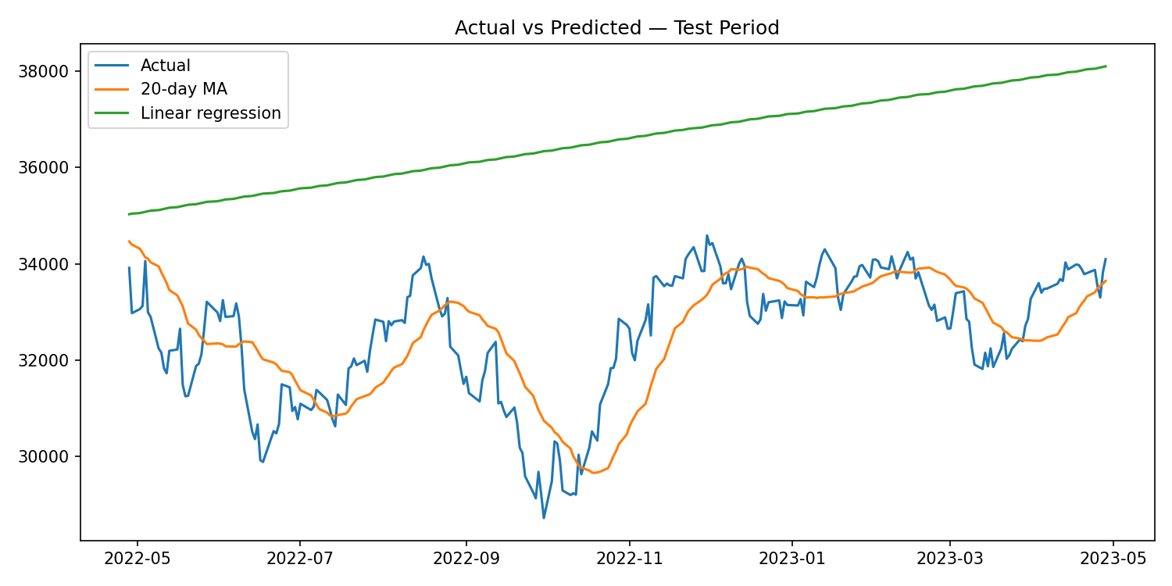
Figure 3. Actual closing prices compared with model predictions during the test period.
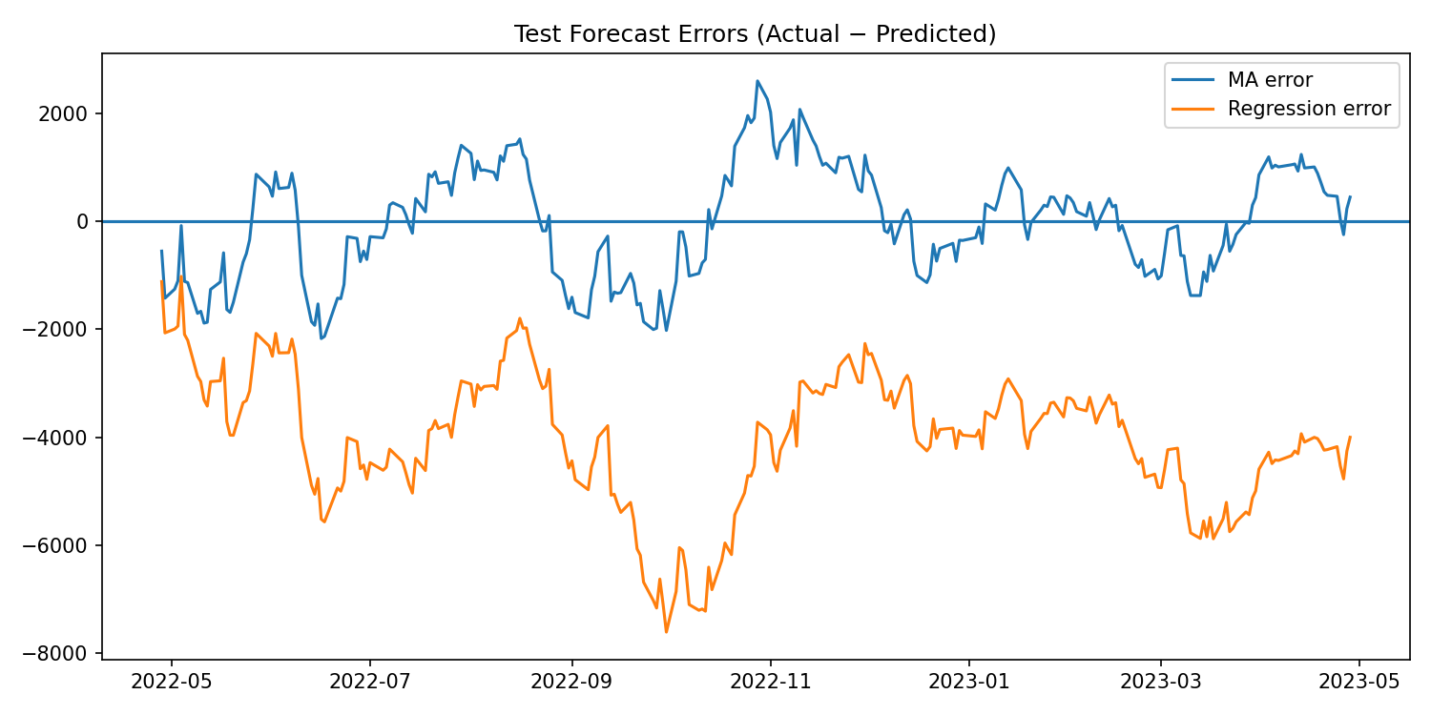
Figure 4. Forecast errors (actual minus predicted); positive values indicate underprediction.

6. Forecast for the Next 30 Trading Days
Forecast dates begin after the last date in the supplied dataset. Business-day dates are used as an approximation and do not account for exchange-specific holidays. The moving average recursively smooths recent prices, while linear regression extends the training-period trend. The average of both paths is shown as a comparison, not as a separately validated model.
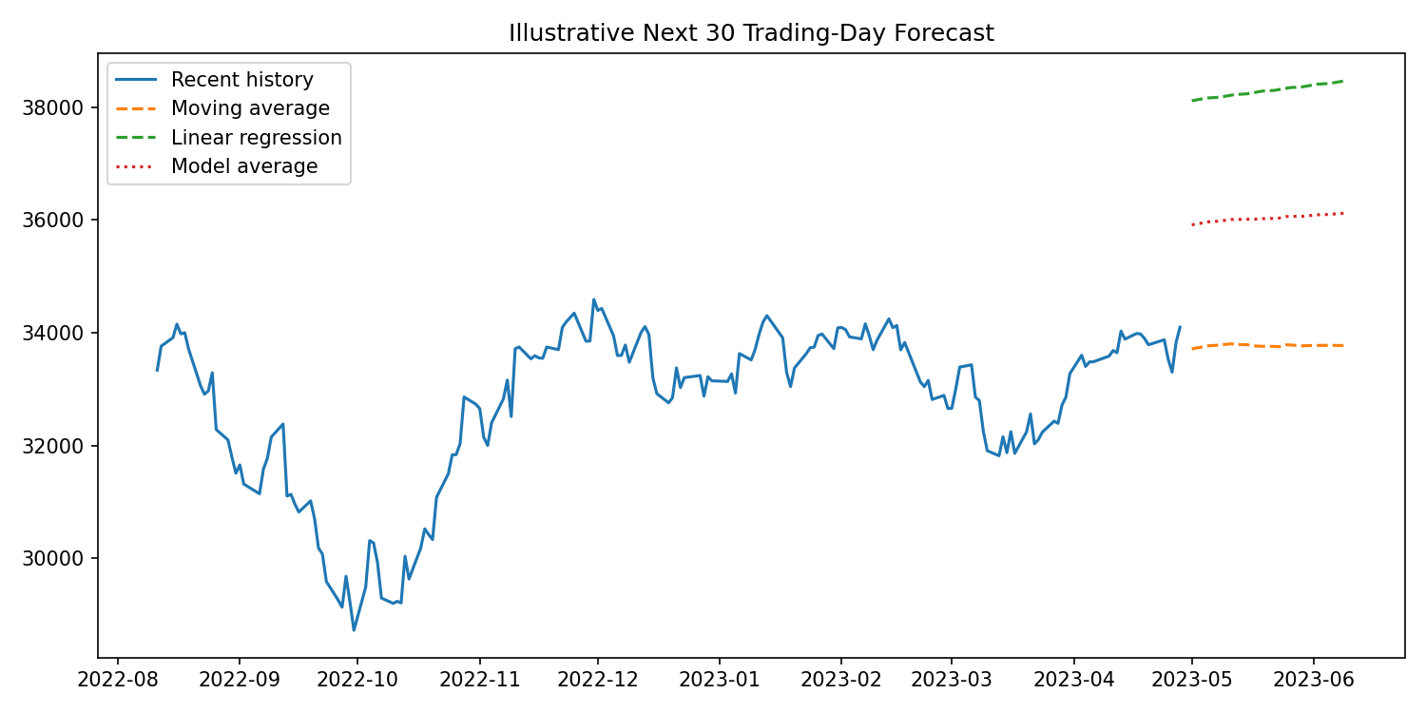
Figure 5. Illustrative 30-business-day forecast.
Forecast date | 20-day MA | Linear regression | Average of models
2023-05-01 | 33,708.42 | 38,112.08 | 35,910.25
2023-05-02 | 33,730.14 | 38,124.30 | 35,927.22
2023-05-03 | 33,736.59 | 38,136.53 | 35,936.56
2023-05-04 | 33,753.30 | 38,148.76 | 35,951.03
2023-05-05 | 33,766.83 | 38,160.98 | 35,963.91
2023-05-08 | 33,780.90 | 38,173.21 | 35,977.06
2023-05-09 | 33,790.62 | 38,185.44 | 35,988.03
2023-05-10 | 33,795.91 | 38,197.67 | 35,996.79
2023-05-11 | 33,803.38 | 38,209.89 | 36,006.64
2023-05-12 | 33,792.07 | 38,222.12 | 36,007.09
2023-05-15 | 33,787.35 | 38,234.35 | 36,010.85
2023-05-16 | 33,777.36 | 38,246.57 | 36,011.97
2023-05-17 | 33,767.39 | 38,258.80 | 36,013.10
2023-05-18 | 33,760.91 | 38,271.03 | 36,015.97
2023-05-19 | 33,759.63 | 38,283.25 | 36,021.44
2023-05-22 | 33,757.16 | 38,295.48 | 36,026.32
2023-05-23 | 33,751.25 | 38,307.71 | 36,029.48
2023-05-24 | 33,762.27 | 38,319.93 | 36,041.10
2023-05-25 | 33,785.29 | 38,332.16 | 36,058.73
2023-05-26 | 33,783.25 | 38,344.39 | 36,063.82
2023-05-29 | 33,767.50 | 38,356.62 | 36,062.06
2023-05-30 | 33,770.46 | 38,368.84 | 36,069.65
2023-05-31 | 33,772.47 | 38,381.07 | 36,076.77
2023-06-01 | 33,774.27 | 38,393.30 | 36,083.78
2023-06-02 | 33,775.31 | 38,405.52 | 36,090.42
2023-06-05 | 33,775.74 | 38,417.75 | 36,096.74
2023-06-06 | 33,775.48 | 38,429.98 | 36,102.73
2023-06-07 | 33,774.72 | 38,442.20 | 36,108.46
2023-06-08 | 33,773.66 | 38,454.43 | 36,114.05
2023-06-09 | 33,772.18 | 38,466.66 | 36,119.42

The moving-average path begins at 33,708.42 and ends at 33,772.18. The regression path begins at 38,112.08 and ends at 38,466.66. Differences arise because the models rely on different assumptions; they are not a guaranteed range for future prices.

7. Interpretation of Results
The closing price changed 41.49% between the first and last observations, but endpoint change alone does not explain the intervening volatility. The test scores show 20-day Moving Average had the lower RMSE in the selected holdout. The moving average reacts to recent observations but tends to lag during sharp changes; linear regression follows a fixed trend and can miss turning points. Divergence in future paths demonstrates how model assumptions affect forecasts.

8. Limitations and Responsible Use
- Only historical closing prices are used; macroeconomic variables, fundamentals, interest rates, news, sentiment and other market drivers are excluded.
- Linear regression assumes a constant linear trend, while financial markets can change regime and behave nonlinearly.
- A moving average is lagging and cannot predict unexpected shocks.
- Business-day forecast dates do not account for exchange-specific holidays.
- Historical test performance is not a guarantee of future performance. These results are for education and are not investment advice.

9. Conclusion
This project demonstrates a reproducible forecasting workflow: clean the dataset, preserve chronological order, fit two interpretable models, compare their test errors, and communicate a future forecast with limitations. 20-day Moving Average had the lower RMSE in this evaluation. The main lesson is to justify model design, test on unseen later data, and explain uncertainty rather than treating forecasts as certain.

Appendix: Reproducibility
The project folder includes the cleaned dataset, Python script, Jupyter notebook, five charts, CSV outputs and this report. Install requirements.txt, then run `python src/financial_forecasting.py` from the repository root.

