**1.Array Implementation of a list**

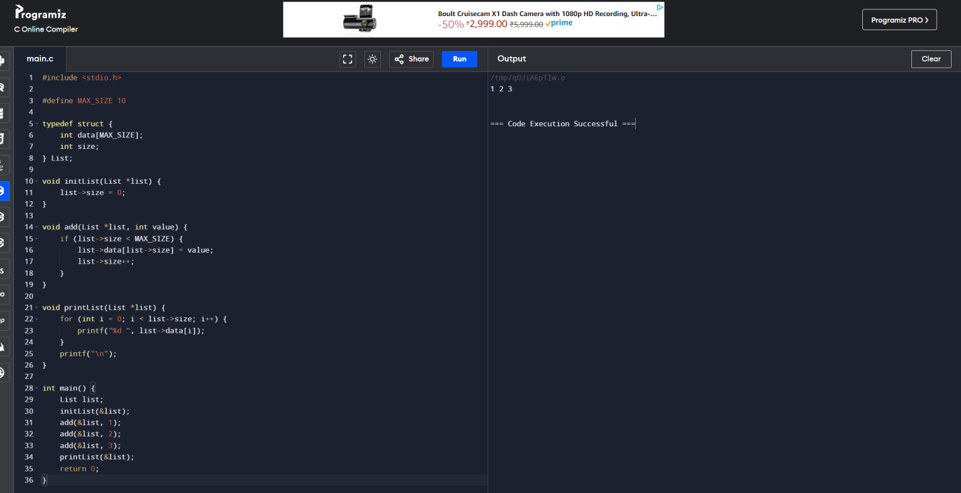

**2.Linked List implementation of a List**

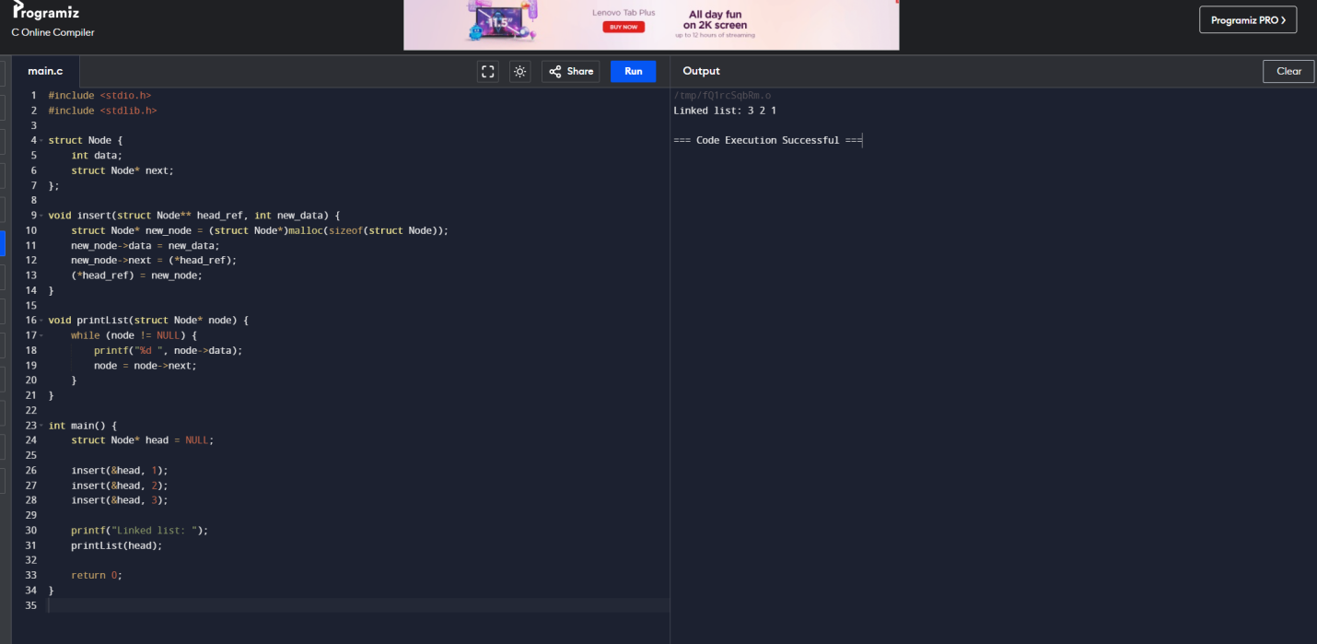

**3. Implement Circular Linked list using C**

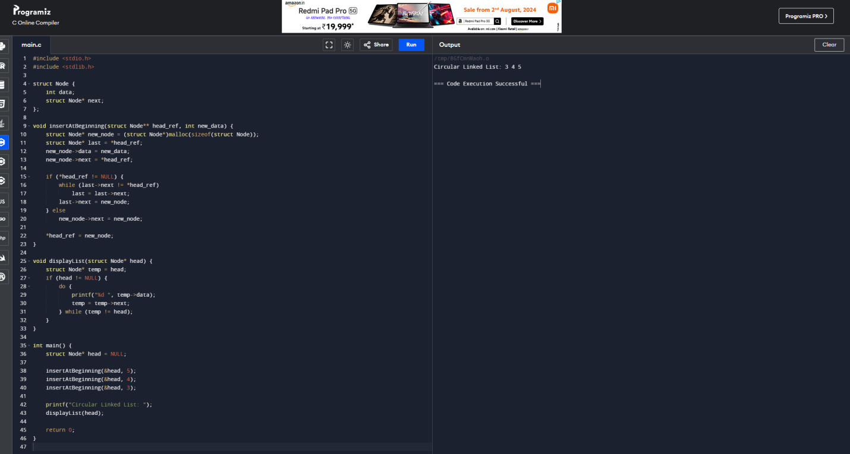

**4.Implement doubly linked list using C**

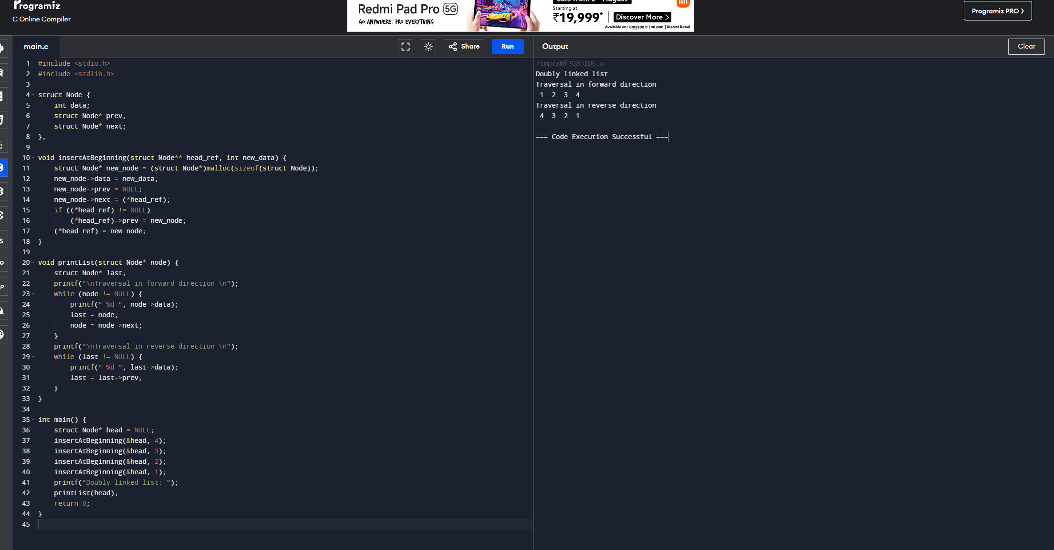

**5.Implement circular doubly linked list using C**

**7. Implement a stack and using an array**

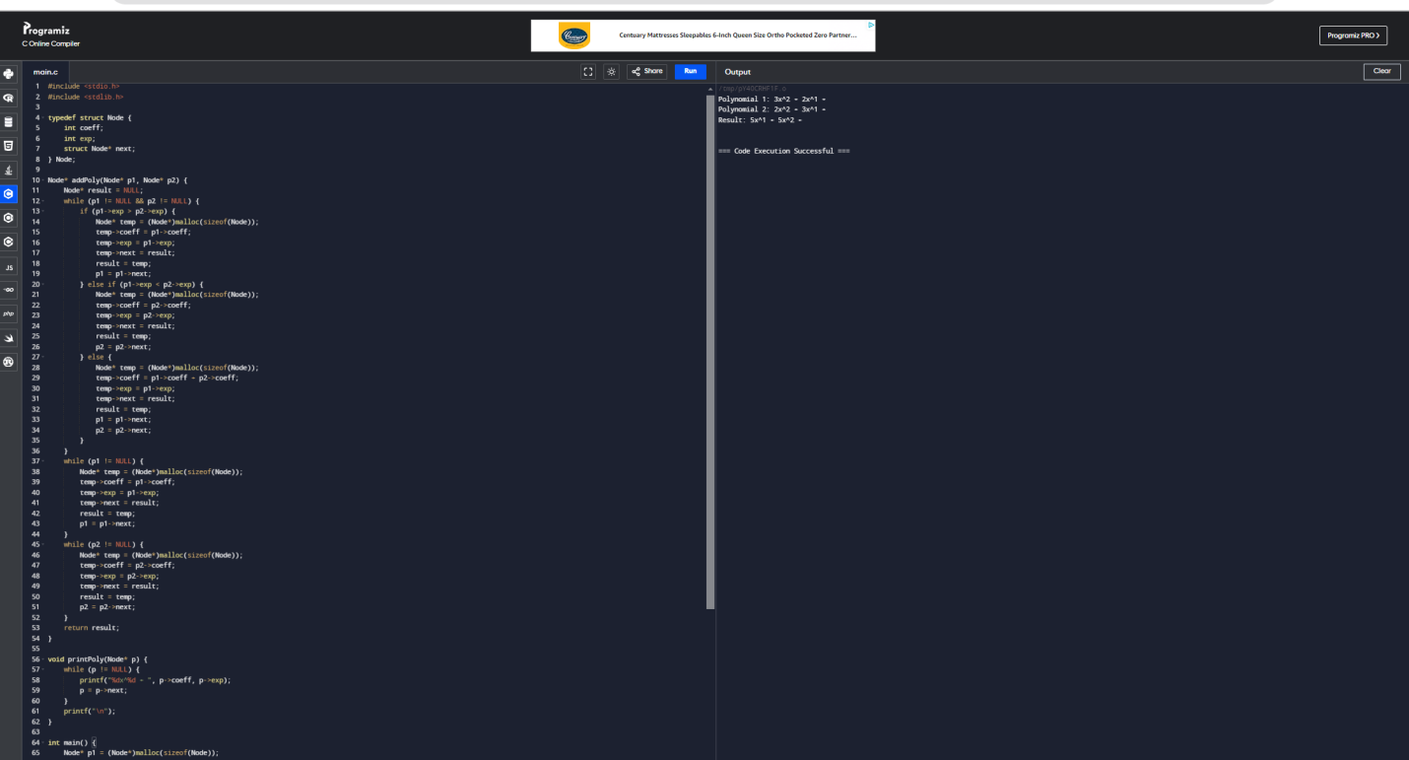

**8. Implement a stack using linked list**

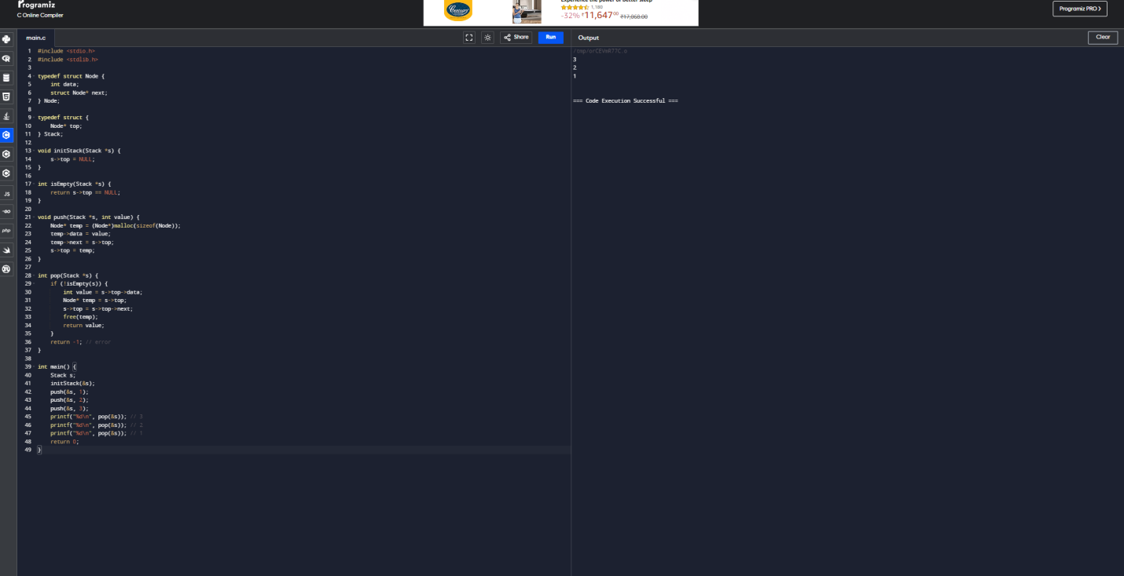

**9. Write a C program to convert infix expression to postfix expression**

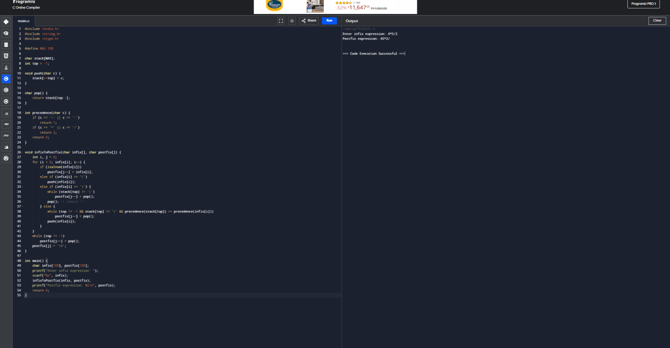

**10. Write a C program to evaluate a postfix expression**

