**Easiest way to clone a git repository**

1. **Create a new folder on local machine , like c:/git/src**
2. **Go to src folder location and open cmd or use git bash tool**
3. **git clone** [**https://github.com/XXXXX/XXXXX.git**](https://github.com/XXXXX/XXXXX.git) **, here XXXXX denotes the name of git folder , as shown below in picture**

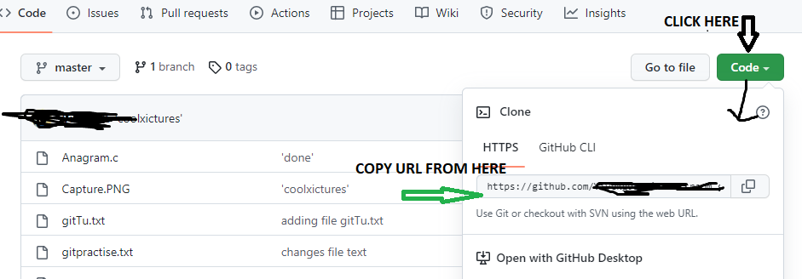

1. **All repository will be displayed here, as shown in picture**

