1. Go to **File -> New Project**. Select **Java Web in categories** and **Web** **Application in Projects. Click on Next** to create web based project.

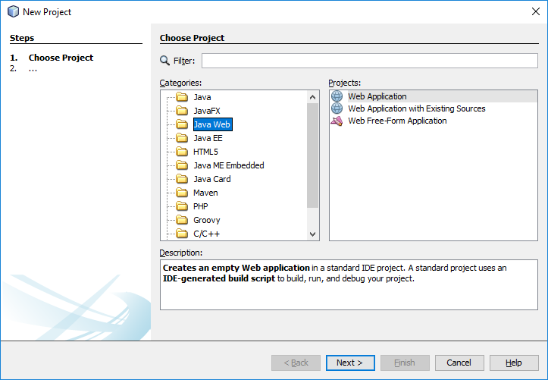

1. Enter a project name whatever you want and then click on **Next**. On next page click **Finish**.

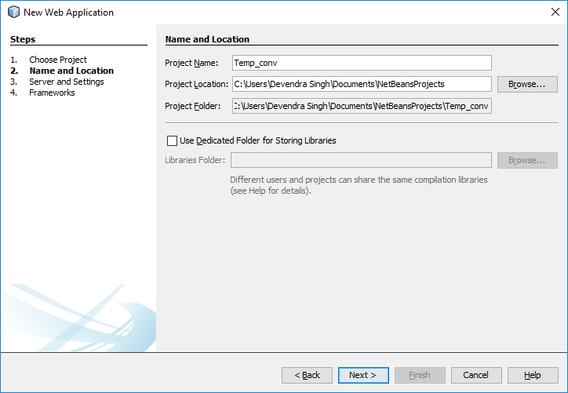

1. After completion of project creation process a window will appear like below.

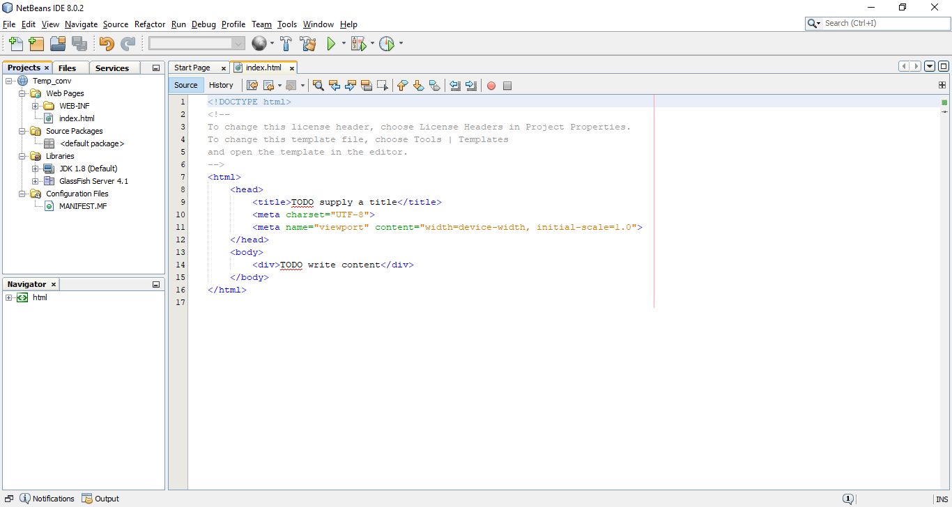

1. Create web service.

**Right click on Project -> New -> Web Service**

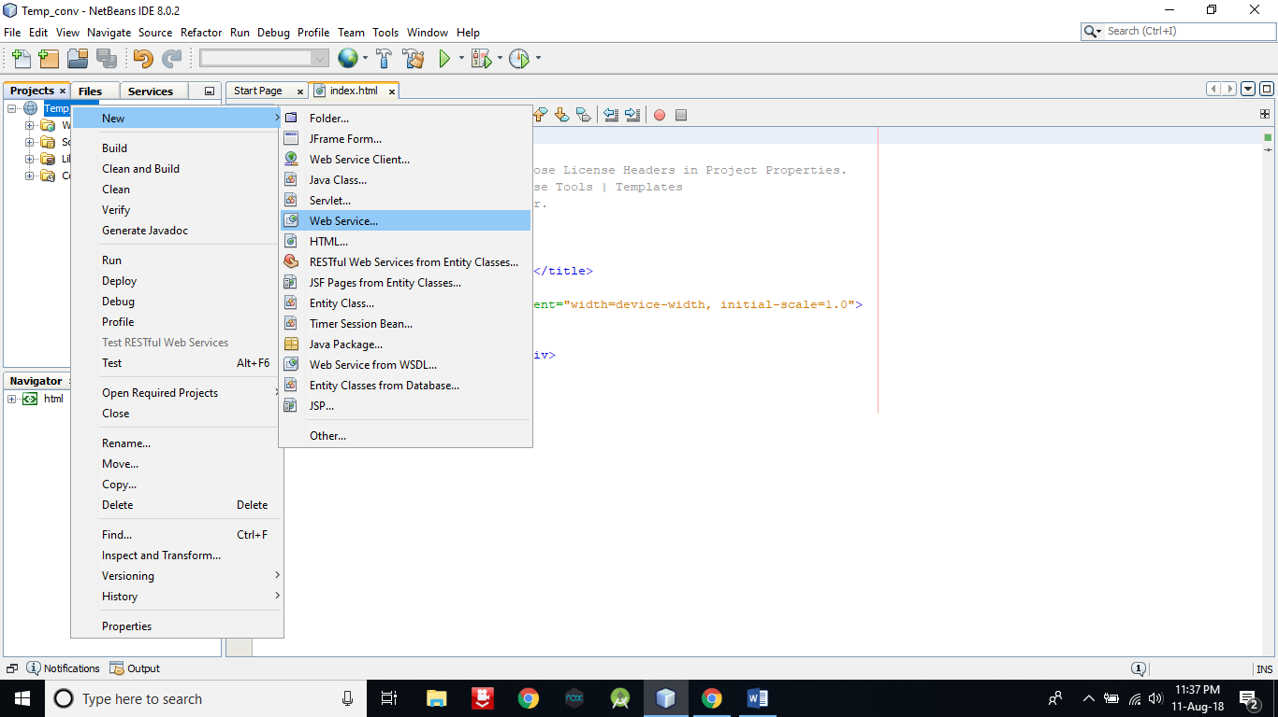

1. **Enter a Web Service Name** **and package name** and then **click on Finish** to create a Web Service.

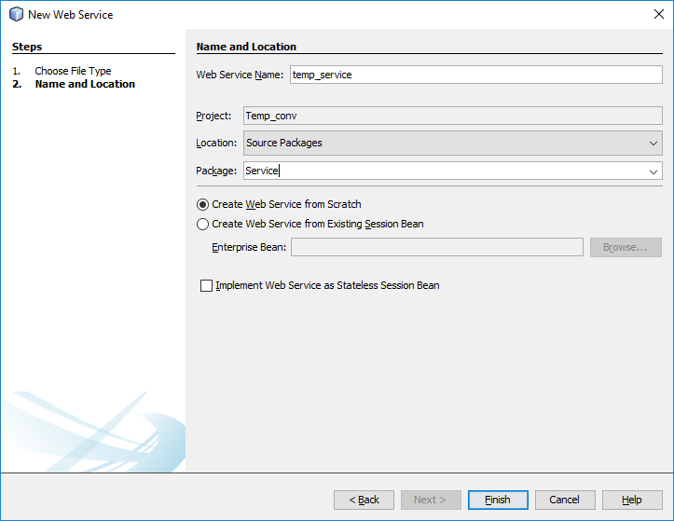

1. As you can see in following pic; In **Source Packages** there is a package **Service** which contains the service file **temp_service.java**. Open this file by double click on it, So that we can add two operation that will convert temperature from celcious to farhenheit and vice-versa.

Go to design mode by click on **Design** .

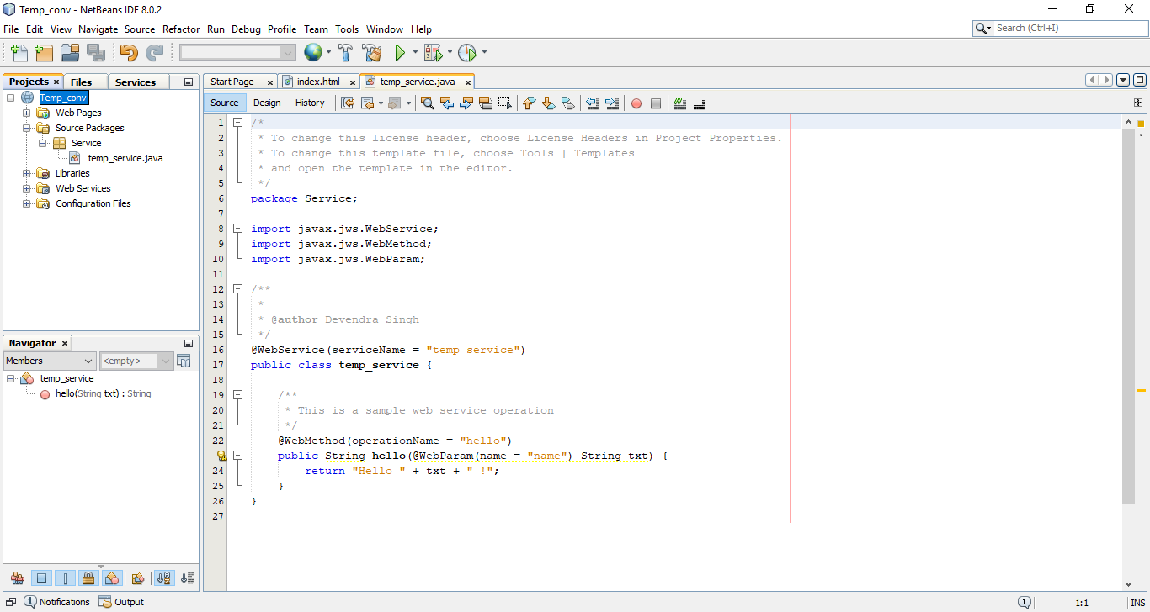

1. **Click on Add Operation** to add operation.

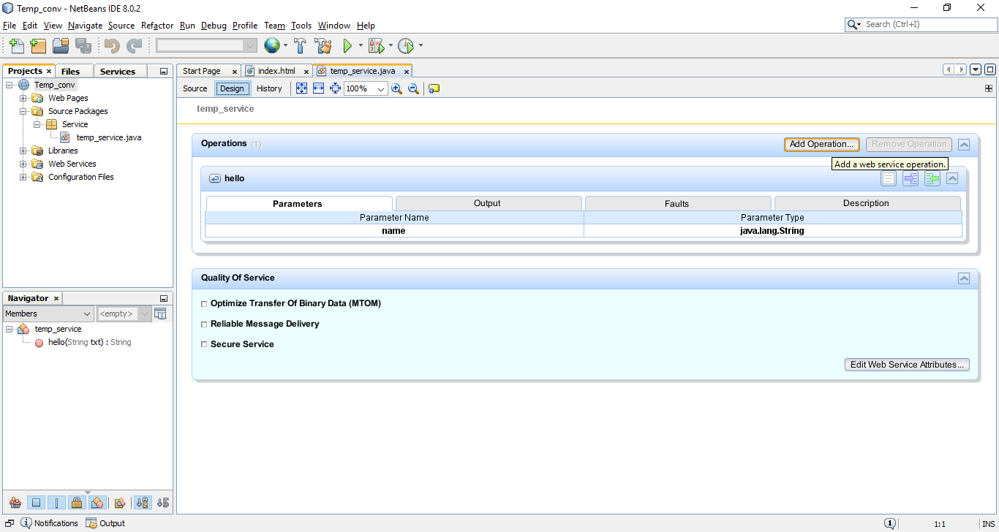

1. Give Operation name **F_to_C** and return type as **Double**. So this method will return value in Double data type. After that click on **Add** button to give parameters for method. Give its name as **f** and type as **Double** and then click on **OK** button. Your one operation is now successfully created.

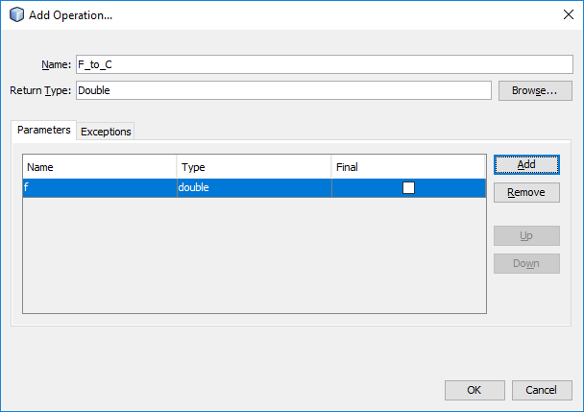

1. **Repeat step 7 & 8** to create second operation. But this time replace some above entered data with following data.

**F_to_C -> C_to_F**

**f -> c**

1. Now go to source mode by click on **Source** and **delete the selected** segment of code. Because it is default operation and we don’t need this.

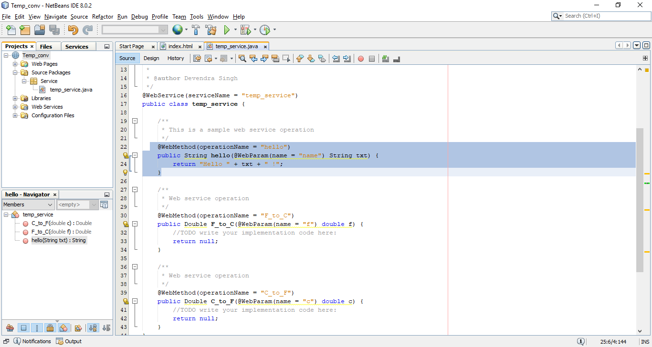

1. Now **replace the selected area with following code** to convert Fahrenheit to Celsius.

Double c = (f-32)*1.8;

return c;

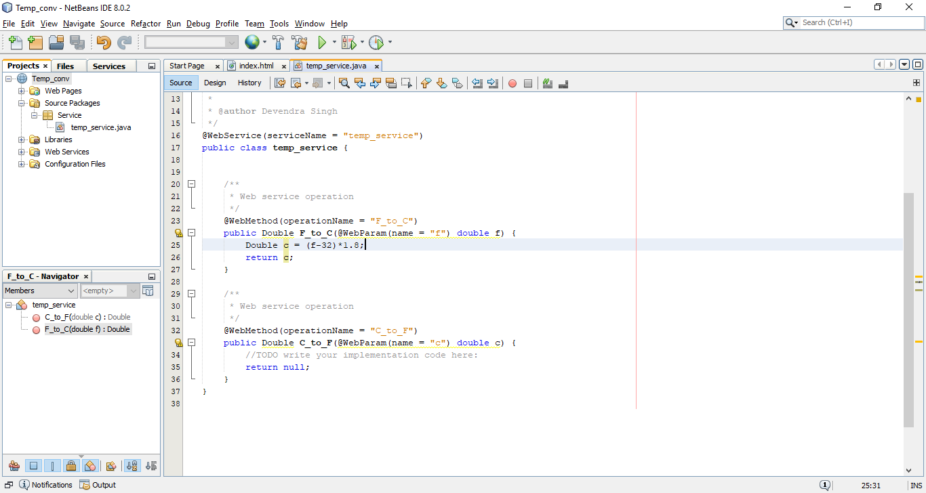

1. Now **replace the selected area with following code** to convert Celsius to Fahrenheit and then press Ctrl+S to save.

Double f = (c*1.8)+32;

return f;

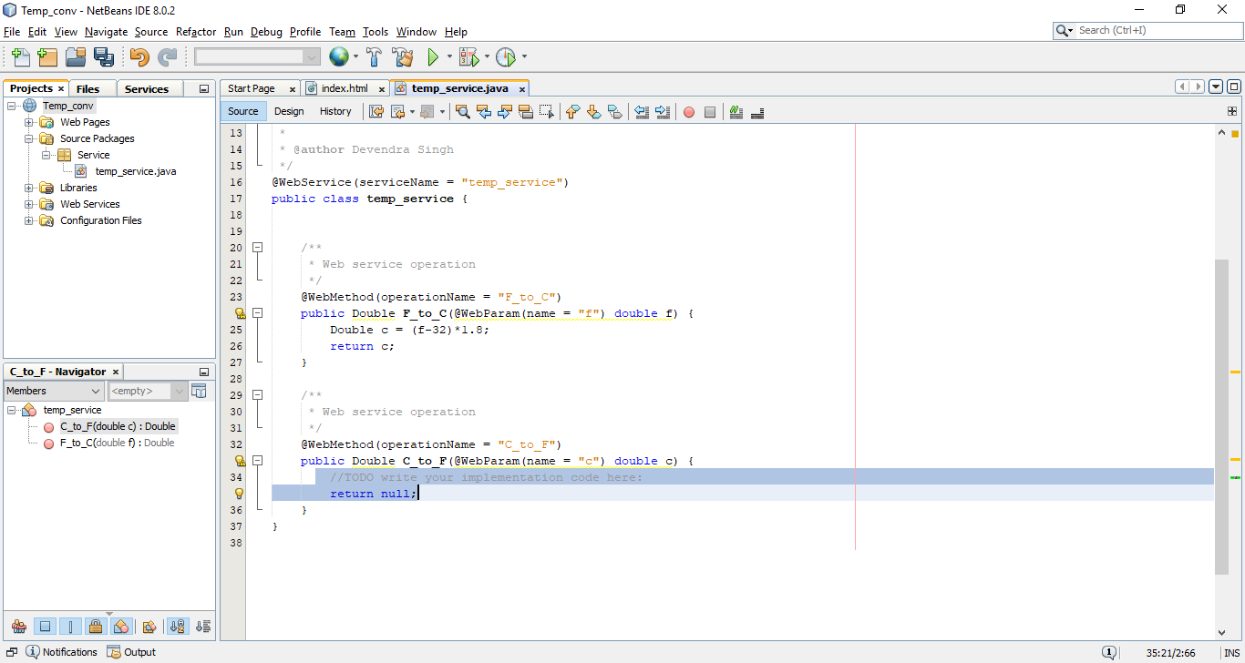

1. Now **right click on project name** and **click on Deploy** to deploy your project.

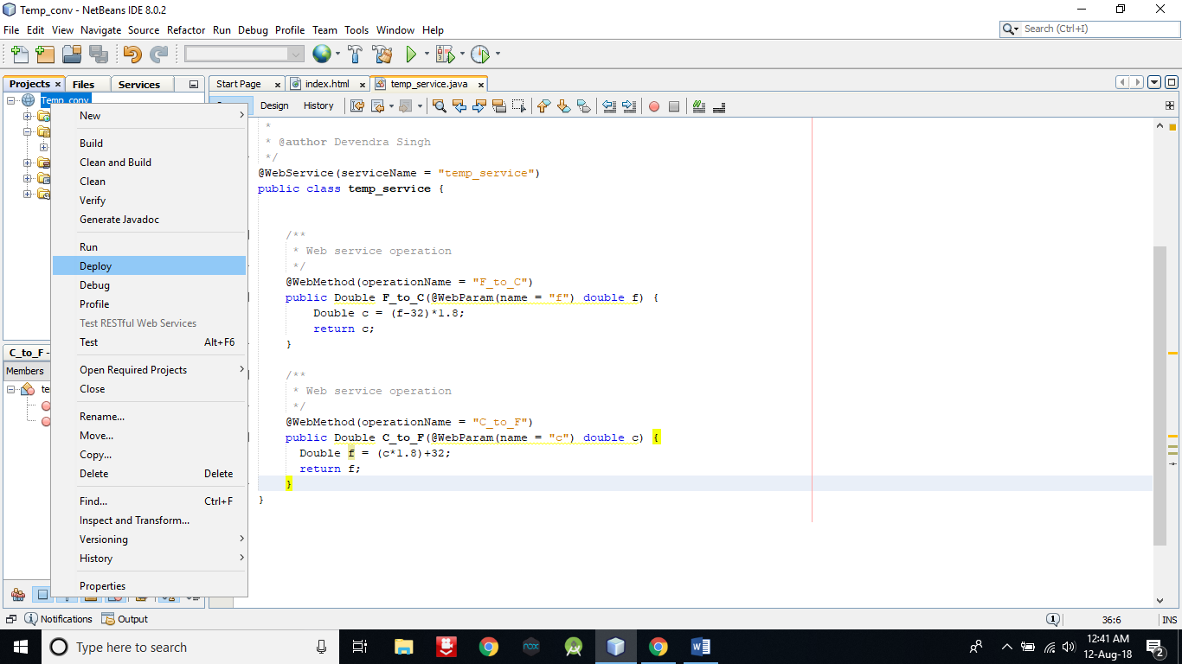

1. To test your web service follow the following process as in picture.

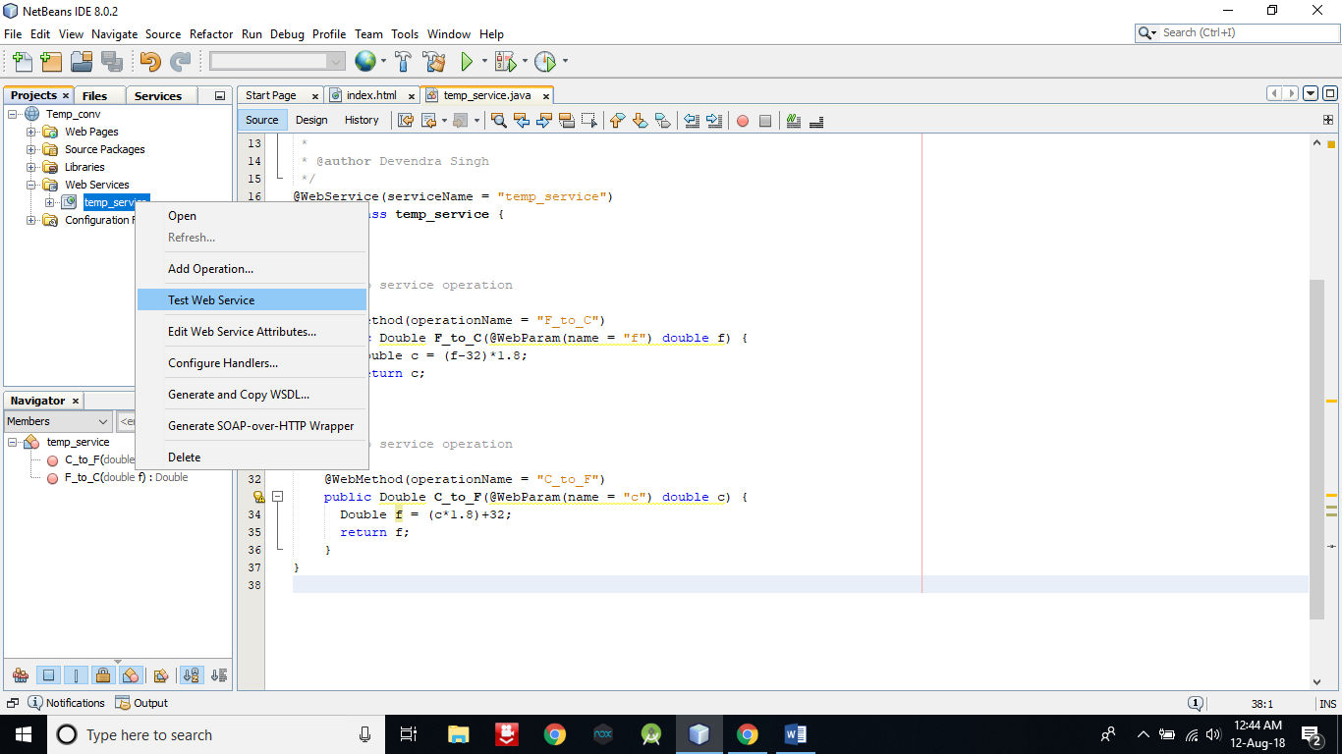

1. Following window will open in in browser. Now if you will enter a numeric data into first box and you will click on first button it will convert the entered data into Celsius. 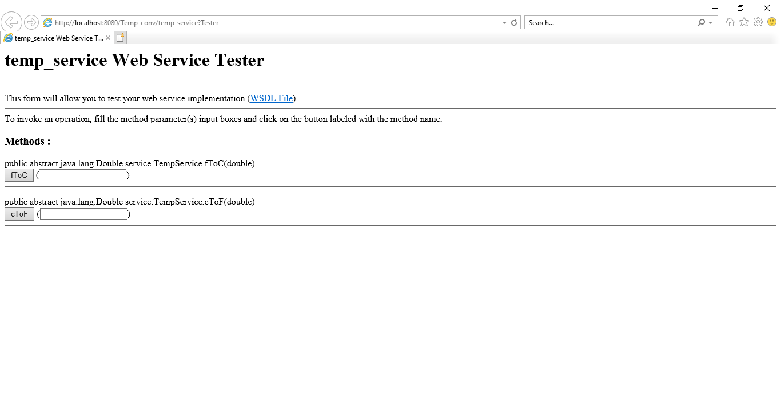

**16.** Selected value is in celsius of 56.

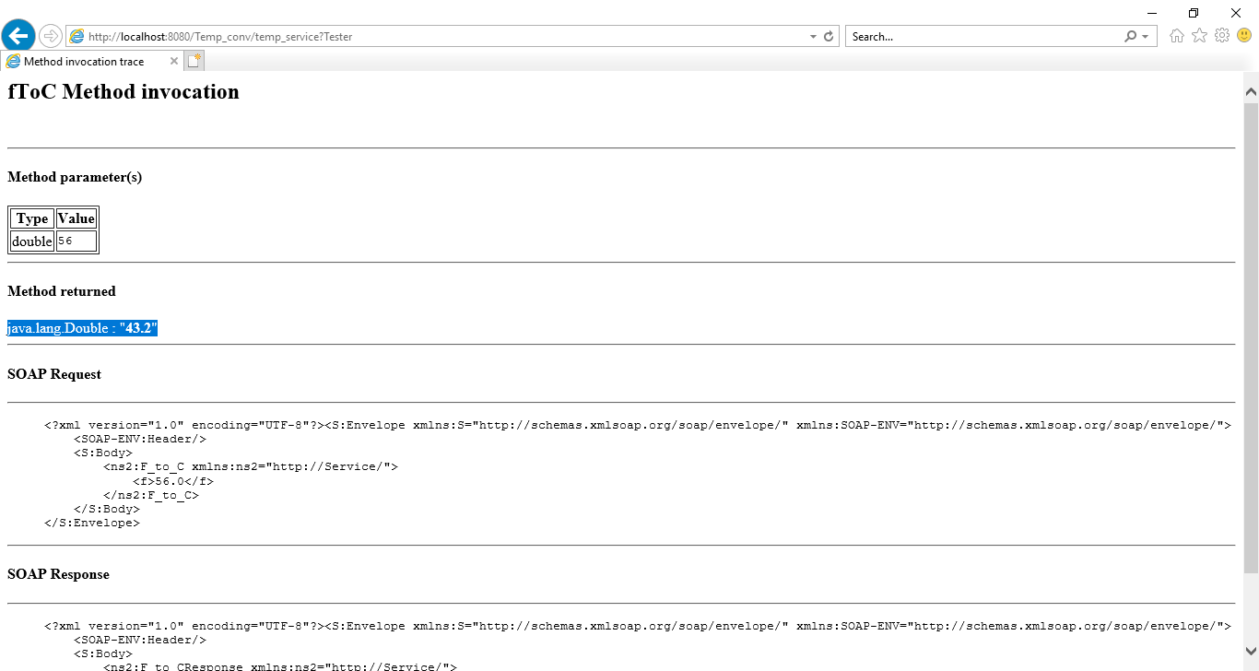

1. Similarly second textbox and button will convert the numeric value into Fahrenheit. Now to consume this web service we are creating a client.
2. Now create a new web application project with **name** as **Temp_client**.

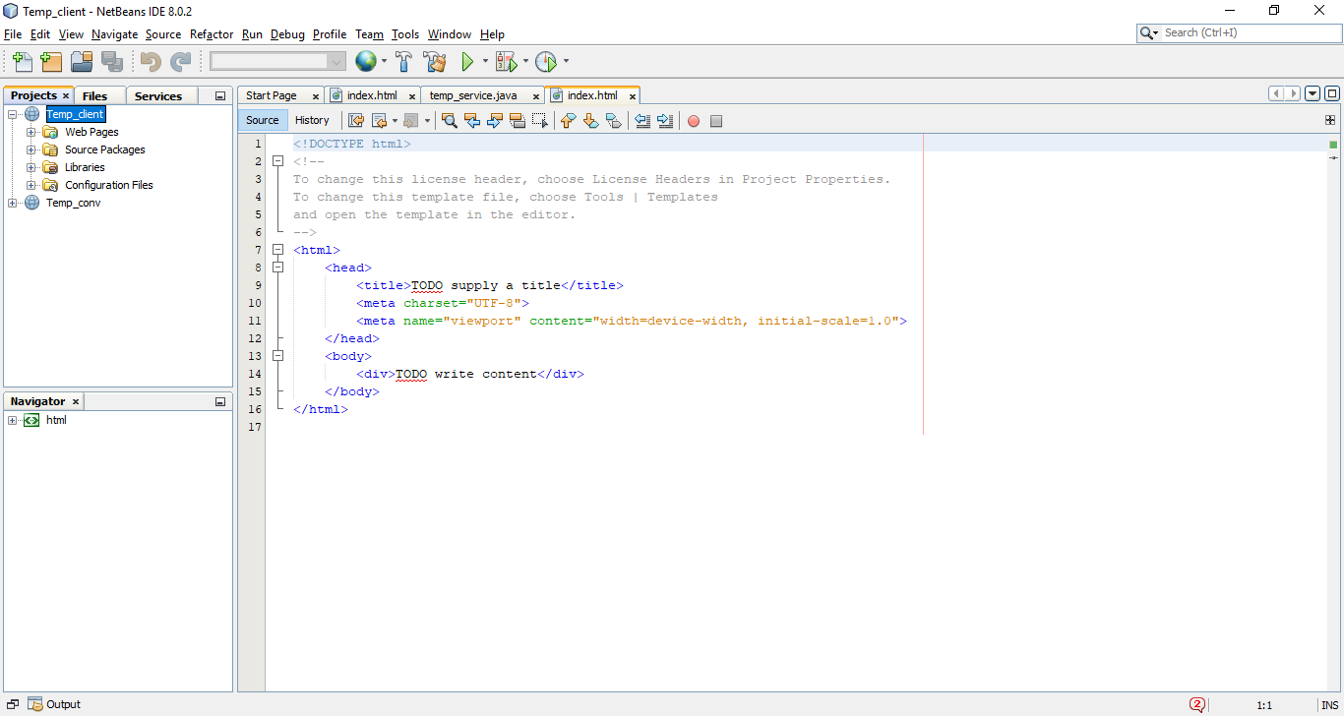

1. Now **open the index.html** page of Temp_client and write the following code into that.

**<html>**

**<head>**

**<title>Temperature converter</title>**

**<meta charset="UTF-8">**

**<meta name="viewport" content="width=device-width, initial-scale=1.0">**

**</head>**

**<body>**

**<form>**

**<br><input type="text" name="data"><br>**

**<br><input type="submit" value="Convert F to C" name="ftoc" formaction="f_to_c.jsp"><br>**

**<br><input type="submit" value="Convert C to F" name="ctof" formaction="c_to_f.jsp">**

**</form>**

**</body>**

**</html>**

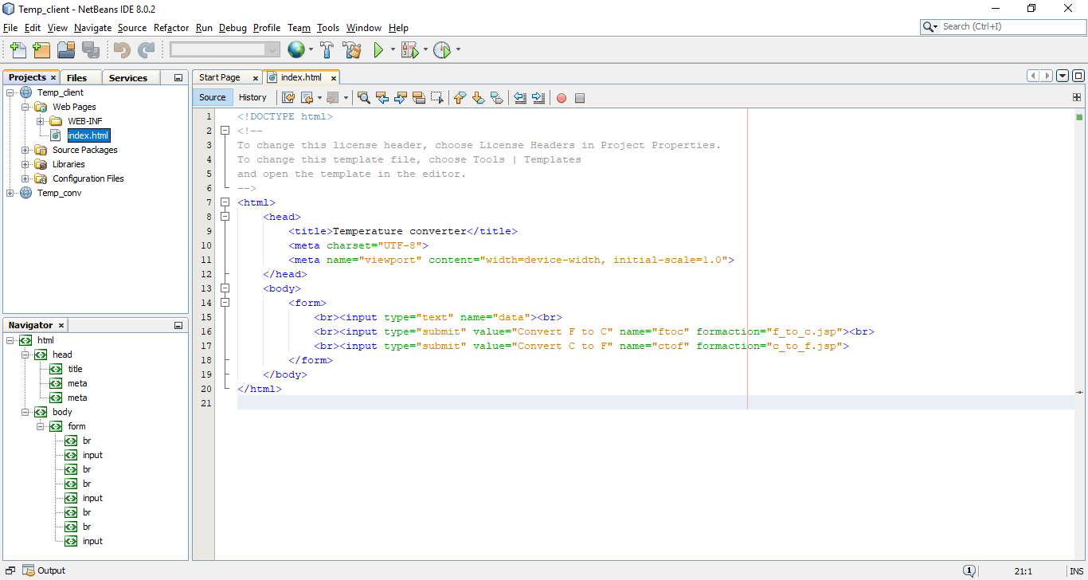

1. Now create two jsp pages for both submit button.

**Right click on Web Pages -> New -> JSP**

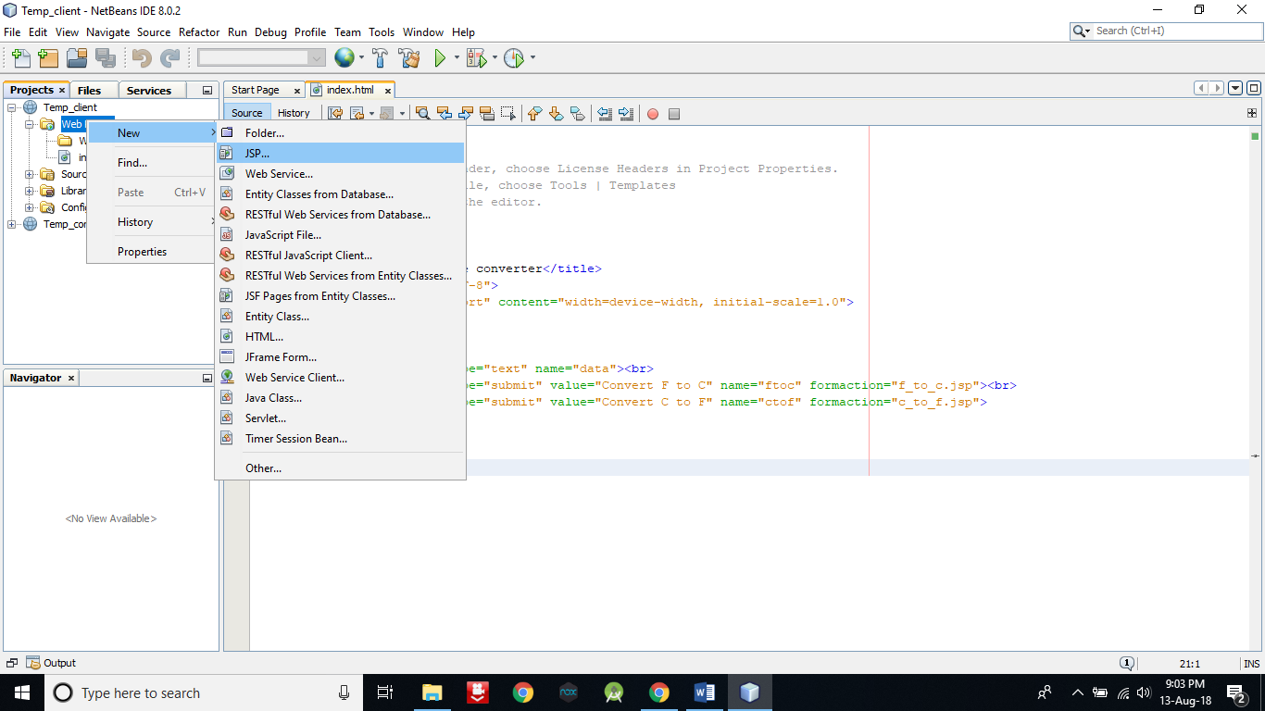

1. **Enter file name f_to_c** and then **click on Finish**.

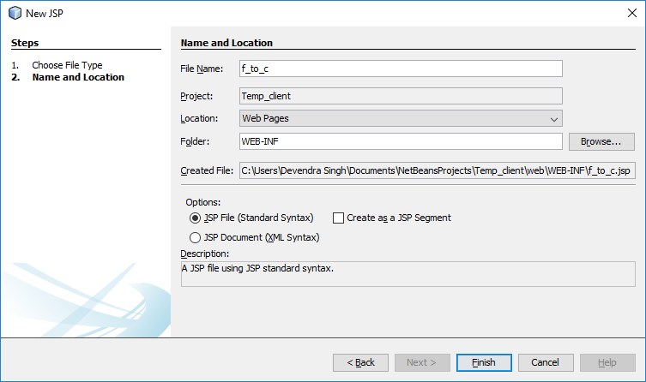

1. Now **repeat the step number 20 & 21.** But **give the File Name as c_to_f**.
2. Now you have created two jsp files.

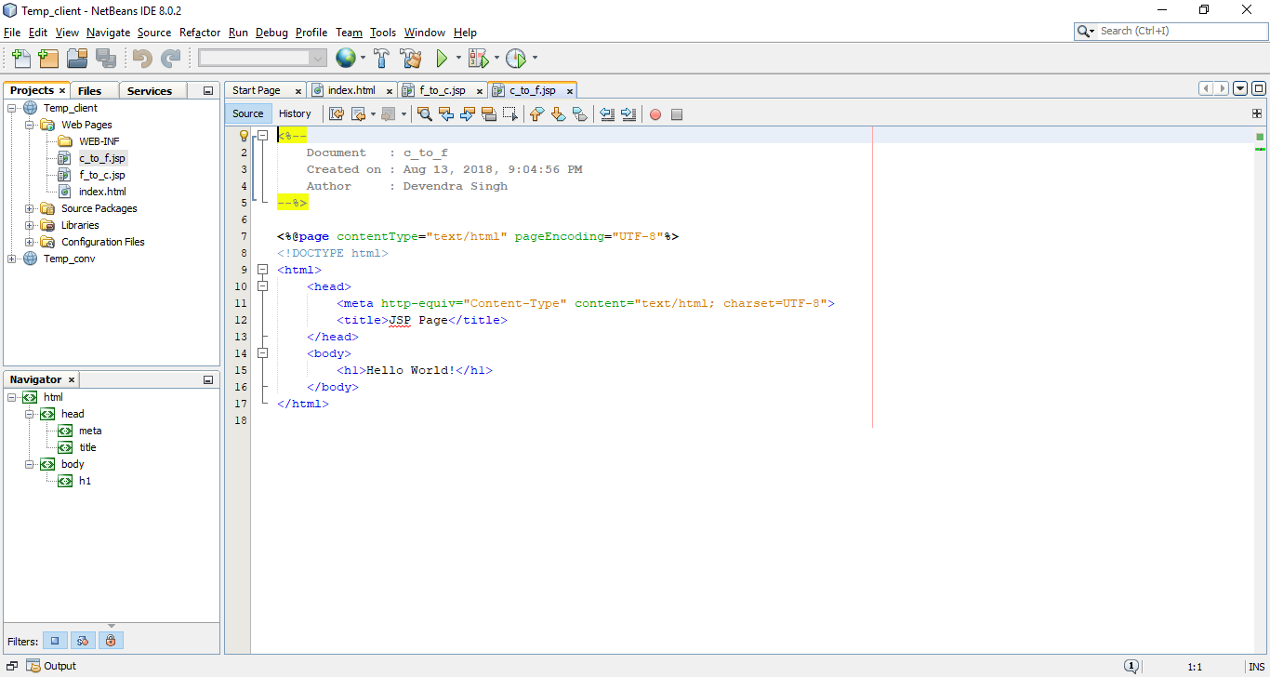

1. **Right click on Temp_client** and **select Web Service Client** as below.

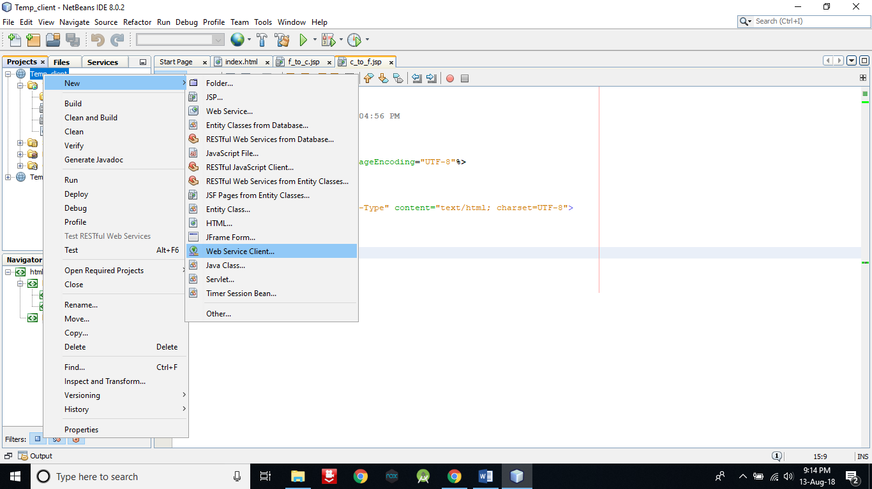

1. **Click on Browse**.

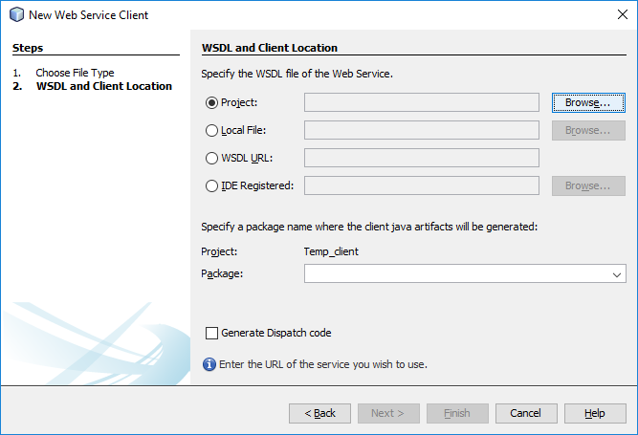

1. New window will appear and then select **temp_service** and click on **OK**.

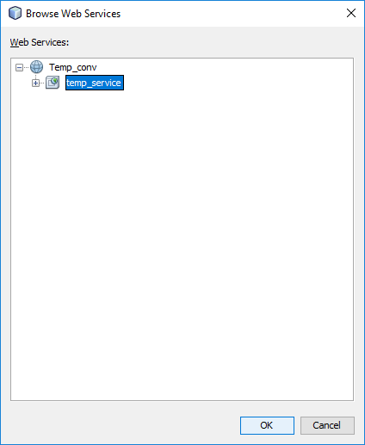

1. **Click on Finish.**

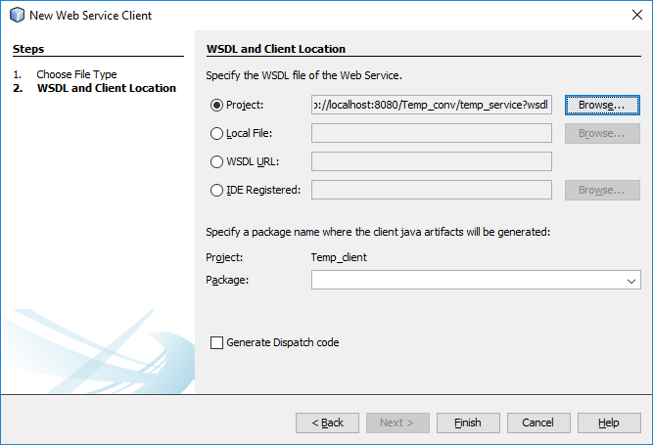

1. Now **open the c_to_f.jsp file** and **delete the selected line**.

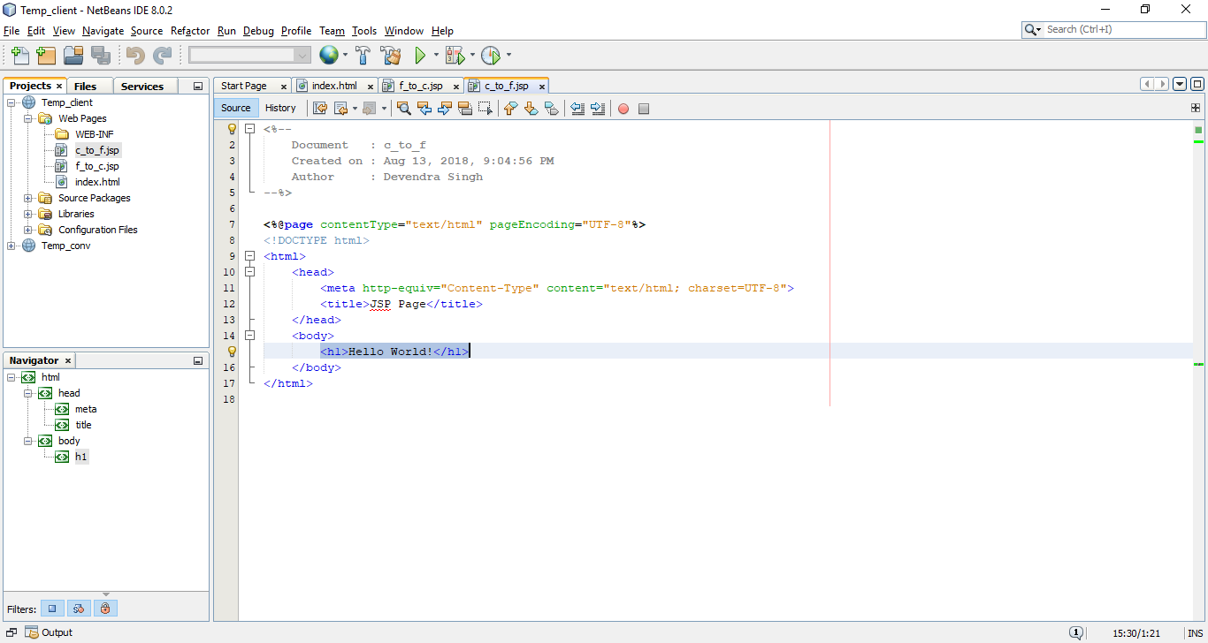

1. Now **right click in between the body section** and **select Call Web Service** **Operatin** as below.

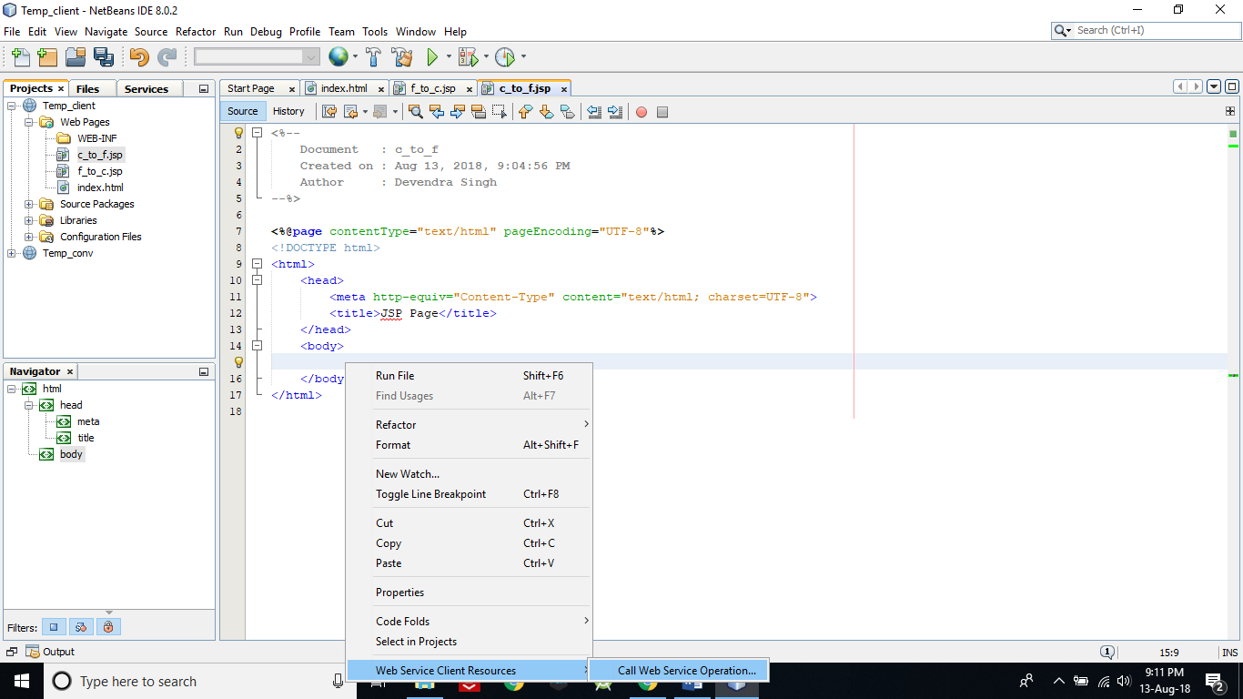

1. New window will appear **select the C_to_F by expanding it** and **click on OK**. So that selected code in second pic will be automatically generated.

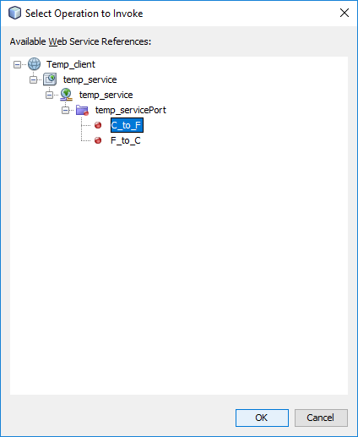

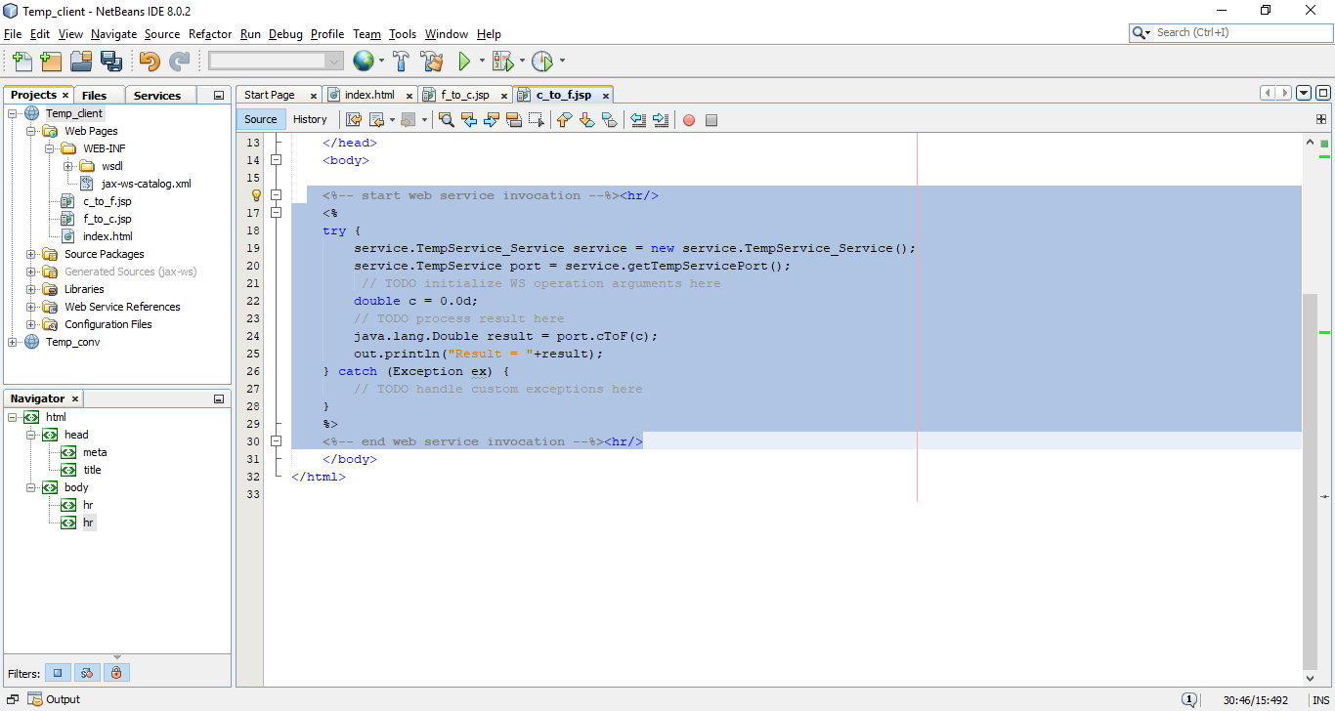

1. Now, **make the selected area in step 30 as like selected area in below pic** by adding some line of code.

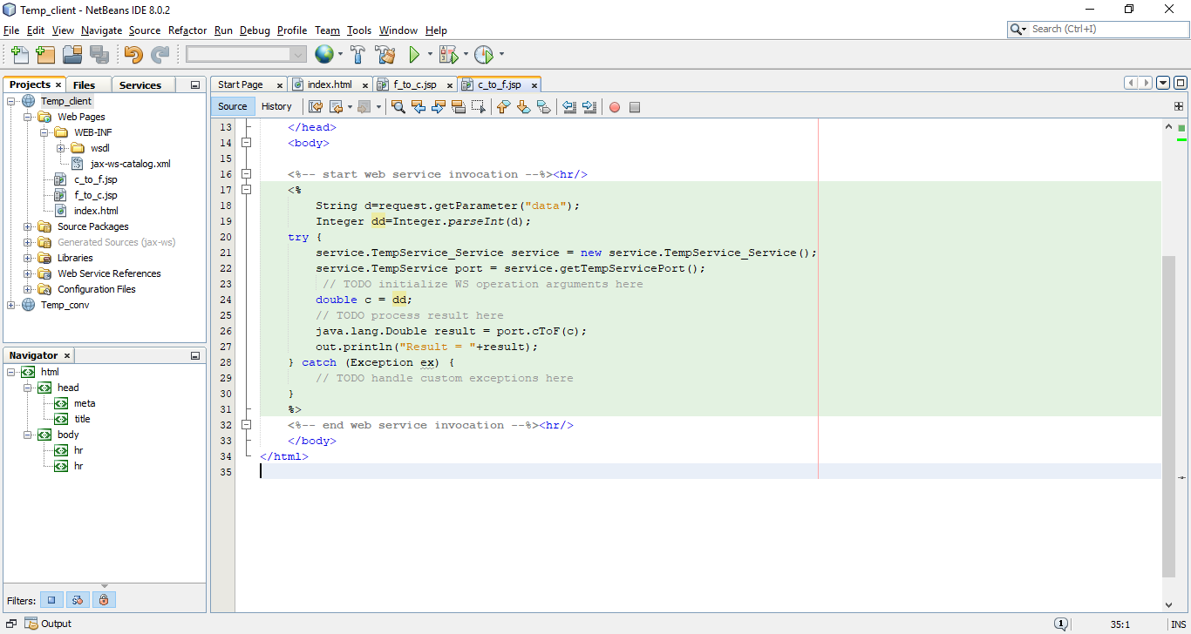

1. Now **Open the f_to_c.jsp file** and **follow the steps from 28 to 31**. **Only the** **change** is in **30 number step** and i.e. **instead of C_to_F, you have to select** **F_to_C.**
2. Now **run the Temp_client project**. An window will be open like below.

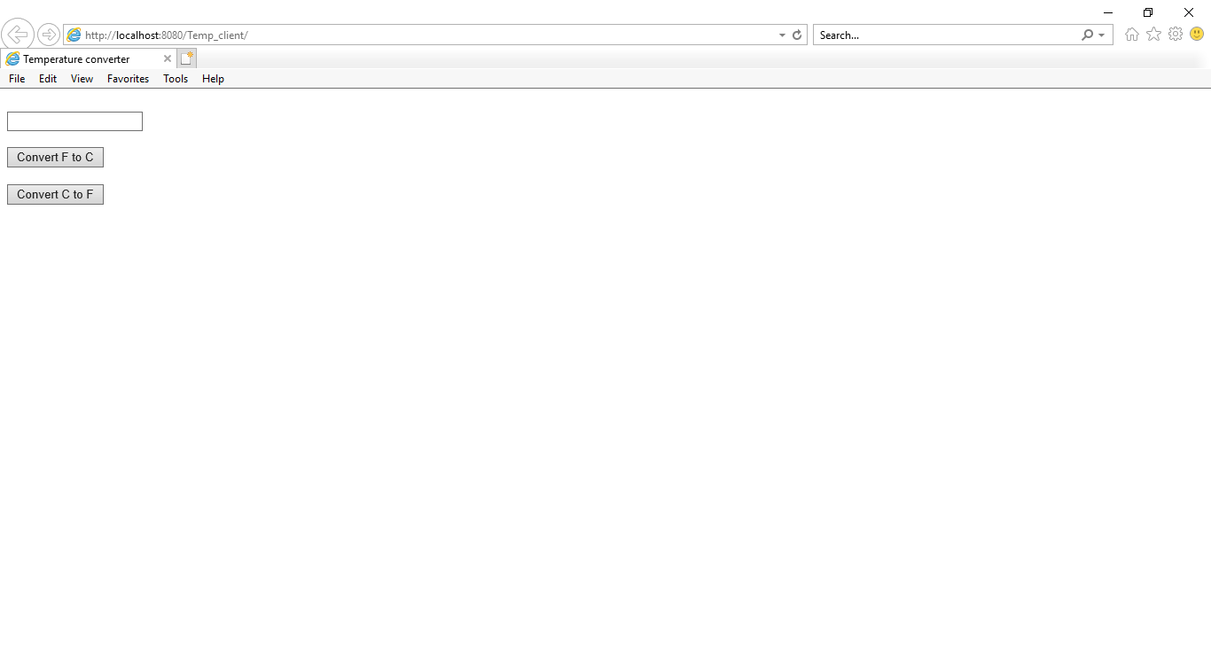

1. Now you can to enter any numeric data into textbox and if you will click the first button it will convert the numeric value into Celsius and vice-versa for the second button.
2. There are so many methods to consume the web service. But I found it easy.

Top of Form