**PRACTICAL-4**

**Aim:** **Develop client which consumes web services developed in different**

**platform.**

**Requirement:**

1. Visual Studio Community 2017
2. Version : 15.8 or latest

In this practical we are creating Web Service in Visual Studio ant then we will consume it in NetBeans.

1. **Open Visual Studio IDE** and **click on File**.

**File -> New -> Project**

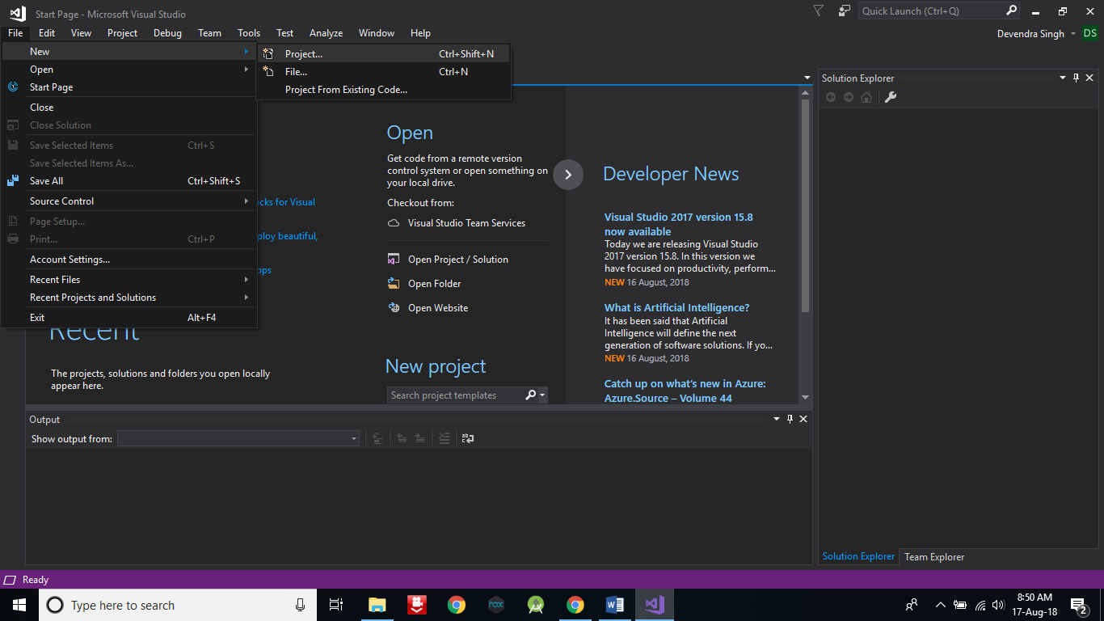

1. **Click on Web**.

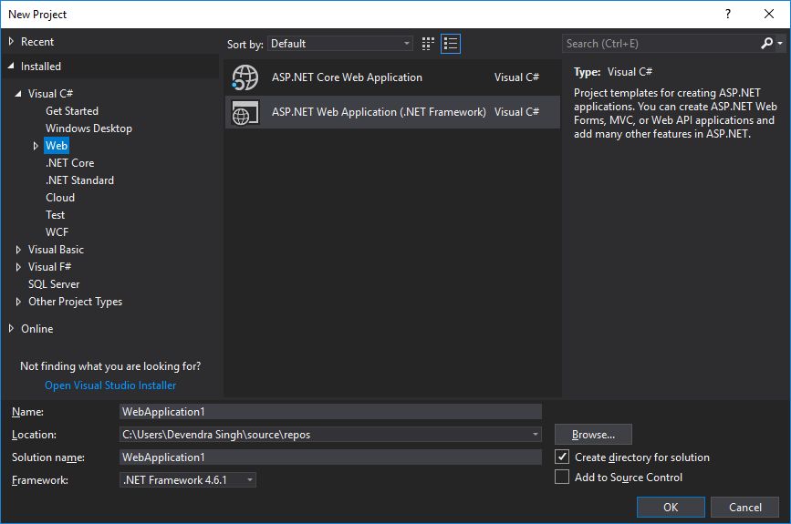

1. **Select ASP.NET Web Application** and give **Name** as **Service**. After that **click on OK** button.

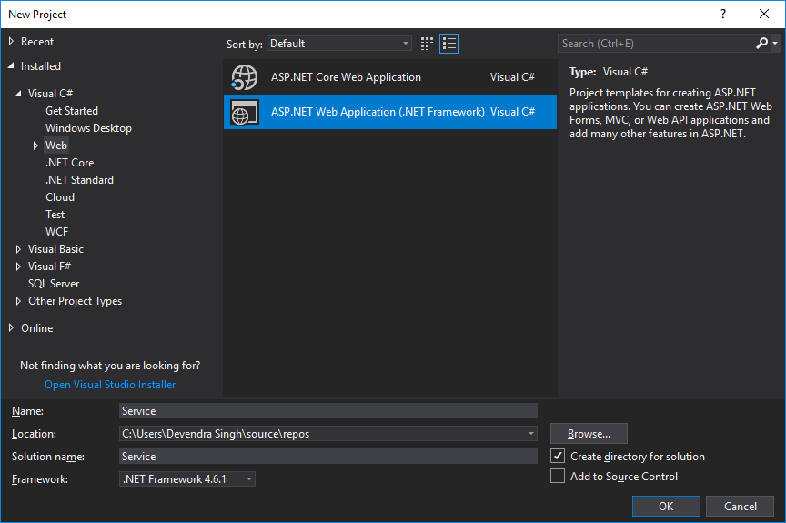

1. **Select Empty** and **click on OK** button.

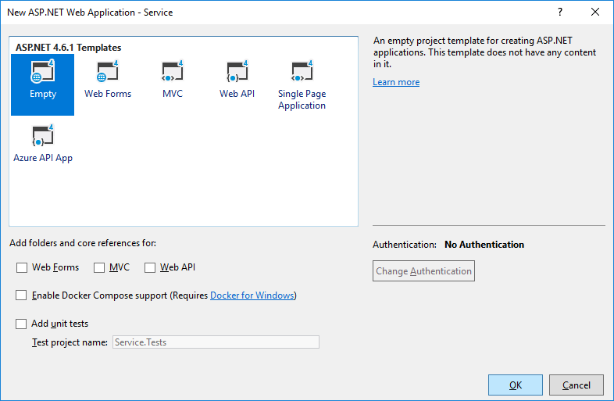

1. Now you can see, on right side in Solution Explorer Service project is created.

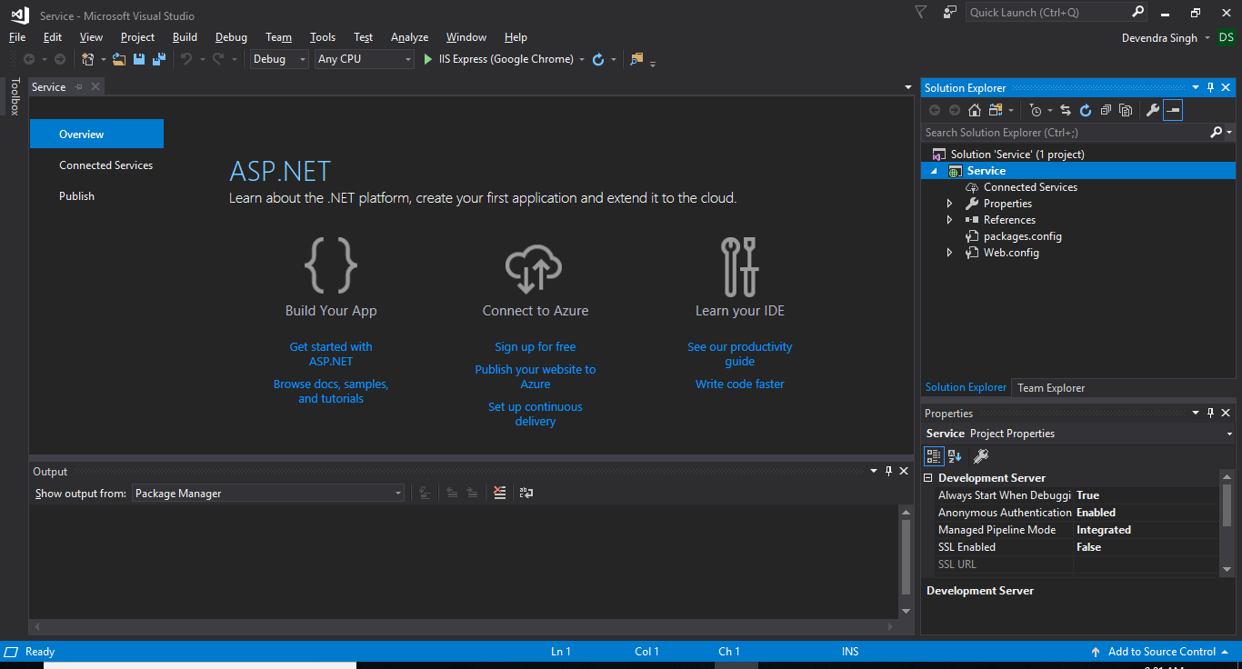

1. **Right click on Service -> Add -> New Item**.

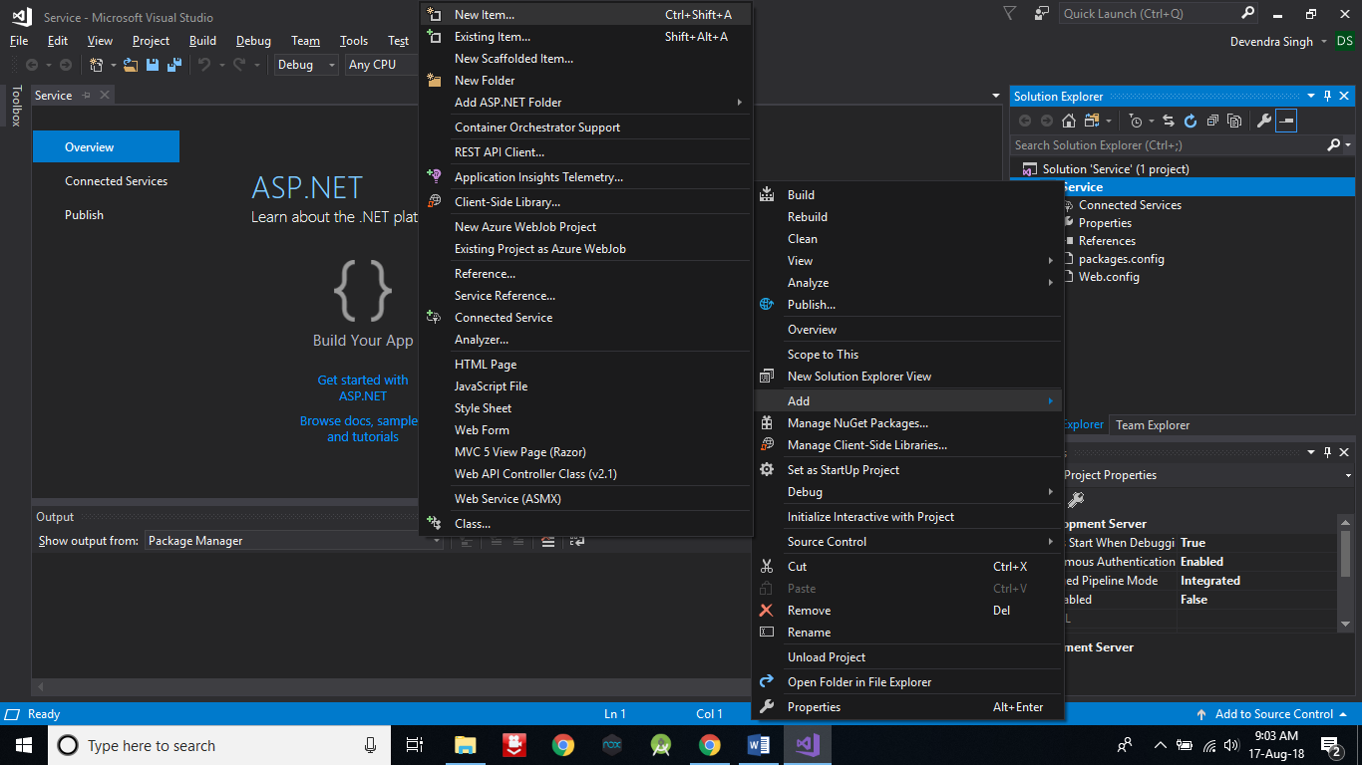

1. **Search for Web Service**.

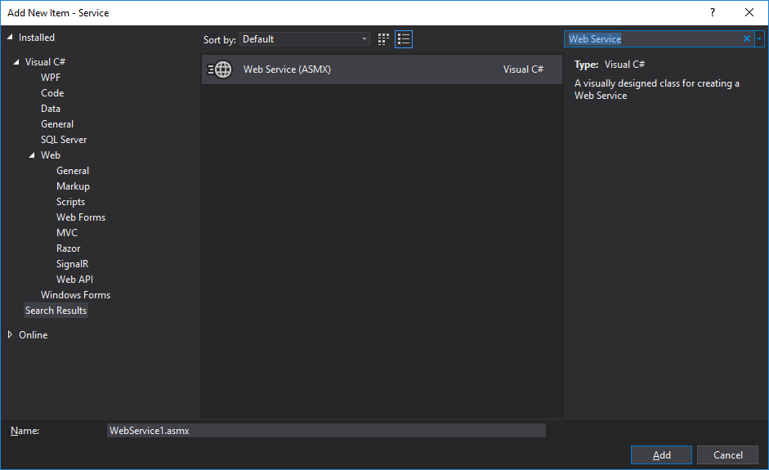

1. **Select Web Service** and **give Name** as **Operation**. After then **click on Add** button.

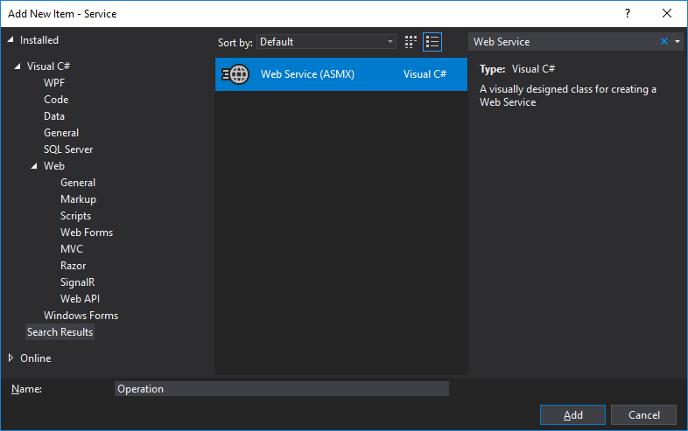

1. After click on Add button, Operaion.asmx.cs file will be automatically open otherwise open it from Solution Explorer and **Add the following code into** **Class Operation**.

**[WebMethod]**

**public double Add(double a, double b)**

**{**

**double sum = a + b;**

**return sum;**

**}**

**[WebMethod]**

**public double Multi(double a, double b)**

**{**

**double sum = a * b;**

**return s**

**}**

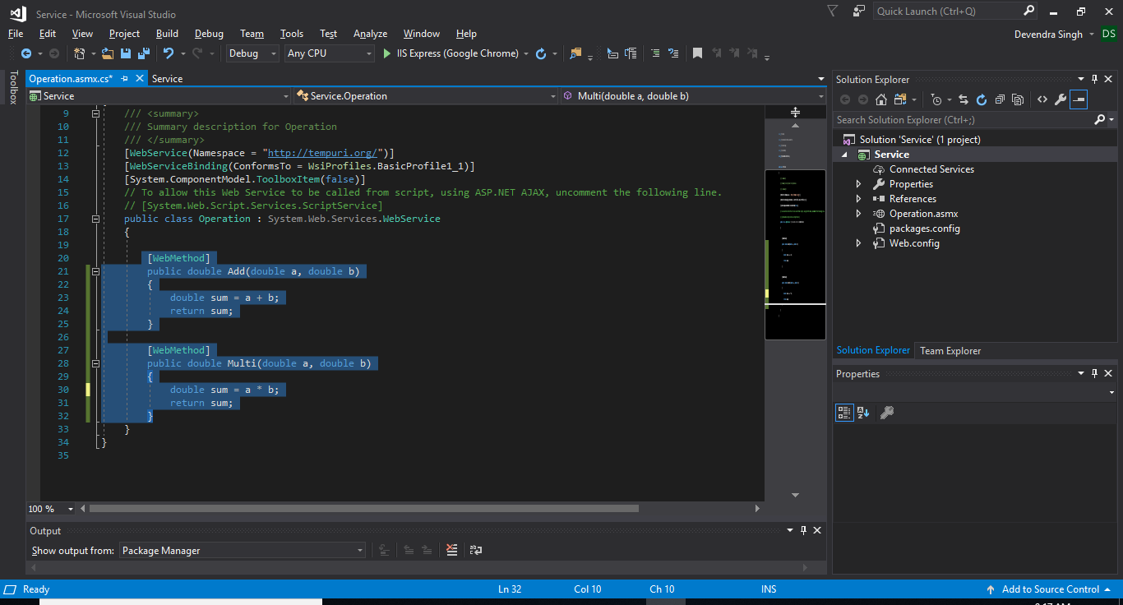

**After that press Ctrl+S** to save the methods. Actually we are creating two methods for Web Service. One is for addition of two numbers and second one is for multiplication of two numbers.

1. Now **run the project** by **click on Green arrow button below the Window** **menu**.

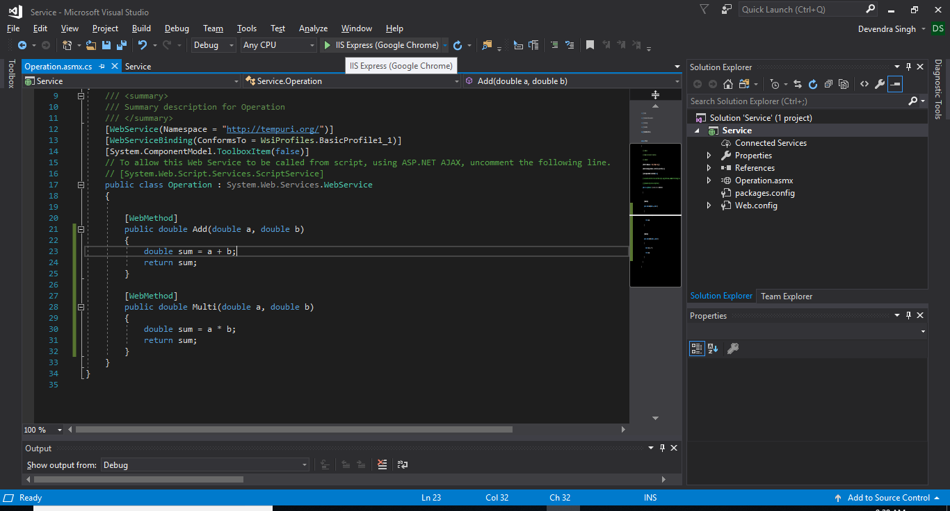

1. A window will open in browser and that is our web service.

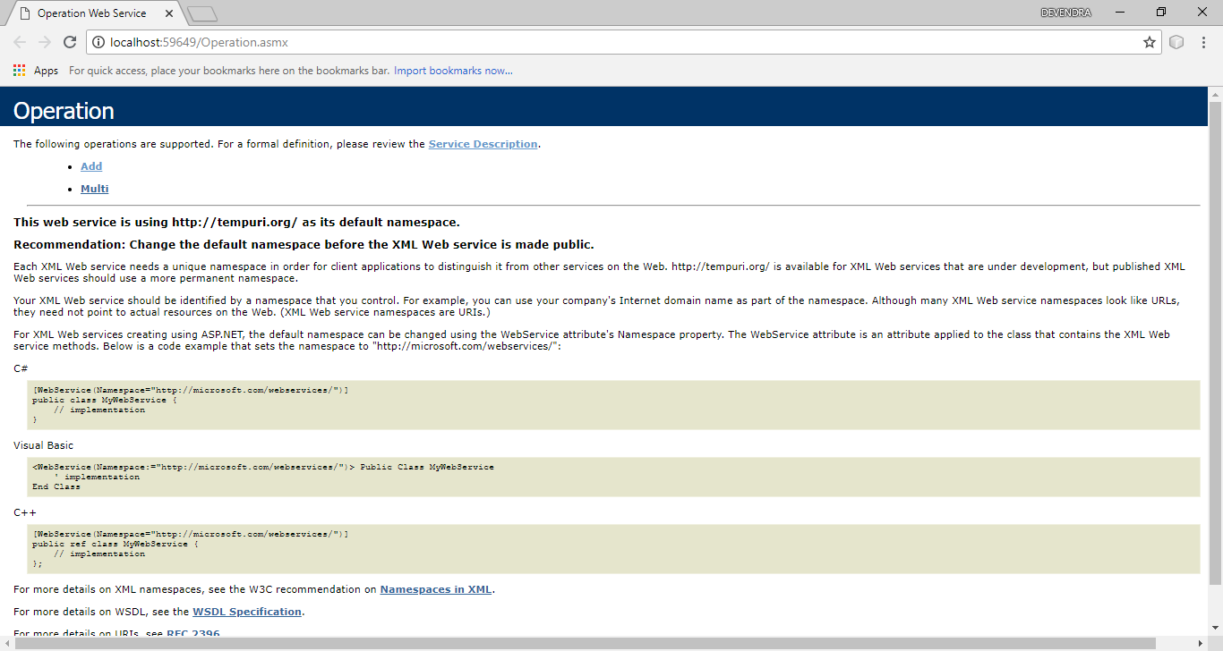

1. You can check services by click on Add or Multi option. But we don’t need this.
2. Now **click on Service Description** option.



1. Now a new window will open. **Select the link and copy it**. **We will use this** **link in NetBeans to consume these services**.

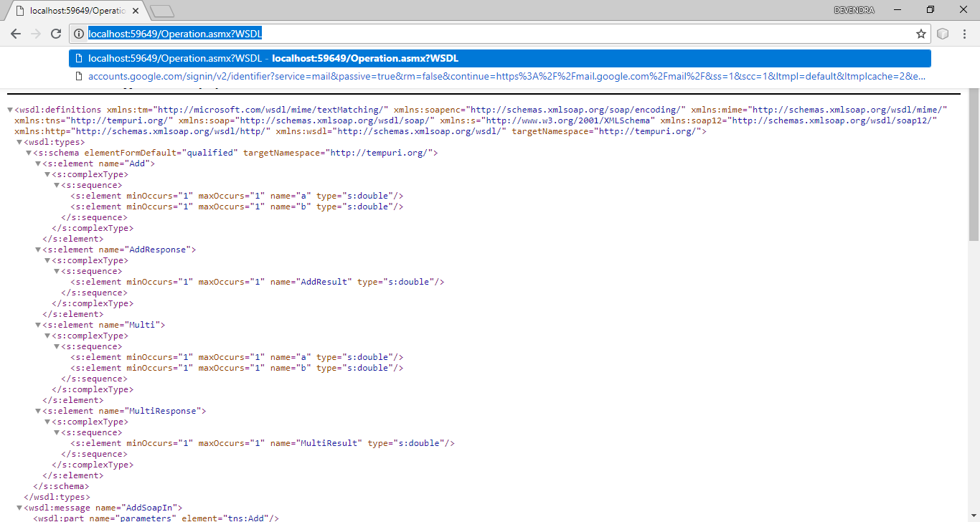

1. **Don’t close Visual Studio and browser, just minimize it otherwise server will** **stop.** **But save the link anywhere**, so that we can use it later.
2. Now **open NetBeans**.
3. **Create a Web Application with name ServiceClient. Next -> Finish**.

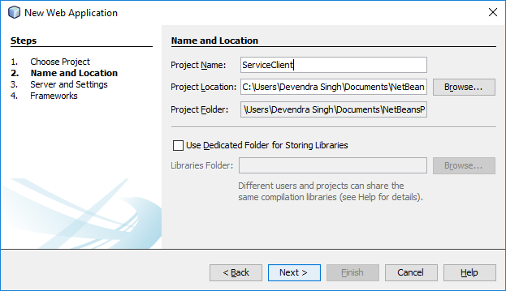

1. Now **create a Web Service Client**.

**Right click on ServiceClient -> New -> Other**.

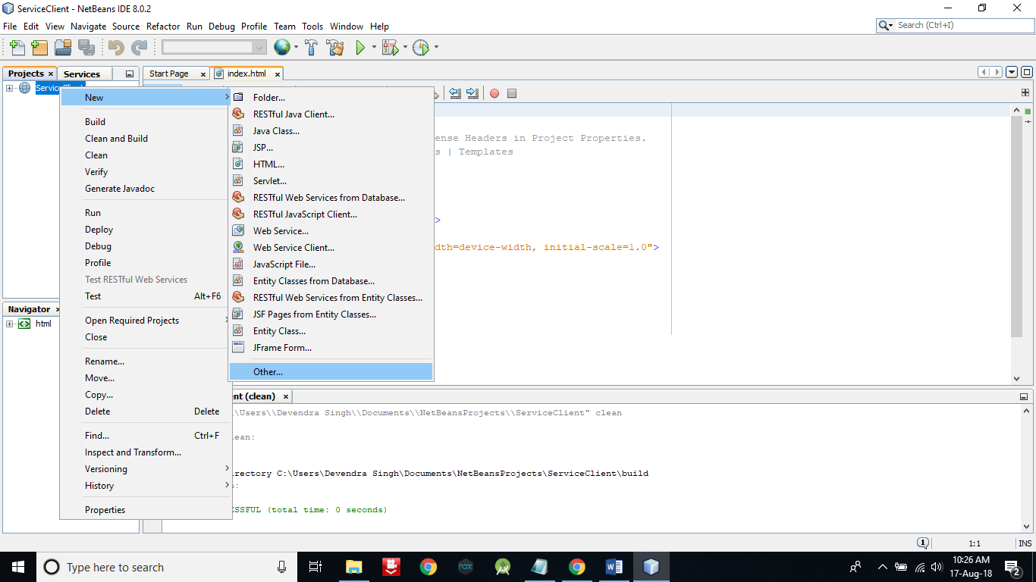

1. Now **select Web Services in Categories** section.

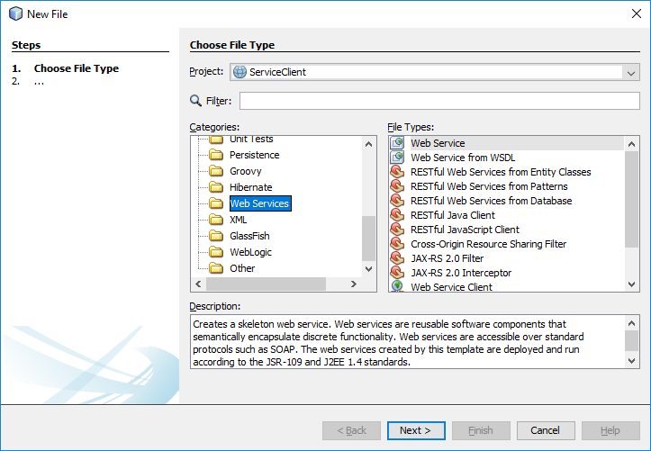

1. **Select Web Service Client** **in File Types** and **Click on Next** button.

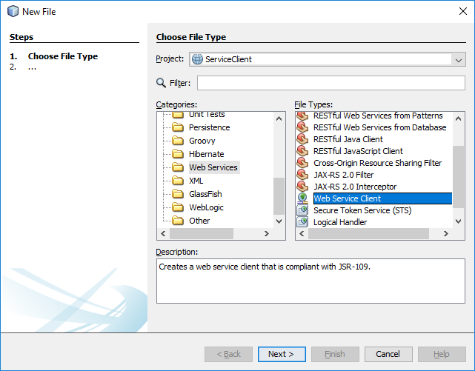

1. **Select WSDL URL and paste the link** that you have copied from browser on run of Visual Studio **enter package name com.dd**. After that **click on Finish** button.

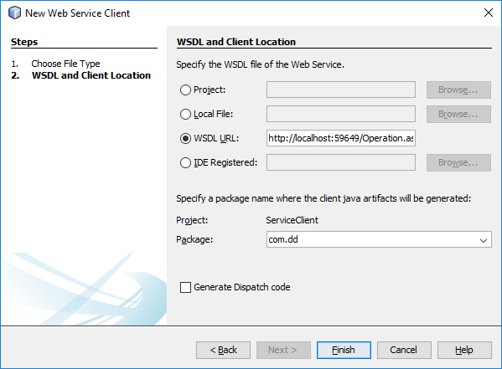

1. As you can see, we got both the service methods i.e. Add & Multi. But in this practical I’m going to use only one service method. You can do for both also.

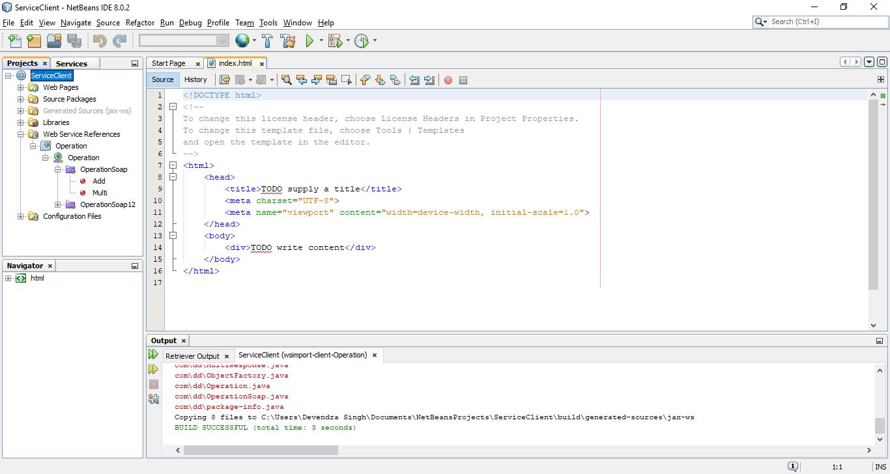

1. Now create a JSP page. **Right click on ServiceClient -> New -> Other**

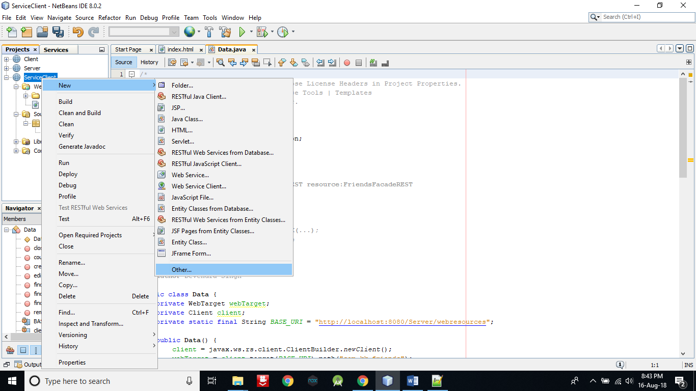

1. **Select Web in Categories section -> Select JSP and click on Next button**.

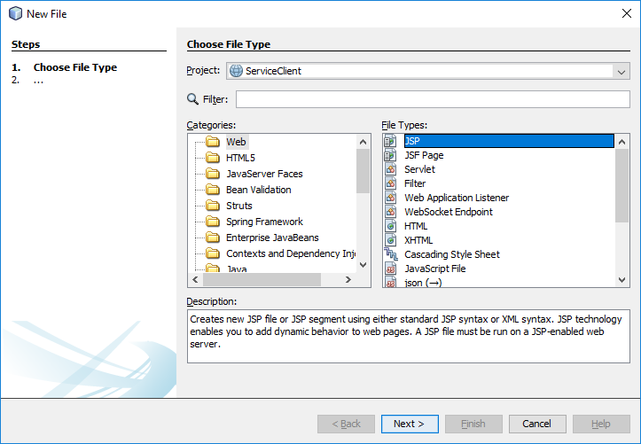

1. **Enter File Name Add** and **click on Finish button**.

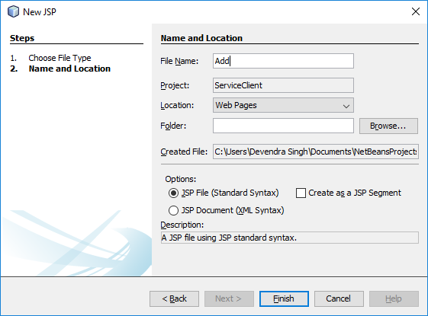

1. **In Add.jsp file delete the selected part in body tag**, because we don’t need this.

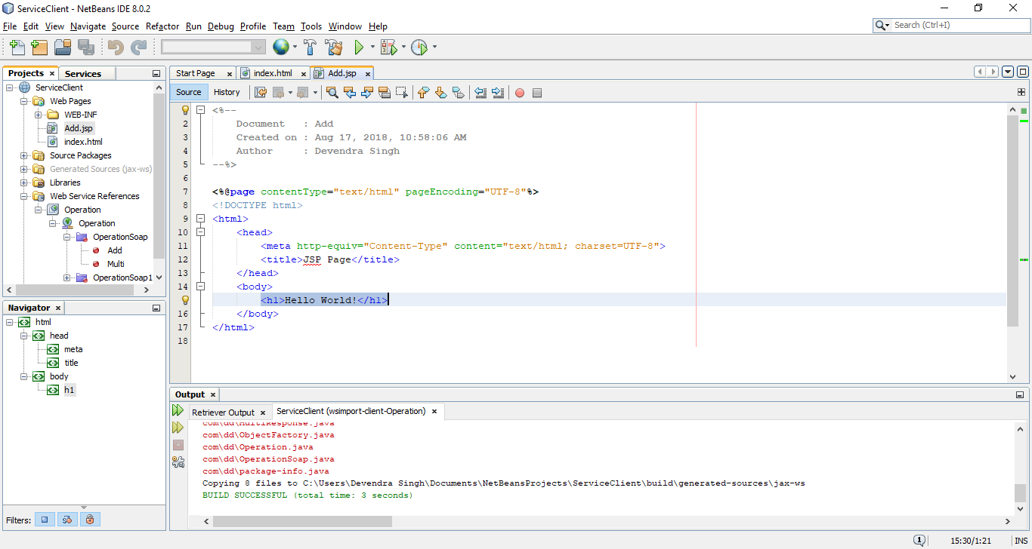

1. **Right click between body tag** and **select Call Web Service Operation**.

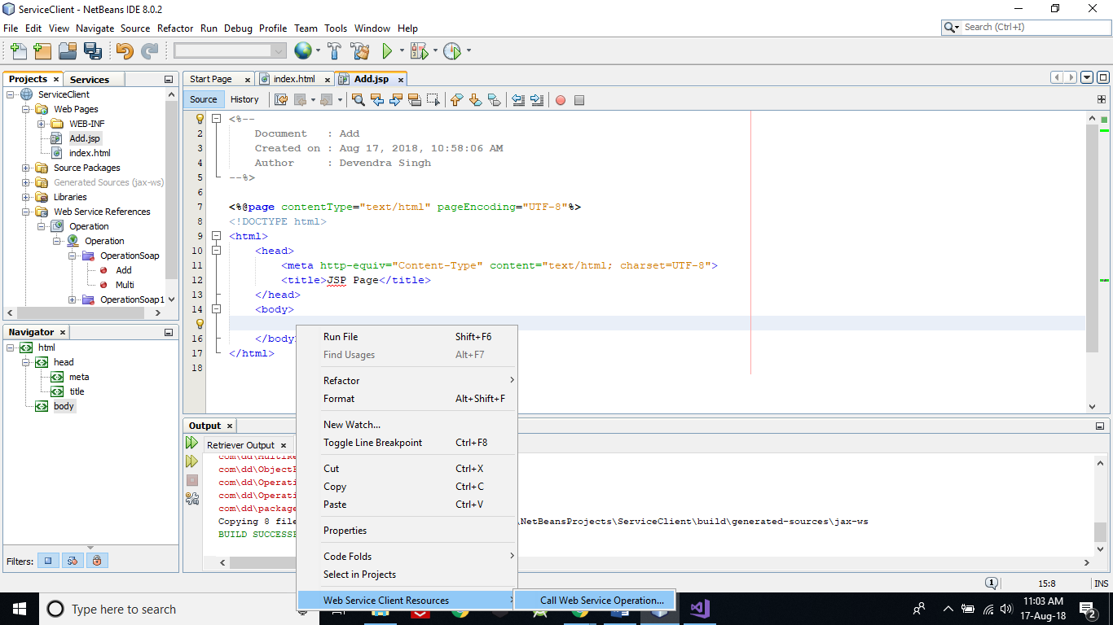

1. **Expand and select Add**. After select, **click on OK** button.

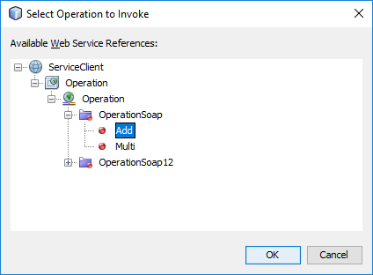

1. Now **add the following code outside of try block**.

**double num1 = Double.parseDouble(request.getParameter("txt1"));**

**double num2 = Double.parseDouble(request.getParameter("txt2"));**

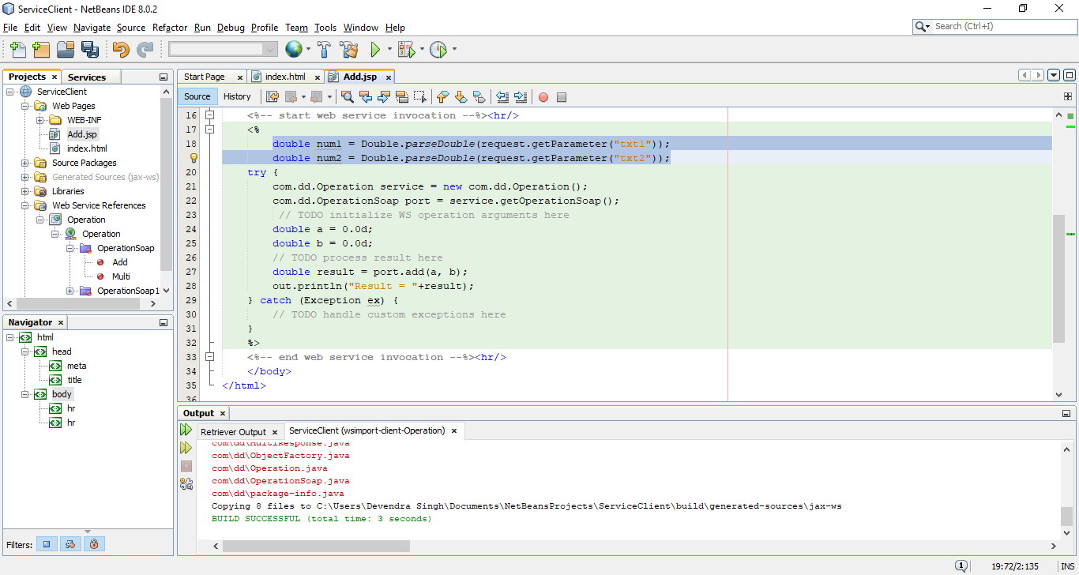

1. Now **pass num1 & num2 to a & b variable respectively**. After that **press** **Ctrl+S** to save this code.

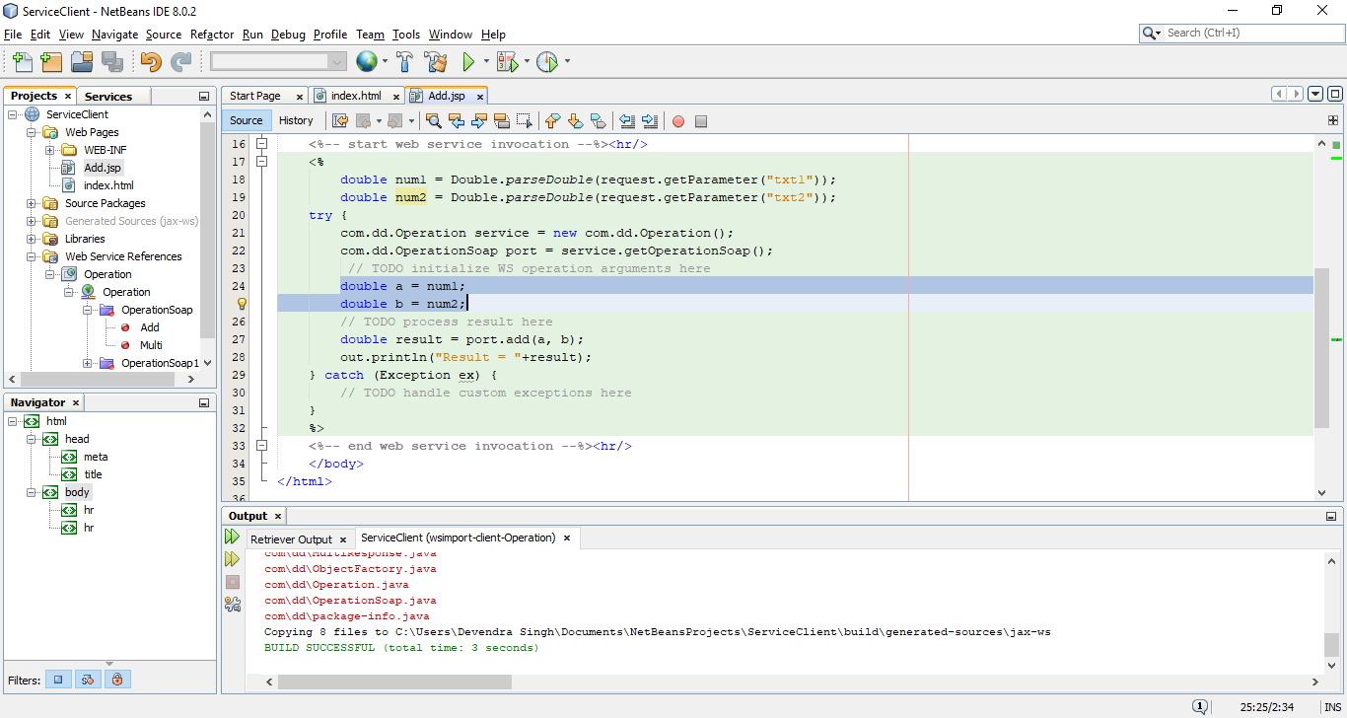

1. Now **open index.html file of ServiceClient** project and **replace the contents** **of body tag with following code**. **After that** **press Ctrl+S** to save it.

**<form>**

**<input type="text" name="txt1" placeholder="Enter First Number"><br><br>**

**<input type="text" name="txt2" placeholder="Enter Second Number"><br><br>**

**<input type="submit" formaction="Add.jsp" value="Add Numbers">**

**</form>**

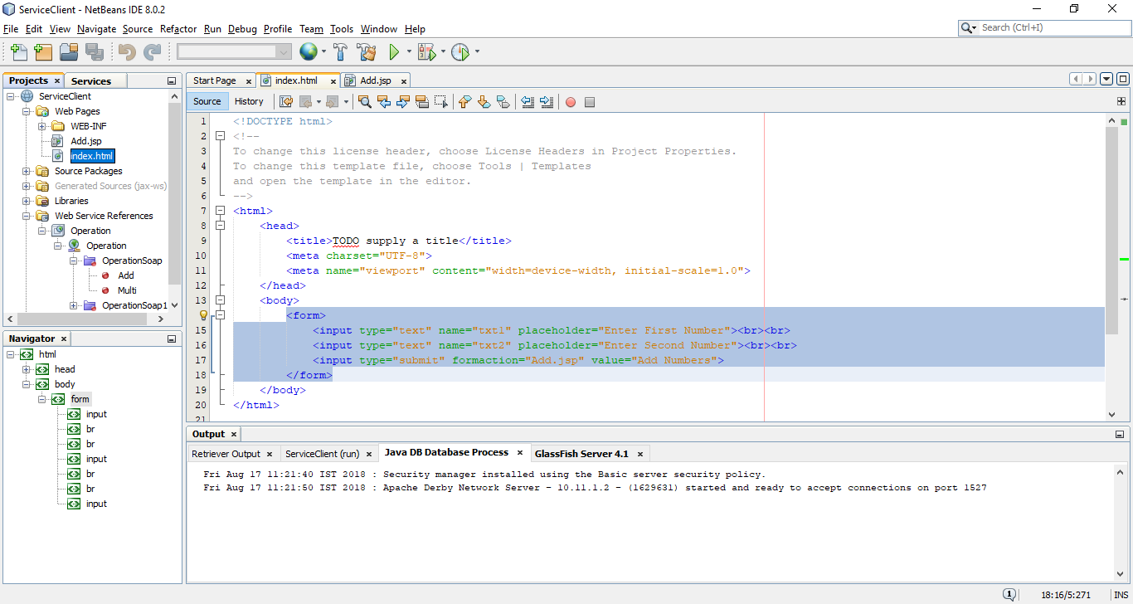

1. Now **run the ServerClient** web application.

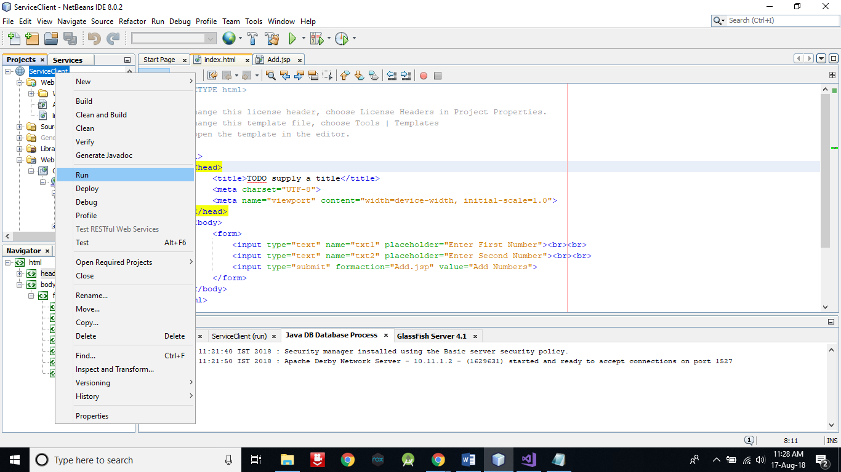

1. A window will open in browser as below.

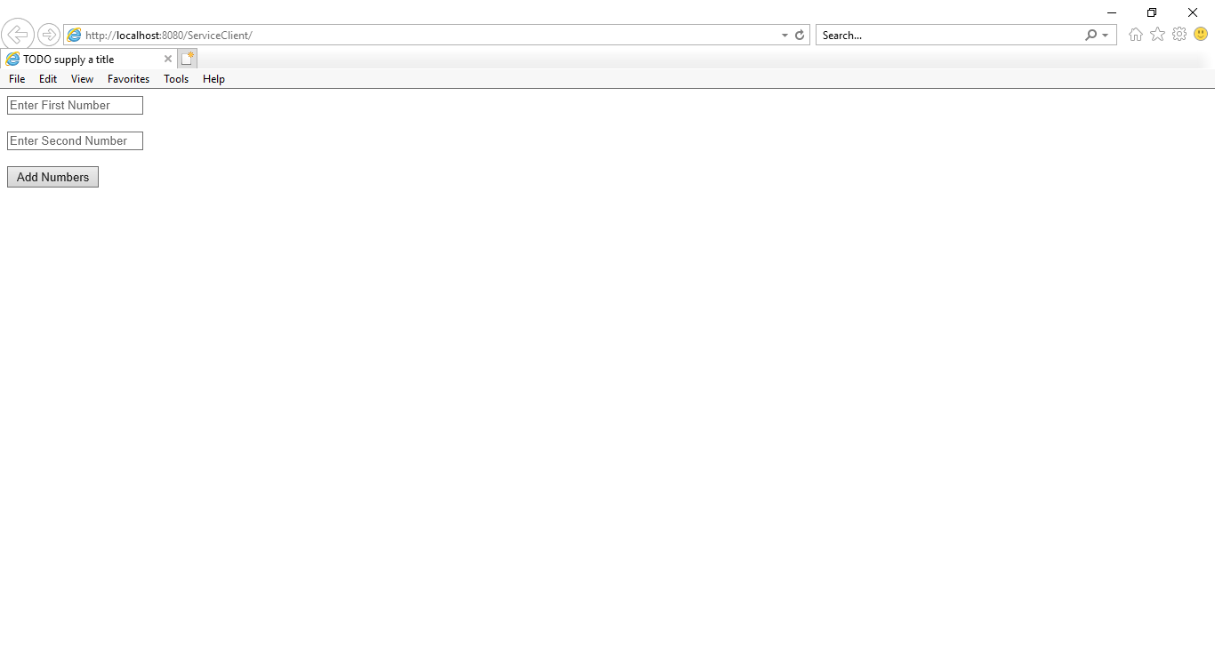

1. Now **enter two numbers and click on Add Numbers button**. **Wait to get** **result**……..

You will get result on a new page.

