**PRACTICAL-6**

**Aim: Define a web service method that returns the contents of a database in a JSON string. The contents should be displayed in a tabular format.**

1. Click on Window menu and click on **Projects, Files** & **Services** to open it.

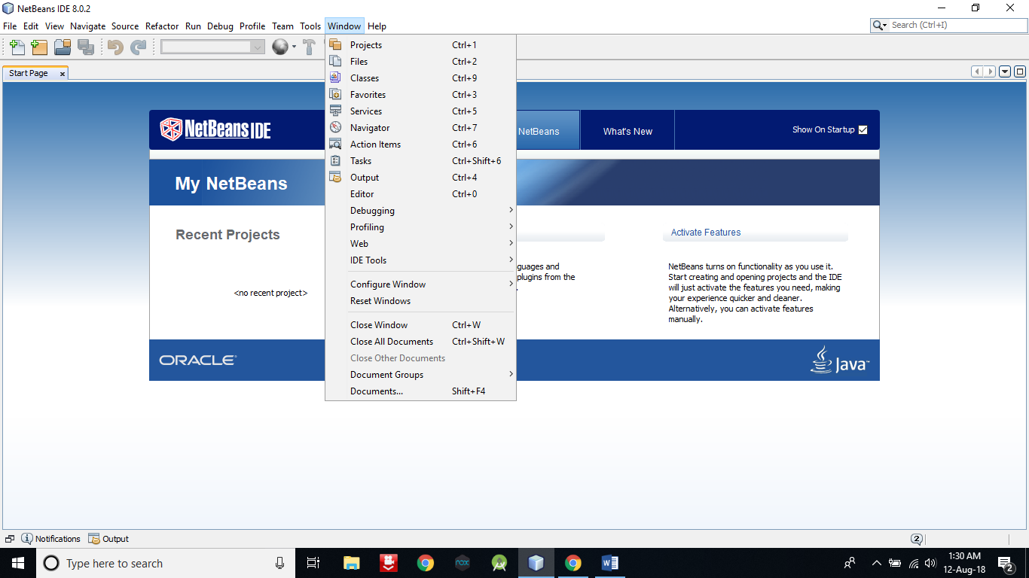

1. **Right click on Java DB** and then **click on Start Server** to start the server .

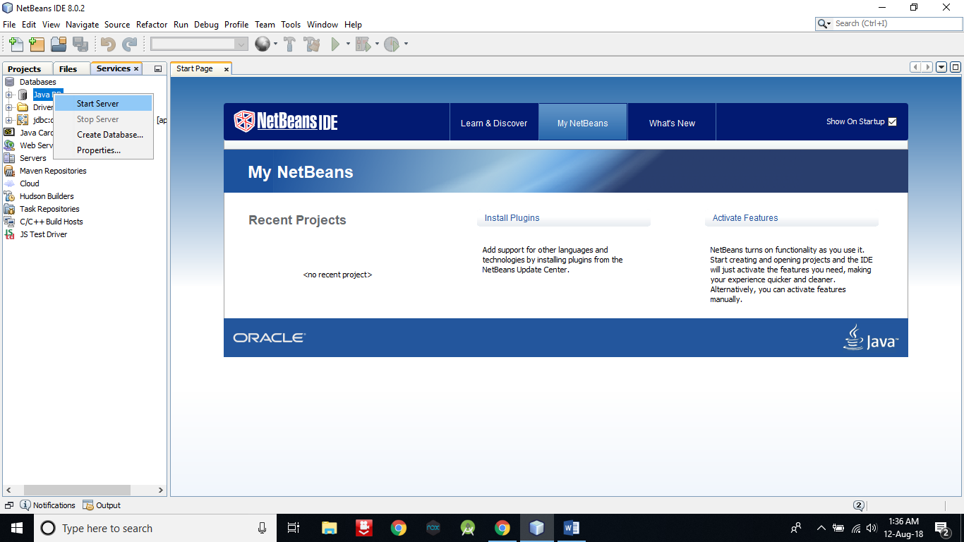

1. Now expand Java DB and **right click on sample** and then **click on connect** to connect the sample database with server.

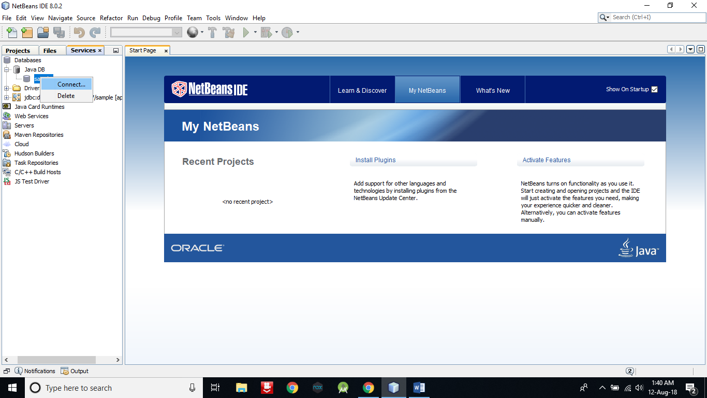

1. Now we are going to create a table in default database **sample**.

**Right click on Table -> Create Table**

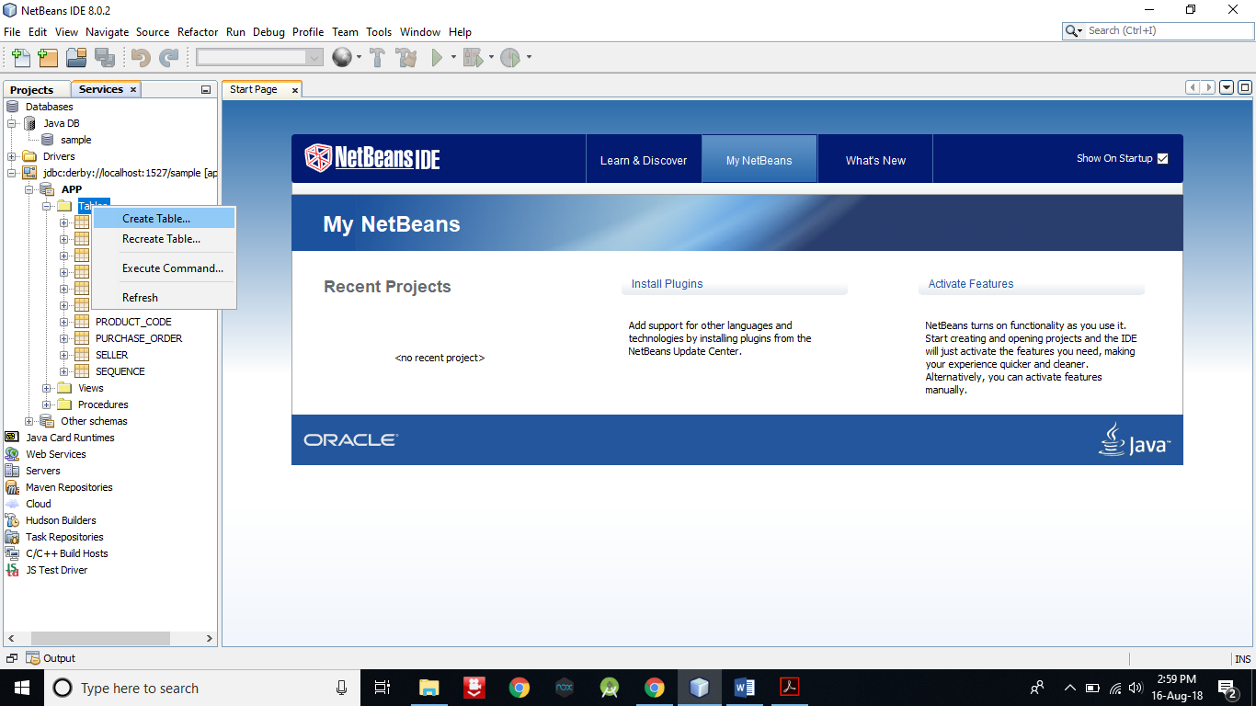

1. Give **table name** as **FRIENDS**.

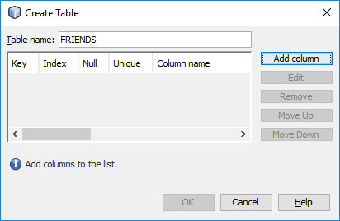

1. Now **click on Add column** button **to add columns** in table.

Enter details as in below pic and **select Primary key**. After that **click on OK** button.

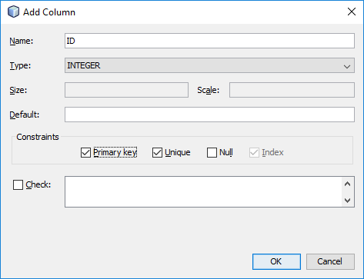

1. Now **add second column** with following detail. But **don’t select primary** and click on OK button.

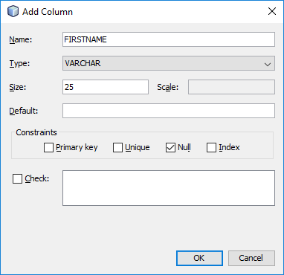

1. Now **click on OK** button.

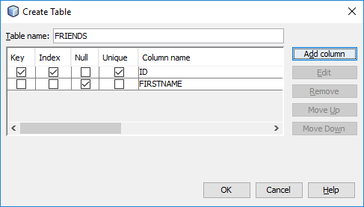

1. Now you can see a table with name **FRIENDS** in the table.

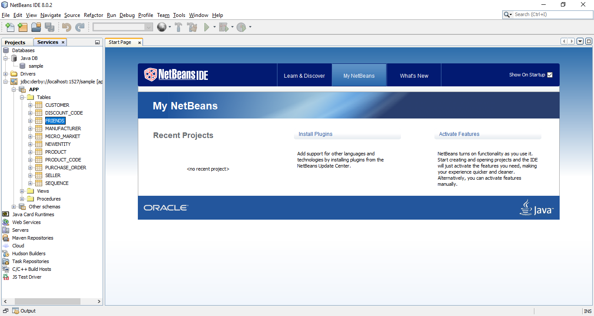

1. **Right click on FRIENDS to view and add records** into it.

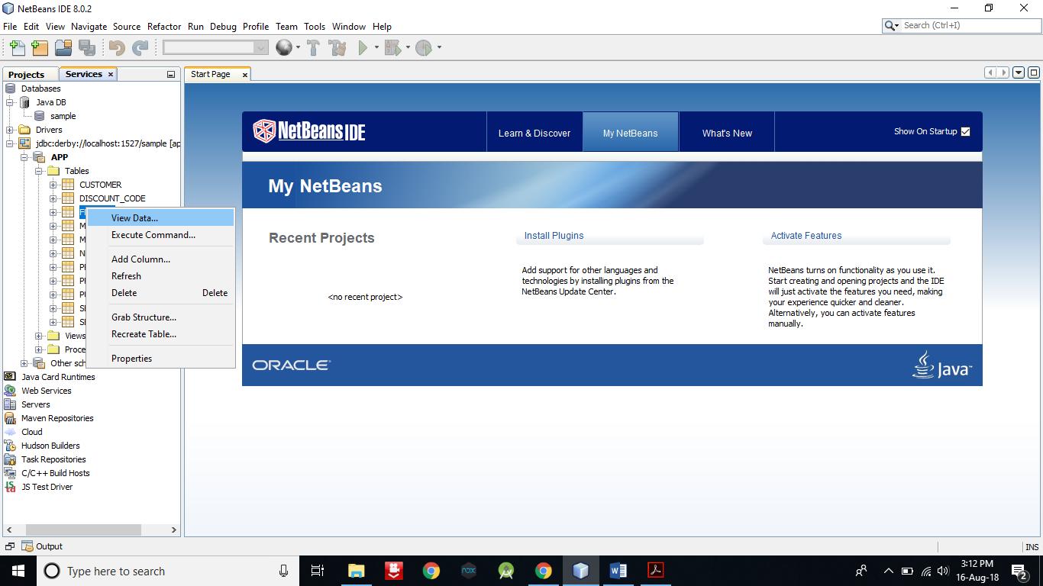

1. Now **click on the leftmost icon in second panel to insert some record**.

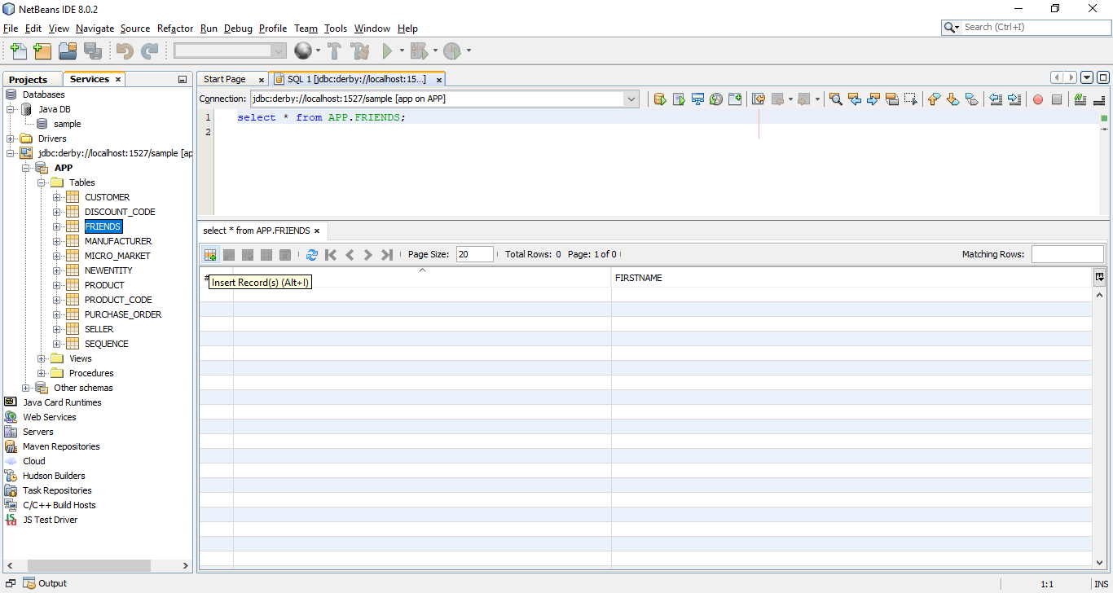

1. **Insert a record** and then **click on Add Row button to insert more record**. After that **click on OK button** to finish.

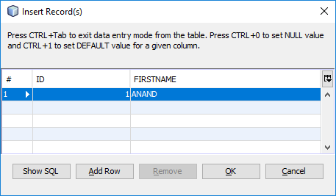

1. As you can see, I have entered 7 records.

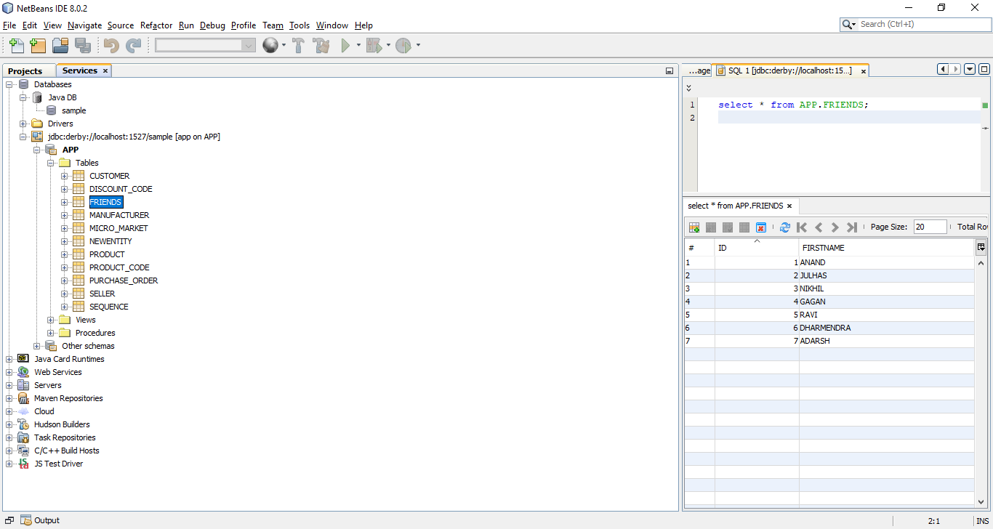

1. Now **create a web application** with name **Server**. After that **click on Next and** **then Finish** button.

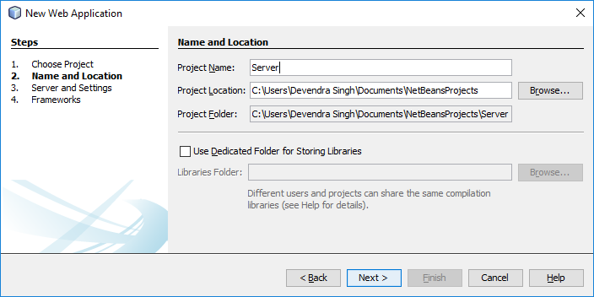

1. Now **create a RESTful Web Service from Database by right click on project** name.

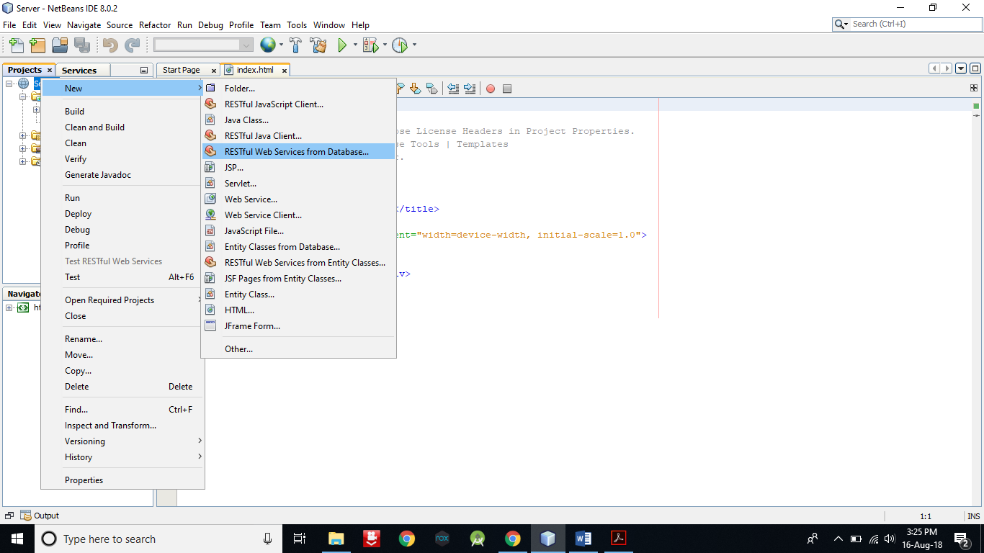

1. Choose **Data Source jdbc/sample**.

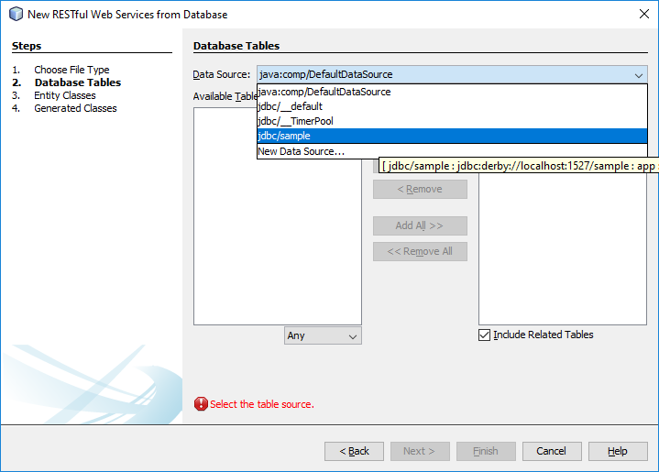

1. Now **select FRIENDS** and **click on Add button**. After that **click on Next** button.

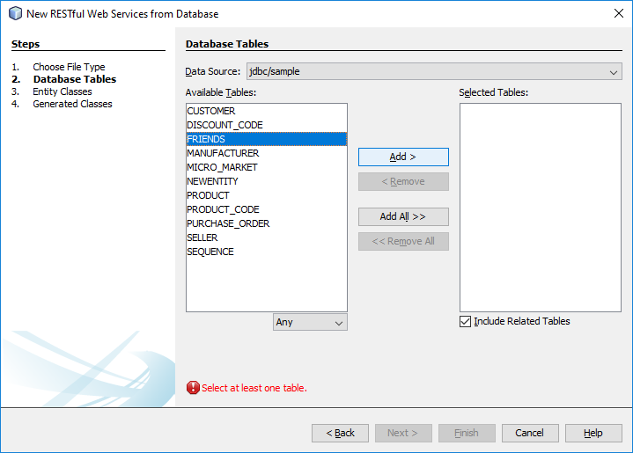

1. **Enter Package name** as **com.kk** and **click on Next** button and **then Finish**.

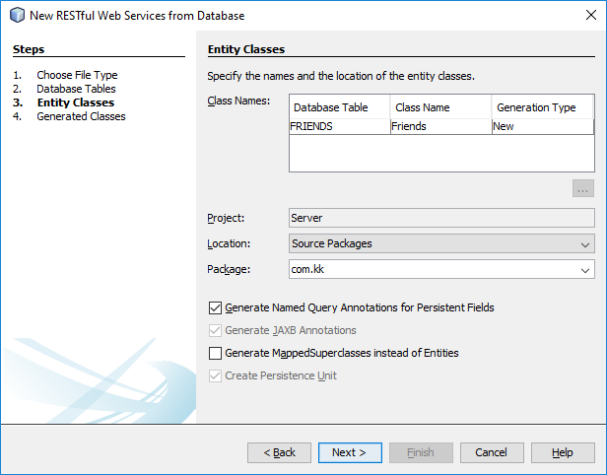

1. Now **open selected file by double click** on it.

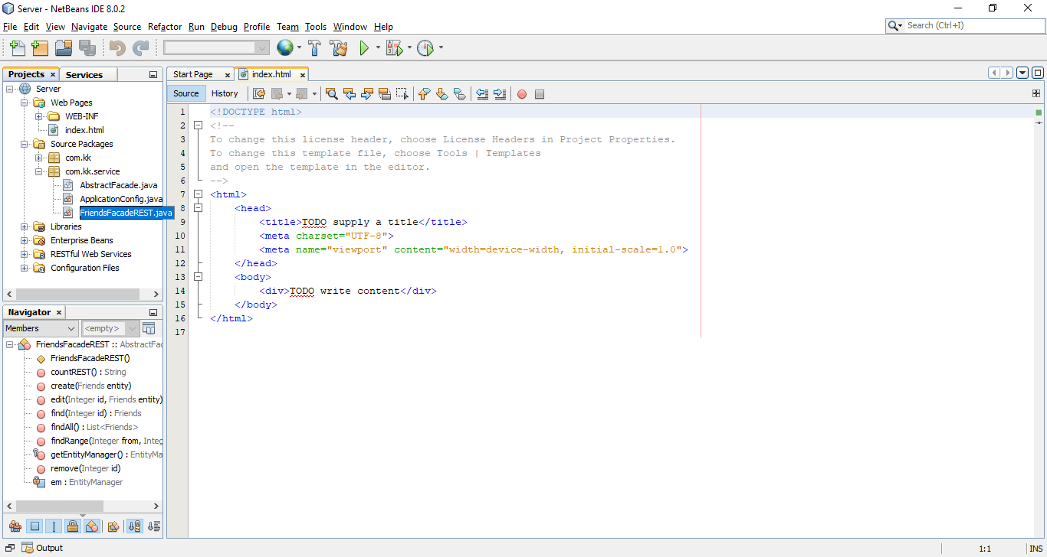

1. Now **remove the selected part from every method in this file**. So that it will communicate only in JSON format. You can also use methods to convert it. But this is easiest method.

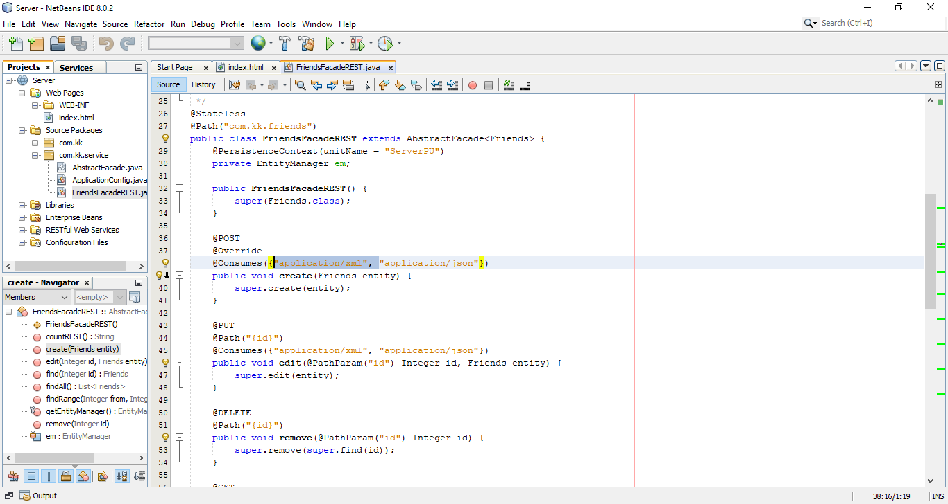

1. After that **right click on project name and Deploy** it.

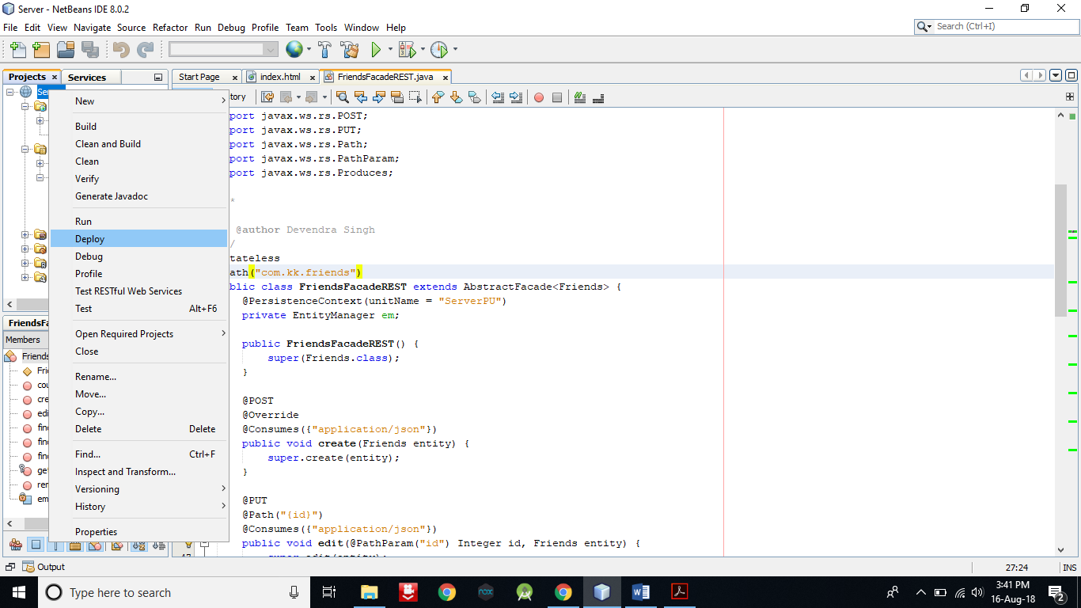

1. Now **create one more Web Application** as **Client**. After that **click on Next** and then **Finish** button.

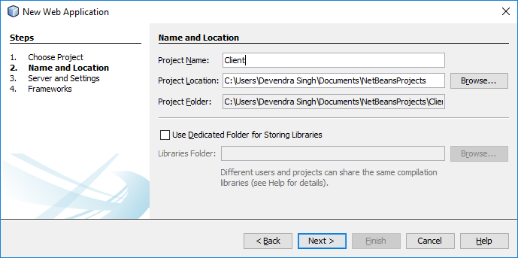

1. Now **open the index.html file** **of Client project** and **add the following code in** **between HEAD tag**.

**<style>**

**table {**

**font-family: arial, sans-serif;**

**border-collapse: collapse;**

**}**

**td, th {**

**border: 1px solid #000000;**

**text-align: center;**

**padding: 8px;**

**}**

**</style>**

**<script>**

**var request = new XMLHttpRequest();**

**request.open('GET',** **'**http://localhost:8080/Server/webresources/com.kk.friends/**', true);**

**request.onload = function () {**

**// begin accessing JSON data here**

**var data = JSON.parse(this.response);**

**for (var i = 0; i < data.length; i++) {**

**var table = document.getElementById("myTable");**

**var row = table.insertRow();**

**var cell1 = row.insertCell(0);**

**var cell2 = row.insertCell(1);**

**cell1.innerHTML = data[i].id;**

**cell2.innerHTML = data[i].firstname;**

**}**

**};**

**request.send();**

**</script>**

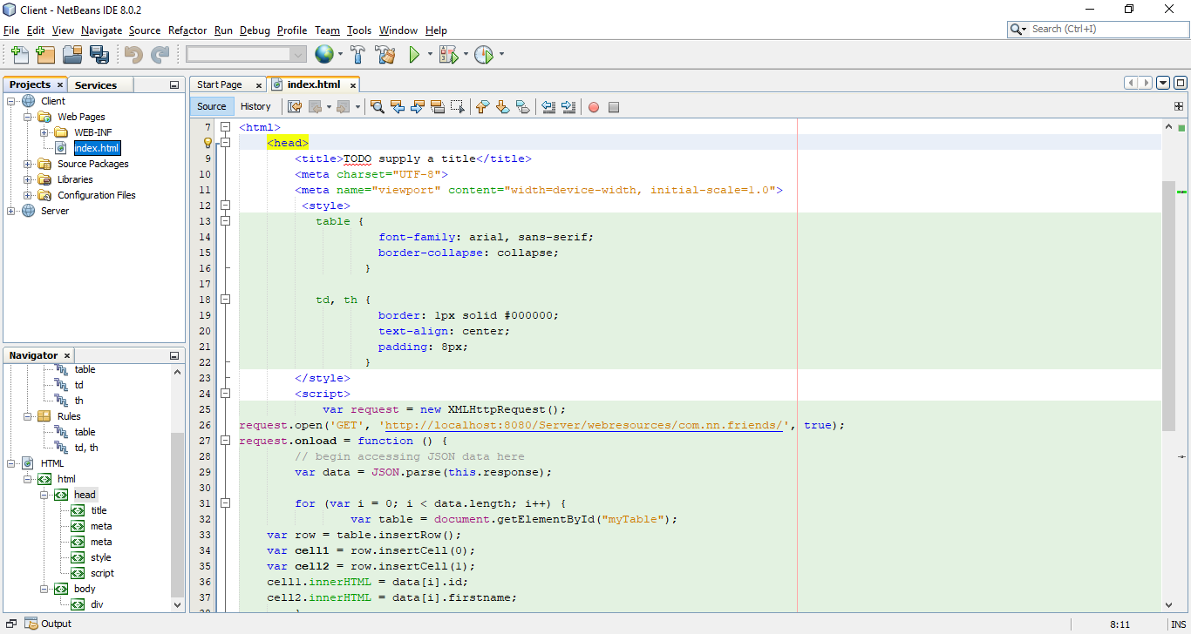

**URL in the red font is sensitive**. It will change accordingly if you have not given the project and file names as of mine.

1. **Replace the content of body** tag **with following code**.

**<table id="myTable">**

**<tr>**

**<th> ID</th>**

**<th>NAME</th>**

**</tr>**

**</table>**

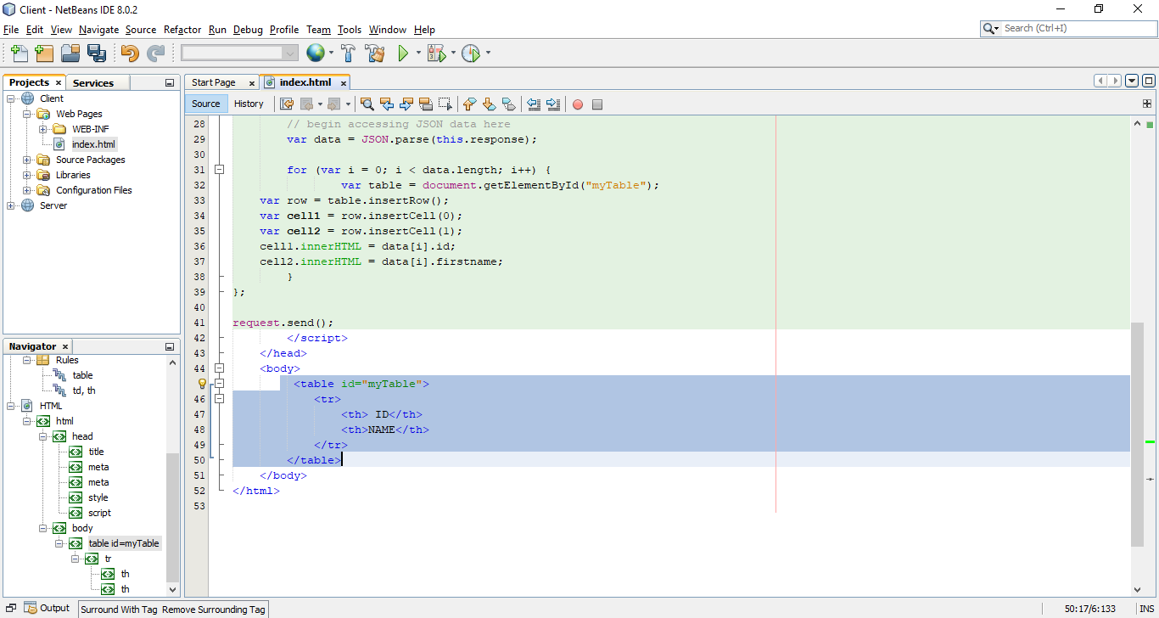

1. Now **run** the **Client** Web Application.

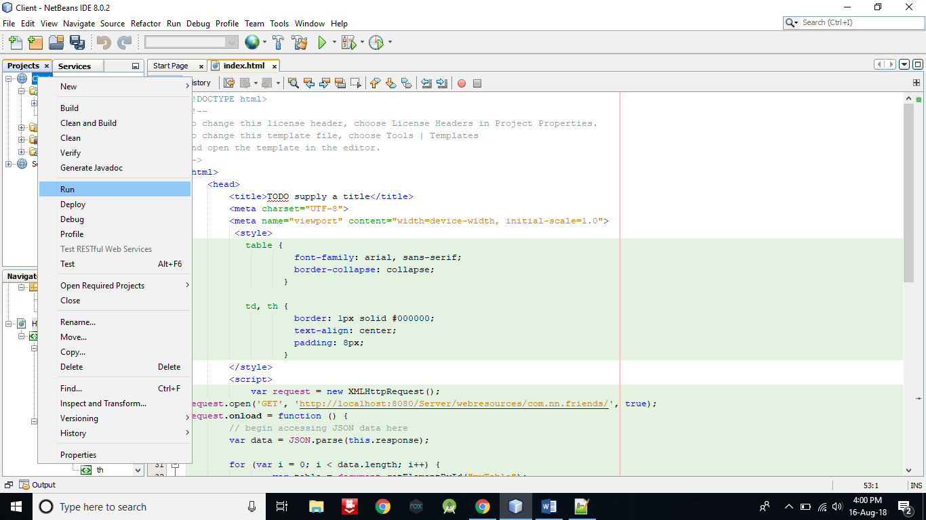

1. A window will open in browser which represents a data in tabular format.

These **data are the records entered in FRIEND table**.

