1. Click on Window menu and click on **Projects, Files** & **Services** to open it.

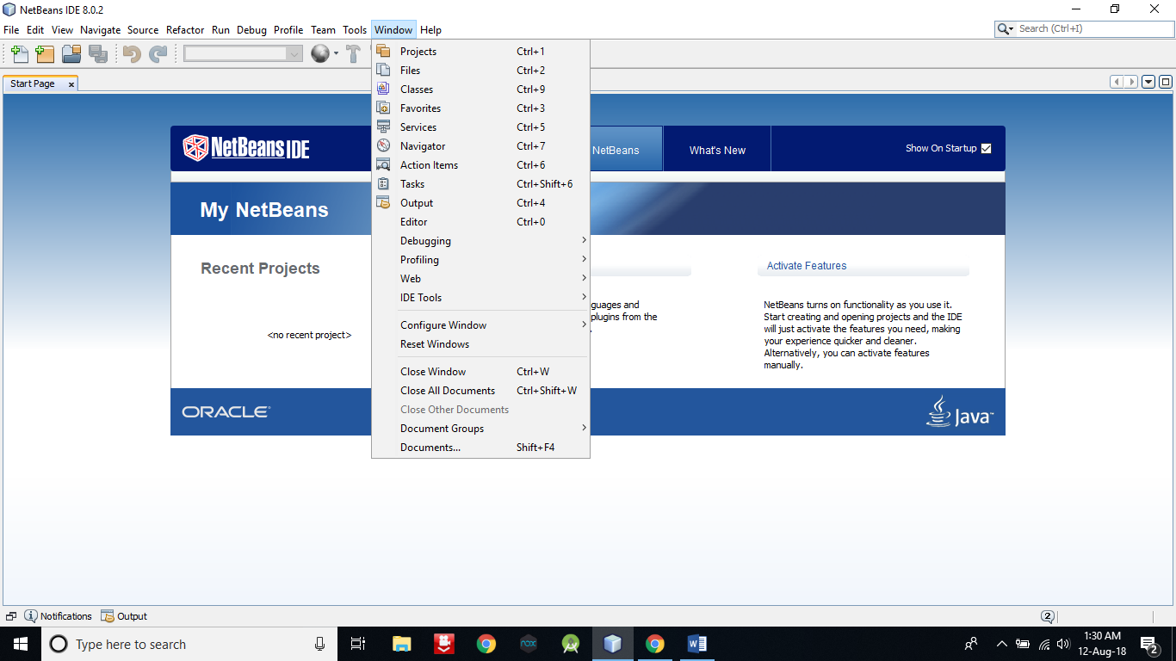

1. **Right click on Java DB** and then **click on Start Server** to start the server .

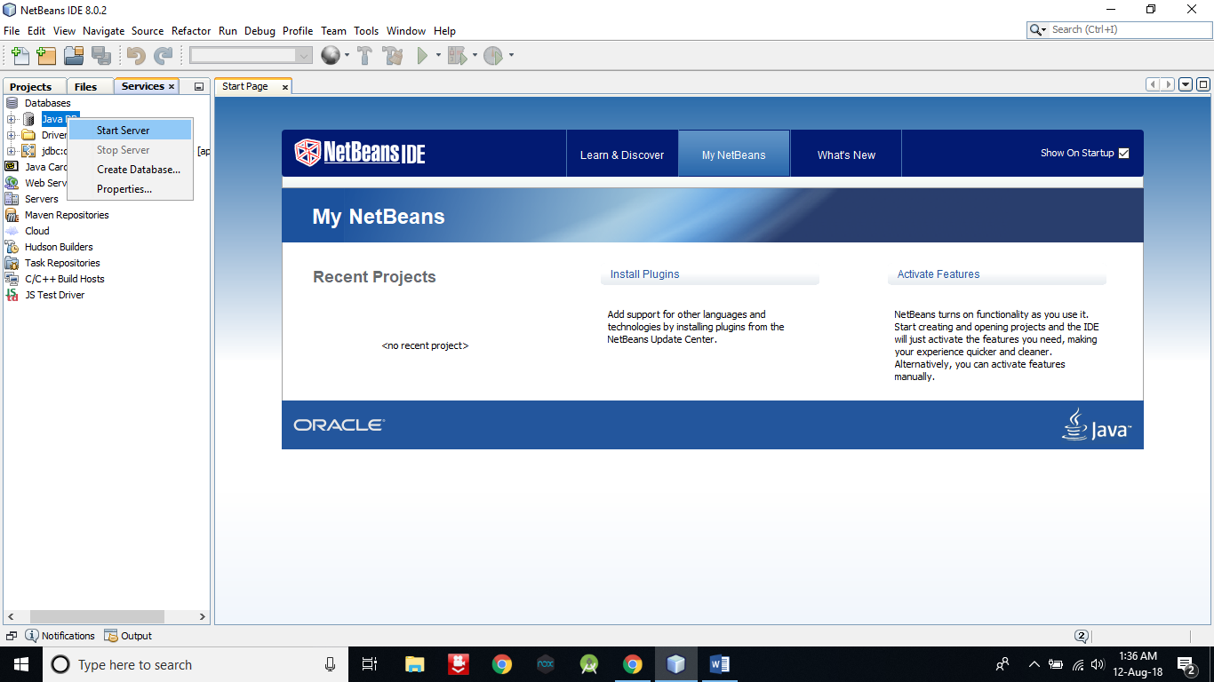

1. Now expand Java DB and **right click on sample** and then **click on connect** to connect the sample database with server.

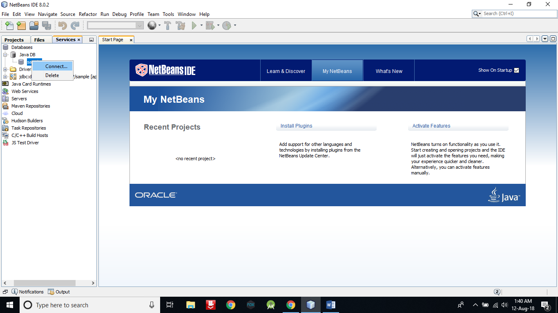

1. Now create a web application with the name **CRUD_Operation**. A window will open like following pic.

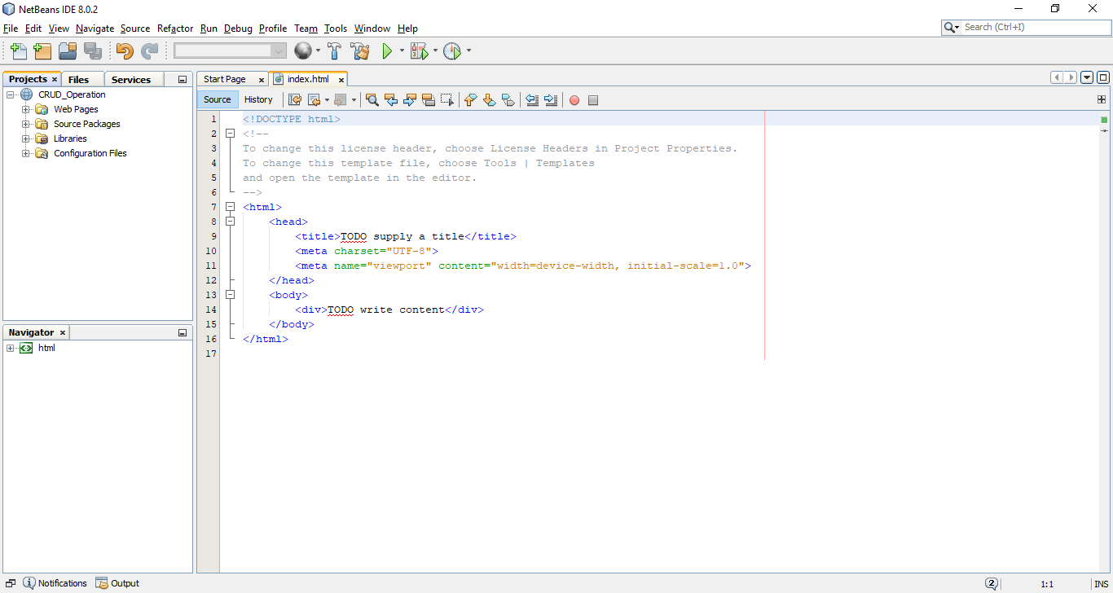

1. Create an entity class. **Right click on project name -> New -> Entity Class**.

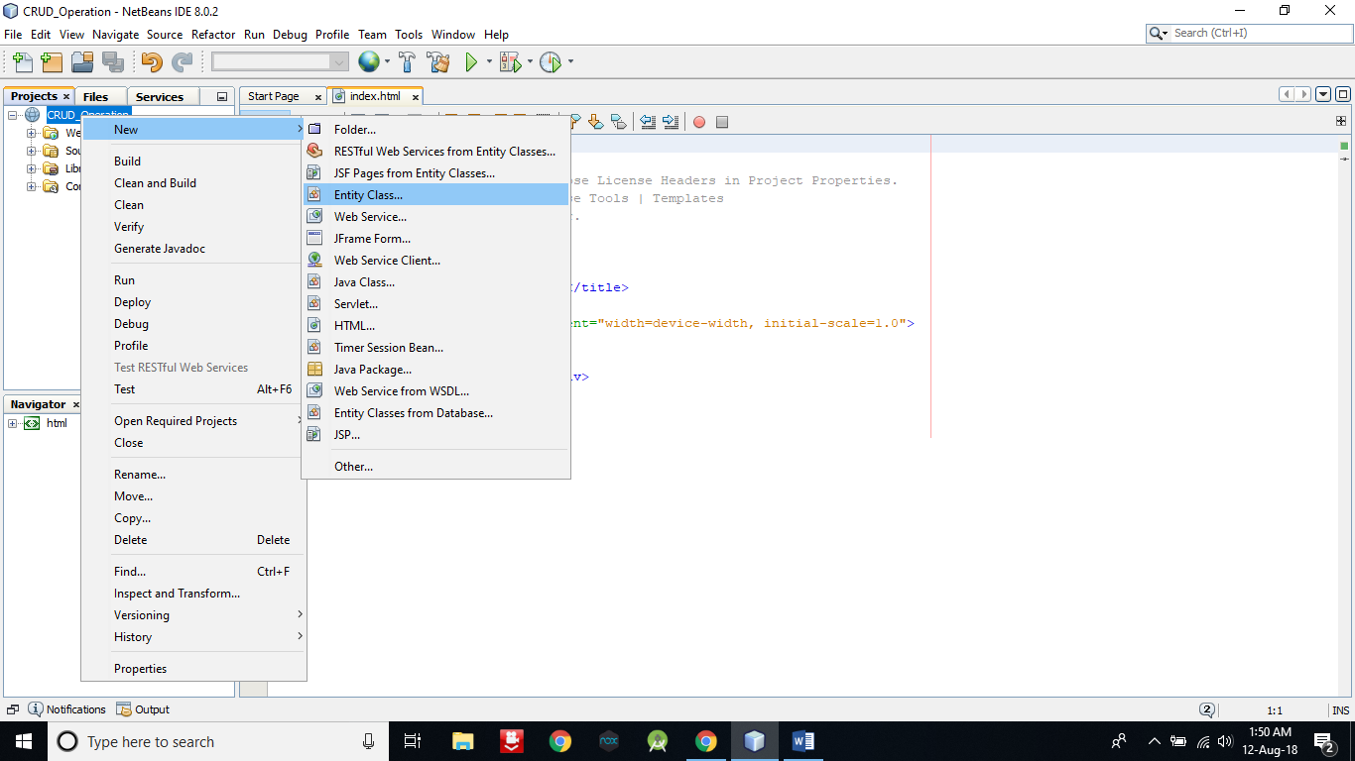

1. A window will appear like bellow pic. Enter following data and click on Next ….

**Class Name -> seller**

**Package Name -> com.kk**

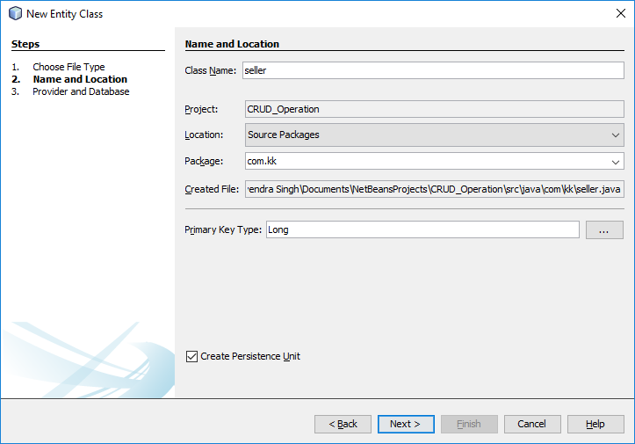

1. **Click on Finish**.

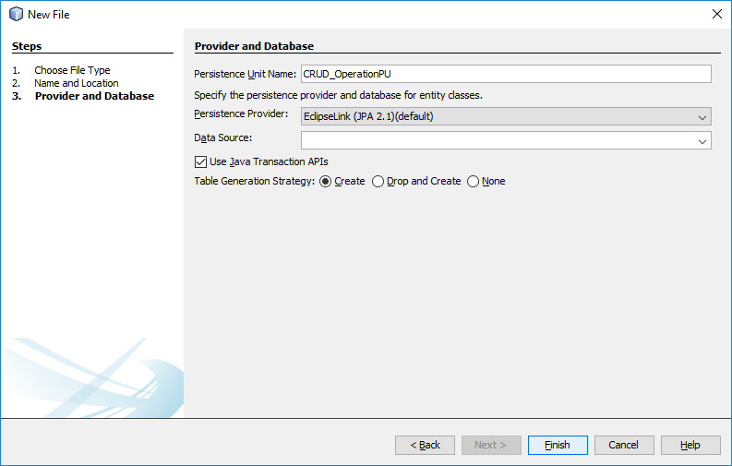

1. Right click on project name and create JSF Pages from Entity Classes.

**Right click on project name -> New -> JSF Pages from Entity Classes**

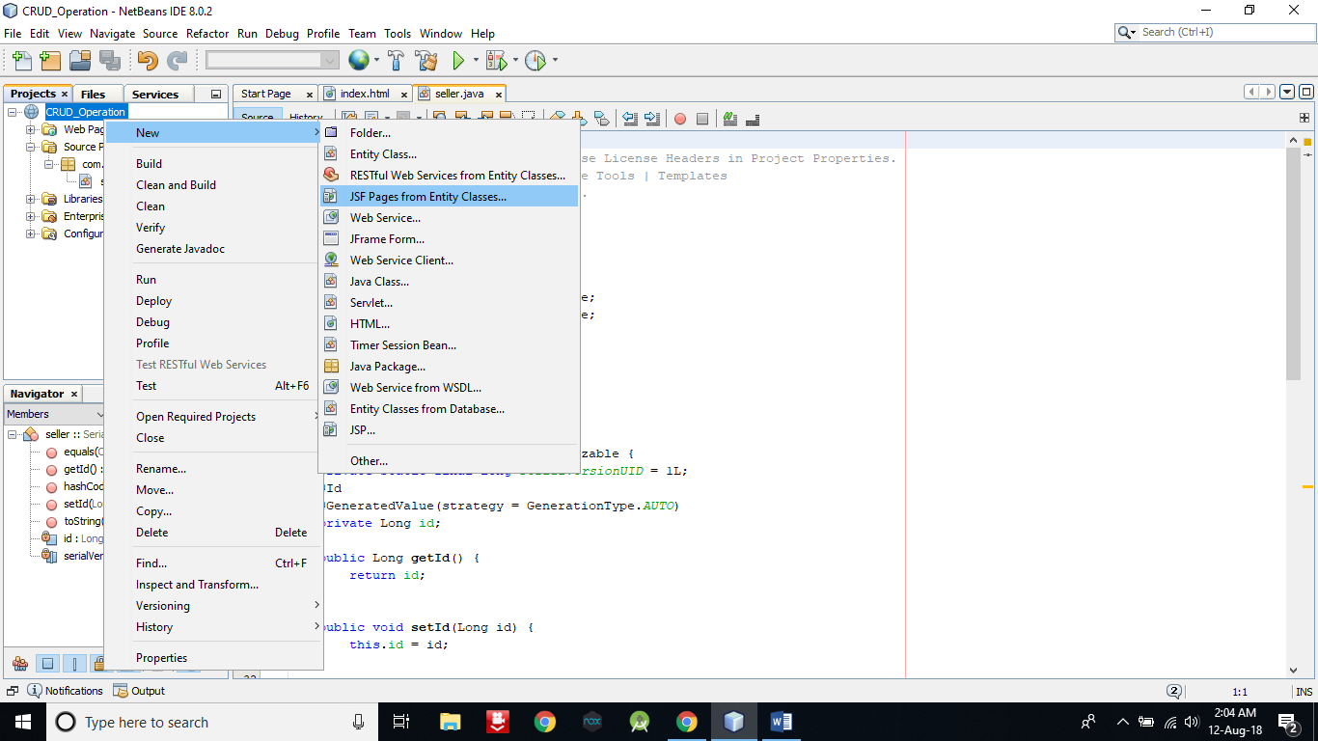

1. **Select com.kk.seller** and **click on Add button** **and then Next button** on below.

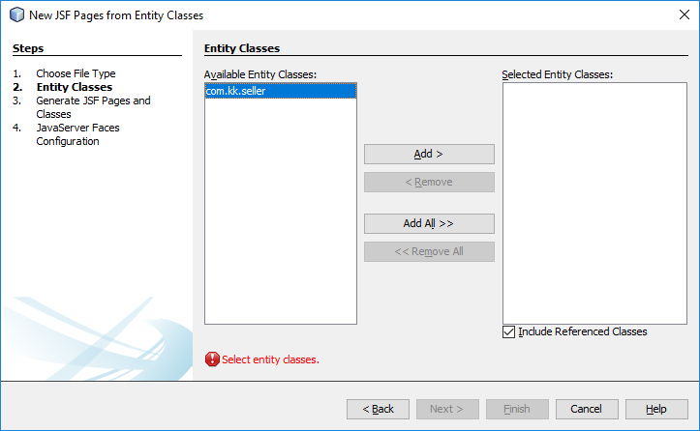

1. A window like below will appear on the screen. **Enter the data into that** **window as entered in below pic** and **click on Next button**.

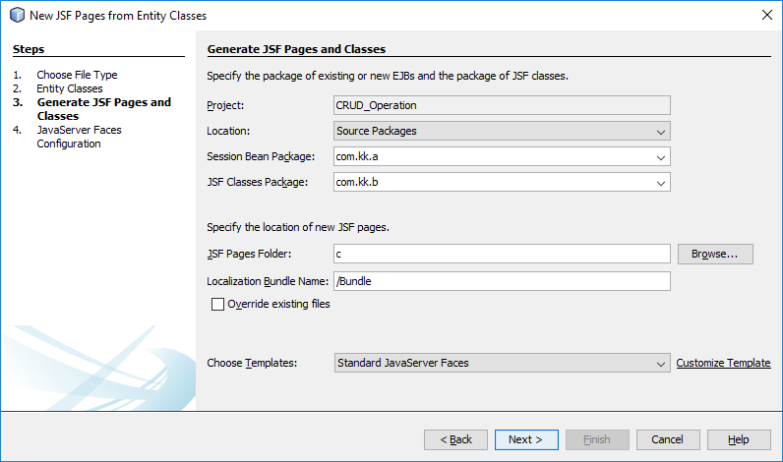

1. Now **click on Finish**.

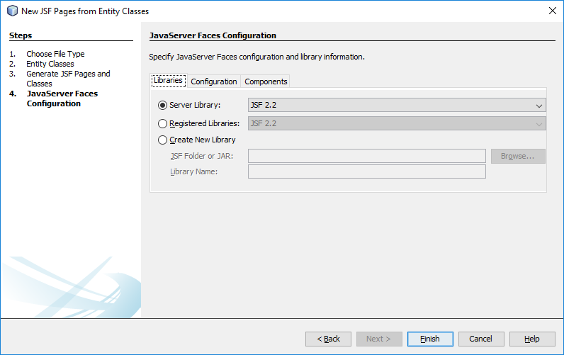

1. Right click on project name and create RESTful Web Services from Entity Classes.

**Right click on project name -> New -> RESTful Web Services from Entity Classes**

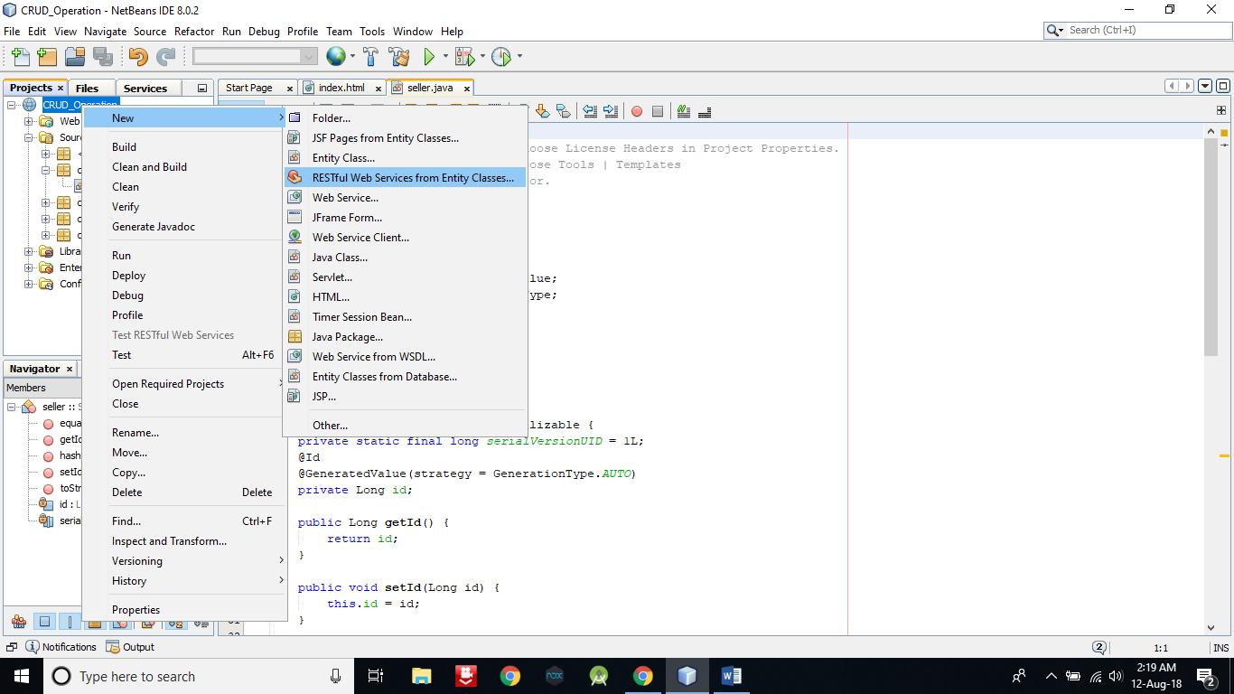

1. **Repeat step 9** and then it will go on next page. Then **enter the com.kk.service** in Resource Package and then **click on Finish button**.

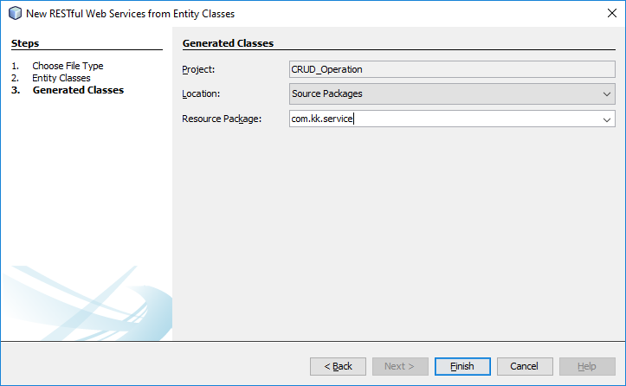

1. Now **open seller.java file under com.kk package**.

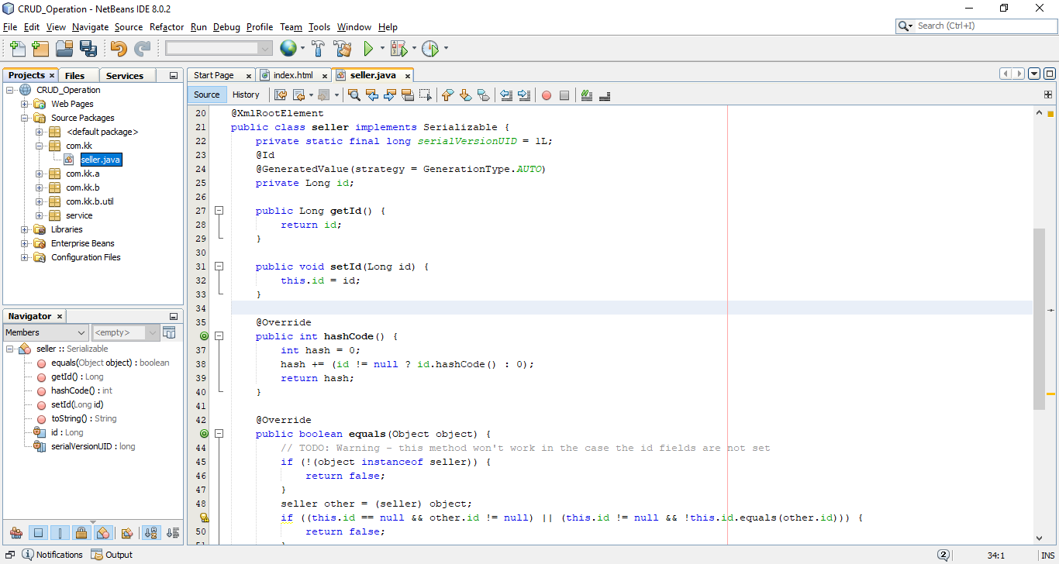

1. In this file **at line number 24**, do the **right click and select Insert Code**.

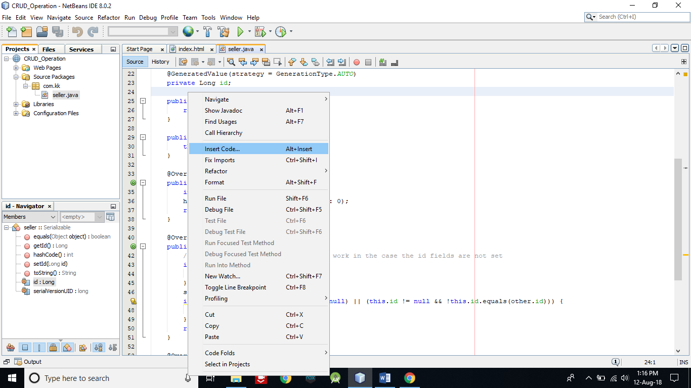

1. A new list will appear. **Click on Add Property**.

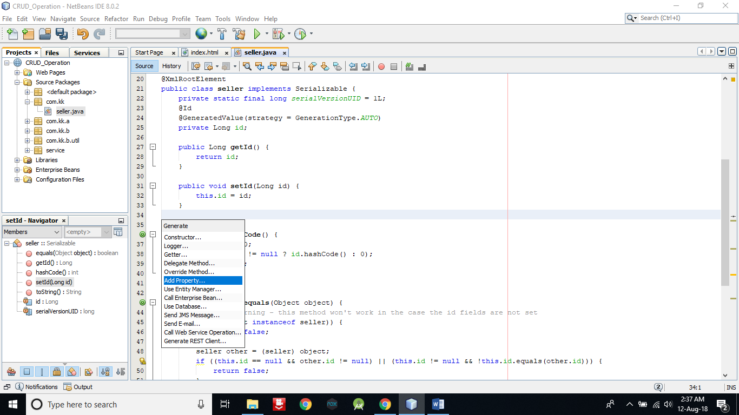

1. A new window will open. Enter name as **firstName**. Make sure name should be exact same as of mine and then **click on OK button**. Actually we are setting getter and setter method for firstName.

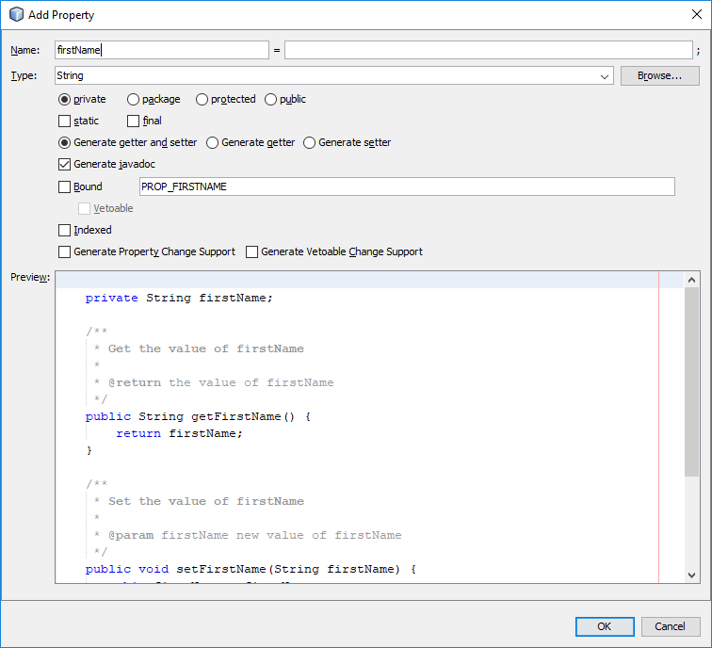

1. Now **right click on web application name and Deploy** it.

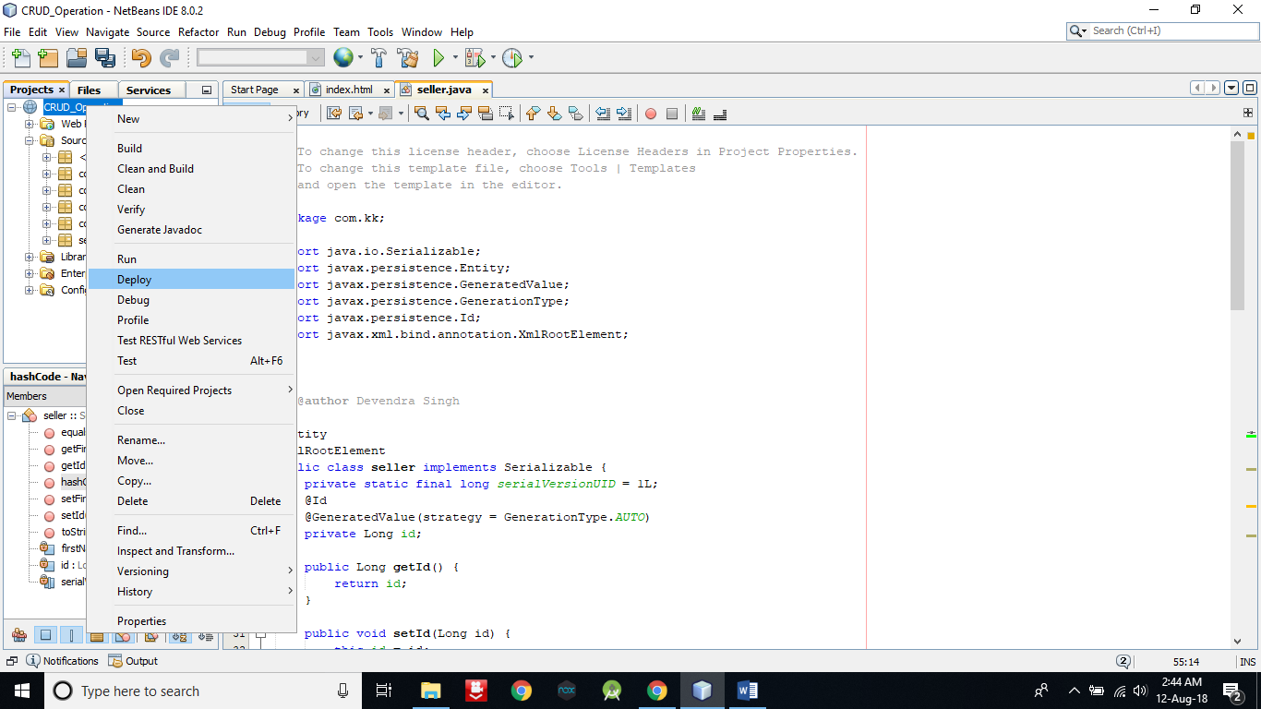

1. Now **right click on project name** and **run** it.

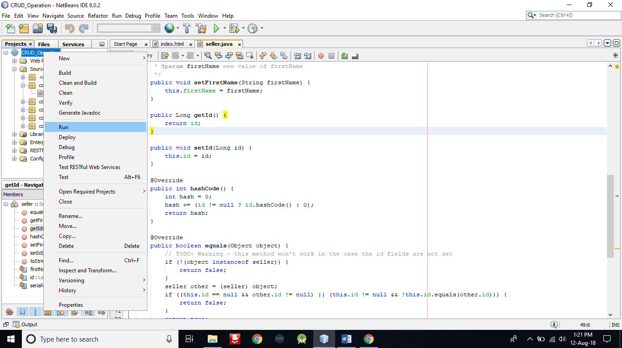

1. A window will open in browser like below….

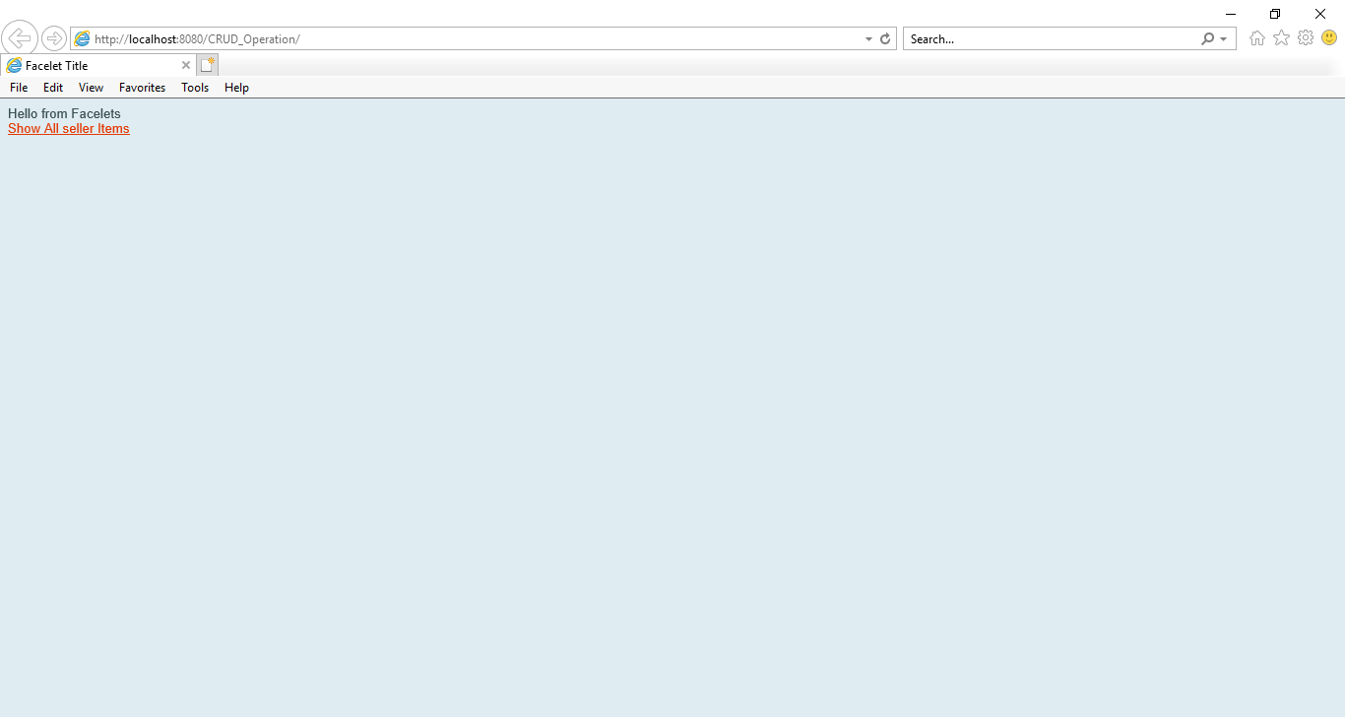

1. Now **click on Show All sellers** Items for CRUD operation.

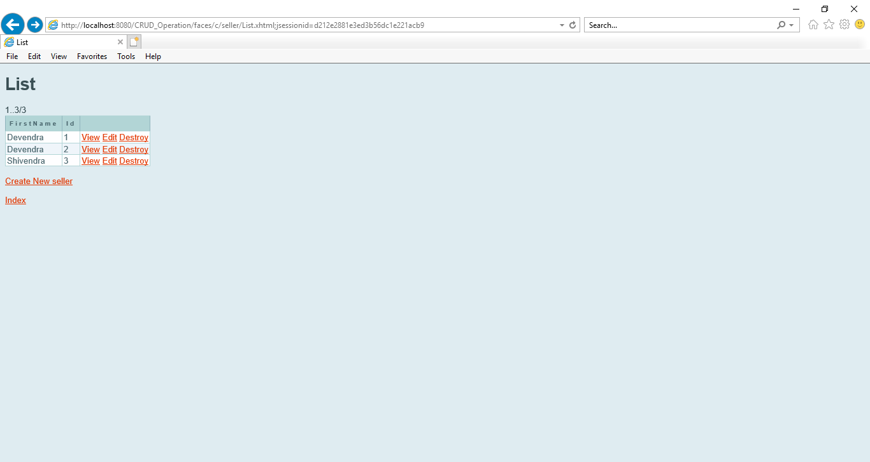

1. As I have added three data into database. **You can add more data by click on** **Create New seller and can view, edit and delete by click on View, Edit and Destroy option**.



1. Adding one more data into database for demo. Just click on Create New seller.

**Enter a name into FirstName and id into Id**. Now **click on Save** option to save the data.

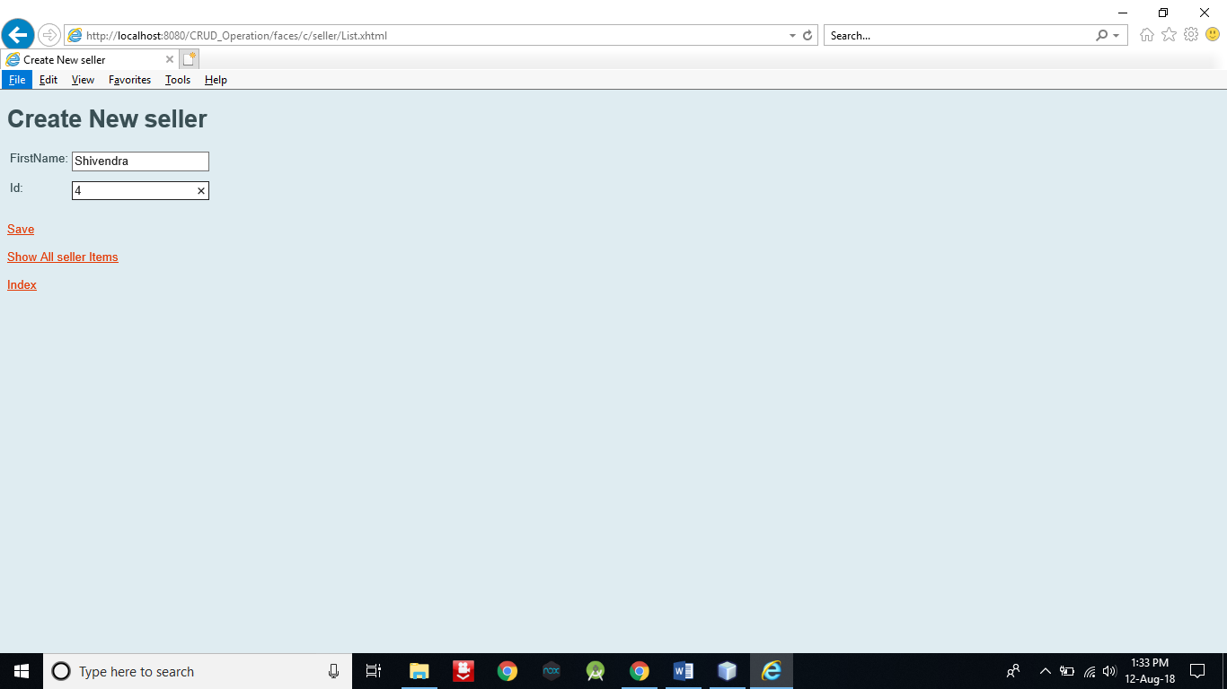

1. Now **click on Show All seller Items** **to view all records** whether our data is entered or not. We can see that one more Shivendra name is appearing.

