**User Register / Admin Register**

~ If admin Registration (is_staff = True ) ,for users (is_staff=False)

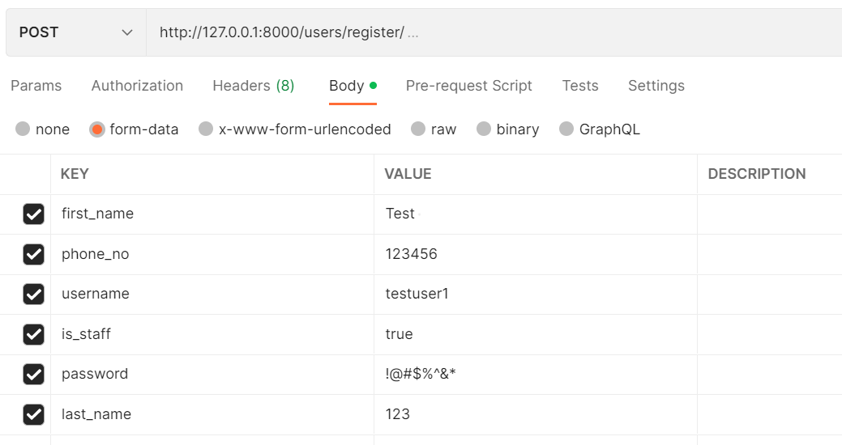

**User Login/Admin Login:-**

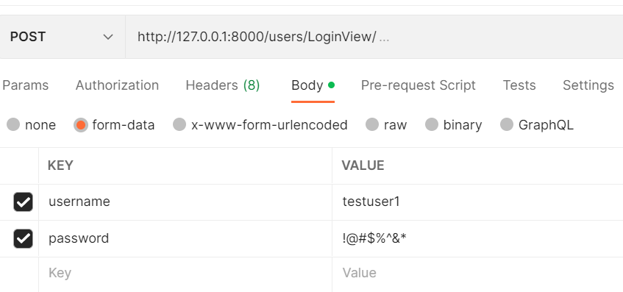

**Category Insertion :-**

~ From admin side Api for New category Insertions.

**Category_getter:-**

~ From user side Api for category getter.

~its also used for admin side upload video based on category id

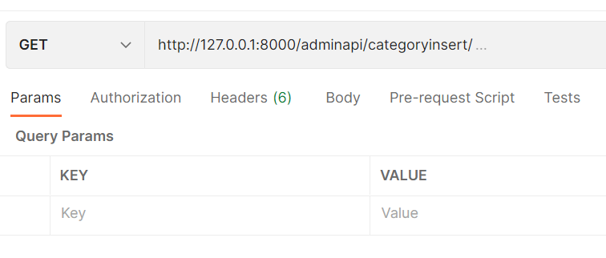

**AdminUpload Videos:-**

~ From Admin side upload sample/template video based on category.

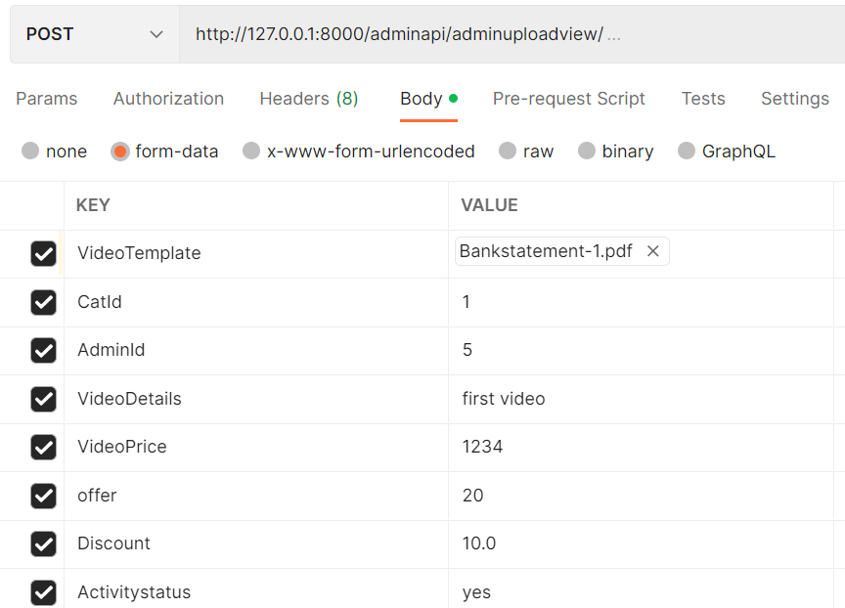

**Getting videos:**

~ From user side get sample/template video based on category.(now its for getting all videos)

**User History :-**

~ From user side purchased video based on category to store details of purchasing.

**User History View:-**

~ view user side history of video based on category and details of purchasing.(now its for all purchased videos)

