Social Media — Task Sheet
Instructions: Do not change the question text. Write your answer directly below each question. For Objective questions, the expected output columns and row counts are given below the question. For Subjective questions, no such details are given, work out and write the answer on your own.

Objective Questions
Q1 Are there any tables with duplicate or missing null values? If so, how would you handle them?
users — rows with NULL username
Output columns (in order): id, username, created_at (3 columns)
Row count: Varies — this is what O1 is asking you to determine. Run the query and report what you find.
users — duplicate usernames
Output columns (in order): username, count (2 columns)
Row count: Varies — this is what O1 is asking you to determine. Run the query and report what you find.
photos — rows with NULL image_url / user_id / created_dat
Output columns (in order): id, image_url, user_id, created_dat (4 columns)
Row count: Varies — this is what O1 is asking you to determine. Run the query and report what you find.
photos — duplicate (image_url, user_id) pairs
Output columns (in order): image_url, user_id, count (3 columns)
Row count: Varies — this is what O1 is asking you to determine. Run the query and report what you find.
comments — rows with NULL comment_text / user_id / photo_id / created_at
Output columns (in order): id, comment_text, photo_id, user_id, created_at (5 columns)
Row count: Varies — this is what O1 is asking you to determine. Run the query and report what you find.
comments — duplicate (comment_text, user_id, photo_id) triples
Output columns (in order): comment_text, user_id, photo_id, count (4 columns)
Row count: Varies — this is what O1 is asking you to determine. Run the query and report what you find.
likes — rows with NULL user_id / photo_id / created_at
Output columns (in order): user_id, photo_id, created_at (3 columns)
Row count: Varies — this is what O1 is asking you to determine. Run the query and report what you find.
likes — duplicate (user_id, photo_id) pairs
Output columns (in order): user_id, photo_id, count (3 columns)
Row count: Varies — this is what O1 is asking you to determine. Run the query and report what you find.
follows — rows with NULL follower_id / followee_id / created_at
Output columns (in order): follower_id, followee_id, created_at (3 columns)
Row count: Varies — this is what O1 is asking you to determine. Run the query and report what you find.
follows — duplicate (follower_id, followee_id) pairs
Output columns (in order): follower_id, followee_id, count (3 columns)
Row count: Varies — this is what O1 is asking you to determine. Run the query and report what you find.

Q2 What is the distribution of user activity levels (e.g., number of posts, likes, comments) across the user base?
Output columns (in order): user_id, username, total_posts, total_likes_given, total_comments_made (5 columns)
Row count: 100 rows (verified — 1 row per user).
Code:-
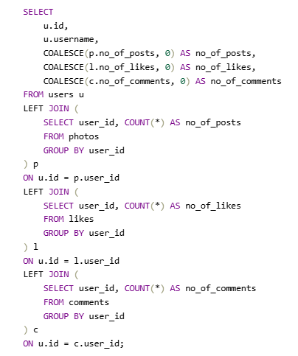
Output:-
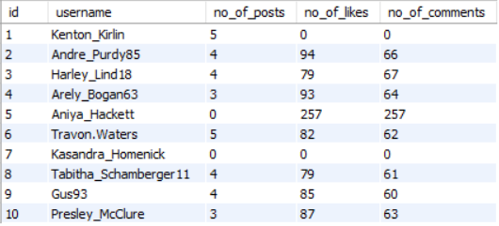

Q3 Calculate the average number of tags per post (photo_tags and photos tables).
Output columns (in order): AverageTags (1 column)
Row count: 1 row (single aggregate value).
-- IF THE QUESTION IS TAG PER PHOTO THEN
Code:-
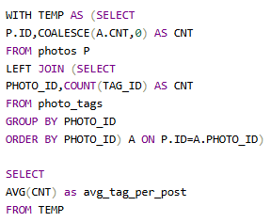
Output:-
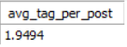
-- IF THE QUESTION IS ONLY TAG PHOTO THEN
Code:-
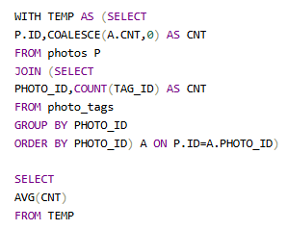
Output:-
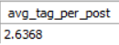

Q4 Identify the top users with the highest engagement rates (likes, comments) on their posts and rank them.
Output columns (in order): user_id, Total, rnk (3 columns)
Row count: 74 rows (verified — 1 row per photo-owner whose photos have ≥1 like AND ≥1 comment).
Code:-
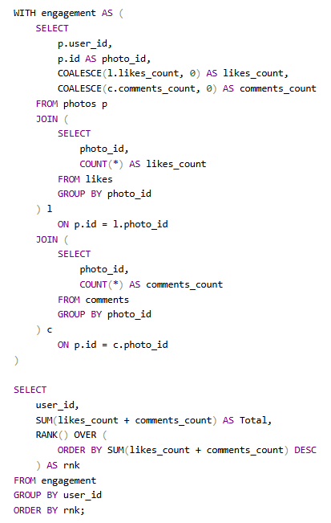
Output:-
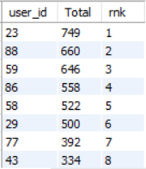

Q5 Which users have the highest number of followers and followings?
Output columns (in order): user_id, username, followers, following (4 columns)
Row count: 100 rows (verified — 1 row per user).
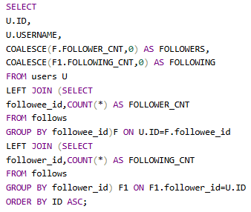
Output:-
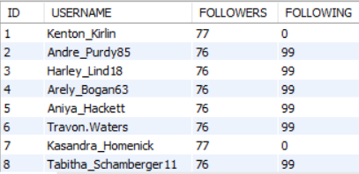

Q6 Calculate the average engagement rate (likes, comments) per post for each user.
Output columns (in order): id, username, avg_engagement (3 columns)
Row count: 74 rows (verified — 1 row per user who has posted ≥1 photo).
Code:-
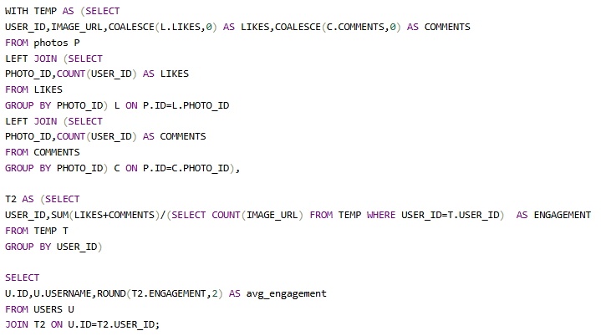
Output:-
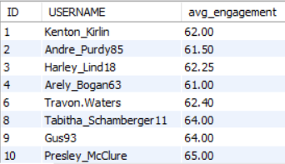

Q7 Get the list of users who have never liked any post (users and likes tables)
Output columns (in order): id, username (2 columns)
Row count: 23 rows (verified).
Code:-
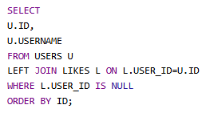
Output:-
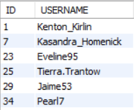

Q8 How can you leverage user-generated content (posts, hashtags, photo tags) to create more personalized and engaging ad campaigns?
Output columns (in order): user_id, username, tag_name, tag_usage, total_likes_received, total_comments_received, total_engagement (7 columns)
Row count: 459 rows (verified — 1 row per user/tag combination that appears in that user's posts).
Code:-
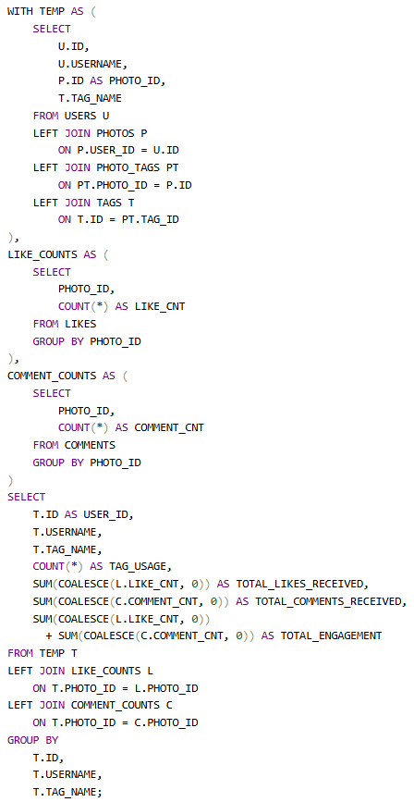

Output:-
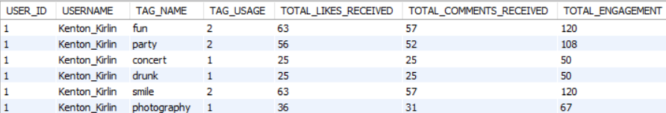

Q9 Are there any correlations between user activity levels and specific content types (e.g., photos, videos, reels)? How can this information guide content creation and curation strategies?
Output columns (in order): user_id, total_posts, total_likes, total_comments, total_engagement (5 columns)
Row count: 74 rows (verified — 1 row per user_id with ≥1 photo).
Code:-
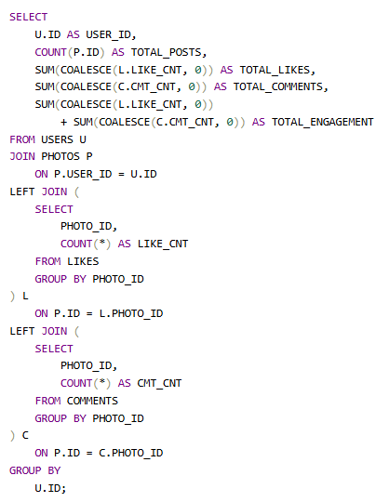

Output:-
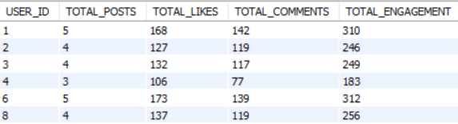

Q10 Calculate the total number of likes, comments, and photo tags for each user.
Output columns (in order): user_id, username, total_likes, total_comments, total_tags (5 columns)
Row count: 100 rows (verified — 1 row per user).
Code:-
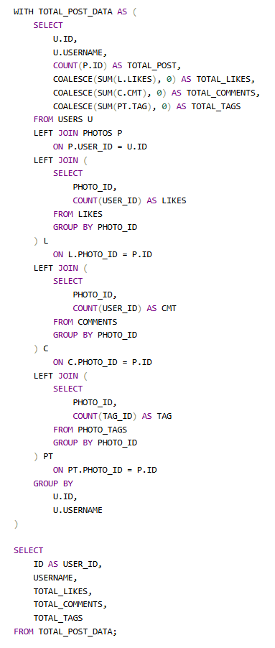

Output:-
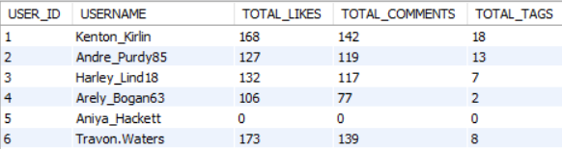

Q11 Rank users based on their total engagement (likes, comments, shares) over a month.
Output columns (in order): user_id, username, likes_given, comments_made, total_engagement, engagement_rank (6 columns)
Row count: 100 rows (verified — 1 row per user).
Code:-
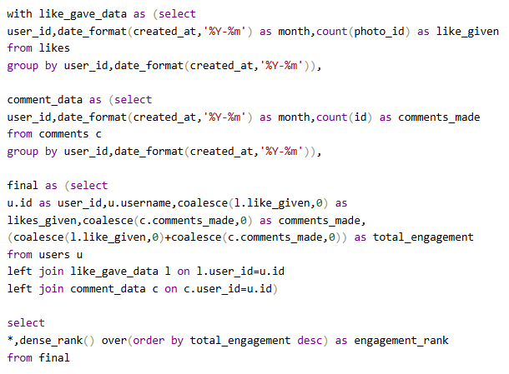
Output:-
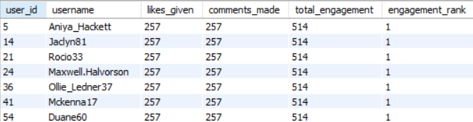

Q12 Retrieve the hashtags that have been used in posts with the highest average number of likes. Use a CTE to calculate the average likes for each hashtag first.
Output columns (in order): tag_id, tag_name, avg_likes_per_photo, total_likes, total_photos (5 columns)
Row count: 10 rows (LIMIT 10; 21 tags exist in total, so the limit is reached).
Code:-
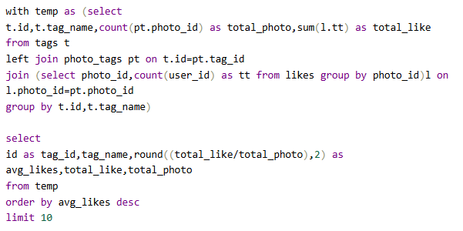
Output:-
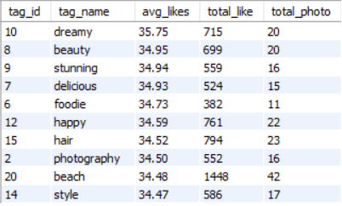

Q13 Retrieve the users who have started following someone after being followed by that person.
Output columns (in order): id, username (2 columns)
Row count: 77 rows (verified).
Code:-
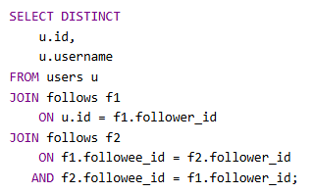

Output:-
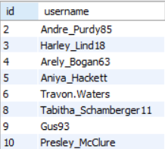

Subjective Questions
Q1 Based on user engagement and activity levels, which users would you consider the most loyal or valuable? How would you reward or incentivize these users?
For our most loyal customers, we measure user activity by tracking how many posts they have liked and commented on. We then sum these interactions to calculate total engagement and rank users accordingly. Based on this ranking, we can confidently identify 13 users as our most loyal.
Code:-
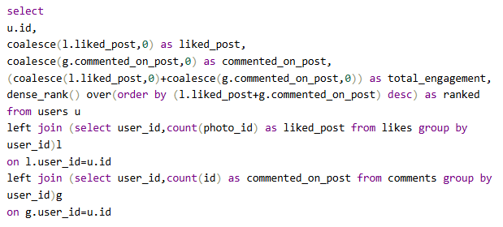
Output;-
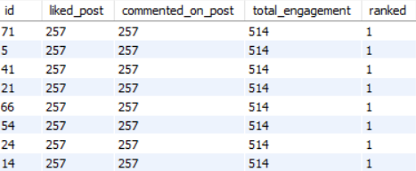
Visual:-
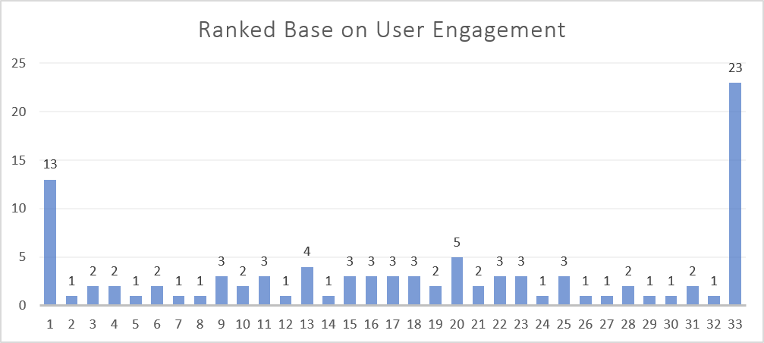
I identified valuable users based on the engagement their content receives. I calculated the total likes and comments received on each user's posts, combined them into a total engagement metric, and then ranked users in descending order using DENSE_RANK. Users with rank 1 have the highest engagement and can be considered the most valuable based on this metric.
Code:-
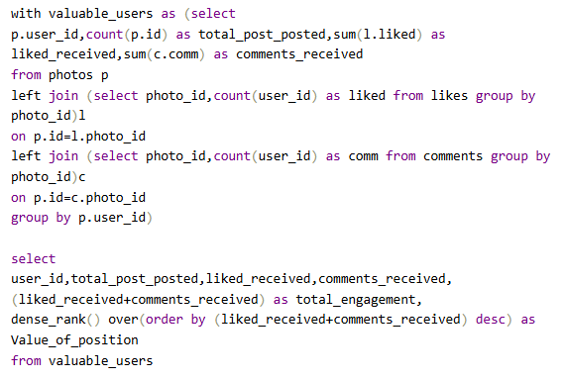
Output:-
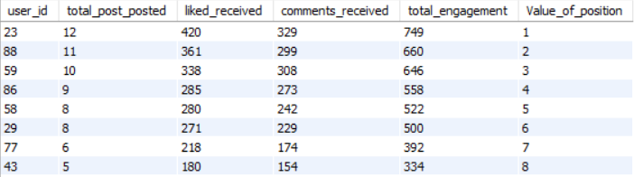

Q2 For inactive users, what strategies would you recommend to re-engage them and encourage them to start posting or engaging again?
Inactive users can be categorised into three groups: users who stopped posting, users who stopped posting but still have identifiable content preferences through likes, and users with no observable posting or liking activity.
For users who are inactive in posting
Code:-
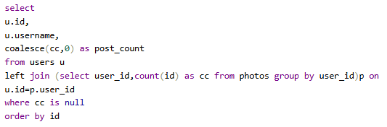
Output:-
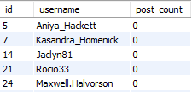
Conclusion
The analysis highlights 26 inactive users regarding post creation, specifically User IDs: 5, 7, 14, 21, 24, 25, 34, 36, 41, 45, 49, 53, 54, 57, 66, 68, 71, 74, 75, 76, 80, 81, 83, 89, 90, and 91.
To re-engage these users and encourage posting, we can target them with personalized emails or notifications based on the content they previously liked or commented on.

– The content preference of users who are inactive for posting
Code:-
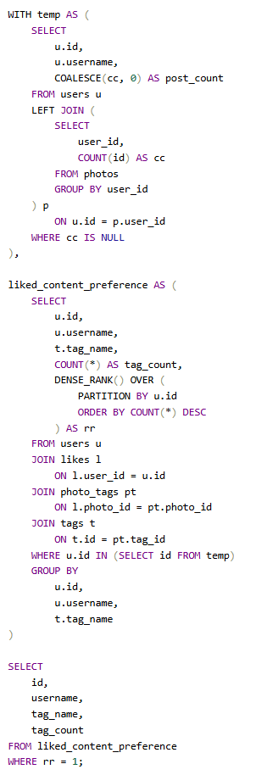
Output:-
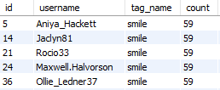
Conclusion
Among the inactive users who had previously liked content, 13 users showed engagement with content tagged smile. This indicates that smile was a frequently engaged topic within this subgroup. Personalized notifications or content recommendations related to this topic could be used to encourage them to return and eventually start posting.
For users whose content cannot be classified by likes and posts, we use their comment activity
Code:-
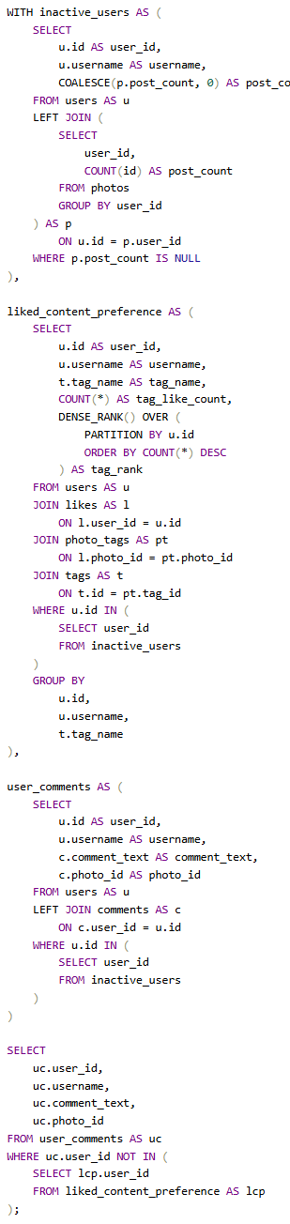
Output:-
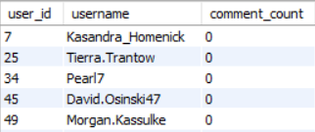

Conclusion
Among users who had neither posted nor liked any content, all identified users also had zero comments. Since these users showed no observable engagement through posting, liking, or commenting, their content preferences cannot be reliably inferred from behavioural data. Therefore, generic re-engagement strategies such as trending-content recommendations, onboarding prompts, posting challenges, and personalised reminders can be used to encourage their first meaningful interaction.

Q3 Which hashtags or content topics have the highest engagement rates? How can this information guide content strategy and ad campaigns?
Code:-
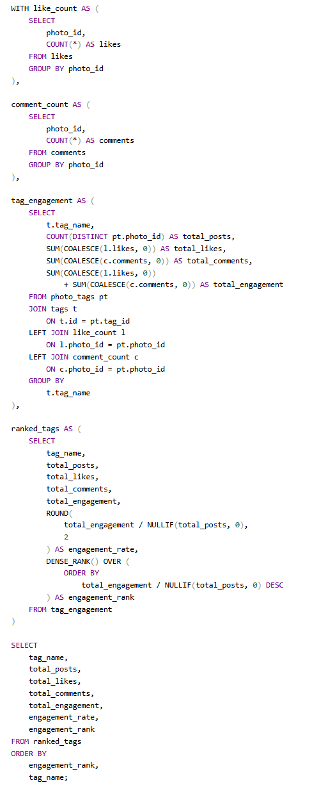
Output:-
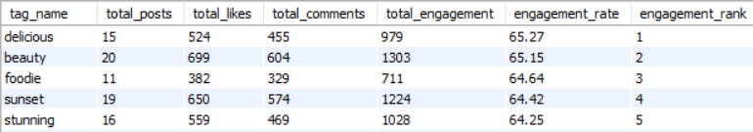
Approach
First, likes and comments are calculated separately for each photo so that duplicate counting does not happen. Then these likes and comments are connected with the hashtags using the photo_tags and tags tables. For each hashtag, we calculate the total number of posts, total likes, total comments and total engagement, where total engagement means likes + comments. we calculate the engagement rate based on the total engagement per post. After that, we rank all the hashtags using DENSE_RANK() in descending order of engagement rate. The hashtag with rank 1 will be considered as the hashtag having the highest engagement per post

Conclusion
The analysis helps us to find which hashtags or content topics are getting more engagement from users. For example, delicious gets rank 1, it means delicious-related content is getting the highest engagement per post compared to other hashtags. Based on this, the company can focus more on creating content around high-engagement topics and can also use these topics while planning their advertising campaigns. For hashtags with lower engagement, the company can try different types of content and formats to improve user engagement.

Q4 Are there any patterns or trends in user engagement based on demographics (age, location, gender) or posting times? How can these insights inform targeted marketing campaigns?

Approach
For this analysis, I checked the posting time of the content to identify whether there is any pattern in user posting behaviour. I extracted the hour and minute from the created_dat column and counted the number of posts created at each time. The dataset does not contain information about user age, location, or gender, so demographic-based engagement patterns cannot be analysed from the available data.
Code:-
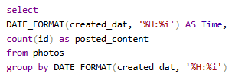
Output:-
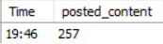

Conclusion
The analysis shows that all the recorded posts in the dataset were created at 19:46, so there is no variation in posting time available in this dataset to identify different peak posting periods. Also, age, location, and gender information is not available, so demographic-based user engagement patterns cannot be determined. If demographic and more varied timestamp data were available, the company could identify specific user segments and their active posting periods and use these insights to send targeted notifications, schedule campaigns at suitable times, and personalize marketing campaigns based on user characteristics.

Q5 Based on follower counts and engagement rates, which users would be ideal candidates for influencer marketing campaigns? How would you approach and collaborate with these influencers?

Approach
First, the follower and following counts are calculated for each user using the follows table. After that, the total number of posts, likes received, and comments received are calculated for each user. The likes and comments are aggregated separately at the photo level to avoid duplicate counting. Since the dataset does not contain impressions or reach, engagement per post is used as the engagement metric, calculated using total likes and comments received divided by total posts. Finally, follower count and engagement per post are combined to identify users who have both a good audience size and strong user engagement, making them potential candidates for influencer marketing campaigns.

Code:-
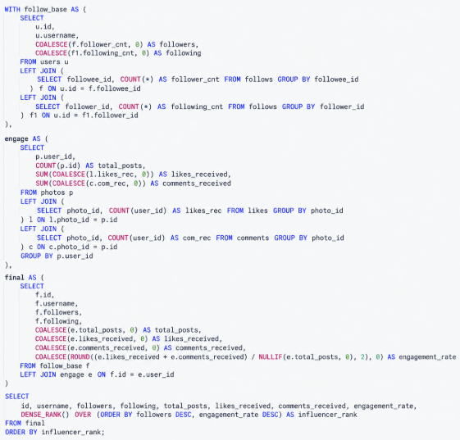

Output:-
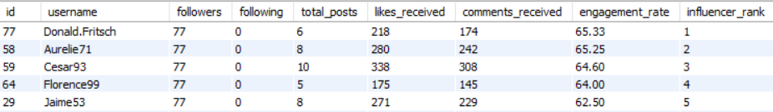

Conclusion
The analysis helps identify users who have a relatively high number of followers along with strong engagement on their posts. These users can be considered potential influencer marketing candidates because they have both an audience and active interaction with their content. The company can collaborate with these users through sponsored posts, product promotions, or campaign-based content. Users with high engagement but fewer followers can also be considered for smaller targeted campaigns, while users with high followers but low engagement may require further analysis before collaboration.
Q6 Based on user behavior and engagement data, how would you segment the user base for targeted marketing campaigns or personalized recommendations?

Approach
First, I analysed the content that each user interacted with through likes. I calculated the number of times each user liked posts under each tag and then used DENSE_RANK() to find the tag that each user liked the most. Based on this, users were divided into different segments such as Beach Interested User, Fun Interested User, and Smile Interested User. Users who did not have any like activity were placed in the No Identifiable Preference segment. These segments can then be used to show users more relevant content and run targeted marketing campaigns based on their interests.
Code:-
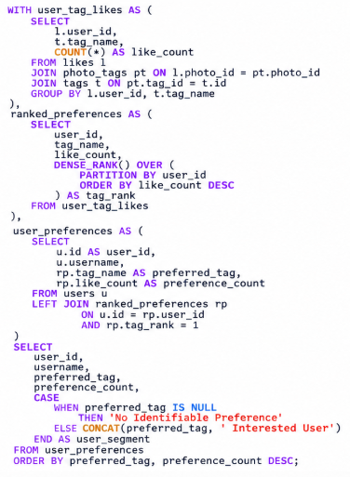
Output:-
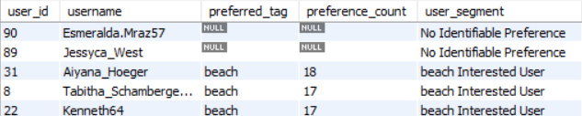

Conclusion
The analysis helps us understand the different interests of users based on their previous behaviour. Users in the Beach, Fun, and Smile segments can be targeted with content, recommendations, or marketing campaigns related to their preferred topics. Users with No Identifiable Preference can be shown general or trending content to understand their interests and encourage them to engage more. This type of segmentation can help the company avoid showing the same content to every user and make marketing campaigns more relevant to each user group.

Q7 If data on ad campaigns (impressions, clicks, conversions) is available, how would you measure their effectiveness and optimize future campaigns?
The current dataset does not contain ad campaign data like impressions, clicks, or conversions, so we cannot directly measure the effectiveness of the campaigns. If this data is available in the future, we can calculate metrics like CTR and conversion rate to understand which campaigns, audiences, and content are performing better. Based on these results, we can improve the future campaigns by targeting the better-performing audience and using the content or ad creatives that are getting better engagement and conversions.
Q8 How can you use user activity data to identify potential brand ambassadors or advocates who could help promote Instagram's initiatives or events?

Approach
First, I calculated the follower and following count for each user from the follows table. Then I calculated the total posts created by each user along with the total likes and comments received on their posts. After that, I calculated engagement per post using total likes and comments received divided by total posts. Finally, I combined the follower count and engagement per post to rank users and identify users who have a good audience size and strong engagement, which can make them potential brand ambassadors or advocates.
Code:-
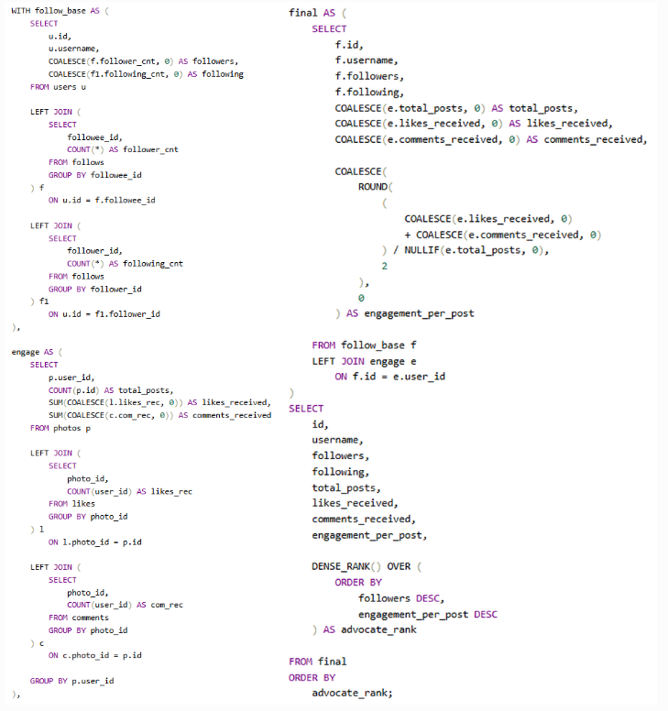

Output:-
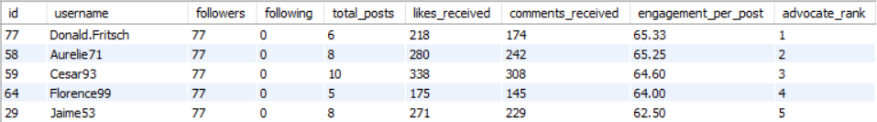

Conclusion
The analysis helps identify users who are active on the platform and have a good follower base with strong engagement on their content. These users can be considered as potential brand ambassadors for promoting Instagram initiatives, events, or campaigns. Instagram can collaborate with these users by involving them in events or encouraging them to share campaign-related content with their audience.

Q9 How would you approach this problem, if the objective and subjective questions weren't given?
If the objective and subjective questions were not given, I would first understand the dataset and identify what type of information is available in each table. Then I would explore important metrics related to users, posts, likes, comments, follows, and tags to understand user activity and engagement. After that, I would look for patterns such as inactive users, popular content, highly engaged topics, user preferences, follower growth, and highly active users. Based on these findings, I would identify the important business problems and convert them into analytical questions. Finally, I would use SQL to analyse those questions and provide insights and recommendations that can help improve user engagement, content strategy, and marketing campaigns.

Q10 Assuming there's a "User_Interactions" table tracking user engagements, how can you update the "Engagement_Type" column to change all instances of "Like" to "Heart" to align with Instagram's terminology?

Approach
First, I would identify all records where the Engagement_Type is currently Like. Then I would use the UPDATE statement to replace those values with Heart. The WHERE condition ensures that only the records having Like are updated and other engagement types remain unchanged
Code:
UPDATE User_Interactions
SET Engagement_Type = 'Heart'
WHERE Engagement_Type = 'Like';
.

Conclusion
This will change all existing Like values to Heart in the Engagement_Type column, while keeping the other engagement types unchanged.

