**CONTENTS**

**Topic Page NO.**

**1.Introduction**

**A.)Mining................................................................................................................1**

**B.) Project Objectives.............................................................................................1**

**2.System design**

**A.)Arduino Uno……………………………………………………………………….3**

**B.)MQ-2gas sensor………………………………………………………………………5**

**C.)ESP8266 Node MCU…………………………………………………………………8**

**3. Connection & working of project..................................................................10**

**4. Coding of measurement of gases through Arduino Uno..............................12**

**5. Coding of server through Arduino Uno...........................................................18**

**6. Getting IP Address……………………………………………………............25**

**7. Future Scope & Conclusion………………………………………………...26**

**UNIT-1**

**INTRODUCTION**

**A.)Mining:-**

Mining is a process in which minerals are extracted from earth crust, which involves different minerals such as Coal, Iron minerals etc. Mining is of two types Underground mining and Surface mining. In underground mining such as coal mining worker do their job in very hazardous environment. Environment under coal mines is hazardous because it contains various poisonous gas such as Methane, Carbon Monoxide, Propane etc.Therefore many research centre like CSIR-CIMFR are working on these type of issue to protect workers inside mines from these harmful gases. Therefore IoT (Internet of Things) devices are designed for helping the miners. IoT uses various computing machine, embedded devices, equipment, appliances, and sensors. These all are connected to the internet. IoT is a subject in which study of computing devices are done in order to help people in their daily life. IoT can help to -:

* Automate maintenance and operation of machine.
* Standardize processes.
* Ensure safety of people and equipment.

**B.)Project Objectives**

Project objective is to determine concentration of toxic gases inside the coal mines.

The project to be carried out with the following objectives:-

**1.Detection of different toxic gases within mining environment.**

**2. Communication establishment between sensors and node mcu.**

**3. Establishment of Wireless Sensor Network.**

**4. Design of a real-time monitoring system.**

**UNIT-2**

**SYSTEM DESIGN**

This unit explains how fundamental IoT devices like Arduino Uno, ESP 8266 Node MCU and MQ-2 sensor is connected to detect concentration of harmful gas present inside mines.

**1.Arduino Uno.**

Arduino Uno is a microcontroller board used for IoT devices. It is based on ATmega328P. It has total 32 pins out of which 14 pins are used for digital input/ output pins (of which 6 can be used for PWM Pulse Width Modulation outputs). And there are 6 analog pins. It contains everything which is required to support the microcontroller. Simply connect Arduino and computer with USB cable. Using this USB cable you should upload Sketch code to the Arduino. While it is connected to computer, Arduino consumes power fromUSB port to which it is connected. We can give power to Arduino by DC AC-to-DC adaptor. We use Arduino IDE to write sketch code. Using Arduino IDE we upload code to the Arduino board. “UNO” means one in Italian and was chosen to mark release of Arduino Software (IDE).

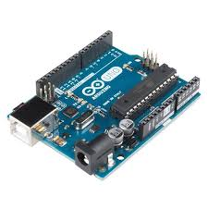

figure2.1-Arduino UNO

**Figure 2.2-Techanical specification of Arduino Uno**

|  |  |
| --- | --- |
| Microcontoller  Operating Voltage | ATmega328  5V |
| Input Voltage (recommended) | 7-12V | |
| Input Voltage(limits) | 6-20 V | |
| Digital I/O Pins | 14(of which 6 provide PWM output) | |
| Analog Input Pins | 6 | |
| DC Current for 3.3V pin | 50mA | |
| DC Current per I/O | 40mA | |
| EEPROM | 1KB | |
| Flash Memory | 32 KB of which 0.5 KB used by boot loader | |
| SRAM | 2KB | |
| Clock Speed | 16MHz | |

**2.MQ-2 Sensor -:**

Gas sensor MQ-2 is very suitable and useful module for detecting gas leakage in home or industry. It can detect H2, LPG, CH4, CO, Alcohol, Smoke or Propane. It’s sensitivity and response time is fast so the measurement can be taken very quickly. The sensitivity of the sensor can be adjusted by the potentiometer embedded on it. The sensor value only reflects the approximated trend of gas concentration in a permissible error range, it does not represent exact gas concentration. The detection of certain components in the air usually requires more precise instruments, which can’t be done a single gas sensor.

**FEATURES**

* Power supply needs : 5 v
* Interface type: Analog
* Wide detecting scope
* First response and high
* Simple drive circuit

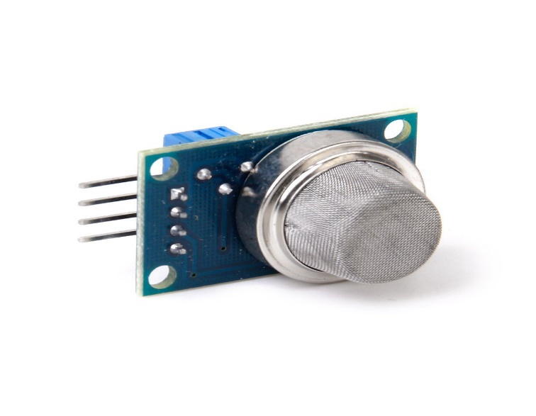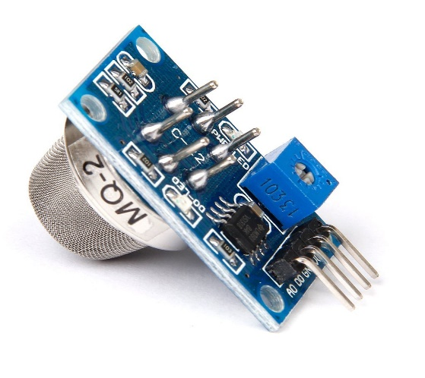

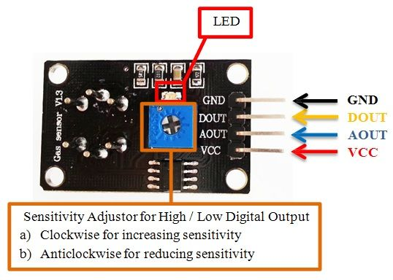

**Figure: - MQ-2 Sensor.**

**HOW TO USE THE MQ-2 SENSOR TO MEASURE PPM -:**

A basic wiring for the sensor from datasheet is shown below -:

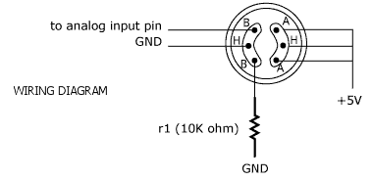

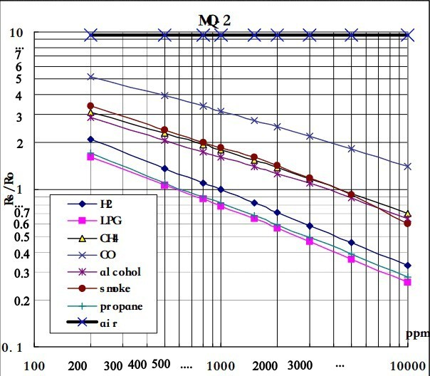

Above graph shows how MQ-2 sensor works under the presence of gas.Ro is the value of resistance in fresh air. First, we calibrate the sensor in fresh air by finding value of Ro and then we use that value to calculate Rs.

We calculate Rs by using formula -:

Resistance of sensor (Rs) = (VC/VRL– 1) * RL

Above graph is also used for calculation of {x1, y1, slope} for each gas. For example -:

For LPG -: x1 = 2.3, y1 = 0.20 and x2 = 4, y2 = -0.58

These values are taken from graph.

Then, slope = (y2-y1)/(x2 – x1) = (-0.58 – 0.20)/(4 – 2.3)

= -0.78/ 1.7

= -0.45

(x1, y1, slope) = (2.3, 0.40, -0.45) for LPG

Similarly, for H2, CO, Alcohol, Smoke and for Propane (x1, y1, slope) are calculated. These values are used in Arduino’s coding part.

**3.ESP 8266 Node MCU:-**

ESP8266 Integrates 802.11b/g/n HT40 Wi-Fi transceiver, so it can not only connect to a Wi-Fi network and interact with the internet, but it can also set up a network of its own, allowing other devices to connect directly to it. This makes the ESP8266 NodeMCU even more versatile.

ESP 8266 NodeMCU provides access to the GPIO (General Purpose Input Output). It is a device that refers to the firmware rather than the development by default.

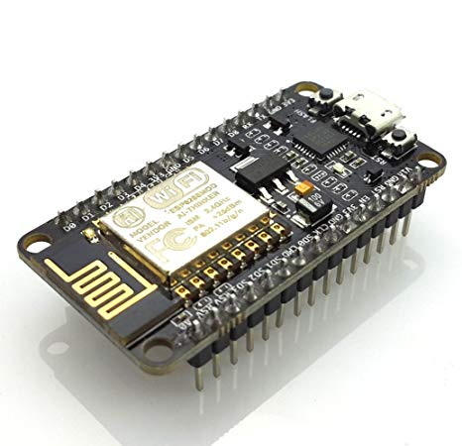

**Figure:- ESP 8266 Node MCU**

**PINOUT DIAGRAM OF NODE MCU ESP8266.**

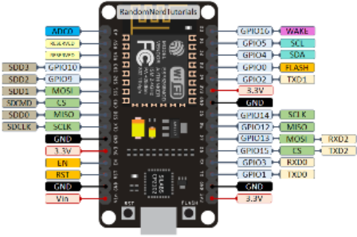

**figure3.2:- Pin out diagram of ESP 8266 Node MCU**

**UNIT-3**

**Connection & Working of the project-:**

1.In both Arduino UNO and ESP8266 Node MCU there aretwo pins called as RX and TX. Rx and Tx pins stands for Receiving and Transmitting pins. The RX pin of Arduino is connected to the TX of ESP8266 Node MCU and the TX pin of Node MCU is connected to the RX of Arduino UNO. This connection is used for serial communication.

2.The ground pin VIN of ESP8266 Node MCU is connected to battery for power supply. And one of the ground pins is used here to complete the circuit.

3.MQ-2 gas sensor is connected to A0 pin of Arduino UNO. The ground pin is connected to the ground pin of Arduino UNO. The Vcc of MQ-2 gas sensor is connected to the 5v pin of Arduino UNO to get power supply from it.

4.Arduino UNO gets power supply from battery,adaptor pin is connected to battery. This adaptor pin is used to give power to Arduino UNO.

5.Arduino UNO can’t supply 5 V power to ESP8266 Node MCU because it is already giving power to MQ-2. If we connect ESP8266 Node MCU also to the Arduino UNO then ESP8266 Node MCU will not work properly.Therefore, in order to give power to ESP8266 Node MCU we have connected one more 9 V battery to ESP8266 Node MCU.

6.VIN and GND pin is connected to positive terminal of battery and GND pin is connected to negative terminal of battery. In this way ESP8266 Node MCU gets power.

Now we have seen how these devices are connected. Now we will see how these all are working internally. See the given screenshot of Sketch code used in this project. Code is commented so that anyone can understand how our device is working internally.

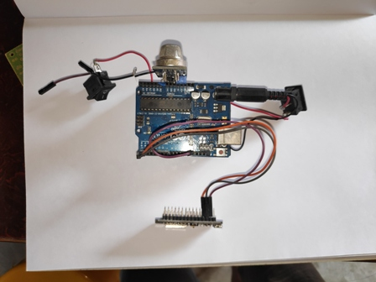

**UNIT-4**

**CODING OF MEASUREMENT OF GASES THROUGH ARDUINO UNO:-**

**Arduino Code:-**

**Screenshot 01** :-

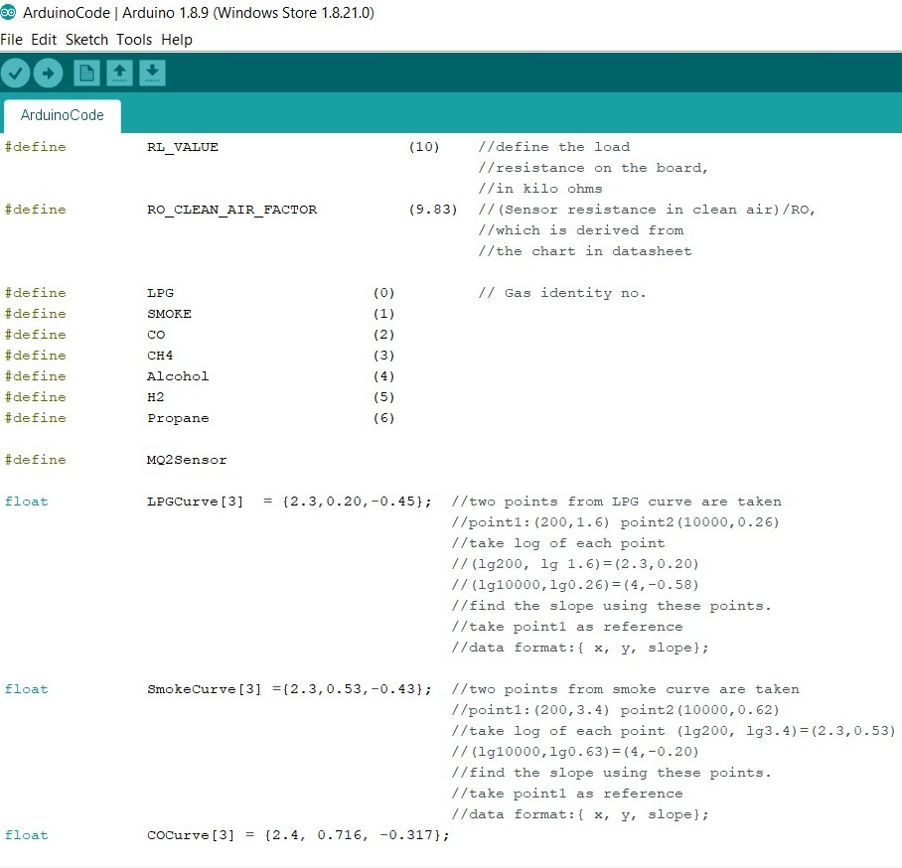

**Screenshot 02 :-**

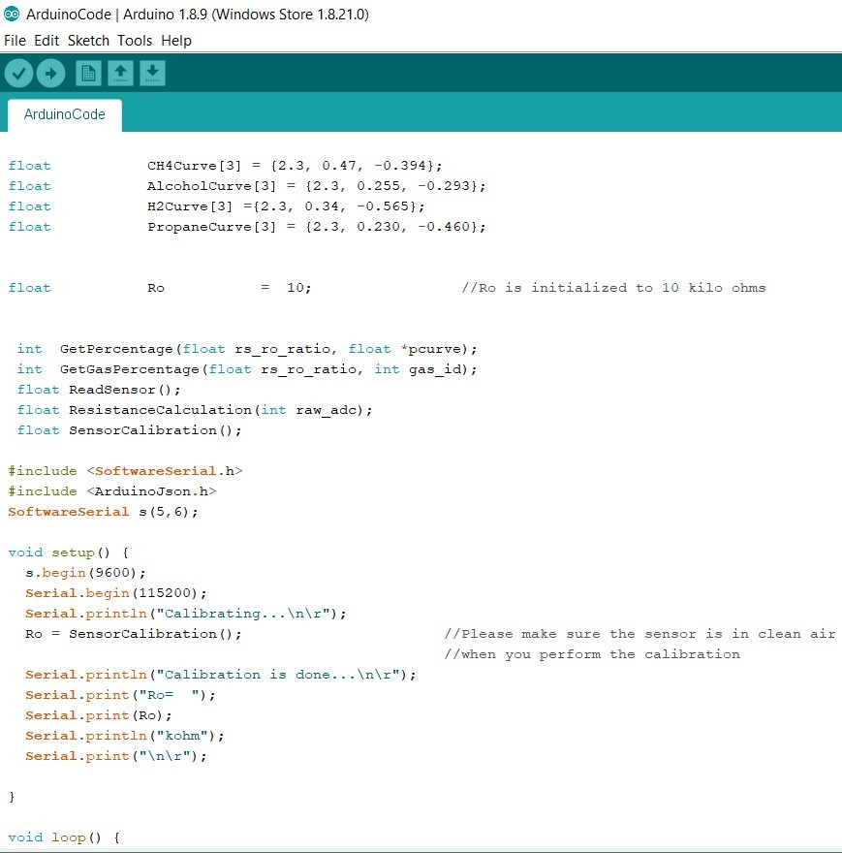

**Screenshot 03 :-**

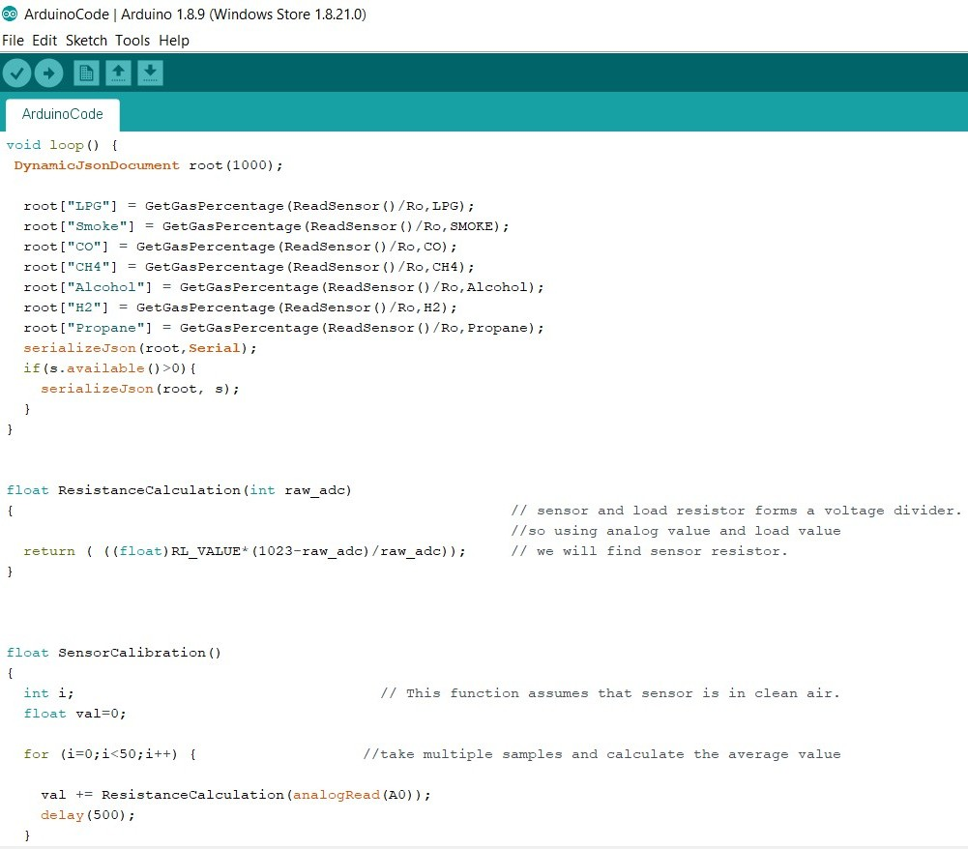

**Screenshot 04:-**

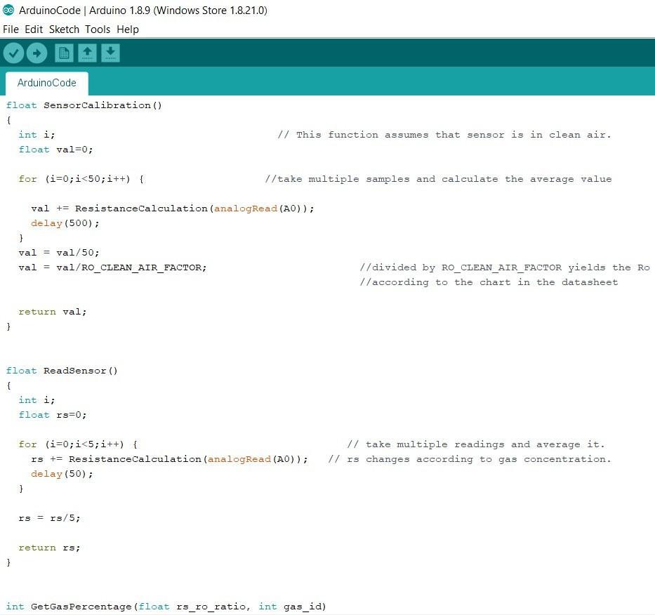

**Screenshot 05 :-**

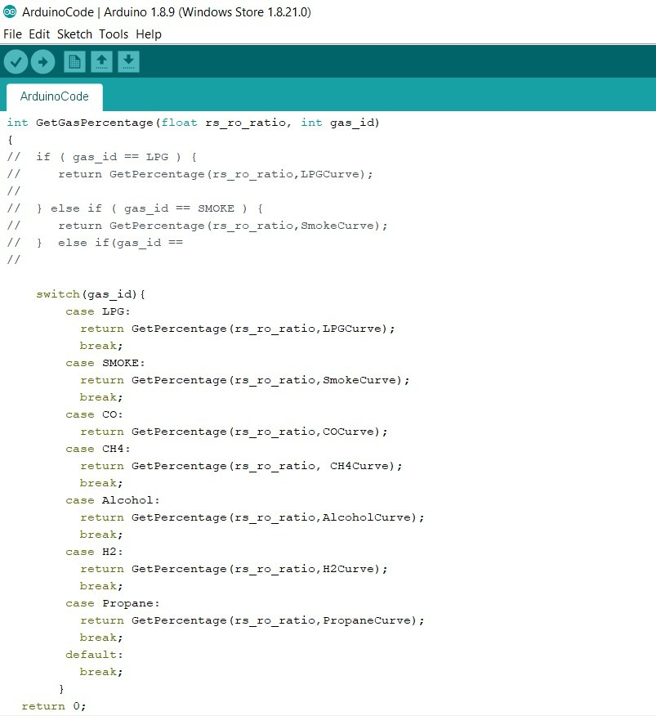

**Screenshot 06 :-**

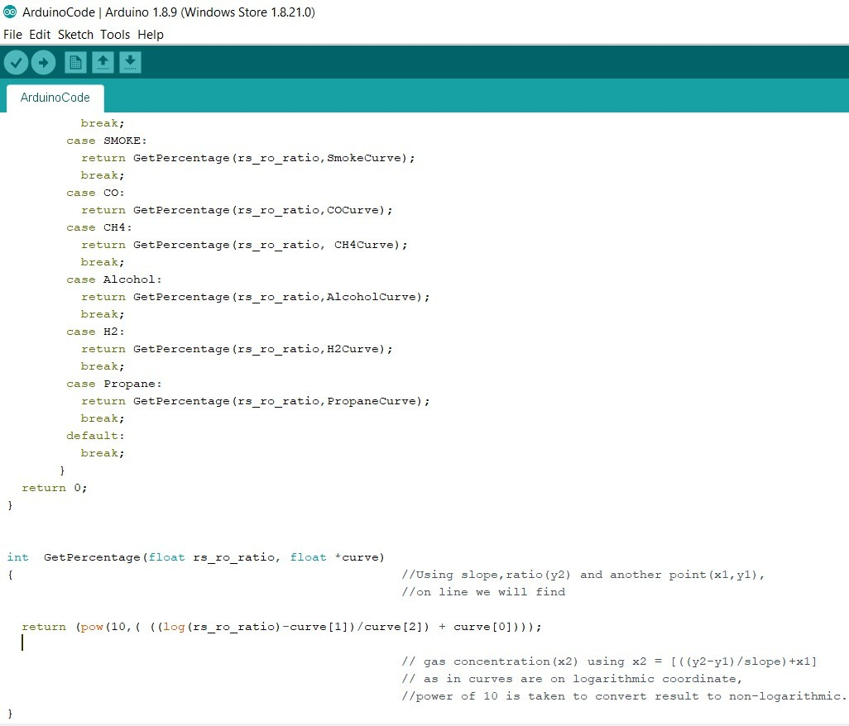

//End of code.

**UNIT-5**

**CODING OF SERVER THROUGH ARDUINO UNO**

**ESP 8266 Node mcu code:-**

**Screenshot 01:-**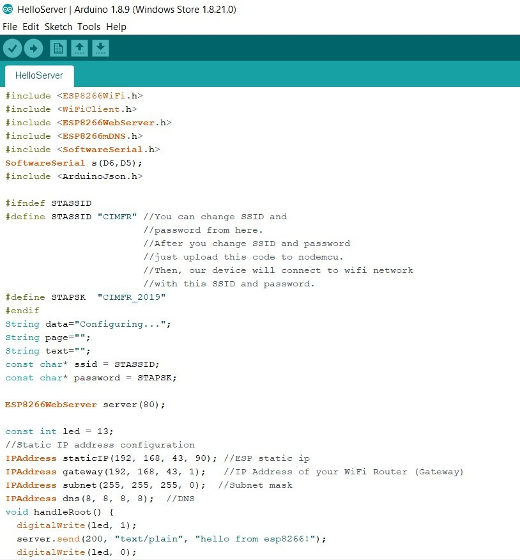

**Screenshot 02** :-

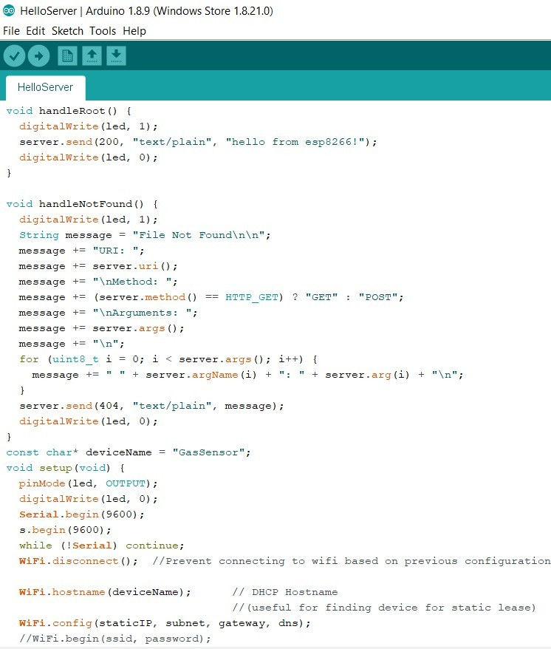

**Screenshot 03 :-**

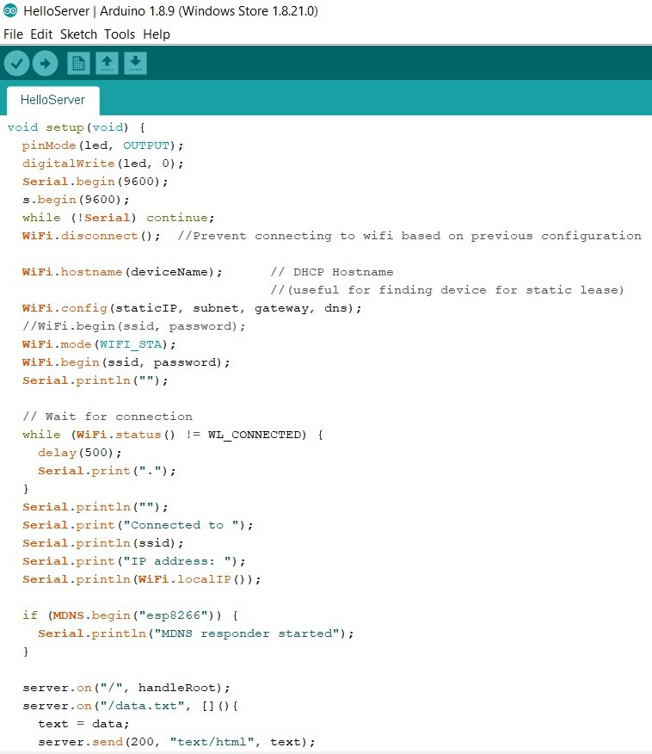

**Screenshot 04 :-**

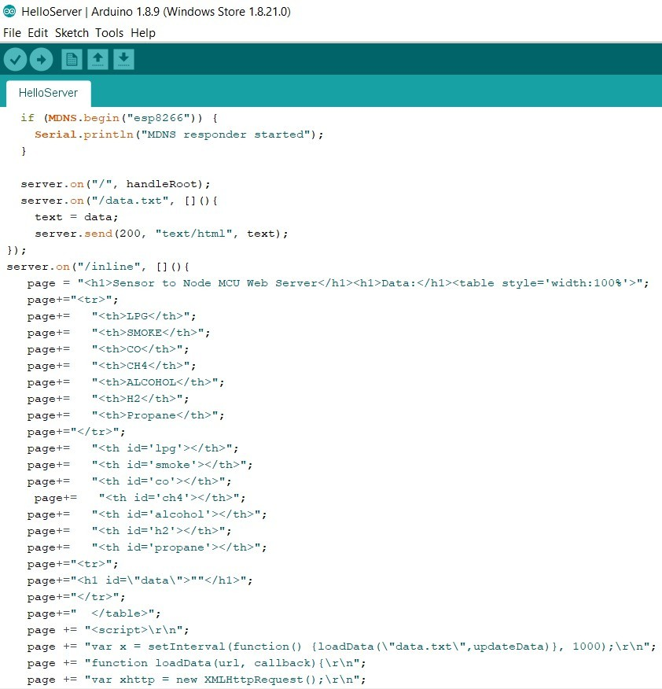

**Screenshot 05 :-**

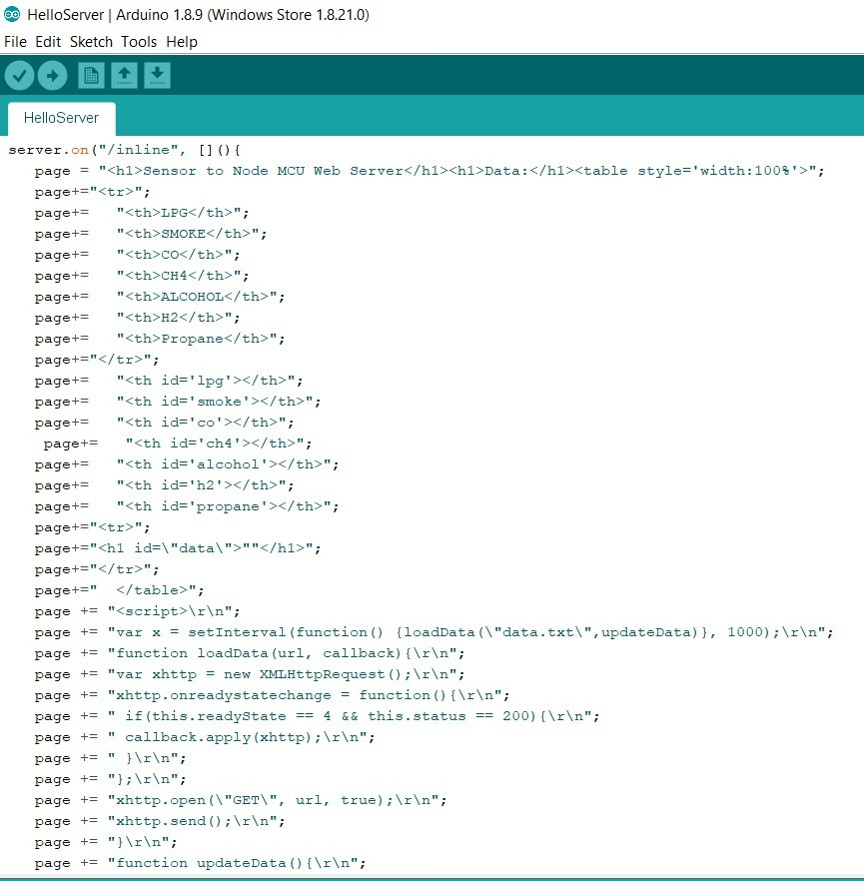

**Screenshot 06 :-**

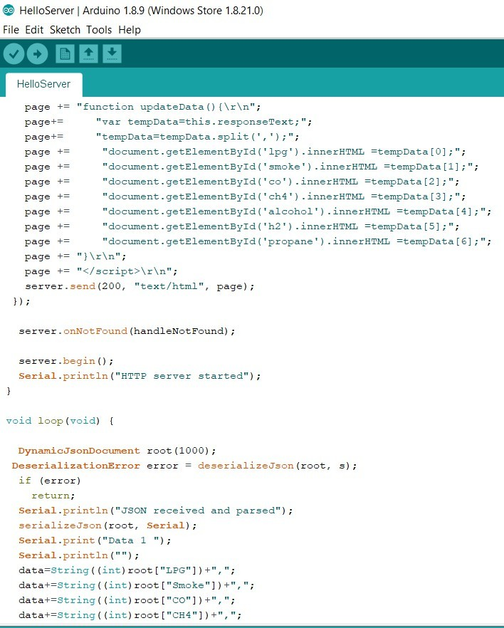

**Screenshot 07 :-**

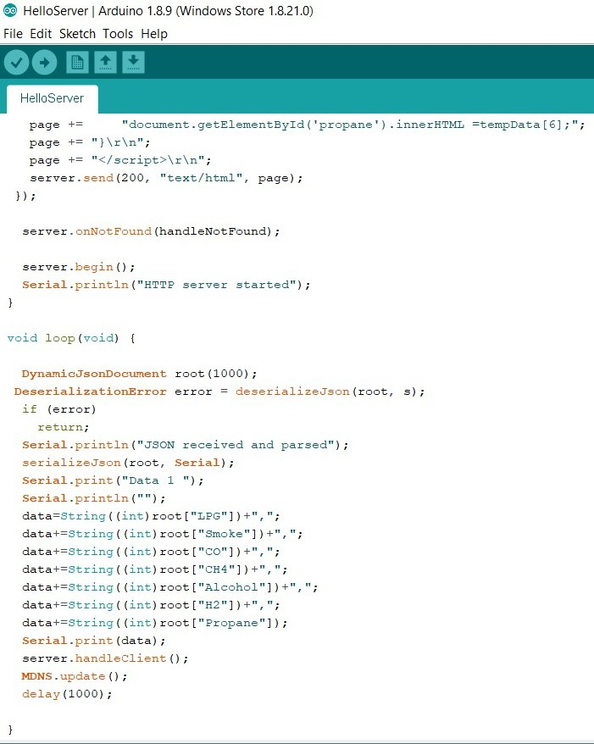

//End of code.

**UNIT-6**

**GETTING IP ADDRESS:-**

**Steps for getting IP address:-**

1. Connect our device to computer with data cable.
2. Open Arduino IDE, and then select the port in which ESP 8266 Node MCU is connected. In this case COM3 is selected.
3. Then open serial monitor and set baud rate at 9600.
4. IP address will be printed on serial monitor.

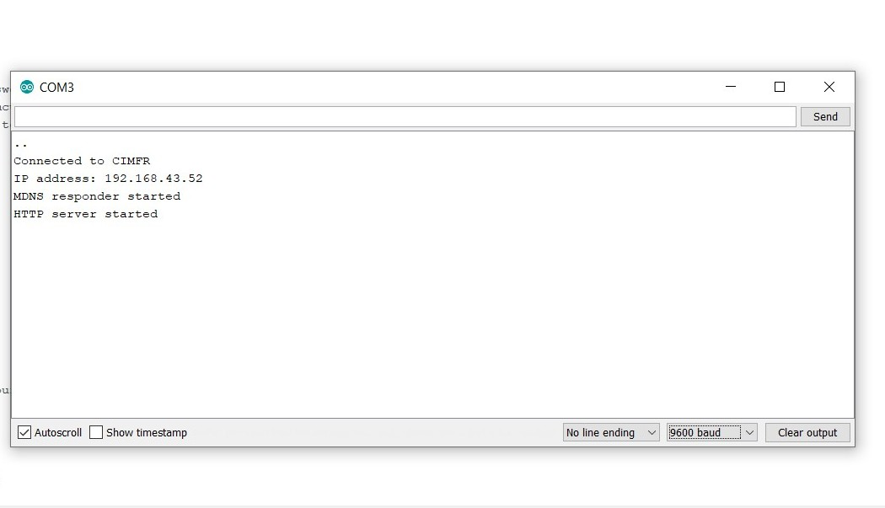

1. Now on your mobile web browser put

<http://192.168.43.52/inline>

and then you will get output on your mobile browser.

**UNIT-7**

**FUTURE SCOPE & CONCLUSION**

* **Future Scope**

1.Using additional sensors all possible safety issues could be monitored such as gases,dust,vibrations, fire ,etc.

2. Node mcu ESP 8266 can also be used for the surveillance of mining operations such as subsidence, water leakage etc.

3. The other important data can be communicated through this system making it feasible where wired communication is a hindrance.

4. The control can be governed from the surface itself as the system provides easy access.

* **Conclusion**

The study on real time monitoring of toxic gases and other parameters present in underground mine has analyzed using wireless sensor network. A real time monitoring system is developed to provide clearer and more point to point perspective of the underground mine. This system is displaying the parameters on the LCD at the underground section where sensor unit is installed as well as on the monitoring unit; it will be helpful to all miners present inside the mine to save their life before any casualty occurs. Alarm triggers when sensor values cross the threshold level. This system also stores all the data in the computer for future inspection. From the experiments and observations, the following conclusion can be drawn:

1. Each node in a particular framework functions as the pioneer robot when all its parameters are configured properly.
2. Sensor nodes can reconfigure remotely over a wireless network and most of the processing done in software on computer side.
3. The calibration equations of gas sensors may have affected the accuracy of the ppm results.

**References**

1. <http://ethesis.nitrkl.ac.in/6942/1/Real_Shrivastav_2015.pdf>
2. https://cityos-air.readme.io/docs/esp8266-nodemcu.