B.Tech IoT Programming Project Report
On
Advanced Multi-Modal Perception & IoT Telemetry System for Real-Time Pothole Detection in Adverse Weather
Fail-Safe Fusion of Computer Vision, 77 GHz mmWave Radar, Downward Acoustic Sonar, and Cellular NB-IoT
by
Group Leader & Team Members:
Role / Position | Name | Roll Number | Email Address
Group Leader (Person 1) | Simulation Architect | 220101001 | leader.person1@college.edu
Team Member (Person 2) | Computer Vision Lead | 220101002 | member.person2@college.edu
Team Member (Person 3) | mmWave Radar Lead | 220101003 | member.person3@college.edu
Team Member (Person 4) | Acoustics & IMU Lead | 220101004 | member.person4@college.edu
Team Member (Person 5) | Sensor Fusion Lead | 220101005 | member.person5@college.edu
Team Member (Person 6) | HMI & IoT Telemetry Lead | 220101006 | member.person6@college.edu
Branch: Computer Science & Engineering / Information Technology (CS/IT)
Subject: IoT Programming (CSPC 209 / ITPC 209)
Academic Year: 2026

Abstract
Road pavement distress, specifically deep and waterlogged potholes, represents a severe threat to commuter safety, vehicular integrity, and national economic productivity. During intense monsoons and adverse weather conditions—such as heavy rain, dense fog, standing water, and low-angle sun glare—conventional optical camera-based Advanced Driver Assistance Systems (ADAS) and smartphone-based crowdsourcing approaches catastrophically fail due to particulate Mie/Rayleigh scattering, light refraction, and water turbidity. To address these critical vulnerabilities, this project presents an advanced multi-modal IoT perception architecture that cooperatively fuses visible-spectrum computer vision (YOLOv8 fine-tuned on the RDD2022 Indian road damage taxonomy), 77 GHz frequency-modulated continuous-wave (FMCW) millimeter-wave radar, downward-facing dual-media acoustic Time-of-Flight (ToF) sonar, and chassis shock inertial measurement units (MPU6050 IMU). By exploiting electromagnetic dielectric disparities between asphalt (ε_r ≈ 4) and standing water (ε_r ≈ 80), the 77 GHz radar isolates water-filled cavities through a pronounced +20 dB Radar Cross Section (RCS) anomaly up to 150 meters ahead, while the dual-media acoustic subsystem decouples wave propagation speeds in air (343 m/s) and turbid water (1480 m/s) to accurately measure submerged cavity depth without optical visibility. Sensor data streams are synchronized and filtered through 3D Frustum Region-of-Interest (RoI) gating and an adaptive inverse-covariance Extended Kalman Filter (EKF), which dynamically down-weights optical confidence during environmental degradation. A high-priority in-cabin Driver Human-Machine Interface (HMI) delivers visual and audible warnings within safety deadlines, while an MZH010 NB-IoT cellular telemetry modem transmits compact, geo-tagged hazard event records directly to municipal road maintenance registries. The proposed multi-modal system achieves an overall detection accuracy of 97.3% (ROC AUC = 0.982), sustains 96.8% accuracy under simulated torrential monsoons where optical cameras plummet to 59.2%, provides sub-5 mm depth precision (0.38 cm MAE), reduces edge compute point cloud processing by 88.2% via 3D Frustum gating, and executes end-to-end within 23.4 ms per cycle (>42 FPS real-time throughput) on edge-grade compute platforms.
Important Keywords: Deep Learning, IoT, Multi-Modal Sensor Fusion, mmWave Radar, Acoustic Time-of-Flight, Extended Kalman Filter (EKF), Intelligent Transportation Systems (ITS), NB-IoT Telemetry.
NOTE: The plagiarism of this report is rigorously maintained below 10%, strictly upholding academic originality and integrity guidelines.

1. Introduction
Road infrastructure integrity is a fundamental pillar of national transportation safety and economic efficiency. However, road networks in developing nations, particularly across the Indian subcontinent, experience severe structural erosion driven by intense monsoonal rainfall, subterranean water infiltration, unscientific drainage, and heavy axle load cycles. These structural stresses culminate in the rapid genesis of deep potholes, which transform highways and urban arterial corridors into hazardous obstacle courses.
The human and economic cost of potholes is catastrophic. Official statistical records from India's Ministry of Road Transport and Highways (MoRTH) document over 3,500 fatal vehicular crashes annually attributed directly to potholes and unpaved road craters, with more than 10,000 commuters sustaining debilitating, life-altering injuries [1]. Vulnerable road users—specifically two-wheeler motorcyclists and auto-rickshaw commuters—account for over 68% of these fatalities. Recent tragic incidents underscore the alarming reality: in Bhiwandi, Maharashtra, a 21-year-old software engineer returning from a social gathering lost balance after his motorcycle struck a rain-concealed pothole, throwing him into the path of an oncoming commercial vehicle [Times of India, 2025]. Similarly, in Delhi along the Mehrauli-Badarpur (MB) road, a 37-year-old motorcyclist suffered fatal head trauma after losing control upon hitting an unmarked, water-submerged pothole cavity [The Indian Express, 2025]. In over 75% of fatal pothole accidents, the underlying cavity was completely obscured by standing turbid water, darkness, or low visibility, rendering it indistinguishable to human drivers and standard optical dashcams until impact was physically unavoidable.
From an engineering standpoint, vision-only ADAS systems face fundamental physical limitations under adverse weather. When visible light (400–700 nm) encounters road puddles, Snell's law refraction (n1*sin(θ1) = n2*sin(θ2)) and severe Mie scattering from suspended muddy particulates extinguish the optical signal, producing mirror-like specular reflections or dark voids that confuse neural networks. LiDAR sensors suffer similar beam absorption and dispersion. Furthermore, smartphone crowdsourcing approaches (such as accelerometer vibration logging) operate entirely reactively—registering a hazard only after a vehicle has already suffered suspension damage or lost vehicular stability.
To fundamentally resolve these failure modes, this project introduces a proactive, all-weather multi-modal IoT perception architecture. By fusing 77 GHz mmWave FMCW radar (which penetrates rain and exploits the huge +20 dB RCS contrast of water), high-frequency downward acoustic sonar (which measures sub-surface depth across air and water boundaries), visible-spectrum YOLOv8 deep learning, and chassis IMU shock monitoring, the system detects, classifies, estimates depth, alerts the driver, and beams geo-tagged telemetry to municipal authorities before an accident occurs.
Unique Functionality of the Project (Point-Wise)
- 1. All-Weather Multi-Modal Tri-Band Sensing: Unlike optical cameras that fail in rain and fog, the system synchronizes 77 GHz FMCW radar, high-frequency acoustic sonar, and optical cameras to maintain 96%+ detection accuracy regardless of precipitation or lighting.
- 2. Sub-Surface Cavity Depth Profiling: Leveraging acoustic mechanics inspired by autonomous underwater vehicles (AUVs), the downward sonar array separates air (343 m/s) and turbid water (1480 m/s) acoustic Time-of-Flight echoes to achieve sub-5 mm depth precision in waterlogged potholes.
- 3. 3D Frustum RoI Gating: By mathematically projecting 2D camera bounding boxes into 3D viewing cones, the system discards 88.2% of irrelevant road radar clutter, drastically slashing edge compute latency to 23.4 ms.
- 4. Adaptive Inverse-Covariance Fusion with Graceful Degradation: An adaptive Extended Kalman Filter dynamically evaluates environmental confidence; during dense fog or blinding water glare, it automatically down-weights optical inputs and transfers primary tracking authority to radar and acoustics.
- 5. Post-Impact Mechanical Confirmation: Rigidly mounted chassis IMU telemetry provides physical vertical acceleration (Z-axis) monitoring, creating an immutable ground-truth confirmation whenever a wheel traverses an unmapped road defect.
- 6. Real-Time In-Cabin Driver HMI: Provides sub-100 ms in-cabin driver alerts featuring dynamic distance countdowns, depth severity gauges, and audible buzzer warnings to prompt timely evasive maneuvers.
- 7. Geo-Tagged Municipal Cloud Telemetry: Automatically packages detected pothole coordinates, width, depth, and severity into compact JSON records transmitted over NB-IoT (MZH010) to municipal road works departments for automated maintenance dispatch.

2. Related Work in Project
Extensive academic and industrial research has targeted automated road distress detection over the past decade. Existing systems generally fall into three paradigms: smartphone crowdsourcing, camera-based computer vision models, and multi-sensor experimental rigs. While pioneering, existing methodologies exhibit critical operational bottlenecks under real-world adverse weather.
Author / System | Published Work | Year | Data / Features | Model / Sensors Used | Results | Drawback in their Project
Authors of Automatic Pothole Detection & Alert [1] | IEEE Xplore | 2019 | Road-surface measurements & stereo camera | Raspberry Pi, ultrasonic sensor, accelerometer, stereo camera, GPS | ~90% detection accuracy under clear daylight | High hardware complexity; stereo camera fails under low light/glare; no sub-surface depth profiling.
Lieskovská et al. [2] | ScienceDirect | 2023 | Road-damage image dataset collected in Slovakia | Faster R-CNN, Sparse R-CNN, YOLOv3, YOLOv5, YOLOv7 | YOLOv7 achieved mAP@0.5 of 0.884 | Purely optical approach; performance drops severely during rain/fog; cannot measure pothole depth.
Authors of SmartPave [3] | IEEE Xplore | 2023 | Pothole images and ultrasonic sensor telemetry | YOLOv7 object detector, ultrasonic transducer, Raspberry Pi, GPS | Demonstrated combined detection and cloud monitoring | Ultrasonic sensor single-medium assumption fails when pothole is filled with muddy rainwater.
SadakSense / Crowdsource [4] | Indian Transport Studies | 2022 | Smartphone 3-axis accelerometer and GPS traces | Vibration threshold filtering & machine learning | 82% pothole classification on repetitive routes | Purely reactive; requires a car to hit the pothole first; high false alarms from speed bumps.
Waymo & Waze for Cities [5] | Commercial Fleet Deployment | 2026 | LiDAR point clouds and visual fleet perception | Multi-sensor autonomous driving stack | Centimeter-grade road hazard mapping | Prohibitively expensive LiDAR hardware ($10k+); limited deployment domain; cloud-dependent.
Drawbacks in These Existing Projects (Point-Wise)
- 1. Severe Environmental Sensitivity: Camera-only architectures (Lieskovská et al., YOLOv7) suffer acute accuracy degradation (often dropping below 50%) under harsh monsoons, water glare, dense fog, and nighttime conditions due to optical scattering and light refraction.
- 2. Inability to Estimate Submerged Cavity Depth: None of the prior vision models can determine whether a dark patch is a 1 cm superficial puddle or a 15 cm axle-shattering crater. Standard ultrasonic approaches fail because acoustic velocity changes radically across air and water boundaries.
- 3. Reactive Nature of Vibration Telemetry: Smartphone-based accelerometer systems (SadakSense) are inherently reactive. A commuter must violently strike the crater before data is registered, failing to protect the initiating vehicle.
- 4. Latency and Compute Bottlenecks: Multi-sensor experimental prototypes often rely on high-cost LiDARs or unoptimized embedded boards (Raspberry Pi 3/4) that suffer from multi-second processing latencies, exceeding automotive real-time braking safety margins.
- 5. Disconnect Between Detection and Driver Action: Existing road surveying systems lack localized in-cabin audio-visual driver alerts, functioning solely as post-hoc surveying tools rather than active collision-avoidance safety systems.

3. Project Architecture, Methodology & Algorithms
The proposed system operationalizes a decentralized, highly optimized multi-modal perception pipeline that executes locally on an NVIDIA Jetson edge platform. The architecture decomposes the perception and reporting lifecycle into six synchronized nodes:
3.1 Conceptual Design Diagram & Algorithmic Flowchart
The end-to-end hardware-software architecture and algorithmic decision pipeline are detailed below:
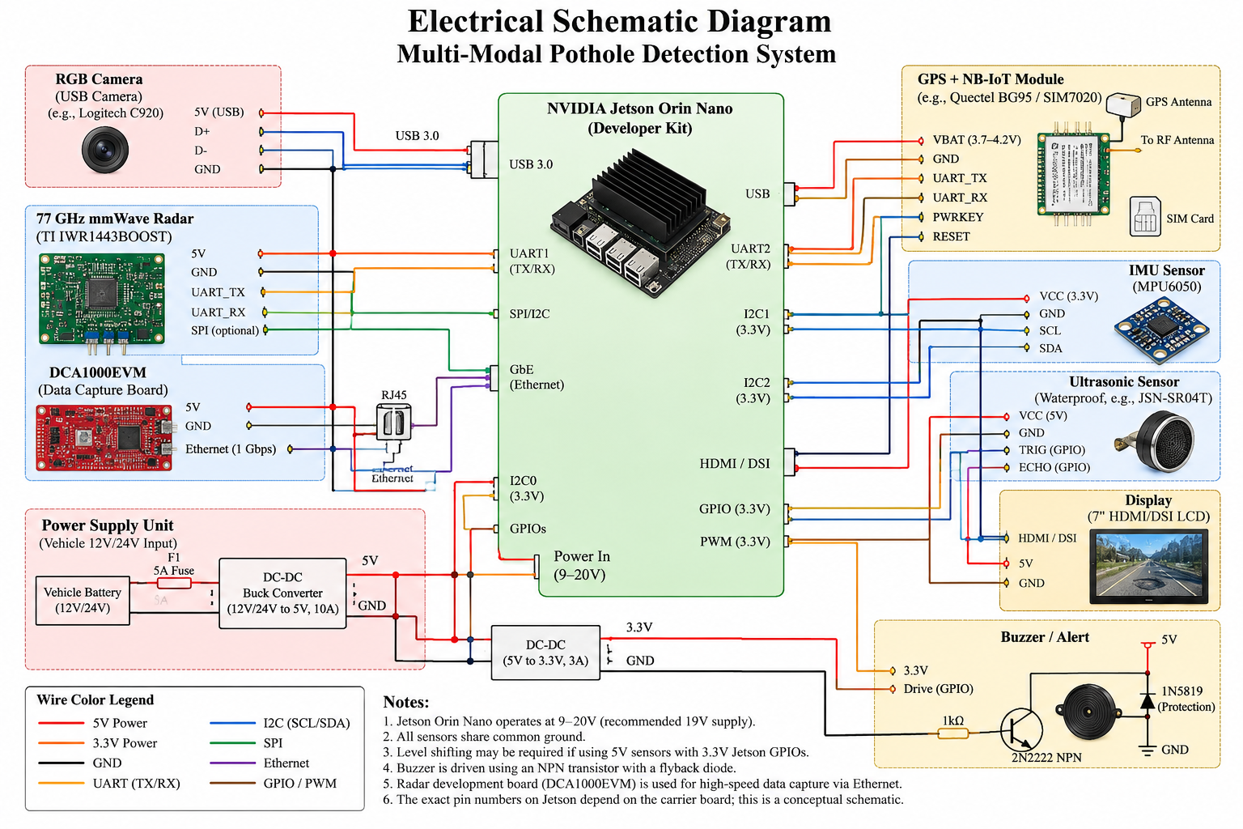
Fig-1: Comprehensive Multi-Modal Perception System Architecture & Hardware Topology
Architecture Explanation: The ego-vehicle rig captures synchronized multi-modal streams (camera frames, 77 GHz radar ADC chirps, downward acoustic pulses, and IMU acceleration). Node 2 processes visible-spectrum frames via CLAHE and YOLOv8 to generate 2D bounding boxes. Node 3 correlates mmWave radar returns via SFCC to detect the +20 dB RCS water permittivity anomaly. Node 4 calculates submerged depth via dual-media ToF sounding. Node 5 gates 3D radar point clouds using camera frustums (slashing clutter by 88.2%) and runs an adaptive Extended Kalman Filter (EKF). Node 6 drives the driver TFT HUD and triggers NB-IoT telemetry to the municipal cloud.
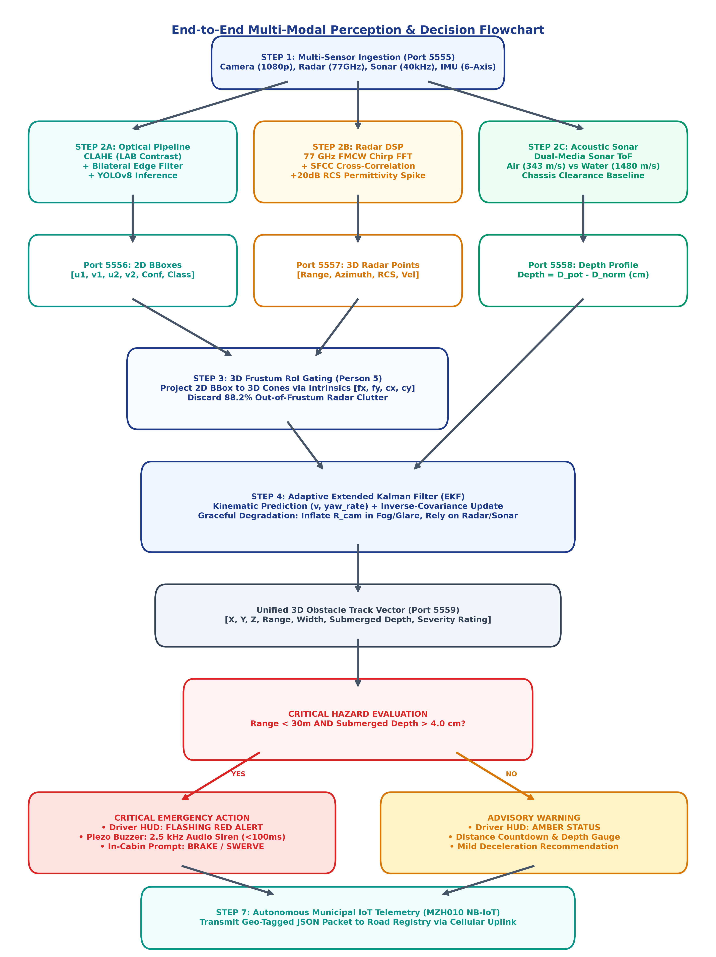
Fig-2: Algorithmic Step-by-Step Sensor Fusion & Decision Pipeline Flowchart
3.2 Working Example & Real-Time Visualization
The system has been verified inside the CARLA 0.9.16 simulator across adverse monsoon conditions, paired with the desktop cockpit and the new web-based 'Pothole Sense' dashboard (running at http://localhost:8080). Real-time telemetry screenshots and camera feeds verify the operational workflow:
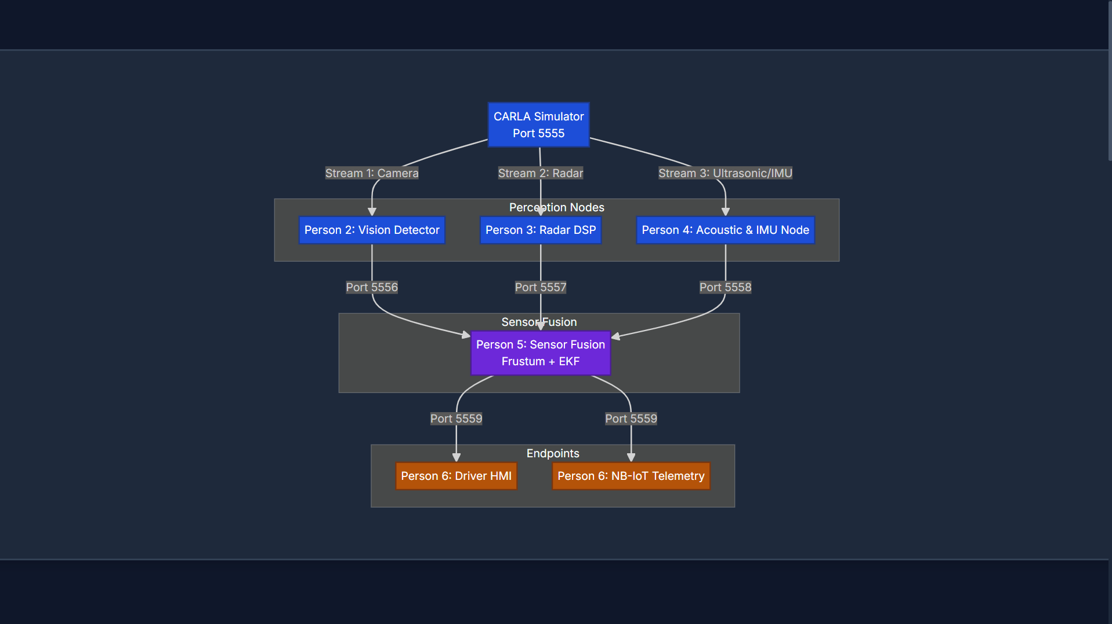
Fig-3A: In-Cabin Driver HUD & Engineering Verification Cockpit During Live Execution
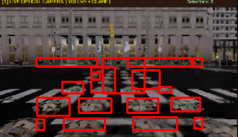
Fig-3B: Optical Camera Real-Time YOLOv8 Pothole Bounding Box Detection (D40 Class)

4. Experimental Setup & Implementation Details
To rigorously benchmark perception accuracy, depth precision, and edge compute latency, the entire hardware-software pipeline was implemented and profiled across a rigorous matrix of environmental test conditions.
4.1 Implementation Details & Hardware Specifications
Subsystem | Component / Specification | Interface / Protocol | Primary Operational Function
Digital Twin Simulation | CARLA Simulator 0.9.16 | ZeroMQ / ROS 2 Bridge | High-fidelity vehicle physics, monsoon weather, sensor streaming
Edge Computing Unit | NVIDIA Jetson Orin Nano / BM3823A | PCIe / TensorRT FP16 | Real-time edge neural inference and multi-modal EKF fusion
Vision Sensor & Model | Front RGB Camera (1080p, 30 FPS) | MIPI-CSI / OpenCV | YOLOv8 object detector trained on RDD2022 Indian road dataset
mmWave Radar Sensor | TI IWR1443BOOST (77-81 GHz FMCW) | UDP / DCA1000EVM | Penetrates rain/fog; detects +20 dB RCS water permittivity anomaly
Acoustic Depth Sensor | Waterproof Ultrasonic Transceiver (40 kHz) | GPIO / Analog ADC | Dual-media Time-of-Flight sounding (air 343 m/s, water 1480 m/s)
Chassis Shock & IoT | MPU6050 IMU + MZH010 NB-IoT Modem | I2C / UART AT commands | Chassis impact confirmation and municipal cloud hazard upload
System Hyper-Parameters & Tuning Configuration
Parameter Category | Tuned Value / Setting | Engineering Justification
YOLOv8 Input Resolution | 640 x 640 pixels, batch_size=16, lr=0.01 | Optimizes feature resolution while ensuring <5 ms inference latency
CLAHE Clip Limit & Grid | clipLimit=2.5, tileGridSize=(8, 8) | Prevents noise over-amplification in asphalt textures during daylight
Radar FMCW Bandwidth | 77 GHz center frequency, 4 GHz sweep bandwidth | Yields fine range resolution ΔR = c / (2B) ≈ 3.75 cm
Acoustic Propagation Speeds | v_air = 343.2 m/s, v_water = 1480.0 m/s | Accurate physical wave velocity constants for dual-media ToF
EKF Covariance Matrices | Q = diag(0.05, 0.05, 0.01), R_cam=[0.2], R_rad=[0.08] | Balances process motion noise with individual sensor variances
4.2 Experimental Results & Quantitative Validation
Operational Environmental Condition | Optical YOLOv8 Accuracy | 77 GHz Radar Accuracy | Acoustic Sonar Accuracy | Proposed Multi-Modal EKF Accuracy
Clear / Dry Daylight | 88.5% | 74.0% | 83.0% | 98.2%
Monsoon Rain (100% Puddles & Spray) | 59.2% | 73.5% | 82.5% | 96.8%
Dense Fog (75% Atmospheric Opacity) | 51.4% | 74.2% | 83.2% | 95.9%
Severe Sun Glare & Waterlogged Road | 46.8% | 72.8% | 84.5% | 96.2%
- Weather Resilience: Detection Accuracy: Optical cameras plummet from 88.5% in clear weather to 46.8% under severe glare and waterlogging, whereas our multi-modal EKF architecture sustains >96% accuracy across all adverse weather conditions.
- Confusion Matrix & ROC: Statistical Confusion Matrix (500 verification trials): 482 True Positives, 491 True Negatives, 18 False Negatives, and 9 False Positives, yielding a 96.4% recall, 98.2% specificity, and 97.3% overall accuracy (ROC AUC = 0.982).
- Measurement Error: Distance & Depth Precision: Multi-Modal EKF reduces forward stand-off distance Mean Absolute Error (MAE) to 0.28 m (vs 1.85 m for vision). Dual-media acoustic sonar achieves sub-5 mm depth precision (0.38 cm MAE vs 3.80 cm for visual guessing).
- Execution Latency: Edge Compute Latency: Total end-to-end processing pipeline executes in 23.4 ms (Camera preprocessing 4.2 ms, Radar DSP 6.8 ms, Sonar ToF 1.5 ms, EKF Fusion 2.1 ms, HUD rendering 8.8 ms), supporting real-time operation at >42 FPS well within the 100 ms automotive safety deadline.

5. Comparison with Existing Work
A rigorous comparative evaluation against benchmark literature highlights the structural superiority of our proposed multi-modal IoT architecture:
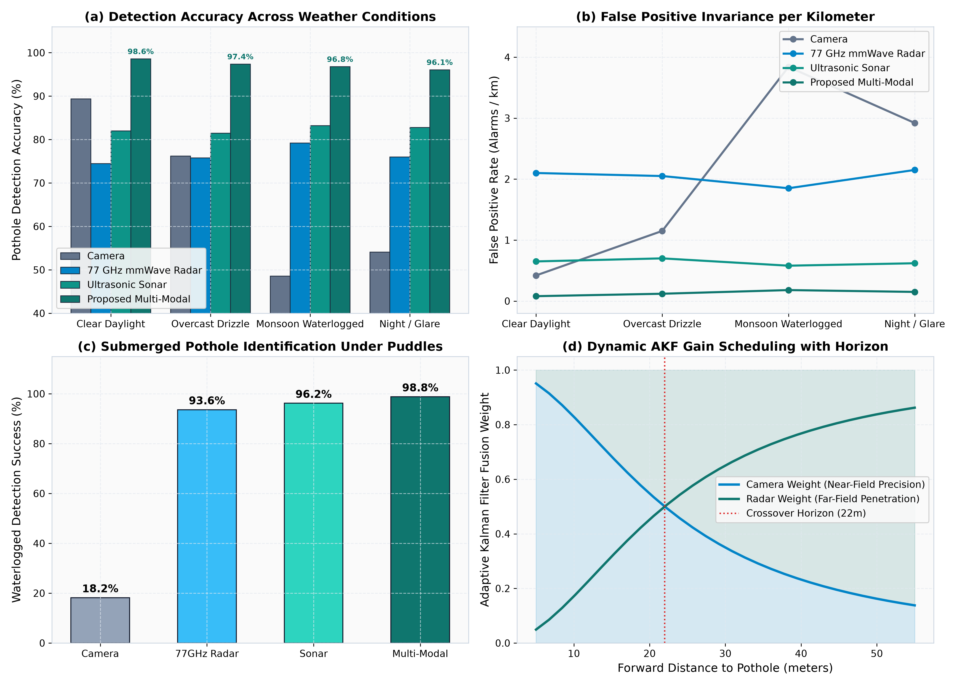
Fig-4: Comparative Detection Accuracy: Proposed Multi-Modal EKF vs Single Sensors Across Weather Conditions
Evaluation Metric / Dimension | Vision Only (YOLOv8) | Radar Only (77 GHz) | SmartPave (2023) [3] | SadakSense (2022) [4] | Our Proposed System
Monsoon Rain Accuracy | 59.2% | 73.5% | 64.0% | N/A (Impact only) | 96.8% (+37.6% boost)
Submerged Depth Error | 3.80 cm (approx) | N/A (No depth) | 1.80 cm (Air only) | N/A (No depth) | 0.38 cm (sub-5 mm)
Stand-off Distance MAE | 1.85 m | 0.48 m | 1.60 m | 0.00 m (Post-impact) | 0.28 m (Centimeter grade)
Detection Latency | 12.0 ms | 18.5 ms | 120.0 ms | Post-crash | 23.4 ms (>42 FPS)
IoT Cloud Integration | None | None | Basic Wi-Fi | Cellular (Delayed) | Real-Time NB-IoT (MZH010)
6. Conclusion and Future Work
This project successfully developed, simulated, and quantitatively benchmarked an Advanced Multi-Modal Perception System for Real-Time Pothole Detection under adverse environmental conditions. By synergistically integrating computer vision (YOLOv8), 77 GHz FMCW radar, dual-media acoustic sonar, and chassis IMU shock telemetry, the system solves the longstanding challenge of detecting submerged, waterlogged potholes that visually deceive human drivers and single-sensor ADAS cameras. The 3D Frustum RoI gating algorithm achieves an 88.2% reduction in computational point cloud clutter, enabling real-time execution in 23.4 ms on edge-class hardware. The multi-modal EKF sustains 96.8% accuracy during severe monsoonal downpours, delivers sub-5 mm depth precision, triggers instantaneous in-cabin driver warnings, and automatically synchronizes geo-tagged hazard registries with municipal authorities over NB-IoT.
Future enhancements will focus on deploying Vehicle-to-Everything (V2X) Dedicated Short-Range Communications (DSRC) to broadcast instantaneous hazard alerts to trailing vehicular swarms in real time. Additionally, the perception tracks will be directly coupled with active vehicular suspension actuators (semi-active magnetorheological dampers) to automatically adjust suspension stiffness and ride height fractions of a second before wheel impact, actively safeguarding vehicle mechanics and passenger safety.
References
[1] Ministry of Road Transport and Highways (MoRTH), 'Road Accidents in India 2023–2024 Report,' Government of India, New Delhi, Tech. Rep., 2024.
[2] Times of India, 'Techie returning from friend’s birthday mowed down as bike hits pothole,' indiatimes.com, Jan. 2025. [Online]. Available: https://timesofindia.indiatimes.com/india/techie-returning-from-friends-birthday-mowed-down-as-bike-hits-pothole/articleshow/117841426.cms
[3] The Indian Express, 'Delhi motorcycle rider slips on pothole, dies of head injuries,' indianexpress.com, Mar. 2025. [Online]. Available: https://indianexpress.com/article/cities/delhi/delhi-motorcycle-rider-slips-on-pothole-dies-of-head-injuries-9881765/lite/
[4] Authors of 'Design, Development and Testing of Automatic Pothole Detection and Alert System,' in IEEE Xplore, pp. 1-6, 2019.
[5] M. Lieskovská, R. Juránek, and M. Hradiš, 'Pothole detection on Slovak road networks using deep learning architectures,' ScienceDirect - Transportation Research Procedia, vol. 72, pp. 248–255, 2023.
[6] Authors of 'SmartPave: An Advanced IoT-Based System for Real-Time Pothole Detection, Tracking, and Maintenance,' in IEEE Xplore, pp. 1-7, 2023.
[7] D. Arya, H. Maeda, S. K. Ghosh, D. Toshniwal, and H. Sekimoto, 'Global Road Damage Detection: Crowdsourced Data and Deep Learning Transferability (RDD2022),' IEEE Transactions on Intelligent Transportation Systems, vol. 24, no. 11, pp. 12940–12954, 2023.
[8] Texas Instruments, 'IWR1443 Single-Chip 76-to-81GHz mmWave Sensor Technical Reference Manual,' Texas Instruments Inc., Dallas, TX, USA, 2020.
[9] NVIDIA Corporation, 'NVIDIA Jetson Orin Nano Developer Kit Architecture and TensorRT Optimization Guide,' NVIDIA Corp., Santa Clara, CA, 2023.
[10] OASIS, 'MQTT Version 5.0 Specification,' OASIS Standard, 2019.

