**TENANCY _ HISTORIES**

**PROJECT-**

**EMPLOYEMENT SYSTEM**

**PROJECT ON SQL**

**NAME – VIVEK NAYAK**

**BATCH – T406**

**FACULTY INCHARGE – SANDIP JAISWAR**

**ENTITY RELATIONSHIP DIAGRAM**

|  |
| --- |
| **HOUSES** |
| HOUSE_ID (PK) |
| HOUSE_TYPE |
| BHK_TYPE |
| BED_COUNT |
| FURNISHING_TYPE |
| BEDS_VACANT |

|  |
| --- |
| **PROFILES** |
| PROFILE_ID(PK) |
| FIRST_NAME |
| LAST_NAME |
| EMAIL |
| PHONE |
| CITY |
| CREATED_AT |
| GENDER |
| REFERRAL_CODE |
| MARITAL_STATUS |

|  |
| --- |
| **TENANCY_HISTORIES** |
| ID(PK) |
| PROFILE_ID(FK) |
| HOUSE_ID(FK) |
| MOVE_IN_DATE |
| MOVE_OUT_DATE |
| RENT |
| BED_TYPE |
| MOVE_OUT_REASONS |

**`**

|  |
| --- |
| **ADDRESSES** |
| ID(PK) |
| NAME |
| DESCRIPTION |
| CITY |
| PINCODE |
| HOUSE_ID(FK) |

|  |
| --- |
| **EMPLOYMENT_STATUS** |
| ID(PK) |
| PROFILE_ID(FK) |
| LATEST_EMPLOYER |
| OFFICIAL MAIL_ID |
| YEARS_EXPERIENCE |
| OCCUPATIONAL_CATEGORY |

|  |
| --- |
| **REFERRRAL** |
| ID(PK) |
| PROFILE_ID(FK) |
| REFERRER_BONUS_AMOUNT |
| REFERRAL_VALID |
| VALID_FROM |
| VALID_TILL |

**STRUCTURE OF TABLE:**

PROFILES

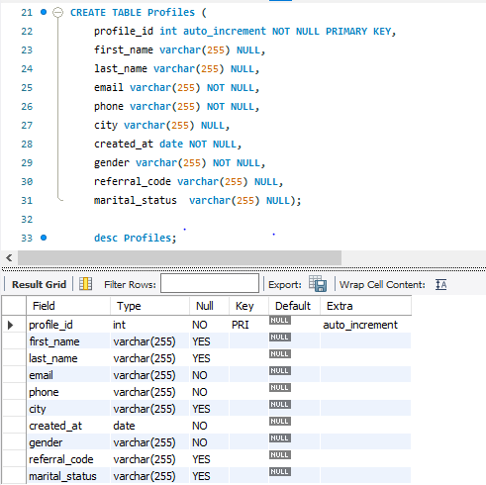

HOUSES

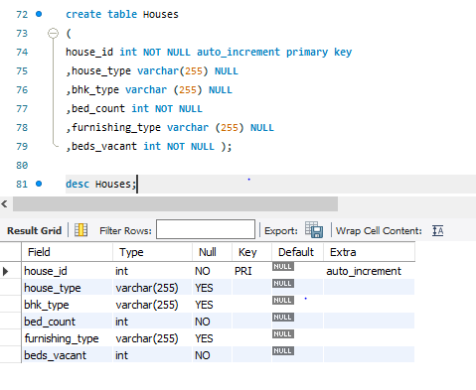

TENANCY_HISTORIES:

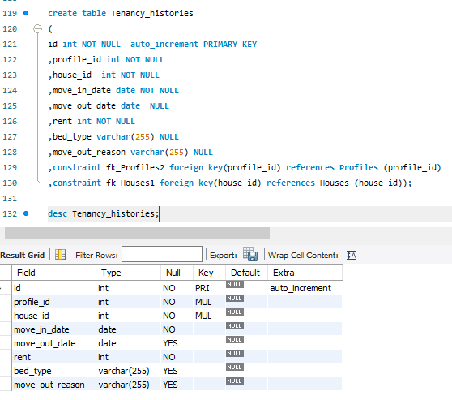

ADDRESS:

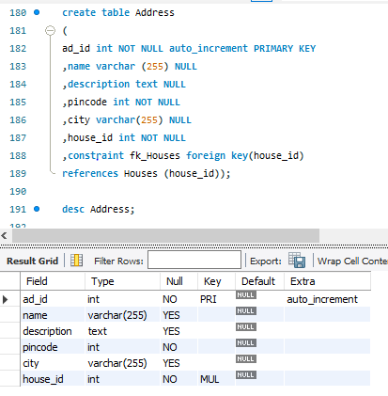

REFERRALS:

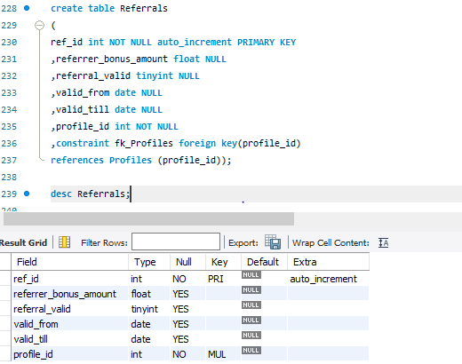

EMPLOYMENT_DETAILS:

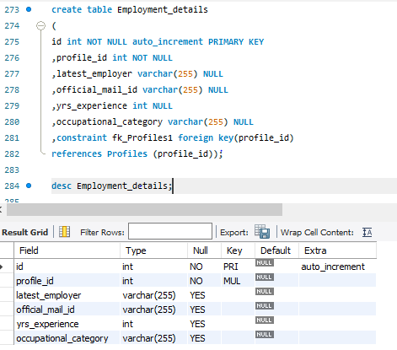

**INSERT VALUES INTO TABLE:**

**PROFILES:**

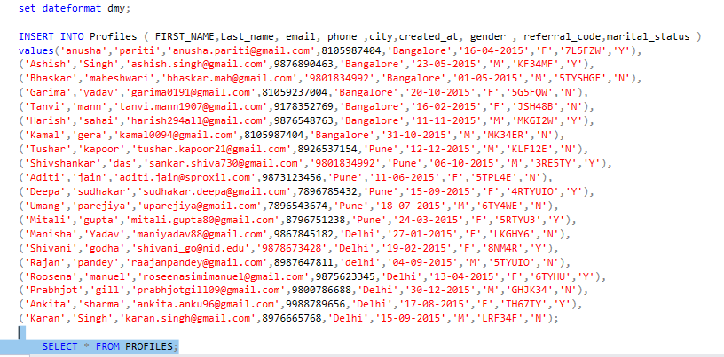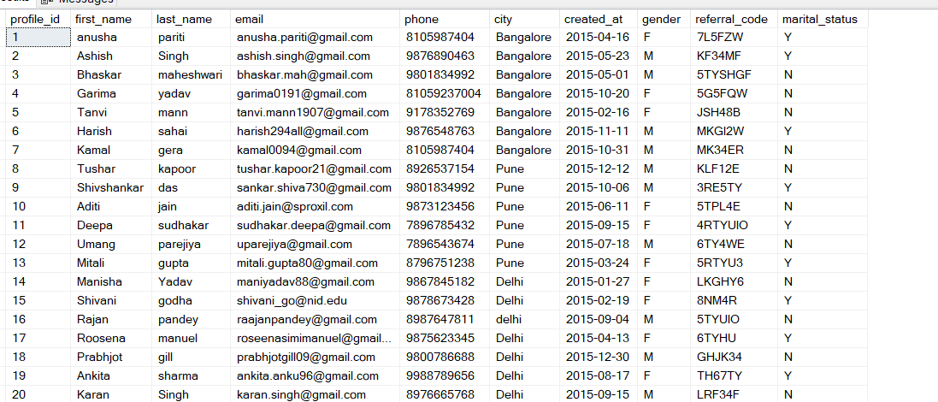

**HOUSES:**

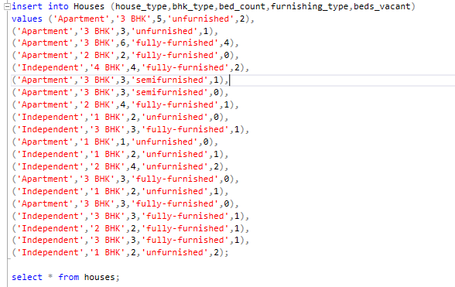

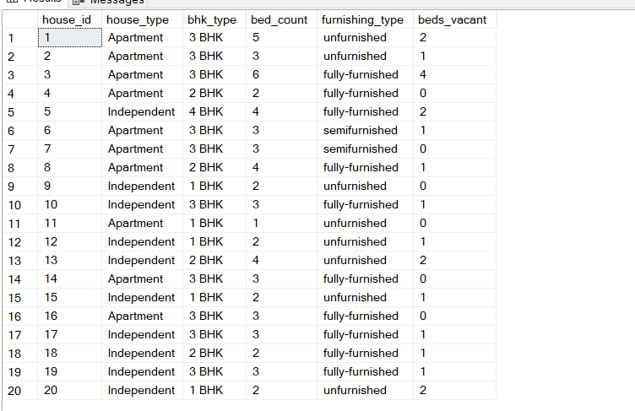

**Tenancy_histories:**

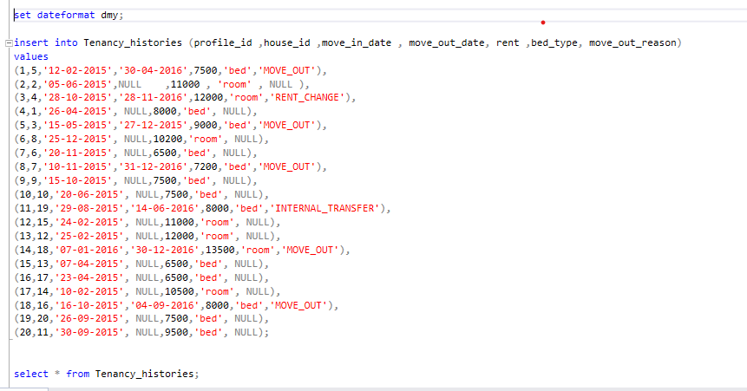

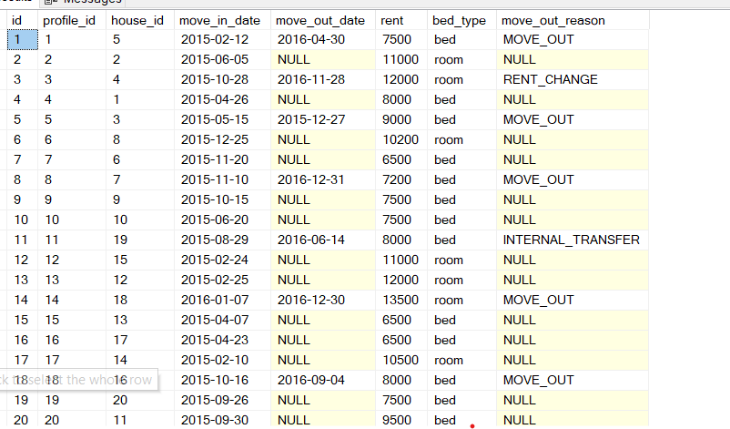

**ADDRESS:**

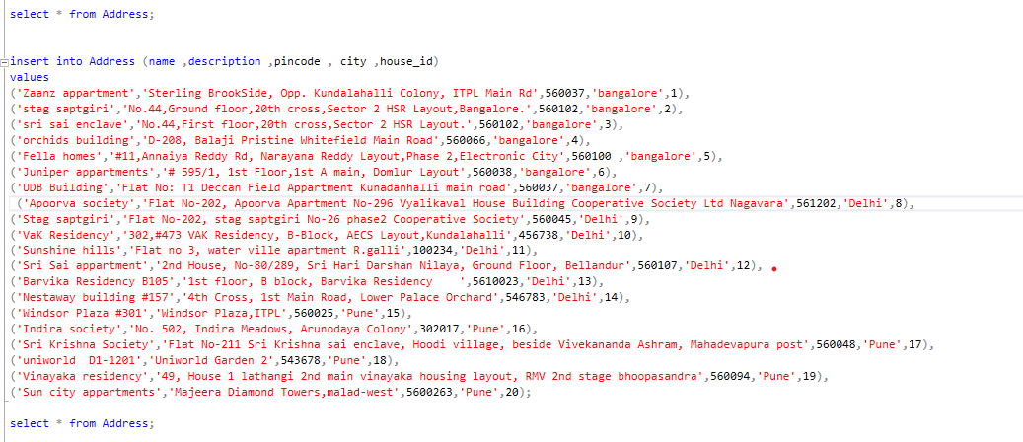

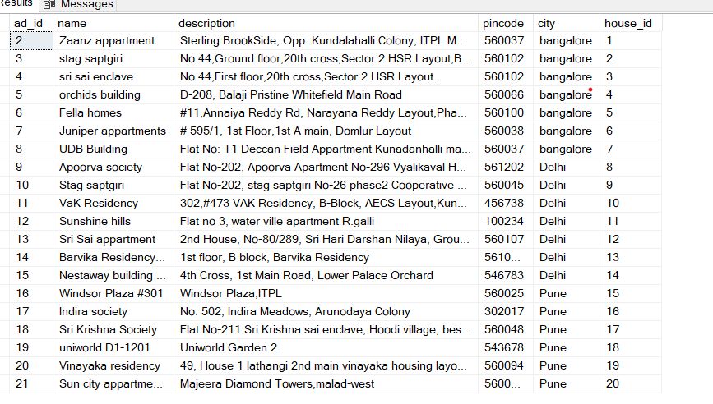

**REFERRAL:**

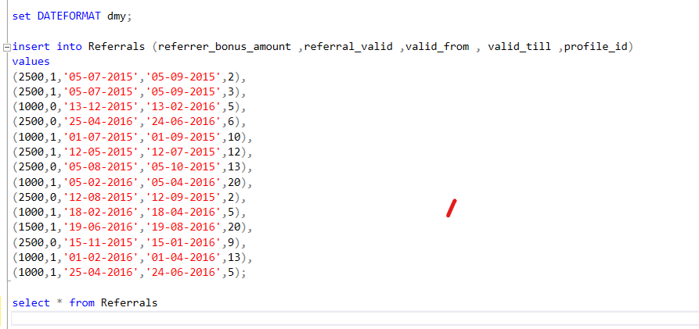

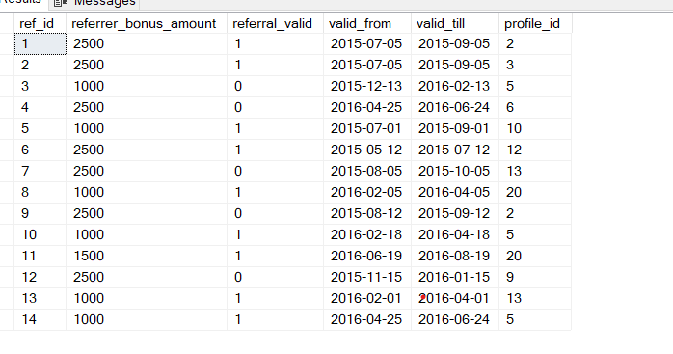

**EMPLOYMENT DETAILS:**

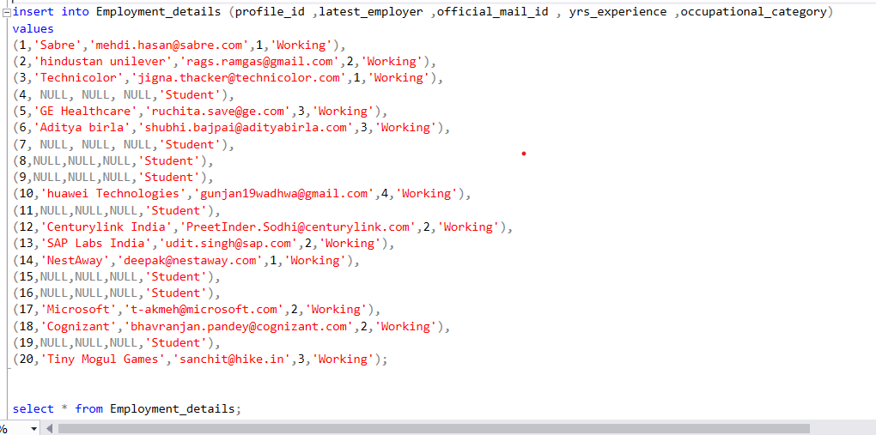

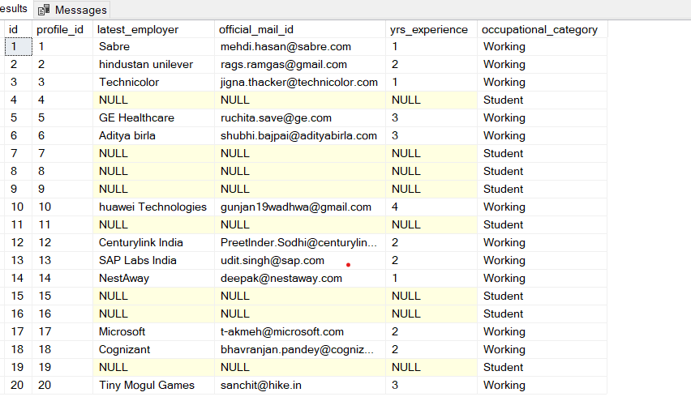

**QUERY:**

1.

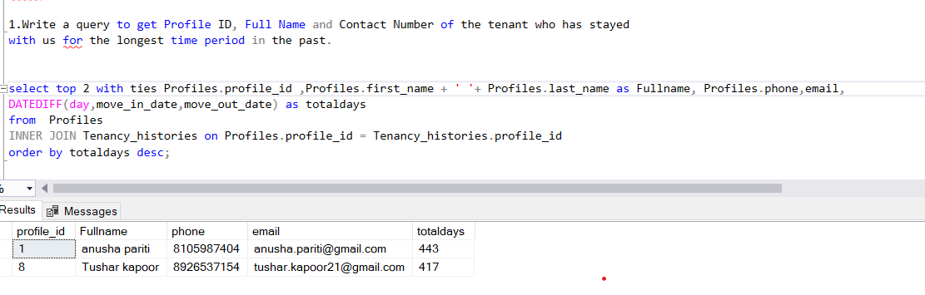

2.

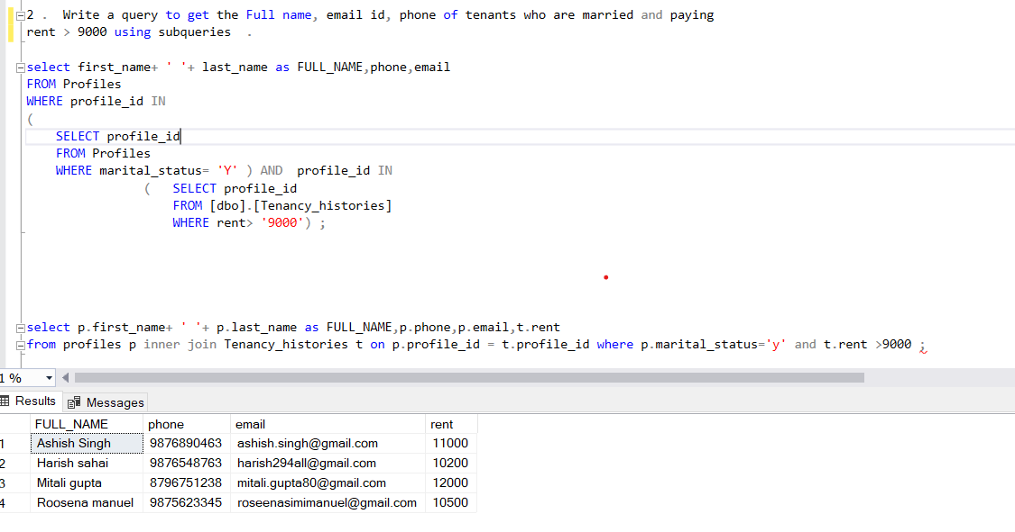

3.

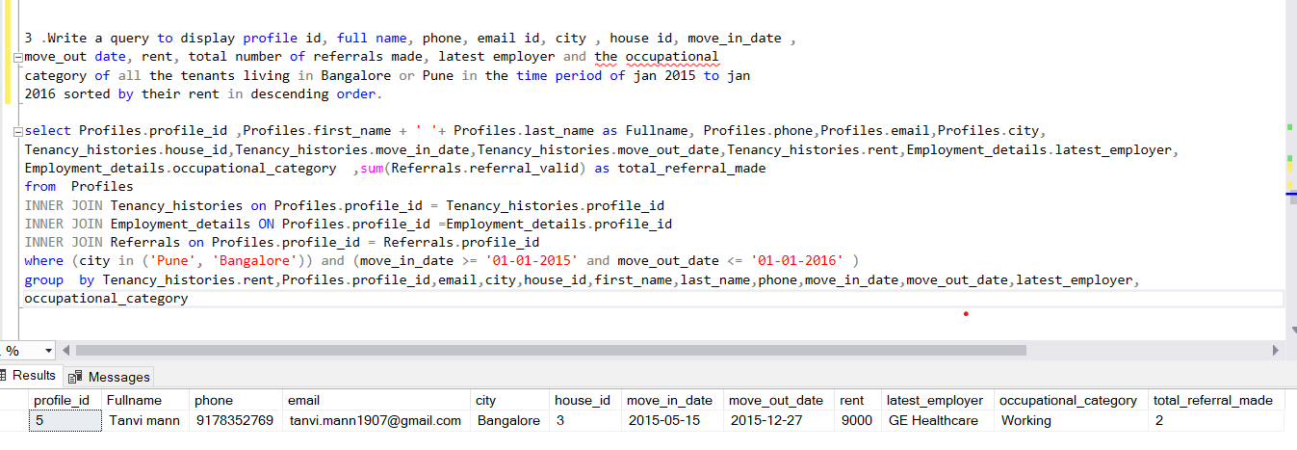

4.

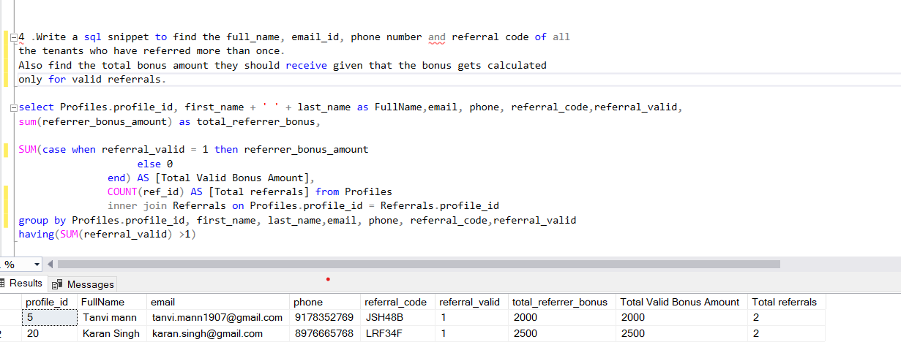

5.

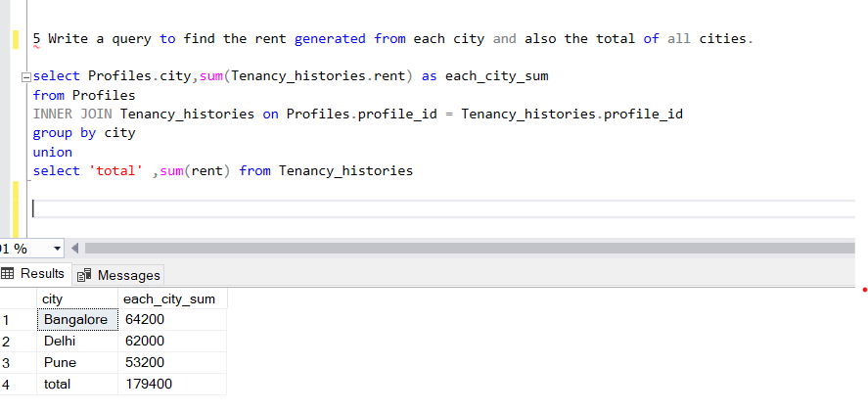

6.

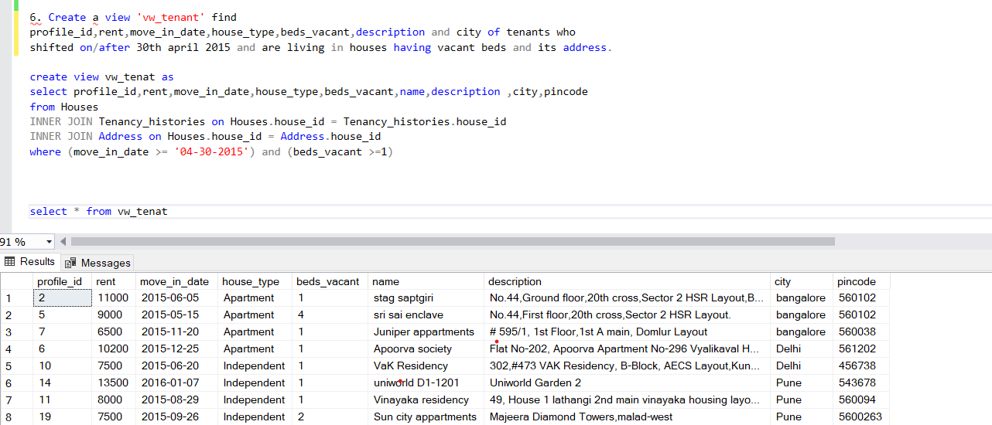

7.

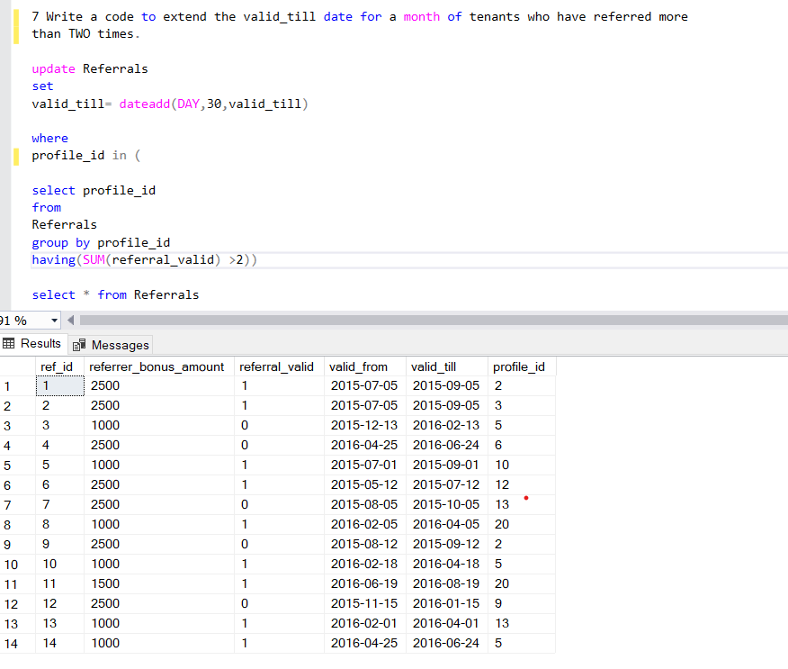

8.

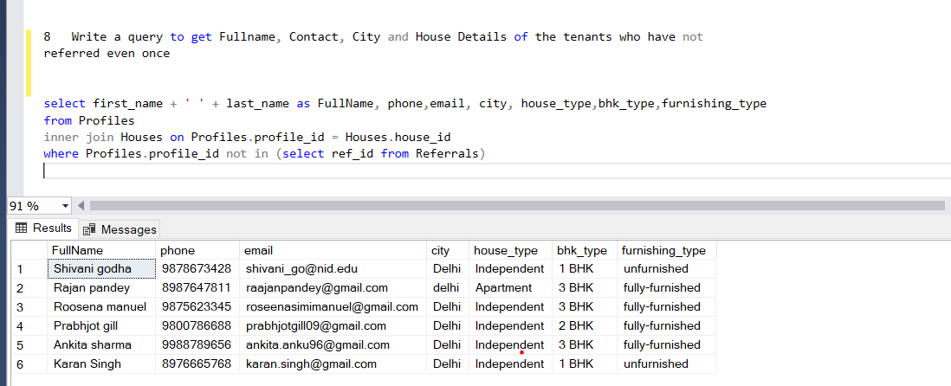

9.

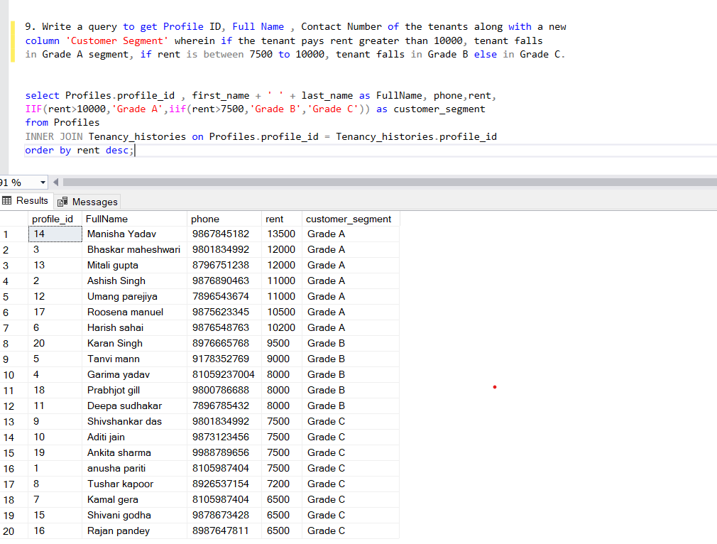

10.

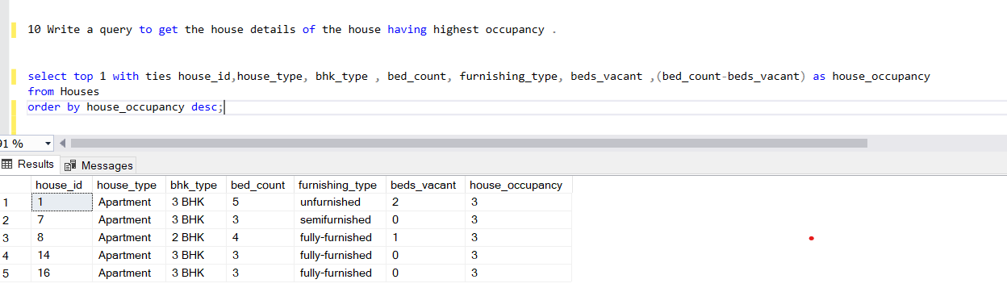

11.

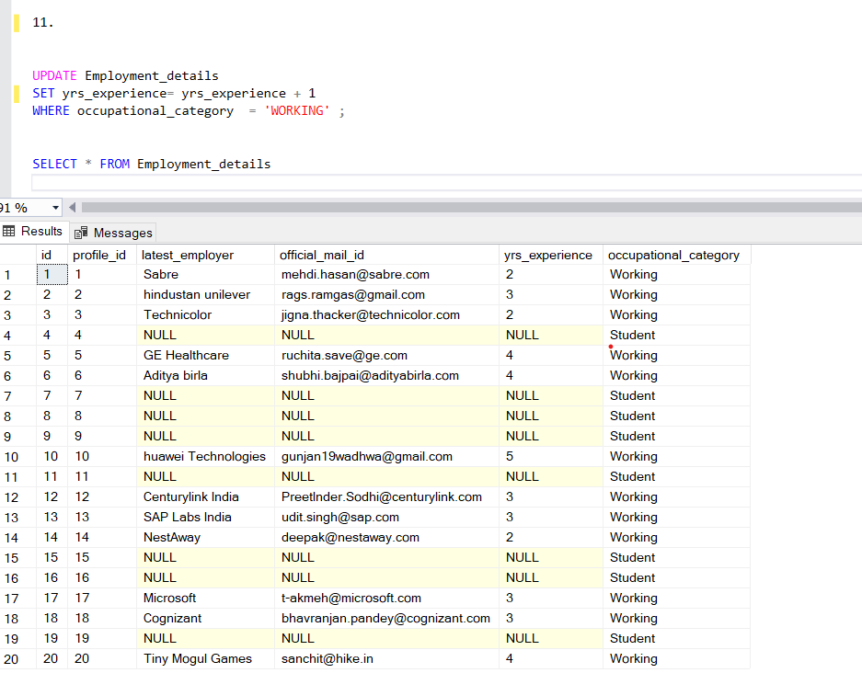

12. 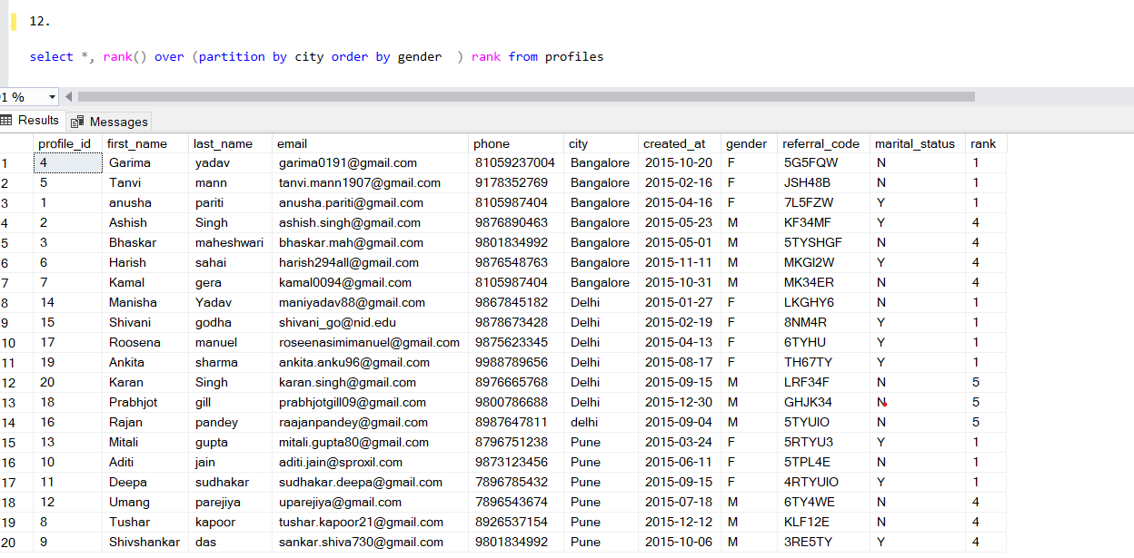

13.

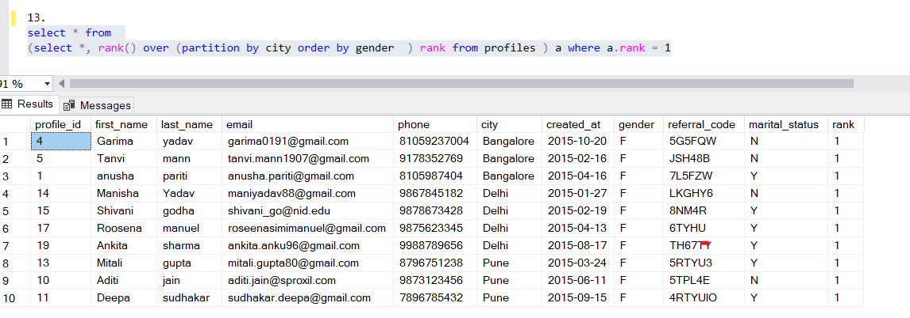

14.

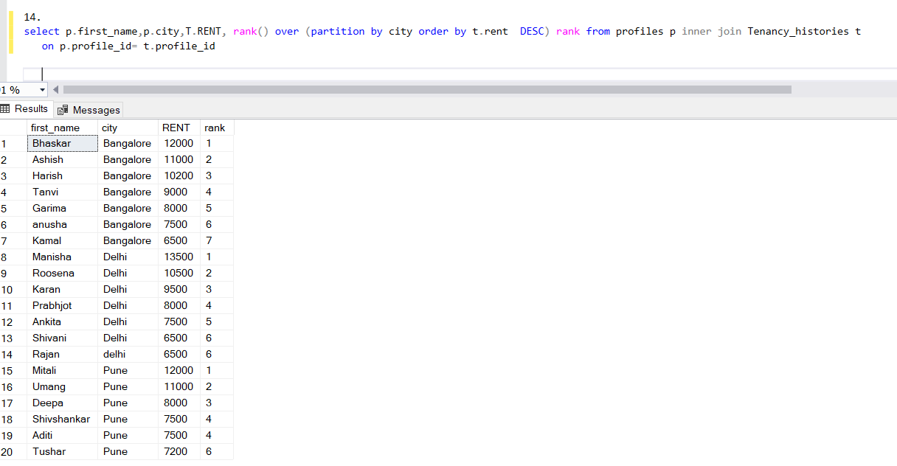

15.

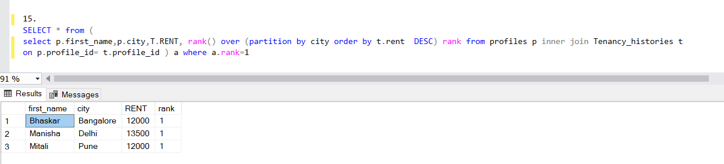

16.

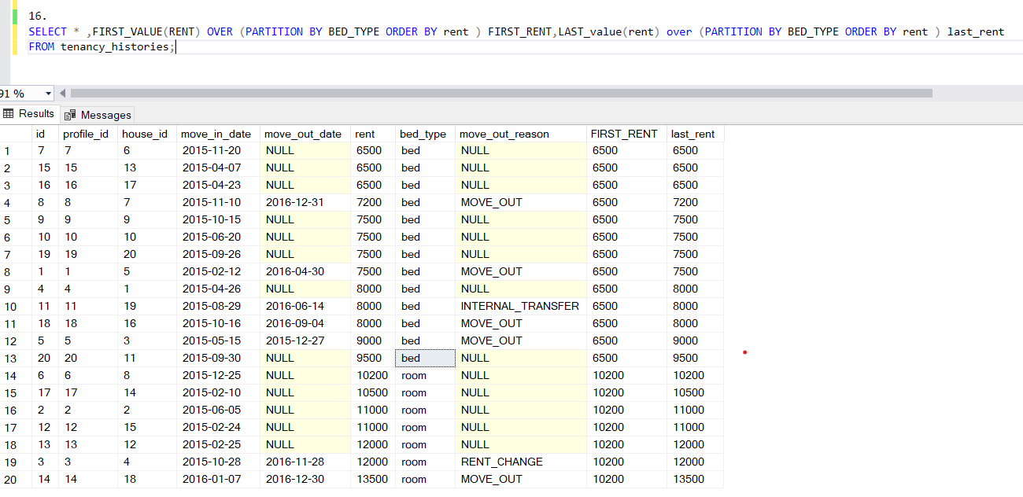

17.

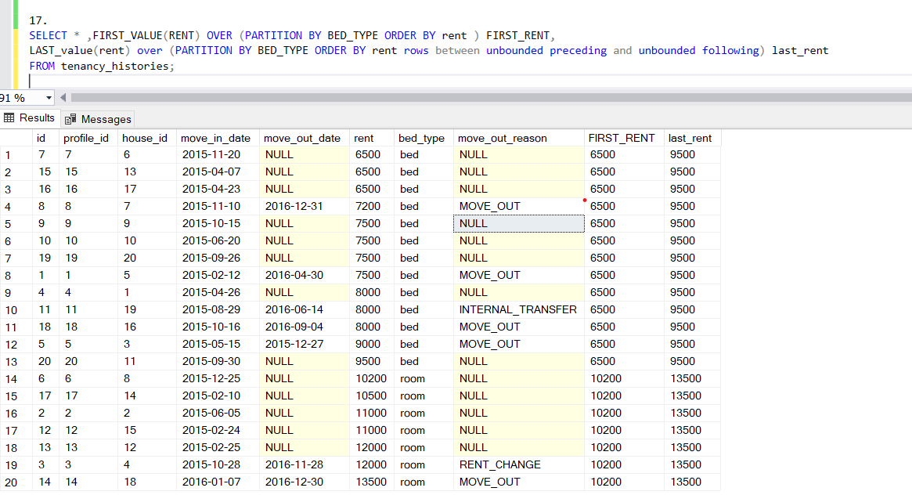

18.

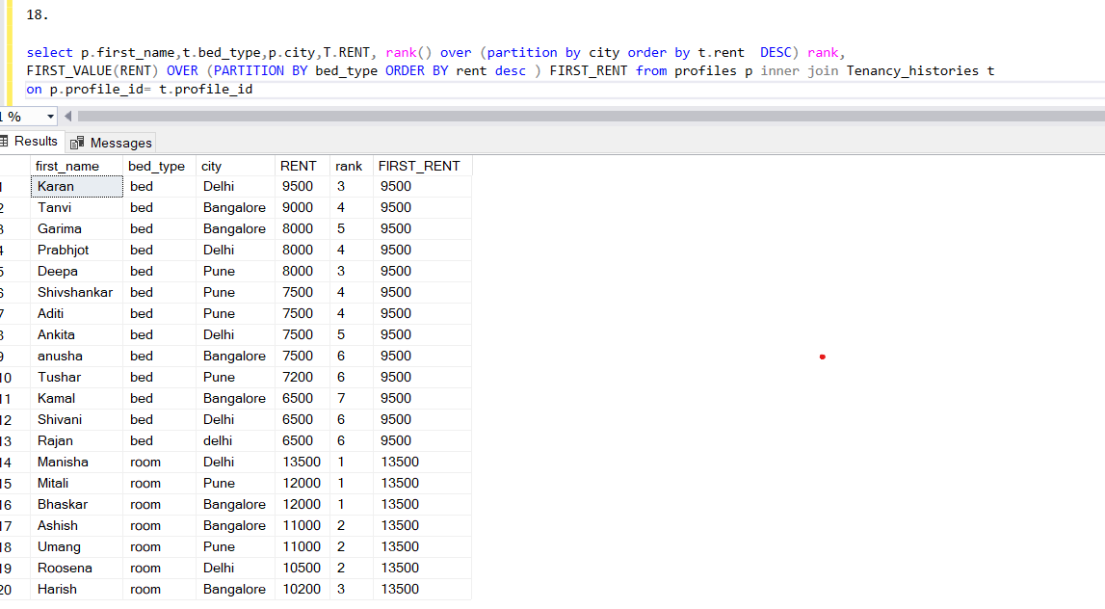

19.what is happening =avg of 3 only like 10333=(10166+9250+7500)/3 and 9666=(10333+10166+9250)/3 and so on……… u can do more like 4 avg ,5 avg by changing 3 preceding and 4 preceding …………

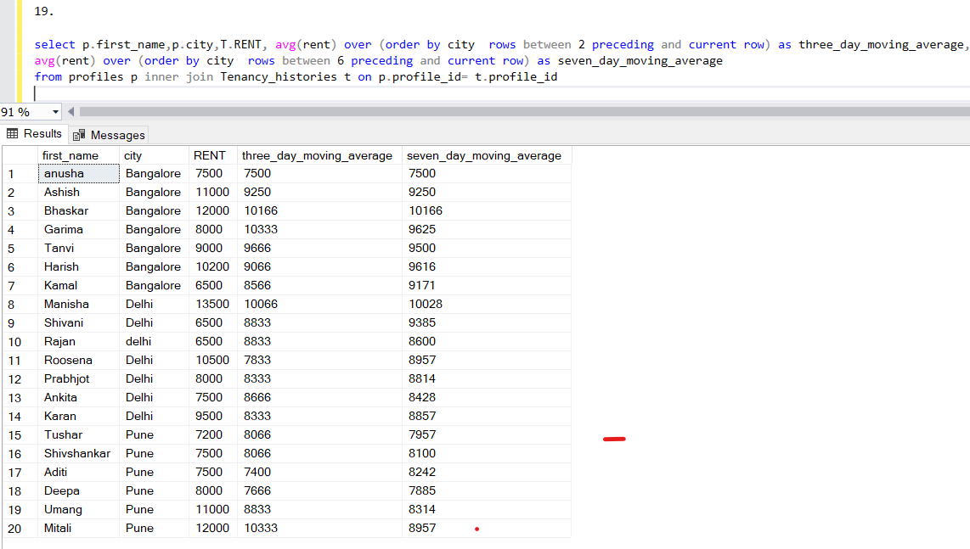

20.

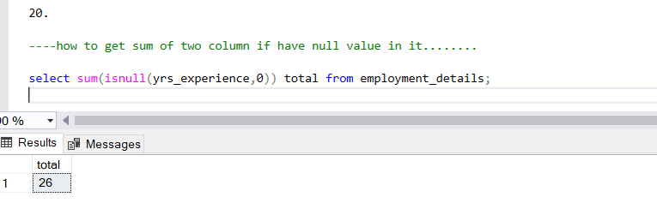

22.

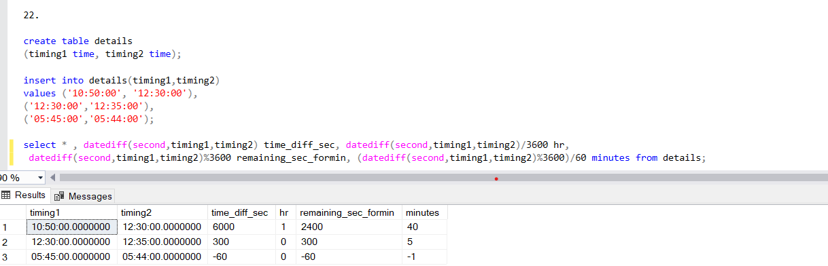

21.

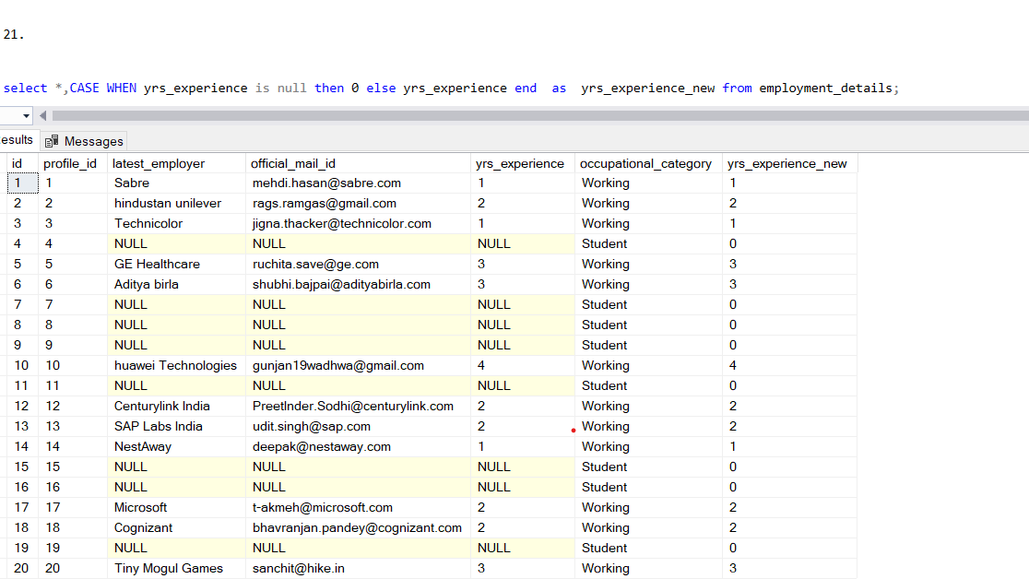

23.

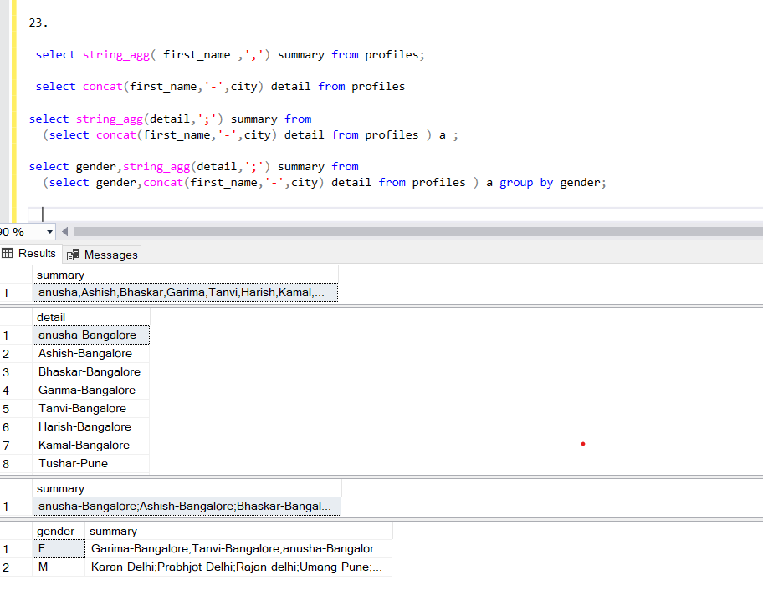

24.

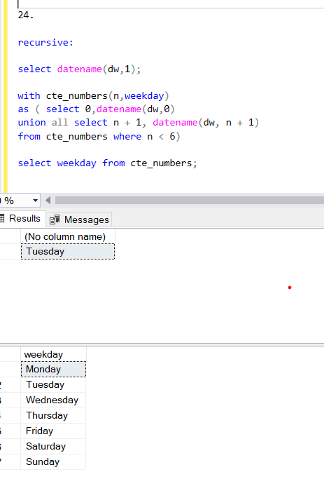

25.

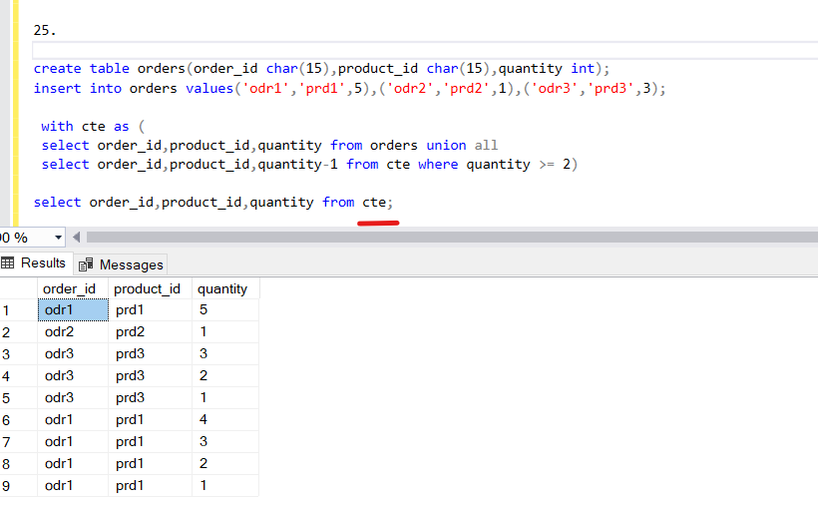

26.

