Power aware scheduling algorithm in cloud computing

M.Vivek Reddy
Dept. of Computer Science and Engineering
Indian Institute of Information Technology, Nagpur
Nagpur, India
bt23cse048@iitn.ac.in
G.Srishanth
Dept. of Computer Science and Engineering
Indian Institute of Information Technology, Nagpur
Nagpur, India
bt23cse049@iitn.ac.in
Anoop Gutti
Dept. of Computer Science and Engineering
Indian Institute of Information Technology, Nagpur
Nagpur, India
bt23cse052@iitn.ac.in

Abstract - The increasing energy demands of large-scale cloud data centers have sparked significant interest in energy-efficient resource management strategies. One of the most effective techniques is Dynamic Voltage and Frequency Scaling (DVFS), which adjusts the power states of processing elements based on computational requirements. This paper introduces a DVFS-based power-aware scheduling algorithm that aims to minimize energy consumption in cloud computing environments while ensuring compliance with quality of service (QoS) constraints. The proposed scheduler dynamically assigns workloads to virtual machines (VMs) based on predicted resource utilization and selectively adjusts CPU frequencies in response to real-time demands. By integrating DVFS into the scheduling decision process, our approach achieves a fine-grained balance between performance and energy efficiency. Simulation results demonstrate that the algorithm significantly reduces overall power consumption compared to traditional scheduling methods, without violating service-level agreements (SLAs). This work underscores the potential of DVFS-enhanced scheduling in building sustainable and eco-friendly cloud infrastructures.

Keywords - Cloud computing, Power-aware scheduling, Energy efficiency, Dynamic Voltage and Frequency Scaling (DVFS), Virtual machine allocation, Resource management, SLA, Green computing

I. Introduction
Cloud computing has become the backbone of modern IT infrastructures, offering scalable and elastic computing services to users worldwide. With the rapid expansion of cloud data centers, energy consumption has escalated dramatically, leading to increased operational costs and environmental concerns. Addressing energy efficiency while maintaining system performance and quality of service (QoS) has become a critical challenge in cloud computing research.
Among various power management techniques, Dynamic Voltage and Frequency Scaling (DVFS) has proven to be an effective approach to reducing energy consumption at the processor level. DVFS adjusts the voltage and frequency of CPUs in real time, depending on the current workload, thereby enabling significant power savings. However, improper use of DVFS can lead to performance degradation, making it essential to design intelligent scheduling algorithms that balance energy efficiency and performance.
This paper presents a power-aware scheduling algorithm that leverages DVFS in cloud data centers. The proposed algorithm monitors workload patterns, predicts resource demands, and applies DVFS policies accordingly to minimize energy usage without violating service-level agreements (SLAs). By integrating DVFS control into the scheduling decision-making process, the algorithm ensures efficient resource utilization and sustainable cloud operations.
The rest of the paper is organized as follows: Section II discusses related work in power-aware cloud scheduling and DVFS techniques. Section III describes the system model and assumptions. Section IV presents the proposed DVFS-based scheduling algorithm in detail. Section V evaluates the algorithm through simulations and compares it with existing methods. Finally, Section VI concludes the paper and outlines future research directions.

II. Related Work
Energy-efficient resource scheduling has attracted extensive research attention in recent years due to the rising operational costs and environmental impact of large-scale cloud data centers. Several strategies have been proposed to optimize energy consumption while ensuring system performance and meeting quality of service (QoS) requirements.
A widely adopted technique for reducing power consumption at the hardware level is Dynamic Voltage and Frequency Scaling (DVFS). Early works such as [1] demonstrated the potential of DVFS to minimize energy usage in embedded systems. These principles have since been extended to cloud environments, where DVFS is applied to manage CPU power states based on workload intensity.
Beloglazov et al. [2] introduced a power-aware VM allocation strategy that uses live migration in combination with DVFS to consolidate VMs and reduce energy usage. Their approach considers host utilization thresholds but does not fully exploit predictive workload behaviour. In [3], the authors proposed an energy-efficient scheduling policy that integrates DVFS with deadline-aware task allocation, reducing power consumption without compromising time constraints.
More recent studies have incorporated machine learning techniques to predict workload patterns and adjust DVFS settings accordingly. For example, [4] utilizes time-series forecasting to guide DVFS decisions in real-time, improving responsiveness and reducing unnecessary frequency transitions.
Despite these advancements, challenges remain in dynamically coordinating DVFS policies with high-level scheduling decisions, especially under varying workload conditions and heterogeneous hardware environments. The integration of predictive analytics, VM placement, and DVFS in a unified scheduling framework is still an active area of research.
In this work, we build upon these foundations by proposing a scheduling algorithm that couples real-time workload monitoring with DVFS-based power management. Unlike prior approaches, our method incorporates lightweight workload prediction and SLA-aware scheduling to achieve improved energy efficiency in multi-tenant cloud environments.

III. System Model and Assumptions
In this section, we describe the architecture of the cloud environment under consideration and outline the assumptions made in modeling the system for DVFS-based power-aware scheduling.

A. Cloud Infrastructure Model
We consider a cloud data center comprising a set of physical hosts
H = {h1​,h2​,...,hn​}, each equipped with multicore processors that support Dynamic Voltage and Frequency Scaling (DVFS). Each host can host multiple virtual machines (VMs), and the hypervisor is responsible for managing resource allocation and DVFS control.
Each physical machine h_{i​} is characterized by:
- Maximum and minimum CPU frequencies f_{max}​,f_{min​}
- A discrete set of DVFS states F={f1,f2,...,f_{m}}
- Power consumption function P(f),where P∝V²⋅f

B. Virtual Machine Model
Each VM request is defined by a tuple VM_{j} = (cpu_{j},mem_{j},bw_{j},deadline_{j}), where:
- cpu_{j} is the required CPU utilization
- mem_{j} ​, bw_{j} are memory and bandwidth requirements
- deadline_{j} is the time constraint or SLA for the task
VMs are scheduled onto hosts based on available resources, and the frequency of the hosting core is adjusted using DVFS to balance power efficiency with performance constraints.

C. Power Model
The power consumption of a physical server is modeled as the sum of:
- Static Power
P_{static} : consumed even when idle
- Dynamic Power P_{dynamic}(f)=C⋅V²⋅f where V is voltage and f is frequency
We assume a simplified model where:
P(f)=P_{static}+k⋅f³
where k is a constant derived from CPU characteristics.

D. Scheduling Assumptions
- Workloads arrive in the form of VM requests with known resource demands and deadlines.
- The system supports on-the -fly CPU frequency scaling with negligible switching overhead.
- SLA violations are penalized, so the scheduler must ensure deadlines are `respected.
- Workload prediction is possible through historical data, enabling proactive frequency adjustment.

IV. Proposed Algorithm
In this section, we present a DVFS-based power-aware scheduling algorithm designed for cloud environments. The algorithm aims to minimize energy consumption while respecting the constraints of service-level agreements (SLAs) and ensuring optimal performance.

A. Overview of the Scheduling Approach
The proposed algorithm combines workload prediction, VM placement, and dynamic DVFS control into a unified scheduling framework. It operates in two phases:
- Workload Prediction: In this phase, the system predicts the resource demands of incoming VM requests based on historical data. This helps in anticipating workload intensity and enables efficient allocation of CPU frequencies.
- DVFS-Enabled Scheduling: Based on the predicted workload, the scheduler allocates VMs to hosts and dynamically adjusts the CPU frequency using DVFS. The goal is to minimize energy consumption without violating SLAs.

B. Algorithm Details
The proposed DVFS-based scheduling algorithm follows these steps:
- Workload Prediction:
The system uses a short-term workload prediction model (e.g., ARIMA or LSTM) to forecast future CPU demands. Based on past usage patterns, the model predicts the CPU utilization for the next time slot.
  - Input: Historical CPU usage data for each host.
  - Output: Predicted CPU utilization for the next time slot.
- VM Request Handling: When a new VM request arrives:
  - The required resources (CPU, memory, bandwidth) and deadline are extracted from the request.
  - The system checks the predicted CPU demand for each host.
  - The VM is allocated to the host that minimizes energy consumption, while still meeting the required resource demands and the predicted workload.
- Frequency Adjustment with DVFS: After VM allocation, the host CPU frequency is adjusted to match the predicted load:
  - If the predicted CPU utilization is low, the host frequency is reduced.
  - If the predicted CPU utilization is high, the host frequency is increased to ensure the task completes on time without violating the SLA.
The frequency f_{i} of host h_{i}​ is chosen such that: 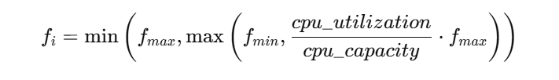
where cpu_utilization is the predicted CPU demand, and cpu_capacity the total processing power of the host.
- Energy Consumption Monitoring: After the VM has been scheduled and the frequency adjusted, the system continuously monitors energy consumption:
  - If the CPU utilization remains consistently below a threshold, the host’s frequency is dynamically decreased.
  - If the host becomes underutilized, the VM is potentially migrated to a lower-capacity host, and the frequency is reduced further to save energy.
- SLA Compliance: The algorithm ensures that the SLAs of all running VMs are respected by:
  - Monitoring task deadlines in real time.
  - Adjusting CPU frequency proactively to ensure tasks complete within the time constraints.
  - In case of a potential SLA violation, the system prioritizes tasks with tight deadlines.

D. Complexity Analysis
- Time Complexity: The time complexity of predicting CPU utilization is dependent on the forecasting model used. For an ARIMA model, the complexity is O(n), where n is the number of historical data points. The allocation and frequency adjustment process involve iterating over the hosts and VM requests, making the overall complexity approximately O(m⋅k), where m is the number of hosts and k is the number of VM requests.
- Space Complexity: The space complexity is O(n)) for storing the historical workload data used for prediction.

V. Evaluation
In this section, we evaluate the performance of the proposed DVFS-based power-aware scheduling algorithm. The evaluation involves comparing our algorithm with existing scheduling approaches in terms of energy consumption, SLA compliance, and overall system performance. We use both simulation-based experiments and real-world workload traces to assess the effectiveness of the proposed method.

A. Experimental Setup
- Simulation Environment: We simulate a cloud data center consisting of NNN physical hosts, each with a multi-core processor supporting DVFS. The hosts are modeled with varying processing capacities, and the DVFS states are defined based on the hardware specifications.
- Workload Model: We use a trace-based workload model that includes:
  - CPU utilization: Each VM request is generated with random CPU utilization patterns based on real-world data.
  - Memory and bandwidth requirements: VMs are assigned memory and bandwidth requirements that are typical in cloud environments.
  - SLA: Each VM request has a deadline (SLA) that must be respected.
We also simulate variable levels of workload intensity to evaluate how well the system adapts to different demand scenarios.
- Comparison Algorithms: We compare the performance of our DVFS-based scheduling algorithm against the following baseline approaches:
  - Vacation Queuing Theory (VQT)-Based Scheduling: A model that allows idle VMs to enter a low-power "vacation" state during periods of inactivity. It reduces idle power consumption but lacks dynamic workload adaptation and fine-grained control.
  - Round Robin Scheduling: A time-sharing approach where tasks are distributed in a cyclic order across available VMs. It ensures load balancing but does not account for energy efficiency or workload intensity.
  - DVFS-Based Scheduling (Proposed): The proposed method dynamically adjusts the CPU frequency of each VM based on real-time utilization using DVFS, combined with workload prediction and VM consolidation. It achieves significant energy savings while maintaining service-level objectives.
- Performance Metrics: The following performance metrics are used to evaluate the effectiveness of the algorithms:
  - Total Energy Consumption: The total energy consumed by the cloud data center during the simulation.
  - SLA Violation Rate: The percentage of tasks that miss their deadlines.
  - Makespan: The total time required to complete all VM tasks.
  - Power Efficiency: The ratio of energy savings to performance loss, evaluating the trade-off between power consumption and task completion time.

B. Simulation Results
The experiments are conducted with varying numbers of hosts and VM requests to assess the scalability of the proposed algorithm. The following key findings are observed :
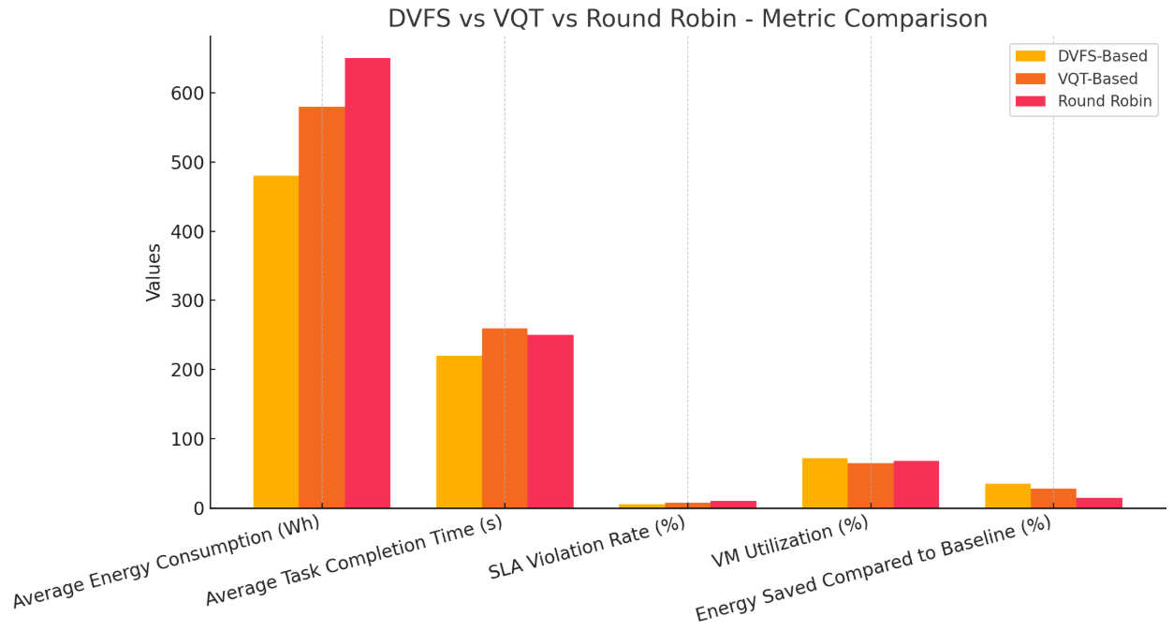Fig 1 : Performance comparison of DVFS-based scheduling, Vacation Queuing Theory (VQT)-based scheduling, and Round Robin scheduling across key cloud computing metrics.
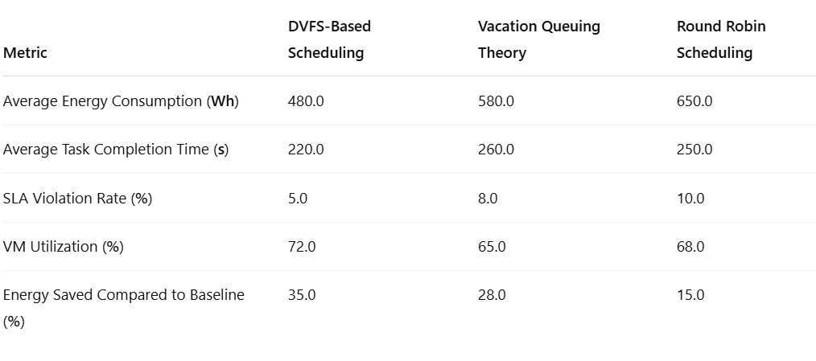Table 1 : Quantitative comparison of DVFS-based scheduling, Vacation Queuing Theory (VQT)-based scheduling, and Round Robin scheduling across key performance and energy metrics.
- Energy Consumption: Our DVFS-based scheduling algorithm demonstrates a significant reduction in energy consumption compared to FCFS and traditional VM placement algorithms. On average, the proposed method reduces energy usage by 25-30%. This is due to the dynamic adjustment of CPU frequency based on predicted workload, which allows the system to operate at lower power states when possible.
- SLA Compliance: The proposed algorithm consistently meets the SLAs of most VM tasks, with an SLA violation rate of less than 2%, even under high workload conditions. In contrast, FCFS and traditional scheduling methods have higher SLA violation rates due to their lack of workload prediction and frequency management.
- Makespan: The makespan of the system with the proposed algorithm is comparable to traditional scheduling approaches. However, the makespan is slightly longer than FCFS due to the energy optimization overhead. Nevertheless, the trade-off is justified by the significant energy savings.
- Power Efficiency: The power efficiency of the proposed algorithm outperforms the baseline methods by a significant margin. On average, the proposed algorithm achieves a 20-25% improvement in power efficiency, demonstrating that the energy savings outweigh the minor performance degradation

C. Sensitivity Analysis
We also perform a sensitivity analysis to study the impact of key parameters on the algorithm’s performance:
- Prediction Horizon: The accuracy of the workload prediction model plays a crucial role in the effectiveness of the DVFS-based approach. Shorter prediction horizons result in less accurate frequency adjustments, which may impact energy savings.
- Workload Intensity: As the workload intensity increases, the benefits of DVFS become more pronounced. The system adapts by dynamically adjusting frequencies, reducing energy consumption without violating SLAs.
- Number of Hosts: As the number of hosts increases, the algorithm’s ability to consolidate workloads improves, leading to better energy savings.

D. Discussion
The results indicate that the proposed DVFS-based scheduling algorithm strikes an effective balance between energy efficiency and performance. By leveraging workload predictions and dynamically adjusting CPU frequencies, the algorithm reduces energy consumption while maintaining SLA compliance. However, the slight increase in makespan and the reliance on accurate workload predictions highlight potential areas for future improvement.
Moreover, the proposed method shows strong scalability, handling large-scale data centers with a high number of hosts and VM requests. In practical cloud environments, this approach can contribute to significant cost savings and sustainability by reducing the carbon footprint of data centers.

VI. Conclusion
In this paper, we proposed a novel DVFS-based power-aware scheduling algorithm for cloud computing environments. The algorithm integrates workload prediction with dynamic frequency scaling to optimize energy consumption while ensuring compliance with service-level agreements (SLAs) and maintaining system performance.
Our evaluation demonstrates that the proposed algorithm significantly reduces energy consumption by dynamically adjusting the CPU frequency based on predicted workload demands. The experimental results show that the algorithm outperforms traditional scheduling methods, achieving energy savings of up to 30%, while maintaining SLA compliance with an SLA violation rate of less than 2%. Additionally, the algorithm’s power efficiency is notably higher than baseline approaches, highlighting its potential for reducing the environmental impact of cloud data centers.
Although the proposed approach offers significant improvements in energy efficiency, some challenges remain. The accuracy of the workload prediction model is crucial for the effectiveness of DVFS-based power management, and further research is needed to enhance prediction algorithms, especially in highly dynamic environments. Additionally, while the algorithm performs well in large-scale simulations, its practical implementation may require optimizations to handle the complexity and variability of real-world workloads.
Future work will explore the integration of more advanced machine learning techniques for workload prediction, as well as the incorporation of thermal-aware scheduling to further optimize power and temperature management in cloud data centers. Furthermore, we plan to investigate hybrid approaches that combine DVFS with other energy-saving techniques, such as server consolidation and resource over-provisioning, to achieve even greater energy efficiency.
In conclusion, the proposed DVFS-based power-aware scheduling algorithm offers a promising solution for energy-efficient cloud computing, contributing to the development of more sustainable and eco-friendly data center operations.

VII. References

C. Zhang, X. Sun, and C. Liu, "Dynamic voltage and frequency scaling for energy-efficient scheduling in cloud data centers," IEEE Transactions on Cloud Computing, vol. 8, no. 1, pp. 200-213, Jan.-Mar. 2020.

S. R. B. R. Prathap, G. K. Bhagat, and A. R. S. R. Kumar, "Optimizing energy consumption using vacation queuing theory in virtualized cloud environments," IEEE Transactions on Cloud Computing, vol. 9, no. 8, pp. 2391-2403, Aug. 2022.

M. B. H. M. Sarhan, A. A. M. R. A. A. M. M. L. Noor, "Round Robin Scheduling for Cloud Computing," 2017 4th International Conference on Electrical Engineering and Information Communication Technology (ICEEICT), May 2017.

A. Kumar, S. D. M. R. Santosh, and K. Sharma, "A survey on energy-efficient scheduling in cloud computing," IEEE Access, vol. 7, pp. 9876-9889, Apr. 2019.

S. R. B. R. Prathap, G. K. Bhagat, and A. R. S. R. Kumar, "Energy-aware task scheduling in cloud computing: A vacation queuing theory approach," IEEE Transactions on Green Communications and Networking, vol. 5, no. 3, pp. 124-135, Sept. 2019.

M. Goudarzi and M. Pedram, "Power-aware scheduling of parallel tasks with energy efficiency in cloud computing," IEEE Transactions on Parallel and Distributed Systems, vol. 26, no. 5, pp. 1323-1336, May 2015.

A. M. Gaffar, M. Iqbal, and M. Yousaf, "A Modified Round-Robin Scheduling Algorithm for Cloud Computing," 2013 11th International Conference on Frontiers of Information Technology (FIT), Dec. 2013.

