Vivek Reddy Doudagiri, Venugopal Gonela, Ramcharan Varma Golla

Sentiment Analysis

Using CNN And LSTM

[1] *Abstract*—Sentiment analysis is a sub-domain of opinion mining where the analysis is focused on the extraction of emotions and opinions of the people on a topic from a structured, semi-structured or unstructured textual data. In the recent years, sentiment analysis has become a major research problem in the field of Natural Language Processing. In this project, we try to focus our interest on one special area where Sentiment analysis is critical i.e., movie reviews. Here we consider binary (positive and negative) classification based on CNN and LSTM.

*Keywords—Convolution Neural Network, Opinion Mining, Recurrent Neural Network, Structured data*

# **INTRODUCTION**

World Wide Web has become the biggest database being fed with data by every internet user around the world. A lot of data from millions of users in the form of text, images, music that indicate people’s ideas, interests and emotional experiences is being exchanged. This makes Opinion Mining or Sentiment analysis an important area of research.

Since the data boom from 2010, the database sizes have been growing rapidly (exponential rate) which poses new challenges. Opinions which are being expressed in the form of reviews provide an opportunity for new explorations to find likes and dislikes of the people. One such domain of reviews is the domain of movie reviews which affects everyone from audience who want to decide whether to watch the movie or not, film critics to the production company who wants to estimate the profits. Movie reviews posted in blogs and review sites are usually informal and unstructured. The reviews tell the true emotion of a person about the topic of interest, in this case it is the emotion/opinion towards a movie.

# **Related Research**

Sentiment analysis of content in online is important for many social media analytics tasks. In case of social media, there are several challenges. First, there are huge amounts of data available. Second, messages on social networks are by nature informal and short. Therefore, sentiment analysis is a very challenging task. Xi Ouyang, Cheng Hua Li, Lijun Liu [1] proposed a framework called Word2vec + Convolutional Neural Network (CNN). Initially they have used Word2vec of google to compute word vectors which are fed as input to CNN. An architecture consisting of 3 Convolution layers and Pooling layers is used and the accuracy of the model is improved by considering Parametric Rectified Linear unit as the activation function, Normalization and Drop out technology. Andrew M. Dai and Quoc V. Le from Google have proposed two approaches [3], one of them is to use a Sequence auto encoder and another is to predict what comes next in a sequence. Their experimental result with long short term memory recurrent networks (LSTM) after pretraining using the above proposed models shows that strong performance is achieved in many of the classification tasks.

# **Sentiment Analysis**

Sentiment analysis represents a person’s polarity on a topic, product which determines very important factor in deciding the actual consumer behavior rather than ratings. The attitude may be the person’s judgement on that topic or emotional state of person while writing a review. Sentiment is defined as any kind of emotion and in the context of sentiment analysis is the opinion that is being expressed in the form of text or speech. Sentiment Analysis is a technology that will be very important in the next few years. With Sentiment analysis, we can distinguish poor content from high quality content. With the technologies, available we can know if a movie has more good or bad opinion and find the reasons why those opinions are positive or negative. The early research in this field was focused on product reviews, such as reviews of different products on Amazon.com, defining sentiments as positive, negative, or neutral. Most sentiment analysis studies are now focused on social media sources such as IMDB, Twitter and Facebook, requiring the approaches be tailored to serve the rising demand of opinions in the form of text. Furthermore, performing the phrase-level analysis of movie reviews proves to be a challenging task.

# **Neural Network**

As present day PCs, have turned out to be always intense, researchers keep on being tested to utilize machines adequately for errands that are generally straightforward for people. More experience allows humans to refine responses and improve their performance. Albeit in the end, we might have the capacity to depict leads by which we can settle on such choices, these don't mirror the real procedure we utilize. Yet another common human activity is trying to achieve a goal that involves maximizing a resource while satisfying certain constraints. Each of these types of problems illustrates tasks for which computer solutions may be sought.

An artificial Neural Network is an information processing system that has certain performance characteristics in common with biological neural networks. They have been developed as generalization of mathematical models of human cognition of neural biology based on assumptions that information processing occurs at many simple elements called neurons, signals are passed between neurons over connection links, each connection link has an association weight, each neuron applies an activation function to its net input to determine output signal.

A neural network is characterized by its architecture, training or learning algorithm and its activation function. Most neural networks use ReLU or tanh as activation function.

Neural networks are sometimes described in terms of their depth, including how many layers they have between input and output, or the model's so-called hidden layers. They can also be described by the number of hidden nodes the model has or in terms of how many inputs and outputs each node has. Variations on the classic neural-network design allow various forms of forward and backward propagation of information among tiers.

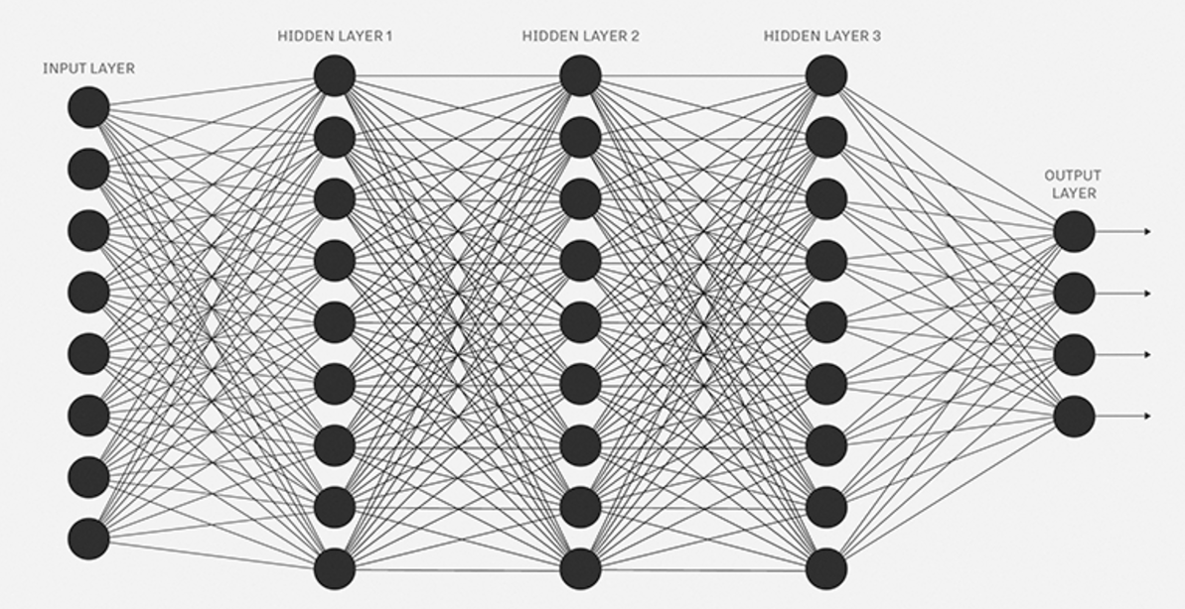

Fig 1: Neural Network with 3-hidden layers

## **Convolution Neural Networks (CNN)**

Convolutional neural network (ConvNet) also known as shift invariant or space invariant artificial neural network is a type of [feed-forward](https://en.wikipedia.org/wiki/Feedforward_neural_network) [artificial neural network](https://en.wikipedia.org/wiki/Artificial_neural_network) that are made up of neurons that have learnable weights and biases. Each neuron receives some inputs, performs a dot product and optionally follows it with a non-linearity. The whole network still expresses a single differentiable score function: from the raw data on one end to class scores at the other. And they still have a loss function (e.g. SVM/Softmax) on the last (fully-connected) layer.

A simple ConvNet is a sequence of layers, and every layer of a ConvNet transforms one volume of activations to another through a differentiable function. We use three main types of layers to build ConvNet architectures: **Convolutional Layer, Pooling Layer**, and Fully Connected Layer.

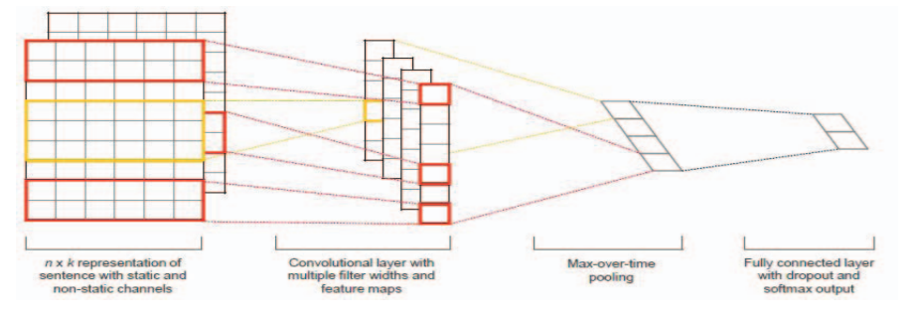

Fig 2: Convolutional Neural Network

## **Recurrent Neural Network (RNN)**

A recurrent neural network (RNN) is a class of [artificial neural network](https://en.wikipedia.org/wiki/Artificial_neural_network) where connections between units form a [directed cycle](https://en.wikipedia.org/wiki/Directed_cycle). This creates an internal state of the network which allows it to exhibit dynamic temporal behavior. Unlike feedforward neural networks, RNNs can use their internal memory to process arbitrary sequences of inputs. This makes them applicable to tasks such as unsegmented connected handwriting recognition or speech recognition.

The idea behind RNNs is to make use of sequential information. In a traditional neural network, we assume that all inputs (and outputs) are independent of each other. But for many tasks that’s a very bad idea. If you want to predict the next word in a sentence you better know which words came before it. RNNs are called recurrent because they perform the same task for every element of a sequence, with the output being depended on the previous computations. In theory RNNs can make use of information in arbitrarily long sequences, but in practice they are limited to looking back only a few steps.

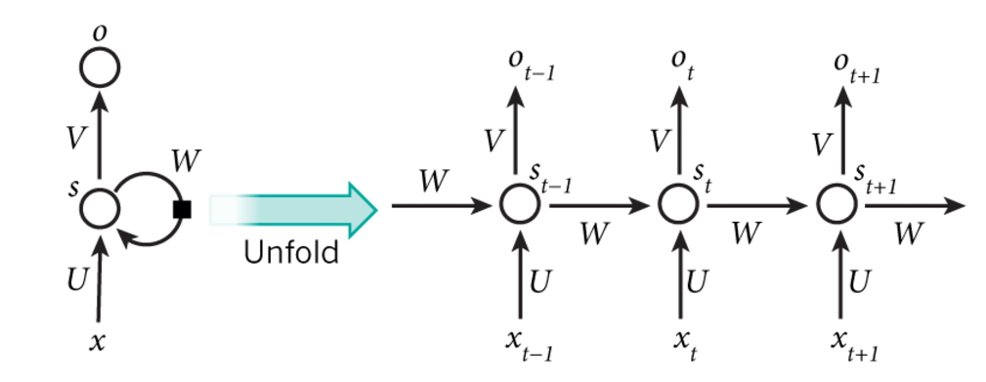

Fig 3: Typical RNN and foldings in time

## **LSTM**

## The LSTM addresses the problem of “vanishing gradient”

by replacing the self-connected hidden units with memory blocks as illustrated in Fig. 4. The memory units enable the network to be aware of when to learn new information and when to forget old information. Our LSTM implementation is standard and has input gates, forget gates, and output gates

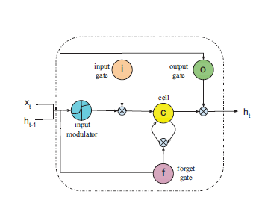

Fig 4: Long Short Term Memory Recurrent Network

# **Preliminaries**

## **Word Embedding**

Word embedding is a technique of representing a word in terms of numerical vectors usually of lower dimension compared to vocabulary. The words that have similar meaning can be made to correspond to close vectors to obtain meaningful results. Word Embedding plays a crucial role in all natural language processing applications like POS tagging. There are two embedding’s that are commonly used, Word2Vec and GloVe.

***Word2Vec:***

Word2Vec by google provides an efficient implementation of the continuous bag-of-words and skip-gram architectures for computing vector representations of words. The word2vec tool takes a text corpus as input and produces the word vectors as output. It first constructs a vocabulary from the training text data and then learns vector representation of words. The resulting word vector file can be used as features in many applications.

***GloVe:***

GloVe is an unsupervised learning algorithm for obtaining vector representations for words. Training is performed on aggregated global word-word co-occurrence statistics from a corpus, and the resulting representations showcase interesting linear substructures of the word vector space. It is a count based model.

The GloVe model is trained on the non-zero entries of a global word-word co-occurrence matrix, which tabulates how frequently words co-occur with one another in given corpus. Populating this matrix requires a single pass through the entire corpus. This is computationally expensive as the size of data grows, but it is a one-time cost. Subsequent training iterations are much faster because the number of non-zero matrix entries is typically much smaller than the total number of words in the corpus.

## **Drop out**

Over fitting is a serious problem in machine learning models. Large networks are also slow to use, making it difficult to deal with overfitting by combining the predictions of many different large neural nets at test time. Deep neural networks contain multiple non-linear hidden layers and this makes them very expressive models that can learn very complicated relationships between their inputs and outputs. With limited training data, however, many of these complicated relationships will be the result of sampling noise, so they will exist in the training set but not in real test data even if it is drawn from the same distribution. This leads to overfitting and many methods have been developed for reducing it. Dropout is a regularization technique in neural networks which avoids model from overfitting by preventing co-adaptation on training data.

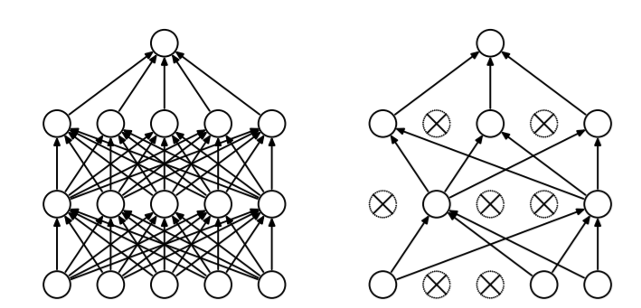

Fig 5: a) Standard Neural Network b) Neural net after Drop Out

## **Activation function**

In computational networks, the activation function of a node defines the output of that node given an input or set of inputs. The role of activation function in a neural network is to make it non-linear. There are many Activations that are in use. Some of them are Identity function, Tanh, Rectified Linear Unit (ReLU), Soft plus, Sinc, sigmoid etc.

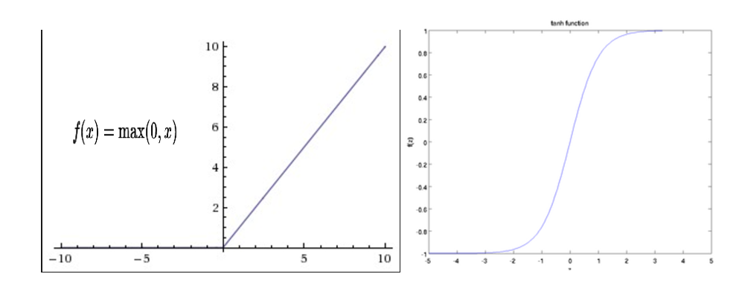

Fig 6: a) ReLU function b) Tanh function

## **ADAM optimizer**

ADAM optimization algorithm [4] for first-order gradient-based optimization of stochastic objective functions, based on adaptive estimates of lower-order moments. The method is straightforward to implement, is computationally efficient, has little memory requirements, is invariant to diagonal rescaling of the gradients, and is well suited for problems that are large in terms of data. The method is also appropriate for non-stationary objectives and problems with very noisy and/or sparse gradients. The hyper-parameters have intuitive interpretations and typically require little tuning. The method computes individual adaptive learning rates for different parameters from estimates of first and second moments of the gradients.

## **One Hot Encoding**

One hot encoding transforms categorical features to a format that works better with classification and regression algorithms. In machine learning encoding to nominal values is no use, since we cannot say which category is greater than other by looking at nominal values. What we do instead is generate one Boolean column for each category. Only one of these columns could take on the value 1 for each sample. Hence, the term one hot encoding

# **DataSet**

The dataset we used is the [Movie Review data from Rotten Tomatoes](http://www.cs.cornell.edu/people/pabo/movie-review-data/). The data set is originally collected by Pang and Lee [5]. It contains 10,662 example review sentences, half positive and half negative. The dataset has a vocabulary of size around 20k. Since this data set is small we’re likely to overfit with a powerful model. Using Random Sub-sampling the whole data set is divided into validation set, Training Set and Test Set. 10% of the data is taken as a validation set, 70 % for training and 20% for testing.

# **Experiment**

**Baseline SVM**:

To provide point of reference to the results achieved by CNN and RNN, we report the performance achieved using SVM. As a baseline, we used RBF-kernel SVM as a classifier exploiting unigrams and bigrams features. We have tuned hyperparameters (C and gamma) using the development set by doing the grid search and then reported result on test set with best hyperparameters chosen.

**CNN:**

In CNN, we have used rectifier linear units, filter windows of 3, 4, 5 with 128 feature maps each, dropout rate of 0.7, l2 constraint of 0.8, and mini-batch size of 64. These values were chosen via a grid search on dev set. The output layer is SoftMax and loss is computed using log function. We have experimented with random word vectors and google news word vectors. The results are reported on test set with above parameters.

**RNN:**

For experimenting we have used the following parameters, we provided two types of results which includes using word2vec and using LSTM rand. We used one hot encodings for output predictions, LSTM is used with 128 nodes, initial layer is either embedding layer for if word2vec is used or random embedding if LSTM rand is used, Adam optimizer is used with loss function of binary cross entropy, the final layer is sigmoid function, we also used early stopping on loss of development set with a patience of 30 epochs, we ran the model on 1500 epochs. We conducted experiments by changing the dropouts ranging from 0.2 to 0.6 and we found out that with 0.5 the model gave best results. We extended the experiments on recurrent dropout ranging from 0.2 to 0.8, where the model performed best with recurrent dropout of 0.4.

|  |  |
| --- | --- |
| Models | Accuracy |
| SVM | 73.71 |
| CNN Rand | 74.12 |
| CNN – Word2Vec | 77.29 |
| RNN (LSTM) Rand | 74.93 |
| RNN (LSTM) – Word2Vec | **78.57** |

Table 1: Experiment results of various models on Movie Review dataset (Rand means randomly initialized word vectors, Word2Vec is google word embeddings with 300 dimensions

The following are the graphs which show how accuracy and loss changes with number of epochs in CNN and RNN. The graphs show the performance on training data and development data.

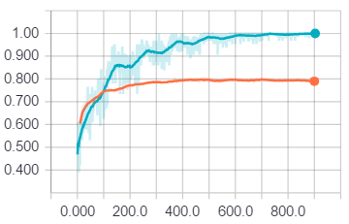

Fig 7: a) Accuracy vs epochs graph on train, development dataset in CNN.

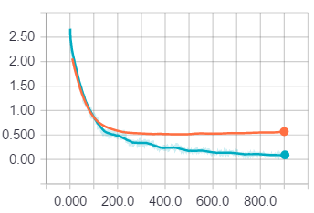

Fig 7: b) Loss vs epochs graph on train, development dataset in CNN

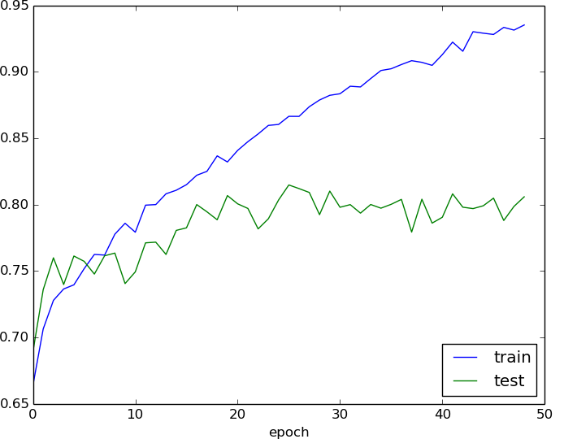

Fig 8: a) Accuracy vs epochs graph on train, development dataset with dropout of 0.5 and recurrent drop out of 0.4

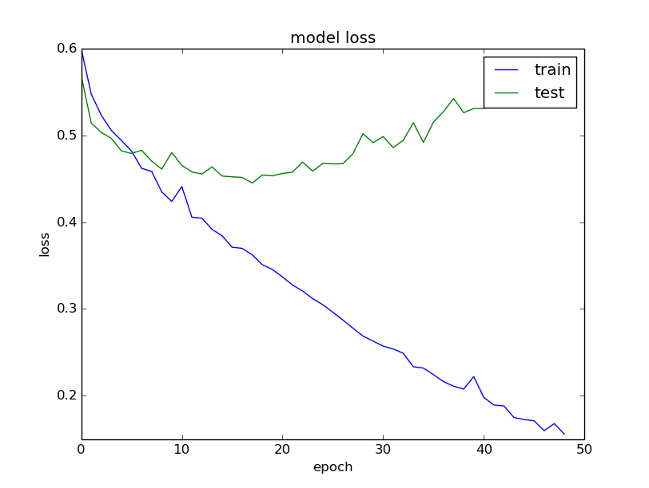

Fig 8: b) Loss vs epochs graph on train, development dataset with dropout of 0.5 and recurrent drop out of 0.4

# **Conclusion**

Sentiment Analysis is a challenging task. In our project, we considered two different models CNN and RNN to classify the given movie review dataset. By properly tuning the parameters the maximum accuracy is obtained using RNN (LSTM) using word2vec. Since LSTM considers the long-term dependencies of previous words it performed better than CNN and SVM model. The results show that LSTM models are more adaptable for tasks like sentiment analysis, word predictions.

# **References**

[1] Ouyang Xi, Cheng Hua Li, Lijun Liu, “Sentiment Analysis

Using Convolution Neural Networks”, *In proceedings of*

*the International Conference on Computing and*

*Information technology;* *Ubiquitous Computing and*

*Communications; Dependable, Autonomic and Secure*

*Computing; Pervasive Intelligence and Computing,*

Pages: 2539-2364, 2015.

[2] Yoon Kim, “Convolutional Neural Networks for Sentence

Classification”, WildML.com, Referenced on 10th march,

2017.

[3] Andrew M. Dai, Quoc V. Le, “Semi-Supervised Sequence

Learning”, *In proceedings of the Neural Information*

*Processing Systems Conference.*

[4] Diederik P. Kingma, Jimmy Lei Ba, “ADAM: A Method

For Stochastic Optimization”, *In proceedings of*

*International Conference on Learning Perspective (ICLR),*

2015.

[5] Pang B, Lee L, “Seeing Stars: Exploiting Class Reation-

Ships for Sentiment Categorization with respect to rating

scales”, *In proceedings of the 43rd Annual Meeting on*

*Association for Computational Linguistics,* PP. 115-124,

2005.

1.