Jury Selection

1. Creating the dataset

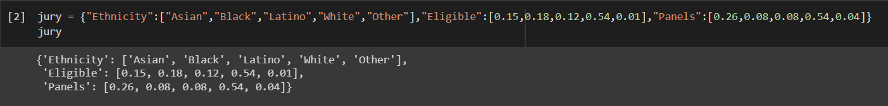

1. Converting into dataframe

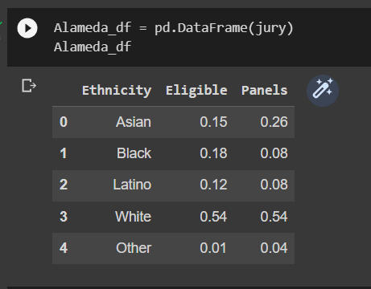

1. Ethnicity making as the index

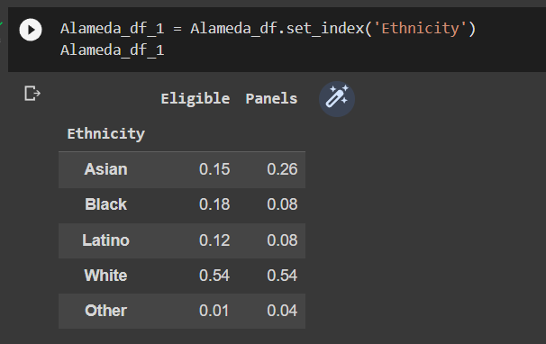

1. Ploting the Bar graph X-axis(Eligible,Panels) and Y-axis(Ethnicity)

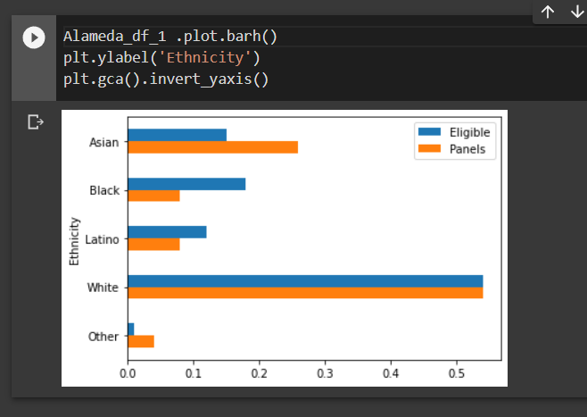

1. Finding difference b/w Panels and Eligible (as “jury_with_diffs”)

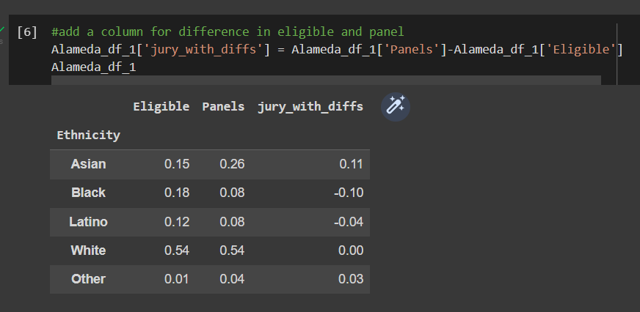

1. Before find out the difference b/w Panels and Eligible making as the absolute.

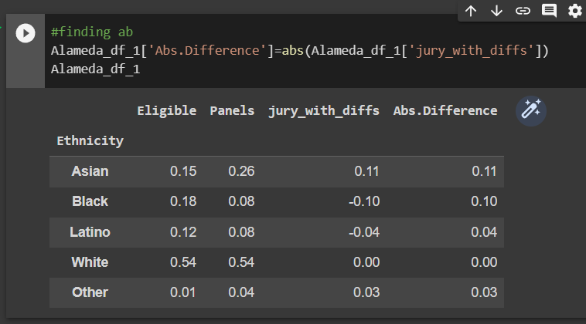

1. Find the avg of the abs.difference

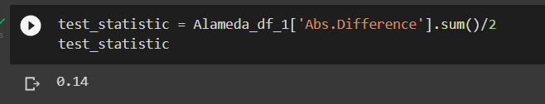

1. Finding out the variation distance b/w Eligible and Panels

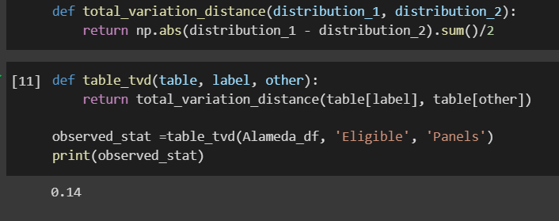

1. The total bias is the sum of the positive and negatives,hence we perform the abs fuction,but this adds twice so,we divide by half which is 0.14

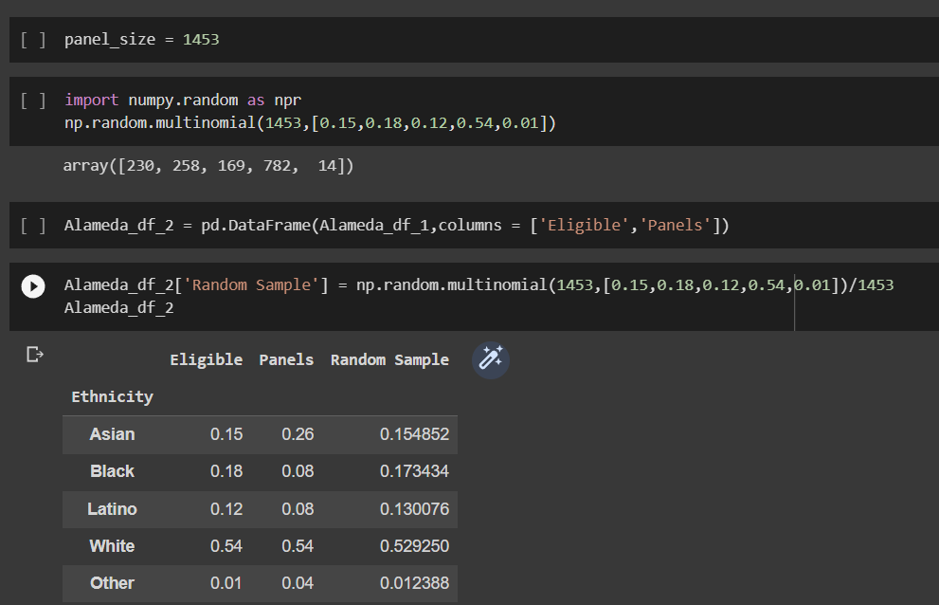

1. The green bar are closer in size to the blue bars than the orange bars are. The random sample resembles the eligible population, but the panels don't.

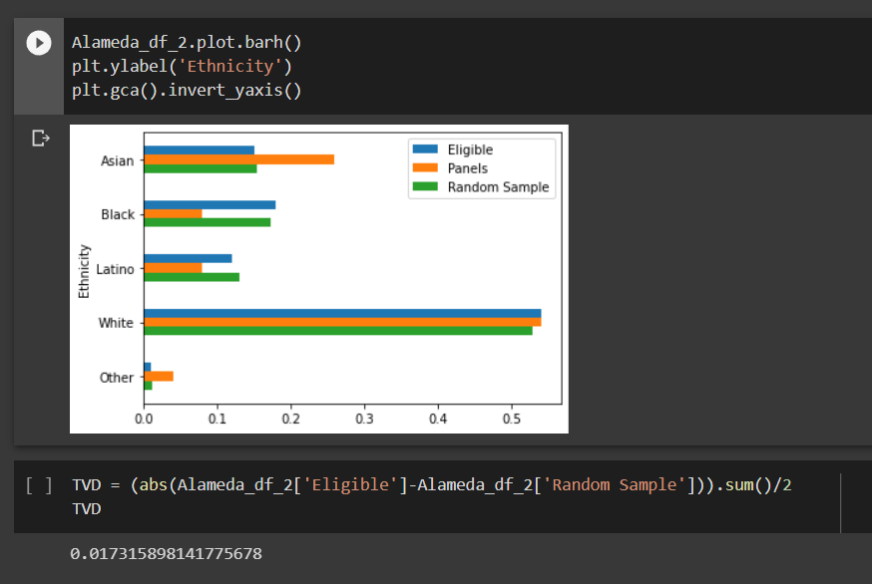

1. The Total variation distance(TVD) between the eligible population and the panels was 0.14, but the TVD between the eligible population and the random sample is much smaller.

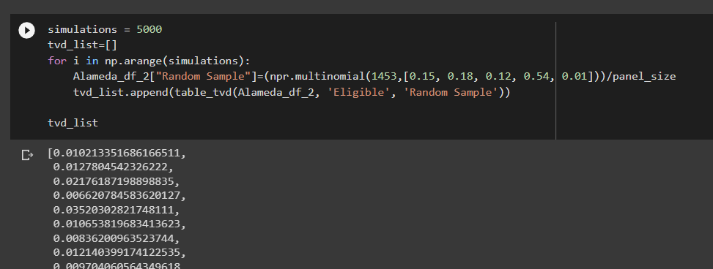

1. The empirical histogram plotted above of the simulated distances. Distribution that does not exceed the eligible jurors distribution by more than 0.059085. The Total variation distance(TVD) between the eligible population and the panels was 0.14, but the TVD between the eligible population and the random sample is much smaller. the Panels were not representative of the distribution provided for the eligible jurors. Hence, Null hypothesis is rejected.

