**Theory:**

**Generator:-**

A.C. Generatormeans Alternating current generator. It is a

device which is used to convert mechanical energy into

electrical energy.

A.C. generator forces electric current to flow through an

external circuit. The source of mechanical energy may be a

reciprocating or turbine steam engine, water falling through

a turbine or waterwheel, an internal combustion engine,

a wind turbine, a hand crank, compressed air ,or any other

source of mechanical energy.

It is based on the principle **of electro magnetic**

**induction**, i.e., whenever amount of magnetic flux

linked with a coil changes, an e.m.f. is induced in the

coil. The direction of current induced is given by

Fleming’s right hand rule.

The A.C. Generator is consist of four main parts :

**(1) THE COIL (ARMATURE) :**

A rectangular coil ABCD consist of a large number

of turns of copper bound over a soft iron core is called

armature. The soft iron core is used to increase the magnetic

flux.

**(2) MAGNETIC FIELD :**

It is usually a permanent sponge magnet having concave

poles. The armature is rotated of a magnet so that axis of the

armature is perpendicular to magnetic field lines.

**(3) SLIP RINGS :**

Slip rings are the magnetic rings which are connected

in the terminal of the armature. These rings are rotated

with the coil and these are use to draw the current from

the generator.

**(4) BRUSHES :**

The brushes B1 & B2 are just touch the slip rings. They are

not rotating with the coil and these brushes leads to the

output of load resistance.

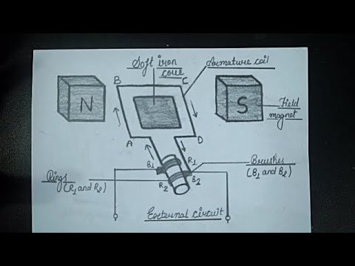

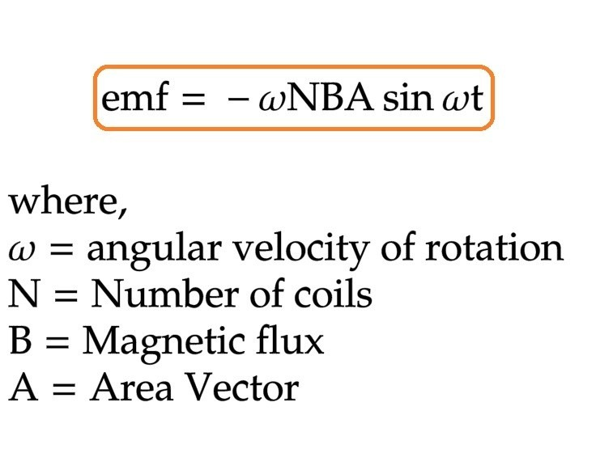

**Potentiometer:-**

Potentiometer is a device used to compare the e.m.f. (electromotive force) of two cells, to measure the internal resistance of a cell, and potential difference across a resistor. It consists of a long wire of uniform cross-sectional area and of 10 m in length. The material of wire should have a high resistivity and low temperature coefficient.  The wires are stretched parallel to each other on a wooden board. The wires are joined in series by using thick copper strips. A metre scale is also attached on the wooden board.

The potentiometer works on the principle that when a constant current flows through a wire of uniform cross sectional area, potential difference between its two points is directly proportional to the length of the wire between the two points.

**Electromotive force (e.m.f) of a cell**

http://amrita.olabs.edu.in/userfiles/1/1513335848_comparisonemf_theory1.pngElectromotive force (emf) is a measurement of the energy that causes current to flow through a circuit.  It is the energy provided by a cell or battery per coulomb of charge passing through it. It can also be defined as the potential difference across the terminals of a cell, when no current flows through it. Electromotive force is also known as voltage, and it is measured in volts. Electromotive force is not truly a force; rather, it is a measurement of energy per unit charge.

where E is the energy and Q is the charge.

Using a potentiometer, we can determine the emf of a cell by obtaining the balancing length l.  Here, the fall of potential along the length l of the potentiometer wire is equal to the emf of the cell, as no current is being drawn from the cell.

Then,

http://amrita.olabs.edu.in/userfiles/1/1513335858_comparisonemf_theory2.png    or,   http://amrita.olabs.edu.in/userfiles/1/1513335869_comparisonemf_theory3.png ;

where k is the potential gradient along the wire.

Thus it is possible to compare the emf’s of two given cells by measuring the respective balancing lengths l1 and l2.

ie;                            http://amrita.olabs.edu.in/userfiles/1/1513335880_comparisonemf_theory4.png           and       http://amrita.olabs.edu.in/userfiles/1/1513335891_comparisonemf_theory5.png

http://amrita.olabs.edu.in/userfiles/1/1513335903_comparisonemf_theory6.pngor

The relation between potential difference, EMF, and internal resistance of a cell is given by

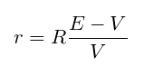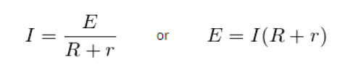

## The internal resistance of the cell is given by

## Circuit Diagram

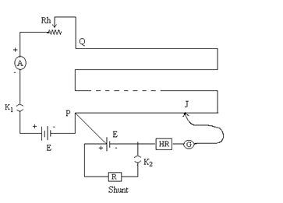

Determine The Internal Resistance Of A Given Primary Cell Using A Potentiometer-5

**Working:-**

**Generator:-**

1.The strong magnetic field is produced by a current flow through the

field coil of the rotor.

2. The field coil in the rotor receives excitation through the

use of slip rings and brushes.

3. Two brushes are spring-held in contact with the slip rings to provide the

continuous connection between the field coil and external circuit.

4. The armature is contained within the windings of the stator and is

connected to the output.

5. Each time the rotor makes one complete revolution, one complete

cycle of AC is developed.

6. A generator has many turns of wire wound into the slots of the rotor.

7. The magnitude of AC voltage generated by an AC generator is

dependent on the field strength and speed of the rotor.

8. Most generators are operated at a constant speed; therefore, the

generated voltage depends on field excitation, or strength.

***Working of an A.C. Generator***

The coil is rotated in anti-clock wise direction. In the first

half rotation the arm AB is moving outward and CD is

moving inward. So the e.m.f. is induced in the arm AB

from A to B. And in the arm CD from C to D. After half

rotation (in the second half). The arm CD is moving

outward and AB is moving inward. In this time current is

induced in arm CD from D to C. And in arm AB from B to

A. In the second half rotation the current direction is

changing so in this generator AC is produced.

**In this simulation ;**

* This HTML5 app simulates a generator which is reduced to the most important parts for clarity. Instead of an armature with many windings and iron nucleus there is only a single rectangular conductor loop; the axis the loop rotates on is omitted.
* The radio buttons in the top right corner allow you to choose an AC generator (without commutator), or a DC generator (with commutator).

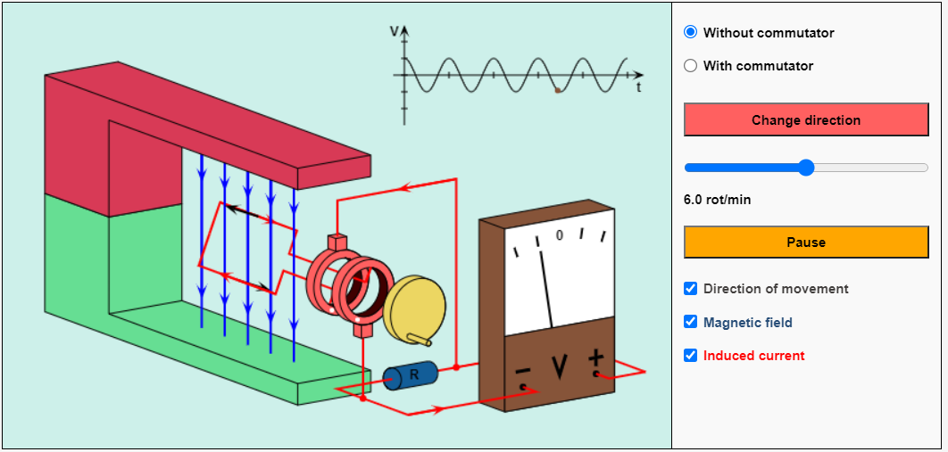

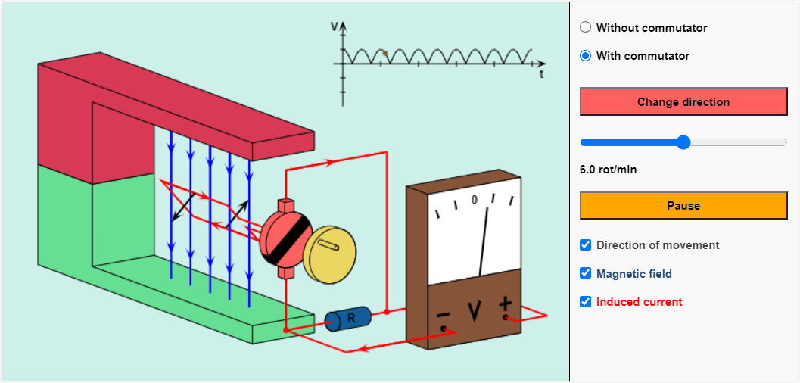

* You can change the direction of rotation by using the corresponding button.
* You can stop and continue the simulation with the button "Pause / Resume".This, however, does *not* mean a real stop of the movement, for in this case the induced voltage would be reduced to zero.
* Two black arrows mark the momentary direction of movement.You can recognize the magnetic field lines (directed from the red painted north pole to the green painted south pole) by the blue color.
* The red arrows represent the direction of the induced current (conventional direction of current).

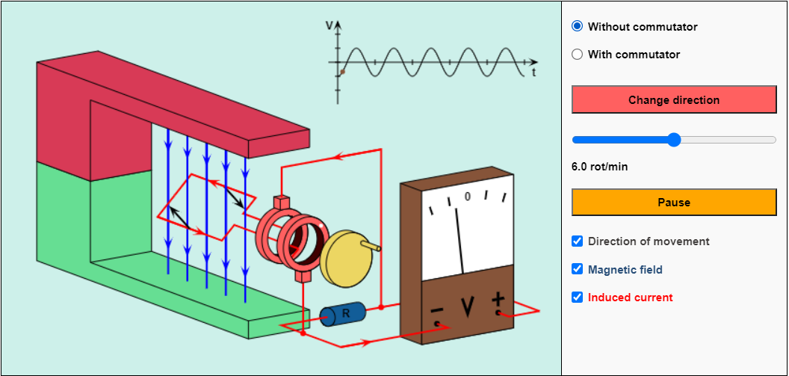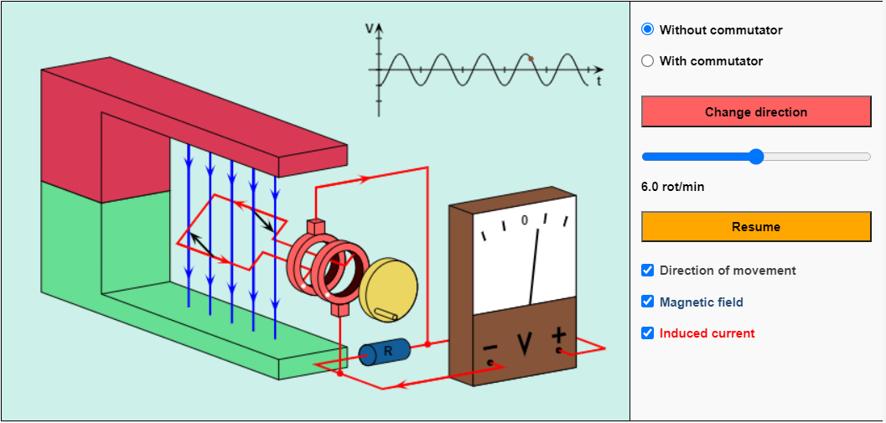

**Potentiometer:-**

A potentiometer is a [passive electronic component](https://www.electrical4u.com/active-and-passive-elements-of-electrical-circuit/). Potentiometers work by varying the position of a sliding contact across a uniform resistance. In a potentiometer, the entire input [voltage](https://www.electrical4u.com/voltage-or-electric-potential-difference/) is applied across the whole length of the [resistor](https://www.electrical4u.com/what-is-resistor/), and the output voltage is the voltage drop between the fixed and sliding contact as shown below.

A potentiometer has the two terminals of the input source fixed to the end of the resistor. To adjust the output voltage the sliding contact gets moved along the resistor on the output side.

This is different to a [rheostat](https://www.electrical4u.com/materials-used-for-rheostats/), where here one end is fixed and the sliding terminal is connected to the circuit, as shown below.

This is a very basic instrument used for comparing the emf of two cells and for calibrating [ammeter](https://www.electrical4u.com/ammeter/), voltmeter, and watt-meter. The basic **working principle of a potentiometer** is quite simple. Suppose we have connected two batteries in parallel through a galvanometer. The negative battery terminals are connected together and positive battery terminals are also connected together through a galvanometer as shown in the figure below.

Here, if the [electric potential](https://www.electrical4u.com/voltage-or-electric-potential-difference/) of both battery cells is exactly the same, there is no circulating [current](https://www.electrical4u.com/electric-current-and-theory-of-electricity/) in the circuit and hence the galvanometer shows null deflection. The **working principle of potentiometer** depends upon this phenomenon.

Now let’s think about another circuit, where a [battery](https://www.electrical4u.com/battery-working-principle-of-batteries/) is connected across a resistor via a switch and a rheostat as shown in the figure below.

The resistor has the uniform [electrical resistance](https://www.electrical4u.com/what-is-electrical-resistance/) per unit length throughout its length.  
Hence, the voltage drop per unit length of the resistor is equal throughout its length. Suppose, by adjusting the rheostat we get v volt voltage drop appearing per unit length of the resistor.

Now, the positive terminal of a standard cell is connected to point A on the resistor and the negative terminal of the same is connected with a galvanometer. The other end of the galvanometer is in contact with the resistor via a sliding contact as shown in the figure above. By adjusting this sliding end, a point like B is found where there is no current through the galvanometer, hence no deflection in the galvanometer.

That means, emf of the standard cell is just balanced by the voltage appearing in the resistor across points A and B. Now if the distance between points A and B is L, then we can write emf of standard cell E = Lv volt.

This is how a potentiometer measures the voltage between two points (here between A and B) without taking any current component from the circuit. This is the specialty of a potentiometer, it can measure voltage most accurately.