AIASSISTEDCODINGASS–14.1

2303A51838
B-27

Task1–PortfolioWebsiteDesign
Youarebuildingapersonalportfoliowebsiteto showcaseyourwork.

Requirements:
CreatesectionsforAboutMe,Projects,andContact.

UseAI to:
- Suggestcolorpalettesand typography.
- CreatearesponsivelayoutwithGrid/Flexbox.
- Addsmoothscrollingnavigation.

CODE:
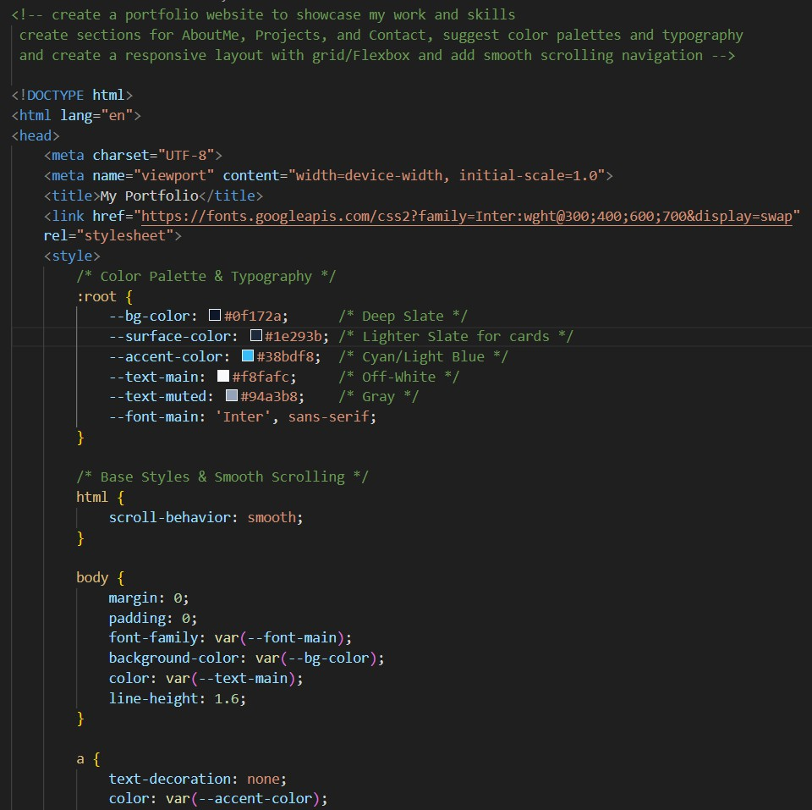

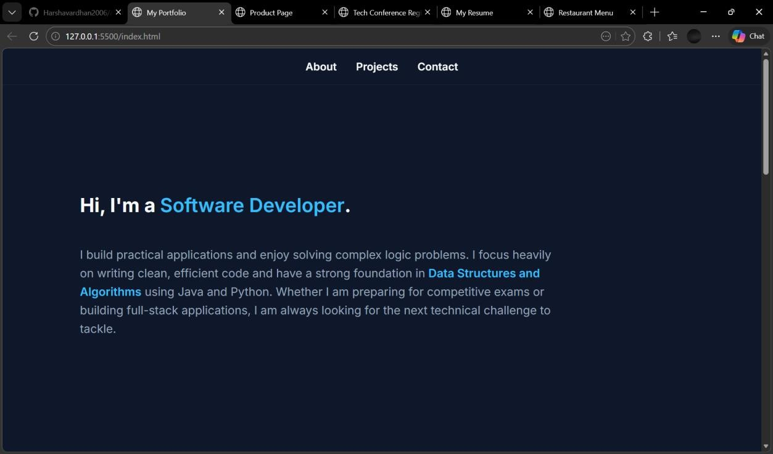
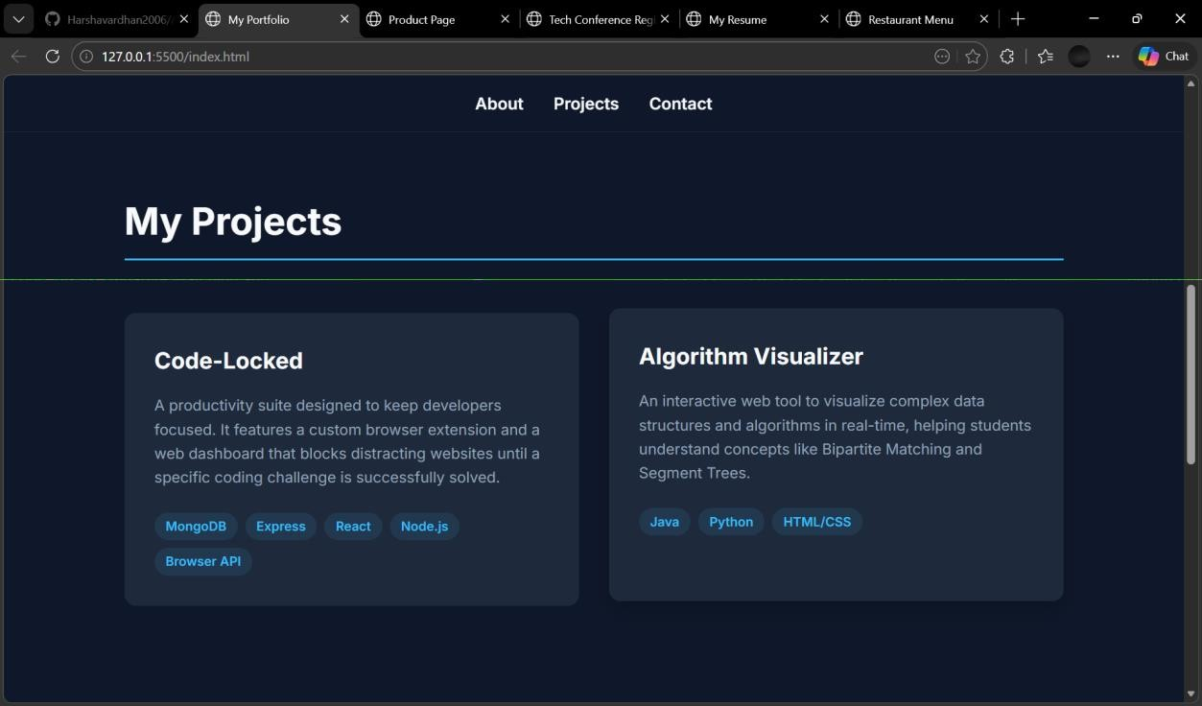

Designaproductdisplaypagefor anonline store.

Requirements:
Displayproductimage,title,price,and "AddtoCart"button.

UseAI to:
- StylewithBEMmethodology.
- Makelayoutresponsive.
- Addhovereffectsand"AddtoCart"alert.

CODE:
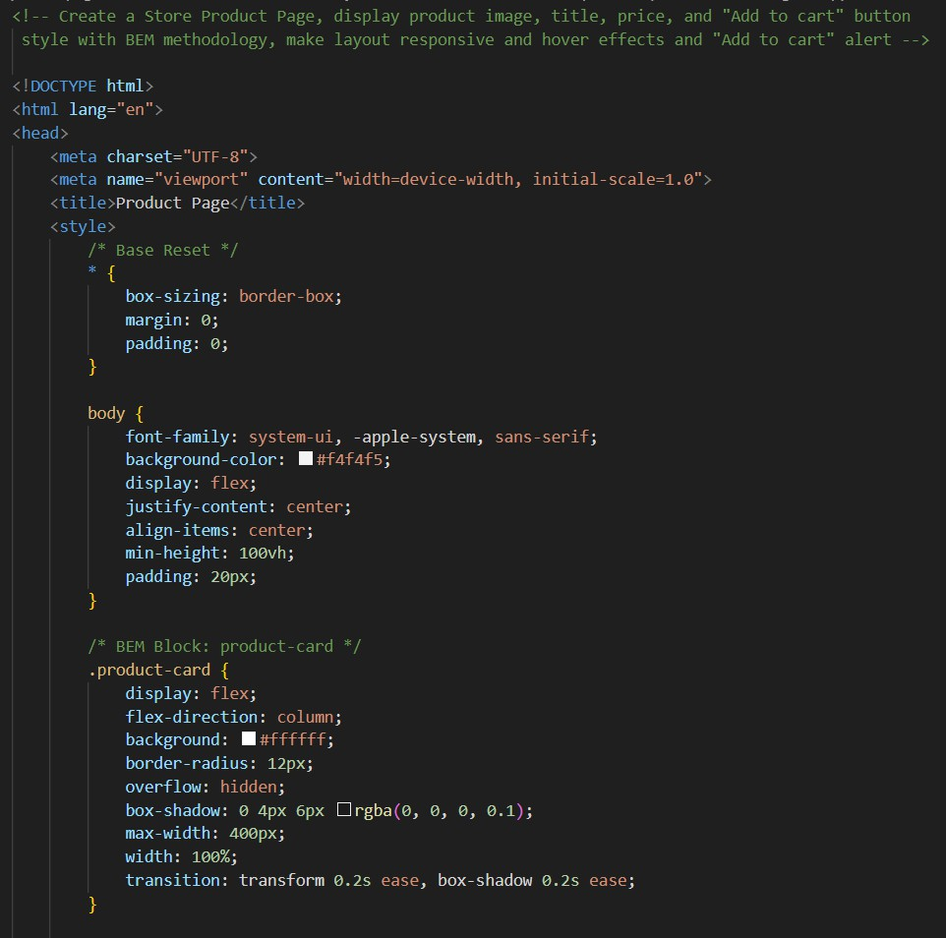

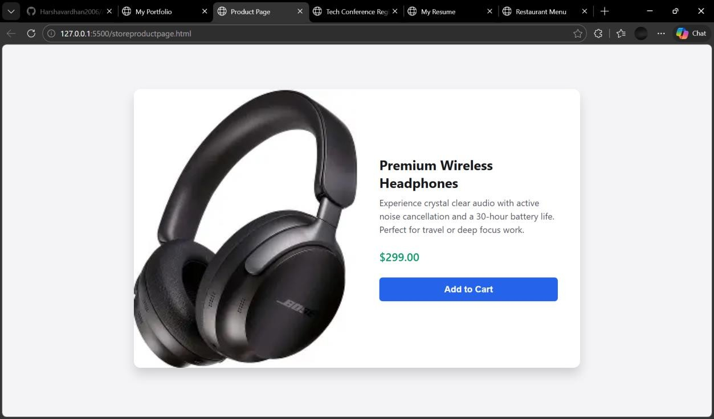

Task3–EventRegistrationForm
Buildaneventregistrationformfor a conference.

Requirements:
Collectname,email,phonenumber,andsessionselection.

UseAI to:
- AddformvalidationwithJavaScript.
- MaketheformaccessiblewithlabelsandARIA.
- Stylewithaprofessionallook

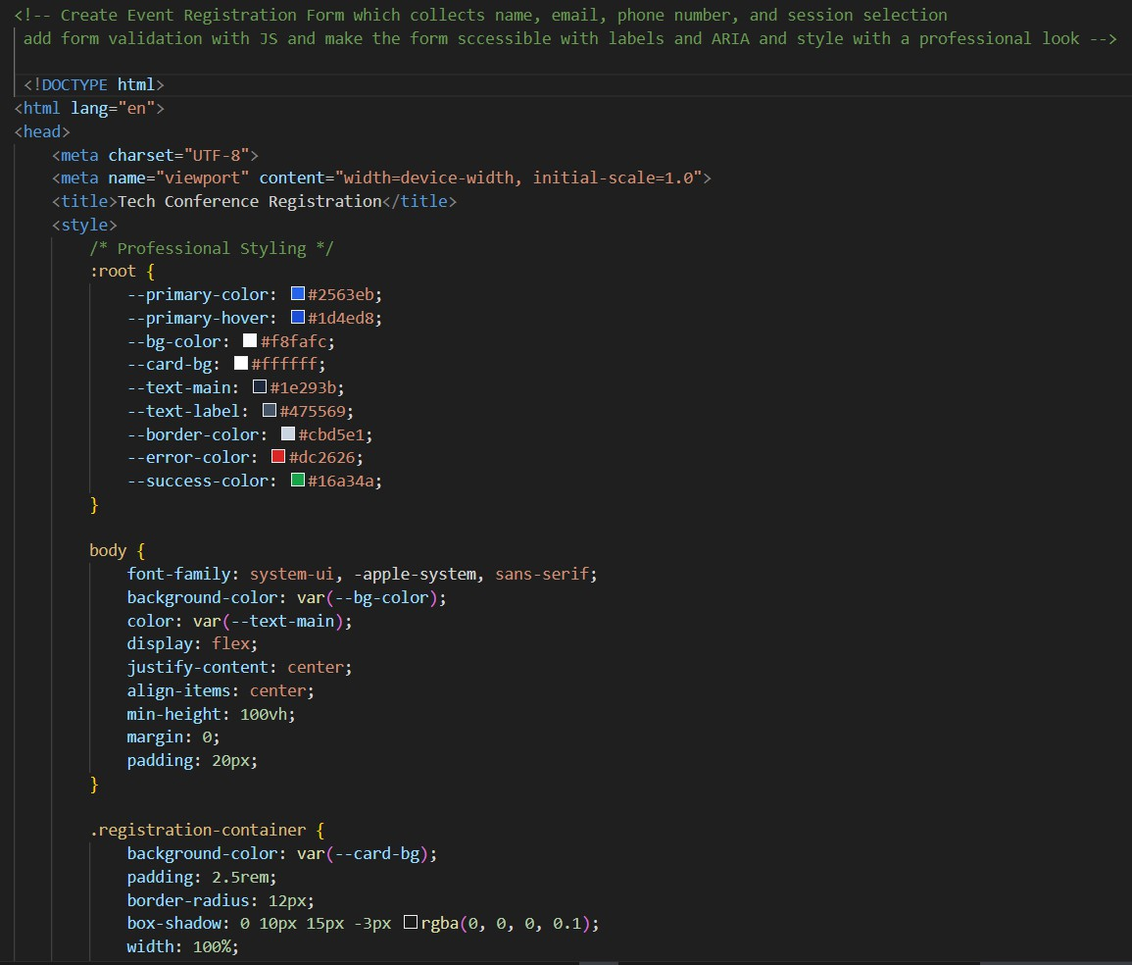

Output:
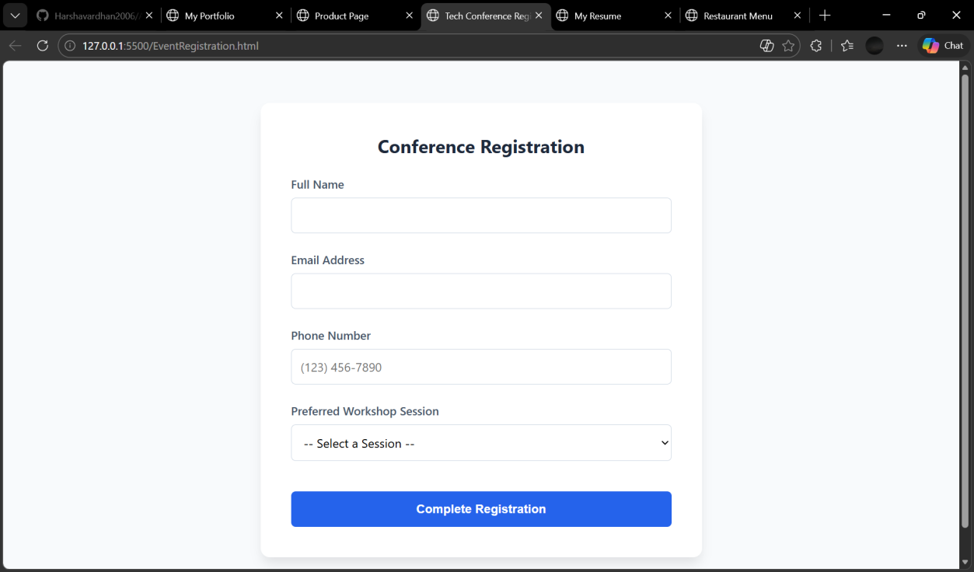

Buildaone-pageonlineresume.

Requirements:
Sections:ProfileSummary,Skills,Education,Experience.

UseAI to:
- Proposeprofessionaltypographystyles.
- AlignsectionsusingCSSGrid.
- Add smoothscrollnavigationbetweensections.

CODE:
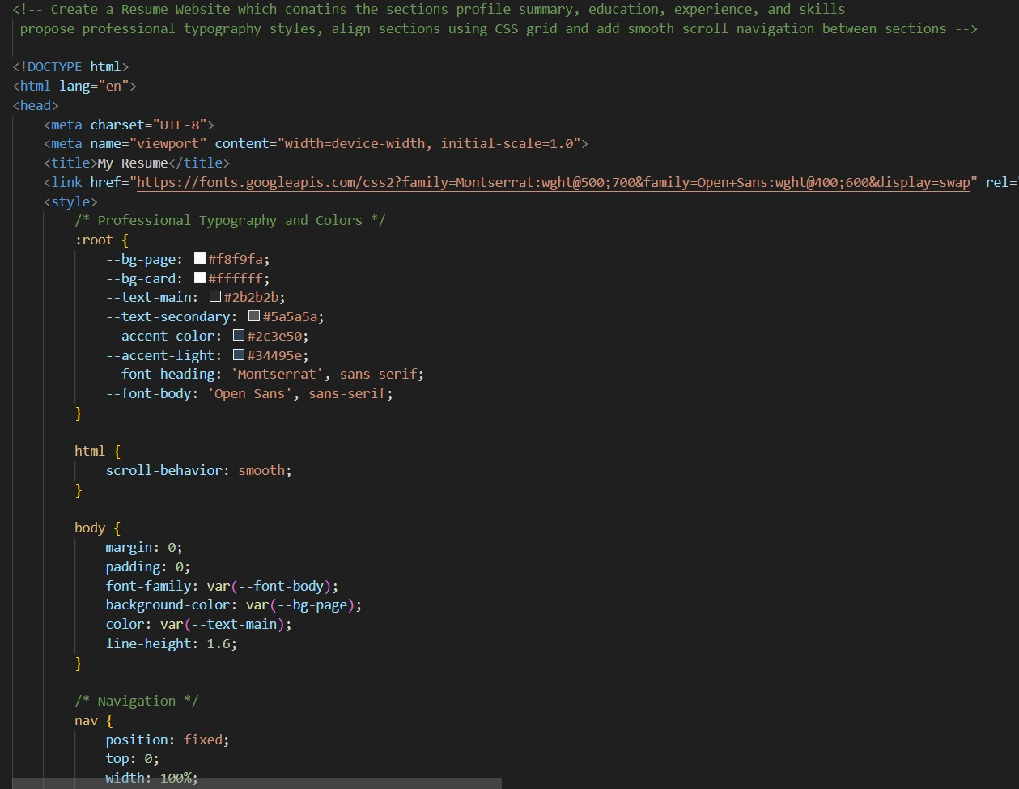

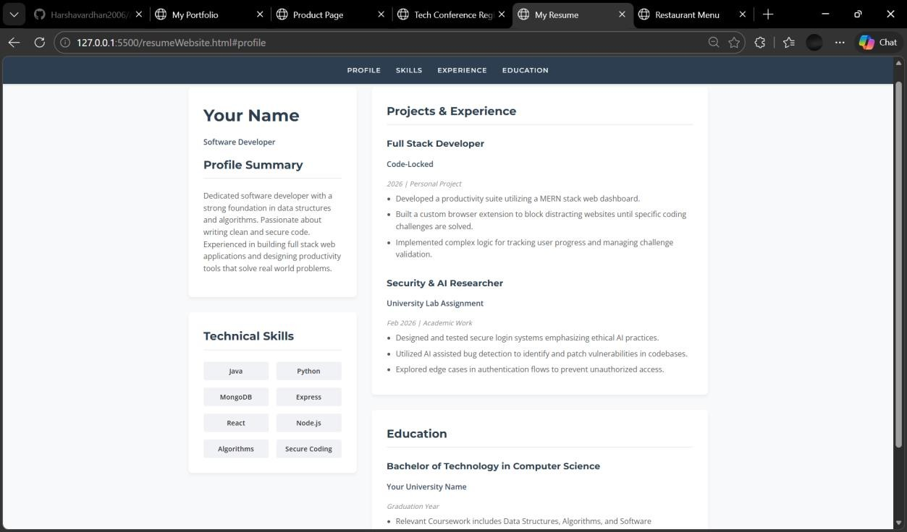

Task5–RestaurantMenuPage
Designadigitalmenupageforarestaurant.

Requirements:
Displaymenu itemswithname,description,andprice.

UseAI to:
- Suggestafood-friendlycolor palette.
- Designaresponsivecard-basedlayout.
- Add hovereffectsonmenuitems.

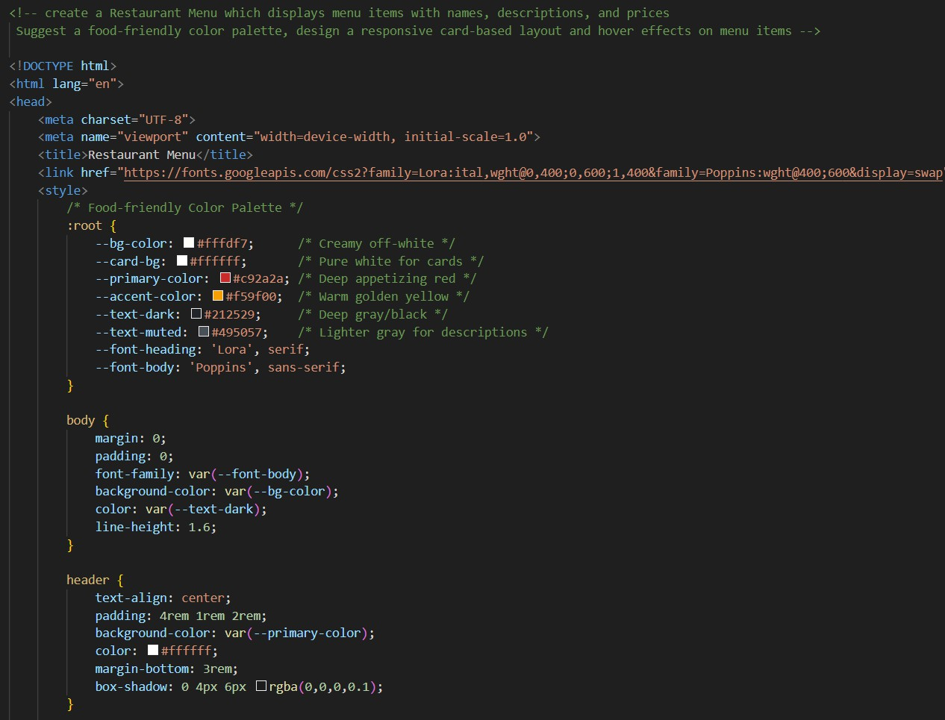

Output:
