WD_MODULE: 1 ( HTML )

- Are the HTML tags and elements the same thing?

- No, HTML tags & HTML elements are not the same thing. HTML tags indicate beginning and ending of an HTML element in an HTML document & HTML elements are everything from start tag to the end tag.
Ex.
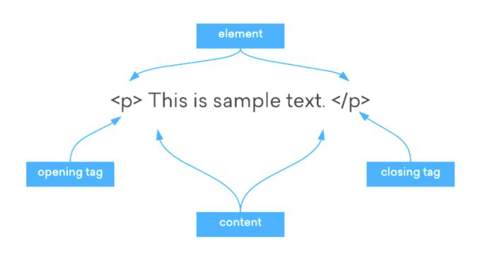

- What are tags and attributes in HTML?

- HTML tags are text which we have to write between angular brackets “<__>”.

- HTML tags do not display in the final page of the webpage. The tags provide the name of the HTML elements, usually an abbreviation.
Ex. “<h1>” = Heading level 1 or “<em>” = Emphasised text

- HTML attributes provide additional information about HTML elements. Attributes are always specified in the start tag.

Ex. <input type=“__”> in this example type is an attribute.

- What are void elements in HTML?

- Void elements are tags which we do not have to close. They are self close tags. Ex. <br> , <hr> , <link> , <img> , etc.

- What are HTML Entities?

- There are so many characters in HTML which are reserved, like “<”, “>”, “ ”[space], they have some meaning in HTML already. So we have to replace those characters with character entities.
- If you use the less than (<) or greater than (>) signs in your text, the browser might mix them with tags.
Ex. &nbsp = Non-breaking space, &lt = Less than, &gt = Greater than, etc.

- What are different types of lists in HTML?

➢ There are three different types of lists in HTML.

  - Ordered List [ <ol>__</ol> ]

  - Unordered list [ <ul>__</ul> ]

  - Description List [ <dl>__<dt>_</dt><dd>_</dd>_</dl>]

- What is the ‘class’ attribute in HTML?

- The HTML class attribute is used to specify a class for an HTML element.

- Multiple HTML elements can share the same class.

- What is the difference between the ‘id’ attribute and the ‘class’ attribute of HTML elements?

- There is no functional difference between the ‘id’ and the ‘class’ attribute.

- But the difference is, we can give each element a ‘id’ but we can share a ‘class’ to multiple elements.
- ID name starts with the “#” symbol followed by a unique name assigned to it. On the other hand, the class assigned to an element has its name starts with “.” followed by the class name.

- What are the various formatting tags in HTML?

- There are many formatting tags in HTML, each for different formations in text to make it more attractive.
1. | <b> |  |  | Bold
2. | <strong> |  | Strong
3. | <i> |  |  | Italic
4. | <em> |  | Emphasised
5. | <mark>
 |  |  |  | Mark
6. | <strike> |  | Strike
7. | <del> |  |  | Delet
8. | <sub> & <sup> |  | Sub_{script} & Super^{script}
9. | <u> & <ins> |  | Underline & Inserted
10. | <h1> to <h6> |  | Heading Tags

- How is Cell Padding different from Cell Spacing?

- Cellpadding basically defines the space present between a table cell's border and the content present in it. Cellspacing basically defines the space present between individual adjacent cells.
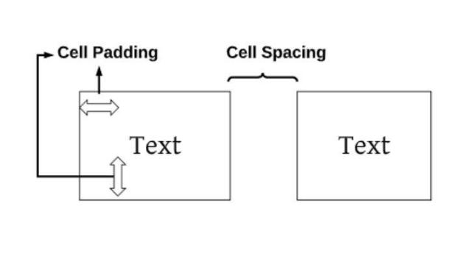

- How can we club two or more rows or columns into a single row or column in an HTML table?

- To club/merge two or more rows or columns into single row or column we use ‘ rowspan=“_” ’ and ‘ colspan=“_” ’ attributes in “ <li> ” tag and we just have to put number in blank space that many rows or columns we have to club/merge.

- What is the difference between a block-level element and an inline element?

➢ Block level element can contain the whole space of your screen resolution width and cover its content in it.

➢ Inline elements do not contain the whole space of screen resolution width, it just takes only that much space which you use for your content.
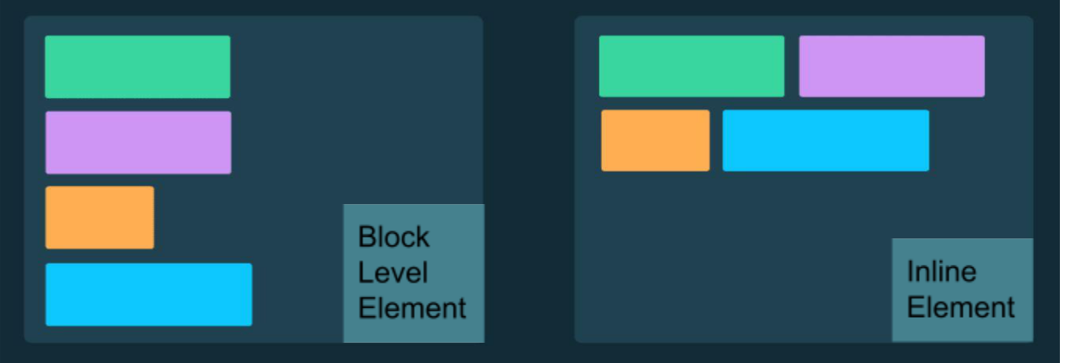

- How to create a Hyperlink in HTML?

- To make a hyperlink in an HTML page, use the <a> and </a> tags, which are the tags used to define the links. The <a> tag indicates where the hyperlink starts and the </a> tag indicates where it ends. Whatever text gets added inside
these tags, will work as a hyperlink. Add the URL for the link in the <a href=“ ”>.
- A link does not have to be text. A link can be an image or any other HTML element!

- What is the use of an iframe tag?

- An HTML iframe is used to display a web-page or some other frame within a web page.
- Iframe is being used as a frame tag before HTML5 , but for HTML5 we have to put an iframe tag to put another frame into the mainframe.
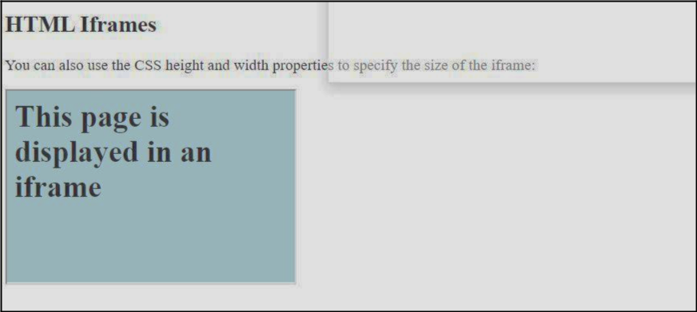

- To use of iframe : <iframe src= “_” style= “_”></iframe>

- What is the use of a span tag? Explain with an example?

- The <span> tag is an inline container used to mark up a part of a text, or a part of a document.
- The <span> tag is easily styled by CSS or manipulated with JavaScript using the class or id attribute.

- The <span> tag is much like the <div> element, but <div> is a block-level element and <span> is an inline element.
Ex.

CODE:

PREVIEW:

- How to insert a picture into a background image of a web page?

- For inserting a picture into a background image of a web page we have to use CSS, basically <style> tag and ‘background-image’ property.
- Images must be in JPG, PNG, PNG, or GIf type of graphic for better use.
- How are active links different from normal links?

➢ There are three main type of links in HTML5.

  - Active link

  - Unvisited link / Normal link

  - Visited link

  - Active link: - Active link is when we open a link once in the browser it is set to be open and remains open. Then the colour of the link name is changed into Red [by default] and remains like that.
    - When we put our mouse on the link and focus on it then a normal link turns into an active link.
  - Normal Link: - When we put a link via <a> tag in HTML and run it in the browser it appears in blue colour with underline. This is called a normal link.

- What are the different tags to separate sections of text?

- There are few tags being used for separation of sections of text.

  - <br> : - ‘br’ is usually used as a breaking tag.

  - <hr> : - ‘hr’ is a tag for horizontal lines. It adds a horizontal line between text.
  - <p> : - ‘p’ is a paragraph tag for the addition of a new paragraph in text.

  - <pre> : - ‘pre’ is the same as a paragraph tag but in a more refined way.

- What is SVG?

- SVG stands for ‘Scalable Vector Graphics’.

- SVG only works in HTML5.

- SVG is used to define graphics for the web.

- The HTML <svg> element is a container for SVG graphics.

- SVG has several methods for drawing paths, boxes, circles, text, and graphic images.
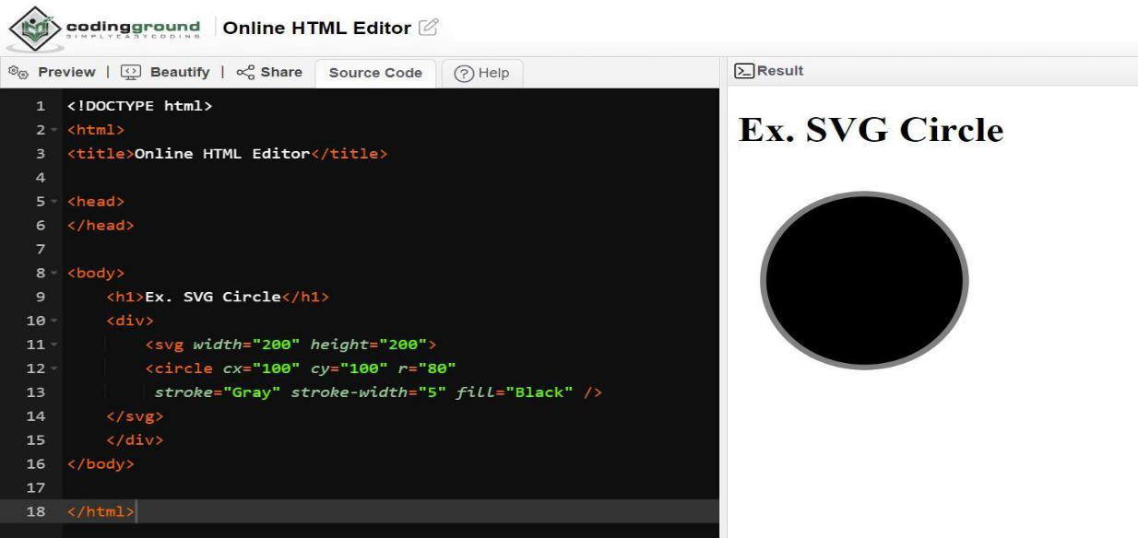
- What is the difference between HTML and XHTML?

- HTML is Hypertext Markup Language while XHTML is Extensible Hypertext Markup Language.
- HTML works on SGML [Standard Generalised Markup Language] application, where XHTML works on XML [Extensible Markup Language] application.
- HTML is not case sensitive but XHTML is Case sensitive.

- HTML is less expressive than XHTML.

- Compatibility of XHTML to browsers are more than HTML.

- XHTML has much more value for the rules than HTML.

- What are logical and physical tags in HTML?

➢ Physical Tags : -

  - Physical tags are used to decide the appearance of the text and do not provide any information about the text.
  - It is extremely straightforward.

  - Physical tags are used to style the content only. For instance, ‘<i>’ is used to display the text in italic format.
  - Page accessibility is comparatively low.

- Logical tags : -

  - Logical tags describe the behaviour, nature of content for the text enclosed inside the tag. They represent the function of text on the page.
  - It carries certain obligations.

  - Logical tags are used to provide information by giving special importance to the text. For instance, ‘<em>’ tag is used to emphasise the text by representing it in italic format.
  - Pages are more accessible.

“ The End ”

