HackTheBox Academy

Web Requests Module

Course name: Certified Junior Cybersecurity Associate

GET REQUEST

GET parameter is a key-value pair appended to a URL to send small amounts of data like search terms or settings to a web server.
In this task, we have to Use the browser devtools to see what is the request it is sending when we search, and use cURL to search for 'flag' and obtain the flag.

In order to do that first we have to power up a linux terminal, I use Kali Linux and spawn the HackTheBox target IP and port.

The Port and IP address: 154.57.164.67:31628

Once the target spawned, we will in our browser type the target in our search bar: http://154.57.164.67:31628
This will take us to the labs website where we have to input the valid credentials.
For this exercise HackTheBox provided us with the credentials: admin:admin

Once we logged in we see a search icon in the middle of the page and in order to obtain the flag we need a search.php?search=”flag” GET request.

Once we open Devtools we will go to the Network tab.
The Network tab in Devtools shows the requests a browser makes to the back end server (inclusing the websites back end services) and the response it receives.

We can search any city in the search bar, but we want to search for to obtain the flag is the word “flag”.
Then in the terminal we will type the following command:

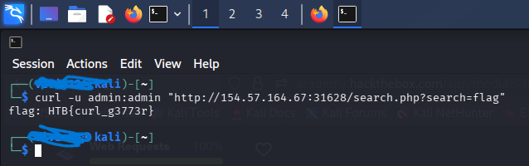

Command breakdown:

- curl – command line tool and library that primarily supports HTTP along with other protocols. It is used to transfer data to and from servers using various network protocols.

- -u – a flag used to provide the credentials through the cURL command.

- admin:admin – the credentials we provide the cURL.

- “http://154.57.164.67:31628” – our the lab website, that contains the IP and Port.

- search.php?search=”flag” – URL parameter.

