HackTheBox Academy

Web Requests Module

Course name: Certified Junior Cybersecurity Associate

POST REQUEST

POST request is a request that web applications utilize when they need to move the user parameters or transfer files from the URL.
The task that we have for this section is: Obtain a session cookie through a valid login, and then use the cookie with cURL to search for the flag through a JSON POST request to ‘/search.php’

We will first start by spawning the HackTheBox target IP and Port address: 154.57.164.72:30847
In the browser we will type the IP and Port into our browser to access the city search: http://154.57.164.72:30847

We will log in using the credentials provided: admin:admin.
To capture the cookie we can obtain it on the Network tab in DevTools.
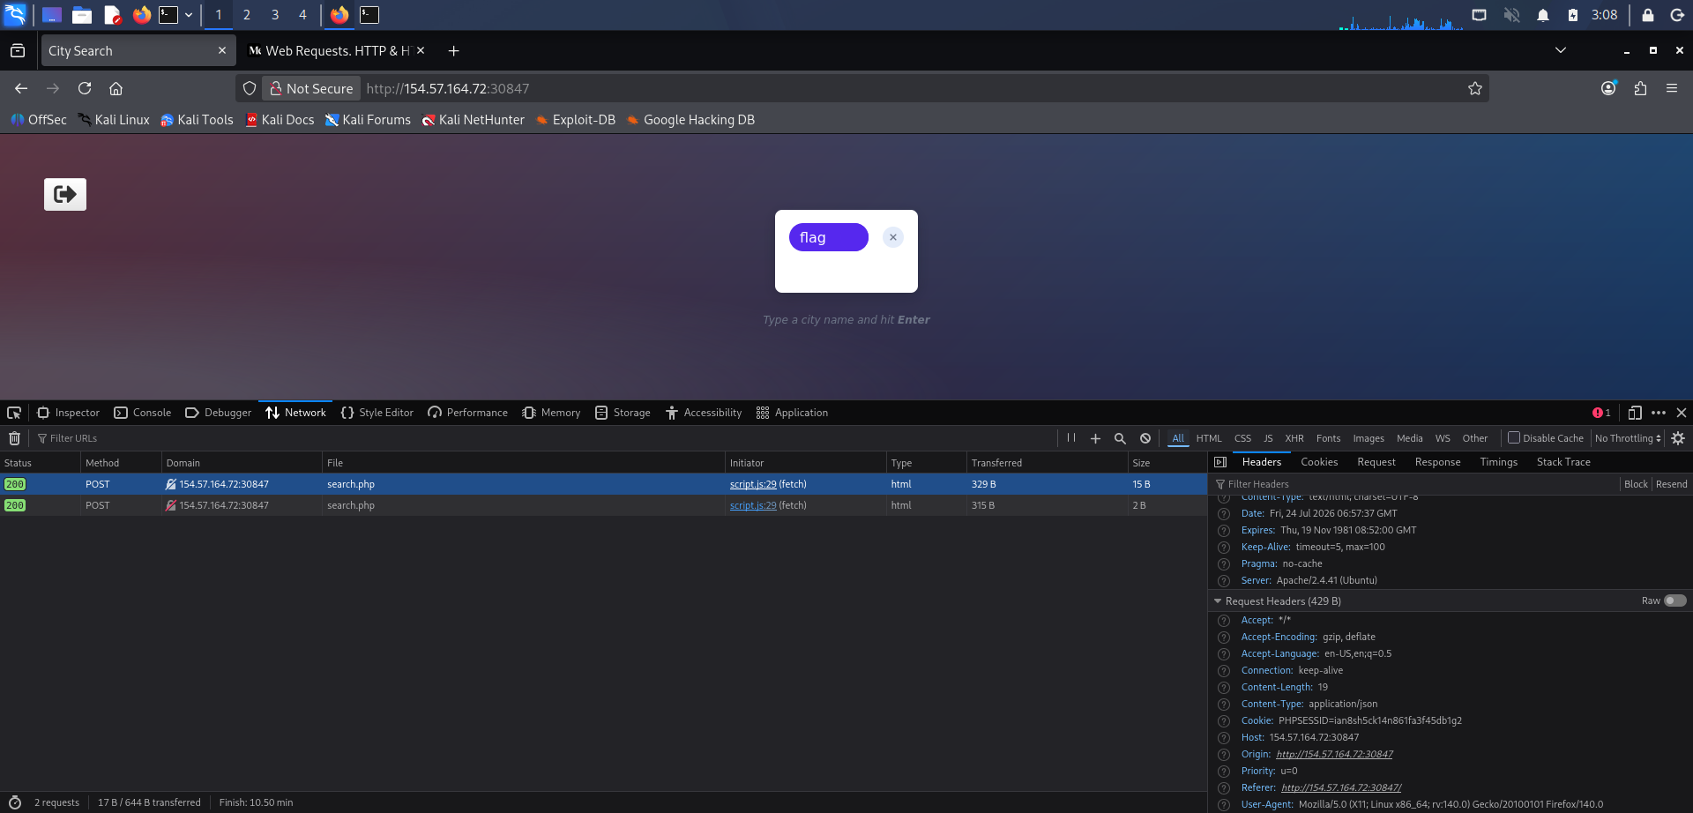
As we can see in the image, the cookie is: PHPSESSID=ian=8sh5ck14n861fa3f45db1g2

The next step is to type the command: curl -X POST -d ‘{“search”:”flag”}’ -b
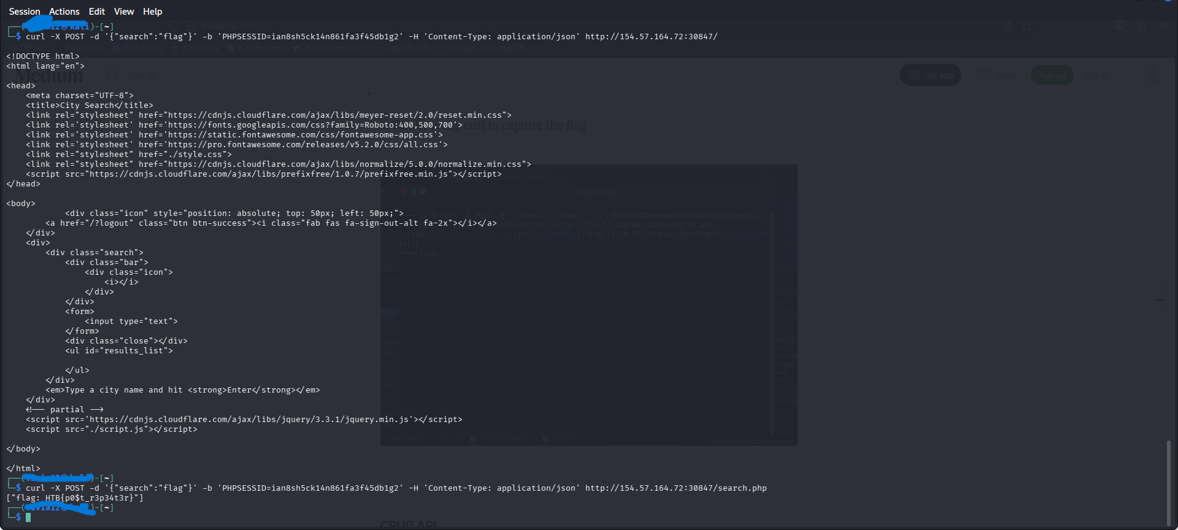
‘PHPSESSID=ian=8sh5ck14n861fa3f45db1g2’ -H ‘Content-Type: application/json’ http://154.57.164.72:30847/search.php

once we execute the command we get the flag.
Command breakdown:
- curl - command line tool and library that primarily supports HTTP along with other protocols. It is used to transfer data to and from servers using various network protocols.
- -X POST – flag, that is used to send the request.
- -d ‘{“search”:”flag”}’ – sends data in the request body, here JSON object contains the search value “flag”.
- ‘PHPSESSID=ian=8sh5ck14n861fa3f45db1g2’ – session cookie.
- -H ‘Content-Type: application/json’ – adds header telling the server that the request body is JSON format.
- http://154.57.164.72:30847/search.php – endpoint receiving and processing the request.

