HackTheBox Academy

Module: Windows Fundamentals

Course: Junior Cybersecurity Associate

Skills Summary in Windows Fundamentals.

This section is a summary of everything I learned from the Windows Fundamentals module. It contained 14 sections, teaching the basics of navigating Windows permissions and some PowerShell commands.

1. The most common task I was completing in order to get access to HackTheBox’s lab network is connecting to VPN and using the Remote Desktop Protocol (RDP)
- RDP uses a client/server architecture, where clients side application is used to specify a computers target IP address or a hostname over a network where RPD access is considered the server.
- The default port RDP listens to is 3389.
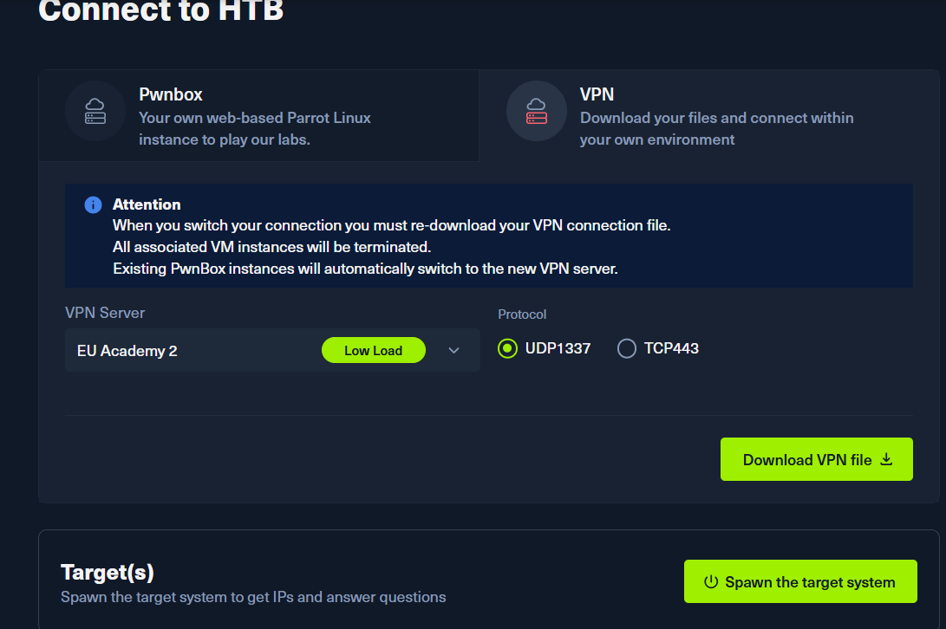
In order to connect to it, I first downloaded a VPN, HackTheBox offers in the bottom of the sections, so you can use your own workspace and not the browser built workspace.
After downloading the VPN and spawning the target IP address, I powered up my Kali Linux terminal and used a command: sudo openvpn <the vpn file name>.ovpn
As the VPN connects to HackTheBox lab network, if successful we will see a message displayed: Initialization Sequence Completed

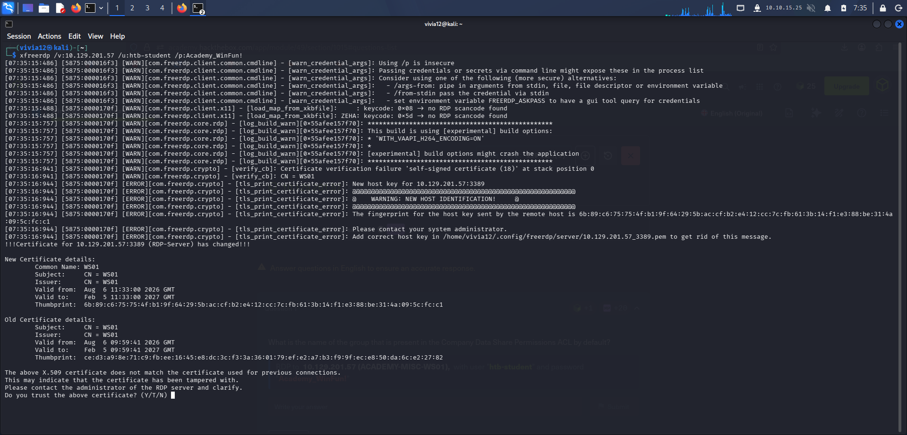
In the image above we see that, we are using a remote desktop protocol to log into the windows target.
The command we used is: xfreerdp /v:10.129.201.57 /u:htb-student /p:Academy_WinFun!
/v:10.129.201.57 – the target IP address
/u:htb-student - username
/p:Academy_WinFun! – password
At the very bottom we see a ‘Do you trust the above certificate? (Y/T/N)”, and since this was provided by a learning platform we just type “Y” meaning “Yes” and with that we have successfully reached the destination computer.

2. Another task that I had is: List the SID associated with the user account Jim you created.
In order to create a new user, first we had to go to: Computer Management.
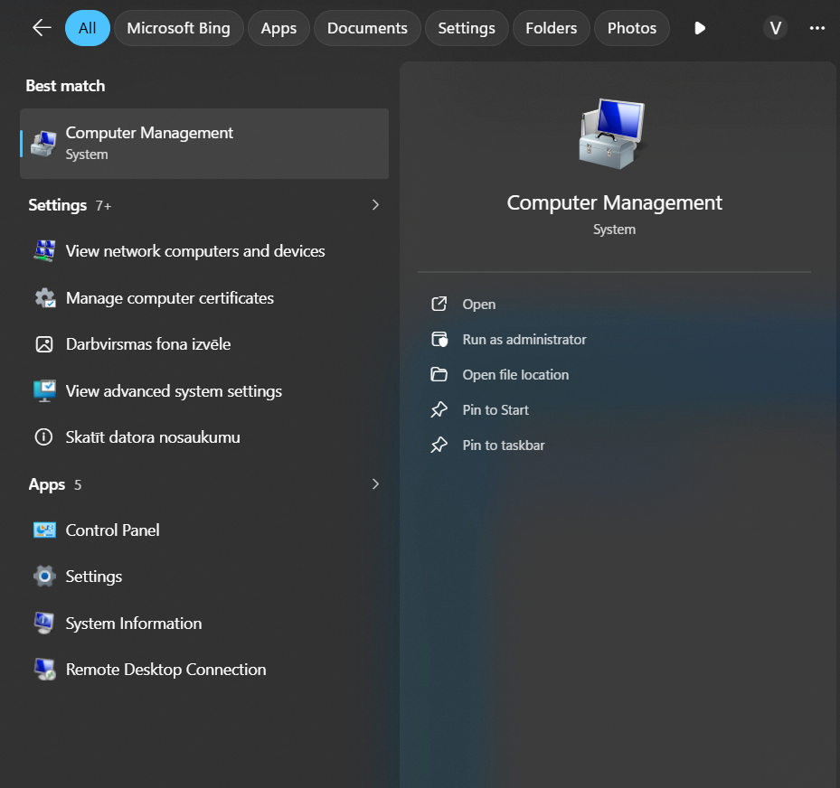
The reason we are opening Computer Management, it is because the task asked that the user not change his password at logon.

We will go to the Local Users and Groups section and then right click → choose New User.
A window will pop up there we insert name “Jim” and check the User not change password at next logon.
With that we have create a new user.

The next part of the task was involved using the Windows PowerShell command to list this new users SID.
An SID or Security Identifier is a automatically generated unique string of values, that are stored in the security database.
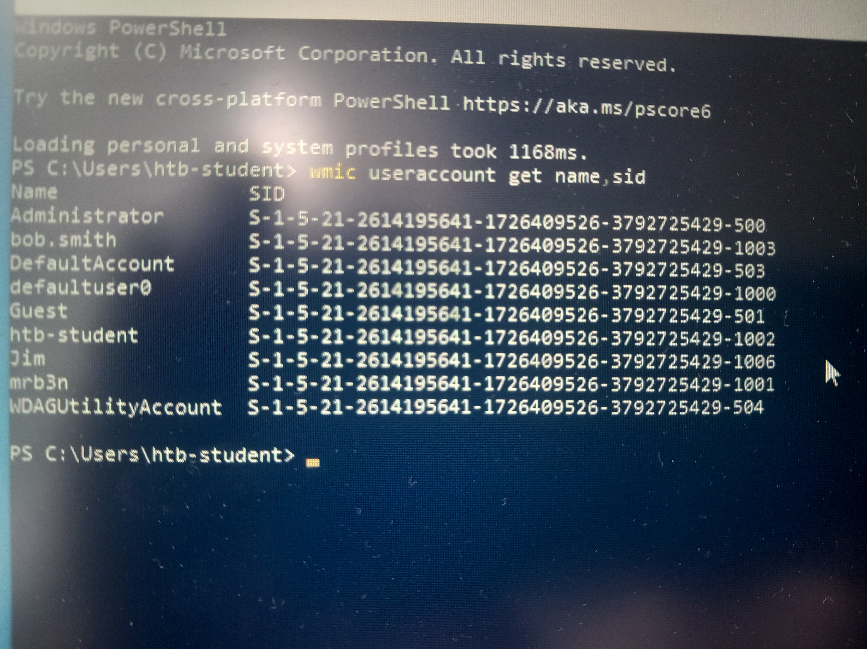
With the command: wmic useraccount get name,sid the command outputs the unique security identifier of all users.

The similar steps can be done to output the groups SID.
In the same section Local Users and Groups, this time we head to Groups section.
By right-clicking again, and selecting New Group, we get a window pop up to create the group.
Once we create the group, we can move users to that specific group and also output the SID of the group.
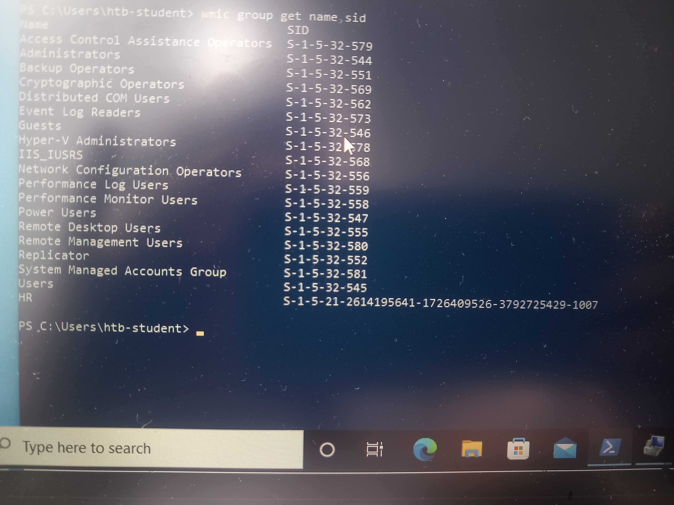
The command: wmic group get name,sid
It outputs the SID of the groups.

