HackTheBox Academy

Module: Network Enumeration with Nmap

Summary

Network Enumeration – What is it?

Enumeration is a process attackers use to connect to the target network or system to then gather information like open ports, usernames and system configurations.

One of most common enumeration tools attackers use is Nmap, which will be explained in this write up.

What is Nmap?

Nmap is an open source analysis and security auditing tool, that is designed to scan networks and also identify which ports are exposed.
Nmap also offers scanning options that can determine if packet filters, firewalls or intrusion detection systems (IDS) are configured.

The syntax of the nmap command looks like:

nmap <scan types> <options> <target>

So, the first thing we can look at is the first list of scanning techniques that nmap offers.
To do that, we issue a –help command, that will look like this:

(screenshot of nmap -help)

Port Scanning.
Most common point attackers want to find out about their target is the information about the actual system. Commonly nmap is used with a tool for exploitation and gaining control over the system with Metasploit.

In order to see the open ports on the target system we use the -sS. This is a SYN scan that checks TCP ports to find out which ones are open.
We can obtain six different states which are:
                - open
                - closed
                - filtered
                - open/filtered
                - closed/filtered
                - unfiltered

For example, right now in the following images we will see the commands for enumerating the hostname on the target and open ports.
These were done using the HackTheBox private lab network and the target IP address they provided in order to complete this exercise. Testing was conducted within the authorized lab network.

1. Finding how many open ports does the target has.
Using HackTheBox’s target IP spawn, we have gotten the IP address we were allowed to use, which in my case was: 10.129.203.96
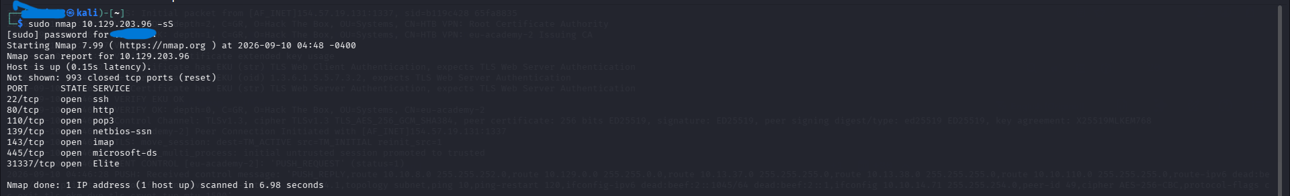
In this example image, using the -sS option or the default SYN scan, we were able to find out on the target IP address there are 7 open ports.

2. Enumerate the hostname of the target.
With this task, we have to enumerate the hostname of the target, in order to do that, we will scan one single port and the port we will use is 445/tcp
The reason we will choose 445/tcp port, that is because this is a SMB (microsoft-ds), which is typically associated with Windows systems.
SMB can expose useful information about the target, such as hostname, domain, available network shares
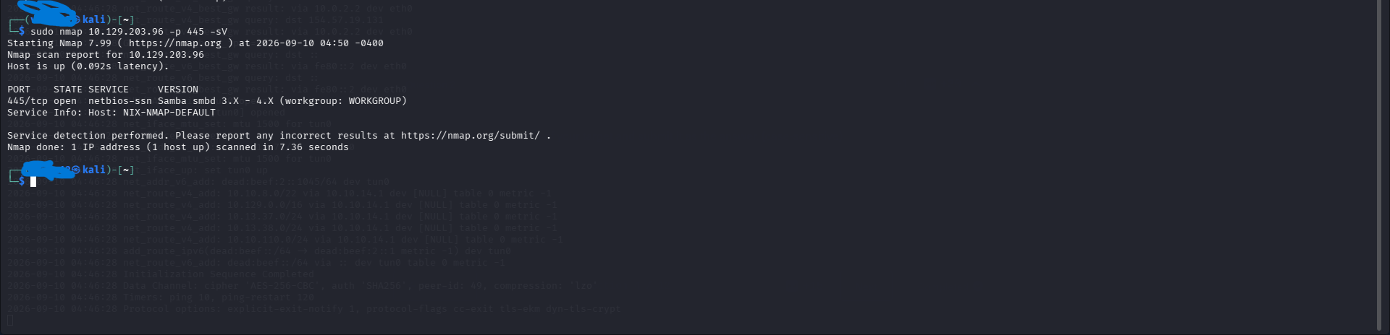
The command, that was used to enumerate the hostname was: sudo nmap 10.129.203.96 -p 445 -sV
- -p – option used to scan a specific port, which in our case was 445/tcp.
- -sV – This option performs a scan to find out service version and name.

There can be situations, where we will need to save the scan results. To do that we use one of the three options:
- Normal output (-oN) with the .nmap file extension
- Grepable output (-oG) with the .gnmap file extension
- XML output (-oX) with the .xml file extension

But to save in all formats, use the -oA
1.Operating system identification with Nmap
This task was completed on HackTheBox’s authorized lab network.
The task, that the platform requested we do is identify which operating system is running on the specific target.
By doing this, the platform spawned a target IP address, that we are allowed to use. In this case the target IP address was: 10.129.2.80
In order to find out the operating system that is running, firstly, we will do a default scan, just to see which ports are exposed:
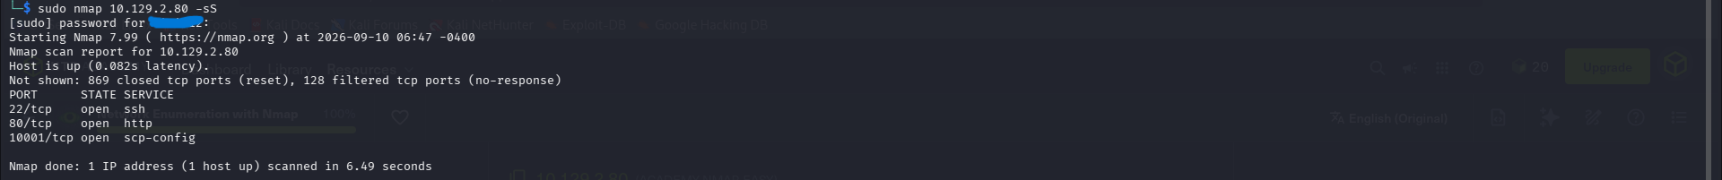
As we can see, the secure shell (SSH) is exposed.
SSH is a security protocol, that is used to log into and execute commands on the remote system.
So with that, I will perform an aggressive nmap scan with the -sV option, which is used to identify the operating system running, but also the service and its version.

And with the scan, we find out, that the operating system, that is running on the target machine is Ubuntu.

2. Finding the target’s DNS server version
For this task, we have to find the target’s DNS server version. The version will be written as a string with characters, with the first letters will be HTB.

Firstly after spawning the target, which was: 10.129.2.48, first, just like the previous task, we do a quick SYN scan, using -sS to see which ports are exposed.
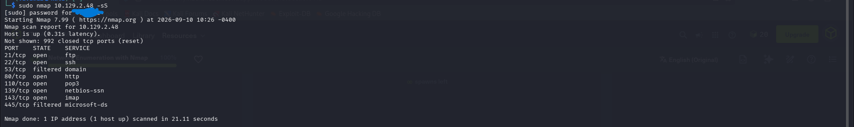
We can see there are two filtered tcp ports, which are 53/tcp and 445/tcp ports.
- 53/tcp – The DNS domain port was identified on the target, which is used for resolving domain names to IP addresses.
- 445/tcp – A Windows associated service, commonly used for file and network resource sharing. This suggest that the machine is running Windows.
Also we can see, that these two ports are labeled as “filtered”.
Filtered means that nmap cannot identify whether they are open or closed, likely due to network traffic rules or filtered by the firewall.

In order to access the DNS server version, we will use a Nmap Scripting Engine or NSE.
NSE provides the possibility to create scripts in Lua programming language, for interacting with certain services.
The script, that will be used is the –script dns-nsid. This script retrieves information from a DNS name server.
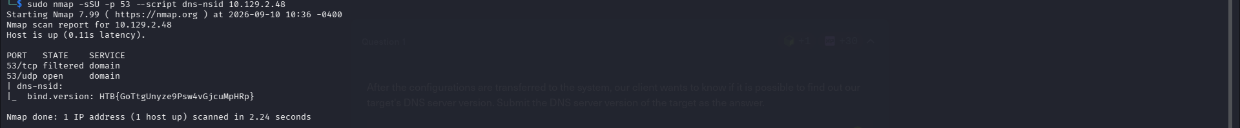
The command option -sSU, will perform both UDP and TCP scans on the target.
With that, we see the DNS server version, which HackTheBox put it as HTB{GoTtgUnyze9Psw4vGjcuMpHRp}.

3. Version of the running services identification.

The third, more difficult task is identifying the running services version on the target.
So the first task is to perform, just like other two, a default SYN scan, using -sS.
We can see there are two ports open, but the sneaky part is that the lab is hiding a port.
In this section, we are learning also to scan all ports on the target, which in total there are 65,535 ports and by doing the default scan it will take a long time.
With that, we will use the –min-rate 1000, which will tell nmap to send 1000 probes/packets per second during the scan when possible, which will speed up the process.
-Pn disables ICMP Echo requests
-T4 is a timing template, that determine the aggressiveness of the scan.

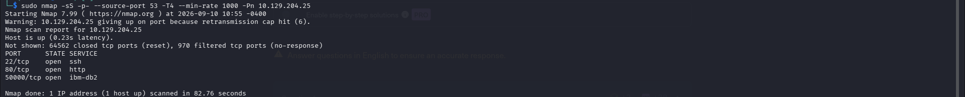
With that we have found port 50000, which is a ibm-db2, meaning its a database software used by organizations to store and manage structured data.

The final step is to use ncat -nv, that is used to connect directly to an identified open service and inspect its banner/response.
In the results, we see the running services, that was asked to identified, which in the lab’s case is: HTB{kjnsdf2n982n1827eh76238s98di1w6}
And the version is 7.99

